Mineral Titles Act
NOTICE OF GRANT OF A MINERAL TITLE
Title Type and Number: | Exploration Licence 33346
Granted: | 03 February 2023, for a period of 6 Years
Area: | 5 Blocks, 5.25 km²
Locality: | BYNOE
Name of Holder/s: | 100% RED MOUNTAIN MINING LTD [ACN. 119 568 106]
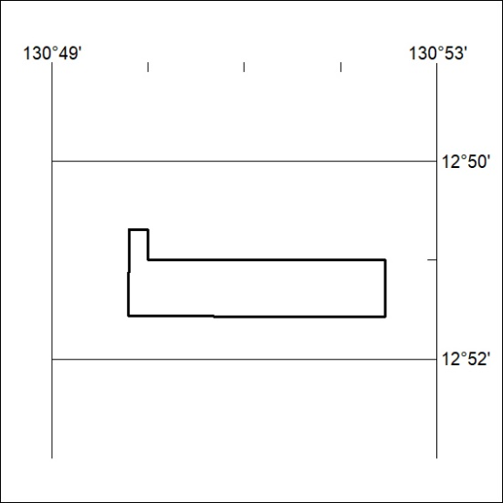
Area granted is indicated above. The titleholder is not permitted to exercise occupational rights on any land that is subject to a development title, or an application for a development title. Any land the subject of a Reserved Land gazettal under the Mineral Titles Act and all land vested in the Commonwealth of Australia is also excluded by description but not excised from the grant area.

036/23

