Mineral Titles Act 2010
NOTICE OF LAND CEASING TO BE A MINERAL TITLE APPLICATION AREA
Title Type and Number: | Exploration Licence 33216
Area Ceased on: | 21 October 2022
Area: | 244 Blocks, 788.44 km²
Locality: | BRUNCHILLY
Name of Applicant(s)/Holder(s): | 100% CHEVELLE MINERALS PTY LTD [ACN. 655 142 199]
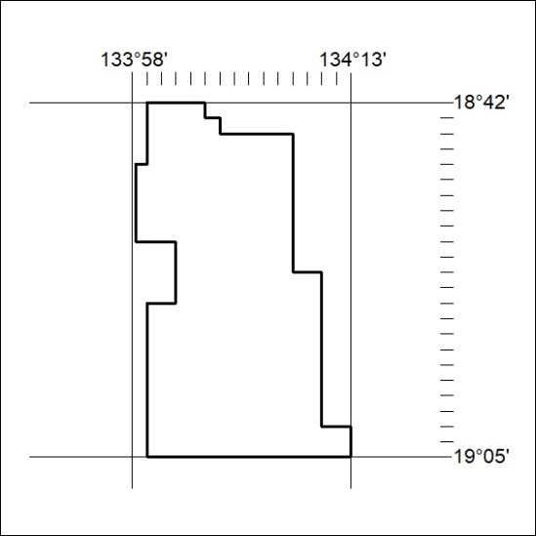

360/22

