Extractive Mining Management Plan User Guide
  - June 2022
Document title | Extractive Mining Management Plan User Guide
Contact details | Department of Industry Tourism and Trade  Mines Division – Mining Operations  GPO Box 4550, DARWIN NT 0801, AUSTRALIA  E: mineralinfo.ITT@nt.gov.au, Tel: 08 8999 6528
Approved by | Executive Director Mining Operations
Date approved | xx June 2022
Document review | Annually
TRM number | N/A

Version | Date | Author | Changes made
1.0 | 10 March 2021 | Mining Operations | Updated diagrams
1.1 | 21 February 2022 | Mining Operations | Text and diagrams

Acronyms | Full form
AAPA | Aboriginal Areas Protection Authority
ABN and ACN | Australian Business Number and Australian Company Number
ASIC-ABR | Australian Securities and Investments Commission – Australian Business Register
DEPWS | Department of Environment, Parks and Water Security
DITT/  The Department | Department of Industry, Tourism and Trade
EMEL | Extractive Mineral Exploration Lease
EML | Extractive Mineral Lease
EMP | Extractive Mineral Permit
EMS | Environmental Management System
EP | Environment Protection Act 2019
EPBC | Environment Protection and Biodiversity Conservation Act 1999
MCA | Minerals Council of Australia
ML | Mineral Lease
MMA | Mining Management Act 2019
MMP | Mining Management Plan
MTA | Mineral Titles Act 2010
NT | Northern Territory
SOBS | Site of Botanical Significance
SOCS | Site of Conservation Significance
STRIKE | Spatial Territory Resource Information Kit for Exploration

Contents
Purpose 4
Regulatory Requirements 4
Project Details 5
Operator Details 5
Declaration 5
Project Details 6
Legislation 6
Existing Disturbance 7
Environmental Considerations 7
Assessment of the Environmental Risk 8
Activities Proposed 10
Environmental Management System 11
Rehabilitation 11
Closure Planning 12
Security Costings 12
Required Attachments 13

Purpose

This user guide has been developed to provide guidance and support to individuals and companies (the Operator) completing the Application for Authorisation and preparing a Mining Management Plan (MMP), in order to undertake extractive activities in the Northern Territory (NT). The guide also clarifies the additional information necessary to obtain an Authorisation under the Mining Management Act 2001 (MMA).

The Application for Authorisation and Mining Management Plan templates and guidance can be found at https://nt.gov.au/industry/mining-and-petroleum/mining-activities

Regulatory Requirements

Before undertaking any mining activity (extractive) in the NT, the following documentation must be submitted for assessment to the Department:

- Application for Authorisation – for application for initial grant of Authorisation, or if operator contact details have changed
- Nomination of Operator form- where the Operator is not the title holder and this has not been previously provided.
- Mining Management Plan
- Security Calculation

This applies to any extractive activities likely to cause substantial disturbance (e.g. land clearing, extraction, etc. as described at https://nt.gov.au/industry/mining-and-petroleum/mining-activities/substantial-disturbance ). An Operator is required to hold a mineral title granted under the Mineral Titles Act 2010 (MTA), or be appointed Operator by the owner of a mining site under the MMA. These documents contain Project information to enable full assessment by the Department against the requirements of the MMA.

The MMP and supporting information must be reviewed every 12 months as specified in your Authorisation. . If on review the MMP needs amending, the Operator is to submit an amended MMP to be assessed on or before the anniversary of the Authorisation. If on review the MMP does not need amending, the Operator is requested to advise the Department in writing on or before the anniversary of the Authorisation.

If changes to an approved MMP are proposed, an amended MMP must be submitted and approved prior to the new mining activities commencing.

The information requested in the following Sections is required under the MMA.

  - Step 1. Application for Authorisation
The Authorisation provides the Operator with approval to undertake the work detailed in the MMP for the period specified, and subject to the conditions, in the Authorisation.

The Application for Authorisation submitted to the Department will not be made public.

The Application for Authorisation has to be provided when submitting a MMP for the first time and thereafter only when details on the form need to be updated. Contact details are used by the Department to communicate matter related to the Project with the person included as contact in the form. It is the Operator responsibility to ensure updated details are communicated to the Department at any stage.

Project Details
The purpose of this Section is for providing clear details about what approval is being sought
The applicant must select the appropriate checkboxes in this Section:

- ‘New Authorisation’ – for applications under Section 36(1) of the MMA. For instance, where there is a new Project and/or the ACN/ABN related to an existing project changes.
- ‘Variation of Authorisation’ if the applicant holds an existing Authorisation and proposes changes to the approved activities, mining interests, Operator’s name and/or project’s name.
- ‘Extractive’ is for mining activities that involve a pit or excavation made in land below the natural surface for the purpose of extracting sand, rock, soil or gravel. Can also include removal of stockpiled material and fall within an EMP, EML, EMEL or ML.
- The Project name is required to identify which project the Authorisation pertains to and the Authorisation number for existing Authorisations.

Operator Details
This Section is required to ensure contact details are kept current in the Department’s database.

- Include name of Operator as shown on the ASIC-ABR register or the applicant’s name in the case where an ACN number does not exist.
- Include ACN and ABN numbers if both available.
- Include the main business street and postal address.
- Include the contact details (name and title position) of the nominated contact in which the Department will deal with for all matters related to the Authorisation/Project.
- Include the nominated contact phone number and email address. More than one contact detail can be added if needed (e.g. security matter, general contact).

Declaration
This application must be signed and dated by a senior representative of the company who has the appropriate level of Authority to do so. This ensures the Operator is accountable for the information provided in the application.

  - Step 2. Mining Management Plan
The MMP is the primary tool for managing compliance with the MMA. The MMP clearly sets out all the environmental and other legal obligations that must be met by the Operator.

The MMP template can be adjusted to suit each operation. However, the omission of information requested will impede on the assessment process. Therefore, the applicant is strongly encouraged to provide the information requested to the Department and/or provide justification if information cannot be supplied.

Note: Your approved MMP, excluding any commercial in confidence material and personal details, may be made public. The department considers commercial-in-confidence material and personal information to include:

- Security estimates and calculations
- Commercial contractual information
- Staff personal details including signatures.

Following approval of the MMP the Operator may be required to make the MMP, with the agreed commercial-in-confidence information removed, available to the public within 14 days of approval. If so, the Operator is required to provide to the Department the website link to the MMP published on the company website or request that it be published on the DITT website.

Project Details
Some of the information requested in this Section has already been provided in the Application for Authorisation. The Application for Authorisation and the MMP are two separate documents, and operator/project identifying information is required to link the two documents. In this Section, provide the following information:

- Project name, existing Authorisation number and Operator name consistent with the details provided in the Application for Authorisation.
- A brief description of how to access the project site from the nearest town or community.
- The mineral commodity(s) that are being explored for.
- A short explanation of the extractive activities.
- Include the planned start and finish dates for the activities proposed in the MMP. Note: the MMP is not limited to a yearly period. Works can be outlined for a number of years or the life of the project. Where appropriate, stages for the project may be outlined. Stages must be clearly identified along with the related disturbance . Please beware that staged security payments, that correlate with the staged works can be considered. Contact a Mining Officer for assistance in regards to staged payments.

Mining Interests, Land Ownership and Organisational Structure

- List the mining interests (titles), the titleholder name/s, the expiry date and the property name/land holder (e.g. pastoralist, Aboriginal land trust, and freehold land) for each title. The titles provided here will be included in the Authorisation document. Should a title be omitted, work will not be authorised on that title.
- Include organisational structure or detail in the table details of key positions and names of those with responsibility and accountability for the mining activities detailed in this MMP.

Legislation
It is the operator’s responsibility to be aware that, whilst regulated under the MMA, mining operations are also subject to additional legislation. Operations must be undertaken in accordance with the legislation listed in Section 2 of the MMP template.

Existing Disturbance
The information contained in this Section provides details of previous works carried out at the site, either by previous operators, or under previous MMPs. The operator is responsible for previous disturbances where a title has been purchased from a previous operator.

This table will inform the status of disturbance and must be completed for each title in your project. Disturbances here will be included in the security calculation, along with proposed disturbances detailed in Section 6 of the MMP template.

Environmental Considerations
Identification of Environmental Risk
In preparing your MMP it is important to identify the environmental risks associated with the proposed mining activities. Follow the process outlined in Figure 1 when developing your MMP.

In addition, ensure you check the “Offer of Grant” letter received from Titles, as this may contain comments from other Government Departments and the Mining Operations Section that will help guide you in identifying and addressing potential risk.

Figure 1: Developing an MMP
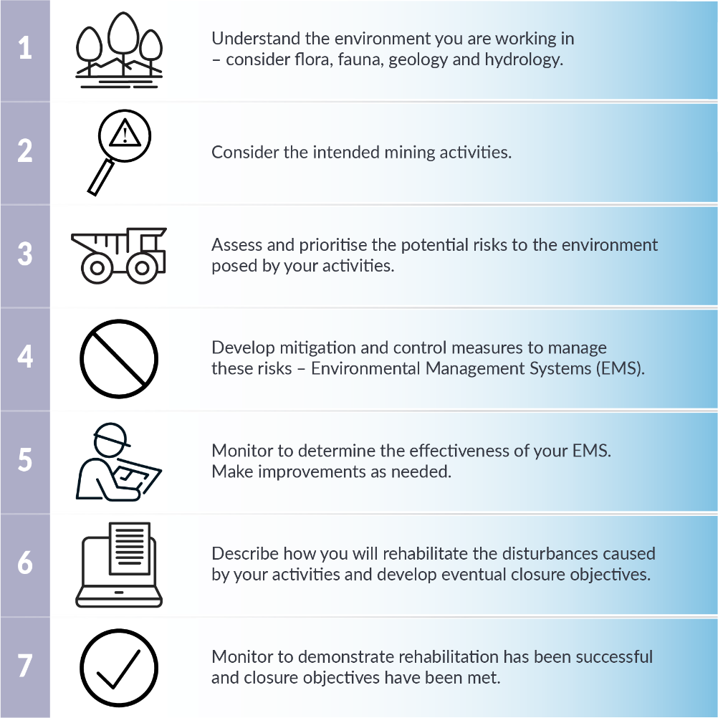

Assessment of the Environmental Risk
The Operator is responsible for identifying all key environmental risks and ensuring compliance with relevant legislation. Follow the steps outlined in the assessment tables. Evidence of consultation and the resulting management plans, must be provided as an appendix to the MMP.

The Department recommends risk assessments are undertaken by suitably qualified persons. It is essential that persons undertaking ecological studies/specialised surveys for environmental assessment have the appropriate skills, knowledge and experience to ensure that reported outcomes are adequate, accurate and robust. This includes the capability to:

- Interpret local data in a regional context, including through access to relevant, current spatial environmental datasets hosted by government agencies; and
- Clearly report on methods, results, interpretation and relevance to environmental risks and their management and mitigation.

Step 1: Check for threatened species. It is likely a threatened species will show up in all reports. Therefore, the Operator must undertake a likelihood analysis, which looks at the likelihood of the species or its habitat occurring at or near the site. If the analysis results in a high likelihood, then a “Significant Impact Assessment” must be undertaken, and results appended to the MMP. A comment describing actions taken (e.g. consulted NR MAPS and EPBC Protected Matters Search Tool, outcome from EPBC Protected Matters Search Tool appended to the MMP) can be included in this Section. However, this Section is NOT intended as a summary of outcomes.

The Matters of National Environmental Significance - Significant Impact Guidelines 1.1, contain information in relation to undertaking a likelihood analysis and significant impact assessment.

Useful Resources | Web address
STRIKE | http://strike.nt.gov.au/
NR MAPS | http://nrmaps.nt.gov.au/
EPBC Protected Matters Search Tool | htttp://www.environment.gov.au/epbc/protected-matters-search-tool
Significant Impact Guidelines 1.1 | http://www.environment.gov.au/system/files/resources/42f84df4-720b-4dcf-b262-48679a3aba58/files/nes-guidelines_1.pdf

Step 2: Determine if declared weeds have been reported in the project area. Contact the relevant landholder/s and/ DEPWS – Weeds Management Branch to determine if weeds are present and what management actions are required to control/manage the weeds. It is the responsibility of the owner and occupier of land to eradicate or control declared weeds.

Useful resource | Web address
NR MAPS | http://nrmaps.nt.gov.au/

Step 3: Water related matters on mining sites are no longer exempt from the Water Act 1992. Determine your requirements for a licence and or permit under the Water Act 1992 should you intend extracting water for your project and or interfering with a water way.

Useful resource | Web address
DEPWS Water Resources | https://nt.gov.au/environment/water
Contact Water Resources | water.regulation@nt.gov.au

Step 4: Determine if the project is likely to have a significant impact on the environment.

Useful resources | Web address
Environmental Factors and Objectives | https://ntepa.nt.gov.au/__data/assets/pdf_file/0005/546791/guideline_environmental_factors_objectives.pdf
Referring a Proposal to the NTEPA | https://ntepa.nt.gov.au/__data/assets/pdf_file/0011/570872/guideline_referring_proposal_to_ntepa.pdf

Step 5: Determine if sacred sites exist with the project area. The Aboriginal Areas Protection Authority (AAPA) is responsible for the administration of the Northern Territory Aboriginal Sacred Site Act 1989. Evidence of an Authority Certificate or Register Search are not required; however, locations of sacred sites or exclusion areas should be shown on maps appended to the MMP.

Useful resource | Web address
Aboriginal Areas Protection Authority | http://www.aapant.org.au/

Step 6: Determine if there are any archaeological and heritage sites within the project area. The Department of Territory Families, Housing and Communities (DTFHC) administers the Heritage Act 2011. Evidence of archaeological and heritage searches are not required; however, locations of sites should be shown on maps appended to the MMP.

Useful resource | Web address
NT Heritage Register | https://nt.gov.au/property/land/heritage-listings/heritage-register-search-for-places-or-objects

Please contact a Mining Officer if assistance is required in completing Section 2 of the MMP.

Activities Proposed
This Section should detail only the proposed activities for the duration of the MMP asexisting disturbances are already accounted for in Section 3. Where no new activities are proposed, but completion of prior approved activities are planned, an amended MMP is not required.

Note: All Authorisations require annual review of the approved MMP, by a specific date. If on review the MMP does not need to be amended, please advise the department that no amendments will be submitted as a result of the review.

Details of the proposed activities should be outlined in the Table provided. For projects with numerous titles, columns can be added in the existing table or additional table/s included. These details assist Mining Officers in making the assessment of the risk and management of the project and the required security. Multiple work programs can be included as a staged approach. Only a security for the first stage is required until the Operator is ready to commence the next stage. Liaise with the Department where this is required.

Site Map
Include a site map/s detailing existing and proposed pits, lay down areas, access tracks. Ensure the map includes:
- north arrow
- legend
- scale
- existing disturbances
- proposed disturbances
- title boundaries and numbers
- buffers and avoidance areas
- rehabilitated areas and
- date
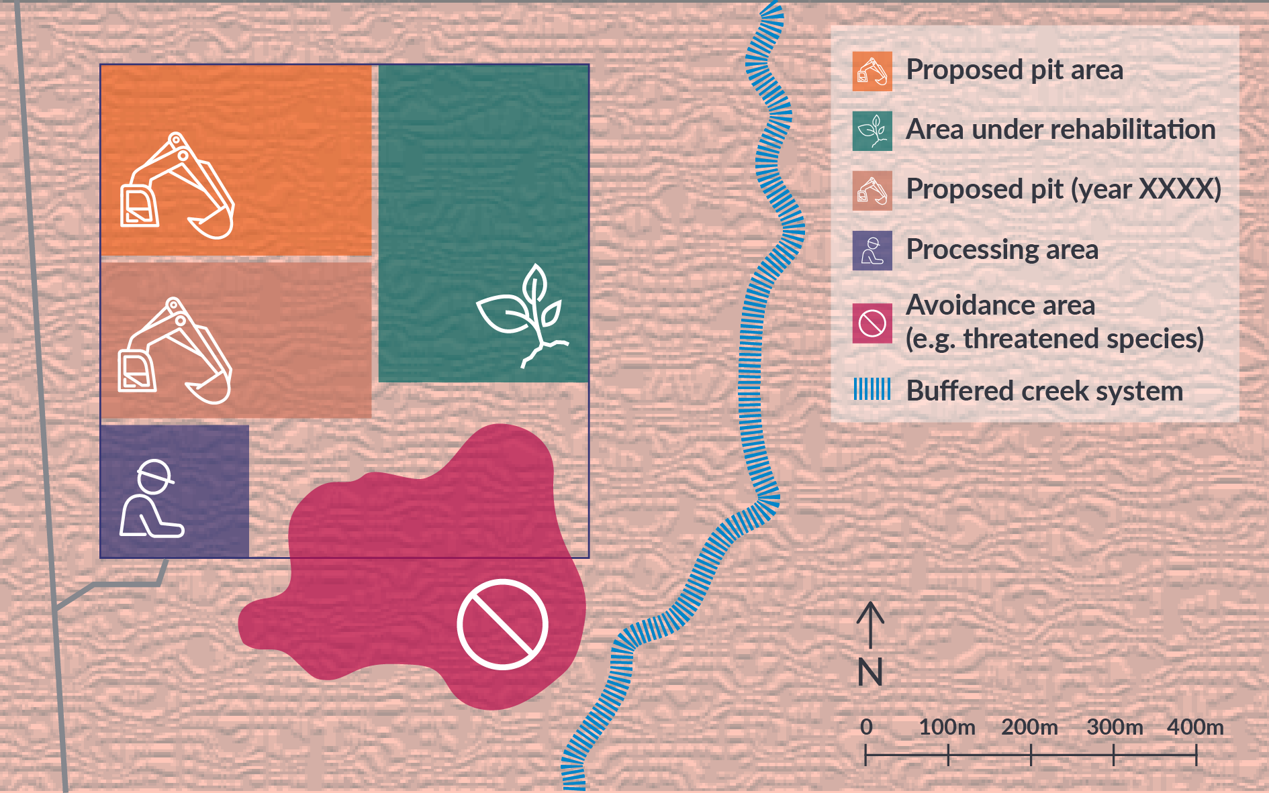
Conceptual diagram for illustration purposes only.

Where disturbances are located on multiple titles, include a map for each title, or as appropriate to effectively demonstrate all working areas.

In addition to maps, the department requires current and proposed disturbance areas be provided in an appropriate spatial dataset (i.e. gpx, kmz or kml files, MapInfo tab files, ARC GIS files, or QGIS files).

Environmental Management System
Under the Section 16 of the MMA an operator must establish and maintain an environmental protection management system that is appropriate to the proposed mining activities and will, as far as practicable, protect the environment. The Environmental Management System (EMS) fulfils this requirement.

Table 9 of the MMP template details the Department’s minimum requirements for an EMS for extractive activities. Consider the prompt’s in the table, and tailor the content to your specific project and activities. Should the Operator choose not to follow the Department’s minimum standards, justification and alternative measures must be provided. Omitting information required for assessment will impede the process as further information will be requested.

To be effective the EMS will include:
- monitoring to measure the effectiveness of the management actions
- set appropriate ‘trigger’ values (the point at which action will be taken)
- corrective actions that will be undertaken should a trigger value be breached or where a management system is deemed to be not be as effective as planned.

Prior to, and during the life of the project, it is recommended the Operator establish photo monitoring points which may assist with tracking change over time, specifically rehabilitation and closure.

Rehabilitation
The next land use dictates rehabilitation requirements. Consultation with the underlying landowner or lessee should be undertaken to determine the next land use. Detail the outcomes of this consultation in the MMP. Where next land use and appropriate alternative rehabilitation has not been agreed upon, Table 10 of the MMP template details the Department’s minimum standards for rehabilitation of the proposed activities. By checking ‘Yes’ in each box, the Operator agrees to adopt these standards and implement the rehabilitation.

Conceptual diagram for illustration purposes only.

Evidence must be provided for disturbances that are to remain after closure, e.g. where the land holder has accepted the liability and future management.

Should the Operator choose not to adopt the Department’s minimum standards, justification and alternative measures must be provided. Omitting information required for assessment will impede the process as further information will be requested.

Completed rehabilitation may require a Departmental site inspection and submission of a rehabilitation report, updated security calculation and updated rehabilitation register. Before and after photographs of completed works are required in the rehabilitation report to demonstrate successful rehabilitation (Aerial drone imagery may also be submitted).

Where successful rehabilitation is demonstrated a partial release of security may occur. Where successful rehabilitation is not demonstrated, the security cannot be released.

Closure Planning
Under Section 40 of the MMA, the MMP must detail closure for a site. Planning for closure from the outset will help you achieve closure in a timely manner. A key component of Closure Planning is the development of closure criteria, against which achievements can be measured. To identify closure criteria, key themes should be developed which consider the previously defined "next land use” and may include landform, vegetation, sediment management, removal of infrastructure. Examples of closure criteria are provided in table 11 of the MMP template and should be tailored to your specific project.

Closure planning will dictate the progressive rehabilitation that you undertake on site. Progressive rehabilitation will help you achieve closure and release of all security in a timely manner.

Security Costings
Rehabilitation and post rehabilitation monitoring and closure costings must be determined using the Departmental Security Calculation Tool, available from the departmental website. Costings should be based upon existing and proposed disturbance; and account for rehabilitation, where it has been conducted and accepted.
Ensure that a security calculation is submitted with the MMP to limit delays in assessment times.
Resource | Web address
Security and Levy | https://nt.gov.au/industry/mining-and-petroleum/mining-activities/security-and-levy.

Should a security release be requested, evidence of rehabilitation is required to be submitted as per Section 8 and clearly identified in the security calculation.

The Department may retain part of the security amount for rehabilitation and rehabilitation monitoring for the purpose of ensuring closure objectives are met before closing the project out.

A Certificate of Closure, subject to the MMA may be issued and the security released when the Operator can demonstrate the closure objectives have been achieved.

Required Attachments
All the required attachments, if applicable, must be submitted as appendices to the MMP. Should one of the attachments not be included, justification must be provided.

Note: Omitting information required for assessment will impede the process as further information will be requested.

Please provide the following:

- A completed Application for Authorisation form including all the necessary contact details for the Department to communicate with the Operator on diverse matters (e.g. security, MMP assessment).
- A completed ‘Nomination of Operator form’, if the title holder is not the Operator of the site as shown on Section 1 ‘Mining Interests and Ownership’ of the Mining Management Plan. This is only required if this has not been previously provided and accepted.
- The completed security calculation spreadsheet, ensuring the information included reflects the existing and proposed disturbance outlined in the MMP. Should any of the information included in the spreadsheet contradict those of the MMP, explanation will be required prior its assessment and acceptance.
- Spatial data (kml, .shp) of all disturbances, (ensure a clear distinction between the existing and the proposed disturbances), buffers or exclusion zones, areas rehabilitated.
- A topographic map including the work areas showing all current and proposed disturbances, title boundaries, tracks, rehabilitated areas, and environmental, sacred and heritage site constraints.
- The documents related to Section 5 must also be included as appendix when required (e.g. threatened species search, current biodiversity management plan if related to proposed work, evidence of consultation with DEPWS in relation to weeds and water and related documents if requested by DEPWS).

