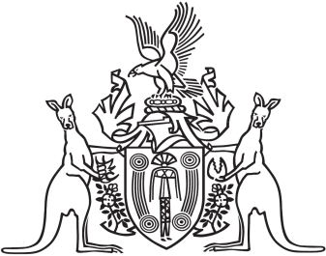
Northern Territory of Australia

Government Gazette
ISSN-0157-833X
No. S92 26 November 2018

Assent to Proposed Laws
Her Honour the Administrator has declared assent to the following proposed laws:
22 November 2018
Animal Protection Act 2018 (Act No. 25 of 2018)
Training and Skills Development Amendment Act 2018 (Act No. 26 of 2018)
Michael Tatham
Clerk of the Legislative Assembly
23 November 2018

