Front cover page.
Heading of Remote Towns Jobs Profile 2017
Jobs profile remote town name Utopia
Remote Towns Jobs Profile 2017

UTOPIA

**© Northern Territory of Australia 2018**

**Preferred Reference:** Department of Trade, Business and Innovation, 2017 Remote Towns Jobs Profiles, Northern Territory Government, June 2018, Darwin.

**Disclaimer**

The data in this publication were predominantly collected by conducting a face-to-face survey of businesses within town boundaries during mid-2017. The collection methodology was created in accordance with Australian Bureau of Statistics data quality framework principles. Data in this publication are only reflective of those businesses reported on as operating in the town at the time of data collection (see table at the end of publication for list of businesses reported on).

To comply with privacy legislation or where appropriate, some data in this publication may have been adjusted and will not reflect the actual data reported by businesses. As a result of this, combined with certain data not being reported by some businesses, some components may not add to totals. Changes over time may also reflect business' change in propensity to report on certain data items rather than actual changes over time. Total figures have generally not been adjusted.

Notes for each table and chart are alphabetically ordered and listed at the end of the publication.

Any use of this report for commercial purposes is not endorsed by the Department of Trade, Business and Innovation.

Contents

Utopia 4

Introduction 5

Summary 6

Jobs Overview 7

Jobs by Aboriginal Status 8

Jobs by Sector: Private and Public 10

Job Status: Permanent and Temporary 13

Job Vacancies 15

Jobs by Industry 16

In 2017 in Utopia: 18

Jobs by Occupation 19

Jobs by Industry by Occupation 21

Jobs by Gender 22

Jobs by Age 24

Vocational Education and Training 27

Population 29

Community Development Programme 31

Businesses 32

Notes 33

Abbreviations and Acronyms 34

# Utopia

Utopia is a region covering approximately 50002 kilometres of land north east of Alice Springs and comprises of several large and small communities, with a population of 517 residents.

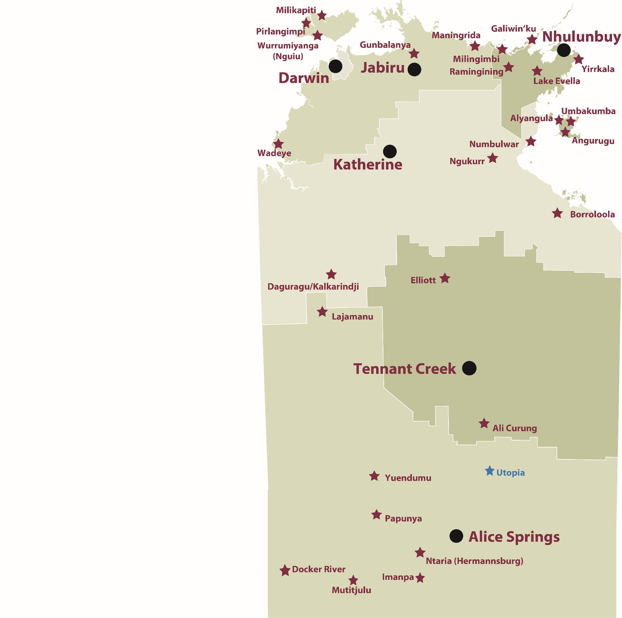

*Source: Department of Trade, Business and Innovation*

# Introduction

This jobs profile provides a snapshot of jobs and the characteristics of job holders in Utopia as at July 2017.

This job profile is one of 28 profiles developed for remote towns in the Northern Territory. It is anticipated these and subsequent profiles will contribute to a robust evidence base to inform decision making in and relating to these remote Territory towns.

This profile contains information collected by the Northern Territory Department of Trade, Business and Innovation from businesses operating within the town and is supplemented by other administrative data sets and information.

Each profile provides up-to-date information that is intended to inform the planning and design of current and future government programs and as an evidence base to inform decision making relating to workforce development, enterprise and job opportunities.

The data collection methodology and corresponding questionnaire were created in partnership with the Australian Bureau of Statistics (ABS) and in accordance with ABS data quality framework and survey principles.

The surveys were predominantly conducted by the Department’s Small Business Champions and Workforce Training Coordinators, on a face-to-face basis with business representatives.

The information collected and reported on represents a significant goodwill investment by those businesses and organisations that participated. Each business is listed at the end of this publication.

# Summary

The 2017 jobs profile was developed based on responses from 11 businesses operating within the Utopia town boundary. Of these, there were:

* 8 businesses from the private sector, accounting for 70 filled jobs or 52% of total filled jobs
* 3 businesses from the public sector, accounting for 65 filled jobs or 48% of total filled jobs.

A total of 166 filled and vacant jobs in Utopia were reported.[1]

The 2017 profile highlights:

* there were 135 filled jobs of which:
* 79 jobs (59%) were filled by Aboriginal persons
* 56 jobs (41%) were filled by non-Aboriginal persons
* 32% of employed Aboriginal people are working in the private sector
* Aboriginal females made up 53% of total Aboriginal filled jobs
* there were 31 vacant jobs, of which:
* job vacancies as a percentage of jobs is 19%
* job vacancies equate to 1 in 5 jobs
* 19 of the vacancies were in Community and personal Service Workers and Professional areas
* Education and Training was the largest industry employer in 2017 with 46 filled jobs, followed by Health Care and Social Assistance with 36
* Building and Construction was the largest training activity sector in 2016 with 26 students, followed by General Education and Training with 22.

The overall population in Utopia increased by 227 persons (78%) between 2006 and 2016 to 517 persons.

In comparison, the overall Northern Territory population increased by 16.5% between 2006 and 2016.

In 2016, the working age population (15 years and over) in Utopia was an estimated 350 persons compared to 195 in 2006 an increase by 79%.

There were 0.5 jobs in Utopia per working age person compared to 0.4 jobs per working age person across the 28 remote towns in the Northern Territory.

# Jobs Overview

Table 1: Count of filled jobs and vacancies, 2017 (a)(b)

|  |  |
| --- | --- |
|  | **2017** |
| **Total All Jobs** | **166** |
| **Vacancies** | **31** |
| Vacancies as % of Total All Jobs | 18.7% |
| **Filled Jobs** | **135** |
| Full-time | 100 |
| Part-time | 35 |

Source: Department of Trade, Business and Innovation

Chart 1: Count of vacant jobs and filled jobs by full-time/part-time status, 2017 (a)(b)

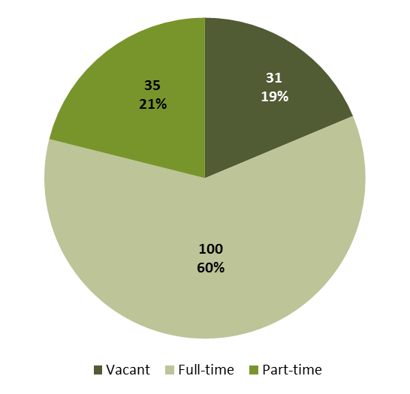

Source: Department of Trade, Business and Innovation

In 2017 in Utopia:

* there were a total of 135 **filled jobs**. Of these:
* 100 were **full-time** jobs
* 35 were **part-time** jobs
* there were 31 total job **vacancies**.

# Jobs by Aboriginal Status

Chart 2: Count of filled jobs by Aboriginal status, 2017 (a)(c)

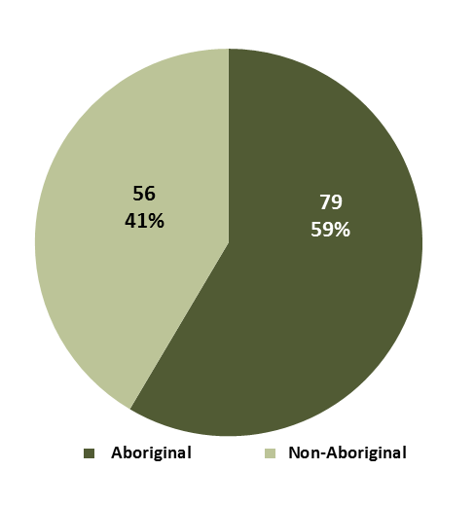

Source: Department of Trade, Business and Innovation

In 2017 in Utopia:

* of the 135 **filled jobs**:
* 79 jobs were filled by **Aboriginal** persons
* 56 jobs were filled by **non-Aboriginal** persons
* **Aboriginal** persons accounted for 59% of job holders.

Table 2: Count of filled jobs by full-time/part-time status and Aboriginal status of person in job, 2017 (a)(b)(c)

|  |  |  |  |
| --- | --- | --- | --- |
| **Indicator** | **2017** | | |
| **Aboriginal** | **Non-Aboriginal** | **Total** |
| Full-time | 47 | 53 | **100** |
| Part-time | 32 | 3 | **35** |
| **Total** | **79** | **56** | **135** |

Source: Department of Trade, Business and Innovation

Chart 3: Count of filled jobs by full-time/part-time status and Aboriginal status of person in job, 2017 (a)(b)(c)

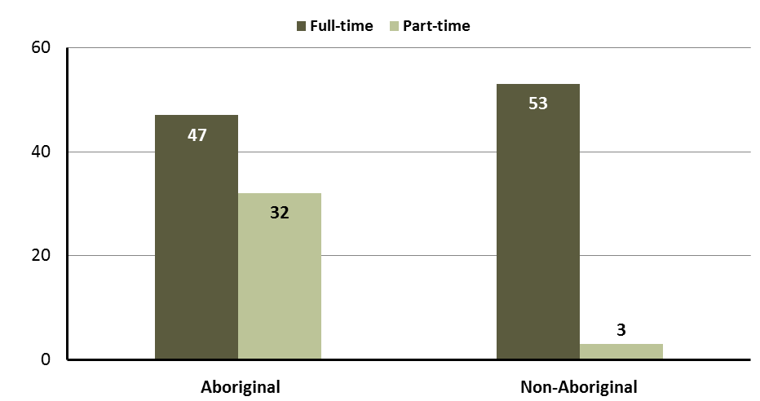

Source: Department of Trade, Business and Innovation

In 2017 in Utopia:

* of the 135 filled jobs:
* 47 were **full-time** jobs filled by **Aboriginal** persons
* 32 were **part-time** jobs filled by **Aboriginal** persons
* 53 were **full-time** jobs filled by **non-Aboriginal** persons
* 3 were **part-time** jobs filled by **non-Aboriginal** persons.

# Jobs by Sector: Private and Public

Table 3: Count of filled jobs by sector and Aboriginal status of person in job, 2017 (a)(c)(d)

|  |  |  |  |
| --- | --- | --- | --- |
| **Indicator** | **2017** | | |
| **Aboriginal** | **Non-Aboriginal** | **Total** |
| **Public Sector** | 36 | 29 | **65** |
| Australian Government | 0 | 0 | **0** |
| Territory Government | 22 | 26 | **48** |
| Local Government | 14 | 3 | **17** |
| **Private Sector** | 43 | 27 | **70** |
| **Total** | **79** | **56** | **135** |

Source: Department of Trade, Business and Innovation

Chart 4: Count of filled jobs by sector of business, 2017 (a)(d)

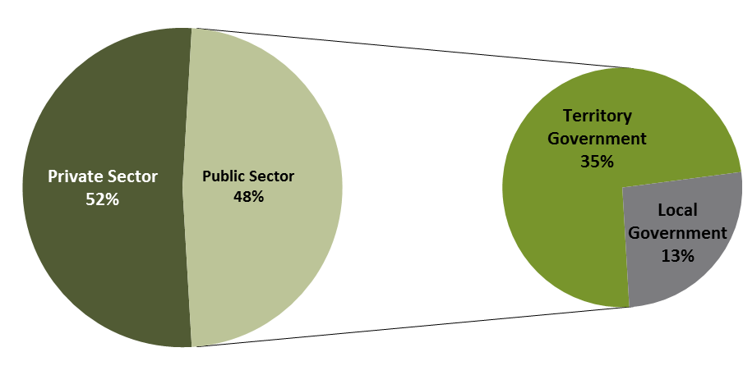

Source: Department of Trade, Business and Innovation

In 2017 in Utopia:

* of the 65 jobs in the **public** **sector**:
* none were in the Australian Government
* 48 jobs were in the Territory Government
* 17 jobs were in the Local Government
* there were 70 jobs in the **private** **sector**.

Chart 5: Count of filled jobs by sector and Aboriginal status of person in job, 2017 (a)(c)(d)

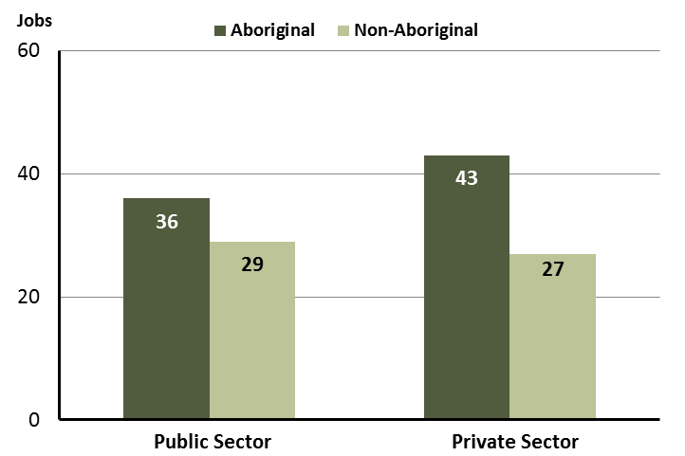

Source: Department of Trade, Business and Innovation

In 2017 in Utopia:

* of the 65 jobs in the **public** **sector**:
* 36 jobs were filled by **Aboriginal** persons
* 29 jobs were filled by **non-Aboriginal** persons
* of the 70 jobs in the **private** **sector**:
* 43 jobs were filled by **Aboriginal** persons
* 27 jobs were filled by **non-Aboriginal** persons.

Chart 6: Count of filled jobs by sector and full-time/part-time status of person in job, 2017 (a)(b)(d)

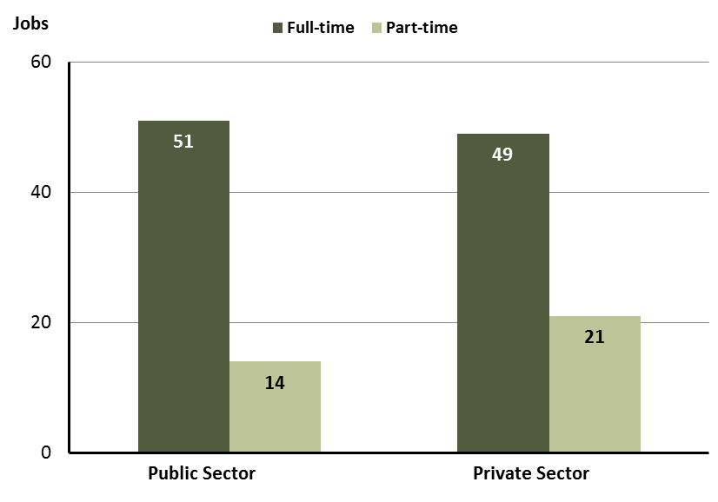

Source: Department of Trade, Business and Innovation

In 2017 in Utopia:

* of the 65 jobs in the **public** **sector**:
* 51 were full-time jobs
* 14 were part-time jobs
* of the 70 jobs in the **private** **sector**:
* 49 were full-time jobs
* 21 were part-time jobs.

Table 4: Count of filled jobs by full-time/part-time status and Aboriginal status of person in job by sector, 2017 (a)(b)(c)(d)

|  |  |  |  |  |  |  |  |  |  |  |
| --- | --- | --- | --- | --- | --- | --- | --- | --- | --- | --- |
| **Indicator** | **2017** | | | | | | | | | |
| **Aboriginal** | | | **Non-Aboriginal** | | | **Total** | | | |
| **Full-time** | **Part-time** | **Total** | **Full-time** | **Part-time** | **Total** | **Full-time** | **Part-time** | **Total** |
| Public Sector | 23 | 13 | **36** | 28 | 1 | **29** | 51 | 14 | **65** |
| Private Sector | 24 | 19 | **43** | 25 | 2 | **27** | 49 | 21 | **70** |
| **Total** | **47** | **32** | **79** | **53** | **3** | **56** | **100** | **35** | **135** |

Source: Department of Trade, Business and Innovation

In 2017 in Utopia:

* of the 36 jobs in the **public** **sector** filled by **Aboriginal** persons:
* 23 were full-time jobs
* 13 were part-time job
* of the 43 jobs in the **private** **sector** filled by **Aboriginal** persons:
* 24 were full-time jobs
* 19 were part-time jobs
* of the 29 jobs in the **public** **sector** filled by **non-Aboriginal** persons:
* 28 were full-time jobs
* 1 was a part-time job
* of the 27 jobs in the **private** **sector** filled by **non-Aboriginal** persons:
* 25 were full-time jobs
* 2 were part-time jobs.

# Job Status: Permanent and Temporary

Table 5: Count of filled jobs by employment status and Aboriginal status of person in job, 2017 (a)(c)(e)

|  |  |  |  |
| --- | --- | --- | --- |
| **Indicator** | **2017** | | |
| **Aboriginal** | **Non-Aboriginal** | **Total** |
| Permanent | 19 | 20 | **39** |
| Temporary | 60 | 36 | **96** |
| **Total** | **79** | **56** | **135** |

Source: Department of Trade, Business and Innovation

**Chart 7: Count of filled jobs by employment status and Aboriginal status of person in job, 2017 (a)(c)(e)**

See detailed description below.

Source: Department of Trade, Business and Innovation

In 2017 in Utopia:

* there were 39 **permanent** jobs, of which:
* 19 jobs were filled by **Aboriginal** persons
* 20 jobs were filled by **non-Aboriginal** persons
* there were 96 **temporary** jobs, of which:
* 60 jobs were filled by **Aboriginal** persons
* 36 jobs were filled by **non-Aboriginal** persons.

Table 6: Count of filled jobs by sector, Aboriginal status and employment status of person in job, 2017 (a)(c)(d)(e)

|  |  |  |  |  |  |  |  |  |  |
| --- | --- | --- | --- | --- | --- | --- | --- | --- | --- |
| **Indicator** | **2017** | | | | | | | | |
| **Aboriginal** | | | **Non-Aboriginal** | | | **Total** | | |
| **Perm** | **Temp** | **Total** | **Perm** | **Temp** | **Total** | **Perm** | **Temp** | **Total** |
| Public Sector | 11 | 25 | **36** | 12 | 17 | **29** | 23 | 42 | **65** |
| Private Sector | 8 | 35 | **43** | 8 | 19 | **27** | 16 | 54 | **70** |
| **Total** | **19** | **60** | **79** | **20** | **36** | **56** | **39** | **96** | **135** |

Source: Department of Trade, Business and Innovation

In 2017 in Utopia:

* of the 65 jobs in the **public** **sector**:
* 23 jobs were **permanent**, of which:
* 11 jobs were filled by **Aboriginal** persons
* 12 jobs were filled by **non-Aboriginal** persons
* 42 jobs were **temporary**, of which:
* 25 jobs were filled by **Aboriginal** persons
* 17 jobs were filled by **non-Aboriginal** persons
* of the 70 jobs in the **private** **sector**:
* 16 jobs were **permanent**, of which:
* 8 jobs were filled by **Aboriginal** persons
* 8 jobs were filled by **non-Aboriginal** persons
* 54 jobs were **temporary,** of which:
* 35 jobs were filled by **Aboriginal** persons
* 19 jobs were filled by **non-Aboriginal** persons.

# Job Vacancies

Table 7: Job vacancies, 2017

|  |  |
| --- | --- |
| **Indicator** | **2017** |
| **Job vacancies** | **31** |

Source: Department of Trade, Business and Innovation

Table 8: Job vacancies by occupation, 2017 (f)(g)

|  |  |
| --- | --- |
| **Occupation (ANZSCO major group)** | **2017** |
| Professionals | 8 |
| Clerical and Administrative Workers | 4 |
| Community and Personal Service Workers | 11 |
| Labourers | 6 |
| Machinery Operators and Drivers | 1 |
| Managers | 1 |
| **Total** | **31** |

Source: Department of Trade, Business and Innovation

Table 9: Job vacancies by job title, July 2017 (f)

|  |  |
| --- | --- |
| **Job Vacancy** | **No.** |
| **Aboriginal** and Torres Strait Islander Education Worker | 1 |
| Aged or Disabled Carer | 1 |
| Chief Executive or Managing Director | 1 |
| Community Worker | 3 |
| Family Support Worker | 2 |
| General Clerk | 2 |
| Handyperson | 5 |
| Liaison Officer | 2 |
| Primary School Teacher | 1 |
| Receptionist (General) | 1 |
| Registered Nurses nec | 5 |
| Storeperson | 1 |
| Teacher of English to Speakers of Other Languages | 1 |
| Teachers' Aide | 5 |
| **Total** | **31** |

Source: Department of Trade, Business and Innovation

In 2017 in Utopia:

* there were 31 **vacancies** reported
* of the 31 reported vacancies, the largest requirements were for:
* 11 Community and Personal Service Workers, the majority of which is in the following jobs:
* Teachers’ Aide
* Family Support and Community Worker
* 8 Professionals, the majority of which is in the following job:
* Registered Nurses nec
* 6 Labourers, the majority of which is in the following job:
* Handyperson.

# Jobs by Industry

Table 10: Count of filled jobs by industry of business, 2017 (a)(h)

|  |  |  |
| --- | --- | --- |
| **Industry (ANZSIC Division)** | **2017** | |
| **Total** | **% of Total** |
| Administrative and Support Services | 5 | 3.7% |
| Arts and Recreation Services | 3 | 2.2% |
| Education and Training | 46 | 34.1% |
| Health Care and Social Assistance | 36 | 26.7% |
| Public Administration and Safety | 20 | 14.8% |
| Retail Trade | 25 | 18.5% |
| **Total** | **135** | **100.0%** |

Source: Department of Trade, Business and Innovation

In 2017 in Utopia:

* the Education and Training industry was the **largest** **industry** **employer**, with 46 filled jobs or 34.1% of filled jobs
* **other** **significant** industry employers were:
* Health Care and Social Assistance with 36 jobs (or 26.7% of filled jobs)
* Retail Trade with 25 jobs (or 18.5% of filled jobs)
* Public Administration and Safety with 20 jobs (or 14.8% of filled jobs).

Table 11: Count of filled jobs by industry of business and Aboriginal status of person in job, 2017 (a)(c)(h)

|  |  |  |  |
| --- | --- | --- | --- |
| **Industry (ANZSIC division)** | **2017** | | |
| **Aboriginal** | **Non-Aboriginal** | **Total** |
| Administrative and Support Services | 1 | 4 | **5** |
| Arts and Recreation Services | 2 | 1 | **3** |
| Education and Training | 22 | 24 | **46** |
| Health Care and Social Assistance | 23 | 13 | **36** |
| Public Administration and Safety | 14 | 6 | **20** |
| Retail Trade | 17 | 8 | **25** |
| **Total** | **79** | **56** | **135** |

Source: Department of Trade, Business and Innovation

Chart 8: Count of filled jobs by top 5 industries of business and Aboriginal status of person in job, 2017 (a)(c)(h)

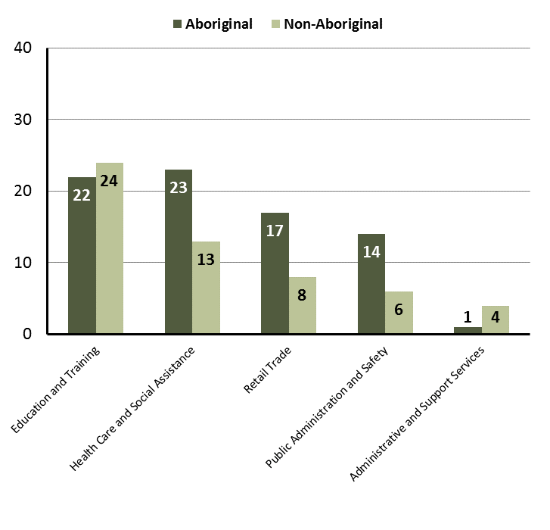

Source: Department of Trade, Business and Innovation

In 2017 in Utopia:

* of the 79 jobs filled by **Aboriginal** persons, there were:
* 22 jobs in Education and Training
* 23 jobs in Health Care and Social Assistance
* 17 jobs in Retail Trade
* of the 56 jobs filled by **non-Aboriginal** persons, there were:
* 24 jobs in Education and Training
* 13 jobs in Health Care and Social Assistance
* 8 jobs in Retail Trade.

Table 12: Count of filled jobs by industry, employment status and Aboriginal status of person in job, 2017 (a)(c)(e)(h)

|  |  |  |  |  |  |  |  |  |  |
| --- | --- | --- | --- | --- | --- | --- | --- | --- | --- |
| **Industry (ANZSIC division)** | **2017** | | | | | | | | |
| **Aboriginal** | | | **Non-Aboriginal** | | | **Total** | | |
| **Perm** | **Temp** | **Total** | **Perm** | **Temp** | **Total** | **Perm** | **Temp** | **Total** |
| Administrative and Support Services | 0 | 1 | **1** | 3 | 1 | **4** | 3 | 2 | **5** |
| Arts and Recreation Services | 0 | 2 | **2** | 0 | 1 | **1** | 0 | 3 | **3** |
| Education and Training | 7 | 15 | **22** | 8 | 16 | **24** | 15 | 31 | **46** |
| Health Care and Social Assistance | 0 | 23 | **23** | 0 | 13 | **13** | 0 | 36 | **36** |
| Public Administration and Safety | 4 | 10 | **14** | 5 | 1 | **6** | 9 | 11 | **20** |
| Retail Trade | 8 | 9 | **17** | 4 | 4 | **8** | 12 | 13 | **25** |
| **Total** | **19** | **60** | **79** | **20** | **36** | **56** | **39** | **96** | **135** |

Source: Department of Trade, Business and Innovation

# In 2017 in Utopia:

* of the **permanent** jobs, there were:
* 15 jobs in Education and Training, including:
* 7 jobs filled by **Aboriginal** persons
* 8 jobs filled by **non-Aboriginal** persons
* 12 jobs in Retail Trade, including:
* 8 jobs filled by **Aboriginal** persons
* 4 jobs filled by **non-Aboriginal** persons
* 9 jobs in Public Administration and Safety, including:
* 4 jobs filled by **Aboriginal** persons
* 5 jobs filled by **non-Aboriginal** persons
* of the 96 **temporary** jobs, there were:
* 36 jobs in Health Care and Social Assistance, including:
* 23 jobs filled by **Aboriginal** persons
* 13 jobs filled by **non-Aboriginal** persons
* 31 jobs in Education and Training, including:
* 15 jobs filled by **Aboriginal** persons
* 16 jobs filled by **non-Aboriginal** persons
* 13 jobs in Retail Trade, including:
* 9 jobs filled by **Aboriginal** persons
* 4 jobs filled by **non-Aboriginal** persons.

# Jobs by Occupation

Table 13: Count of filled jobs by occupation, 2017 (a)(f)(g)

|  |  |  |
| --- | --- | --- |
| **Occupation (ANZSCO major group)** | **2017** | |
| **Total** | **% of Total** |
| Clerical and Administrative Workers | 17 | 12.6% |
| Community and Personal Service Workers | 25 | 18.5% |
| Labourers | 14 | 10.4% |
| Machinery Operators and Drivers | 13 | 9.6% |
| Managers | 19 | 14.1% |
| Professionals | 33 | 24.4% |
| Sales Workers | 14 | 10.4% |
| **Total** | **135** | **100.0%** |

Source: Department of Trade, Business and Innovation

Chart 9: Count of filled jobs by occupation, 2017 (a)(f)(g)

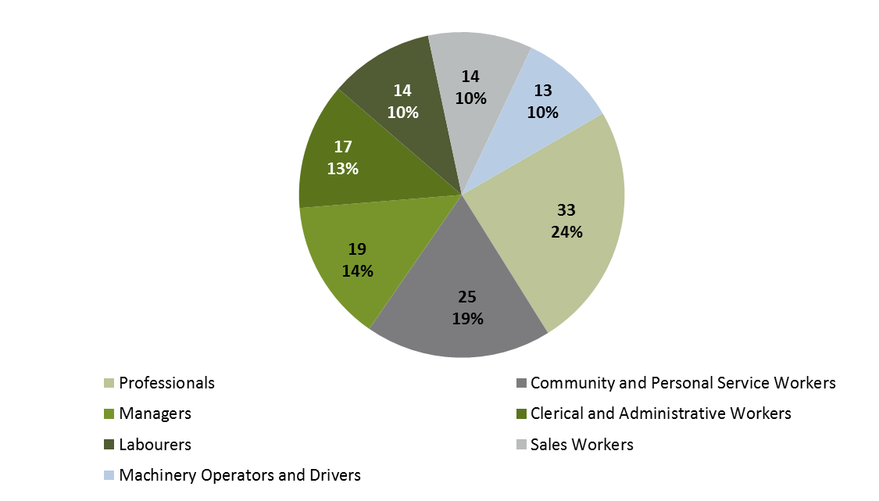

Source: Department of Trade, Business and Innovation

In 2017 in Utopia:

* **Professionals** was the **largest** **occupation** **classification** in terms of filled jobs, accounting for 33 jobs (24.4% of total filled jobs)
* **other** **significant** occupation classifications were:
* Community and Personal Service Workers (25 jobs or 18.5%)
* Managers (19 jobs or 14.1%)
* Clerical and Administrative Workers (17 jobs or 12.6%).

**Table 14: Count of filled jobs by ANZSCO occupation by Aboriginal status of person employed in job, 2017 (a)(c)(f)(g)**

|  |  |  |  |
| --- | --- | --- | --- |
| **Occupation (ANZSCO major group)** | **2017** | | |
| **Aboriginal** | **Non-Aboriginal** | **Total** |
| Clerical and Administrative Workers | 8 | 9 | **17** |
| Community and Personal Service Workers | 21 | 4 | **25** |
| Labourers | 13 | 1 | **14** |
| Machinery Operators and Drivers | 12 | 1 | **13** |
| Managers | 4 | 15 | **19** |
| Professionals | 8 | 25 | **33** |
| Sales Workers | 13 | 1 | **14** |
| **Total** | **79** | **56** | **135** |

Source: Department of Trade, Business and Innovation

In 2017 in Utopia:

* of the 79 jobs filled by **Aboriginal** persons, there were:
* 21 Community and Personal Service Workers
* 13 Labourers
* 13 Sales Workers
* of the 56 jobs filled by **non-Aboriginal** persons, there were:
* 25 Professionals
* 15 Managers
* 9 Clerical and Administrative Workers.

# Jobs by Industry by Occupation

**Table 15: Count of filled jobs by occupation and by industry, 2017 (a)(f)(g)(h)**

|  |  |  |  |  |  |  |  |  |  |  |
| --- | --- | --- | --- | --- | --- | --- | --- | --- | --- | --- |
| **2017** | | | | | | | | | | |
| **Industry (ANZSIC Division)** | **Occupation (ANZSCO major group)** | | | | | | | | | |
| **Clerical and Administrative Workers** | **Community and Personal Service Workers** | **Labourers** | **Machinery Operators and Drivers** | **Managers** | **Professionals** | **Sales Workers** | **Technicians and Trades Workers** | **Other occupations** | **Total** |
| Administrative and Support Services | 4 | 0 | 0 | 0 | 0 | 1 | 0 | 0 | 0 | **5** |
| Arts and Recreation Services | 0 | 0 | 0 | 0 | 1 | 2 | 0 | 0 | 0 | **3** |
| Education and Training | 7 | 16 | 1 | 0 | 3 | 19 | 0 | 0 | 0 | **46** |
| Health Care and Social Assistance | 4 | 1 | 5 | 12 | 5 | 9 | 0 | 0 | 0 | **36** |
| Public Administration and Safety | 2 | 8 | 6 | 0 | 2 | 2 | 0 | 0 | 0 | **20** |
| Retail Trade | 0 | 0 | 2 | 1 | 8 | 0 | 14 | 0 | 0 | **25** |
| **Total** | **17** | **25** | **14** | **13** | **19** | **33** | **14** | **0** | **0** | **135** |

Source: Department of Trade, Business and Innovation

In 2017 in Utopia:

* the majority of Professionals (33) jobs (the largest occupation group) were shared across the Education and Training (19) , and Health Care and Social Assistance (9) industries
* the majority of Community and Personal Service Workers (25) jobs (the second largest occupation group) were shared across Education and Training (16), and Public Administration and Safety (8) industries.

# Jobs by Gender

**Table 16: Count of filled jobs by gender[2] and Aboriginal status of person employed in job, 2017 (a)(c)(i)**

|  |  |  |  |
| --- | --- | --- | --- |
| **Indicator** | **2017** | | |
| **Aboriginal** | **Non-Aboriginal** | **Total** |
| Male | 36 | 24 | **60** |
| Female | 42 | 32 | **74** |
| **Total** | **78** | **56** | **134** |

Source: Department of Trade, Business and Innovation

**Chart 10: Count of filled jobs by gender and Aboriginal status of person in job, 2017 (a)(c)(i)**

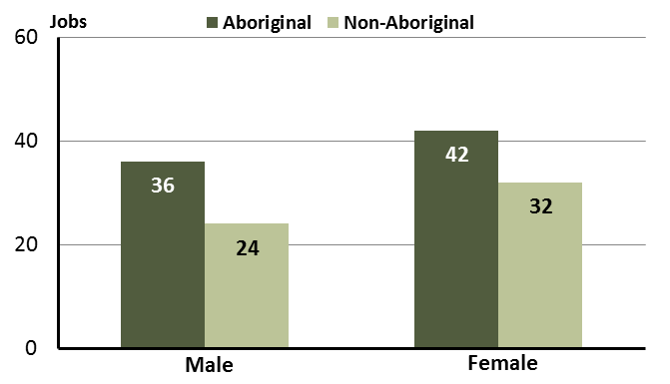

Source: Department of Trade, Business and Innovation

In 2017 in Utopia:

* of the 60 **jobs filled by males:**
* 36 were **Aboriginal**
* of the 74 **jobs filled by females:**
* 42 were **Aboriginal**
* 32 were **non-Aboriginal.**

**Table 17: Count of filled jobs by gender, by Aboriginal status of person in the job, by full-time/part-time status, by job permanency and by sector, 2017 (a)(b)(c)(d)(e)(i)**

|  |  |  |  |  |  |  |  |  |  |
| --- | --- | --- | --- | --- | --- | --- | --- | --- | --- |
| **2017** | | | | | | | | | |
| **Indicator** | **Male** | | | **Female** | | | **Total** | | |
| **Aboriginal** | **Non-Aboriginal** | **Total** | **Aboriginal** | **Non-Aboriginal** | **Total** | **Aboriginal** | **Non-Aboriginal** | **Total** |
| Full-time | 31 | 22 | **53** | 15 | 31 | **46** | 47 | 53 | **100** |
| Part-time | 5 | 2 | **7** | 27 | 1 | **28** | 32 | 3 | **35** |
| **Total** | **36** | **24** | **60** | **42** | **32** | **74** | **79** | **56** | **135** |
| Permanent | 6 | 10 | **16** | 12 | 10 | **22** | 19 | 20 | **39** |
| Temporary | 30 | 14 | **44** | 30 | 22 | **52** | 60 | 36 | **96** |
| **Total** | **36** | **24** | **60** | **42** | **32** | **74** | **79** | **56** | **135** |
| Public Sector | 13 | 12 | **25** | 22 | 17 | **39** | 36 | 29 | **65** |
| Private Sector | 23 | 12 | **35** | 20 | 15 | **35** | 43 | 27 | **70** |
| **Total** | **36** | **24** | **60** | **42** | **32** | **74** | **79** | **56** | **135** |

Source: Department of Trade, Business and Innovation

In 2017 in Utopia:

* of the 60 **jobs filled by males**, there were:
* 36 jobs filled by **Aboriginal** males, including:
* 31 full-time jobs and 5 part-time jobs
* 6 permanent jobs and 30 temporary jobs
* 13 public sector jobs and 23 private sector jobs
* 24 jobs filled by **non-Aboriginal** males, including:
* 22 full-time jobs and 2 part-time jobs
* 10 permanent jobs and 14 temporary jobs
* 12 public sector jobs and 12 private sector jobs
* of the 74 **jobs filled by females**, there were:
* 42 jobs filled by **Aboriginal** females, including:
* 15 full-time jobs and 27 part-time jobs
* 12 permanent jobs and 30 temporary jobs
* 22 public sector jobs and 20 private sector jobs
* 32 jobs filled by **non-Aboriginal** females, including:
* 31 full-time jobs and 1 part-time job
* 10 permanent jobs and 22 temporary jobs
* 17 public sector jobs and 15 private sector jobs.

# Jobs by Age

**Table 18: Count of filled jobs by age and Aboriginal status of person employed in job, 2017 (a)(c)(j)**

|  |  |  |  |
| --- | --- | --- | --- |
| **Indicator** | **2017** | | |
| **Aboriginal** | **Non-Aboriginal** | **Total** |
| 15-24 years | 7 | 2 | **9** |
| 25-44 years | 53 | 26 | **79** |
| 45+ years | 18 | 28 | **46** |
| **Total** | **79** | **56** | **135** |

Source: Department of Trade, Business and Innovation

**Chart 11: Count of filled jobs by age and Aboriginal status of person in job, 2017 (a)(c)(j)**

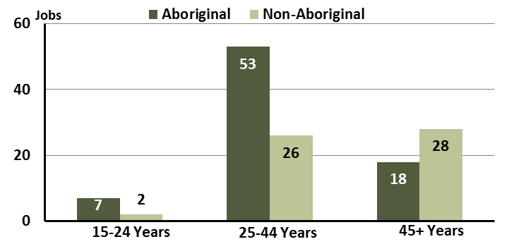

Source: Department of Trade, Business and Innovation

In 2017 in Utopia:

* of the 9 **jobs filled** by persons aged **15-24 years:**
* 7 jobs were filled by **Aboriginal** persons
* 2 jobs were filled by **non-Aboriginal** persons
* of the 79 **jobs filled** by persons aged **25-44 years**:
* 53 jobs were filled by **Aboriginal** persons
* 26 jobs were filled by **non-Aboriginal** persons
* of the 46 **jobs filled** by persons aged **45+ years**:
* 18 jobs were filled by **Aboriginal** persons
* 28 jobs were filled by **non-Aboriginal** persons.

**Table 19: Count of filled jobs by age, by Aboriginal status of person in the job, by full-time/part-time status, by job permanency and by sector, July 2017 (a)(b)(c)(d)(e)(i)**

|  |  |  |  |  |  |  |  |  |  |  |  |  |  |  |
| --- | --- | --- | --- | --- | --- | --- | --- | --- | --- | --- | --- | --- | --- | --- |
| **2017** | | | | | | | | | | | | | | |
| **Indicator** | **15-24 years** | | | **25-44 years** | | | **45+ years** | | | **Total** | | | |
| **Aboriginal** | **Non-Aboriginal** | **Total** | **Aboriginal** | **Non-Aboriginal** | **Total** | **Aboriginal** | **Non-Aboriginal** | **Total** | **Aboriginal** | **Non-Aboriginal** | **Total** |
| Full-time | 5 | 2 | **7** | 28 | 24 | **52** | 13 | 27 | **40** | 47 | 53 | **100** |
| Part-time | 2 | 0 | **2** | 25 | 2 | **27** | 5 | 1 | **6** | 32 | 3 | **35** |
| **Total** | **7** | **2** | **9** | **53** | **26** | **79** | **18** | **28** | **46** | **79** | **56** | **135** |
| Permanent | 0 | 0 | **0** | 14 | 11 | **25** | 4 | 9 | **13** | 19 | 20 | **39** |
| Temporary | 7 | 2 | **9** | 39 | 15 | **54** | 14 | 19 | **33** | 60 | 36 | **96** |
| **Total** | **7** | **2** | **9** | **53** | **26** | **79** | **18** | **28** | **46** | **79** | **56** | **135** |
| Public Sector | 2 | 2 | **4** | 23 | 12 | **35** | 10 | 15 | **25** | 36 | 29 | **65** |
| Private Sector | 5 | 0 | **5** | 30 | 14 | **44** | 8 | 13 | **21** | 43 | 27 | **70** |
| **Total** | **7** | **2** | **9** | **53** | **26** | **79** | **18** | **28** | **46** | **79** | **56** | **135** |

Source: Department of Trade, Business and Innovation

In 2017 in Utopia:

* of the 9 **jobs** **filled** by persons aged **15-24 years**, there were:
* 7 jobs filled by **Aboriginal** persons, of which:
* 5 were full-time jobs and 2 were part-time jobs
* none were permanent jobs and 7 were temporary jobs
* 2 were public sector jobs and 5 were private sector jobs
* 2 jobs filled by **non-Aboriginal** persons, of which:
* 2 were full-time jobs and none were part-time jobs
* none were permanent jobs and 2 were temporary jobs
* 2 were public sector jobs and none were private sector jobs
* of the 79 **jobs** **filled** by persons aged **25-44 years**, there were:
* 53 jobs filled by **Aboriginal** persons, of which:
* 28 were full-time jobs and 25 were part-time jobs
* 14 were permanent jobs and 39 were temporary jobs
* 23 were public sector jobs and 30 were private sector jobs
* 26 jobs filled by **non-Aboriginal** persons, of which:
* 24 were full-time jobs and 2 were part-time jobs
* 11 were permanent jobs and 15 were temporary jobs
* 12 were public sector jobs and 14 were private sector jobs
* of the 46 **jobs** **filled** by persons aged **45+ years**, there were:
* 18 jobs filled by **Aboriginal** persons, of which:
* 13 were full-time jobs and 5 were part-time jobs
* 4 were permanent jobs and 14 were temporary jobs
* 10 were public sector jobs and 8 were private sector jobs
* 28 jobs filled by **non-Aboriginal** persons, of which:
* 27 were full-time jobs and 1 was a part-time job
* 9 were permanent jobs and 19 were temporary jobs
* 15 were public sector jobs and 13 were private sector jobs.

# Vocational Education and Training

Table 20: Northern Territory Vocational Education and Training (VET) students, 2016 (k)

|  |  |  |
| --- | --- | --- |
| **VET Funding Group** | **2016** | |
| **No.** | **% of Total** |
| Arts, Entertainment, Sports and Recreation | 12 | 11 |
| Building and Construction | 26 | 25 |
| Community Services, Health and Education | 13 | 12 |
| Engineering and Mining | 1 | 1 |
| General Education and Training | 22 | 21 |
| Primary Industry | 13 | 12 |
| Transport and Storage | 18 | 17 |
| **Total** | **105** | **100** |

Source: Department of Trade, Business and Innovation

In Utopia in 2016:

* there were 105 **VET students**
* the areas of VET activity with the most students were Building and Construction (26), General Education and Training (22), and Transport and Storage (18).

Table 21: Northern Territory Vocational Education and Training (VET) unit enrolments, 2016 (l)

|  |  |  |
| --- | --- | --- |
| **VET Funding Group** | **2016** | |
| **No.** | **% of Total** |
| Arts, Entertainment, Sports and Recreation | 21 | 8 |
| Building and Construction | 26 | 10 |
| Community Services, Health and Education | 23 | 9 |
| General Education and Training | 110 | 43 |
| Primary Industry | 25 | 10 |
| Transport and Storage | 53 | 21 |
| **Total** | **258** | **100** |

Source: Department of Trade, Business and Innovation

In Utopia in 2016:

* there were 258 **VET unit enrolments**
* the areas of VET activity with the most unit enrolments were General Education and Training (110), Transport and Storage (53), and Building and Construction (26).

Table 22: Northern Territory Vocational Education and Training (VET) nominal hours, 2017(m)

|  |  |  |
| --- | --- | --- |
| **VET Funding Group** | **2016** | |
| **No.** | **% of Total** |
| Arts, Entertainment, Sports and Recreation | 1540 | 29 |
| Building and Construction | 138 | 3 |
| Business and Clerical | 0 | 0 |
| General Education and Training | 1290 | 24 |
| Primary Industry | 760 | 14 |
| Transport and Storage | 1540 | 29 |
| **Total** | **5268** | **100** |

Source: Department of Trade, Business and Innovation

In Utopia in 2016:

* there were 5268 **VET nominal hours** delivered, an increase of 5268 nominal hours delivered from 2013 and an increase of 5268 nominal hours delivered from 2010.

Caveat: *Nominal hours are based on the hours funded through Department of Trade Business and Innovation contracts; students and units includes delivery that has been funded in a previous year, fee for service or training that did not meet the funding requirements. Because of this a direct match cannot be made between hours and student/units*.

Table 23: Northern Territory Vocational Education and Training (VET) unit completions, 2016 (n)

|  |  |  |
| --- | --- | --- |
| **VET Funding Group** | **2016** | |
| **No.** | **% of Total** |
| Arts, Entertainment, Sports and Recreation | 35 | 12 |
| Building and Construction | 26 | 9 |
| Community Services, Health and Education | 30 | 10 |
| Engineering and Mining | 1 | 0 |
| General Education and Training | 123 | 42 |
| Primary Industry | 25 | 9 |
| Transport and Storage | 54 | 18 |
| **Total** | **294** | **100** |

Source: Department of Trade, Business and Innovation

In Utopia in 2016:

* there were 294 **VET unit completions**
* the areas of VET activity with the most unit completions were General Education and Training (123), Transport and Storage (54), and Arts, Entertainment, Sports and Recreation (35).

# Population

**Table 24: Population distribution by gender and age (p)(r)**

|  |  |  |  |  |  |  |  |  |  |
| --- | --- | --- | --- | --- | --- | --- | --- | --- | --- |
| **Indicator** | **2006** | | | **2016** | | | **Change** | | |
| **Male** | **Female** | **Total** | **Male** | **Female** | **Total** | **Male** | **Female** | **Total** |
| **0-4 years** | 12 | 21 | 33 | 32 | 14 | 46 | 20 | -7 | 13 |
| **5-14 years** | 27 | 35 | 62 | 47 | 74 | 121 | 20 | 39 | 59 |
| **15-24 years** | 19 | 28 | 47 | 35 | 29 | 64 | 16 | 1 | 17 |
| **25-44 years** | 48 | 43 | 91 | 68 | 85 | 153 | 20 | 42 | 62 |
| **45-64 years** | 21 | 24 | 45 | 43 | 82 | 125 | 22 | 58 | 80 |
| **65+ years** | 3 | 9 | 12 | 3 | 5 | 8 | 0 | -4 | -4 |
| **TOTAL** | 130 | 160 | 290 | 228 | 289 | 517 | 98 | 129 | 227 |

*Source: Department of Trade, Business and Innovation*

In 2016 in Utopia:

* there were an estimated 517 persons, of which:
* 228 (44.1%) were male
* 289 (55.9%) were female
* between 2006 and 2016, the overall population in Utopia increased by 227 persons from 2006, or an average of 6% per year compared to 0.7% across the 28 remote towns and 1.5% Territory wide
* the male population increased by 98 persons from 2006
* the female population increased by 129 persons from 2006
* in 2016, the working age population (15 years and over) in Utopia was an estimated 350 persons (67.7% of the total population) compared with 195 persons (67.2% of the total population) in 2006. Of these:
* 64 (12.4%) were between 15 and 24 years of age
* 153 (29.6%) were between 25 and 44 years of age
* 125 (24.2%) were between 45 and 64 years of age
* 8 (1.5%) were over 65 years of age
* of the 350 persons of working age:
* 149 (42.6%) were male
* 201 (57.4%) were female.

There were 0.5 jobs in Utopia per working age person compared to 0.4 jobs per working age person across the 28 remote towns in the Northern Territory.

**Chart 12: Population by Aboriginal status, 28 remote towns and the NT (p)(q)**

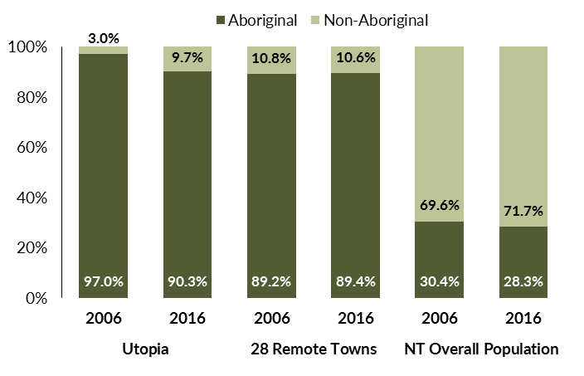

*Source: Department of Trade, Business and Innovation*

In 2016 in Utopia:

* 90.3% of the population in Utopia were **Aboriginal**, compared to 97% in 2006
* 89.4% of the population across all 28 remote towns were **Aboriginal**
* 28.3% of the Northern Territory population were **Aboriginal**.

**Table 25: Unemployment and participation rates by Aboriginal status compared to the NT (q)**

|  |  |  |  |  |  |  |
| --- | --- | --- | --- | --- | --- | --- |
|  | **Utopia** | | | **Northern Territory** | | |
| **Aboriginal** | **Non-Aboriginal** | **Total** | **Aboriginal** | **Non-Aboriginal** | **Total** |
| **Unemployment rate** | 74.6% | 0.0% | 61.2% | 26.7% | 3.8% | 7.0% |
| **Participation rate** | 69.3% | 93.0% | 72.3% | 41.0% | 79.9% | 70.6% |

*Source: Department of Trade, Business and Innovation*

In 2016 in Utopia the:

* **total unemployment rate** was 61.2% compared to 7% for the total Northern Territory
* **Aboriginal unemployment rate** was 74.6% compared to 26.7% for the total Northern Territory
* **non-Aboriginal unemployment rate** was 0% compared to 3.8% for the total Northern Territory
* **total participation rate** was 72.3% compared to 70.6% for the total Northern Territory
* **Aboriginal** **participation rate** was 69.3% compared to 41% for the total Northern Territory
* **non-Aboriginal participation rate** was 93% compared to 79.9% for the total Northern Territory.

# Community Development Programme

**Table 26: Community Development Programme Aboriginal Job Seekers, 30 April 2018 (o)**

|  |  |  |
| --- | --- | --- |
| **Indicator** | **Aboriginal** | |
| **No.** | **%** |
| **Total Aboriginal Job Seekers** | 53 | N/A |
| **Age (years)** | | |
| 19 and under | < 20 | N/A |
| 20-24 | < 20 | N/A |
| 25-44 | 22 | N/A |
| 45+ | < 20 | N/A |
| **Total** | 53 | 100.0 |
| **Gender** | | |
| Male | 28 | 52.8 |
| Female | 25 | 47.2 |
| **Total** | 53 | 100.0 |
| **Employment Outcome - 1 July 2015 to 30 April 2018** | | |
| 13 Weeks | < 20 | N/A |
| 26 Weeks | < 20 | N/A |
| **Currently in Activities** | 38 |  |

*Source: Department of Prime Minister and Cabinet*

**Chart 13: Community Development Programme Aboriginal Job Seekers by Gender,**

**30 April 2018 (o)**

See detailed description below.

*Source: Department of Prime Minister and Cabinet*

As at 30 April 2018, in Utopia (Arlparra), there were 53 CDP **Aboriginal** job seekers, of these:

* 28 (52.8%) were male and 25 (47.2%) were female
* less than 20 were aged 19 years and under, less than 20 were aged 20-24 years, 22 were aged 25-44 years, and less than 20 were aged 45+ years
* between 1 July 2015 and 30 April 2018, less than 20 had reached the 13 week reporting milestone and less than 20 had reached the 26 week reporting milestone
* 38 were currently in activities.

# Businesses

**Table 27 Businesses by sector (d)(s)**

|  |
| --- |
| **Business Name** |
| **PUBLIC SECTOR** |
| Barkly Regional Council |
| Department of Education |
| Northern Territory Police, Fire Emergency Services |
| PRIVATE SECTOR |
| Aherrenge Community Store Aboriginal Corporation |
| Ampilatwatja Health Centre Aboriginal Corporation |
| Arlparra Aboriginal Corporation trading as Arlparra Community Store |
| Artists of Ampilatawatja |
| Enterprise Management Group Pty Ltd trading as My Pathways |
| River Gum Store |
| Urapuntja Aboriginal Corporation |
| Urapuntja Health Service Aboriginal Corporation |

*Source: Department of Trade, Business and Innovation*

*Note Business names captured have been identified by the current 2017 Business ABN name listed.*

In 2017 in Utopia:

* there were 11 businesses reported on, of which:
* 3 businesses were from the public sector (27%)
* 8 businesses were from the private sector (73%).

# Notes

1. These counts represent numbers of filled jobs and not numbers of persons. As such the totals represent the total number of filled jobs, not the total number of employees. This count is not directly comparable to the total number of employed persons as a person may have several jobs or one job may be shared by more than one person.
2. Full-time is defined as a job usually requiring 35 hours or more per week or that required 35 hours or more work during the reference week. Part-time is defined as a job usually requiring less than 35 hours per week or that required less than 35 hours work during the reference week. The reference week refers to the period that respondents were asked to provide information about. In most instances it would be the week prior to the week the questionnaire was completed. Questionnaires were predominantly conducted in June and July.
3. Care needs to be taken when analysing the counts of filled jobs by the Aboriginal status of persons in the jobs. The Aboriginal status of the person employed in a job was reported by the business representative completing the questionnaire.
4. Sector was classified using the Standard Economic Sector of Classifications of Australia (SESCA), 2008.
5. Job permanency is classified according to what the business believes the level of job permanency is based on guidelines provided by data collectors. Those guidelines state a permanent job has paid annual and/or sick leave entitlements while a temporary job includes casual and fixed-term contract jobs.
6. Classified according to the Australian and New Zealand Standard Classification of Occupations (ANZSCO), 2006, major occupation level.
7. Other occupations include jobs where occupation was not stated, not known or inadequately described.
8. Classified using the Australian and New Zealand Standard Industrial Classification (ANZSIC), 2006, division level.
9. Care needs to be taken when analysing the counts of filled jobs by the gender of persons in the jobs. The gender of the person employed in a job is reported by the business representative completing the questionnaire.
10. Care needs to be taken when analysing the counts of filled jobs by the age of persons in the jobs. The age of the person employed in a job is reported by the business representative completing the questionnaire.
11. Students represent the number of individual clients that enrolled in a Vocational Education and Training unit during the calendar year.
12. Unit enrolments represent the count of individual units that students enrolled in during the calendar year.
13. Nominal hours delivered is the sum of the nominal hours of the units commenced during the calendar year regardless of when the course enrolment commenced.
14. Unit completions are the count of all successfully completed units reported in the calendar year regardless of the year of commencement of the units.
15. The Community Development Programme (CDP) supports job seekers in remote Australia to build skills, address barriers and contribute to their communities through a range of flexible activities. Under the CDP, job seekers with activity requirements are expected to do up to 25 hours per week of work-like activities that benefit their community. It should be noted that some CDP participants may be reported on within the profile if they are attached to a filled position with an employer captured in the survey. Due to confidentiality issues, data below 20 people is not published.
16. Population estimates for both 2006 and 2016 are taken from the estimated resident population (ERP) data produced by the Australian Bureau of Statistics (ABS) and based on Australian Statistical Geography Standard (ASGS) Statistical Area Level 1 (SA1) regions. ERP are official estimates of the Australian population, which link people to a place of usual residence with Australia. All ERP data sources, including the Census of Population and Housing (Census), are subject to error (including inaccuracies in collection, recording and processing data) and should be used with caution.
17. Indigenous population proportions, unemployment and workforce participation rates are based on ABS Census counts at ASGS Indigenous Locations (ILOCs) for each remote town.
18. Working-age population includes all residents aged 15 years and over (commonly referred to as the civilian population) and consists of persons that are employed, unemployed or not in the labour force.
19. A ‘business’ has been defined as any organisation that has undertaken productive activities in the last year, including companies, non-profit organisations, government departments and enterprises operating within the designated remote geography (town), and has one or more employees in paid employment and an Australian Business Number (ABN).

# Abbreviations and Acronyms

ABN Australian Business Number

ABS Australian Bureau of Statistics

ANZSCO Australian and New Zealand Standard Classification of Occupations

ANZSIC Australian and New Zealand Standard Industrial Classification

ASGS Australian Statistical Geography Standard

CDP Community Development Programme

ERP Estimated Resident Population

ILOC Indigenous Locations

nec Not Elsewhere Classified

No. Number

Perm Permanent

ppt Percentage point

RJCP Remote Jobs and Communities Program

Temp Temporary

SA1 Statistical Area Level 1

VET Vocational Education and Training

1. The number of filled jobs does not represent numbers of persons as a person may have several jobs or one job may be shared by more than one person.
2. 1 Aboriginal filled job gender status not identified in 2017