Front cover page.
Heading of Remote Towns Jobs Profile 2017
Jobs profile remote town name Pirlangimpi 
Remote Towns Jobs Profile

PIRLANGIMPI

**© Northern Territory of Australia 2018**

**Preferred Reference:** Department of Trade, Business and Innovation, 2017 Remote Towns Jobs Profiles, Northern Territory Government, June 2018, Darwin.

**Disclaimer**

The data in this publication were predominantly collected by conducting a face-to-face survey of businesses within town boundaries during mid-2017. The collection methodology was created in accordance with Australian Bureau of Statistics data quality framework principles. Data in this publication are only reflective of those businesses reported on as operating in the town at the time of data collection (see table at the end of publication for list of businesses reported on).

To comply with privacy legislation or where appropriate, some data in this publication may have been adjusted and will not reflect the actual data reported by businesses. As a result of this, combined with certain data not being reported by some businesses, some components may not add to totals. Changes over time may also reflect business' change in propensity to report on certain data items rather than actual changes over time. Total figures have generally not been adjusted.

Notes for each table and chart are alphabetically ordered and listed at the end of the publication.

Any use of this report for commercial purposes is not endorsed by the Department of Trade, Business and Innovation.

Contents

Pirlangimpi 4

Introduction 5

Summary 6

Jobs Overview 7

Jobs by Aboriginal Status 8

Jobs by Sector: Private and Public 10

Job Status: Permanent and Temporary 13

Job Vacancies 15

Jobs by Industry 16

Jobs by Occupation 19

Jobs by Industry by Occupation 21

Jobs by Gender 22

Jobs by Age 24

Vocational Education and Training 27

Population 29

Community Development Programme 31

Businesses 32

Notes 33

Abbreviations and Acronyms 34

# Pirlangimpi

Milikapiti is located on Melville Island which is approximately 100 kilometres north of Darwin, with a population of 424 residents.

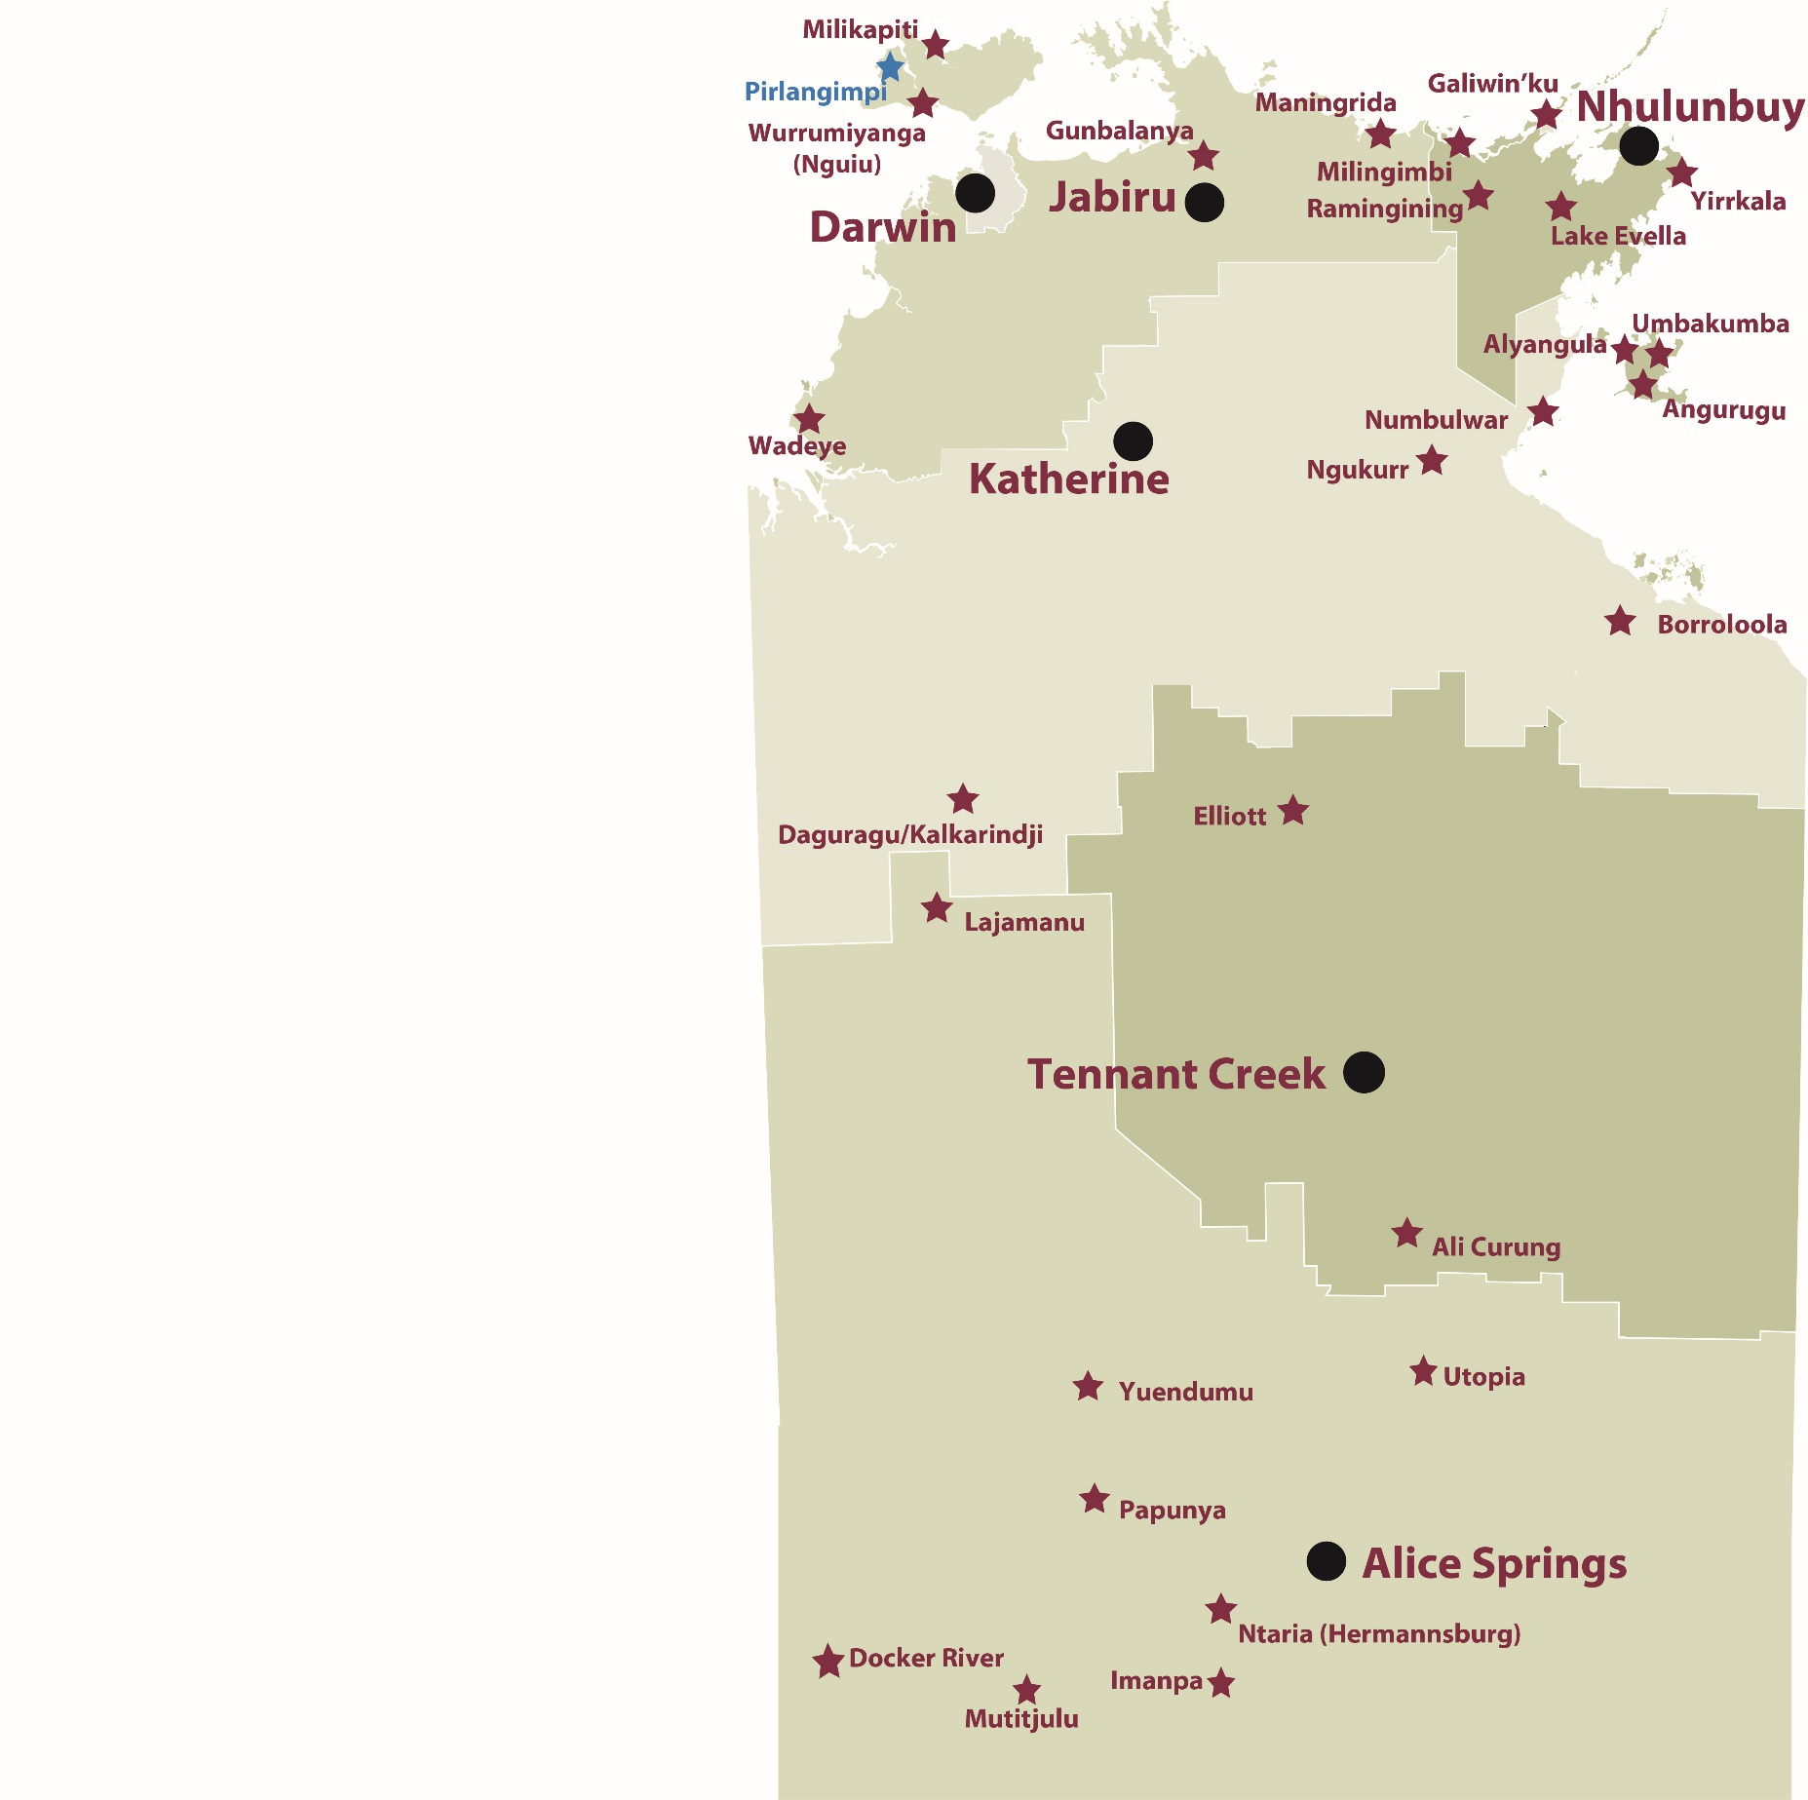

*Source: Department of Trade, Business and Innovation*

# Introduction

This jobs profile provides a snapshot of jobs and the characteristics of job holders in Pirlangimpi as at July 2017.

This job profile is one of 28 profiles developed for remote towns in the Northern Territory. It is anticipated these and subsequent profiles will contribute to a robust evidence base to inform decision making in and relating to these remote Territory towns.

This profile contains information collected by the Northern Territory Department of Trade, Business and Innovation from businesses operating within the town and is supplemented by other administrative data sets and information.

Each profile provides up-to-date information that is intended to inform the planning and design of current and future government programs and as an evidence base to inform decision making relating to workforce development and enterprise and job opportunities.

The data collection methodology and corresponding questionnaire were created in partnership with the Australian Bureau of Statistics (ABS) and in accordance with ABS data quality framework and survey principles.

The surveys were predominantly conducted by the Department’s Small Business Champions and Workforce Training Coordinators, on a face-to-face basis with business representatives.

The information collected and reported on represents a significant goodwill investment by those businesses and organisations that participated. Each business is listed at the end of this publication.

# Summary

The 2017 jobs profile was developed based on responses from 12 businesses operating within the Pirlangimpi town boundary. Of these, there were:

* 7 businesses from the private sector, accounting for 57 filled jobs or 53% of total filled jobs
* 5 businesses from the public sector, accounting for 50 filled jobs or 47% of total filled jobs.

A total of 120 filled and vacant jobs in Pirlangimpi were reported.[1]

The 2017 profile highlights:

* there were 107 filled jobs of which:
* 89 jobs (83%) were filled by Aboriginal persons
* 18 jobs (17%) were filled by non-Aboriginal persons
* 49% of employed Aboriginal people are working in the private sector
* Aboriginal females made up 53% of total Aboriginal filled jobs
* there were 13 vacant jobs, of which:
* job vacancies as a percentage of jobs is 11%
* job vacancies equate to 1 in 10 jobs
* 9 of the vacancies were in Labouring and Community and Personal Service Workers areas
* Retail Trade was the largest industry employer with 38 filled jobs in 2017 followed by Public Administration and Safety with 31
* Building and Construction was the largest training activity section in 2016 with 32 students.

The overall population in Pirlangimpi increased by 3 persons (0.7%) between 2006 and 2016 to 424 persons.

In comparison, the overall Northern Territory population increased by 16.5% between 2006 and 2016.

In 2016, the working age population (15 years and over) in Pirlangimpi was an estimated 325 persons compared to 279 in 2006 an increase by 16%.

There were 0.4 jobs in Pirlangimpi per working age person compared to 0.4 jobs per working age person across the 28 remote towns in the Northern Territory.

# Jobs Overview

Table 1: Count of filled jobs and vacancies, 2017 (a)(b)

|  |  |
| --- | --- |
|  | **2017** |
| **Total All Jobs** | **120** |
| **Vacancies** | **13** |
| Vacancies as % of Total All Jobs | 10.8% |
| **Filled Jobs** | **107** |
| Full-time | 44 |
| Part-time | 63 |

Source: Department of Trade, Business and Innovation

Chart 1: Count of vacant jobs and filled jobs by full-time/part-time status, 2017 (a)(b)

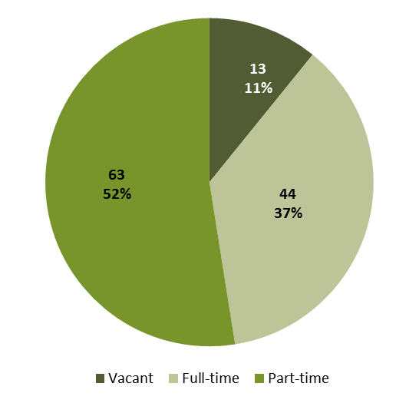

Source: Department of Trade, Business and Innovation

In 2017 in Pirlangimpi there were:

* a total of 107 **filled jobs**. Of these:
* 44 were **full-time** jobs
* 63 were **part-time** jobs
* 13 total job **vacancies**.

# Jobs by Aboriginal Status

Chart 2: Count of filled jobs by Aboriginal status, 2017 (a)(c)

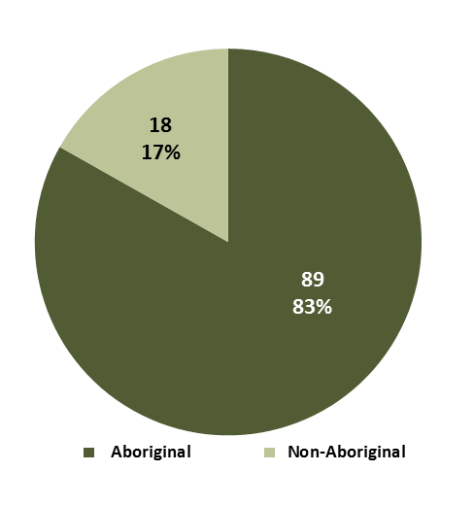

Source: Department of Trade, Business and Innovation

In 2017 in Pirlangimpi:

* of the 107 **filled jobs**:
* 89 jobs were filled by **Aboriginal** persons
* 18 jobs were filled by **non-Aboriginal** persons
* **Aboriginal** persons accounted for 83% of job holders.

Table 2: Count of filled jobs by full-time/part-time status and Aboriginal status of person in job, 2017 (a)(b)(c)

|  |  |  |  |
| --- | --- | --- | --- |
| **Indicator** | **2017** | | |
| **Aboriginal** | **Non-Aboriginal** | **Total** |
| Full-time | 28 | 16 | **44** |
| Part-time | 61 | 2 | **63** |
| **Total** | **89** | **18** | **107** |

Source: Department of Trade, Business and Innovation

Chart 3: Count of filled jobs by full-time/part-time status and Aboriginal status of person in job, 2017 (a)(b)(c)

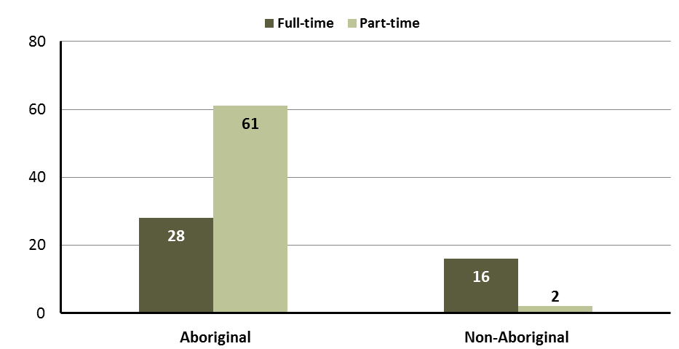

Source: Department of Trade, Business and Innovation

In 2017 in Pirlangimpi:

* of the 107 **filled jobs**:
* 28 were **full-time** jobs filled by **Aboriginal** persons
* 61 were **part-time** jobs filled by **Aboriginal** persons
* 16 were **full-time** jobs filled by **non-Aboriginal** persons
* 2 were **part-time** jobs filled by **non-Aboriginal** persons.

# Jobs by Sector: Private and Public

Table 3: Count of filled jobs by sector and Aboriginal status of person in job, 2017 (a)(c)(d)

|  |  |  |  |
| --- | --- | --- | --- |
| **Indicator** | **2017** | | |
| **Aboriginal** | **Non-Aboriginal** | **Total** |
| **Public Sector** | 37 | 13 | **50** |
| Australian Government | 1 | 0 | **1** |
| Territory Government | 10 | 11 | **21** |
| Local Government | 26 | 2 | **28** |
| **Private Sector** | 52 | 5 | **57** |
| **Total** | **89** | **18** | **107** |

Source: Department of Trade, Business and Innovation

Chart 4: Count of filled jobs by sector of business, 2017 (a)(d)

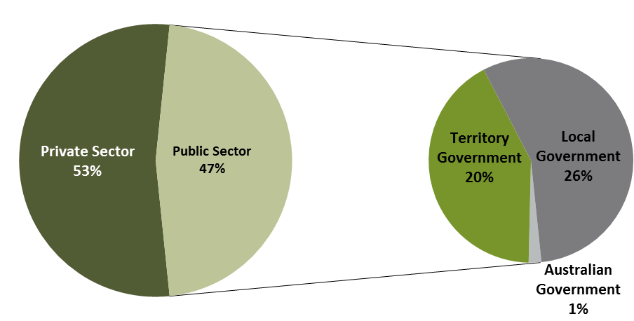

Source: Department of Trade, Business and Innovation

In 2017 in Pirlangimpi:

* of the 50 jobs in the **public** **sector**:
* 1 job was in the Australian Government
* 21 jobs were in the Territory Government
* 28 jobs were in the Local Government
* there were 57 jobs in the **private** **sector**.

Chart 5: Count of filled jobs by sector and Aboriginal status of person in job, 2017 (a)(c)(d)

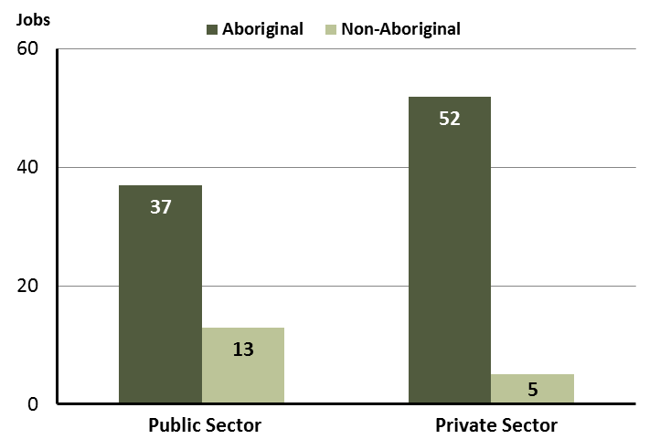

Source: Department of Trade, Business and Innovation

In 2017 in Pirlangimpi:

* of the 50 jobs in the **public** **sector**:
* 37 jobs were filled by **Aboriginal** persons
* 13 jobs were filled by **non-Aboriginal** persons
* of the 57 jobs in the **private** **sector**:
* 52 jobs were filled by **Aboriginal** persons
* 5 jobs were filled by **non-Aboriginal** persons.

Chart 6: Count of filled jobs by sector and full-time/part-time status of person in job, 2017 (a)(b)(d)

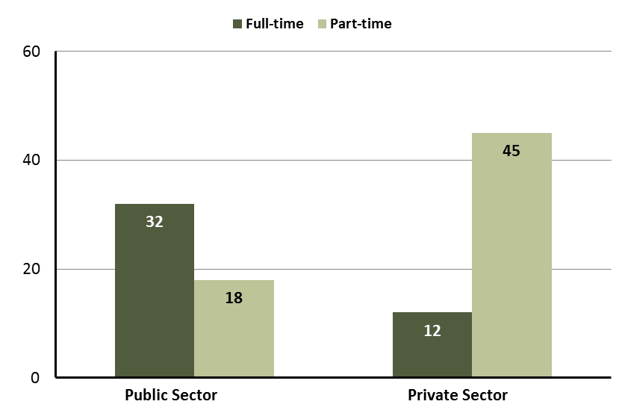

Source: Department of Trade, Business and Innovation

In 2017 in Pirlangimpi:

* of the 50 jobs in the **public** **sector**:
* 32 were full-time jobs
* 18 were part-time jobs
* of the 57 jobs in the **private** **sector**:
* 12 were full-time jobs
* 45 were part-time jobs.

Table 4: Count of filled jobs by full-time/part-time status and Aboriginal status of person in job by sector, 2017 (a)(b)(c)(d)

|  |  |  |  |  |  |  |  |  |  |
| --- | --- | --- | --- | --- | --- | --- | --- | --- | --- |
| **Indicator** | **2017** | | | | | | | | |
| **Aboriginal** | | | **Non-Aboriginal** | | | **Total** | | |
| **Full-time** | **Part-time** | **Total** | **Full-time** | **Part-time** | **Total** | **Full-time** | **Part-time** | **Total** |
| Public Sector | 20 | 17 | **37** | 12 | 1 | **13** | 32 | 18 | **50** |
| Private Sector | 8 | 44 | **52** | 4 | 1 | **5** | 12 | 45 | **57** |
| **Total** | **28** | **61** | **89** | **16** | **2** | **18** | **44** | **63** | **107** |

Source: Department of Trade, Business and Innovation

In 2017 in Pirlangimpi:

* of the 37 jobs in the **public** **sector** filled by **Aboriginal** persons:
* 20 were full-time jobs
* 17 were part-time job
* of the 52 jobs in the **private** **sector** filled by **Aboriginal** persons:
* 8 were full-time jobs
* 44 were part-time jobs
* of the 13 jobs in the **public** **sector** filled by **non-Aboriginal** persons:
* 12 were full-time jobs
* 1 was a part-time job
* of the 5 jobs in the **private** **sector** filled by **non-Aboriginal** persons:
* 4 were full-time jobs
* 1 was a part-time job.

# Job Status: Permanent and Temporary

Table 5: Count of filled jobs by employment status and Aboriginal status of person in job, 2017 (a)(c)(e)

|  |  |  |  |
| --- | --- | --- | --- |
| **Indicator** | **2017** | | |
| **Aboriginal** | **Non-Aboriginal** | **Total** |
| Permanent | 40 | 7 | **47** |
| Temporary | 49 | 11 | **60** |
| **Total** | **89** | **18** | **107** |

Source: Department of Trade, Business and Innovation

**Chart 7: Count of filled jobs by employment status and Aboriginal status of person in job, 2017 (a)(c)(e)**

See detailed description below.

Source: Department of Trade, Business and Innovation

In 2017 in Pirlangimpi:

* there were 47 **permanent** jobs, of which:
* 40 jobs were filled by **Aboriginal** persons
* 7 jobs were filled by **non-Aboriginal** persons
* there were 60 **temporary** jobs, of which:
* 49 jobs were filled by **Aboriginal** persons
* 11 jobs were filled by non-Aboriginal persons.

Table 6: Count of filled jobs by sector, Aboriginal status and employment status of person in job, 2017 (a)(c)(d)(e)

|  |  |  |  |  |  |  |  |  |  |
| --- | --- | --- | --- | --- | --- | --- | --- | --- | --- |
| **Indicator** | **2017** | | | | | | | | |
| **Aboriginal** | | | **Non-Aboriginal** | | | **Total** | | |
| **Perm** | **Temp** | **Total** | **Perm** | **Temp** | **Total** | **Perm** | **Temp** | **Total** |
| Public Sector | 27 | 10 | **37** | 7 | 6 | **13** | 34 | 16 | **50** |
| Private Sector | 13 | 39 | **52** | 0 | 5 | **5** | 13 | 44 | **57** |
| **Total** | **40** | **49** | **89** | **7** | **11** | **18** | **47** | **60** | **107** |

Source: Department of Trade, Business and Innovation

In 2017 in Pirlangimpi:

* of the 50 jobs in the **public** **sector**:
* 34 jobs were **permanent**, of which:
* 27 jobs were filled by **Aboriginal** persons
* 7 jobs were filled by **non-Aboriginal** persons
* 16 jobs were **temporary**, of which:
* 10 jobs were filled by **Aboriginal** persons
* 6 jobs were filled by **non-Aboriginal** persons
* of the 57 jobs in the **private** **sector**:
* 13 jobs were **permanen**t, of which:
* 13 jobs were filled by **Aboriginal** persons
* none were filled by **non-Aboriginal** persons
* 44 jobs were **temporary**, of which:
* 39 jobs were filled by **Aboriginal** persons
* 5 jobs were filled by **non-Aboriginal** persons.

# Job Vacancies

Table 7: Job vacancies, 2017

|  |  |
| --- | --- |
| **Indicator** | **2017** |
| **Job vacancies** | **13** |

Source: Department of Trade, Business and Innovation

Table 8: Job vacancies by occupation, 2017 (f)(g)

|  |  |
| --- | --- |
| **Occupation (ANZSCO major group)** | **2017** |
| Professionals | 1 |
| Clerical and Administrative Workers | 1 |
| Community and Personal Service Workers | 4 |
| Labourers | 5 |
| Technicians and Trades Workers | 2 |
| **Total** | **13** |

Source: Department of Trade, Business and Innovation

Table 9: Job vacancies by job title, July 2017 (f)

|  |  |
| --- | --- |
| **Job Vacancy** | **No.** |
| **Aboriginal** and Torres Strait Islander Health Worker | 2 |
| Commercial Cleaner | 1 |
| Cook | 1 |
| Earthmoving Labourer | 1 |
| General Clerk | 1 |
| Handyperson | 3 |
| Liaison Officer | 1 |
| Motor Mechanic (General) | 1 |
| Teachers' Aide | 2 |
| **Total** | **13** |

Source: Department of Trade, Business and Innovation

In 2017 in Pirlangimpi:

* there were 13 **vacancies** reported
* of the 13 reported vacancies, the largest requirements were for:
* 5 Labourers, the majority of which is in the following job:
* Handyperson
* 4 Community and Personal Service Workers in the following jobs:
* Aboriginal and Torres Strait Islander Health Worker
* Teachers’ Aide
* 2 Technicians and Trades Workers in the following jobs:
* Cook
* Motor Mechanic (General).

# Jobs by Industry

Table 10: Count of filled jobs by industry of business, 2017 (a)(h)

|  |  |  |
| --- | --- | --- |
| **Industry (ANZSIC Division)** | **2017** | |
| **Total** | **% of Total** |
| Accommodation and Food Services | 2 | 1.9% |
| Arts and Recreation Services | 12 | 11.2% |
| Construction | 1 | 0.9% |
| Education and Training | 9 | 8.4% |
| Health Care and Social Assistance | 12 | 11.2% |
| Public Administration and Safety | 31 | 29.0% |
| Retail Trade | 38 | 35.5% |
| Transport, Postal and Warehousing | 2 | 1.9% |
| **Total** | **107** | **100.0%** |

Source: Department of Trade, Business and Innovation

In 2017 in Pirlangimpi:

* the Retail Trade industry was the **largest** **industry** **employer**, with 38 filled jobs or 35.5% of filled jobs
* **other** **significant** industry employers were:
* Public Administration and Safety with 31 jobs (or 29% of filled jobs)
* Arts and Recreation Services with 12 jobs (or 11.2% of filled jobs)
* Health Care and Social Assistance with 12 jobs (or 11.2% of filled jobs).

Table 11: Count of filled jobs by industry of business and Aboriginal status of person in job, 2017 (a)(c)(h)

|  |  |  |  |
| --- | --- | --- | --- |
| **Industry (ANZSIC division)** | **2017** | | |
| **Aboriginal** | **Non-Aboriginal** | **Total** |
| Accommodation and Food Services | 2 | 0 | **2** |
| Arts and Recreation Services | 8 | 4 | **12** |
| Construction | 1 | 0 | **1** |
| Education and Training | 4 | 5 | **9** |
| Health Care and Social Assistance | 8 | 4 | **12** |
| Public Administration and Safety | 27 | 4 | **31** |
| Retail Trade | 38 | 0 | **38** |
| Transport, Postal and Warehousing | 1 | 1 | **2** |
| **Total** | **89** | **18** | **107** |

Source: Department of Trade, Business and Innovation

Chart 8: Count of filled jobs by top 5 industries of business and Aboriginal status of person in job, 2017 (a)(c)(h)

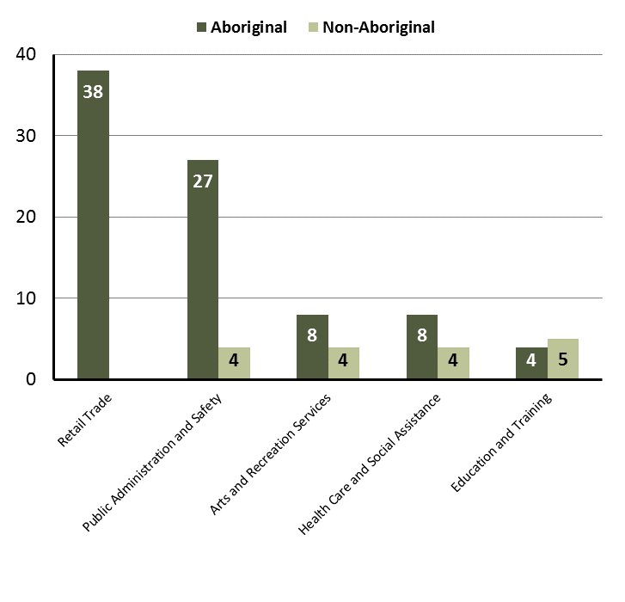

Source: Department of Trade, Business and Innovation

In 2017 in Pirlangimpi:

* of the 89 jobs filled by **Aboriginal** persons, there were:
* 38 jobs in Retail Trade
* 27 jobs in Public Administration and Safety
* 8 jobs in Arts and Recreation Services
* of the 18 jobs filled by **non-Aboriginal** persons, there were:
* 5 jobs in Education and Training
* 4 jobs in Public Administration and Safety
* 4 jobs in Arts and Recreation Services.

Table 12: Count of filled jobs by industry, employment status and Aboriginal status of person in job, 2017 (a)(c)(e)(h)

|  |  |  |  |  |  |  |  |  |  |  |
| --- | --- | --- | --- | --- | --- | --- | --- | --- | --- | --- |
| **Industry (ANZSIC division)** | **2017** | | | | | | | | | |
| **Aboriginal** | | | **Non-Aboriginal** | | | **Total** | | | |
| **Perm** | **Temp** | **Total** | **Perm** | **Temp** | **Total** | **Perm** | **Temp** | **Total** |
| Accommodation and Food Services | 0 | 2 | **2** | 0 | 0 | **0** | 0 | 2 | **2** |
| Arts and Recreation Services | 2 | 6 | **8** | 0 | 4 | **4** | 2 | 10 | **12** |
| Construction | 0 | 1 | **1** | 0 | 0 | **0** | 0 | 1 | **1** |
| Education and Training | 1 | 3 | **4** | 3 | 2 | **5** | 4 | 5 | **9** |
| Health Care and Social Assistance | 1 | 7 | **8** | 0 | 4 | **4** | 1 | 11 | **12** |
| Public Administration and Safety | 25 | 2 | **27** | 4 | 0 | **4** | 29 | 2 | **31** |
| Retail Trade | 11 | 27 | **38** | 0 | 0 | **0** | 11 | 27 | **38** |
| Transport, Postal and Warehousing | 0 | 1 | **1** | 0 | 1 | **1** | 0 | 2 | **2** |
| **Total** | **40** | **49** | **89** | **7** | **11** | **18** | **47** | **60** | **107** |

Source: Department of Trade, Business and Innovation

In 2017 in Pirlangimpi:

* of the 47 **permanent** jobs, there were:
* 29 jobs in Public Administration and Safety, including:
* 25 jobs filled by **Aboriginal** persons
* 4 jobs filled by **non-Aboriginal** persons
* 11 jobs in Retail Trade, including:
* 11 jobs filled by **Aboriginal** persons
* none were filled by **non-Aboriginal** persons
* 4 jobs in Education and Training, including:
* 1 job was filled by an **Aboriginal** person
* 3 jobs filled by **non-Aboriginal** persons
* of the 60 **temporary** jobs, there were:
* 27 jobs in Retail Trade, including:
* 27 jobs filled by **Aboriginal** persons
* none filled by **non-Aboriginal** persons
* 11 jobs in Health Care and Social Assistance, including:
* 7 jobs filled by **Aboriginal** persons
* 4 jobs filled by **non-Aboriginal** persons
* 10 jobs in Arts and Recreation Services, including:
* 6 jobs filled by **Aboriginal** persons
* 4 jobs filled by **non-Aboriginal** persons.

# Jobs by Occupation

Table 13: Count of filled jobs by occupation, 2017 (a)(f)(g)

|  |  |  |
| --- | --- | --- |
| **Occupation (ANZSCO major group)** | **2017** | |
| **Total** | **% of Total** |
| Clerical and Administrative Workers | 9 | 8.4% |
| Community and Personal Service Workers | 22 | 20.6% |
| Labourers | 12 | 11.2% |
| Machinery Operators and Drivers | 3 | 2.8% |
| Managers | 5 | 4.7% |
| Professionals | 12 | 11.2% |
| Sales Workers | 38 | 35.5% |
| Technicians and Trades Workers | 6 | 5.6% |
| **Total** | **107** | **100.0%** |

Source: Department of Trade, Business and Innovation

Chart 9: Count of filled jobs by occupation, 2017 (a)(f)(g)

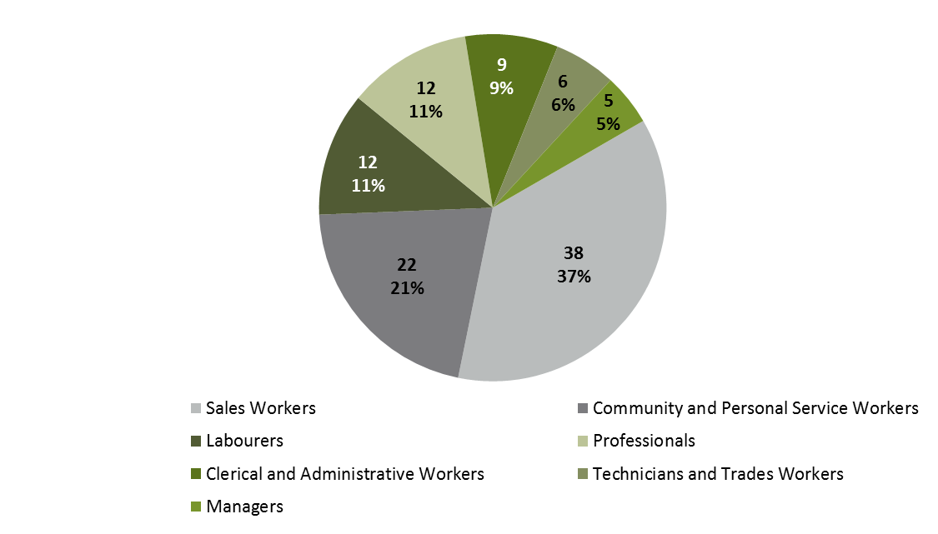

Source: Department of Trade, Business and Innovation

In 2017 in Pirlangimpi:

* Sales Workers was the **largest** **occupation** **classification** in terms of filled jobs, accounting for 38 jobs (35.5% of total filled jobs)
* **other** **significant** occupation classifications were:
* Community and Personal Service Workers (22 jobs or 20.6%)
* Labourers (12 jobs or 11.2%)
* Professionals (12 jobs or 11.2%).

**Table 14: Count of filled jobs by ANZSCO occupation by Aboriginal status of person employed in job, 2017 (a)(c)(f)(g)**

|  |  |  |  |
| --- | --- | --- | --- |
| **Occupation (ANZSCO major group)** | **2017** | | |
| **Aboriginal** | **Non-Aboriginal** | **Total** |
| Clerical and Administrative Workers | 9 | 0 | **9** |
| Community and Personal Service Workers | 19 | 3 | **22** |
| Labourers | 9 | 3 | **12** |
| Machinery Operators and Drivers | 2 | 1 | **3** |
| Managers | 1 | 4 | **5** |
| Professionals | 7 | 5 | **12** |
| Sales Workers | 38 | 0 | **38** |
| Technicians and Trades Workers | 4 | 2 | **6** |
| **Total** | **89** | **18** | **107** |

Source: Department of Trade, Business and Innovation

In 2017 in Pirlangimpi:

* of the 89 jobs filled by **Aboriginal** persons, there were:
* 38 Sales Workers
* 19 Community and Personal Service Workers
* 9 Clerical and Administrative Workers
* of the 18 jobs filled by **non-Aboriginal** persons, there were:
* 5 Professionals
* 4 Managers
* 3 Community and Personal Service Workers.

# Jobs by Industry by Occupation

**Table 15: Count of filled jobs by occupation and by industry, 2017 (a)(f)(g)(h)**

|  |  |  |  |  |  |  |  |  |  |  |  |
| --- | --- | --- | --- | --- | --- | --- | --- | --- | --- | --- | --- |
| **2017** | | | | | | | | | | | |
| **Industry (ANZSIC Division)** |  | **Occupation (ANZSCO major group)** | | | | | | | | | |
| **Clerical and Administrative Workers** | **Community and Personal Service Workers** | **Labourers** | **Machinery Operators and Drivers** | **Managers** | **Professionals** | **Sales Workers** | **Technicians and Trades Workers** | **Other occupations** | **Total** |
| Accommodation and Food Services | 0 | 0 | 0 | 0 | 0 | 2 | 0 | 0 | 0 | **2** |
| Arts and Recreation Services | 1 | 3 | 4 | 0 | 2 | 1 | 0 | 1 | 0 | **12** |
| Construction | 0 | 0 | 1 | 0 | 0 | 0 | 0 | 0 | 0 | **1** |
| Education and Training | 1 | 3 | 0 | 0 | 1 | 4 | 0 | 0 | 0 | **9** |
| Health Care and Social Assistance | 1 | 6 | 2 | 1 | 1 | 1 | 0 | 0 | 0 | **12** |
| Public Administration and Safety | 6 | 10 | 5 | 0 | 1 | 4 | 0 | 5 | 0 | **31** |
| Retail Trade | 0 | 0 | 0 | 0 | 0 | 0 | 38 | 0 | 0 | **38** |
| Transport, Postal and Warehousing | 0 | 0 | 0 | 2 | 0 | 0 | 0 | 0 | 0 | **2** |
| **Total** | **9** | **22** | **12** | **3** | **5** | **12** | **38** | **6** | **0** | **107** |

Source: Department of Trade, Business and Innovation

In 2017 in Pirlangimpi:

* all Sales Workers (38) jobs (the largest occupation group) were within the Retail Trade industry
* the majority of Labourers jobs (the second largest occupation group) were shared across the Public Administration and Safety and Health Care and Social Assistance industries.

# Jobs by Gender

**Table 16: Count of filled jobs by gender and Aboriginal status of person employed in job, 2017 (a)(c)(i)**

|  |  |  |  |
| --- | --- | --- | --- |
| **Indicator** | **2017** | | |
| **Aboriginal** | **Non-Aboriginal** | **Total** |
| Male | 42 | 10 | **52** |
| Female | 47 | 8 | **55** |
| **Total** | **89** | **18** | **107** |

Source: Department of Trade, Business and Innovation

Chart 10: Count of filled jobs by gender and Aboriginal status of person in job, 2017 (a)(c)(i)

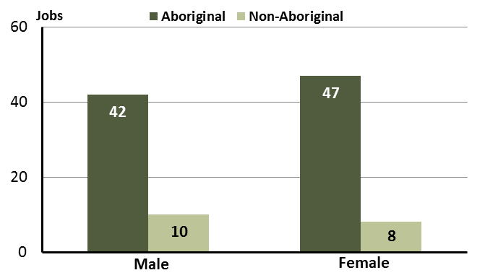

Source: Department of Trade, Business and Innovation

In 2017 in Pirlangimpi:

* of the 52 **jobs filled by males**, there were:
* 42 were **Aboriginal**
* 10 were **non-Aboriginal**
* of the 55 **jobs filled by females**, there were:
* 47 were **Aboriginal**
* 8 were **non-Aboriginal.**

**Table 17: Count of filled jobs by gender, by Aboriginal status of person in the job, by full-time/part-time status, by job permanency and by sector, 2017 (a)(b)(c)(d)(e)(i)**

|  |  |  |  |  |  |  |  |  |  |
| --- | --- | --- | --- | --- | --- | --- | --- | --- | --- |
| **2017** | | | | | | | | | |
| **Indicator** | **Male** | | | **Female** | | | **Total** | | |
| **Aboriginal** | **Non-Aboriginal** | **Total** | **Aboriginal** | **Non-Aboriginal** | **Total** | **Aboriginal** | **Non-Aboriginal** | **Total** |
| Full-time | 18 | 9 | **27** | 10 | 7 | **17** | 28 | 16 | **44** |
| Part-time | 24 | 1 | **25** | 37 | 1 | **38** | 61 | 2 | **63** |
| **Total** | **42** | **10** | **52** | **47** | **8** | **55** | **89** | **18** | **107** |
| Permanent | 15 | 6 | **21** | 25 | 1 | **26** | 40 | 7 | **47** |
| Temporary | 27 | 4 | **31** | 22 | 7 | **29** | 49 | 11 | **60** |
| **Total** | **42** | **10** | **52** | **47** | **8** | **55** | **89** | **18** | **107** |
| Public Sector | 15 | 7 | **22** | 22 | 6 | **28** | 37 | 13 | **50** |
| Private Sector | 27 | 3 | **30** | 25 | 2 | **27** | 52 | 5 | **57** |
| **Total** | **42** | **10** | **52** | **47** | **8** | **55** | **89** | **18** | **107** |

Source: Department of Trade, Business and Innovation

In 2017 in Pirlangimpi:

* of the 52 **jobs** **filled** **by** **males**, there were:
* 42 jobs filled by **Aboriginal** males, including:
* 18 full-time jobs and 24 part-time jobs
* 15 permanent jobs and 27 temporary jobs
* 15 public sector jobs and 27 private sector jobs
* 10 jobs filled by **non-Aboriginal** males, including:
* 9 full-time jobs and 1 part-time job
* 6 permanent jobs and 4 temporary jobs
* 7 public sector jobs and 3 private sector jobs
* of the 55 **jobs** **filled** **by** **females**, there were:
* 47 jobs filled by **Aboriginal** females, including:
* 10 full-time jobs and 37 part-time jobs
* 25 permanent jobs and 22 temporary jobs
* 22 public sector jobs and 25 private sector jobs
* 8 jobs filled by **non-Aboriginal** females, including:
* 7 full-time jobs and 1 part-time job
* 1 permanent job and 7 temporary jobs
* 6 public sector jobs and 2 private sector jobs.

# Jobs by Age

**Table 18: Count of filled jobs by age and Aboriginal status of person employed in job, 2017 (a)(c)(j)**

|  |  |  |  |
| --- | --- | --- | --- |
| **Indicator** | **2017** | | |
| **Aboriginal** | **Non-Aboriginal** | **Total** |
| 15-24 years | 17 | 0 | **17** |
| 25-44 years | 48 | 11 | **59** |
| 45+ years | 24 | 7 | **31** |
| **Total** | **89** | **18** | **107** |

Source: Department of Trade, Business and Innovation

**Chart 11: Count of filled jobs by age and Aboriginal status of person in job, 2017 (a)(c)(j)**

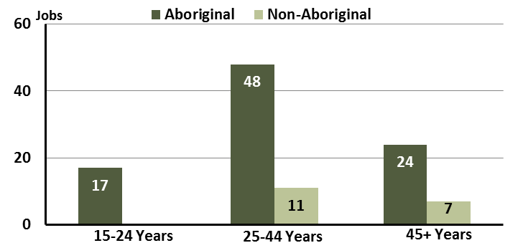

Source: Department of Trade, Business and Innovation

In 2017 in Pirlangimpi:

* of the 17 **jobs filled** by persons aged **15-24 years**, there were:
* 17 jobs were filled by **Aboriginal** persons
* none were filled by **non-Aboriginal** persons
* of the 59 **jobs filled** by persons aged **25-44 years**, there were:
* 48 jobs were filled by **Aboriginal** persons
* 11 jobs were filled by **non-Aboriginal** persons
* of the 31 **jobs filled** by persons aged **45+ years**, there were:
* 24 jobs were filled by **Aboriginal** persons
* 7 jobs were filled by **non-Aboriginal** persons.

**Table 19: Count of filled jobs by age, by Aboriginal status of person in the job, by full-time/part-time status, by job permanency and by sector, July 2017 (a)(b)(c)(d)(e)(i)**

|  |  |  |  |  |  |  |  |  |  |  |  |  |  |  |
| --- | --- | --- | --- | --- | --- | --- | --- | --- | --- | --- | --- | --- | --- | --- |
| **2017** | | | | | | | | | | | | | | |
| **Indicator** | **15-24 years** | | | **25-44 years** | | | **45+ years** | | | **Total** | | | |
| **Aboriginal** | **Non-Aboriginal** | **Total** | **Aboriginal** | **Non-Aboriginal** | **Total** | **Aboriginal** | **Non-Aboriginal** | **Total** | **Aboriginal** | **Non-Aboriginal** | **Total** |
| Full-time | 2 | 0 | **2** | 15 | 9 | **24** | 11 | 7 | **18** | 28 | 16 | **44** |
| Part-time | 15 | 0 | **15** | 33 | 2 | **35** | 13 | 0 | **13** | 61 | 2 | **63** |
| **Total** | **17** | **0** | **17** | **48** | **11** | **59** | **24** | **7** | **31** | **89** | **18** | **107** |
| Permanent | 5 | 0 | **5** | 24 | 4 | **28** | 11 | 3 | **14** | 40 | 7 | **47** |
| Temporary | 12 | 0 | **12** | 24 | 7 | **31** | 13 | 4 | **17** | 49 | 11 | **60** |
| **Total** | **17** | **0** | **17** | **48** | **11** | **59** | **24** | **7** | **31** | **89** | **18** | **107** |
| Public Sector | 4 | 0 | **4** | 21 | 9 | **30** | 12 | 4 | **16** | 37 | 13 | **50** |
| Private Sector | 13 | 0 | **13** | 27 | 2 | **29** | 12 | 3 | **15** | 52 | 5 | **57** |
| **Total** | **17** | **0** | **17** | **48** | **11** | **59** | **24** | **7** | **31** | **89** | **18** | **107** |

Source: Department of Trade, Business and Innovation

In 2017 in Pirlangimpi:

* of the 17 **jobs** **filled** by persons aged **15-24 years**, there were:
* 17 jobs filled by **Aboriginal** persons, of which:
* 2 were full-time jobs and 15 were part-time jobs
* 5 were permanent jobs and 12 were temporary jobs
* 4 were public sector jobs and 13 were private sector jobs
* no jobs filled by **non-Aboriginal** persons
* of the 59 **jobs** **filled** by persons aged **25-44 years**, there were:
* 48 jobs filled by **Aboriginal** persons, of which:
* 15 were full-time jobs and 33 were part-time jobs
* 24 were permanent jobs and 24 were temporary jobs
* 21 were public sector jobs and 27 were private sector jobs
* 11 jobs filled by **non-Aboriginal** persons, of which:
* 9 were full-time jobs and 2 were part-time jobs
* 4 were permanent jobs and 7 were temporary jobs
* 9 were public sector jobs and 2 were private sector jobs
* of the 31 **jobs** **filled** by persons aged **45+ years**, there were:
* 24 jobs filled by **Aboriginal** persons, of which:
* 11 were full-time jobs and 13 were part-time jobs
* 11 were permanent jobs and 13 were temporary jobs
* 12 were public sector jobs and 12 were private sector jobs
* 7 jobs filled by **non-Aboriginal** persons, of which:
* 7 were full-time jobs and none were part-time jobs
* 3 were permanent jobs and 4 were temporary jobs
* 4 were public sector jobs and 3 were private sector jobs.

# Vocational Education and Training

Table 20: Northern Territory Vocational Education and Training (VET) students, 2016 (k)

|  |  |  |
| --- | --- | --- |
| **VET Funding Group** | **2016** | |
| **No.** | **% of Total** |
| Building and Construction | 32 | 47 |
| Community Services, Health and Education | 15 | 22 |
| Primary Industry | 9 | 13 |
| Sales and Personal Service | 12 | 18 |
| **Total** | **68** | **100** |

Source: Department of Trade, Business and Innovation

In Pirlangimpi in 2016:

* there were 68 **VET students**, an increase of 68 students from 2013 and unchanged from 2010
* the areas of VET activity with the most students were Building and Construction (32), Community Services, Health and Education (15), and Sales and Personal Service (12).

Table 21: Northern Territory Vocational Education and Training (VET) unit enrolments, 2016 (l)

|  |  |  |
| --- | --- | --- |
| **VET Funding Group** | **2016** | |
| **No.** | **% of Total** |
| Building and Construction | 271 | 71 |
| Community Services, Health and Education | 18 | 5 |
| Primary Industry | 26 | 7 |
| Sales and Personal Service | 68 | 18 |
| **Total** | **383** | **100** |

Source: Department of Trade, Business and Innovation

In Pirlangimpi in 2016:

* there were 383 **VET unit enrolments**, an increase of 383 unit enrolments from 2013 and unchanged from 2010
* the areas of VET activity with the most unit enrolments were Building and Construction (271), Sales and Personal Service (68), and Primary Industry (26).

Table 22: Northern Territory Vocational Education and Training (VET) nominal hours, 2017 (m)

|  |  |  |
| --- | --- | --- |
| **VET Funding Group** | **2016** | |
| **No.** | **% of Total** |
| Building and Construction | 12 582 | 76 |
| Community Services, Health and Education | 409 | 2 |
| Primary Industry | 1180 | 7 |
| Sales and Personal Service | 2350 | 14 |
| **Total** | **16 521** | **100** |

Source: Department of Trade, Business and Innovation

In Pirlangimpi in 2016:

* there were 16 521 **VET nominal hours** delivered, an increase of 16 521 nominal hours delivered from 2013 and an increase of 16 521 nominal hours delivered from 2010
* the areas of VET activity with the most nominal hours delivered were Building and Construction (12 582), Sales and Personal Service (2350), and Primary Industry (1180)
* Building and Construction reported the largest increase in nominal hours delivered (12 582) compared to 2013.

Caveat: *Nominal hours are based on the hours funded through Department of Trade Business and Innovation contracts; students and units includes delivery that has been funded in a previous year, fee for service or training that did not meet the funding requirements. Because of this a direct match cannot be made between hours and student/units*.

Table 23: Northern Territory Vocational Education and Training (VET) unit completions, 2016 (n)

|  |  |  |
| --- | --- | --- |
| **VET Funding Group** | **2016** | |
| **No.** | **% of Total** |
| Building and Construction | 419 | 77 |
| Community Services, Health and Education | 21 | 4 |
| Primary Industry | 26 | 5 |
| Sales and Personal Service | 80 | 15 |
| **Total** | **546** | **100** |

Source: Department of Trade, Business and Innovation

In Pirlangimpi in 2016:

* there were 546 **VET unit completions**, an increase of 546 unit completions from 2013 and unchanged from 2010
* the areas of VET activity with the most unit completions were Building and Construction (419), Sales and Personal Service (80) and Primary Industry (26).

# Population

**Table 24: Population distribution by gender and age (p)(r)**

|  |  |  |  |  |  |  |  |  |  |
| --- | --- | --- | --- | --- | --- | --- | --- | --- | --- |
| **Indicator** | **2006** | | | **2016** | | | **Change** | | |
| **Male** | **Female** | **Total** | **Male** | **Female** | **Total** | **Male** | **Female** | **Total** |
| **0-4 years** | 15 | 23 | 38 | 16 | 15 | 31 | 1 | -8 | -7 |
| **5-14 years** | 59 | 45 | 104 | 39 | 29 | 68 | -20 | -16 | -36 |
| **15-24 years** | 26 | 25 | 51 | 26 | 21 | 47 | 0 | -4 | -4 |
| **25-44 years** | 77 | 73 | 150 | 87 | 92 | 179 | 10 | 19 | 29 |
| **45-64 years** | 26 | 34 | 60 | 45 | 44 | 89 | 19 | 10 | 29 |
| **65+ years** | 7 | 11 | 18 | 2 | 8 | 10 | -5 | -3 | -8 |
| **TOTAL** | 210 | 211 | 421 | 215 | 209 | 424 | 5 | -2 | 3 |

*Source: Department of Trade, Business and Innovation*

In 2016 in Pirlangimpi:

* there were an estimated 424 persons, of which:
* 215 (50.7%) were male
* 209 (49.3%) were female
* between 2006 and 2016, the overall population in Pirlangimpi increased by 3 persons from 2006, or an average of 0.1% per year compared to 0.7% across the 28 remote towns and 1.5% Territory wide
* the male population increased by 5 persons from 2006
* the female population decreased by 2 persons from 2006
* in 2016, the working age population (15 years and over) in Pirlangimpi was an estimated 325 persons (76.7% of the total population) compared with 279 persons (66.3% of the total population) in 2006. Of these:
* 47 (11.1%) were between 15 and 24 years of age
* 179 (42.2%) were between 25 and 44 years of age
* 89 (21%) were between 45 and 64 years of age
* 10 (2.4%) were over 65 years of age
* of the 325 persons of working age:
* 160 (49.2%) were male
* 165 (50.8%) were female.

There were 0.4 jobs in Pirlangimpi per working age person compared to 0.4 jobs per working age person across the 28 remote towns in the Northern Territory.

**Chart 12: Population by Aboriginal status, 28 remote towns and the NT (p)(q)**

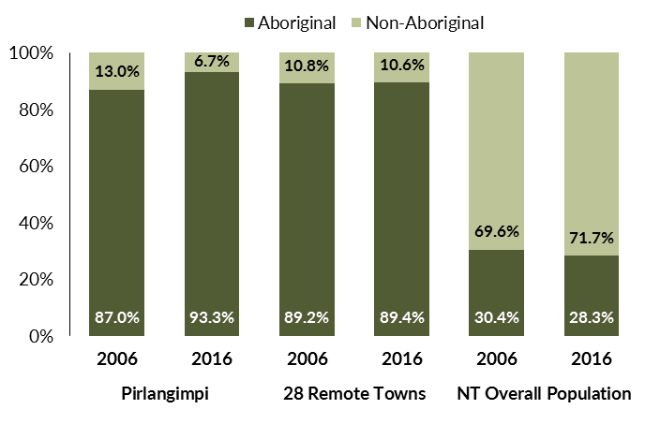

*Source: Department of Trade, Business and Innovation*

In 2016 in Pirlangimpi:

* 93.3% of the population in Pirlangimpi were **Aboriginal**, compared to 87% in 2006
* 89.4% of the population across all 28 remote towns were **Aboriginal**
* 28.3% of the Northern Territory population were **Aboriginal**.

**Table 25: Unemployment and participation rates by Aboriginal status compared to the NT (q)**

|  |  |  |  |  |  |  |
| --- | --- | --- | --- | --- | --- | --- |
|  | **Pirlangimpi** | | | **Northern Territory** | | |
| **Aboriginal** | **Non-Aboriginal** | **Total** | **Aboriginal** | **Non-Aboriginal** | **Total** |
| **Unemployment rate** | 14.1% | 0.0% | 14.1% | 26.7% | 3.8% | 7.0% |
| **Participation rate** | 36.6% | 100.0% | 40.5% | 41.0% | 79.9% | 70.6% |

*Source: Department of Trade, Business and Innovation*

In 2016 in Pirlangimpi the:

* **total unemployment rate** was 14.1% compared to 7% for the total Northern Territory
* **Aboriginal** **unemployment rate** was 14.1% compared to 26.7% for the total Northern Territory
* **non-Aboriginal unemployment rate** was 0% compared to 3.8% for the total Northern Territory
* **total participation rate** was 40.5% compared to 70.6% for the total Northern Territory
* **Aboriginal participation rate** was 36.6% compared to 41% for the total Northern Territory
* **non-Aboriginal** **participation rate** was 100% compared to 79.9% for the total Northern Territory.

# Community Development Programme

**Table 26: Community Development Programme Aboriginal Job Seekers, 30 April 2018 (o)**

|  |  |  |
| --- | --- | --- |
| **Indicator** | **Aboriginal** | |
| **No.** | **%** |
| **Total Aboriginal Job Seekers** | 98 | N/A |
| **Age (years)** | | |
| 15-24 | 23 | 23.5 |
| 25-44 | 44 | 44.9 |
| 45+ | 31 | 31.6 |
| **Total** | 98 | 100.0 |
| **Gender** | | |
| Male | 56 | 57.1 |
| Female | 42 | 42.9 |
| **Total** | 98 | 100.0 |
| **Employment Outcome - 1 July 2015 to 30 April 2018** | | |
| 13 Weeks | < 20 | N/A |
| 26 Weeks | < 20 | N/A |
| **Currently in Activities** | 75 |  |

*Source: Department of Prime Minister and Cabinet*

**Chart 13: Community Development Programme Aboriginal Job Seekers by Gender and Age Group, 30 April 2018 (o)**

See detailed description below.

*Source: Department of Prime Minister and Cabinet*

As at 30 April 2018, in Pirlangimpi, there were 98 CDP **Aboriginal** job seekers, of these:

* 56 (57.1%) were male and 42 (42.9%) were female
* 23 (23.5%) were aged 15-24 years, 44 (44.9%) were aged 25-44 years, and 31 (31.6%) were aged 45+ years
* between 1 July 2015 and 30 April 2018, less than 20 had reached the 13 week reporting milestone and less than 20 had reached the 26 week reporting milestone
* 75 were currently in activities.

# Businesses

**Table 27 Businesses by sector (d)(s)**

|  |
| --- |
| **Business Name** |
| **PUBLIC SECTOR** |
| Department of Education |
| Department of Health |
| Department of the Prime Minister and Cabinet |
| Northern Territory Police, Fire Emergency Services |
| Tiwi Islands Regional Council |
| PRIVATE SECTOR |
| Bathurst Island Housing Association (BIHA) |
| Catholic Care NT |
| Hardy Aviation (NT) Pty Limited - Fly Tiwi |
| Munupi Arts and Craft Association Inc |
| Munupi Wilderness Lodge Pty Ltd |
| Pirlangimpi Store - ALPA |
| Tiwi Enterprises Pty Ltd |

*Source: Department of Trade, Business and Innovation*

*Note: Business names captured have been identified by the current 2017 Business ABN name listed.*

In 2017 in Pirlangimpi:

* there were 12 businesses reported on, of which:
* 5 businesses were from the public sector (42%)
* 7 businesses were from the private sector (58%).

# Notes

1. These counts represent numbers of filled jobs and not numbers of persons. As such the totals represent the total number of filled jobs, not the total number of employees. This count is not directly comparable to the total number of employed persons as a person may have several jobs or one job may be shared by more than one person.
2. Full-time is defined as a job usually requiring 35 hours or more per week or that required 35 hours or more work during the reference week. Part-time is defined as a job usually requiring less than 35 hours per week or that required less than 35 hours work during the reference week. The reference week refers to the period that respondents were asked to provide information about. In most instances it would be the week prior to the week the questionnaire was completed. Questionnaires were predominantly conducted in June and July.
3. Care needs to be taken when analysing the counts of filled jobs by the Aboriginal status of persons in the jobs. The Aboriginal status of the person employed in a job was reported by the business representative completing the questionnaire.
4. Sector was classified using the Standard Economic Sector of Classifications of Australia (SESCA), 2008.
5. Job permanency is classified according to what the business believes the level of job permanency is based on guidelines provided by data collectors. Those guidelines state a permanent job has paid annual and/or sick leave entitlements while a temporary job includes casual and fixed-term contract jobs.
6. Classified according to the Australian and New Zealand Standard Classification of Occupations (ANZSCO), 2006, major occupation level.
7. Other occupations include jobs where occupation was not stated, not known or inadequately described.
8. Classified using the Australian and New Zealand Standard Industrial Classification (ANZSIC), 2006, division level.
9. Care needs to be taken when analysing the counts of filled jobs by the gender of persons in the jobs. The gender of the person employed in a job is reported by the business representative completing the questionnaire.
10. Care needs to be taken when analysing the counts of filled jobs by the age of persons in the jobs. The age of the person employed in a job is reported by the business representative completing the questionnaire.
11. Students represent the number of individual clients that enrolled in a Vocational Education and Training unit during the calendar year.
12. Unit enrolments represent the count of individual units that students enrolled in during the calendar year.
13. Nominal hours delivered is the sum of the nominal hours of the units commenced during the calendar year regardless of when the course enrolment commenced.
14. Unit completions are the count of all successfully completed units reported in the calendar year regardless of the year of commencement of the units.
15. The Community Development Programme (CDP) supports job seekers in remote Australia to build skills, address barriers and contribute to their communities through a range of flexible activities. Under the CDP, job seekers with activity requirements are expected to do up to 25 hours per week of work-like activities that benefit their community. It should be noted that some CDP participants may be reported on within the profile if they are attached to a filled position with an employer captured in the survey. Due to confidentiality issues, data below 20 people is not published.
16. Population estimates for both 2006 and 2016 are taken from the estimated resident population (ERP) data produced by the Australian Bureau of Statistics (ABS) and based on Australian Statistical Geography Standard (ASGS) Statistical Area Level 1 (SA1) regions. ERP are official estimates of the Australian population, which link people to a place of usual residence with Australia. All ERP data sources, including the Census of Population and Housing (Census), are subject to error (including inaccuracies in collection, recording and processing data) and should be used with caution.
17. Indigenous population proportions, unemployment and workforce participation rates are based on ABS Census counts at ASGS Indigenous Locations (ILOCs) for each remote town.
18. Working-age population includes all residents aged 15 years and over (commonly referred to as the civilian population) and consists of persons that are employed, unemployed or not in the labour force.
19. A ‘business’ has been defined as any organisation that has undertaken productive activities in the last year, including companies, non-profit organisations, government departments and enterprises operating within the designated remote geography (town), and has one or more employees in paid employment and an Australian Business Number (ABN).

# Abbreviations and Acronyms

ABN Australian Business Number

ABS Australian Bureau of Statistics

ANZSCO Australian and New Zealand Standard Classification of Occupations

ANZSIC Australian and New Zealand Standard Industrial Classification

ASGS Australian Statistical Geography Standard

CDP Community Development Programme

ERP Estimated Resident Population

ILOC Indigenous Locations

nec Not Elsewhere Classified

No. Number

Perm Permanent

ppt Percentage point

RJCP Remote Jobs and Communities Program

Temp Temporary

SA1 Statistical Area Level 1

VET Vocational Education and Training

1. The number of filled jobs does not represent numbers of persons as a person may have several jobs or one job may be shared by more than one person.