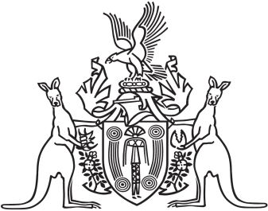
Northern Territory of Australia

Government Gazette
ISSN-0157-833X
No. S71 31 August 2018
Northern Territory of Australia

Liquor Amendment (Minimum Pricing) Act 2018
Commencement Notice
I, Vicki Susan O'Halloran, Administrator of the Northern Territory of Australia, under section 2 of the Liquor Amendment (Minimum Pricing) Act 2018 (No. 16 of 2018) (the Act):
(a) fix 1 September 2018 as the day on which sections 7 and 8 of the Act commence; and
(b) fix 1 October 2018 as the day on which the remaining provisions of the Act commence.
Dated 31 August 2018
V. S. O'Halloran
Administrator

