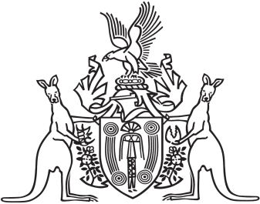
Northern Territory of Australia

Government Gazette
ISSN-0157-833X
No. S70 31 August 2018

Assent to Proposed Laws
Her Honour the Administrator declared assent to the following proposed law:
27 August 2018
Liquor Amendment (Minimum Pricing) Act 2018 (Act No. 16 of 2018)
Michael Tatham
Clerk of the Legislative Assembly
Date 31 August 2018

