

Northern Territory of Australia

Government Gazette

ISSN-0157-8324

No. G23 6 June 2018

# General information

The Gazette is published by the Office of the Parliamentary Counsel.

The Gazette will be published every **Wednesday**, with the closing date for notices being the previous Friday at 4.00 pm.

Notices not received by the closing time will be held over until the next issue.

Notices will not be published unless a Gazette notice request form together with a copy of the signed notice and a clean copy of the notice in Word or PDF is emailed to [gazettes@nt.gov.au](mailto:gazettes@nt.gov.au)

Notices will be published in the next issue, unless urgent publication is requested.

# Availability

The Gazette will be available online at 12 Noon on the day of publication at <https://nt.gov.au/about-government/gazettes>

Unauthorised versions of Northern Territory Acts and Subordinate legislation are available online at <https://legislation.nt.gov.au/>

Northern Territory of Australia

*Biological Control Amendment Act 2018*

**Commencement Notice**

I, Vicki Susan O'Halloran, Administrator of the Northern Territory of Australia, under section 2 of the *Biological Control Amendment Act 2018*(No. 5 of 2018), fix the day on which this notice is published in the *Gazette* as the day on which the Act commences.

Dated 18 May 2018

V. S. O'Halloran

Administrator

Assent to Proposed Laws

Her Honour the Administrator declared assent to the following proposed laws:

#### 23 May 2018

Expungement of Historical Homosexual Offence Records Act 2018 **(Act No 8 of 2018)**

Liquor Amendment (Point of Sale Intervention) Act 2018 **(Act No 9 of 2018)**

Statute Law Revision Act 2018 (**Act No 10 of 2018)**

Residential Tenancies Amendment Act 2018 **(Act No 11 of 2018)**

Youth Justice Legislation Amendment Act 2018 **(Act No 12 of 2018)**

#### MICHAEL TATHAM

Clerk of the Legislative Assembly

## Northern Territory of Australia

# *Traffic Act*

***Traffic Regulations***

Authorised Operators of Prescribed   
Breath Analysis Instrument

I, Bruce D Porter APM, Commander, College Command, in pursuance of regulation 59 of the *Traffic Regulations*, being of the opinion that each member of the Police Force whose name appears in the attached Schedule is: -

(a) trained in the use of a prescribed breath analysis instrument known as the Drager Alcotest 9510; and

(b) capable of using that prescribed breath analysis instrument correctly,

Authorise those members of the Police Force to use that prescribed breath analysis instrument for the purpose of the *Traffic Act.*

Dated this 2 day of March 2018

Bruce D Porter APM

Commander

College Command

|  |  |
| --- | --- |
| **Name** | **Police Service No** |
| Aland, John Paul | 2623 |
| Barclay, Hugh Douglas | 3256 |
| Bradley, Curtis Samuel | 3645 |
| Briggs, Kylie Michelle | 3259 |
| Brown, Stephen Edward | 3449 |
| Canning, Jason Andrew | 3223 |
| Carter, Christopher Michael | 3562 |
| Cavaliere, Luke Mitchell | 3473 |
| Ciolka, George John | 2278 |
| Coleman, Ben James | 2909 |
| Cowton, Jacinta | 3568 |
| Downie, Steven Roy | 2989 |
| Dunne, Andrew Peter | 2485 |
| Dunne, Peter John | 3147 |
| Emery, Kim Elizabeth | 7362 |
| Ericksen, Christopher Edward | 2910 |
| Fernandes, Paulo Alexandre | 2064 |
| Forno, Christopher John James | 3652 |
| Garling, Richard Namin | 7382 |
| Golding, Brady John | 3622 |
| Goodworth, Blake Peter | 3391 |
| Gouverneur, Timothy Liam | 3623 |
| Graf, Kirsten Jo | 3526 |
| Gray, Carmella Michelle | 2918 |
| Hansen, Andrew Benjamin | 2708 |
| Hatton, Timothy Ian | 2635 |
| Hegarty, Sarah Rachel | 3366 |
| Horwood, Deana | 2382 |
| Irwin, Marrianne | 2662 |
| Johnson, Jonas | 3061 |
| Jones, Anthony Charles | 2712 |
| Kamiko, Vincent | 3337 |
| Keeble, Madeline Joy | 3482 |
| Kennedy, Melissa Ann | 2609 |
| Kennon, Elisha Jane | 3050 |
| Lovett, Joe Kendall | 2663 |
| Lumsden, Katherine Ann | 3628 |
| Lush, Bradley John | 3484 |
| Masani, Kolisi | 3500 |
| McCarthy, Daniel James | 2813 |
| McClure, Teagan Isobel | 3235 |
| McElhinney, Carl Michael | 3273 |
| McKie, Dean Curtis | 2474 |
| Mclinden, Brendan Joseph | 3152 |
| Merker, Emma Marie | 2933 |
| Moore, Belinda Lee | 3238 |
| Mora, Daniel James | 3046 |
| Morrissey, Paul Joseph | 3075 |
| Nazareth, Sunil Basil | 3153 |
| Nicholson, Jacqueline | 3010 |
| O'Toole, Adrian Robert | 3047 |
| Parbs, Mark William | 3486 |
| Pedrotti, Fredy Roman | 3131 |
| Perkinson, Brett | 3439 |
| Pickersgill, Rebecca Anne | 2505 |
| Plowright, Ian John | 2956 |
| Ramage, Martin Small | 2077 |
| Rantanen, Troy Andrew | 3241 |
| Ravunacagi, Sireli | 3676 |
| Reeves, Aden Edward Richard | 3192 |
| Schopfer, John William | 3318 |
| Schremmer, Justin John | 2331 |
| Scott, Amelia Jane | 3135 |
| Thomson, Andrew John | 3100 |
| Threlfo, Adam Thomas | 2942 |
| Tregea, Craig Mitchell | 3540 |
| Valladares, Michael Donald | 2099 |
| Vivian, Cameron Perry | 2906 |
| Wallis, Vanessa | 3283 |
| Watson, Marc | 2672 |
| Woldseth, Matthew Geoffrey | 3412 |
| Young, Ian Stuart | 2134 |
| Young, Jennifer Hazel | 2966 |
| Zantvoort, Caitlyn Louise | 3539 |

## Northern Territory of Australia

# *Traffic Act*

Authorised Operators of Prescribed   
Drug Analysis Instrument

I, Bruce D Porter APM, Commander, College Command, in pursuance of section 27B(2) of the *Traffic Act*, being of the opinion that each member of the Police Force whose name appears in the attached Schedule is: -

(a) trained in the use of a prescribed drug analysis instrument known as the Drager DrugTest 5000; and

(b) capable of using that prescribed drug analysis instrument correctly,

Authorise those members of the Police Force to use that prescribed drug analysis instrument for the purpose of the *Traffic Act.*

Dated this 6 day of March 2018

Bruce D Porter APM

Commander

College Command

|  |  |  |
| --- | --- | --- |
|  | **Surname** | **Given Names** |
| 2505 | Pickersgill | Rebecca Anne |
| 3010 | Nicholson | Jacqueline |
| 2946 | Grigg | Nadine Stacy |
| 3333 | Day | Gemma |
| 3238 | Moore | Belinda Lee |
| 3420 | Dungey | Travis Baden |
| 2129 | Smith | Robert Wayne |

Northern Territory of Australia

*Fisheries Regulations*

Vessel Monitoring System Levy  
Barramundi Fishery Licences

I, Ian Arthur Curnow, Director of Fisheries, under regulation 208D(1) of the *Fisheries Regulations*, prescribe a levy of $98 on each unit of net endorsed on a Barramundi Fishery licence, to be paid by the holder of the licence on application for renewal of the licence.

Dated 31 May 2018

I. A. Curnow

Director of Fisheries

Northern Territory of Australia

*Mineral Titles Act*

**General Reservation of Land**

**(RL31895)**

I, Alan Charles Holland, Senior Director Mines/Director Mineral Titles, as the delegate of the Minister for Primary Industry and Resources, under section 113 of the *Mineral Titles Act*:

(a) reserve the land in the locality of Tennant Creek that is shown within the thick black lines on the plan in the Schedule from the following activities:

(i) exploration for minerals generally;

(ii) extraction of minerals generally;

(iii) exploration for extractive minerals;

(iv) extraction of extractive minerals; and

(b) give notice that:

(i) the reservation takes effect on the day this notice is published in the *Gazette*; and

(ii) the land specified in paragraph (a) is being reserved for a proposed fossicking area; and

(iii) a person is not entitled to apply for the grant of any mineral title in relation to the land.

Dated 24 May 2018

A. C. Holland

Senior Director Mines/Director Mineral Titles

**Schedule**

locality tenant creek

Map of reserved land locality Tenant Creek RL 31895

**RL31895**

**1.2 km2**

Datum: GDA94

Northern Territory of Australia

*Mineral Titles Act*

**General Reservation of Land**

**(RL 31900)**

I, Alan Charles Holland, Senior Director Mines/Director Mineral Titles, as the delegate of the Minister for Primary Industry and Resources, under section 113 of the *Mineral Titles Act*:

(a) reserve the land in the locality of Tennant Creek that is shown within the thick black lines on the plan in the Schedule from the following activities:

(i) exploration for minerals generally;

(ii) extraction of minerals generally;

(iii) exploration for extractive minerals;

(iv) extraction of extractive minerals; and

(b) give notice that:

(i) the reservation takes effect on the day this notice is published in the *Gazette*; and

(ii) the land specified in paragraph (a) is being reserved for a proposed fossicking area; and

(iii) a person is not entitled to apply for the grant of any mineral title in relation to the land.

Dated 29 May 2018

A. C. Holland

Senior Director Mines/Director Mineral Titles

**Schedule**

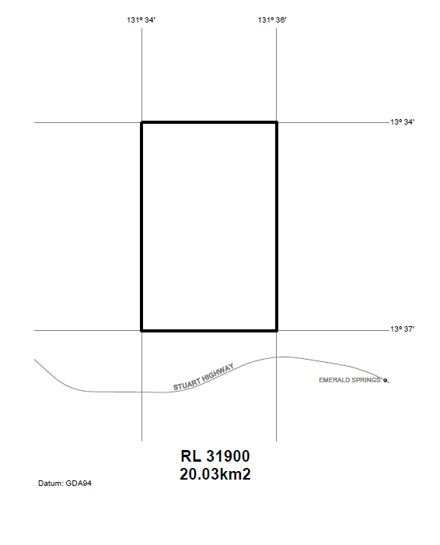

Northern Territory of Australia

*Mineral Titles Act*

**Revocation of General Reservation**

**(RL 29474)**

I, Alan Charles Holland, Senior Director Mines/Director Mineral Titles, as the delegate of the Minister for Primary Industry and Resources, under section 113(4) of the *Mineral Titles Act* and with reference to regulation 92(2) of the *Mineral Titles Regulations*,with effect on and from the date this instrument is published in the *Gazette*:

(a) revoke the General Reservation of Land, dated 23 November 2012 and published in *Gazette* No. 50 dated 12 December 2012, in relation to the land that is shown bounded by the thick black lines on the plan in the Schedule; and

(b) state that the reason for the revocation of the General Reservation is that a further Reservation from certain activities on the land specified in paragraph (a) will take effect on the day that Reservation is published in the *Gazette*.

Dated 29 May 2018

A. C. Holland

Senior Director Mines/Director Mineral Titles

*Note*

*The land mentioned in paragraph (a) became general reserved land on the day the mineral title ceased to be in force by the instrument entitled "General Reservation of Land on Cessation of Title (RL 29474)", dated 23 November 2012 and published in Gazette No. 50 dated 12 December 2012.*

**Schedule**

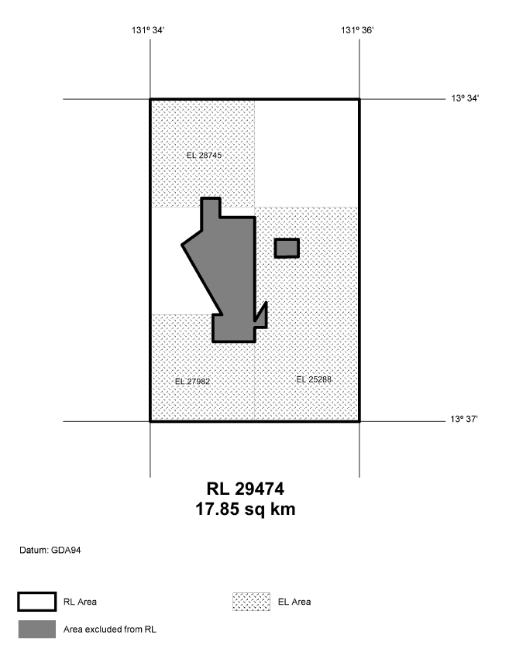

**Notification of Parking**

Usage Schedule

2018/2019 Financial Year

(Darwin Parking Local Rates)

I hereby advise that pursuant to Regulation 6 of the *Local Government (Darwin Parking Local Rates) Regulations*:

(a) that a parking usage schedule has been prepared as at 1 June 2018.

(b) this schedule may be inspected at Customer Services, ground floor of the Civic Centre, Harry Chan Avenue, Darwin between 8.00am and 5.00pm Monday to Friday

(c) that Thursday 5 July 2018 at 5.00pm is the last day for any appeal to be lodged against the Parking usage Schedule.

Enquiries should be directed to Council’s Revenue Team Leader, Mr. Ewan Grenenger on 08 8930 0576.

Appeals must be lodged with the Chief Executive Officer, Department of Housing and Community Development, GPO Box 4621, Darwin NT 0801.

Dated 1 June 2018

**Diana Leeder**

**Chief Executive Officer**