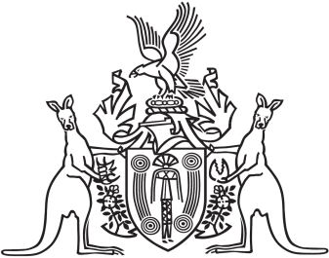
Northern Territory of Australia

Government Gazette
ISSN-0157-833X
No. S27 24 April 2018

Assent to Proposed Laws
Her Honour the Administrator declared assent to the following proposed laws:

19 April 2018
Adoption of Children Legislation Amendment (Equality) Act 2018 (Act No. 4 of 2018)
Biological Control Amendment Act 2018 (Act No. 5 of 2018)
Criminal Code Amendment (Intimate Images) Act 2018 (Act No. 6 of 2018)
Evidence (National Uniform Legislation) Amendment (Journalist Privilege) Act 2018 (Act No. 7 of 2018)

Sean O’Connor
Clerk Assistant Chamber and Serjeant at Arms

