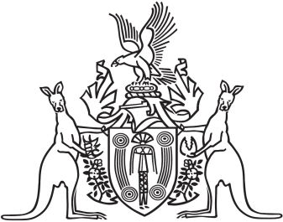
Northern Territory of Australia

Government Gazette
ISSN-0157-833X
No. S13 28 February 2018
Northern Territory of Australia

Liquor Commission Act
Northern Territory Liquor Commission
Appointment of Members
I, Natasha Kate Fyles, Attorney-General and Minister for Justice:
(a) under section 7(1) of the Liquor Commission Act and with reference to section 8 of the Interpretation Act, appoint each person named in the Schedule to be a member of the Northern Territory Liquor Commission from 28 February 2018 to 27 February 2023; and
(b) under section 8(1)(a) of the Liquor Commission Act and with reference to section 8(2) of the Act and section 8 of the Interpretation Act, appoint Richard James Coates to be the Chairperson of the Commission; and
(c) under section 8(1)(b) of the Liquor Commission Act and with reference to section 8(2) of the Act and section 8 of the Interpretation Act, appoint Jodi Marie Truman to be the Deputy Chairperson of the Commission.
Dated 27 February 2018
N. K. Fyles
Attorney-General and Minister for Justice
Schedule
Sandra Lorraine Cannon
Lindsay Carmichael
Richard James Coates
Amy Clare Corcoran
Charles Richard Douglas
Russell Raymond Goldflam
Christine Isobel Hart
Blair Andrew McFarland
Robert Michaelis Parker
Pauline Mary Reynolds
Jodi Marie Truman
Kenton James Winsley

