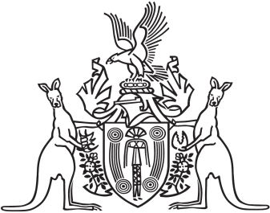
Northern Territory of Australia

Government Gazette
ISSN-0157-833X
No. S11 21 February 2018
Northern Territory of Australia

Police Administration Act
Police Arbitral Tribunal
Appointment of Chairperson
I, Gerald Francis McCarthy, Minister for Public Employment,
under section 36(2)(a) of the Police Administration Act, appoint
Ingrid Catherine Asbury to be the Chairperson of the Police Arbitral Tribunal for 3 years on and from 5 March 2018.
Dated 19 February 2018
G. F. McCarthy
Minister for Public Employment

