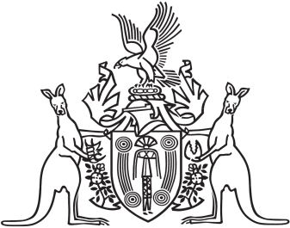
Northern Territory of Australia

Government Gazette
ISSN-0157-833X
No. S89 24 November 2017

Notification of Subordinate Legislation
Notice is given of the making of the following subordinate legislation, effective from the date specified:
Subordinate Legislation | Commencement details | Empowering Act
Domestic and Family Violence Amendment Regulations 2017  (No. 33 of 2017) | These Regulations commence on the commencement of the Domestic and Family Violence (Recognition of Domestic Violence Orders) (National Uniform Law) Amendment Act 2017 | Domestic and Family Violence Act
For copies of legislation please direct your request to the Print Management Unit, email pmu.ntg@nt.gov.au or phone (08) 8999 6727

