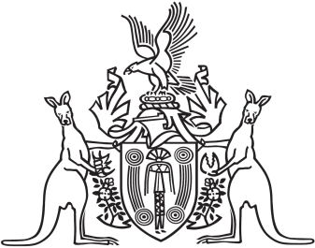
Northern Territory of Australia

Government Gazette
ISSN-0157-833X
No. S86 24 November 2017
Northern Territory of Australia
Domestic and Family Violence (Recognition of Domestic Violence Orders)
(National Uniform Law) Amendment Act 2017
Commencement Notice
I, Vicki Susan O'Halloran, Administrator of the Northern Territory of Australia, under section 2 of the Domestic and Family Violence (Recognition of Domestic Violence Orders) (National Uniform Law) Amendment Act 2017
(No. 2 of 2017), fix 25 November 2017 as the day on which the Act commences.
Dated 22 November 2017
V. S. O'Halloran
Administrator

