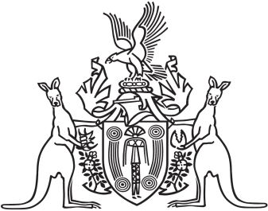
Northern Territory of Australia

Government Gazette
ISSN-0157-833X
No. S74 20 October 2017
Northern Territory of Australia
Licensed Surveyors Act
Notification of Directions given with Respect to
the Practice to be followed by Licensed Surveyors
I, Robert Sarib, the Chairperson of the Surveyors Board of the Northern Territory of Australia, give notice that the Board has given the following directions under section 47(1) of the Licensed Surveyors Act:
Survey Practice Directions 2017, Survey requirements and guidelines for the issue of Section 19 (ALRA) Leases and Section 19A (ALRA) Headleases and subleases for aboriginal communities.
Survey Practice Directions 2017, Survey and plan requirements to facilitate termination of unit developments.
Copies of the above directions may be obtained from: www.surveyorsboard.nt.gov.au.
Dated this 17th day of October 2017
R. Sarib
Chairperson of the Board

