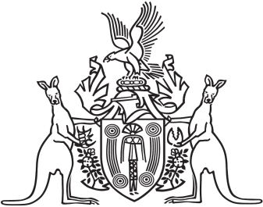
Northern Territory of Australia

Government Gazette
ISSN-0157-833X
No. S73 17 October 2017
Northern Territory of Australia

Territory Parks and Wildlife Conservation Act
Notice of Operation of Plan of Management
Litchfield National Park
I, Lauren Jane Moss, Minister for Tourism and Culture, under section 19(6) of the Territory Parks and Wildlife Conservation Act, give notice that:
(a) the Litchfield National Park plan of management dated December 2016 has come into operation; and
(b) copies of the plan of management may be:
(i) inspected or purchased at the office of the Parks and Wildlife Commission during business hours at Floor 1, JHV2, Jape Homemaker Village, 356 Bagot Road, Millner; and
(ii) viewed at or downloaded from the following website: https://dtc.nt.gov.au/parks-and-wildlife-commission/park-management-strategies-consultation/management-plans.
Dated 13 October 2017
L. J. Moss
Minister for Tourism and Culture

