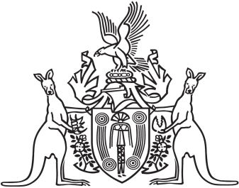
Northern Territory of Australia

Government Gazette
ISSN-0157-833X
No. S15 7 April 2017

Assent to Proposed Laws
His Honour the Administrator assented to the following proposed law:
5 April 2017
Justice Legislation Amendment
(Body-worn Video and Domestic Violence Evidence) Act 2017 (Act No 6 of 2017)
Yours sincerely
Michael Tatham
Clerk of the Legislative Assembly
Date 6 April 2017

