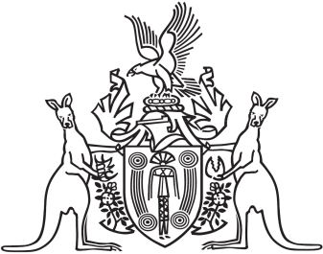
Northern Territory of Australia

Government Gazette
ISSN-0157-833X
No. S2 14 February 2017

Notification of Subordinate Legislation
Notice is given of the making of the following subordinate legislation, effective from the date specified:
Subordinate Legislation | Commencement details | Empowering Act
Public Information Regulations  (No. 1 of 2017) | These Regulations commence on the commencement of the Public Information Amendment Act 2016 | Public Information Act
Motor Vehicles (Fees and Charges) Amendment Regulations 2017  (No. 2 of 2017) | Date of this Gazette | Motor Vehicles Act
For copies of legislation please direct your request to the Print Management Unit, email pmu.ntg@nt.gov.au or phone (08) 8999 6727

Northern Territory of Australia

Public Information Amendment Act 2016
Commencement Notice
I, John Laurence Hardy, Administrator of the Northern Territory of Australia, under section 2 of the Public Information Amendment Act 2016 (No. 34 of 2016), fix the day on which this notice is published in the Gazette as the day on which the Act commences.
Dated 18 January 2017
J. L Hardy
Administrator

