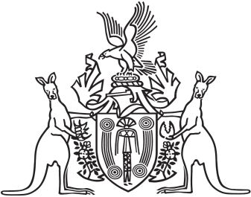
Northern Territory of Australia

Government Gazette
ISSN-0157-833X
No. S98 31 August 2016
Interpretation Act
Notice of Making of Administrative
Arrangements Order
Notice is given of the making of an Administrative Arrangements Order on 31 August 2016, for section 35 of the Interpretation Act, to take effect from 31 August 2016.
An electronic version of the Administrative Arrangements Order will be made available on the Current Northern Territory Legislation database at:
http://www.nt.gov.au/dcm/legislation/current.html
Copies of the Order may also be obtained from the Cabinet Office in the Department of the Chief Minister by telephoning 8999 6949.

