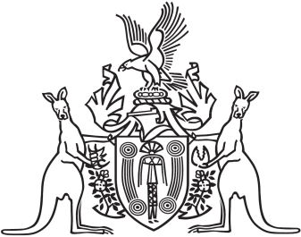
Northern Territory of Australia

Government Gazette
ISSN-0157-833X
No. S56 29 June 2016
Northern Territory of Australia

Pastoral Land Act
Declaration of Rate of Rent
I, Gary John Higgins, Minister for Land Resource Management, under section 55(2) of the Pastoral Land Act, declare 0.616% of the unimproved value of pastoral land, using 2015 valuations as determined under the Valuation of Land Act, to be the rent payable for pastoral leases in all Districts for the financial year commencing on 1 July 2016.
Dated 29 June 2016
G. J. Higgins
Minister for Land Resource Management

