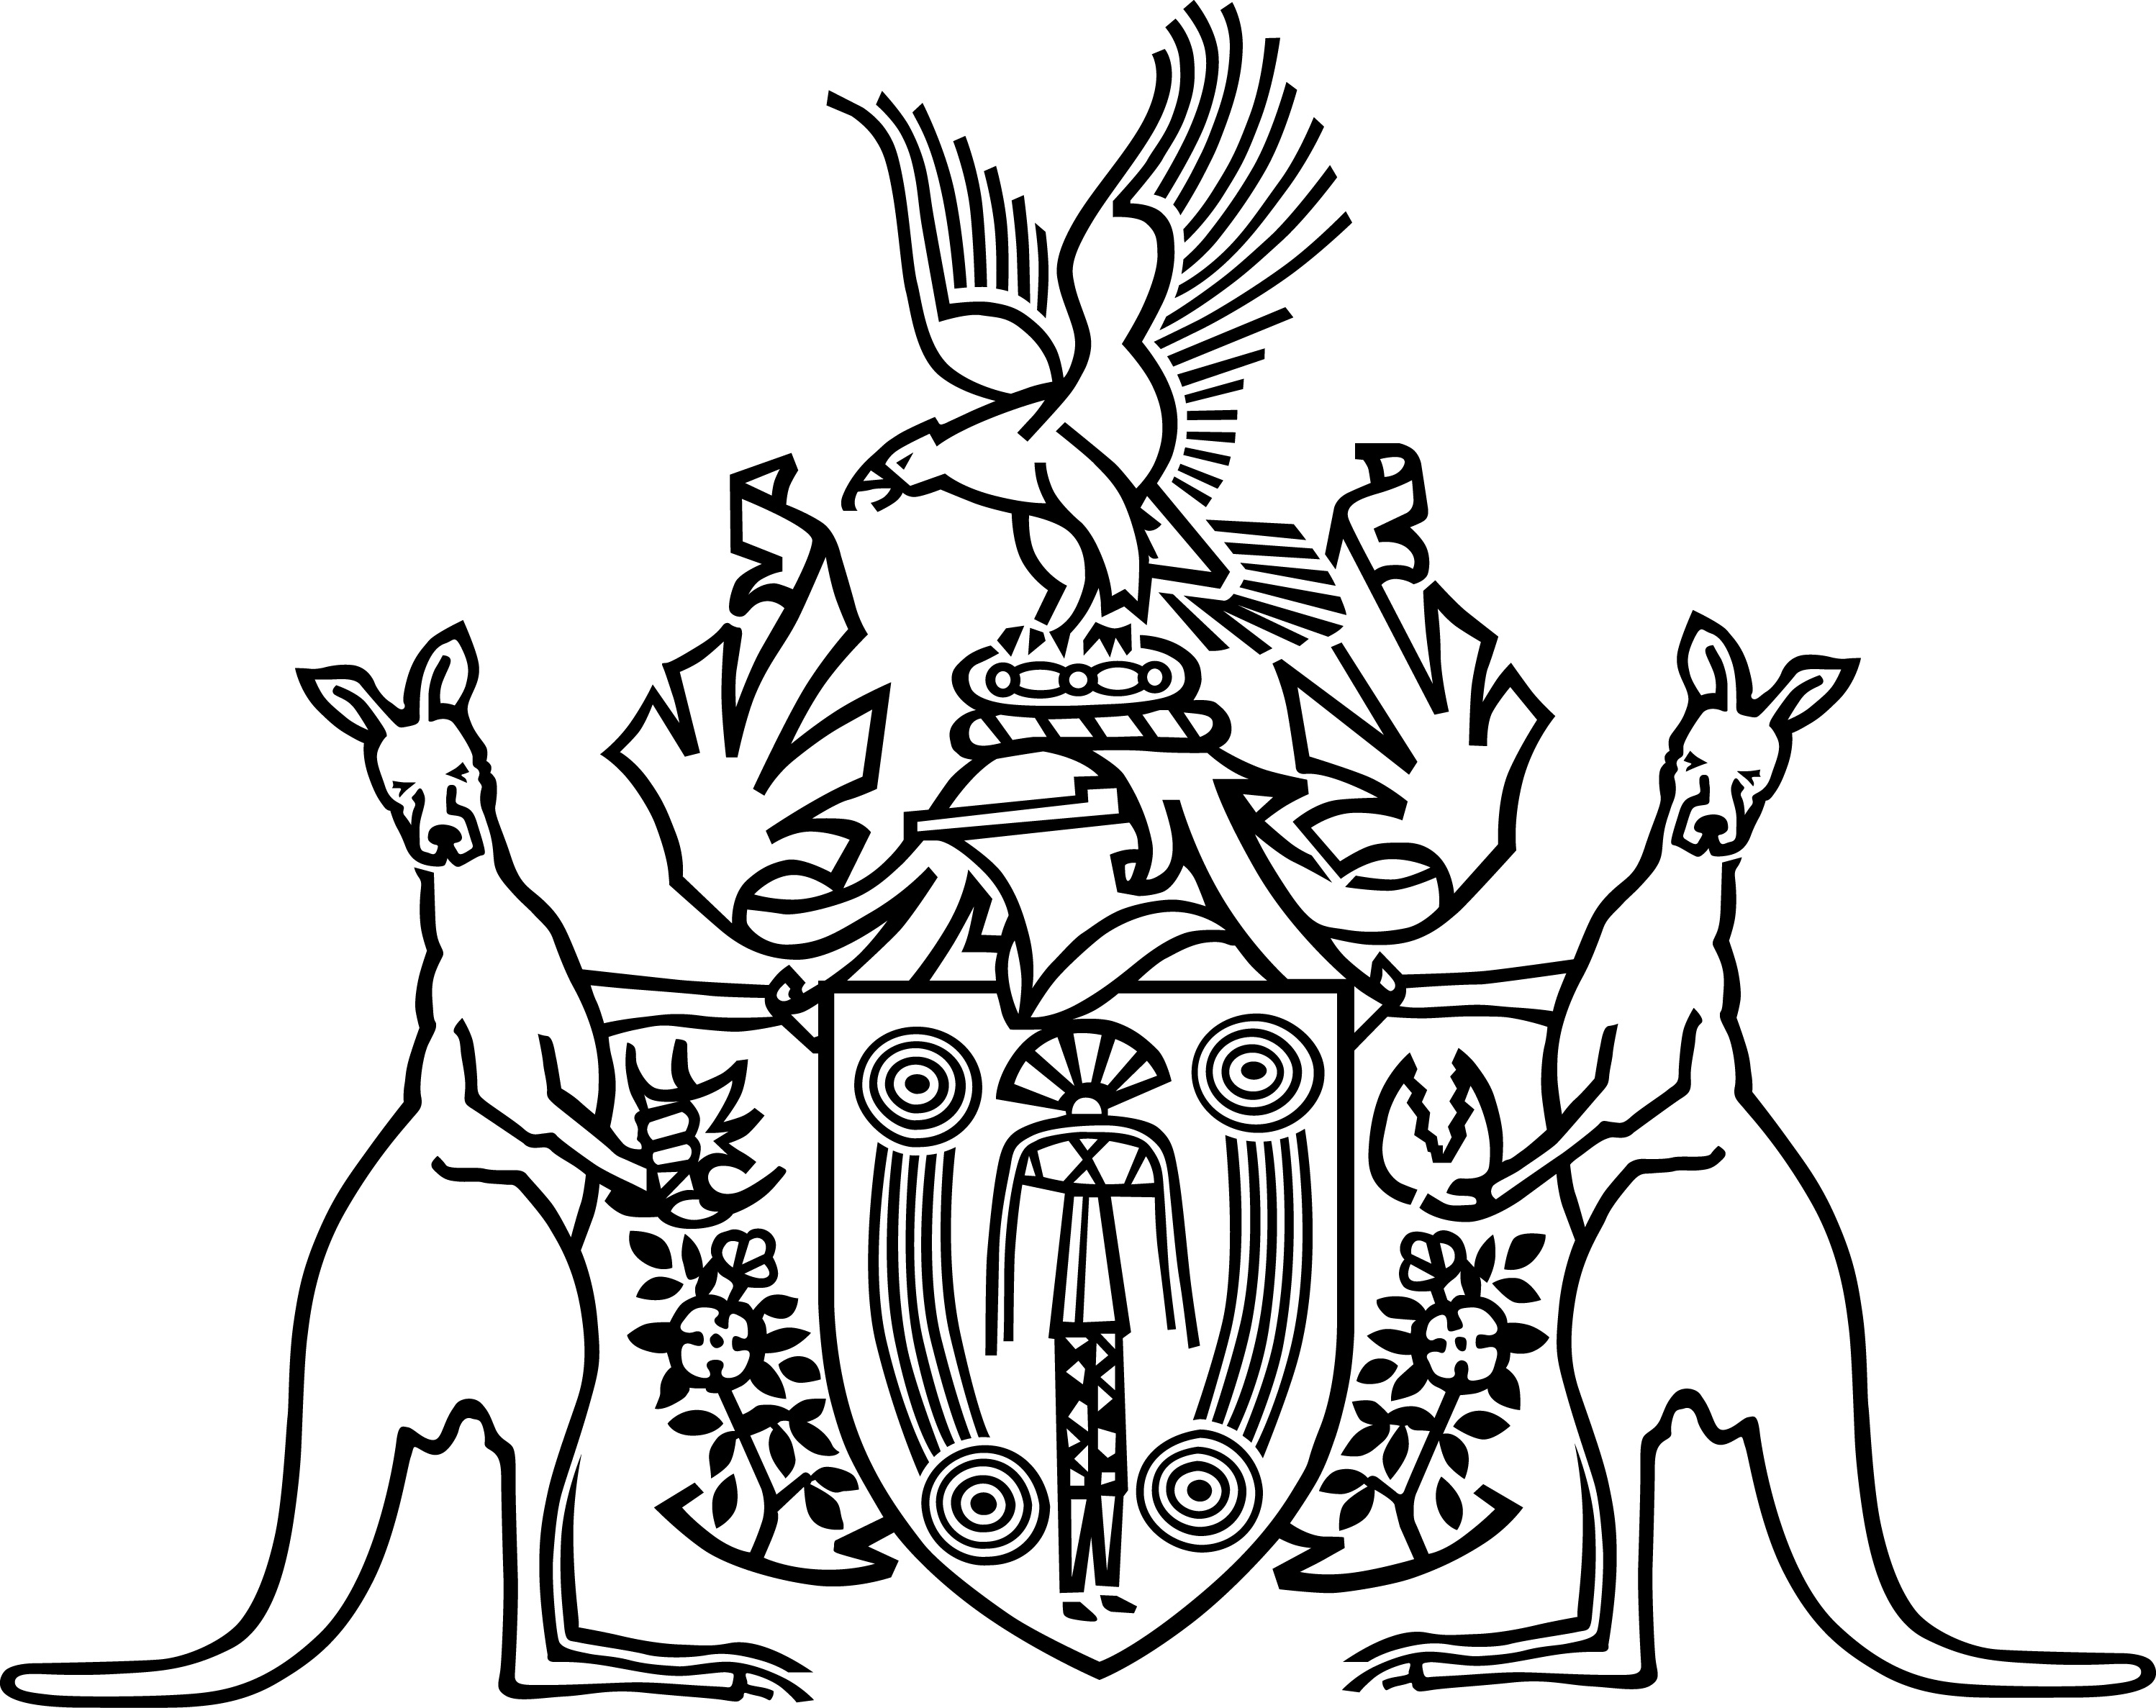
The Northern Territory of Australia

Alcohol Mandatory Treatment Tribunal

Alcohol Mandatory Treatment Act 2013

Practice Direction No. 1
Appointment of an Advocate if Affected Person is Unrepresented
In accordance with section 106(3) of the Alcohol Mandatory Treatment Act 2013 I, Tom Berkley, President of the Alcohol Mandatory Treatment Tribunal make the following Practice Direction.

- This Practice Direction shall be known as Practice Direction No.1 – Appointment of an Advocate if Affected Person is Unrepresented.
- The President, Deputy President, or a member of the Tribunal appointed under section 104(2)(a) of the Act and who is directed pursuant to section 106(3) of the Act to exercise the powers of and perform the functions of the President, may appoint an advocate to represent an affected person if that affected person is unrepresented.
- The advocate is appointed pursuant to section 113(2) of the Act to represent the best interests of, and assist, the affected person in a proceeding and to perform any other functions conferred on the advocate by the Tribunal or under the Act or any other Act.
- The advocate must be a legal practitioner or a person who is approved by the Chief Executive Officer and has expertise in the general care, health care, rehabilitation or treatment of persons who are misusing alcohol.
- The advocate must be provided at no cost to the affected person.

Dated this 8th day of July 2013

…………………………………………………………………..
Tom Berkley
President
Alcohol Mandatory Treatment Tribunal

