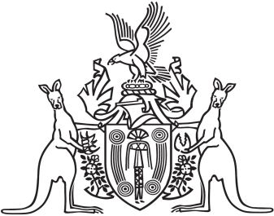
Northern Territory of Australia

Government Gazette
ISSN-0157-833X
No. S19 16 March 2016
Northern Territory of Australia
Ports Management Act
Making of Pilotage Standards for the Port of Darwin
I, Anthony John James O’Malley, the Pilotage Authority for the Port of Darwin, give notice that I have made version 3.0 of the Technical and Safety Standards for Pilotage and the Provision of Pilotage Services in the Port of Darwin in accordance with section 67 of the Ports Management Act. The new version is in effect from 16 March 2016 and is available on the internet at http://www.transport.nt.gov.au/marine/regional-harbourmaster/directions,-standards-and-guidelines
Dated 16 March 2016
A. J. J. O'Malley
Pilotage Authority

