RESPONSIBILITIES AND PLANNING
1 | Time off food and water prior to loading is |  | 7 | Vehicles, and facilities (holding, loading, or |  | pigs. Dogs which are known to bite are
 | managed and, if the journey is likely to exceed  24 hours, recorded and provided to the transporter |  |  | unloading) are constructed, maintained and  operated in a way that minimises risk to the welfare of pigs |  | muzzled when used to move pigs. Dogs in the  vicinity of pigs are kept under control.

TRANSPORT VEHICLES AND FACILITIES
12 Dogs are not transported in the same pen as

2 If the journey is likely to exceed 24 hours, records of the date and time of access to water, inspections and subsequent actions and
emergency contacts are provided to the transporter. These records are updated and passed on to the next person in charge for the duration of the journey

3 Pigs are prepared, inspected and selected as
being ‘fit for the intended journey’.

4. The livestock crate is inspected immediately
before departure, to ensure that doors are closed
and secured

PRE-TRANSPORT SELECTION OF PIGS
5 Pigs are not loaded if they are:
• unable to bear weight on all legs; or
• severely emaciated; or
• visibly dehydrated; or
• showing visible signs of severe injury or distress; or
• suffering from conditions that are likely to cause increased pain or distress during transport; or
• blind in both eyes; or
• in the last four weeks of pregnancy (unless the time off water and journey is less than four hours duration and the destination is directly to another property)
unless under veterinary advice

6 Pigs that are not fit to load are managed, treated
or humanely destroyed promptly

8 Vehicles and facilities are appropriate for pigs;
with effective airflow and flooring that minimises
the likelihood of slipping or falling or injury; free from internal protrusions and other objects that could cause injury; and with sufficient vertical clearance to minimise the likelihood of injury

9. The ramp and the vehicle are properly aligned,
so any gap between them is narrow enough to minimise the likelihood of injury during loading
and unloading

LOADING AND OFF LOADING OF PIGS
10 Loading density minimises risk to pigs and
considers their class, size and body condition,
the predicted climatic conditions, the nature of the journey and the design and capacity of the vehicle.

11 Pigs are segregated according to their class
and size; general health, level of aggression;
and the nature of the journey to minimise risks to their welfare.

12 Pigs are handled appropriately and
competently. They are:
• not lifted by only the head, ears, neck or tail; or
• not lifted off the ground by a single leg, unless they weigh less than 15 kgs
• supported and secured if lifted mechanically;
• not thrown or dropped;
• not unreasonably struck, punched or kicked;
• not dragged if they can’t stand, (except for emergency handling, lifting, treatment or destruction).
13 Electric prodders are not used unless:
• individual pigs weigh 60 kgs (live weight)
or more; and
• other reasonable action to cause movement have failed; and
• there is reasonable risk to the safety of the driver or the pig(s)

14 Electric prodders are not used:
• on genital, anal or facial areas; or
• on pigs under three months of age; or
• on pigs that are unable to move away; or
• excessively on a pig.

TIME OFF WATER, JOURNEYS AND SPELLS
15 Transport and spell times comply with the table
below and the criteria for calculating time off
water and journey duration are applied an met

Class | Maximum time off water | Minimum Spell duration
Pigs  Lactating sows and piglets Weaners | 24 hours  12 hours  12 hours | 12 hours  12 hours  12 hours
Notes
• If pigs are unloaded and provided with water for less than 4 hours, their time off water, is not reduced.
• If water is provided for between 4 and 24 hours, the time for which such access was provided is deducted from the time off water.
• The time off water is calculated by adding: assembly time; time in a holding facility prior to loading; loading; time on a vehicle; unloading; holding in a handling facility during transit or at a destination until water is provided.

16 If pigs are spelled for the duration stated in the table above, the transport process is deemed to be completed and another transport process can be undertaken.

17 Journey time is only extended to 72 hours if:
• pigs have access to water and food on the vehicle within every 24 hours; and
• there is space for all pigs to lie down; and
• the pigs are regularly assessed to be fit for the remainder of the intended journey; and
• the pigs are provided with water, food and rest for 24 hours before another journey.

18 Time off water minimises risks to pigs and takes
into account:
• increased risk of journeys close to the maximum time off water;
• assessment that the pigs are fit for the remainder of the journey;
• climatic conditions, especially heat or cold;
• the class of pigs, especially if weak, pregnant, recently having given birth, lactating or immature; and
• the nature of the intended journey

19 In the absence of records, on arrival at their
destination, pigs are watered within the
maximum time off water for their class and, if their maximum time off water is reached, spelled before commencing another journey

HUMANE DESTRUCTION
20 If a pig is killed, it is done in a manner which
results in rapid loss of consciousness followed
by death while unconscious

21 Pigs are killed by a person who is competent in
the method of killing. If there is no competent
person available and the person in charge of the pig at the time considers that he is
capable of killing it humanely and if it is in the welfare interest of the pig, he may kill it.

20 Weak, ill or injured pigs are identified to the receiver and separated for rest and recovery, treatment, or humane destruction promptly.

21 A pig which has been killed is checked to
ensure that it is dead

22 Blunt trauma is only used to kill pigs weighing
under 15 kg and is a single blow to the head.
Pigs are not killed by cutting their throats

DURING THE JOURNEY
23 Pigs are inspected:
• on the vehicle before departure; and
• within the first hour of the journey; and
• at least every 3 hours or at each driver rest stop, whichever comes first,
• each time the vehicle stops for a change of driver or vehicle; and
• at unloading;
to assess them as being fit for the journey

24 If a pig is distressed or injured, it is attended to
at the first reasonable opportunity

25 The impact of severe weather is minimised
during transport

ON ARRIVAL AT THE DESTINATION
26 The receival yard is inspected before
unloading, to ensure access and sufficient
space for the pigs

27 The receiver is notified of the arrival of the pigs
(if possible) and, if the journey was over 24
hours, provided with the. Weak, ill or injured pigs are promptly identified to the receiver
and separated for rest and recovery, treatment, or destruction

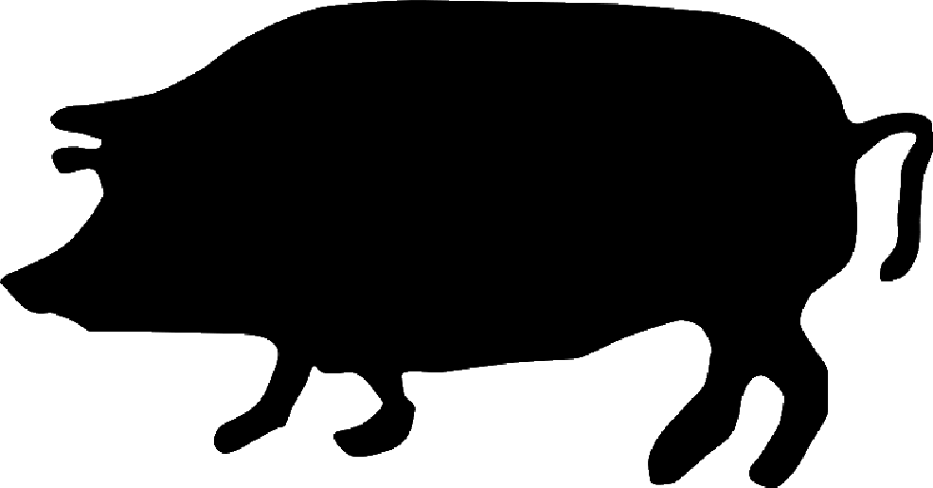

Australian Livestock Transport
Standards and Guidelines

Pig Transport Checklist

This check list applies from the time pigs are assembled for transport until they are unloaded, and fed and watered or killed at their destination. It is a series of outcome statements based on Livestock Transport Standards as they apply to pigs. These are the criteria that inspectors will use when
they conduct a routine inspection of arrangements.

DEPARTMENT OF PRIMARY INDUSTRY AND FISHERIES

