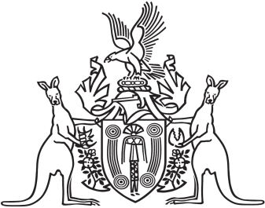
Northern Territory of Australia

Government Gazette
ISSN-0157-833X
No. S16 2 March 2016
Northern Territory of Australia

Health Services Act
Top End Health Service Board
Appointment of Member
I, Johan Wessel Elferink, Minister for Health, under section 21(2) of the Health Services Act, appoint Aminul Islam to be a member of the Top End Health Service Board from 1 January 2016 to 31 December 2017.
Dated 1 December 2015
J. W. Elferink
Minister for Health

