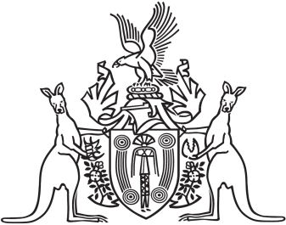
Northern Territory of Australia

Government Gazette
ISSN-0157-833X
No. S7 9 February 2016
Northern Territory of Australia
Livestock Act
Appointment of Chief Inspector
I, Alister John Kent Trier, Chief Executive Officer, Department of Primary Industry and Fisheries, under section 90(1) of the Livestock Act, appoint Kevin William de Witte to the office of Chief Inspector of Livestock on and from 15 February 2016.
Dated 4 February 2016
A. J. K. Trier
Chief Executive Officer
Department of Primary Industry and Fisheries

