Stock assessment of Northwest Grey Mackerel (Scomberomorus semifasciatus) in the Northern Territory, with data to December 2024

Sandra Curin-Osorio
Hannah Innes
Deepak Pazhayamadom
Michael Usher
Document title | Stock assessment of Northwest Grey Mackerel (Scomberomorus semifasciatus) in the Northern Territory, with data to December 2024
Contact details | NT Fisheries
Approved by
Date approved
Document review
TRM number

Version | Date | Author | Changes made
1.1 | 15 July 2024 | Sandra Curin-Osorio | Data processing
1.2 | 24 July 2024 | Sandra Curin-Osorio  Deepak Pazhayamadom | CPUE standardisation
1.3 | 1 August 2024 | Sandra Curin-Osorio | Stock Synthesis (SS) model and Diagnostics
1.4 | 16 February 2025 | Sandra Curin-Osorio | Revised SS model
1.5 | 20 February 2025 | Sandra Curin-Osorio | Forecast
1.6 | 2 May 2025 | Hannah Innes  Sandra Curin-Osorio | Stock Reduction Analysis
1.7 | 16 May 2025 | Sandra Curin-Osorio  Hannah Innes | Expanded and formatted
1.8 | 20 May 2025 | Sandra Curin-Osorio | Biomass & harvest fractions
1.9 | 31 May 2025 | Deepak Pazhayamadom  Hannah Innes  Sandra Curin-Osorio | Full draft review
2.0 | 5 December 2025 | Michael Usher  Phillipa Hunter  Sandra Curin-Osorio | Final review
2.1 | 13 February 2026 | Neil Klear | External Reviewer

Contents
1.1 Acknowledgements 10
2 Summary 11
3 Introduction 12
3.1 The Fishery 12
3.2 Stock Structure 12
3.3 Previous assessments 13
3.4 Modifications to the previous assessments 14
5 Methods 16
5.1 Data summary 16
5.1.1 Catch data 16
5.1.2 Abundance Index 19
5.1.3 Length and age compositions data 20
5.2 Biology 23
5.2.1 Growth 23
5.2.2 Length-weight Relationship 24
5.2.3 Spawning 24
5.2.4 Coefficient of variation of length 24
5.2.5 Recruitment deviations 25
5.3 Stock assessment models 26
5.3.1 Model Structure 26
5.3.2 Tuning method 27
5.3.3 SS3 Diagnostics 28
5.3.4 Criteria for determining the stock status in SS3 30
5.3.5 Recommend biological Catch (RBC) 30
5.3.6 Sensitivity scenarios 31
5.4 Stock Reduction Analysis (SRA) 32
5.4.1 SRA model structure assumptions 32
5.4.2 SRA to SS Bridge scenarios 33
5.4.3 SRA Stock Status 33
6 Model outcomes 34
6.1 SS3 Assessment outcomes 34
6.1.1 Parameter estimates 35
6.1.2 Fits to data 37
6.2 Application of the HCR 44
6.3 Sensitivities scenarios 45
6.4 Model Diagnostics 47
6.5 SRA Assessment outcomes 47
7 Discussion 48
7.1 Performance of model 48
7.2 TACC vs Model-derived RBCs 49
7.3 SRA comparison 49
7.4 Research and data needs 50
8 References 51
9 Appendix 54
9.1 Glossary of abbreviations and terms 54
9.2 Model characteristics of GLM standardisation 55
9.2.1 Catch Per Unit Effort 55
9.2.2 Results 61
9.2.3 Transition from 2000-2021 CPUE to 2006-2024 CPUE standardisation. 68
9.3 Biology 68
9.3.1 Bayes Growth 68
9.3.3 Length-weight relationship 73
9.3.5 Coefficient of variation of length composition 74
9.4 SRA outcomes 74
9.4.1 SRA diagnostics 78
9.4.2 SRA Diagnostics 79
9.5 Bridging Scenarios for CPUE and Estimated Recruitment Deviations 83
9.7 Fits of 2025 base case model 85
9.9 Stock Assessment Diagnostics 94
9.9.1 Retrospective analysis 94
9.9.2 Likelihood profiles 98
9.9.3 Jitter analysis 107
9.10 Constant catch using current TACC 108

List of tables
Table 1. Stock status outcome from the most recent Grey Mackerel stock assessments. 14
Table 2. Comparison of the data inputs and model structure between the Stock Reduction Analysis and Stock Synthesis models. 15
Table 3. Annual total catches from 1983 to 2024 of Grey Mackerel. The base case catch series is presented in the “Total catch” column. 18
Table 4. Standardised indices of abundance, and input CV values, for the North West NT stock of Grey Mackerel. 19
Table 5. Life history and population parameters for the stock assessment of North West NT Grey Mackerel stock. Parameters are estimated or pre-specified to ensure their outcomes are comparable to scenarios explored in the bridging analysis. 27
Table 6. Summary of SRA to SS Bridge scenarios. 33
Table 7. Summary of sex specific parameter estimates for Grey Mackerel. 37
Table 8. Summary of recruitment and commercial fleet selectivity parameter estimates for Grey Mackerel. 37
Table 9. Summary of estimated stock status, RBCs assuming average recruitment projections under the 20:30:48 harvest control rule. 44
Table 10. Summary of the negative log likelihood (NLL), change in NLL, unfished and current spawning biomass and the stock status for the North West NT Grey Mackerel stock base case and sensitivity scenarios. 45
Table 11. Summary of likelihood components for the base case scenario and sensitivity model runs. Likelihood components are unweighted and all cases below the base case are shown as differences from the base case. A negative value either in the total or individual components of likelihood indicates an improvement in fit compared to the base case. A positive value indicates deterioration in the fit. 46
Table 12. The data selection criteria used to generate the nominal CPUE. 56
Table 13. Model Scenarios with nominal CPUE as a response variable using zero-inflated gamma (ZiGamma) and Zero-truncated Negative binomial Distributions for standardisation. 57
Table 14. Model Scenarios catch as a response variable using zero-inflated gamma (ZiGamma) and Negative binomial Distributions. 57
Table 15. Model Scenarios with catch as a response variable using Poisson and Zero-truncated Negative binomial Distributions. 58
Table 16. Model Scenarios with catch as a response variable using Zero-truncated Negative binomial Distributions. 59
Table 17. Model Scenarios with catch as a response variable using Zero-truncated Negative binomial Distributions with zero-inflation covariables (Ziformula). 60
Table 18. Summary statistics for growth parameters of male and females from the MCMC analysis of the North West NT Grey Mackerel stock. 72
Table 19. Heidel Stationarity test for growth parameters of MCMC analysis of the North West NT Grey Mackerel stock. 72
Table 20. Statistic summary of fork length for young and old male and female Grey Mackerel by year, used in the 2025 Integrated Stock Assessment Model. 74
Table 21. Summary statistics for quantities from the SRA MCMC analysis. 82
Table 22. Mohn’s rho values for the recruitment retrospectives. 98

List of figures
Figure 1. North West Northern Territory stock assessment area. 13
Figure 2. Summary of data sources used in the 2025 North West NT Grey Mackerel assessment. Circle area indicates the relative size of catches, magnitude of abundance indices or sample size of compositions. 16
Figure 3. Annual estimated harvest (retained catch) from commercial, recreational and FTO sectors between 1983 and 2024. 17
Figure 4. Nominal and standardised CPUE for North West Northern Territory stock of grey Mackerel (2006-2024). 20
Figure 5. Female length composition data used for the 2025 Grey Mackerel assessment. N is the number of total samples. 21
Figure 6. Male length composition data used for the 2025 Grey Mackerel assessment. N is the number of total samples. 21
Figure 7. Frequency of age composition data used for the 2025 Grey Mackerel assessment. 22
Figure 8. Length-at-age composition data used for the 2025 Grey Mackerel assessment. 23
Figure 9. Estimated variance of recruitment deviation in the model considered. The base case model used recruitment deviation estimates from 1983 until 2021. 25
Figure 10. The 20-30-48 rule. $SSBLim=$ 20% of unfished spawning stock biomass, $Ftarg=$ the fishing mortality rate at which spawning stock biomass is reduced to 48% of the unfished level and $SSBtrig=$30% of unfished spawning stock biomass. 31
Figure 11. Phase plot showing the criteria used for determining stock status (Piddocke et al., 2021). Where $Fcurr/FMSY$ is the relative fishing mortality and $SSBcurr/SSB0$ is the relative spawning biomass. 34
Figure 12. Time-trajectory of the estimated spawning stock biomass (median with approximate 95% asymptotic intervals). 35
Figure 13. The model estimated growth curves for females and males with 95% confidence intervals. 36
Figure 14. Estimated selectivity curves for the commercial, FTO and recreational fleets. 36
Figure 15. Fits to the commercial catch rates (CPUE) showing observed values (circles) and associated 95% confidence intervals, and model-estimated CPUE (blue line). 38
Figure 16. Residuals for fits to CPUE for the commercial fleet for the 2025 base case scenario. Green shading indicates no evidence ($p≥0.05)$ to reject the hypothesis of a randomly distributed time-series residuals. 38
Figure 17. Annual mean index residuals, vertical lines with points show the residuals for the CPUE index (blue). The solid black line shows the loess smoother through all residuals. Root-mean squared error (RMSE) 39
Figure 18. Fits to the aggregated length data by sex for the 2025 base case Grey Mackerel assessment. 39
Figure 19. Residuals for fits to length composition data by fleet for the base case scenario. Green shading means the residuals are randomly distributed ($P≥0.05)$. 40
Figure 20. Recruitment estimation. Top left: Time-trajectories of estimated recruitment numbers; top right: the standard errors of recruitment deviation estimates; bottom left: time-trajectories of estimated recruitment numbers with approximate 95% asymptotic intervals; bottom right: bias ramp adjustment for recruitment in the model. 41
Figure 21. Time trajectory of estimated recruitment deviations for the base case with 95% asymptotic intervals. 41
Figure 22. Stock recruitment curve for the 2025 base case assessment for Grey Mackerel. 42
Figure 23. Kobe plot showing the median relative spawning biomass in year and corresponding median relative fishing intensity in year $t$. Labels indicate the first and final years and correspond to year of the relative spawning biomass. The grey ellipse spans the 95% credibility intervals for the 2024 relative spawning biomass and relative fishing intensity (vertical). 43
Figure 24. Spawning potential ratio (SPR), or relative fishing intensity, through time, the red line represents the target fishing mortality, and each year is a point in the model. 43
Figure 25. The estimated time-series of relative spawning biomass for the base case with projections applying the HCR to 2060. 44
Figure 26. Kobe plot of relative egg production vs fishing intensity from the stochastic SRA bridging analysis for North West NT Grey Mackerel. The central point represents the median of the join posterior distribution with ~95% asymptotic intervals for each scenario (blue and green ellipse). The dashed line is the $SSB0.2$ minimum stock threshold. 48
Figure 27. Grey mackerel total catch and effort reported from the commercial component of the Offshore Net and Line Fishery through logbooks. 61
Figure 28. Distribution of log-transformed CPUE by year. 62
Figure 29. Akaike Information Criterion (AIC) values for the evaluated CPUE scenarios. 63
Figure 30. Akaike Information Criterion (AIC) values for the evaluated catch scenarios. 63
Figure 31. Characteristics of the ZAG - GLM model (M99) used to standardise the abundance index for Grey Mackerel catch in the Northern Territory. 66
Figure 32. Standardised CPUE from 2000 to 2024 with a LOESS-fitted Smoothing. 67
Figure 33. Standardised CPUE from 2006 to 2024 with a LOESS-fitted Smoothing. 67
Figure 34. Estimated initial growth curve by sex for the North West NT stock of Grey Mackerel. 68
Figure 35. Autocorrelation matrix and kernel density overlays of growth parameters estimated by sex from the posterior distribution for the North West NT Grey Mackerel stock. Asterisks indicate statistical significance (0.05, 0.01 and 0.001). 69
Figure 36. Autocorrelation plots for the MCMC samples of growth parameters (L∞, k, L₀, and σ) for the North West NT stock of Grey Mackerel. Each row represents one of the four Markov chains used in the Bayesian von Bertalanffy growth model. 70
Figure 37. Probability of distribution and trace plots of growth parameters estimated from the posterior distribution for North West NT stock of Grey Mackerel. 71
Figure 38. Length-weight relationship by sex of the Northwest Grey Mackerel stock. 73
Figure 39. Coefficient of variation of fork length (cm) for combined sex by year that informed the 2025 SRA and SS3 assessments. 74
Figure 40. The estimate time-series of total biomass for the bridging SRA models of the 2025 North West NT Grey Mackerel assessment. 75
Figure 41. Depletion for the bridging SRA models of the 2025 North West Grey Mackerel assessment. Frequency distribution of depletion $(Ecurrent/E0)$, defined as the ratio of estimated egg production in the current relative to unfished egg production ($E0$) as proxy of ($Bcurr/B0$), based on the join posterior distribution MCMC samples from the Stochastic Reduction Analysis (SRA). The red line represents the median depletion value. 76
Figure 42. Kobe plot of relative egg production vs fishing intensity from the 2022 stochastic SRA model for North West stock of Grey Mackerel. The central point represents the median of the join posterior distribution with ~95% asymptotic intervals (blue ellipse). The dashed red line is the 0.2$SB0$ minimum threshold for relative egg production). 77
Figure 43. Kobe plot of relative egg production vs fishing intensity from the 2025 bridging stochastic SRA analysis for North West Grey Mackerel. The central point represents de median of the join posterior distribution with ~95% asymptotic intervals for each scenario (blue and green ellipse). The dashed line is the 0.2$SB0$ minimum stock threshold. 78
Figure 44. Pairwise correlation matrix among key biological and management parameters from the posterior distribution of Scenarios 1, 6 and 7 of the SRA models for North West NT Grey Mackerel. The plot displays Pearson correlation coefficients, with the colour gradient ranging from red (strong negative correlation) to green (strong positive correlation). Circle size is proportional to the square root of the coefficient. 80
Figure 45. Trace plots to track autocorrelation and posterior density estimates of total biomass ($Btot$) and spawning stock biomass ($SSB$) in 2021, from the SRA posterior distribution of scenario 1 (Updated 2022 SRA, Table 21). 81
Figure 46. Trace plots to track autocorrelation and posterior density estimates of total biomass ($Btot$) and spawning stock biomass ($SSB$) in 2024, from the SRA posterior distribution of scenario 6 (2025 SRA assessment with CPUE: 2000-2024). 81
Figure 47. Trace plots to track autocorrelation and posterior density estimates of total biomass ($Btot$) and spawning stock biomass ($SSB$) in 2024, from the SRA posterior distribution of scenario 7 (2025 SRA assessment with CPUE: 2006-2024). 82
Figure 48. Comparison of the estimated recruitments and estimated recruitments deviations across scenarios used for the stock assessment. 83
Figure 49. Comparison of absolute spawning biomass and relative unfished biomass fits across scenarios used for the stock assessment. 84
Figure 50. Comparison of model fits to CPUE indices considered in the bridging scenarios. 84
Figure 51. Length composition fits from the ONLF (commercial) fleet for the Grey Mackerel stock. 85
Figure 52. Pearson residuals from the model fit to length composition data for the commercial fleet. 86
Figure 53. Mean length for commercial with 95% confidence intervals based on current sample sizes. Francis data weighting method TA1.8: Thinner intervals (with capped ends) show result of further adjusting sample sizes based on suggested multiplier (with 95% interval): 1 (0.7055-1.7118). 87
Figure 54. Pearson residuals from the fits to conditional age-at-length for the commercial fleet from 2007 to 2014. This plot gives an indication of the year-to-year variability in the conditional age-at-length samples. 88
Figure 55. Pearson residuals from the fits to conditional age-at-length for the commercial fleet from 2020 to 2022. This plot gives an indication of the year-to-year variability in the conditional age-at-length samples. 89
Figure 56. Mean age from conditional age-at-length data (aggregated across length bins) for the commercial fleet with 95% confidence intervals based on current samples sizes. Francis data weighting method TA1.8 was applied: Thinner intervals (with capped ends) show result of further adjusting sample sizes based on suggested multiplier (with 95% interval) for conditional age-at-length data: 1 (0.524-5.902) 90
Figure 57. Fits to conditional age at length data for the commercial fleet (2007-2010). 91
Figure 58. Fits to conditional age at length data for the commercial fleet (2011-2014). 92
Figure 59. Fits to conditional age at length data for the commercial fleet (2011-2014). 93
Figure 60. Retrospectives for absolute spawning biomass for the base case assessment of Grey Mackerel, with data included to 2024 (blue) and then successive years removed back to 2019 (red). 94
Figure 61. Retrospectives for relative stock status for the base case assessment of Grey Mackerel, with data included to 2024 (blue) and then successive years removed back to 2019 (red). 95
Figure 62. Retrospectives for Age-0 recruits for the base case assessment of North=western Grey Mackerel stock, with data included to 2024 (blue) and then successive years removed back to 2019 (red). 95
Figure 63. Retrospectives for recruitment deviations for the base case assessment of North West NT Grey Mackerel stock, with data included to 2024 (blue) and then successive years removed back to 2019 (red). 96
Figure 64. Retrospective analysis of recruitment deviations (squid plot), for the Grey Mackerel base case assessment, with data removed in successive years back to 2019. Recruitment deviations are the median log-scale differences between recruitment estimated by the model and expected recruitment from the stock-recruitment relationship. 97
Figure 65. Pinerplot for the likelihood profile of natural mortality (M), showing components of the change in likelihood for length, age and indices (CPUE commercial) in addition to the changes in the total likelihood. 99
Figure 66. Pinerplot for the likelihood profile for steepness (h), showing components of the change in likelihood for length, age and indices (CPUE commercial) in addition to the changes in the total likelihood. 100
Figure 67. Pinerplot for the likelihood profile for the growth coefficient (K) for females, showing components of the change in likelihood for length, age and indices (CPUE commercial) in addition to the changes in the total likelihood. 102
Figure 68. Pinerplot for the likelihood profile for the growth coefficient (K) for males, showing components of the change in likelihood for length, age and indices (CPUE commercial) in addition to the changes in the total likelihood. 102
Figure 69. Pinerplot for the likelihood profile for asymptotic length ($L∞$) for females, showing components of the change in likelihood for length, age and indices (CPUE commercial) in addition to the changes in the total likelihood. 103
Figure 70. Pinerplot for the likelihood profile for asymptotic length ($L∞$) for males, showing components of the change in likelihood for length, age and indices (CPUE commercial) in addition to the changes in the total likelihood. 104
Figure 71. Pinerplot for the likelihood profile for virgin spawning biomass, showing components of the change in likelihood for length, age and indices (CPUE commercial) in addition to the changes in the total likelihood. 105
Figure 72. Pinerplot for the likelihood profile for the 2024 spawning biomass, showing components of the change in likelihood for length, age and indices (CPUE commercial) in addition to the changes in the total likelihood. 106
Figure 73. Piner plot for the likelihood profile for relative spawning biomass (stock status) in the 2024 Grey Mackerel model, showing components of the change in likelihood for length, age and indices (CPUE commercial) in addition to the changes in the total likelihood. 107
Figure 74. Results of models that converged during the jitter analysis and their log likelihood estimates. 108
Figure 75. The estimated time-series of relative spawning biomass with projections to 2060 under the current setting of the Total Allowable Commercial Catch (TACC) applying the 20:30:48 HCR. 109
Figure 76. The estimated time-series of relative spawning biomass with projections to 2060 under the current setting of Total Allowable Commercial Catch (TACC) applying the 20:30:48 HCR. 109

Acknowledgements

Age data were provided by Simon Robertson (Fish Ageing Services). Dr Jeremy Day (Secretariat of the Pacific Community, SPC) is acknowledged for his contributions to data pre-processing and the initial specification of the assessment model. Dr Malcolm Haddon is recognised for his expert guidance on the standardisation of fishery catch-per-unit-effort (CPUE) data. Dr Paul Burch (CSIRO, Southern and Eastern Scalefish and Shark Fishery team) is acknowledged for providing key R code to support the auto-tuning procedures. Both Dr Day and Dr Burch are further recognised for their constructive discussions and ongoing technical input throughout the development of this assessment. Dr Jonathan Smart is also acknowledged for his feedback on the model structure and for his advice on the implementation of Stock Synthesis. The r4ss package, maintained by Ian Taylor (https://github.com/r4ss/r4ss), was instrumental in producing diagnostic outputs and supporting model-tuning activities.

Summary

This document presents the stock assessment of the North West Northern Territory Grey Mackerel (Scomberomorus semifasciatus) biological stock. The document also provides a bridging analysis that builds on the previous stochastic Stock Reduction Analysis (SRA) model by implementing an integrated, sex-structured, age- and size-based model using Stock Synthesis (SS3). This methodological advancement enables a more comprehensive incorporation of biological, fishery-dependent, and fishery-independent data to improve the estimation of stock status and sustainable harvest levels.
The assessment incorporates data through to the end of 2024 (calendar year) and includes data from commercial, Fishing Tour Operator (FTO) and recreational fisheries. The model incorporates a detailed population structure, with sex-specific dynamics, double-normal selectivity for the commercial fleet, logistic selectivity for recreational and Fishing Tour Operator fleets, and internally estimated growth and selectivity parameters. It was fitted to a suite of empirical datasets, including a CPUE index, commercial catch, and length-at-age observations.
The model estimates the current spawning stock biomass (SSB) is at 61% (95% CI: 48% to 74%) of unfished levels (SSB₀), which is above the 48% SSB target reference point specified in the Offshore Net and Line Fishery (ONLF) Harvest Strategy.
The Recommended Biological Catch (RBC) for the ONLF in 2025, calculated under the 20:30:48 harvest control rule, is 605 t. Under this scenario, spawning biomass is projected to remain above the management target and stabilise near the long-term equilibrium level of 48% SSB₀.
As this is the first integrated assessment for this stock, key productivity parameters, including natural mortality (M) and recruitment variability ($σ_{R}$ ), were fixed to biologically plausible values due to current data limitations. These parameters directly influence estimates of stock biomass and the Recommended Biological Catch (RBC), and therefore model outputs should be interpreted with appropriate caution. Until these parameters can be reliably estimated within the model, it is recommended that the current fixed commercial catch limit of 404 t be maintained as a precautionary measure, ensuring that total removals remain conservative relative to the model-derived RBC.
Based on the evidence presented, the stock is unlikely to be depleted, and recruitment is unlikely to be impaired. The 2025 base case model reaffirms the classification of the North West Northern Territory Grey Mackerel stock as Sustainable.

Introduction

The Fishery
The commercial Offshore Net and Line Fishery (ONLF) operates as a mixed-target fishery. Primary target species includes Grey Mackerel (Scomberomorus semifasciatus), Australian Blacktip Shark (Carcharhinus tilstoni), Common Blacktip Shark (C. limbatus) and Spot-Tail Shark (C. sorrah). A variety of other shark and pelagic finfish species are taken as secondary species.
The Offshore Net and Line Fishery is jointly managed by the NT and Commonwealth under the Offshore Constitutional Settlement (OCS) arrangement. This cooperative framework authorises the NT to undertake day-to-day management on behalf of the NT Fisheries Joint Authority (NTFJA), with the fishery’s management practices being formally recognised by the Australian Government as ecologically sustainable.
A full description of the management arrangements in the ONLF can be found here: Management arrangements for the Northern Territory Offshore Net and Line Fishery.

Stock Structure
Grey Mackerel are endemic to the northern waters of Australia. Research on the biological stock structure of Grey Mackerel across northern Australia, based on genetics (SNP-genotypes), otolith isotope chemistry, faunal composition parasites and growth, has suggested the existence of at least five S. semifasciatus biological stocks. These include, a Western Australian stock, a North West Northern Territory stock, a Gulf of Carpentaria stock, a North East Queensland stock and a South East Queensland stock, with a possible additional stock in the north east Gulf of Carpentaria (Broderick et al. 2011, Charters et al. 2010, Newman et al. 2010, Welch et al. 2009, Welch et al. 2015).
In the Northern Territory, Grey Mackerel is managed as two separate stocks, the North West NT stock and the Gulf of Carpentaria stock, due to observed differences in size and age composition, as well as catch rate trends (Welch et al. 2015). Genetic differences have been identified between the Gulf of Carpentaria and North West NT stocks, which, although not sufficient to define fully discrete populations, do suggest demographic structuring (Broderick et al. 2011, Charters et al. 2010, Newman et al. 2010, Welch et al. 2009, Welch et al. 2015). This assessment determines the status of the North West NT stock of Grey Mackerel (Figure 1).

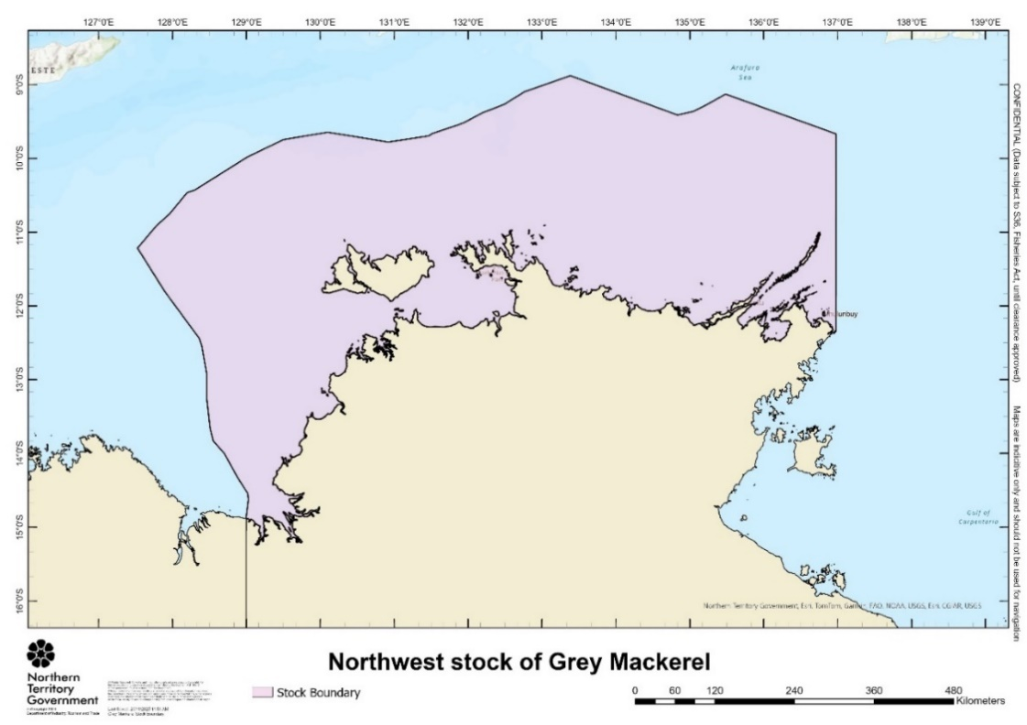
Figure 1. North West Northern Territory stock assessment area.

Previous assessments
Assessments of the Grey Mackerel fishery have been undertaken since the 1980s. Notably, a collaborative evaluation conducted in the mid-1990s by the Northern Territory (NT) Department of Primary Industry and Fisheries, CSIRO, and the Australian Fisheries Service estimated a potential yield of at least 2,000 tonnes per year across Western Australia, the NT, and Queensland (Walters and Buckworth, 1997). The optimal annual harvest rate was estimated at 6–7% of the biomass vulnerable to gillnet fishing. Furthermore, age-structured modelling suggested that the overall stock biomass should have been increasing at an annual rate of 5–10% since the mid-1980s, particularly following a reduction in Taiwanese fishing effort.
Nevertheless, reports indicate that the catch-per-unit-effort (CPUE) data from the NT gillnet fishery, which underpinned the assessment, showed a declining trend in relative abundance since the mid-1980s. Several unquantified sources of mortality were identified, including removals by other fisheries beyond Australia’s northern maritime boundary and undeclared catches within domestic fisheries—estimated to account for up to 1,500 tonnes.
In 2005, the Northern Stock Assessment Group updated the assessment using eight additional years of CPUE data. The previously observed declining trend had stabilised by 1995; however, strong interannual variability persisted, particularly due to pronounced CPUE peaks in 1995 and 1996. These anomalies were attributed to targeted fishing strategies that likely distorted true abundance signals, thereby limiting confidence in the assessment outcomes.
An initial stock assessment of Grey Mackerel conducted in 2006 concluded that the stock was not overfished. However, significant data limitations—most notably, the inability to definitively determine whether sharks or Grey Mackerel were the primary target species—necessitated further investigation. Moreover, the spatial population dynamics of Grey Mackerel were identified as a critical factor for future assessment efforts, as highlighted in the report Determination of Management Units for Grey Mackerel Fisheries in Queensland and the Northern Territory (FRDC 2005/010).
In 2012, the North West NT biological stock of Grey Mackerel was assessed using Stock Reduction Analysis (SRA), incorporating data up to 2011. This assessment indicated a substantial historical depletion due to high Taiwanese catches in the 1970s and 1980s. However, following the cessation of foreign fishing and the introduction of stricter domestic controls, the stock recovered, with biomass estimated at 81% of unfished levels (B₀) in 2011—well within sustainability bounds (Table 1). Supporting this conclusion, CPUE had increased over the preceding decade, while total catches remained relatively stable (Northern Territory Government, 2015). Accordingly, the stock was not considered to be recruitment overfished, and fishing mortality was deemed unlikely to compromise future recruitment potential.
Between 2011 and 2019, the North West NT stock was consistently classified as sustainable, with biomass maintained at approximately 81% of B₀ (Grubert et al., 2013). A subsequent SRA conducted in 2020 revised the biomass estimate to 74% of B₀, with the harvest rate estimated to 54% of that required to achieve maximum sustainable yield (MSY). These results reaffirmed the stock’s sustainability and its resilience to recruitment overfishing (Northern Territory Government, 2022). In addition, an assessment was undertaken in 2022 using SRA that incoproarted aggregated Grey Mackerel harvests from all fishing sectors, including the commercial, recreational and FTO sectors (NT unpublish report).
The 2025 stock assessment uses an integrated stock assessment model using Stock Synthesis (SS3). It differs from 2022 SRA model in several ways allowing for more comprehensive analyses of fishery dynamics, incorporation of sex-specific growth and selectivity patterns, and improved handling of length-frequency and CPUE data.

Table 1. Stock status outcome from the most recent Grey Mackerel stock assessments.
Stock unit | Years of data | Assessment model | Stock status | Stock status summary
North West NT Region | 1983 - 2012 | Stochastic Stock Reduction Analysis ( Grubert et al., 2013) | 81% of unfished levels | Sustainable (Northern Territorry Government, 2015)
North West NT Region | 1983-2021 | Stochastic Stock Reduction Analysis | 74% of unfished levels | Sustainable (Jesson-Kerr et al., 2023)

Modifications to the previous assessments
The current assessment applies an integrated Stock Synthesis (SS3) model that incorporates catch data from multiple fleets with differing vulnerabilities to fishing (e.g., gillnet based commercial fleet, hook and line based FTO and recreational fleets). The model estimates growth parameters and selectivity functions using the available age and length composition data.
The SS3 model differs from the previous SRA assessment in terms of the modelling platform and the structure of the population dynamics. While SRA often fixes key parameters such as growth and maturity a priori, SS3 estimates these parameters within the model framework itself, offering greater flexibility and estimation. In addition, SS3 can be configured to be sex-specific which means models can be fit to observed length-at-age composition structure by sex.
A double-normal selectivity function is applied to the commercial gill net-based fleet (ONLF), while the FTO and recreational fleets use a logistic selectivity function. While SRA outcomes are primarily driven by CPUE trends (as a proxy index for biomass), the SS3 model is fitted to multiple sources of data with relative weighting applied across CPUE, annual catch, and length-at-age composition from all harvest sectors where information is available.
Previously, CPUE from the commercial fishery was standardised from 2000 to 2022 but excluded shots where there was no Grey Mackerel catch. The standardisation used in the current assessment includes nil catch events and additional factors such as fishing vessel characteristics and mesh size. Additionally, the CVs of the standardised CPUE index have been set at a value equal to the standard error from a loess fit and have been re-tuned to the model-estimated standard error within SS3 (Table 2).
Due to significant changes in both the model structure and platform direct comparisons between previous SRA assessments and the current SS3 assessment cannot be made. However, outcomes of an updated SRA assessment are included in the report to explore the impact of moving to a new modelling platform.

Table 2. Comparison of the data inputs and model structure between the Stock Reduction Analysis and Stock Synthesis models.
 | 2022 SRA | 2025 SRA | 2025 base case SS3
Catch-data | 1983-2021 | 1983-2024 | 1983-2024
CPUE | 2000-2021 | 2006-2024 | 2006-2024
Length data | 2001-2021 | 2001-2024 | 2007-2024
Age data | 2007-2021 | 2007-2022
Conditional age-at-length |  |  | 2007-2024
Growth | Not sex-specific | Not sex-specific | Sex-specific
Selectivity | Single fleet  Fixed and predefined | Single fleet  Fixed and predefined | Multiple fleet  * FTO & Recreational (Hook & Line)  Logistic and Fixed  * ONLF (Gill-net)  Double normal estimated
CV length age | Prefixed and not sex-specific | Prefixed and not sex-specific | Estimated by sex
Platform | SRA | SRA | SS3

Methods

Data summary
The assessment is conducted on a calendar-year timestep and incorporates data from multiple fishery-dependent sources, including commercial, FTO and recreational catches. A standardised CPUE time series from the ONLF is used as an indicator of abundance. The model incorporates annual conditional age-at-length (CAAL) compositions and length-composition data from the commercial sector (Figure 2).
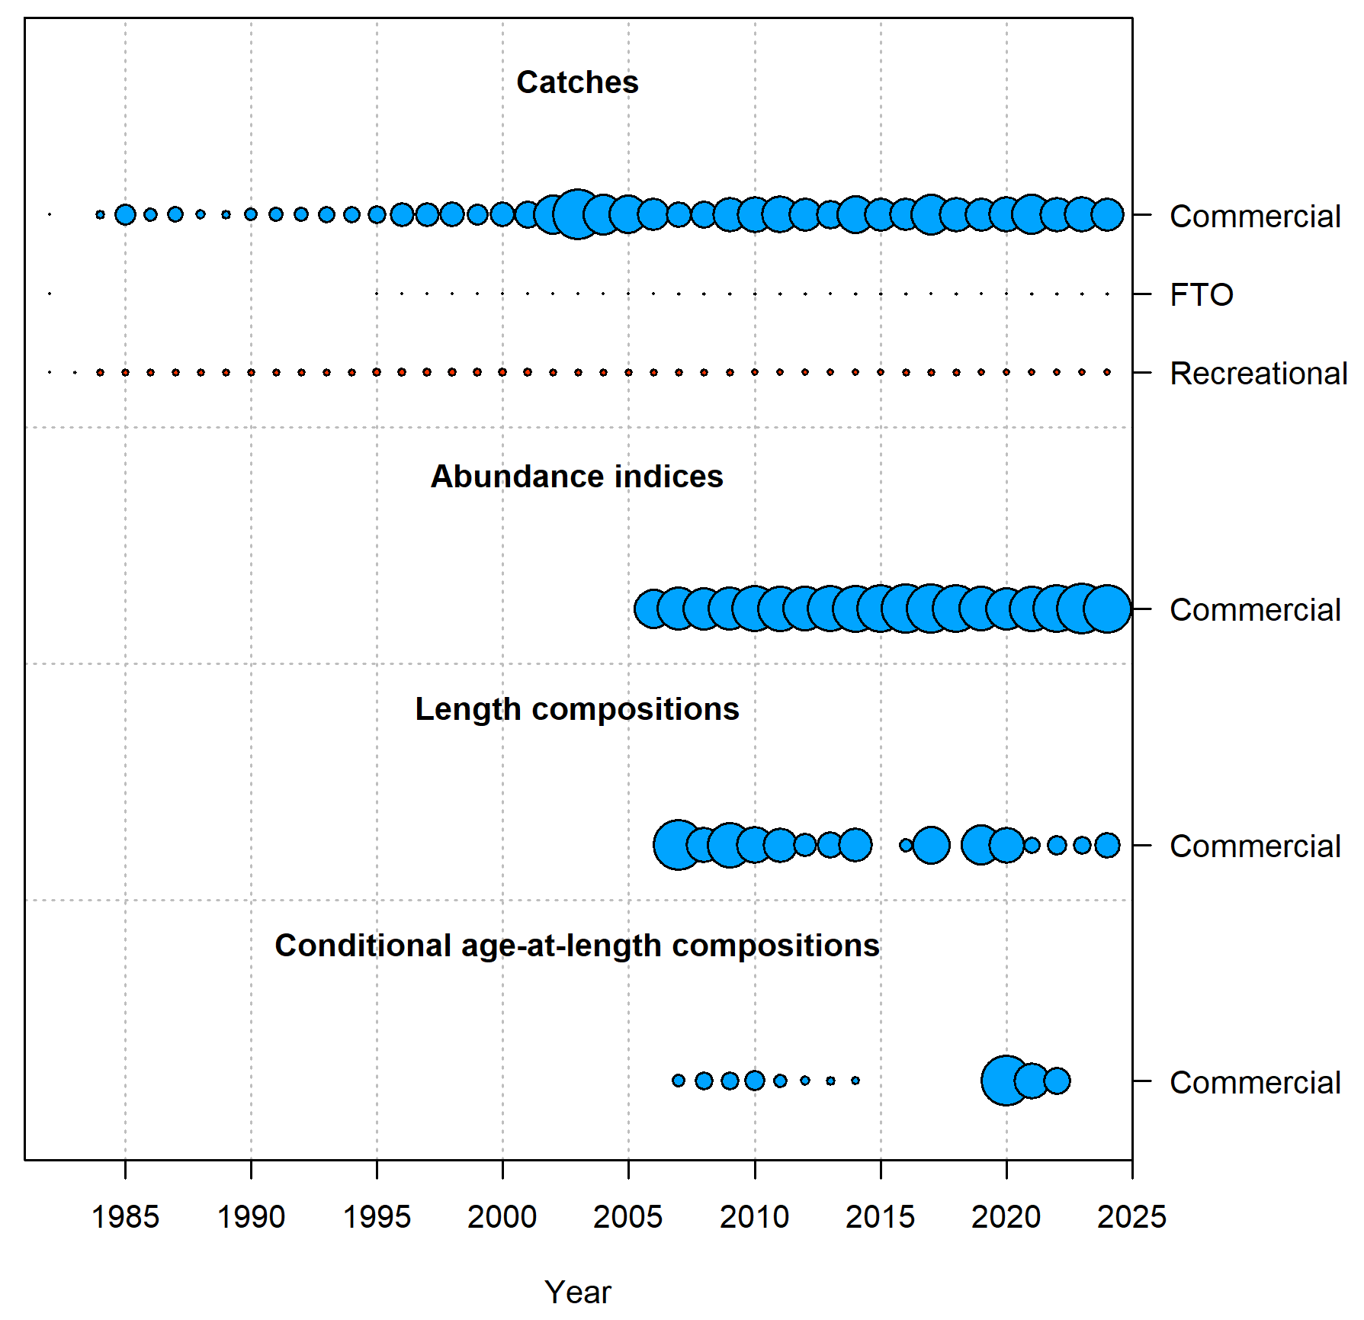
Figure 2. Summary of data sources used in the 2025 North West NT Grey Mackerel assessment. Circle area indicates the relative size of catches, magnitude of abundance indices or sample size of compositions.

Catch data
The commercial sector harvests the largest portion of Grey Mackerel in the Northern Territory, contributing 94.6% of the total catch, while FTO and recreational sectors harvest less than 0.2% and 5.2% respectively. The assessment utilises a catch history series from 1983 to 2024, with all landings aggregated by calendar year. Catch data was compiled from NT commercial logbooks (1983–2024), NT Fishing Tour Operator (FTO) logbooks (1995–2024), and recreational fishery survey reports (1983–2024 with interpolation). Grey Mackerel are typically only discarded by commercial fishers when they have been rendered unmarketable by shark depredation. Observer records indicate that only 1.1% of Grey Mackerel are discarded, however, total discards are difficult to appropriately quantify as it is uncertain how many fish are fully depredated before the net is hauled. Discards have been excluded from the current assessment for the commercial sector.
Total Grey Mackerel catches exhibit a general increasing trend from 1983 onwards, peaking in 2003, followed by a significant decline until 2007. The catch from 2008 to the most recent years has increased while displaying interannual fluctuations. Total annual catch over the last five years has average 374 t (Figure 3, Table 3).
The FTO sector reports catch and effort through a logbook system, with records available from 1983. Catch is reported as numbers of fish and converted to weight using a fixed average individual weight of 3 kg. This conversion factor was applied consistently across all years.
Regular recreational fishing surveys have been conducted since 2000 to estimate the catch and effort from the recreational sector. NT wide recreational survey reports are available for 2000, 2009-10 and 2018-19, and Greater Darwin Region based survey reports are available from 2014 to 2017 (Coleman, 1998; Errity et al., 2022; Matthews et al., 2022, 2019a, 2019b; L D West et al., 2012; West et al., 2022). To reconstruct annual recreational catch data missing for intervening years (1983–2024), estimates were obtained by multiplying per capita fish catch by the number of fishers. The number of fishers per year was estimated by multiplying the NT population by participation rates. Both participation rates and per capita catch estimates were sourced from NT recreational survey reports, with linear interpolation applied for missing years.
Notably, catches from the Taiwanese fleet have not been included in the current assessment. Previous assessments have included considerable catch from this fleet that operated in Northern Australia from the mid-1970s to mid-1980s (Stevens and Davenport 1991). In the 2011 assessment Taiwanese catch peaked at nearly 4000t. However, the total catch of all mackerel by Taiwanese vessels from 1980 to 1986 was estimated to range from 86.4 to 818 tonnes (Buckworth 2004). The large catches that were previously included in assessments likely represent a gross overestimate for this species. A reconstruction exercise is required before Taiwanese catches can be confidently included in the assessment. In addition to Grey Mackerel, the reported mackerel catch from Taiwanese vessels comprised multiple other species, including S. commerson, S. queenslandicus, S. munroi, S. multiradiatus, Acanthocybium solandri and Grammatorcynus spp (Buckworth 2004). Disentangling Grey Mackerel catch from the combined catch will be challenging. Apportioning the total mackerel catch from this fleet to species level at a geographical scale relevant to the current assessment requires further investigation before catches can be confidently incorporated into the model. However, the authors note this represents a source of uncertainty for the current assessment.

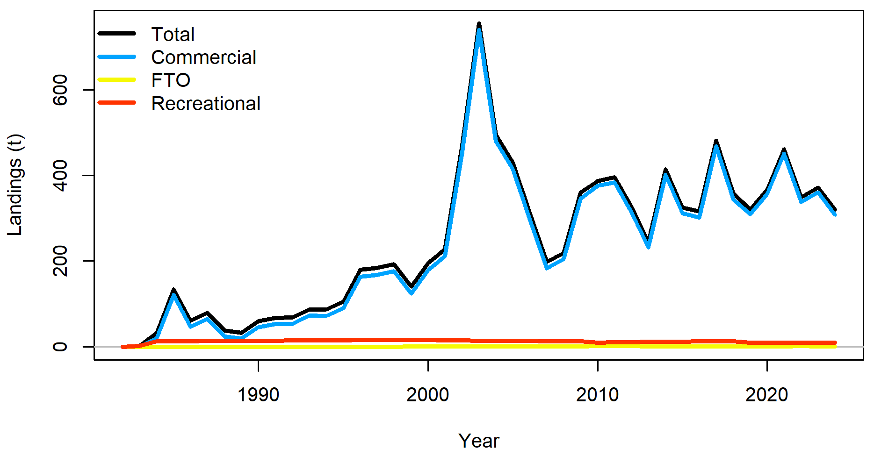
Figure 3. Annual estimated harvest (retained catch) from commercial, recreational and FTO sectors between 1983 and 2024.

Table 3. Annual total catches from 1983 to 2024 of Grey Mackerel. The base case catch series is presented in the “Total catch” column.
Year | Commercial catch (t) | Recreational catch (t) | FTO catch (t) | Total catch (t)
1983 | 0 | 1.9 |  | 1.9
1984 | 20.64 | 12.46 |  | 33.1
1985 | 121.24 | 13.06 |  | 134.3
1986 | 47.23 | 13.43 |  | 60.65
1987 | 65.67 | 13.64 |  | 79.31
1988 | 23.87 | 13.76 |  | 37.63
1989 | 18.98 | 13.9 |  | 32.88
1990 | 45.39 | 14.15 |  | 59.54
1991 | 53.22 | 14.32 |  | 67.5;5
1992 | 53.43 | 14.61 |  | 68.04
1993 | 72.47 | 14.88 |  | 87.35
1994 | 72.24 | 15.16 |  | 87.4
1995 | 89.84 | 15.68 | 0.32 | 105.83
1996 | 163.44 | 15.8 | 0.35 | 179.59
1997 | 167.36 | 15.87 | 0.39 | 183.62
1998 | 176.87 | 15.86 | 0.43 | 193.17
1999 | 124.17 | 15.86 | 0.48 | 140.51
2000 | 178.32 | 15.76 | 0.54 | 194.62
2001 | 211.74 | 15.62 | 0.6 | 227.95
2002 | 447.41 | 15.08 | 0.66 | 463.15
2003 | 739.18 | 14.56 | 0.74 | 754.48
2004 | 480.03 | 14.18 | 0.82 | 495.03
2005 | 415.59 | 13.89 | 0.91 | 430.38
2006 | 298.88 | 13.58 | 1.01 | 313.46
2007 | 183.41 | 13.37 | 1.12 | 197.9
2008 | 205.14 | 13.16 | 1.25 | 219.54
2009 | 345.56 | 12.87 | 1.38 | 359.82
2010 | 375.74 | 10.17 | 1.54 | 387.44
2011 | 383.7 | 10.55 | 1.71 | 395.96
2012 | 314.15 | 11.07 | 1.9 | 327.13
2013 | 232.14 | 11.51 | 0.95 | 244.6
2014 | 400.89 | 11.8 | 1.08 | 413.78
2015 | 311.39 | 12.14 | 1.19 | 324.72
2016 | 301.93 | 12.52 | 1.33 | 315.78
2017 | 467.23 | 12.83 | 0.84 | 480.9
2018 | 342.86 | 13.04 | 1.07 | 356.97
2019 | 309.32 | 9.78 | 1.05 | 320.15
2020 | 356.33 | 9.85 | 0.49 | 366.67
2021 | 450.35 | 9.96 | 1.16 | 461.48
2022 | 337.42 | 10.04 | 1.72 | 349.18
2023 | 360.56 | 10.14 | 1.28 | 371.98
2024 | 308.60 | 10.21 | 1.34 | 320.16

Abundance Index
Catch and effort data from commercial ONLF logbooks were used to obtain Catch Per Unit Effort (CPUE). CPUE was standardised using generalised linear models (GLMs) to remove temporal and spatial dependency to obtain indices of relative abundance over a period of time. Several models were developed and evaluated using a range of probability distributions, including normal, Poisson, negative binomial, zero-inflated models, Tweedie, and hurdle models. Model selection was based on the Akaike Information Criterion (AIC), dispersion tests, zero-inflation tests, and the distribution of residuals around the fitted models. A detailed description of the relative abundance standardisation methods and estimation of the coefficient of variation (CV) is provided in Appendix 9.2.
The ONLF catch and effort data was filtered to remove grid codes with less than 50 efforts and licences with less than 100 efforts throughout the entire time series. Abnormally high catch rates (>300kg/100m net hour) were removed as likely data recording errors. Table 4 and Figure 4 shows the standardised CPUE time-series and the coefficient of variance (CV) for the North West NT stock of Grey Mackerel.
Table 4. Standardised indices of abundance, and input CV values, for the North West NT stock of Grey Mackerel.
Year | $${CPUE}_{2006-24}$$ | $${CV}_{2006-24}$$
2006 | 0.744994 | 0.241231
2007 | 0.585905 | 0.177779
2008 | 0.528402 | 0.19058
2009 | 0.794699 | 0.167838
2010 | 1.026777 | 0.133847
2011 | 0.951743 | 0.141181
2012 | 0.794737 | 0.155906
2013 | 0.972517 | 0.132748
2014 | 1.20759 | 0.126372
2015 | 0.91319 | 0.111822
2016 | 1.582577 | 0.100221
2017 | 1.221712 | 0.095534
2018 | 1.233536 | 0.114583
2019 | 0.915024 | 0.149886
2020 | 0.58625 | 0.184319
2021 | 0.987724 | 0.145274
2022 | 1.161135 | 0.110926
2023 | 1.146295 | 0.082932
2024 | 1.645193 | 0.109939

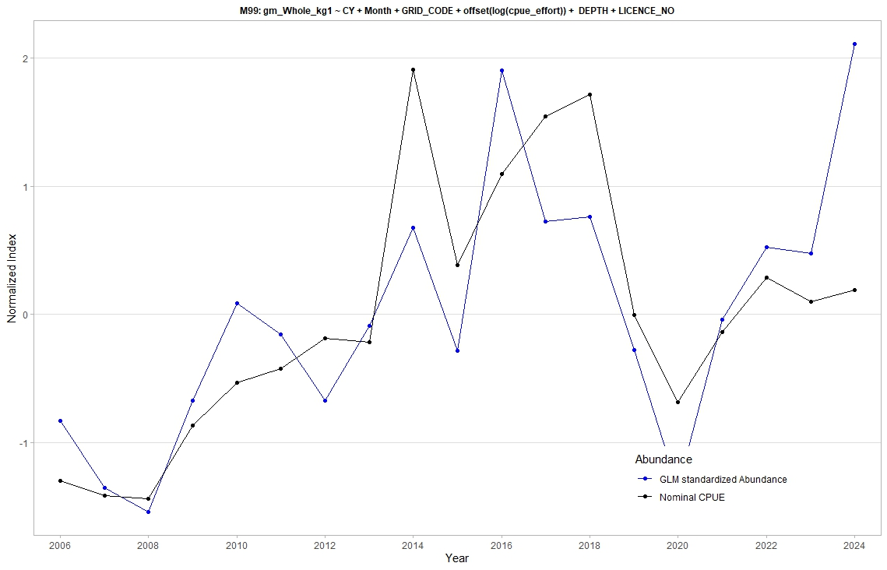
Figure 4. Nominal and standardised CPUE for North West Northern Territory stock of grey Mackerel (2006-2024).

Length and age compositions data
The ONLF observer program is utilised to collect length and age frequency data for Grey Mackerel. Typically, three trips are undertaken each year and observers measure fork length from Grey Mackerel to estimate the length from each shot. The observers also collect 120 otoliths per trip that provides conditional length at age information.

Length composition
Annual length and age data were incorporated into the model as marginal length compositions (samples with length data only) and conditional age-at-length compositions (samples with both length and age data), stratified by year and sex where available. Length composition data were available from 2005 to 2024 and were classified by sex. Samples recorded as indeterminate sex were not included in the assessment due to their small sample size by year, which limited their statistical reliability and contribution to model estimation. Some minor corrections were made to the grid code between the 2022 and 2024 length compositions; these records were excluded from the assessment, resulting in slightly different length composition data compared to the 2022 SRA assessment.
The annual length distributions for both sexes appear multimodal, suggesting the presence of multiple cohorts or size classes. Females exhibit a broader upper tail in the length distribution, indicating a higher proportion of larger individuals compared to males (Figure 5 and Figure 6). Variability in length distributions fluctuates across years, likely driven by recruitment dynamics, availability, or fishing pressure. Some years display higher kurtosis, suggesting periods with more homogeneous length distributions, while density variations may reflect differences in sample sizes or fishing effort (Figure 5 and Figure 6).

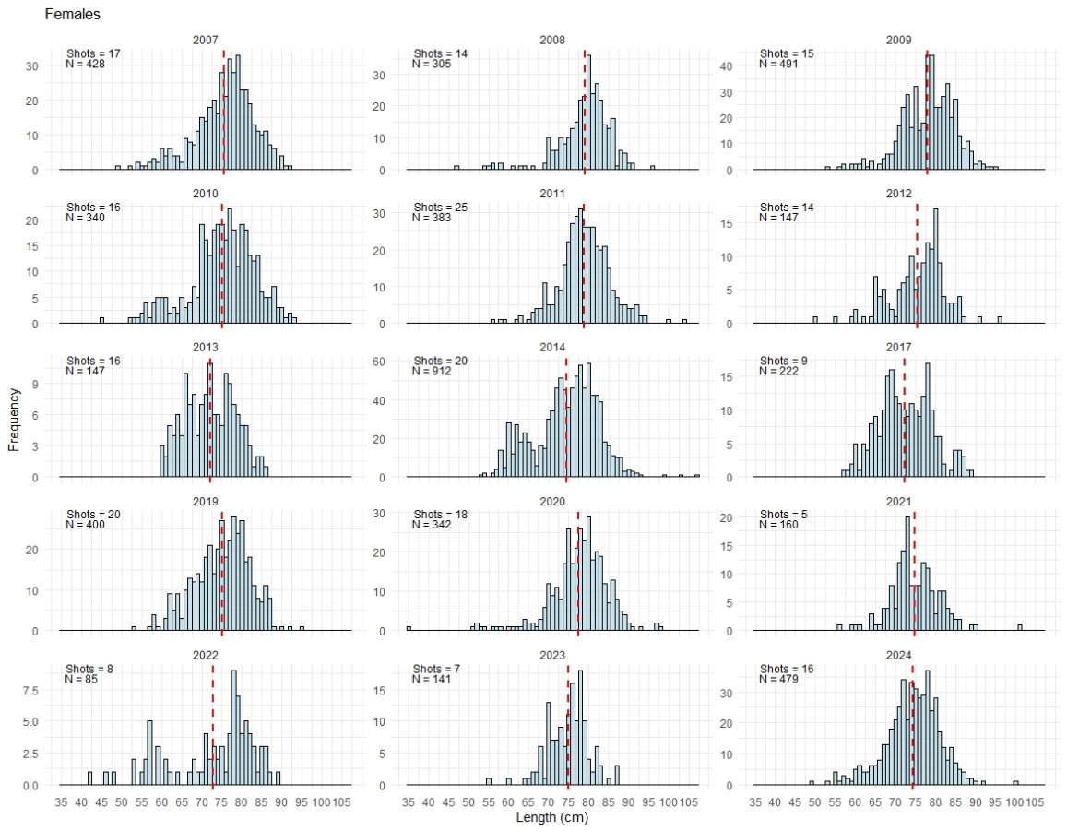
Figure 5. Female length composition data used for the 2025 Grey Mackerel assessment. N is the number of total samples.
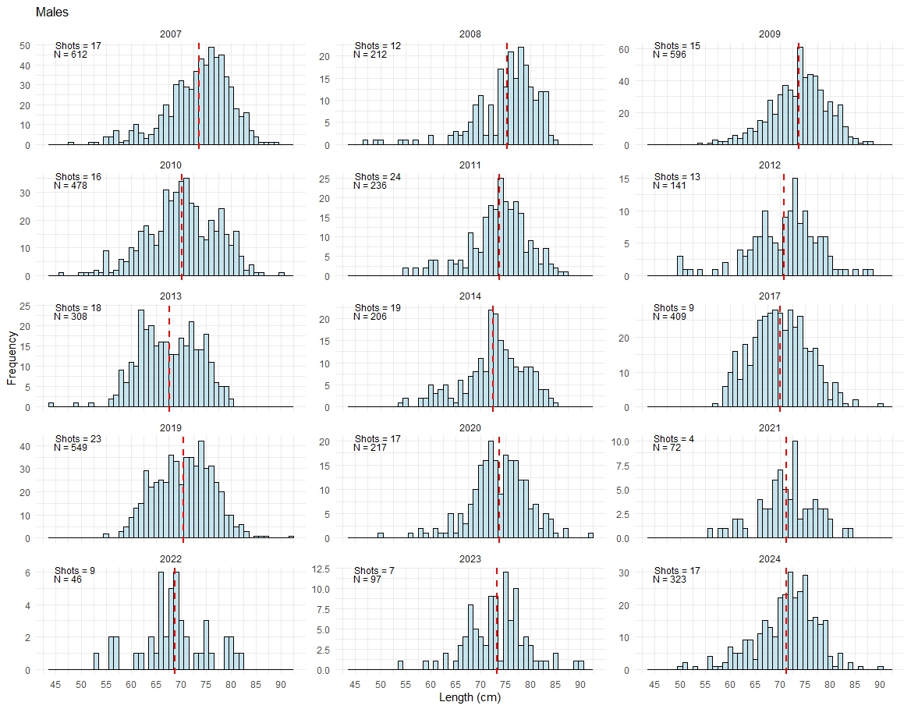
Figure 6. Male length composition data used for the 2025 Grey Mackerel assessment. N is the number of total samples.

Age compositions
The annual age data estimated from otoliths collected through the observer program are available from 2007 to 2022. The length-at-age composition of Grey Mackerel, stratified by sex, exhibits a multimodal distribution, indicative of multiple cohorts within the population (Figure 7). The age-length pairs are input as age frequency distribution by length bins (at 2 cm intervals) for each year and fishery from which the data were collected.
The length-at-age frequency distribution is right-skewed, with a higher density of individuals in the younger age groups, particularly between length bins of approximately 18 to 28 bin numbers (Figure 8). The modal peak occurs around 24–26 bin numbers for both sexes, with a decline in frequency as length increases. The data indicates at least 10 age classes in the Grey Mackerel population. Older age groups (represented by green to yellow hues) are less frequent, highlighting a natural attrition or lower selectivity for larger individuals. Females display a broader distribution with a more extended upper tail, suggesting they attain larger sizes compared to males. Males exhibit a slightly more compact distribution, potentially reflecting differences in growth or movement dynamics rather than gear selectivity patterns (Figure 8). The differences in frequency distributions between sexes may indicate differential growth rates or survival probabilities, further emphasising the importance of sex-specific analyses in stock assessments.

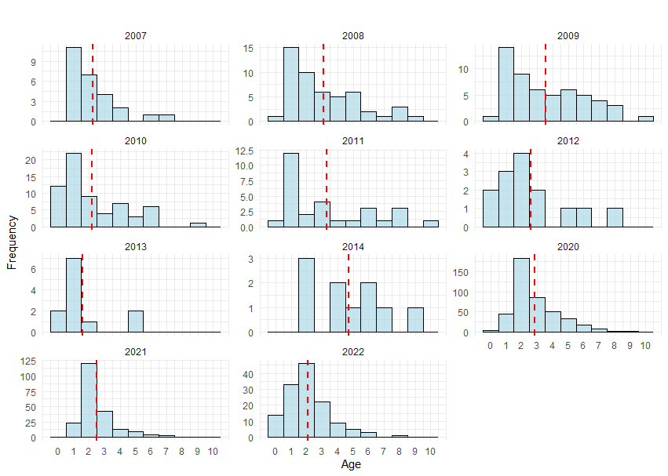
Figure 7. Frequency of age composition data used for the 2025 Grey Mackerel assessment.

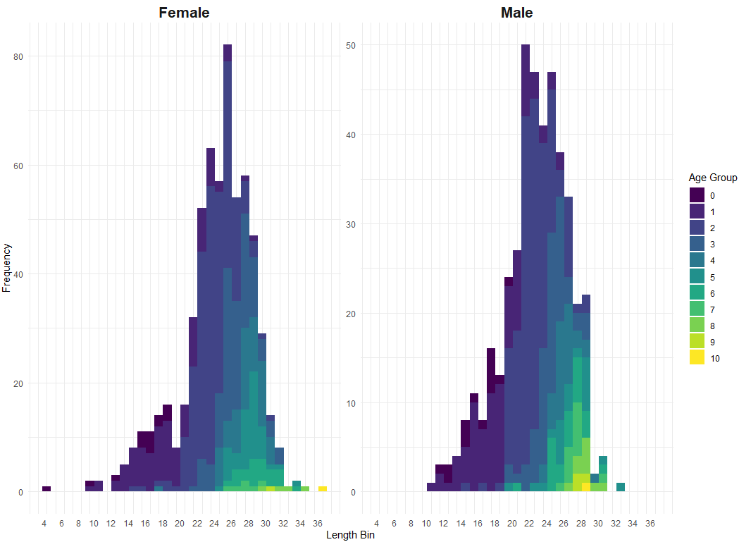
Figure 8. Length-at-age composition data used for the 2025 Grey Mackerel assessment.

Biology

Growth
The growth of Grey Mackerel is consistent across the North West NT and Gulf of Carpentaria stocks with males growing faster and attaining a smaller asymptotic length than females, which obtain a maximum size of 10 kg and 120 cm fork length (FL) (Cameron eta al., 2002). Male and female fish attain sexual maturity at 55-60 cm and 65-70 cm FL respectively, at approximately one to two years of age (Cameron et al., 2002).
To achieve a more plausible prior of Grey Mackerel in the North West NT stock, we implemented a Bayesian von Bertalanffy growth model in Stan (Stan Development Team 2020). The model was fitted using the No-U-Turn Sampler (NUTS), a variant of Hamiltonian Monte Carlo (HMC) that efficiently samples from complex posterior distributions. Growth parameters were estimated separately for males and females using the BayesGrowth package in R (Smart et al., 2021). This Bayesian approach allows for more robust and flexible parameter estimation, particularly in cases where fixing $L_{0}$ (length at birth/age 0) could introduce bias.
The general Bayesian von Bertalanffy growth model is:
$$L_{i,t}\sim Normal({\hat{\overline{L}}}_{i,t},σ)$$
Where,
$${\hat{L}}_{i,t}=L_{∞,i}(1-L_{0})e^{-ka}$$
Each growth parameter is assumed to follow a probability distribution across individuals or group (Smart et al., 2021).
$$L_{∞,i}\sim normal\left(μ_{L_{∞}},σ_{L_{∞}}\right)$$
$$k\sim uniform(μ_{k},σ_{k})$$
$$L_{0}\sim normal(μ_{L_{0}},σ_{L_{0}})$$
$$σ\sim uniform(0,5)$$
Where $L_{t}$ is the predicted mean length-at-age $t$ (years), $σ$ is the multiplicative error of length $t,$ $L_{∞}$ is the asymptotic fork length in cm, $k$ is the growth coefficient, $t$ is the estimated age in years and $i$ represents individual fish or group-level variation. Markov Chain Monte Carlo (MCMC) was used to sample the posterior distributions for each growth parameter. Four chains were used with a 1000 iteration warm up (burn in) and 5000 total post-warmup draws with a thin equal to 1. Posterior distribution means and 95% credible intervals (CI) were reported. Model validation was conducted by inspecting the posterior distributions for each parameter using trace plots, autocorrelation plots, effective samples size and Geweke and Heidelberger and Welch diagnostic tests. These checks ensure that the Markov Chain Monte Carlo (MCMC) simulations have converged and that the estimates are reliable (McElreath 2018). These estimated parameters will be used as initial parameters in the 2025 stock assessment.

Length-weight Relationship
The length-weight relationship of Grey Mackerel was estimated by sex by fitting an exponential curve, $W=a*L^{b}$, to the data (Ricker, 1973, 1975) where W is the total weight (kg), L is the total length (cm), a is the intercept, and b is the allometric coefficient that describes the rate at which weight increases with length.
Parameters a and b of the exponential curve were estimated by linear regression analysis over log-transformed data:
$$\log\left(W\right)=\log\left(a\right)+b*log⁡(b)$$

Spawning
Grey Mackerel are highly fecund, producing approximately 250,000 eggs per spawning, and exhibit a peak spawning period between September and January (Smith et al., 2024).

Coefficient of variation of length
The coefficient of variation (CV) for length used in the SRA assessment (for bridging) was calculated using the entire dataset to maintain consistency with prior Grey Mackerel SRA assessments (Figure 39). For the transition from the SRA to SS3, the CVs were estimated separately by sex and age group (young and old). The CV for young females and males was constrained by the first mature size (65 cm for females and 79 cm for males by Cameron et al., 2002), while the CV for older females and males was bounded by the length at which the fish reaches full maturity and exhibits stable growth (85 cm for both sexes, Table 20). These estimated parameters will be used as initial parameters in the 2025 integrated stock assessment.

Recruitment deviations
In fisheries stock assessments, recruitment deviations are estimated to capture annual variation in recruitment levels that deviate from the expected average pattern. The number of years to estimate recruitment deviations are based on both the quantity and quality of available data that can inform these parameters.
For the base case model, we ensured the recruitment deviations are supported by the data and exhibit a level of variance comparable to that of historical levels. This is illustrated in Figure 9, where the inclusion of recruitment deviations up to 2021 and 2022 resulted in values that are comparable to historical estimates. However, extending the estimation to include 2023 and 2024 led to a significant increase in variance, suggesting reduced precision and potential over-parameterisation. The high variance associated with the 2023 and 2024 recruitment deviations indicates insufficient data to support reliable estimation for these years. As a result, recruitment deviations in the base case model have been limited to the 1983 to 2021 period.
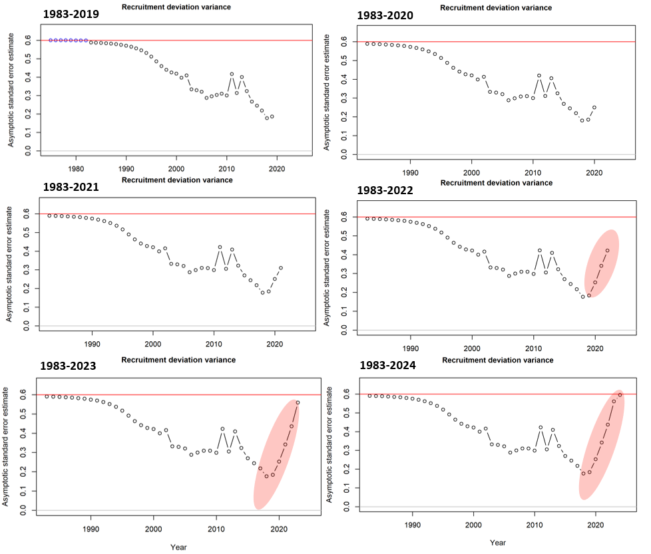
Figure 9. Estimated variance of recruitment deviation in the model considered. The base case model used recruitment deviation estimates from 1983 until 2021.

Stock assessment models
Stock Synthesis (SS3)
The stock assessment of North West NT Grey Mackerel stock applies a conditional age-at-length and size-structured model using the Stock Synthesis (SS3) platform. SS3 is an integrated, generalised stock assessment tool that fits a population model to diverse fishery-dependent and -independent data sources, enabling the estimation of stock abundance by age and year (Methot et al., 2022). It comprises three main components: a population sub-model that simulates biological processes such as growth, maturity, fecundity, recruitment, movement, and mortality; an observation sub-model that predicts expected values for input data; and a statistical sub-model that quantifies model fit and estimates key parameters with uncertainty. SS3 can incorporate multiple fleets or sectors to account for spatial and operational differences in selectivity or vulnerability and estimate selectivity patterns from size composition data (see Table 7). This modelling approach is particularly suitable for Grey Mackerel, whose population dynamics require integration of complex biological and fishery processes. The model is implemented using the generalised stock assessment software package, Stock Synthesis (SS) (Version 3.30.19.01, Methot et al., 2022). Details of the model’s population dynamics and statistical framework, including likelihood functions used to fit the model to data types such as catch, CPUE, length frequencies, and conditional age-at-length compositions, are provided in the Stock Synthesis technical documentation (Methot, 2005; Methot et al., 2022).

Model Structure
The base case assumes the Grey Mackerel population is a single stock with sex-specific population dynamics that is subject to exploitation by three fleets. This assessment adopts a single-region, coast-wide structure, with three aggregated fleets represented separately through sex-specific sub-models.
A variety of parameters were included in the model, with some of these fixed at specified values and other estimated within the assessment framework. Model parameters are estimated by fitting the population dynamics model to a range of data sources, including total catches, catch-per-unit-effort (CPUE) indices, retained catch length frequencies, and conditional age-at-length compositions. Descriptions of the base-case model parameters—indicating whether each was fixed or estimated—are summarised in Table 5, along with information on the statistical likelihoods used for data fitting in the assessment.
The model defines a plus group at age 14, capturing all individuals aged 14 and older. Growth is modelled using a von Bertalanffy length-at-age function, with separate growth curves estimated for males and females (Section 4.2.1). Grey Mackerel become sexually mature at approximately 2 years of age for female and 1-2 years for male (Lyle et al., 2014). Maturity is modelled as a logistic function, with 50% maturity at 2 years fixed for both sexes. Fecundity-at-length is assumed to be proportional to weight-at-length.
Recruitment is modelled using a stochastic Beverton-Holt stock–recruitment relationship, parameterised in terms of steepness (ℎ), unfished average recruitment (𝑅₀), and recruitment variability (𝜎𝑅). Steepness is fixed at 0.75 and recruitment variability (𝜎ᵣ), which constrains the extent of recruitment deviations, is fixed at 0.6. This value is consistent with observed recruitment variation in the time series of estimates and is also consistent with other assessments of this species in Australia (Bessell-Browne., 2019).
Instantaneous rate of natural mortality, 𝑀, is fixed within the assessment with a lognormal prior having a median of 0.45 and a standard deviation (in log-space) of 0.1. Natural mortality is assumed to be time-invariant, constant across ages, and identical for both sexes. Other plausible biological values of $M$ and other parameters are explored through sensitivity testing (Section 6.3).
Length compositions were weighted using the number of shots observed. Sample sizes were then reweighted using the Francis method (Francis, 2011) for length-composition data and the Punt (2017) method for conditional age-at-length data. Samples with fewer than 100 fish measured per year were excluded.
The coefficients of variation (CVs) associated with CPUE indices were initially derived from the standard errors of a loess fit (Appendix 9.2.3), then re-tuned based on SS-derived standard errors to better reflect observation uncertainty.
Table 5. Life history and population parameters for the stock assessment of North West NT Grey Mackerel stock. Parameters are estimated or pre-specified to ensure their outcomes are comparable to scenarios explored in the bridging analysis.
Acronym | Description | Parameters value | Estimated or Pre-specified
$$Ln⁡(R_{0})$$ | Log unfished recruitment | Exponent of 7.29 | Estimated, initial value with no prior
H | Steepness of the Beverton-Holt stock-recruit curve | 0.75 | Pre-specified
M | Natural Mortality for both sexes | 0.34, 0.40 and 0.45 | Pre-specified
$L_{∞}$ | Asymptotic length | Female: 81.44  Male: 76.27 | Calculated externally and used as prior within the model
K | Von Bertalanffy Growth Parameter | Female: 1.04  Male: 1.28 | Calculated externally and used as prior within the model
t₀ | Length at age 0 | Female: 0.41  Male: 0.36 | Pre-specified
CV_{young} | Coefficient of variation in length of young individuals (juveniles) | 0.15 | Calculated externally and used as prior within the model
CV_{old} | Coefficient of variation in length of old individuals (adults) | 0.08 | Calculated externally and used as prior within the model
$$σ_{R}$$ | Recruitment variability | 0.6 | Estimated with SS3 options and bias ramp adjustment
W-L a | Intercept for length-weight relationship | Female: 0.00005  Male: 0.00005 | Calculated externally and used as prior within the model
W-L b | Coefficient for length-weight relationship | Female: 2.61892  Male: 2.58962 | Calculated externally and used as prior within the model
Recruitment |  | 1983-2021 | Estimated
DblS | Double normal selectivity |  | Estimated

Tuning method
Model tuning is an iterative reweighting of input and output CVs or input and effective sample sizes for ensuring that the expected variation of the different data streams is comparable to what is provided as input (Pacific Fishery Management Council, 2019). Tuning was applied to the CVs in standardised CPUE and sample sizes of age/length composition data. This is done by:
- CVs for CPUE: the error for relative abundance indices were set to the estimated standard errors to the standard deviation of a loess curve fitted to the GLM standardised CPUE.
- Recruitment bias ramp adjustment: The magnitude of bias-correction depends on the precision of the estimate of recruitment. Time-dependent bias-correction factors were estimated following the approach of (Methot and Taylor, 2011).
An automated iterative tuning procedure was used for the remaining adjustment. For the marginal age and length composition data:
- Multiply the stage 1 (initial) sample size of marginal age/length composition data: Sample sizes were iteratively adjusted using a multiplier until the effective sample sizes in the model are similar after Stage 2 tuning (Punt, 2017).
- Stage 2 tuning for model data weighting: Francis adjustment (Francis 2011) was applied via SS-DL to adjust relative weighting across CPUE, age and length composition data.
- Repeat steps, until all are converged and stable (proposed changes <1%).
The Stock Synthesis model was tuned to ensure that the final model is biologically sensible, fits appropriately with the abundance index data with additional diagnostic checks for its convergence, goodness of fit, model consistency and prediction skill (Carvalho et al., 2021).

SS3 Diagnostics

Likelihood profiles
Likelihood profiles are a widely used diagnostic tool in stock assessments and applied statistics, primarily employed to evaluate the plausibility of fixed parameter values and to derive approximate 95% confidence intervals for both biological parameters and key management quantities (Punt, 2018). In integrated stock assessments, such as those implemented in Stock Synthesis (SS), parameters including the log of unfished recruitment ($R_{0}$), the steepness of the stock–recruitment relationship (h), and the instantaneous rate of natural mortality (M) are often fixed based on biological rationale or prior empirical studies. Likelihood profiling provides a formal method to test whether the data support values pre-specified for these parameters by sequentially fixing the parameter of interest across a range of plausible values, re-estimating all other model parameters, and calculating the corresponding change in the overall negative log-likelihood (NLL). If the fixed value lies within the interval where the NLL increases by less than 1.92 (for one degree of freedom), the data is considered consistent with the assumed value; otherwise, the exclusion of the value from this confidence interval suggests that the model may be mis-specified, prompting a re-evaluation of the justification for fixing the parameter. This method can also be extended to explore the sensitivity of key derived quantities—such as current spawning biomass (${SSB}_{curr})$, virgin biomass (${SSB}_{0}$) and relative depletion (${SSB}_{curr}/{SSB}_{0}$).
In the current assessment, likelihood profiles were applied using the r4ss R package (Taylor et al., 2021). Base case models were systematically run across a range of fixed values for parameters and quantities of interest, and summary results were visualised using built-in diagnostic tools. This approach also allowed for the identification of potential conflicts among data sources such as inconsistencies between CPUE indices and composition data, which may reflect underlying issues such as sampling error or model misspecification. Consequently, likelihood profiling is not only used for evaluating pre-specified parameters values, but also as a robust diagnostic for improving model fit and informing scientifically defensible management advice.

Retrospective analysis
A retrospective analysis (Cadrin and Vaughan, 1997; Mohn, 1999) has been undertaken to identify whether assessment outcomes may change as data is removed from terminal years retrospectively while using the same assumptions and tuning process.
The retrospective analysis was undertaken using the following procedure:
- One year of data was removed sequentially from the terminal year of model.
- Time dependent model parameters were changed to be one year earlier (e.g. the last year of estimated recruitment).
- The model was run to assess stock status estimates using data up to one year earlier.
- Steps 1–3 were repeated five time (i.e. removing five years of data).
Trends in spawning biomass, stock status, fishing mortality and estimated recruitment are then examined to understand how reliable the assessment is at estimating the stock status in recent years. The severity of retrospective patterns can be quantified using Mohn’s rho, which is defined as the average of the relative differences between an estimate from an assessment with a truncated time series and an estimate of the same quantity from an assessment using the full time series (Hurtado-Ferro et al., 2015). Mohn’s rho values are calculated for a range of quantities, including SSB, recruitment, F and stock status. As a general rule of thumb, Mohn’s rho values greater than 0.20 or less than −0.15 indicate an undesirable retrospective pattern or potential concern in the assessment (Hurtado-Ferro et al., 2015).

Goodness-of fit
Three methods are used to evaluate the goodness of fit of the base case model. The first method plots residuals to observe trends, patterns, and variation in fits to the data over time using the R package ‘ss3diags’ (Carvalho et al. 2017). The residuals could fall below or above the median of the fitted model and systematic drifts in the residual’s mean through time would indicate the presence of temporal auto-correlation which may cause bias in the model fits.
The second common goodness-of-fit statistic used as a diagnostic is the root mean square error (RMSE; Carvalho et al., 2017) which describes the standard deviation of residuals, such that:
$$RMSE=\sqrt{\frac{\sum_{t}{{({\hat{y}}_{t}-y_{t})}^{2}}}{n}}$$
where ${\hat{y}}_{t}$ is the predicted value at time step t, $y_{t}$ is the observed value, and $n$ is the number of observations. A relatively small RMSE (≤0.3) indicates a reasonably precise model fit to relative abundance indices (Winker et al., 2018).
The third method is the Wald-Wolfowitz runs test (Wald-Wolfowitz 1940), hereafter termed the “runs test”. The runs test is a non-parametric test that evaluates the null hypothesis that the elements of a sequence are not independent from each other. We specify a threshold of α=0.05 when applying the runs test to the base case model residuals. To assist in interpretation, green shading on the figure presenting the time series of residuals indicates the runs test has passed (residuals are randomly distributed, p≥0.05), while red indicates it has failed (p<0.05).

Jitter analysis
Jitter analysis is a diagnostic technique used to assess the optimality, robustness, and stability of the maximum likelihood estimates derived from a given model. This procedure entails the random perturbation of the initial values assigned to all estimated parameters, followed by re-running the model to investigate whether alternative solutions can be identified by the optimisation algorithm when initiated from different starting points. This process is commonly referred to as an assessment of the model's sensitivity to initial conditions.
Two key diagnostics are evaluated through jitter analysis: first, the possibility that an improved solution—characterised by a higher likelihood value—may exist; and second, the consistency with which the algorithm identifies the optimal solution across multiple runs. Since all estimated parameters are simultaneously perturbed (or "jittered"), there exists a potential risk that the model may either fail to converge or become trapped in a local maximum within a suboptimal region of the multidimensional parameter space.
A jitter analysis was undertaken consisting of 25 replicates, each involving a 10% modification to the initial parameter values. This allowed for a systematic evaluation of model sensitivity and convergence reliability under varied initial conditions.

Criteria for determining the stock status in SS3

Reference Points
The state of a fish stock is classified based on two indicators:
1) Spawning Stock Biomass (SSB) of the fish stock relative to unfished spawning stock biomass levels
2) Fishing Mortality (F) relative to F at the Maximum Sustainable Yields (F_{MSY}).
Reference points are set from these indicators such that a ‘sustainable’ stock would have $SSB$ that is not recruitment overfished, and F is not high enough to drive the stock in the direction of recruitment overfishing. The reference points used for the current assessment are:
1) ${SSB}_{20}$ – refers to the spawning stock biomass at 20% of the unfished Spawning Stock Biomass (${SSB}_{0}$). A biomass below this reference point may indicate that recruitment is impaired (recruitment overfished). ${SSB}_{20}$ is widely used as the default for the ‘Limit Reference Point’ in fisheries assessments (Haddon et al., 2012; Klaer et al., 2012).
2) $F_{MSY}$ – Fishing mortality at Maximum Sustainable Yield is assumed to be the point beyond which fishing pressure is not sustainable and would drive the stock in the direction towards ‘recruitment overfishing’ or depletion.

Recommend biological Catch (RBC)
The Recommended Biological Catch (RBC) for the stock was estimated using forward projections. These projections implemented the Northern Territory’s formally adopted harvest strategy benchmark, which is defined by the 20:30:48 biomass reference points, as outlined in the ONLF management arrangements. This harvest control rule applies a linear “hockey stick” rule that scales the target fishing mortality rate ($F_{targ}$) according to the estimated spawning stock biomass ($SSB$), expressed as a fraction of the unfished spawning biomass (${SSB}_{0}$, Figure 10).
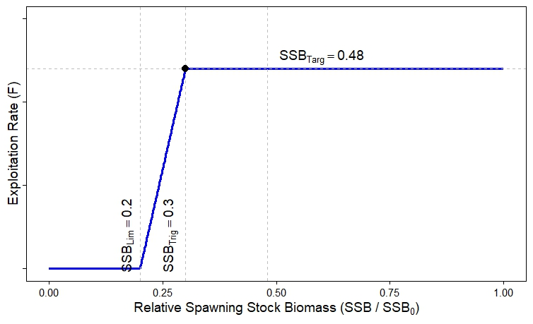
Figure 10. The 20-30-48 rule. ${SSB}_{Lim}=$ 20% of unfished spawning stock biomass, $F_{targ}=$ the fishing mortality rate at which spawning stock biomass is reduced to 48% of the unfished level and ${SSB}_{trig}=$30% of unfished spawning stock biomass.

Sensitivity scenarios
A Sensitivity analyses is conducted to examine the influence of data inputs and structural uncertainty in the SS3 model by evaluating how changes to the model affect estimated parameters and derived quantities. Several key structural assumptions were identified that have been consistently applied across other Australian jurisdictions for Grey Mackerel. These include:
- Consideration of an alternative fixed values for natural mortality ($M$ = 0.3, 0.35, 0.4, 0.5 and 0.65 yr⁻¹).
- Consideration of an alternative fixed value for steepness, to change the resiliency of the stock ($h$ =0.6, 0.65 and 0.7).
- Consideration of higher and lower variation about the stock-recruitment relationship ($σ_{R}$ = 0.4, 0.6 and 0.65).
- Doubling and downweighting the length composition data to evaluate its influence on model outputs.
- Doubling and downweighting the age-at-length data to assess its impact on model outputs.
- Doubling and downweighting on the CPUE index.
Model responses to the sensitivity scenarios are summarised using the following quantities:
- SSB₀: the average unexploited female spawning biomass.
- SSB₂₀₂₄: the female spawning biomass at the start of 2024.
- SSB₂₀₂₄/SSB₀: the stock status at the start of 2024.

Stock Reduction Analysis (SRA)
The current assessment represents a transition from Stochastic Stock Reduction Analysis (SRA) to Stock Synthesis (SS3). Several SRA models, including a model that included data to 2024, were developed to examine the impact of transitioning to the SS3 framework.
SRA is a population dynamics model consisting of life history parameters that describe the underlying production and carrying capacity of a population over time (Walters et al., 2006). SRA has three main assumptions: 1) the population is at virgin conditions the first-year data is provided, 2) there is stochastic variation in recruitment for all years, and 3) survival rate is constant for all years.
Inputs include long term catch history and a time series index of abundance with the option of including age/length composition data (Lombardi and Walters, 2011). Stochastic SRA uses MSY (Maximum Sustainable Yield) and U_{MSY} (exploitation required to achieve MSY) as leading parameters for the assessment.
The model simulates changes in biomass by subtracting estimates of mortality and adding new recruits, where the new recruits are a function of the current stock size and the leading parameters. Stochastic SRA provides probability distributions of population parameters over time, given alternative hypotheses about unfished recruitment rates and variability around the assumed stock-recruitment relationships. These distributions are generated by conducting a very large number of simulation trials and retaining those sample trials for which the stock would not have been driven to extinction by historical catches. A detailed description of Stochastic SRA can be found in Walters et al. (2006) and a summary in Grubert et al. (2013).

SRA model structure assumptions
The SRA uses pre-specified growth parameters to determine population dynamics. Population parameters are not sex-specific, meaning that growth, maturity, and mortality rates are applied uniformly across the population regardless of sex.
Growth is assumed to follow a von Bertalanffy growth function where the growth coefficient is fixed at$K=1.48$, along with the asymptotic length $(L_{∞}=79cm)$. Maturity and weight-at-age relationships are explicitly pre-defined, allowing for stock-recruitment interactions to be accounted. Length at maturity is pre-specified at $L_{mat}=63 cm$ and weight-at-length relationships parameters are also pre-specified, with a reference weight of 8.23 kg at 100 cm. The coefficient of variation in length-at-age is assumed at 0.09. Age at maturity for spawning stock biomass is assumed to be 2 years, while growth at age zero is set to 0. Natural mortality rate is not treated as age-independent and is determined from survival rates $(S=e^{-M})$, with uniform priors ranging from $S_{min}=0.65$ to $S_{max}=0.75$.
Stochastic recruitment follows a lognormal distribution with process error pre-fixed at ${SD}_{R}=0.4$ and no assumed autocorrelation ($ρ=0$). Each of these parameters is reported with a level of uncertainty determined through Markov Chain Monte Carlos (MCMC). MCMC simulations were run for 1 million cycles, the first 1000 samples were omitted from the chain, which resulted in 999,000 posterior samples.
The model initialises with an estimated biomass ($B_{2024})$ and exploitation rate ($U_{2024})$ for 2024, incorporating stochastic recruitment deviations modelled as lognormal random variables with process error in terms of their standard deviation ${(σ}_{R})$. Fishing mortality is simulated within the bounds of the prior distribution on $U_{MSY}$​, that ensure sustainable exploitation levels. The 2024 SRA model also incorporates parameter uncertainty by sampling from predefined distributions for key management quantities such as maximum sustainable yield (MSY). The SRA framework provides a probabilistic assessment of stock status with precautionary management principles.

SRA to SS Bridge scenarios
The transition from Stock Reduction Analysis (SRA) to a fully integrated Stock Synthesis (SS3) model for the North West NT Grey Mackerel stock involves multiple exploratory bridge steps. These steps are to update the 2022 SRA model with additional data up to 2024, alternative time series for CPUE to consider the change in catchability due to targeting Grey Mackerels, re-estimating growth parameters, and recruitment variability assumptions. Seven scenarios were considered as part of the bridging analysis to transition the SRA model to SS3 (Table 6).
Table 6. Summary of SRA to SS Bridge scenarios.
Scenario | Description | Data | CPUE | Standard deviation Log(Rec)
S1 | 2022 SRA, using 2022 growth parameters. | 1983-2021 | 2000-2021 | $$σ_{R}=0.4$$
S2 | 2025 SRA, using 2022 growth parameters. | 1983-2024 | 2000-2024 | $$σ_{R}=0.4$$
S3 | 2025 SRA, using 2022 growth parameters. | 1983-2024 | 2006-2024 | $$σ_{R}=0.4$$
S4 | 2025 SRA, using updated growth parameters | 1983-2024 | 2000-2024 | $$σ_{R}=0.4$$
S5 | 2025 SRA, using updated growth parameters | 1983-2024 | 2006-2024 | $$σ_{R}=0.4$$
S6 | 2025 SRA, using updated growth parameters | 1983-2024 | 2000-2024 | $$σ_{R}=0.6$$
S7 | 2025 SRA, using updated growth parameters | 1983-2024 | 2006-2024 | $$σ_{R}=0.6$$

SRA Stock Status
For the Stochastic Stock Reduction Analysis (SRA), the status of a fish stock is assessed using two key indicators derived from the posterior distributions generated via Markov Chain Monte Carlo (MCMC) sampling:
- Relative Biomass: The ratio of egg production in the terminal year (e.g., 2024) to the unfished equilibrium egg production. This metric serves as a proxy for spawning stock biomass relative to its unfished level and is used to assess the degree of stock depletion (Walter et al., 2016).
- Relative Fishing Mortality (Fₜ/Fₘₛᵧ): The ratio of estimated fishing mortality in the terminal year to the fishing mortality associated with maximum sustainable yield (Fₘₛᵧ). This indicates the sustainability of current fishing pressure.
Reference points to determine status from the SRA are ${SSB}_{20}$ and $F_{MSY}$, which is consistent with the reference points for determining status from the SS3 model (Section 4.3.4). These reference points are displayed in a phase plot to assign the appropriate stock status category (Figure 11).
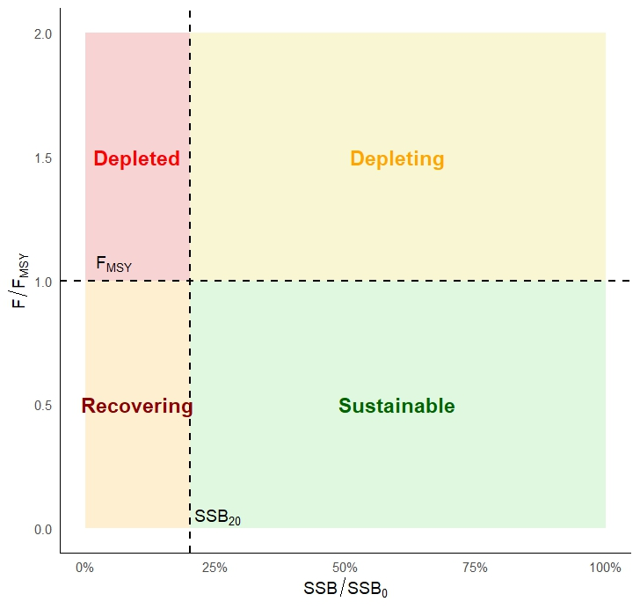
Figure 11. Phase plot showing the criteria used for determining stock status (Piddocke et al., 2021). Where $F_{curr}/F_{MSY}$ is the relative fishing mortality and ${SSB}_{curr}/{SSB}_{0}$ is the relative spawning biomass.

Model outcomes

SS3 Assessment outcomes
The spawning stock biomass is estimated at 61% of unfished levels in 2024, with 95% asymptotic confidence intervals ranging from 48% to 74% (Figure 12). The spawning stock exhibited a gradual decline from the beginning of the fishery in 1983 until around 2000, followed by a sharper decline between 2003 and 2010 due to the increase in annual catch (over 754 t) between 2003 and 2004. From 2011 onwards, the spawning biomass has shown a moderate recovery, fluctuating between approximately 43% and 61% of ${SSB}_{0}$, indicating some resilience in the stock under reduced exploitation pressure.

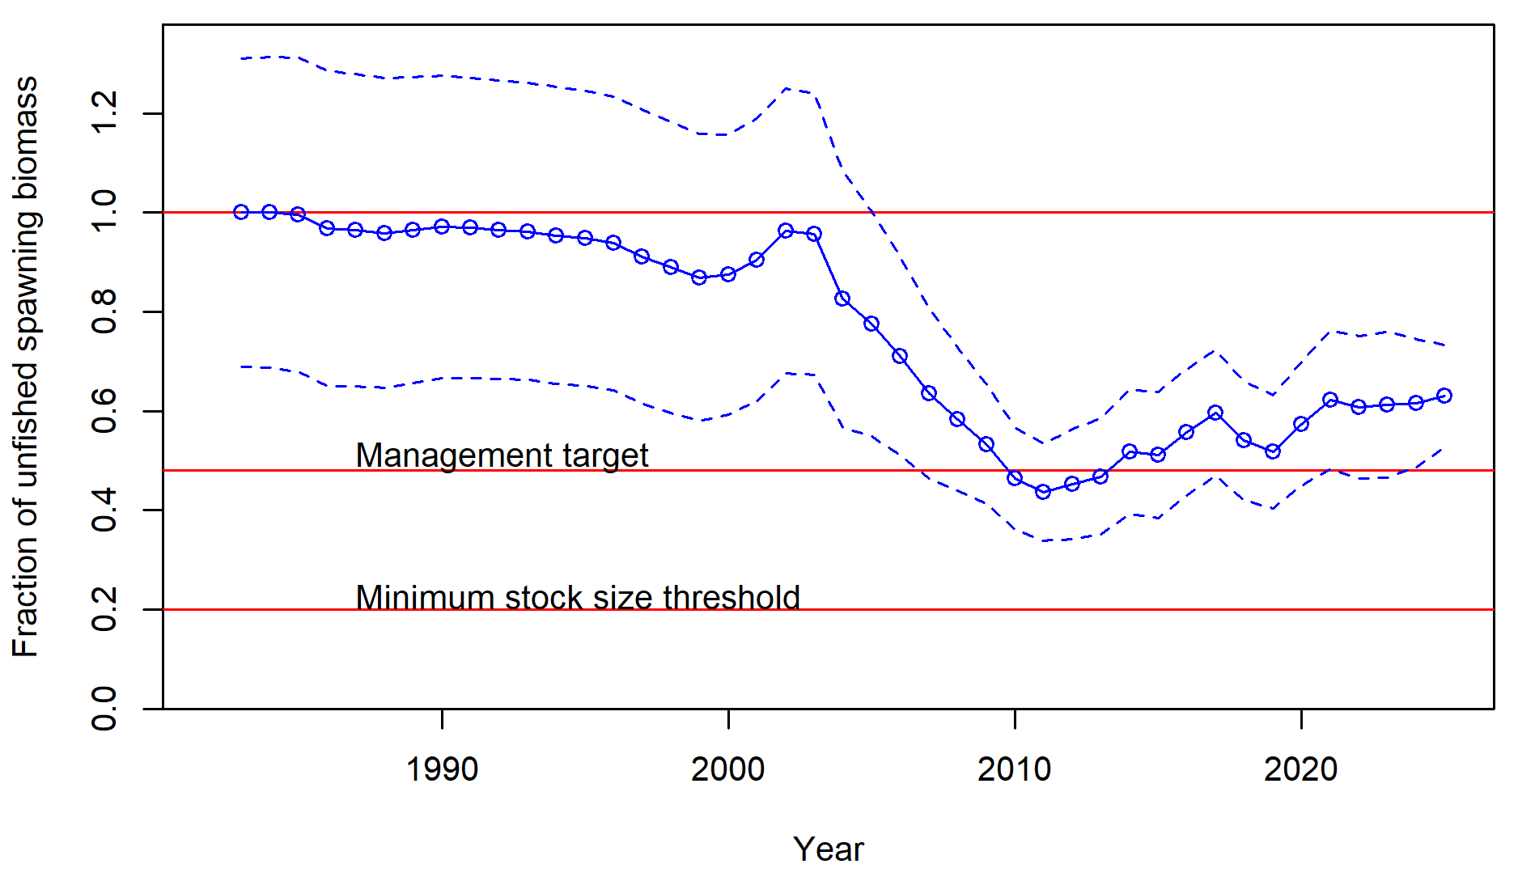
Figure 12. Time-trajectory of the estimated spawning stock biomass (median with approximate 95% asymptotic intervals).

Parameter estimates
The average maximum length L∞, was estimated to be 92.67 cm (95% CIs 81–99 cm) for females and 88.77 cm (95% CIs 77–101 cm; Figure 13 and Table 7) for males. The length at a_{min} (one-year olds) for females was estimated at 36.44 cm and 45.14 cm for males (Figure 13). The growth rate, $κ$ , of the von Bertalanffy growth equation is estimated to be 0.41 for females and 0.31 for males (Table 7).
Selectivity is assumed to be a length based double normal function for the gill based ONLF (commercial) and a logistic function for all FTO and recreational fleets (Figure 14). The parameters that define the selectivity function are the length at 50% selection and the spread (the difference between length at 50% and 95% selection). Selectivity estimates suggest the commercial fleet has the capacity to catch fish between 78.51 cm and 95 cm, with fish smaller than 60cm rarely selected.
The parameter estimates for the selectivity functions are provided in Table 8. Retention for the FTO and recreational fleets was pre-specified as no length frequency composition data are available.
The estimated parameter that defines the initial number (and biomass), ln ($R_{0}$), is 6.56 for the base case scenario.
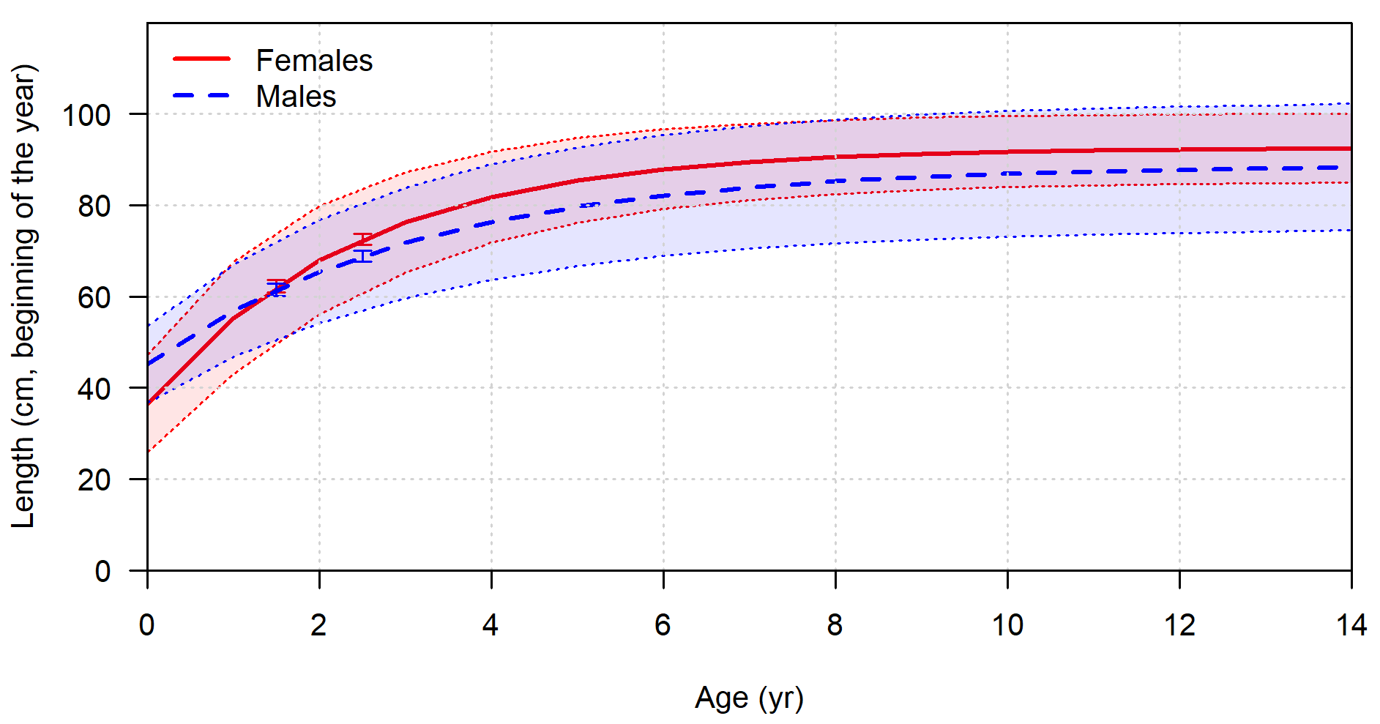
Figure 13. The model estimated growth curves for females and males with 95% confidence intervals.
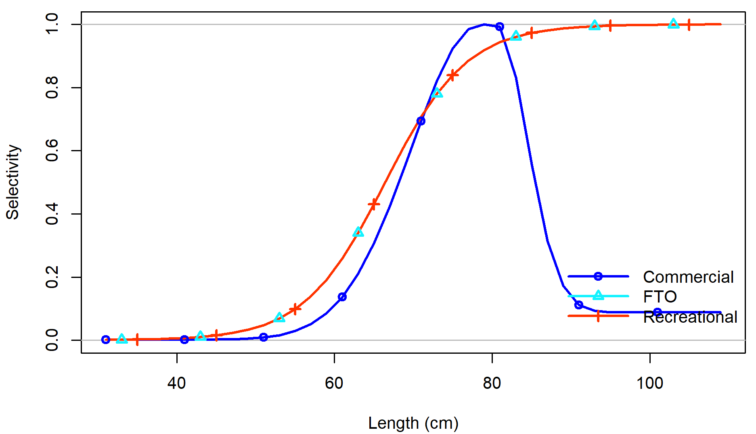

Figure 14. Estimated selectivity curves for the commercial, FTO and recreational fleets.

Table 7. Summary of sex specific parameter estimates for Grey Mackerel.
Parameter | Female | Male
K | 0.40 | 0.31
$L_{min}$ | 36.44 | 45.14
$L_{∞}$ | 92.67 | 88.77
Mat50% | 63

Table 8. Summary of recruitment and commercial fleet selectivity parameter estimates for Grey Mackerel.
Parameter | Estimate from SS3
$$Ln(R_{0})$$ | 6.56
Selectivity DblN Peak | 78.51
Selectivity DblN Top Logit | -11.48
Selectivity DblN Ascend Width | 5.03
Selectivity DblN Descend Width | 3.40
Selectivity DblN Start Logit | -6.32
Selectivity DblN End Logit | -2.33

Fits to data
There is good fit to the commercial CPUE abundance index across most of the time series (Figure 15). However, the model is unable to adequately fit the commercial CPUE estimates between 2006 and 2009, during which the observed CPUE values exhibit moderate interannual variability. Nevertheless, the model captures the overall declining trend in catch rates during this period. The fit of the index is particularly good from 2007 to 2011, where the model-predicted values closely align with the observed data and remain within the associated confidence bounds. From 2012 to 2017, the CPUE values indicate an upward trend, accompanied by some fluctuations and increased uncertainty (Figure 15). The model adequately captures the increasing trend, although there appears to be some underfitting in years with elevated observed values (e.g., Figure 15, year 2016), which lie near the upper bound of the predicted confidence range. Despite these discrepancies, the overall fit remains acceptable, particularly given the interannual variability in the data.
From 2018 onwards, the CPUE index exhibits relative stability, fluctuating around a normalised value of approximately 1.0 to 1.2. The model tracks this period well, capturing both the minor fluctuations and the overall plateauing of the CPUE. Model fits are particularly robust in the final years (2021–2024), with minimal divergence observed between predicted and empirical values.
The consistent fit across the time series, despite some years of poor fit, suggests the model is adequately capturing the dynamics of relative abundance as indicated by the commercial CPUE providing a reliable indication of relative biomass.

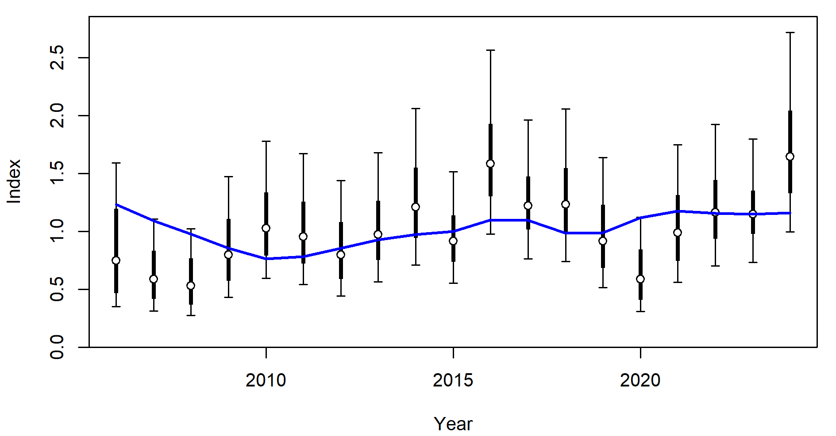
Figure 15. Fits to the commercial catch rates (CPUE) showing observed values (circles) and associated 95% confidence intervals, and model-estimated CPUE (blue line).

Residual patterns for the fits to the abundance index are presented in Figure 16. The residuals for both the CPUE index and length composition data exhibit no evidence of concerning serial autocorrelation, with the runs test indicating that residuals are randomly distributed (p < 0.05; Figure 16). Furthermore, all CPUE observations fall within the 95% confidence interval for sigma, suggesting an absence of model misspecification (Figure 16). Overall, the residual diagnostics for the base case model demonstrate a good fit to the CPUE data (Figure 17), with a root mean square error (RMSE) of approximately 32.3%, indicative of satisfactory model precision (Figure 17).
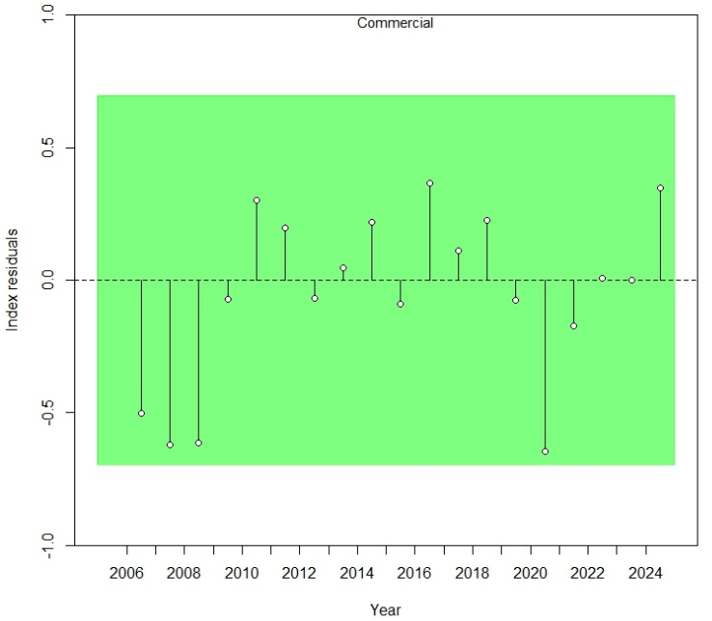
Figure 16. Residuals for fits to CPUE for the commercial fleet for the 2025 base case scenario. Green shading indicates no evidence ($p≥0.05)$ to reject the hypothesis of a randomly distributed time-series residuals.

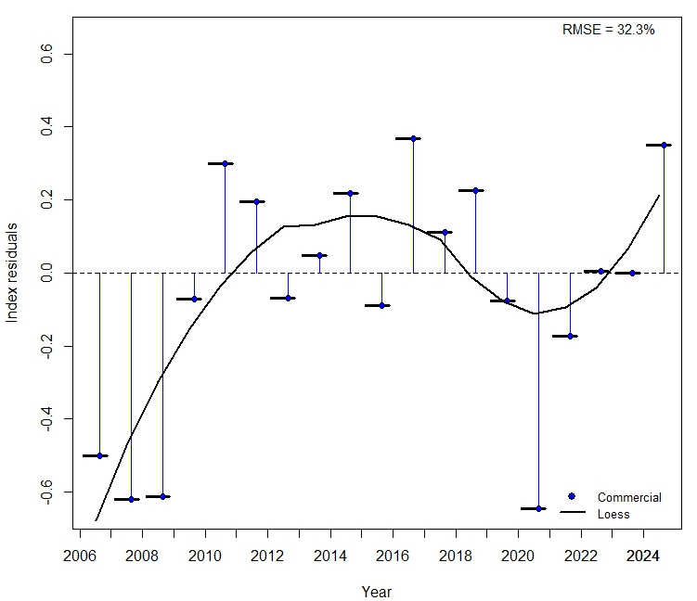
Figure 17. Annual mean index residuals, vertical lines with points show the residuals for the CPUE index (blue). The solid black line shows the loess smoother through all residuals. Root-mean squared error (RMSE)
The model demonstrates a good fit to the retained length-frequency distributions for the commercial fleet (Figure 18). This is further supported by the residuals from the length data (Figure 19), which appear to be normally distributed for the commercial fleets (p≥0.05). Overall, the model fits the length composition data well. Additional fits to the length-composition data are provided in the Appendix 9.7 (Figure 51–Figure 59).

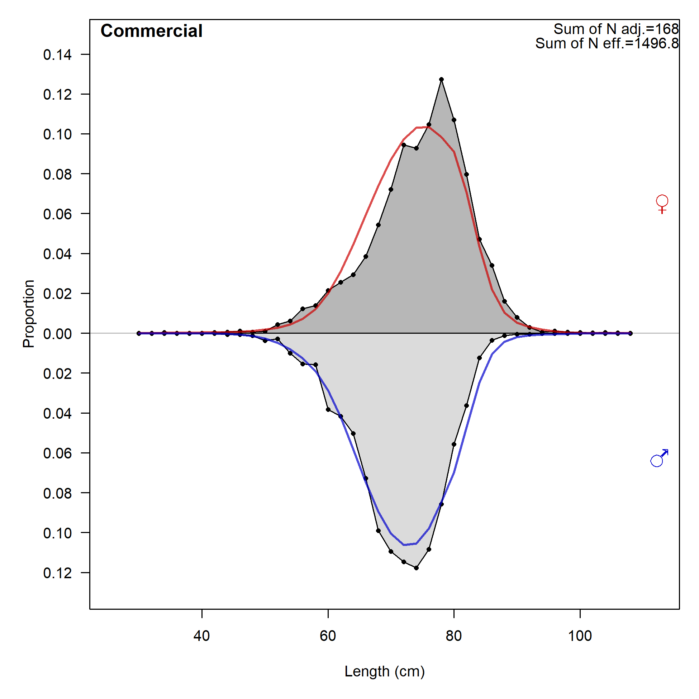
Figure 18. Fits to the aggregated length data by sex for the 2025 base case Grey Mackerel assessment.

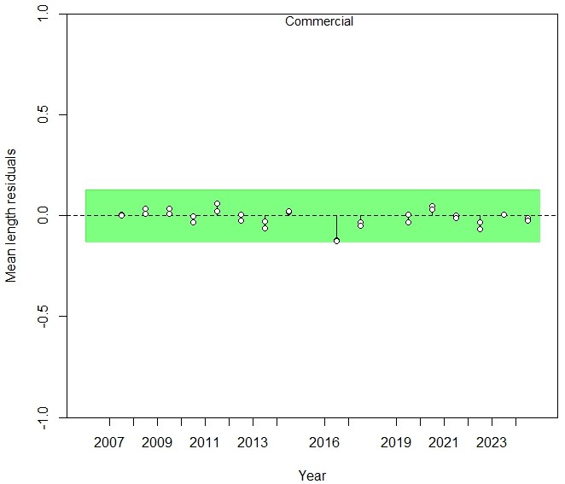
Figure 19. Residuals for fits to length composition data by fleet for the base case scenario. Green shading means the residuals are randomly distributed ($P≥0.05)$.
The estimated recruitment (Figure 20, top left) through the period of the fishery shows moderate interannual variability without pronounced long-term trends, with recruitment levels generally fluctuating around the mean throughout the estimation period where CPUE and length/age composition data are available. This pattern is consistent with the life-history dynamics of pelagic fish species and suggests that recruitment has not undergone any sustained period of suppression or elevated productivity during the past two decades.
In the early 2000s (2000–2005), recruitment appears to have been slightly above average in several years (notably 2001 and 2003), potentially reflecting favourable spawning biomass or environmental conditions. However, this peak in recruitment also coincides with the 2003 historic peak in catch, which may have had some influence on estimation. A brief decline in recruitment is evident in 2006 and 2007, but this is not prolonged, and recruitment returns to average or above-average levels during the 2008–2014 period. From 2015 to 2021, recruitment estimates are relatively stable, with values close to the long-term mean, indicating consistent stock productivity under prevailing environmental and fishing conditions.
The standard errors of the recruitment deviations (Figure 20, top right panel and Figure 21) are relatively low and stable throughout the estimation period (2000–2021), suggesting that the model is well-supported by empirical data during this period. This reflects the availability of age and length composition data in addition to relative abundance indices, which together provide sufficient contrast to support the estimation of recruitment deviations.
The 95% asymptotic confidence intervals around the recruitment estimates (Figure 20, bottom left panel) are similarly narrow, particularly from 2005 onward, further indicating that the model has adequate information content to estimate recruitment deviations in recent years with high precision.
The variance associated with the estimation of recruitment deviations (Figure 20, top right) shows a gradual decline between 1983 and 2000, consistent with the increasing availability of high-quality input data over time. From 2000 to 2021, this variance remains relatively low and stable, suggesting that the model has sufficient information to reliably estimate recruitment deviations across the full estimation period (Figure 20, top and bottom right panels).
Finally, the bias adjustment plot (Figure 20, bottom right) indicates that moderate corrections were applied to earlier estimates, particularly in the pre-1990 period, where data constraints were more pronounced. In contrast, bias adjustments from 2000 to 2022 are minimal, highlighting the strong support for recruitment estimates in recent years and reinforcing the reliability of the model outputs during the main estimation window.
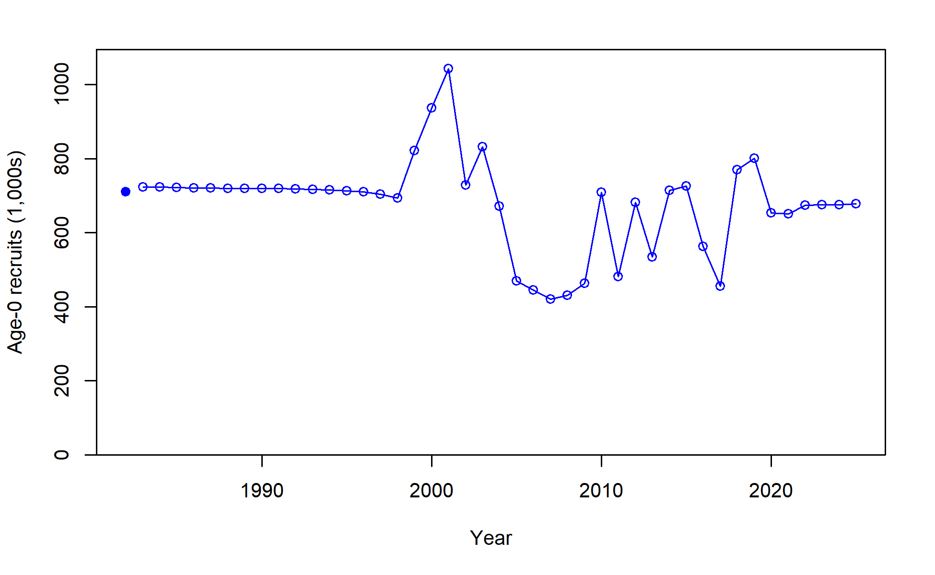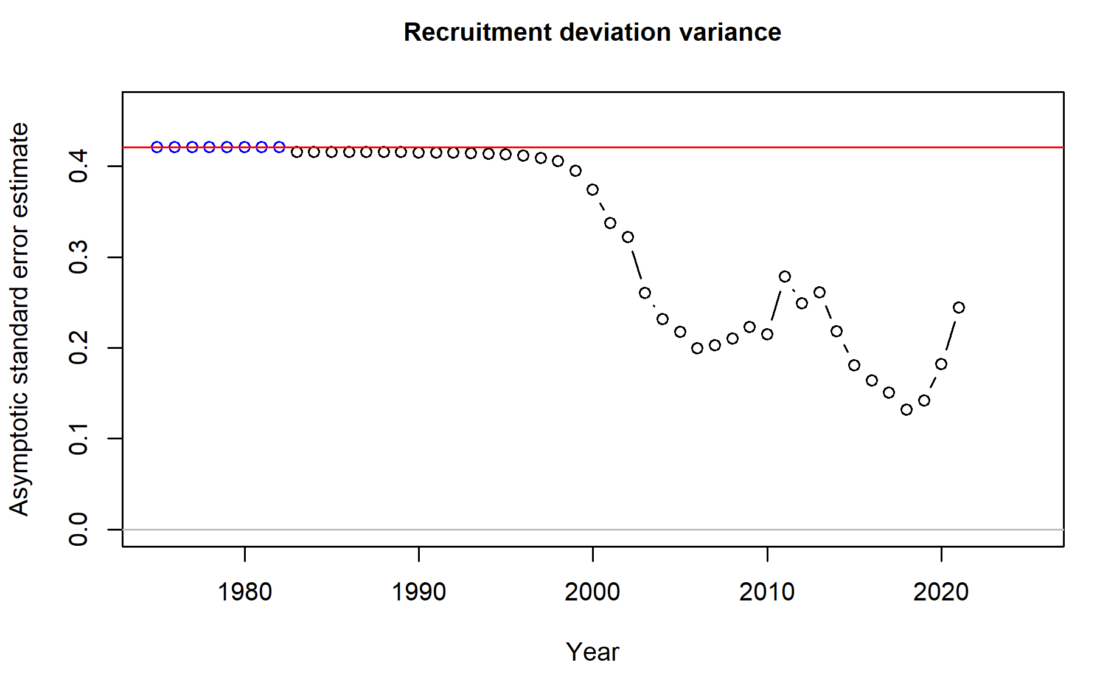
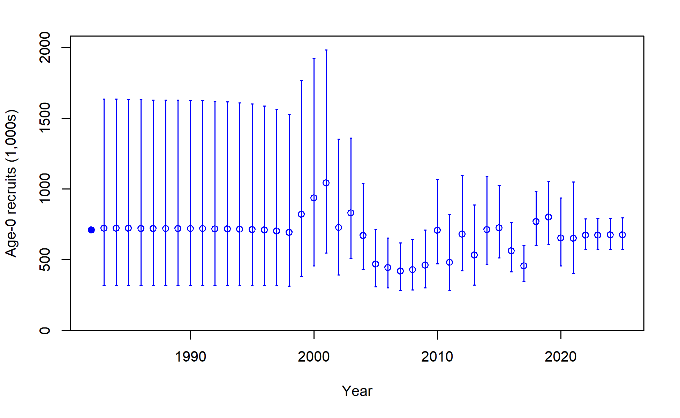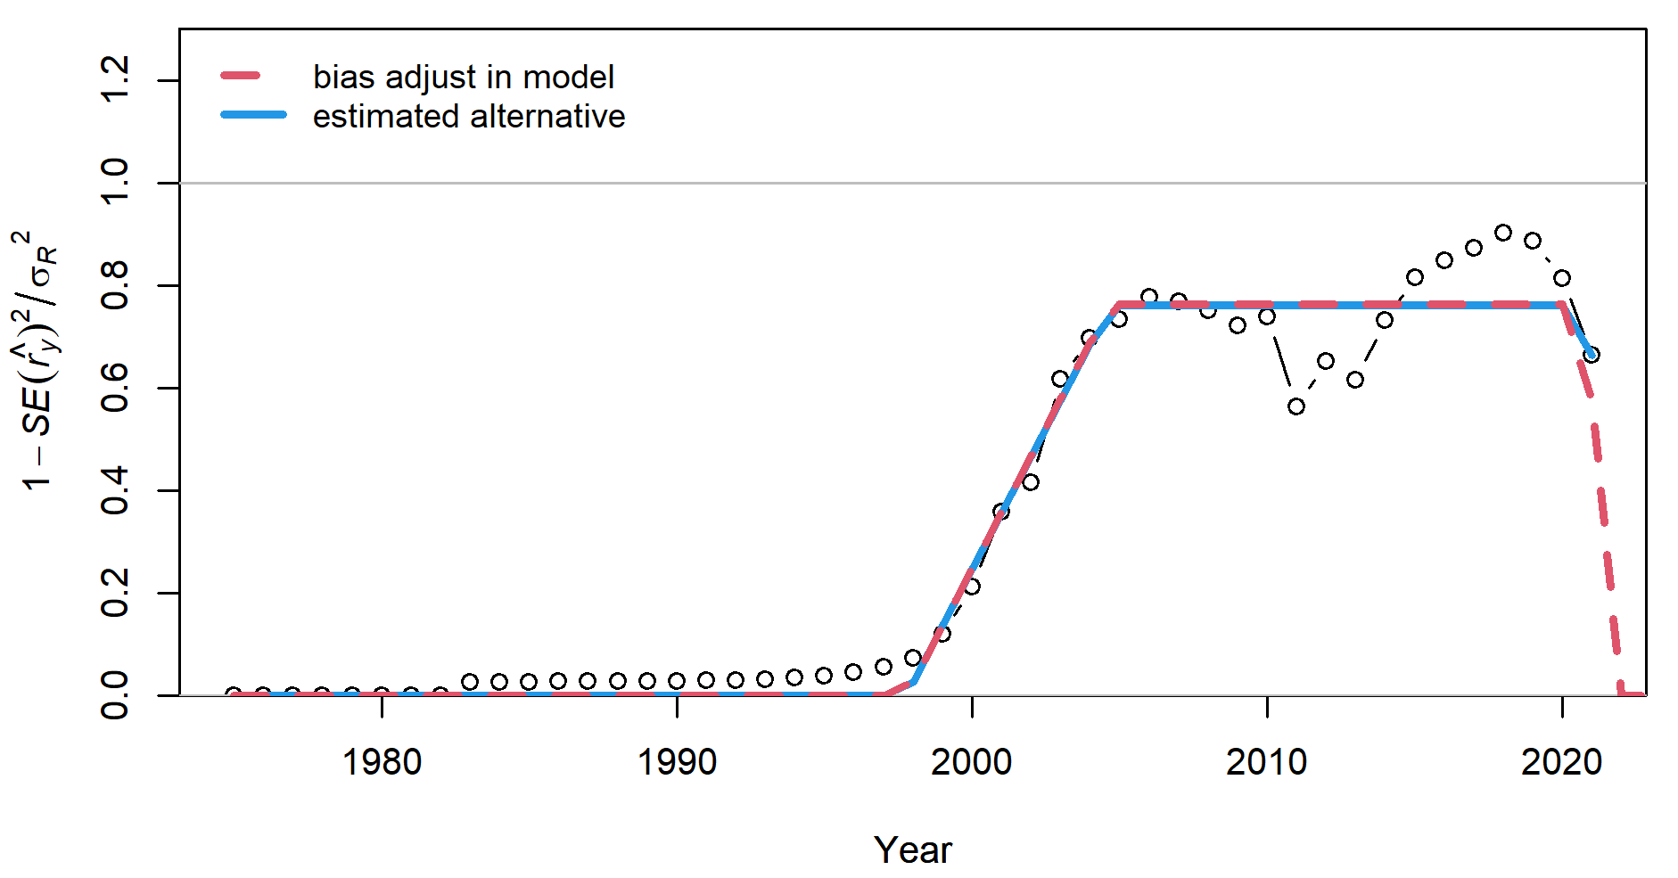
Figure 20. Recruitment estimation. Top left: Time-trajectories of estimated recruitment numbers; top right: the standard errors of recruitment deviation estimates; bottom left: time-trajectories of estimated recruitment numbers with approximate 95% asymptotic intervals; bottom right: bias ramp adjustment for recruitment in the model.

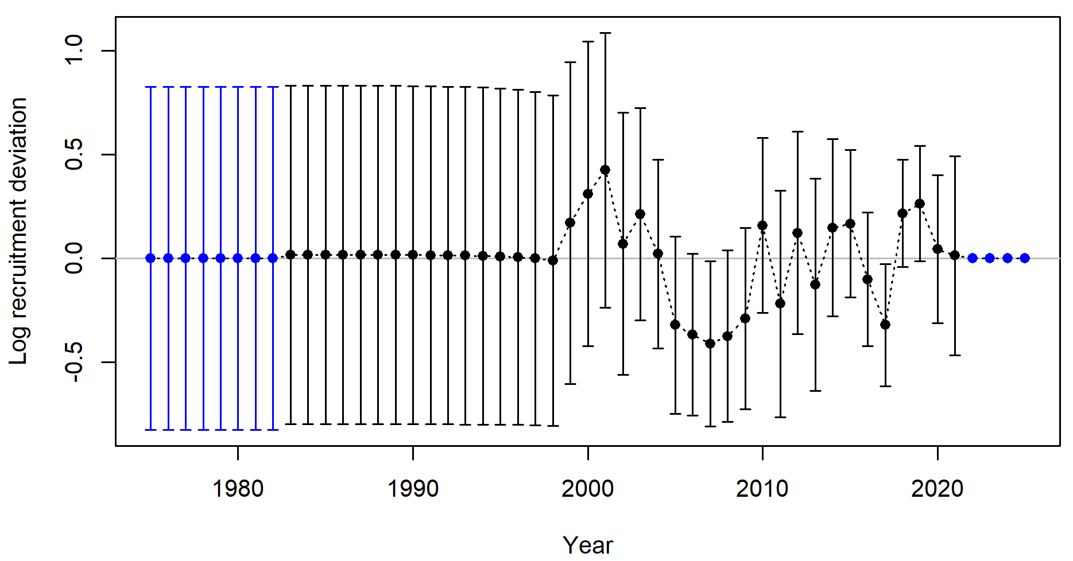
Figure 21. Time trajectory of estimated recruitment deviations for the base case with 95% asymptotic intervals.

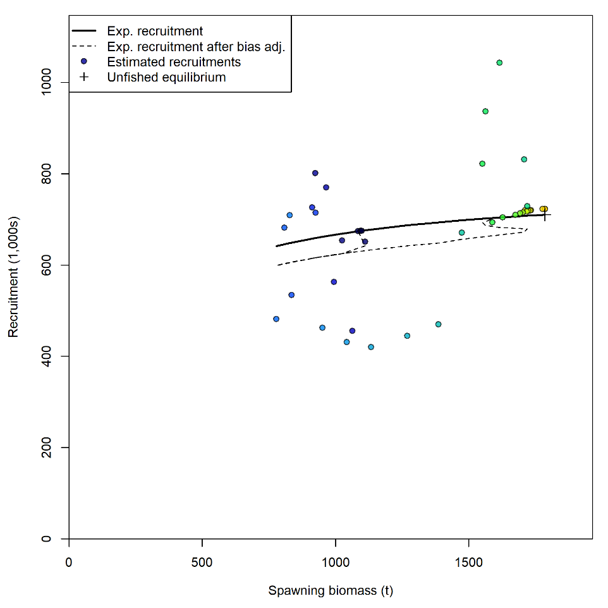
Figure 22. Stock recruitment curve for the 2025 base case assessment for Grey Mackerel.

The Kobe plot displays a time series of SSB relative to unfished levels plotted against the spawning potential ratio, which reflects overall fishing mortality (Figure 23). The trajectory begins in the bottom right corner in 1983, indicating low fishing mortality and high spawning biomass. Fishing pressure increased steadily through the following two decades, resulting in a decline in spawning biomass and a shift toward the upper left quadrant of the plot. By the mid-2000s, fishing mortality had exceeded target levels and biomass had declined to approximately 42% of unfished levels. Between 2005 and 2010, the fishery experienced its highest fishing mortality (~1.1 times the target). From 2010 onwards, there was a reduction in fishing pressure, which allowed spawning biomass to recover gradually. Since 2012, the stock has remained within or near the management target zone. The most recent estimate for 2024 indicates that the stock is operating within this zone, with spawning biomass at approximately 61% of unfished levels and fishing mortality at 64% of the target (Figure 23).
The relationship between fishing pressure and time is presented in Figure 24, demonstrating that fishing pressure has been above the target from 2009 to 2011. However, for the last 13 years fishing pressure has dropped below the target level.

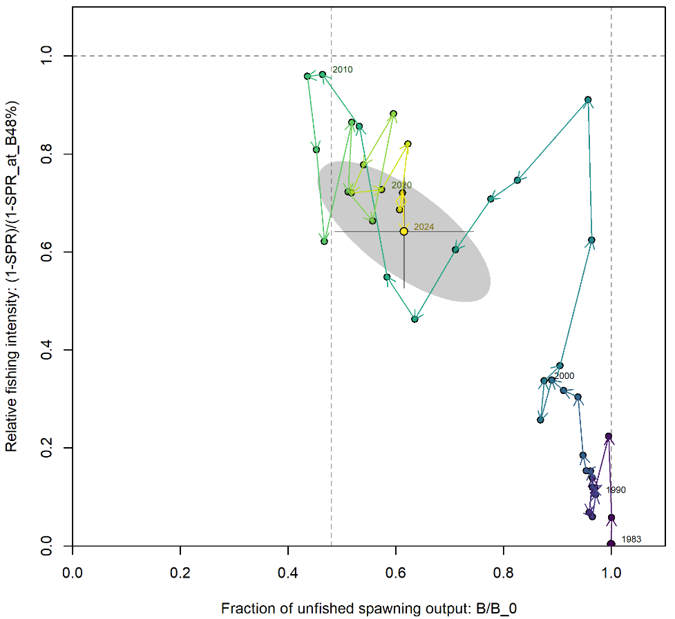
Figure 23. Kobe plot showing the median relative spawning biomass in year and corresponding median relative fishing intensity in year $t$. Labels indicate the first and final years and correspond to year of the relative spawning biomass. The grey ellipse spans the 95% credibility intervals for the 2024 relative spawning biomass and relative fishing intensity (vertical).

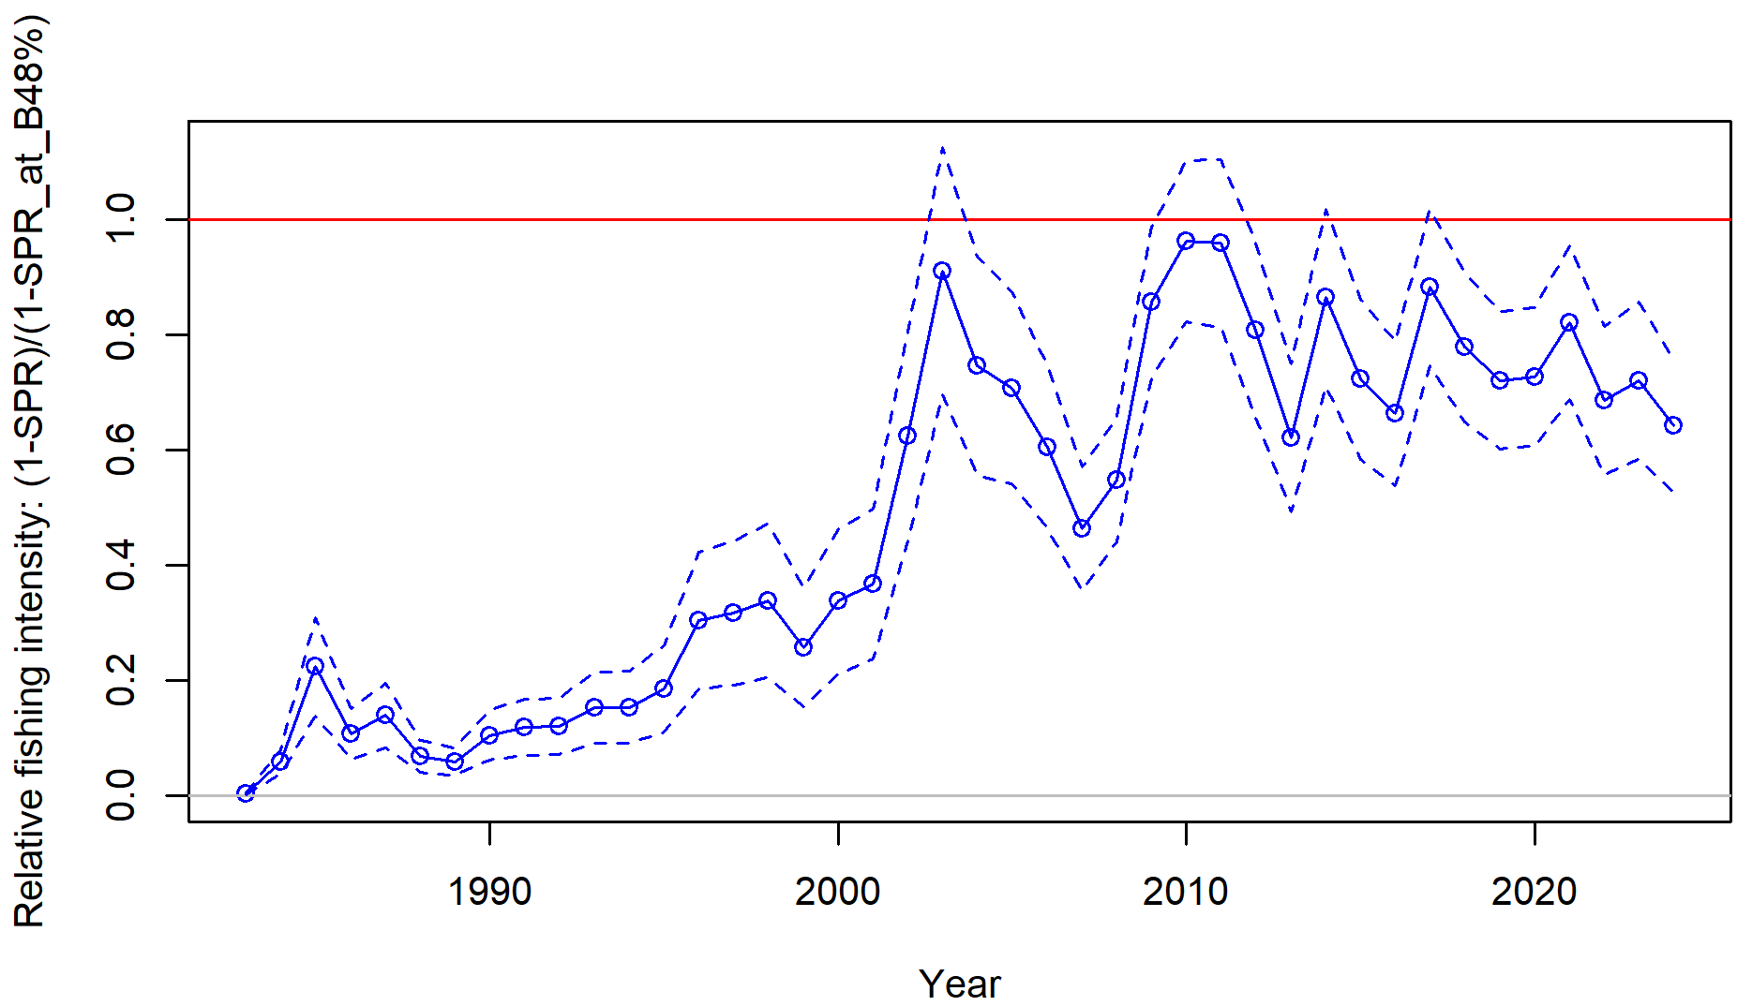

Figure 24. Spawning potential ratio (SPR), or relative fishing intensity, through time, the red line represents the target fishing mortality, and each year is a point in the model.

Application of the HCR
Projections assuming fixed average recruitment and full attainment of the recommended biological catch (RBC) each year indicate that the spawning stock biomass (SSB) is expected to reach 63% and 57% of SSB₀ by 2025 and 2026, respectively (Figure 25).

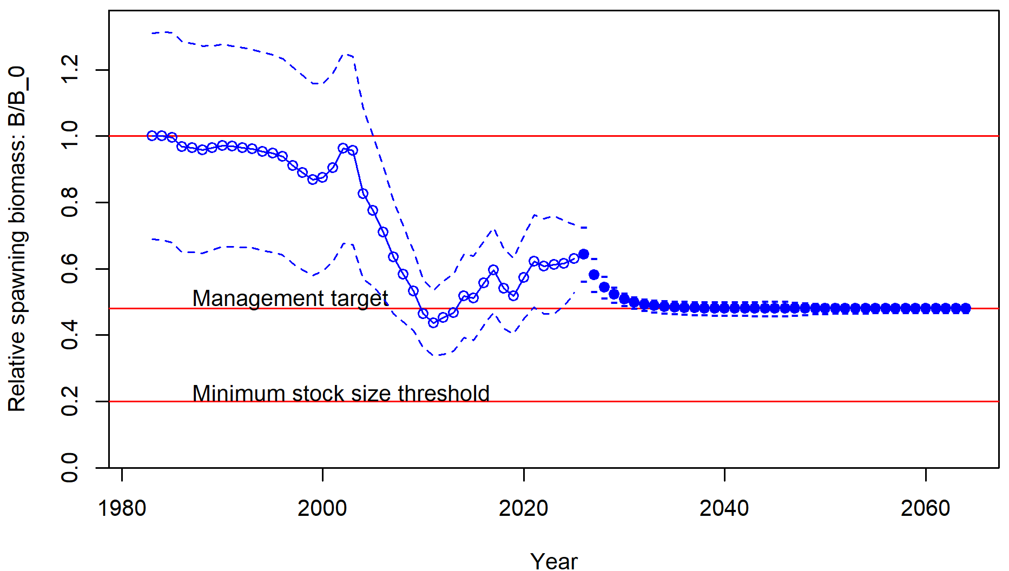
Figure 25. The estimated time-series of relative spawning biomass for the base case with projections applying the HCR to 2060.

The recommended biological catch (RBC) for the North West NT stock in 2025 is 605 t. The long-term yield, assuming average future recruitment, is estimated at 677 t (Table 9). The average RBC over the next three-year period (2025-2027) is 565 t and the average RBC over the next five-year period (2025-2029) is 546 t (Table 9). The RBC for each individual year from 2025 to 2032 is provided in Table 9.

Table 9. Summary of estimated stock status, RBCs assuming average recruitment projections under the 20:30:48 harvest control rule.
YEAR | STOCK STATUS (%) | RBC (t)
2025 | 63.1 | 605
2026 | 57.4 | 558
2027 | 54.0 | 534
2028 | 51.9 | 521
2029 | 50.0 | 514
2030 | 49.7 | 508
2031 | 49.1 | 505
2032 | 48.7 | 503
2050 (Long term) | 48.0 | 499

Sensitivities scenarios
None of the sensitivities resulted in a substantial departure from the population dynamics of the base case (Table 10 and Table 11). Most of the sensitivity scenarios indicate that the relative spawning biomass in 2024 remains above the reference point of B48%, with depletion estimates ranging from 53% to 64% of ${SSB}_{0}$. This suggests that the stock remains in a moderately exploited state under a broad range of biological assumptions and data weighting scenarios.
The base case scenario (M = 0.45, h = 0.75, $σ_{R}$= 0.60) produced estimates of ${SSB}_{0}$ of 1785 t and ${SSB}_{2024}$ of 1098 t, corresponding to a depletion (${SSB}_{2024}/{SSB}_{0}$) of 0.61. Across alternative values for natural mortality (M ranging from 0.30 to 0.65), stock depletion estimates varied from 0.55 to 0.60, with only marginal changes in model fit (ΔNLL ranging from +0.1 to +3.2). Similarly, variation in steepness (h = 0.60–0.80) produced depletion estimates between 0.57 and 0.62, while alternative values of recruitment variability ($σ_{R}$= 0.40–0.65) resulted in depletion estimates from 0.57 to 0.61. These ranges illustrate that the core perception of stock status is robust to uncertainty in key life history parameters.
Most changes in total negative log-likelihood (NLL) were small. For instance, reducing σᵣ from 0.6 to 0.4 slightly improved the model fit (ΔNLL = –1.62), primarily due to a better fit to the recruitment component (ΔRecruitment = –11.02). Increasing σᵣ to 0.65 slightly worsened the fit (ΔNLL = +2.73). Adjustments to steepness values resulted in small ΔNLL changes (within ±2), with minimal impact on individual likelihood components.
Overall, the sensitivity analyses confirm that the base case model provides a reliable, robust, and consistent representation of the North West NT Grey Mackerel stock. Variations in key input parameters and data weighting produced only moderate changes in estimates of spawning biomass and stock depletion. Importantly, no alternative model showed a clear or consistent improvement in fit across all likelihood components. These findings strongly support the use of the base case model as the primary source of scientific advice for the assessment.

Table 10. Summary of the negative log likelihood (NLL), change in NLL, unfished and current spawning biomass and the stock status for the North West NT Grey Mackerel stock base case and sensitivity scenarios.
MODEL | NLL | Delta NLL | $${SSB}_{0}$$ | $${SSB}_{2024}$$ | $${SSB}_{2024}/{SSB}_{0}$$
Base case (M=0.45, h=0.75, 50% $σ_{R}$=0.60) | 344.1 | - | 1,785 | 1,098 | 0.615
M =0.30 | 345.1 | 1.0 | 2,466 | 1,366 | 0.553
M =0.35 | 344.5 | 0.4 | 2,127 | 1,217 | 0.572
M =0.40 | 344.0 | -0.1 | 1,913 | 1133 | 0.592
M =0.50 | 344.5 | 0.4 | 1,715 | 1,100 | 0.641
M =0.65 | 347.3 | 3.2 | 1,808 | 1,356 | 0.766
h =0.60 | 344.0 | -0.1 | 1,899 | 1,099 | 0.578
h =0.65 | 344.0 | -0.1 | 1,852 | 1,099 | 0.593
h =0.70 | 344.1 | 0.0 | 1,815 | 1,099 | 0.605
h =0.80 | 344.1 | 0.0 | 1,760 | 1,098 | 0.623
$σ_{R}$= 0.40 | 343.8 | -0.3 | 1,770 | 1,094 | 0.618
$σ_{R}$= 0.45 | 344.6 | 0.5 | 1,806 | 1,104 | 0.611
$σ_{R}$= 0.50 | 345.3 | 1.2 | 1,845 | 1,113 | 0.603
$σ_{R}$= 0.65 | 347.6 | 3.5 | 1,978 | 1,138 | 0.575
Weighting * 2 length comp | 371.1 | 27.0 | 1,752 | 1,054 | 0.601
Weighting * 0.5 length comp | 317.2 | -26.9 | 1,810 | 1,131 | 0.624
Weighting * 2 age comp | 356.1 | 12.0 | 1,823 | 1,101 | 0.603
Weighting * 0.5 age comp | 355.2 | 11.1 | 1,757 | 1,103 | 0.641
Weighting * 2 CPUE | 327.9 | -16.2 | 1,819 | 1,176 | 0.646
Weighting * 0.5 CPUE | 350.3 | 6.2 | 1,765 | 1,052 | 0.596
Weighting * 0.1. CPUE | 354.1 | 10.0 | 1,648 | 884 | 0.536

Table 11. Summary of likelihood components for the base case scenario and sensitivity model runs. Likelihood components are unweighted and all cases below the base case are shown as differences from the base case. A negative value either in the total or individual components of likelihood indicates an improvement in fit compared to the base case. A positive value indicates deterioration in the fit.
MODEL | Total | Survey | Length | Age | Recruitment
Base case (M=0.45, h=0.75, 50% $σ_{R}$=0.60) | 344.1 | -13.50 | 52.02 | 320.1 | -9.34773
M =0.30 | +1.04 | -13.89 | 54.23 | 319.2 | -8.27
M =0.35 | +0.37 | -13.65 | 53.40 | 319.3 | -8.39
M =0.40 | -0.11 | -13.52 | 52.59 | 319.6 | -8.45
M =0.50 | +0.44 | -13.56 | 51.69 | 320.8 | -8.28
M =0.65 | +3.16 | -13.82 | 51.15 | 322.9 | -5.30
h =0.60 | -0.10 | -13.18 | 52.05 | 319.1 | -5.78
h =0.65 | -0.08 | -13.26 | 52.07 | 319.1 | -5.78
h =0.70 | -0.04 | -13.50 | 52.02 | 320.1 | -8.40
h =0.80 | +0.04 | -13.40 | 52.12 | 319.1 | -5.72
$σ_{R}$= 0.40 | -0.33 | -13.70 | 51.97 | 321.3 | -11.02
$σ_{R}$= 0.45 | +0.45 | -13.58 | 51.99 | 320.6 | -9.48
$σ_{R}$= 0.50 | +1.23 | -13.49 | 52.02 | 320.0 | -8.12
$σ_{R}$= 0.65 | +3.47 | -13.33 | 52.15 | 318.8 | -4.69
Weighting * 2 length comp | 27.01 | -10.84 | 48.06 | 323.6 | -8.19
Weighting * 0.5 length comp | -26.89 | -15.14 | 55.35 | 319.2 | -8.20
Weighting * 2 age comp | 11.97 | -11.25 | 53.83 | 310.0 | -5.86
Weighting * 0.5 age comp | 11.12 | -15.68 | 50.28 | 322.0 | -9.68
Weighting * 2 CPUE | -16.23 | -18.65 | 55.30 | 324.8 | -8.43
Weighting * 0.5 CPUE | 6.16 | -10.93 | 50.54 | 318.9 | -7.88
Weighting * 0.1. CPUE | 10.00 | -7.41 | 49.35 | 318.5 | -7.30

Model Diagnostics
A comprehensive set of diagnostic tests were undertaken to evaluate the performance of the base case model. The model converged with final gradient 5.0222e-05 and a positive definite Hessian (157.3). Jitter analyses indicated high stability, with 25 replicates recovering the global optimum and minimal variability in likelihood components and parameter estimates.
Retrospective analyses show stable spawning biomass and recruitment, with Mohn’s rho values for SSB (0.039), recruitment (–0.021), and fishing mortality (0.048) within acceptable ranges for a short-lived species. Recruitment deviations in squid plots remained within ±0.2, indicating no pathological patterns.
Likelihood profiles reveal well-defined minima for natural mortality, growth parameters (K and L∞), and biomass quantities, though some minor conflicts exist between length composition and index data. Steepness (h) is poorly informed and fixed at 0.75. Age composition data was most informative for growth and L∞ estimates, while index data primarily informed current biomass and stock status.
Residual diagnostics demonstrate satisfactory fits to length-frequency data and reasonable fits to CPUE (RMSE ≈ 32.3%), with no concerning patterns or serial autocorrelation.
Overall, the base case model is stable, convergent, and structurally adequate, providing confidence in the reliability of assessment outputs. Full diagnostic outputs are presented in Appendix 9.9

SRA Assessment outcomes
The stochastic SRA bridging scenarios for the North West NT stock of Grey Mackerel produce consistent biomass and stock status outcomes across a range of model assumptions and data inputs. Biomass estimates decline in the late 1990s to mid-2000s, followed by stabilisation and an increasing trend from approximately 2013 onwards, converging at around 2,500–2,560 t by 2024 (Appendix 9.4).
Stock status indicators derived from the 2024 CPUE bridging scenarios indicate that spawning biomass remains above the limit reference point and that fishing mortality is below $F_{MSY}$. Scenario 6, which incorporates CPUE data from 2000 to 2024, results in a posterior median depletion (${E_{2024}}/{E_{0}}$) of 0.88 and a fishing mortality ratio (${F_{2024}}/{F_{MSY}}$) of 0.22. (Figure 26). Similarly, scenario 7, which excludes pre-2006 CPUE data to better reflect the period of targeted Grey Mackerel fishing, yields comparable results, with a posterior median depletion of 0.79 and a fishing mortality ratio of 0.25. Across both scenarios, estimated depletion levels indicate reproductive capacity well above the biomass limit reference point, while fishing mortality remains substantially below $F_{MSY}$. Collectively, all 2024 CPUE bridging scenarios provide no evidence to suggest that the North West NT stock is currently depleted or subject to overfishing, and the stock is therefore assessed as sustainable (Figure 26). Further details and diagnostic outputs are provided in Appendix 9.4.
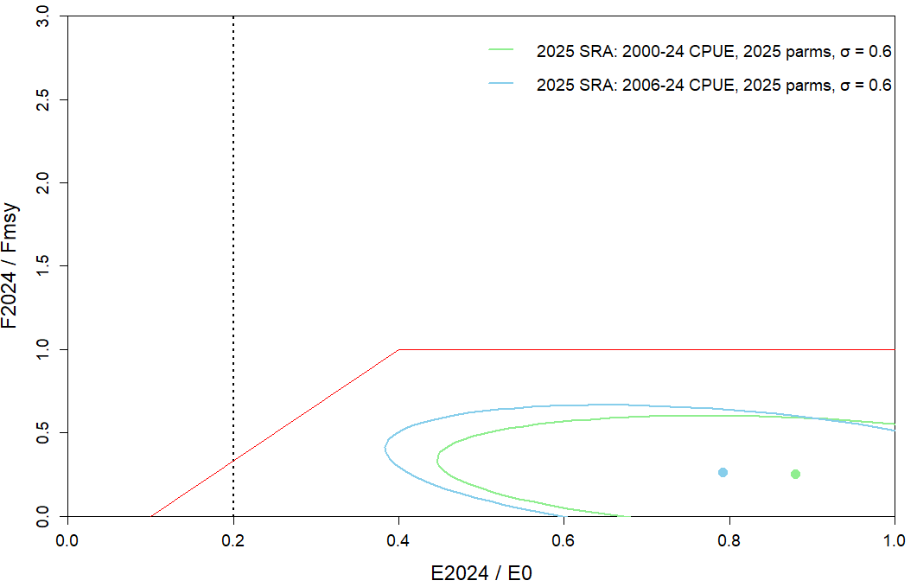
Figure 26. Kobe plot of relative egg production vs fishing intensity from the stochastic SRA bridging analysis for North West NT Grey Mackerel. The central point represents the median of the join posterior distribution with ~95% asymptotic intervals for each scenario (blue and green ellipse). The dashed line is the ${SSB}_{0.2}$ minimum stock threshold.

Discussion

Performance of model
With the current data inputs, it was not possible to reliably estimate natural mortality rate (M), the stock-recruitment steepness (h), and the recruitment variability (σᵣ) simultaneously. Despite this limitation, all parameters estimated within the model for Grey Mackerel were biologically plausible and consistent with known life-history characteristics of the species.
Growth was found to differ between sexes. Female Grey Mackerel showed faster growth, with an estimated asymptotic total length ($L_{∞}$) of 92.67 cm and growth coefficient ($k$) of 0.409, while males had a slightly smaller $L_{∞}$of 89.77 cm and a lower $k$ of 0.31. These estimate growth values are consistent with those reported by Welch et al. (2019). Estimated recruitment showed moderate interannual variability, which corresponded to the years with available data inputs. Recruitment deviations were also estimated, reflecting the model’s capacity to capture year-to-year biological variability.
The model results demonstrated strong internal consistency. Goodness-of-fit diagnostics show residuals from the CPUE and length composition data passed the run tests, indicating that they were randomly distributed. Jitter analyses showed that the model consistently converged to the global minimum negative log-likelihood, providing confidence in the stability of the parameter estimates. In addition, likelihood profiles revealed a well-defined minimum around 61% depletion. The most informative data source for estimating stock status was the commercial CPUE index, while the length and age composition data helped constrain the lower bounds of depletion.
The predicted stock size for the North West NT Grey Mackerel stock varied depending on model parameterisation. Sensitivity analyses exploring uncertainty in M, h, and $σ_{R }$ demonstrated that the 2025 base case consistently estimated current depletion levels above 53% under a range of plausible assumptions. While changing the weighting of composition or index data did affect model fit and depletion estimates to some extent, it did not alter the qualitative interpretation of stock status. For example, doubling the weight on age composition data substantially worsened model fit, whereas reducing it improved the fit. However, across all alternative weighting scenarios and assumptions, estimated depletion remained within a moderate range (0.53–0.76), supporting the robustness of the base case model.

TACC vs Model-derived RBCs
The Total Allowable Commercial Catch (TACC) for the Western Grey Mackerel Management Zone (WGMMZ) is currently set at 404 t under Northern Territory management arrangements for the Offshore Net and Line Fishery. This TACC was established at the time using a precautionary approach in the absence of a formal harvest strategy with explicitly defined biomass-based reference points. As such, the current TACC represents a fixed catch limit intended to maintain harvest levels within historically sustainable bounds while avoiding undue risk to stock productivity.
The 2025 base-case stock assessment model, implemented in Stock Synthesis (SS3), was used to project future stock status and estimate Recommended Biological Catches (RBCs) under the 20:30:48 harvest control rule (HCR), assuming average recruitment. Under this framework, the model projects RBC values ranging from 605 t in 2025 to approximately 499 t in the long term, as the stock stabilises near the management target of 48% of unfished spawning biomass.
The comparison between the model-derived RBC and the current TACC indicates that the existing TACC is conservative relative to the level of catch estimated to be biologically sustainable under the harvest control rule, with the stock projected to be at 62.1% of unfished spawning biomass (SSB₀) in 2025. The model-derived RBC of 605 t in 2025 reflects the catch level that would be expected to maintain the stock above the target biomass level while allowing the stock to gradually decline toward equilibrium at approximately 48% SSB₀. Maintaining the current fixed TACC of 404t also maintains the biomass above the target reference point. Under both scenarios, the stock is expected to remain within biologically sustainable limits and above the management target, indicating that the current TACC is precautionary and consistent with sustainable stock management.
However, the model-derived RBC estimates should be interpreted with caution, as key productivity parameters, such as natural mortality and recruitment variability, are specified as fixed inputs and their uncertainty is not propagated within the assessment. In addition, the current assessment model does not explicitly incorporate depredation or historic Taiwanese catch. Consequently, the RBC values reflect retained catch of recent domestic fisheries only. Until these issues are addressed it is recommended that the current commercial TACC of 404 t be maintained. This approach ensures that total fishing mortality remains precautionary while additional data are collected to improve the accuracy of future RBC estimates. In this context, the model-derived RBC provides a scientifically robust benchmark for evaluating stock productivity and informing future harvest strategy development, while the existing TACC represents an appropriate and precautionary management limit based on the best available scientific information.

SRA comparison
It is important to emphasise that SRA and SS3 are not directly comparable, as they are based on fundamentally different model structures and assumptions. SRA is a simple population model that assumes a fixed stock–recruitment relationship and does not explicitly model age or size structure, selectivity, or compositional data by sex.
Both methods support the conclusion that the stock is sustainably exploited, however, they differ in their estimates of current stock status. The SRA model estimates a relatively high relative egg production in 2024 at 88% of unfished levels, whereas the Stock Synthesis estimates a depletion level of SSB at 54%. This discrepancy reflects differences in model structure and metrics. Despite this difference, both models indicate that the stock remains above target level of 48% unfished levels, supporting the stock status classification as ‘sustainable’. The superior diagnostics of the SS3 model (likelihood profiles, convergence in jitter analyses, and transparent sensitivity to alternative assumptions) reinforce it as the preferred assessment model for stock status determination and management advice.

Research and data recommendations
The current assessment of the North West NT stock of Grey Mackerel has improved upon previous assessments by transitioning to a statistically integrated modelling platform (SS3), refining CPUE inputs and updating biological assumptions. However, several research and data gaps remain that could enhance future assessments and reduce uncertainty in stock status estimates, including:
1. Ongoing Biological Data Collection:
Current life-history parameters—such as maturity, natural mortality, fecundity, and some logistic selectivity parameters—were not estimated within the model and instead rely on limited data, including values borrowed from other jurisdictions. Continuation of the current observer program to collect biological samples covering age, length, sex, and reproductive status to enable estimation of NT specific parameters and improve the accuracy and relevance of future assessments.
2. Ageing Error Matrix Development:
An ageing error matrix was not incorporated in the current assessment due to the absence of sufficient validation data. Continued and standardised collection of otolith samples, including repeated readings and reader calibration exercises, is essential to quantify ageing precision and bias. Developing and integrating an ageing error matrix into the Stock Synthesis framework will improve model robustness by appropriately accounting for uncertainty in age estimates, which is particularly important for age-structured assessments of data-moderate species like Grey Mackerel.
3. Evaluation of uncertainty and management strategy Inputs:
Building on the existing stock assessment framework, further work should be done on assessing major sources of uncertainty related to data availability, model structure, and harvest control rules. As needed, comparative evaluations of alternative modelling approaches should be undertaken to inform adaptive, evidence-based management.
4. Updated catch reconstruction for the Taiwanese fleet
Catch from the Taiwanese fleet was not included in the current assessment due to considerable uncertainty of the scale of Grey Mackerel catch from Taiwanese vessels. A reconstruction exercise is required so that catch from the fleet can be confidently incorporated into future assessments. The reconstruction must disentangle Grey Mackerel from the combined ‘mackerel’ catch at a geographical scale relevant to the stock.
5. Fishery-independent abundance index
A fishery-independent index of abundance is preferred for stock assessments, as it provides an unbiased measure of population trends. The Grey Mackerel assessment currently relies solely on a single fishery-dependent index, and developing an independent index would provide robust relative abundance estimates, CVs, and key biological data to support future assessments. However, fishery-independent surveys can be expensive, and the feasibility of a survey would need to be explored before it is considered for the fishery.

References
Bassell-Browne P., R. Lovett, G. Leight, M.F. O’Neill and Campbell A. 2019. Stock assessment of the Australia east coast Grey Mackerel (Scomberomorus semifasciatus) fishery . Department of Agriculture and Fisheries Queensland, Australia.
Broderick, D., Ovenden, J., Buckworth, R., Newman, S., Lester, R. and Welch, D. 2011, Genetic population structure of Grey Mackerel Scomberomorus semifasciatus in northern Australia. Journal of Fish Biology. 79, 633–661.
Brooks, M.E., Kristensen, K., van Benthem, K.J., Magnusson, A., Berg, C.W., Nielsen, A., Skaug, H.J., Mächler, M., Bolker, B.M. 2017. glmmTMB Balances Speed and Flexibility Among Packages for Zero-inflated Generalized Linear Mixed Modeling. R J. 9, 378–400
Buckworth, R. C., 2004. Effects of spatial stock structure and effort dynamics on the performance of alternative assessment procedures for the fisheries of Northern Australia. Doctor of Philosophy. The University of British Columbia
Burnham, K. P., & Anderson, D. R. 1992. Data-Based Selection of an Appropriate Biological Model: The Key to Modern Data Analysis. Wildlife 2001: Populations, 16–30. doi:10.1007/978-94-011-2868-1_3
Cadrin, S. X., & Vaughan, D. S. 1997. Retrospective Analysis of Virtual Population Estimates for Atlantic Menhaden Stock Assessment. Fishery Bulletin (Washington, D.C.), 95(3), 445–445.
Cameron, D. and Begg, G. 2002. Fisheries biology and interaction in the northern Australian small mackerel fishery. Project Report. State of Queensland, Brisbane. Stock assessment models Projects 92/144et92/144.02.
Carvalho, F., Punt, A.E., Chang, Y.-J., Maunder, M.N., Piner, K.R. 2017. Can diagnostic tests help identify model misspecification in integrated stock assessments? Fish. Res. 192, 28–40.
Charters, R., Lester, R., Buckworth, R., Newman, S., Ovenden, J., Broderick, D., Kravchuk, O., Ballagh, A. and Welch, D. 2010. The stock structure of Grey Mackerel Scomberomorus semifasciatus in Australia as inferred from its parasite fauna. Fisheries Research. 101, 94–99.
Coleman, A.P.M. 1998. Fishcount: A survey of recreational fishing in the Northern Territory (Summary).
Errity, C., Penny, S., Steffe, A., 2022. A Survey of Recreational Fishing in the Greater Darwin Area 2016.
Francis, R.I.C.C. 2011. Data weighting in statistical fisheries stock assessment models. Can. J. Fish. Aquat. Sci. 68, 1124–1138. https://doi.org/10.1139/f2011-025.
Grubert, M., Saunders, T., Martin, J., Lee, H. and Walters, C. 2013. Stock Assessments of Selected Northern Territory Fishes. Fishery Report 110, Northern Territory Government, Australia.
Haddon, M., Klaer, N., Smith, D.C., Dichmont, C.M., Smith, A.D.M., CSIRO, 2012. Technical reviews for
the Commonwealth Harvest Strategy Policy, FRDC 2012/225. Hobart.
Hamel, O. S., & Cope, J. M. 2022. Development and considerations for application of a longevity-based
prior for the natural mortality rate. Fisheries Research, 256, 106477-. https://doi.org/10.1016/j.fishres.2022.106477
Hartig, F., 2022. DHARMa: Residual diagnostics for hierarchial (Multi-levl/Mixed) regression models, R package version 0.4.6.
Hurtado-ferro, F., Szuwalski, C.S., Valero, J.L., Anderson, S.C., Cunningham, C.J., Johnson, K.F., Licandeo, R., Mcgilliard, C.R., Monnahan, C.C., Muradian, M.L., Ono, K., Vert-Pre, K.A., Whitten, A.R., Punt, A.E. 2015. Looking in the rear-view mirror: bias and retrospective patterns in integrated, age-structured stock assessment models. ICES J. Mar. Sci. 72, 99–110.Gabry, J., & Mahr, T. 2019. Bayesplot: Plotting for bayesian models. Retrieved from mc-stan.org/bayesplot.
Ian G. Taylor, Kathryn L. Doering, Kelli F. Johnson, Chantel R. Wetzel, Ian J. Stewart. 2021. Beyond visualizing catch-at-age models: Lessons learned from the r4ss package about software to support stock assessments, Fisheries Research, 239:105924.
Jesson-Kerr. M., Lewis. P., and Usher. M. 2023. Grey Mackerel 2023. Grey Mackerel 2023.

Klaer, N.L., Wayte, S.E., Fay, G. 2012. An evaluation of the performance of a harvest strategy that uses an average-length-based assessment method. Fish. Res. 134–136, 42–51. https://doi.org/10.1016/j.fishres.2012.08.010.
Lewis PD. 2020, Statewide Large Pelagic Resource in Western Australia, Resource Assessment Report No 19, Department of Primary Industries and Regional Development Western Australia, 145pp.
Lombardi, L., Walters, C. 2011. Stochastic Stock Reduction Analysis (SRA) User Guide. NOAA Fish. Serv. Southeast Fish. Sci. Center, Panama City Lab. 3500, 11–13.
Matthews, S., Penny, S., Steffe, A. 2019a. A Survey of Recreational Fishing in the Greater Darwin Area 2014.
Matthews, S., Penny, S., Steffe, A. 2019b. A Survey of Recreational Fishing in the Greater Darwin Area 2015.
Matthews, S., Penny, S., Steffe, A. 2022. A Survey of Recreational Fishing in the Greater Darwin Area 2017.
Maunder, M. N., & Punt, A. E. 2004. Standardizing catch and effort data: a review of recent approaches. Fisheries Research, 70(2-3), 141–159. doi:10.1016/j.fishres.2004.08.002
Methot, R.D. 2005. Technical Description of the Stock Synthesis II Assessment Program. NOAA Fisheries Service, Seattle. 54 pp.
Methot, R.D., and Taylor, I.G. 2011. Adjusting for bias due to variability of estimated recruitments in fishery assessment models. Can. J. Fish. Aquat. Sci. 68, 1744–1760.l
Methot, R.D., and Taylor, I.G. 2011 Adjusting for bias due to variability of estimated recruitments in fishery assessment models. Canadian Journal of Fisheries and Aquatic Sciences 68:1744-1760.
Method, R.D., and Wetzel, C.R. 2013. Stock synthesis: A biological and statistical framework for fish stock assessment and fishery management. Fish.Res. 142, 86-99.
Methot, R.D., Wetzel, C.R., Taylor, I., Doering, K.L., Johnson, K.F. 2022. Stock Synthesis User Manual Version 3.30.19. NOAA Fisheries, Seattle, WA USA. 243pp
Mohn, R. 1999. The retrospective problem in sequential population analysis: an investigation using cod fishery and simulated data. ICES J. Mar. Sci. 56, 473–488.
Newman, S., Wright, I., Rome, B., Mackie, M., Lewis, P., Buckworth, R., Ballagh, A., Garrett, R., Stapley, J., Broderick, D., Ovenden, J. and Welch, D. 2010. Stock structure of Grey Mackerel, Scomberomorus semifasciatus (Pisces: Scombridae) across northern Australia, based on otolith isotope chemistry. Environmental Biology of Fishes. 89, 357–367.
Northern Territory Government. 2019. Status of Key Northern Territory Fish Stocks Report 2017. Northern Territory Government Department of Primary Industry and Resources. Fishery Report No. 121.
Northern Territory Government. 2015. Status of Key Northern Territory Fish Stocks Report 2013. Northern Territory Government. Department of Primary Industry and Fisheries. Fishery Report No. 114.
Pacific Fishery Management Council. 2019. Terms of reference for the Groundfish and Coastal Pelagic species stock assessment review process for 2019-2020
Piddocke, T., Ashby, C., Hartmann, K., Hesp, A., Hone, P., Klemke, J., Mayfield, S., Roelofs, A., Saunders, T., Stewart, J., Wise, B., & Woodhams, J. (eds). 2021. Status of Australian fish stocks reports 2020. Fisheries Research and Development Corporation, Canberra.
Plummer, M., Best, N., Cowles, K., and Vines, K. 2006. CODA: convergence diagnosis and output analysis for MCMC. R News, 6(1) pp. 7–11.
Punt, A.E., Smith, A.D.M., & Cui, G. 2016. Review of progress in the introduction of management strategy evaluation (MSE) for Australia’s Commonwealth fisheries. CSIRO Oceans and Atmosphere Flagship, Hobart.
Punt AE. 2017. Some insights into data weighting in integrated stock assessments. Fisheries Research 192: 52-65.
Punt AE. 2018. On the Use of Likelihood Profiles in Fisheries Stock Assessment. Technical paper for SESSFRAG, August 2018.
Smart JJ, Grammer GL. 2021. Modernising fish and shark growth curves with Bayesian length-at-age models. PLoS ONE 16(2): e0246734. https://doi.org/10.1371/journal.
Smart JJ, Grammer GL. 2021. Modernising fish and shark growth curves with Bayesian length-at-age models. PLOS ONE 16(2): e0246734. https://doi.org/10.1371/journal.pone.0246734).
Smith KA, Lewis P, Travaille K, Crisafulli B, Rynvis L and Mitsopoulos G. 2024. Ecological Risk Assessment for the Western Australian Large Pelagic Fish Resource. Fisheries Research Report No. 341. Department of Primary Industries and Regional Development, Western Australia. 94 pp.
Stan Development Team. 2020. RStan: the R interface to Stan. R package version 2.21.2. http://mc-stan.org/.
Stevens JD and Davenport SR. 1991. Analysis of catch data from the Taiwanese gill-net fishery off northern Australia, 1979 to 1986. CSIRO Marine Laboratories. 213
R Core Team. 2020. R: A language and environment for statistical computing. R Foundation for Statistical Computing, Vienna, Austria. URL https://www.R-project.org/.
Ricker, W. E. 1973: Linear regressions in fishery research. J. Fish. Res. Board Can. 30, 409–434.
Ricker, W. E. 1975: Computing and interpretation of biological statistics of fish populations. Bull. Fish. Res. Board Can. 191, 382
Wald, A. and Wolfowitz, J., 1940. On a Test Whether Two Samples Are from the Same Population. The Annals of Mathematical Statistics, 11, 147-162. https://doi.org/10.1214/aoms/1177731909
Walters, C. J., and Buckworth, R. 1997. Shark and Spanish mackerel stocks assessed. Northern Territory Fishing Industry Council Newsletter. July 1997. 8: 14-15
Walters, C.J., Martell, S.J.D., Korman, J., 2006. A stochastic approach to stock reduction analysis. Can. J. Fish. Aquat. Sci. 63, 212–223.
Welch, D., Buckworth, R., Ovenden, J., Newman, S., Broderick, D., Lester, R., Ballagh, A., Stapley, J., Charters, R. and Gribble, N., 2009. Determination of management units for Grey Mackerel fisheries in northern Australia, Fisheries Research and Development Corporation project 2005/010. Fishing and Fisheries Research Centre Technical Report 4, Fishing and Fisheries Research Centre, James Cook University, Townsville, Australia.
Welch, D., Newman, S., Buckworth, R., Ovenden, J., Broderick, D., Lester, R., Gribble, N., Ballagh, A., Charters, R., Stapley, J., Street, R., Garrett, R. and Begg, G. 2015 Integrating different approaches in the definition of biological stocks: A northern Australian multi-jurisdictional fisheries example using Grey Mackerel Scomberomorus semifasciatus. Marine Policy. 55:73-80.
West, L D, Lyle, J.M., Matthews, S.R., Stark, K.E., Steffe, A.S. 2012. Survey of recreational fishing in the Northern Territory, 2009-10. Northern Territory Government, Australia.
West, L.D., Stark, K.E., Dysart, K., Lyle, J.M. 2022. Survey of recreational fishing in the Northern Territory: 2018 to 2019.
Winker, H., Carvalho, F., Kapur, M. 2018. JABBA: just another Bayesian biomass assessment. Fish. Res. 204, 275–288.

Appendix

Glossary of abbreviations and terms
SSB₂₀₂₄ Spawning stock biomass in year 2024
SSB_{20%} 20% of unfished spawning stock biomass
CV Coefficient of Variation
CPUE Catch Per Unit Effort
ONLF Offshore Net and Line Fishery
DF Demersal Fishery
F Fishing mortality rate
FRDC Fisheries Research and Development Corporation
GOC Gulf of Carpentaria
h Steepness in stock-recruitment indicating resilience of the species
K Kappa/VBGF growth parameter
L∞ Asymptotic length (VBGF parameter)
M Natural mortality rate
MSY Maximum Sustainable Yield
NT Northern Territory
RBC Recommended biological catch
S Population proportion of survival from natural mortality
SRA Stock Reduction Analysis
SS3 Stock Synthesis
SS-DL Stock Synthesis – Data Limited
t tonne
t₀ Age at length zero
TACC Total Allowable Commercial Catch
TRF Timor Reef Fishery
F₂₀₂₄ Fishing mortality in 2024
F_{MSY} Fishing mortality to achieve MSY
U Annual Fishing Mortality Rate
VBGF Von Bertalanffy Growth Function
Z Total mortality rate

Model characteristics of GLM standardisation

Catch Per Unit Effort

Introduction
Commercial catch per unit effort (CPUE) data is commonly used as an index of relative abundance of fish population in fishery stock assessments. The application of CPUE as an indicator of exploitable biomass relies on the assumption of a direct, proportional relationship between catch rates and the underlying biomass. However, catch rates can be influenced by a multitude of factors, such as vessel characteristics, gear type, fishing depth, seasonality, spatial variability (e.g., area fished), and temporal factors (e.g., time of day, including diurnal variations).
The gear used in the ONLF has undergone multiple changes throughout the course of fishery management in the NT. Prior to 1993, mesh sizes in the fishery ranged between 135 and 250 mm. While from 1994 to 2004, the mesh size was typically 250 mm to target sharks, but since December 2005, the mesh size has been reduced to a range of 160 to 185 mm to target Grey Mackerel. However, prior to 2005, Grey Mackerel was fished alongside other species, including Blacktip Sharks, Spot-Tail Shark, hammerheads and other finfish. Therefore, to accurately estimate relative abundance, it is necessary to account for the variation introduced by these extrinsic variables.
The use of CPUE as an index of relative abundance requires the removal of the effect of variation due to changes in these factors, on the assumption that what remains will provide a better estimate of the underlying biomass dynamics (Maunder and Punt, 2004). This adjustment is typically achieved through statistical modelling, which controls for the effects of variables that may confound the true relationship between catch rates and abundance. The objective of this process is to provide a more reliable estimate of biomass dynamics, under the assumption that the remaining variation is attributable to changes in the population abundance rather than external influences.
Transition from 2000-2021 CPUE to 2006-2024 CPUE.
This assessment updates the CPUE index previously used (2000–2021) to an expanded and revised series covering 2006–2024, reflecting changes in fishery targeting, gear configuration, and data availability. The earlier CPUE series included years prior to 2006 when fishing practices were less consistent with the current Grey Mackerel–targeted fishery, due to variable gillnet mesh sizes (135–250 mm) and the retention of multiple species. From 2006 onward, regulatory changes standardised mesh sizes to 160–185 mm and established Grey Mackerel as the primary target species, improving the interpretability of CPUE as an index of relative abundance.
The transition to the 2006–2024 CPUE series therefore aims to better align the abundance index with the period of consistent fishing practices and to incorporate the most recent data available. To assess the effects of this transition on stock assessment outcomes, five alternative bridging scenarios were developed, exploring different CPUE time series and recruitment estimation periods, with and without tuning (Appendix 9.5).

Methods
Data was extracted and filtered following the criteria outlined in Table 12. This dataset was subsequently used to develop a Generalised Linear Model (GLM). The following step were then undertaken to prepare a CPUE timeseries for the GLM:
- The effort was calculated as 100m net hours:
$$Effort=\frac{length of gill net }{100}*fishing time (HRS)$$
- Catch Per Unit Effort of Grey Mackerel is computed for each fishing event as:
$$CPUE=\frac{Catch numbers (Kg)}{Effort}$$
- The CPUE is computed to use as the response variable in the GLM model.
- The year, month and spatial grid are converted into categorical variables to use as covariates (explanatory) in the GLM model.
Table 12. The data selection criteria used to generate the nominal CPUE.
Step | Description
Years | Series 1: From 2000-2024 and series 2: from 2006-2024
Method | Excluded records reported as ‘Pelagic Net (Shark)’
Zones | Only records reporting in the spatial grids pertaining to Northwest stock
Net length | Remove records less than 400m and greater than 2700m
Effort | Remove records with less than 10 min and greater than 12 hrs
Weight | Remove record with more than 10000 tons

Generalised Linear Modelling
A Generalised Linear Model (GLM) was employed to standardise the Catch Per Unit Effort (CPUE) for the North West NT stock of Grey Mackerel. The GLM approach was chosen as it allows for non-normal data distributions and provides flexibility in modelling the relationship between the response variable (catch or CPUE) and predictors.
A total of 99 model scenarios were explored (Table 13- Table 17), each scenario incorporating a range of covariates and varying the inclusion of factors such as spatial grids of the fishery (GRID_CODE), fishing effort in hours (SET_HRS), length of gill net (GEAR_UNITS) and five family distributions. These included distributions that could deal with data with dispersion issues, as well as a zero inflated component to deal with a large number of zeroes in the response variable. i.e., zero-inflated Poisson; zero-inflated negative binomial (ZINB) and Truncated negative binomial. In each case an array of statistical models is fitted sequentially to the available data, with the order of the non-interaction terms being determined by the relative contribution of each term to the model.
The final model used to standardise the CPUE was a hurdle-based model, specifically a zero-truncated negative binomial model. In this approach, the presence/absence of Grey Mackerel in a fishing event was analysed with a Bernoulli Generalised Linear Model (GLM), and the non-zero catch records were modelled using a truncated negative binomial distribution. The model for the presence/absence utilised the equation $Catch\sim CY+Month+GRID_{CODE}+offset(\log\left(CPUE_{EFFORT}\right)+DEPTH+LICENCE_NO$, while the non-zero catch records were analysed with the family truncated negative binomial and equation $\sim 1+GRID_{CODE}+LICENCE_{CODE}+LICENCE_{NO}+GEAR_{UNITS}+SET_{HRS}+DEPTH$. The analysis was conducted using the R programming environment (R Core Team, 2024), employing the ‘glmmTMB’ package (Brooks et al., 2017).
Table 13. Model Scenarios with nominal CPUE as a response variable using zero-inflated gamma (ZiGamma) and Zero-truncated Negative binomial Distributions for standardisation.
Scenarios | Model | Family
M1 | CPUE ~ CY + Month | ZiGamma
M2 | CPUE ~ CY + GRID_CODE | ZiGamma
M3 | CPUE ~ CY + SET_HRS + GEAR_UNITS | ZiGamma
M4 | CPUE ~ CY + DEPTH | ZiGamma
M5 | CPUE ~ CY + LICENCE_NO | ZiGamma
M6 | CPUE ~ CY + Month + GRID_CODE | ZiGamma
M7 | CPUE ~ CY + Month + GRID_CODE + LICENCE_NO | ZiGamma
M8 | CPUE ~ CY + Month + GRID_CODE + DEPTH | ZiGamma
M9 | CPUE ~ CY + Month + GRID_CODE + LICENCE_NO + SET_HRS + GEAR_UNITS | ZiGamma
M10 | CPUE ~ CY + Month + GRID_CODE + SET_HRS + GEAR_UNITS | ZiGamma
M11 | CPUE ~ CY + Month + GRID_CODE + SET_HRS + GEAR_UNITS + DEPTH | ZiGamma
M12 | CPUE ~ CY + Month + GRID_CODE + SET_HRS + GEAR_UNITS + DEPTH + LICENCE_NO | ZiGamma
M13 | CPUE ~ CY + CPUE_EFFORT | ZiGamma
M14 | CPUE ~ CY + Month + GRID_CODE + LICENCE_NO + CPUE_EFFORT | ZiGamma
M15 | CPUE ~ CY + Month + GRID_CODE + CPUE_EFFORT | ZiGamma
M16 | CPUE ~ CY + Month + GRID_CODE + CPUE_EFFORT + DEPTH | ZiGamma
M17 | CPUE ~ CY + Month + GRID_CODE + CPUE_EFFORT + DEPTH + LICENCE_NO | ZiGamma
M18 | CPUE ~ CY + Month + GRID_CODE + CPUE_EFFORT + DEPTH + LICENCE_NO | truncated_nbinom2
M19 | CPUE ~ CY + Month + GRID_CODE + offset(log(CPUE_EFFORT)) + DEPTH + LICENCE_NO | truncated_nbinom2

Table 14. Model Scenarios catch as a response variable using zero-inflated gamma (ZiGamma) and Negative binomial Distributions.
Scenarios | Model | Family
M20 | Catch ~ CY + Month | ZiGamma
M21 | Catch ~ CY + GRID_CODE | ZiGamma
M22 | Catch ~ CY + SET_HRS + GEAR_UNITS | ZiGamma
M23 | Catch ~ CY + DEPTH | ZiGamma
M24 | Catch ~ CY + LICENCE_NO | ZiGamma
M25 | Catch ~ CY + Month + GRID_CODE | ZiGamma
M26 | Catch ~ CY + Month + GRID_CODE + LICENCE_NO | ZiGamma
M27 | Catch ~ CY + Month + GRID_CODE + DEPTH | ZiGamma
M28 | Catch ~ CY + Month + GRID_CODE + LICENCE_NO+ SET_HRS +GEAR_UNITS | ZiGamma
M29 | Catch ~ CY + Month + GRID_CODE + SET_HRS + GEAR_UNITS | ZiGamma
M30 | Catch ~ CY + Month + GRID_CODE + SET_HRS + GEAR_UNITS + DEPTH | ZiGamma
M31 | Catch ~ CY + Month + GRID_CODE + SET_HRS + GEAR_UNITS + DEPTH + LICENCE_NO | ZiGamma
M32 | Catch ~ CY + Month | Negative binomial
M33 | Catch ~ CY + GRID_CODE | Negative binomial
M34 | Catch ~ CY + SET_HRS + GEAR_UNITS | Negative binomial
M35 | Catch ~ CY + DEPTH | Negative binomial
M36 | Catch ~ CY + LICENCE_NO | Negative binomial
M37 | Catch ~ CY + Month + GRID_CODE | Negative binomial
M38 | Catch ~ CY + Month + GRID_CODE + LICENCE_NO | Negative binomial
M39 | Catch ~ CY + Month + GRID_CODE + DEPTH | Negative binomial
M40 | Catch ~ CY + Month + GRID_CODE + LICENCE_NO + SET_HRS + GEAR_UNITS | Negative binomial
M41 | Catch ~ CY + Month + GRID_CODE + SET_HRS + GEAR_UNITS | Negative binomial
M42 | Catch ~ CY + Month + GRID_CODE + SET_HRS + GEAR_UNITS + DEPTH | Negative binomial
M43 | Catch ~ CY + Month + GRID_CODE + SET_HRS + GEAR_UNITS + DEPTH + LICENCE_NO | Negative binomial

Table 15. Model Scenarios with catch as a response variable using Poisson and Zero-truncated Negative binomial Distributions.
Scenarios | Model | Family
M44 | Catch ~ CY + Month | Generalised Poisson distribution
M45 | Catch ~ CY + GRID_CODE | Generalised Poisson distribution
M46 | Catch ~ CY + SET_HRS + GEAR_UNITS | Generalised Poisson distribution
M47 | Catch ~ CY + DEPTH | Generalised Poisson distribution
M48 | Catch ~ CY + LICENCE_NO | Generalised Poisson distribution
M49 | Catch ~ CY + Month + GRID_CODE | Generalised Poisson distribution
M50 | Catch ~ CY + Month + GRID_CODE + LICENCE_NO | Generalised Poisson distribution
M51 | Catch ~ CY + Month + GRID_CODE + DEPTH | Generalised Poisson distribution
M52 | Catch ~ CY + Month + GRID_CODE + LICENCE_NO + SET_HRS + GEAR_UNITS | Generalised Poisson distribution
M53 | Catch ~ CY + Month + GRID_CODE + SET_HRS + GEAR_UNITS | Generalised Poisson distribution
M54 | Catch ~ CY + Month + GRID_CODE + SET_HRS + GEAR_UNITS + DEPTH | Generalised Poisson distribution
M55 | Catch ~ CY + Month + GRID_CODE + SET_HRS + GEAR_UNITS + DEPTH + LICENCE_NO | Generalised Poisson distribution
M56 | Catch ~ CY + Month + offset(log(SET_HRS)) | Zero-truncated version of Negative binomial
M57 | Catch ~ CY + GRID_CODE + offset(log(SET_HRS)) | Zero-truncated version of Negative binomial
M58 | Catch ~ CY + GEAR_UNITS + offset(log(SET_HRS) | Zero-truncated version of Negative binomial
M59 | Catch ~ CY + DEPTH + offset(log(SET_HRS)) | Zero-truncated version of Negative binomial
M60 | Catch ~ CY + LICENCE_NO + offset(log(SET_HRS)) | Zero-truncated version of Negative binomial
M61 | Catch ~ CY + Month + GRID_CODE + offset(log(SET_HRS)) | Zero-truncated version of Negative binomial
M62 | Catch ~ CY + Month + GRID_CODE + LICENCE_NO + offset(log(SET_HRS)) | Zero-truncated version of Negative binomial
M63 | Catch ~ CY + Month + GRID_CODE + DEPTH + offset(log(SET_HRS)) | Zero-truncated version of Negative binomial
M64 | Catch ~ CY + Month + GRID_CODE + LICENCE_NO + GEAR_UNITS + offset(log(SET_HRS)) | Zero-truncated version of Negative binomial
M65 | Catch ~ CY + Month + GRID_CODE + GEAR_UNITS + offset(log(SET_HRS)) | Zero-truncated version of Negative binomial
M66 | Catch ~ CY + Month + GRID_CODE + GEAR_UNITS + DEPTH + offset(log(SET_HRS)) | Zero-truncated version of Negative binomial
M67 | Catch ~ CY + Month + GRID_CODE + GEAR_UNITS + DEPTH + LICENCE_NO + offset(log(SET_HRS)) | Zero-truncated version of Negative binomial
Table 16. Model Scenarios with catch as a response variable using Zero-truncated Negative binomial Distributions.
Scenarios | Model | Family
M68 | Catch ~ CY + Month | Zero-truncated version of Negative binomial
M69 | Catch ~ CY + GRID_CODE | Zero-truncated version of Negative binomial
M70 | Catch ~ CY + SET_HRS + GEAR_UNITS | Zero-truncated version of Negative binomial
M71 | Catch ~ CY + DEPTH | Zero-truncated version of Negative binomial
M72 | Catch ~ CY + LICENCE_NO | Zero-truncated version of Negative binomial
M73 | Catch ~ CY + Month + GRID_CODE | Zero-truncated version of Negative binomial
M74 | Catch ~ CY + Month + GRID_CODE + LICENCE_NO | Zero-truncated version of Negative binomial
M75 | Catch ~ CY + Month + GRID_CODE + DEPTH | Zero-truncated version of Negative binomial
M76 | Catch ~ CY + Month + GRID_CODE + LICENCE_NO + CPUE_EFFORT | Zero-truncated version of Negative binomial
M77 | Catch ~ CY + Month + GRID_CODE + CPUE_EFFORT | Zero-truncated version of Negative binomial
M78 | Catch ~ CY + Month + GRID_CODE + CPUE_EFFORT+ DEPTH | Zero-truncated version of Negative binomial
M79 | Catch ~ CY + Month + GRID_CODE + CPUE_EFFORT + DEPTH + LICENCE_NO | Zero-truncated version of Negative binomial
M80 | Catch ~ CY + Month + GRID_CODE + offset(log(SET_HRS)) + DEPTH + LICENCE_NO | Zero-truncated version of Negative binomial
M81 | Catch ~ CY + Month + GRID_CODE + CPUE_EFFORT + DEPTH + LICENCE_NO | Zero-truncated version of Negative binomial

Table 17. Model Scenarios with catch as a response variable using Zero-truncated Negative binomial Distributions with zero-inflation covariables (Ziformula).
Scenarios | Model | Ziformula | Family
M82 | Catch ~ CY + Month + GRID_CODE + SET_HRS + GEAR_UNITS + DEPTH + LICENCE_NO | ~1 + GRID_CODE + Month +SET_HRS + GEAR_UNITS | truncated_nbinom2
M83 | Catch ~ CY + Month + GRID_CODE + CPUE_EFFORT + DEPTH + LICENCE_NO | ~1 + GRID_CODE + Month + SET_HRS + GEAR_UNITS + DEPTH | truncated_nbinom2
M84 | Catch ~ CY + Month + GRID_CODE + CPUE_EFFORT + DEPTH + LICENCE_NO | ~1 + GRID_CODE + Month + CPUE_EFFORT + DEPTH | truncated_nbinom2
M85 | Catch~ CY + Month + GRID_CODE + offset(log(CPUE_EFFORT)) + DEPTH + LICENCE_NO | ~1 + GRID_CODE + Month + offset(log(CPUE_EFFORT)) + DEPTH | truncated_nbinom2
M86 | Catch ~ CY + Month + GRID_CODE + offset(log(CPUE_EFFORT)) + DEPTH + LICENCE_NO | ~1 + GRID_CODE | truncated_nbinom2
M87 | Catch ~ CY + Month + GRID_CODE + offset(log(CPUE_EFFORT)) + DEPTH + LICENCE_NO | ~1 + DEPTH | truncated_nbinom2
M88 | Catch ~ CY + Month + GRID_CODE + offset(log(CPUE_EFFORT)) + DEPTH + LICENCE_NO | ~1 + SET_HRS | truncated_nbinom2
M89 | Catch ~ CY + Month + GRID_CODE + offset(log(CPUE_EFFORT)) + DEPTH + LICENCE_NO | ~1 + GEAR_UNITS | truncated_nbinom2
M90 | Catch ~ CY + Month + GRID_CODE + offset(log(CPUE_EFFORT)) + DEPTH + LICENCE_NO | ~1 + LICENCE_NO | truncated_nbinom2
M91 | Catch ~ CY + Month + GRID_CODE + offset(log (CPUE_EFFORT)) + DEPTH + LICENCE_NO | ~1 + GRID_CODE + DEPTH | truncated_nbinom2
M92 | Catch ~ CY + Month + GRID_CODE + offset(log(CPUE_EFFORT)) + DEPTH + LICENCE_NO | ~1 + GRID_CODE + DEPTH + SET_HRS | truncated_nbinom2
M93 | Catch ~ CY + Month + GRID_CODE + offset(log(CPUE_EFFORT)) + DEPTH + LICENCE_NO | ~1 + GRID_CODE + DEPTH + SET_HRS + GEAR_UNITS | truncated_nbinom2
M94 | Catch ~ CY + Month + GRID_CODE + offset(log(CPUE_EFFORT)) + DEPTH + LICENCE_NO | ~1 + GRID_CODE + DEPTH + SET_HRS + GEAR_UNITS + LICENCE_NO | truncated_nbinom2
M95 | Catch ~ CY + Month + GRID_CODE + offset(log(CPUE_EFFORT)) + DEPTH + LICENCE_NO | ~1 + GRID_CODE + DEPTH + SET_HRS + GEAR_UNITS + LICENCE_NO + offset(log(CPUE_EFFORT)) | truncated_nbinom2
M96 | Catch ~ CY + Month + GRID_CODE + offset(log(CPUE_EFFORT)) + DEPTH + LICENCE_NO | ~1 + GRID_CODE + DEPTH+SET_HRS+GEAR_UNITS+ offset(log(CPUE_EFFORT)) | truncated_nbinom2
M97 | Catch ~ CY + Month + GRID_CODE + offset(log(CPUE_EFFORT)) + DEPTH + LICENCE_NO | ~1 + GRID_CODE + DEPTH + SET_HRS + CPUE_EFFORT | truncated_nbinom2
M98 | Catch ~ CY + Month + GRID_CODE + CPUE_EFFORT + DEPTH + LICENCE_NO | ~1 + GRID_CODE + LICENCE_NO+ GEAR_UNITS + SET_HRS + DEPTH | truncated_nbinom2
M99 | Catch ~ CY + Month + GRID_CODE + offset(log(CPUE_EFFORT)) + DEPTH + LICENCE_NO | ~1 + GRID_CODE + LICENCE_NO+ GEAR_UNITS + SET_HRS + DEPTH | truncated_nbinom2

Diagnostics
Traditional model validation diagnostics, such as residual analysis, are important for determining whether the model is specified correctly, whether zero observations are handled appropriately, and whether the selected error distribution is suitable (i.e., the model assumptions are not violated). Model validation was determined by the Akaike Information Criterion (AIC), with lower AIC values indicating a better model fit (Burnham and Anderson, 1992). In addition to AIC, the residuals of the model were assessed to ensure they followed a normal distribution and did not exhibit patterns suggestive of model misspecification. Dispersion and zero-inflation were also evaluated using the DHARMa R package (Hartig, 2022). The models that demonstrated residuals heteroscedasticity (i.e., no discernible trends), a low AIC value, and effective handling of zero inflation were considered the most suitable. Diagnostic plots and tables were further examined to confirm the reliability and validity of the selected model. The model or scenario with the best fit, based on these statistical criteria, was subsequently chosen to be used as the standardised relative abundance index for the North West NT stock of Grey Mackerel.

Results
CPUE 2000-2024
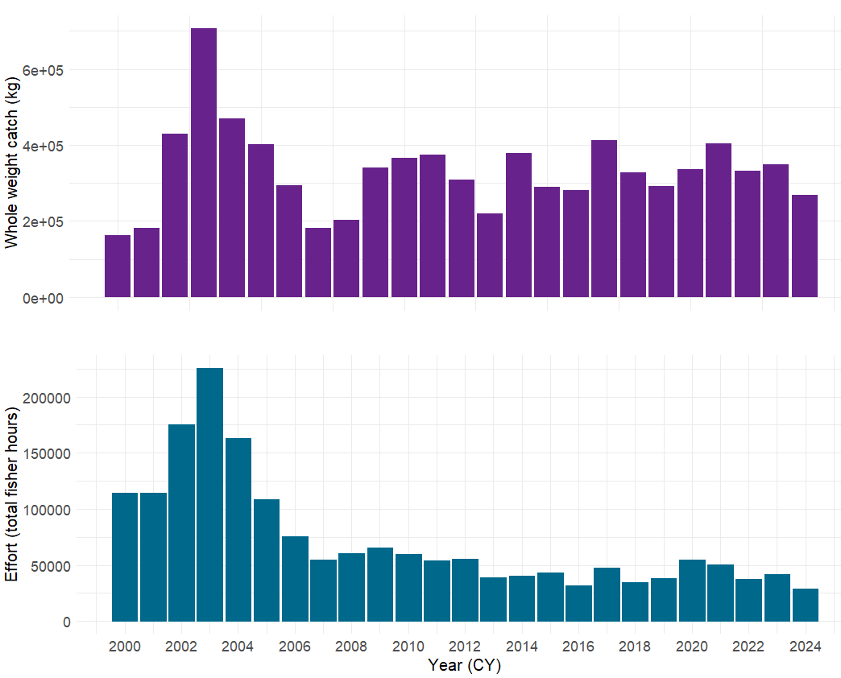
Figure 27. Grey mackerel total catch and effort reported from the commercial component of the Offshore Net and Line Fishery through logbooks.

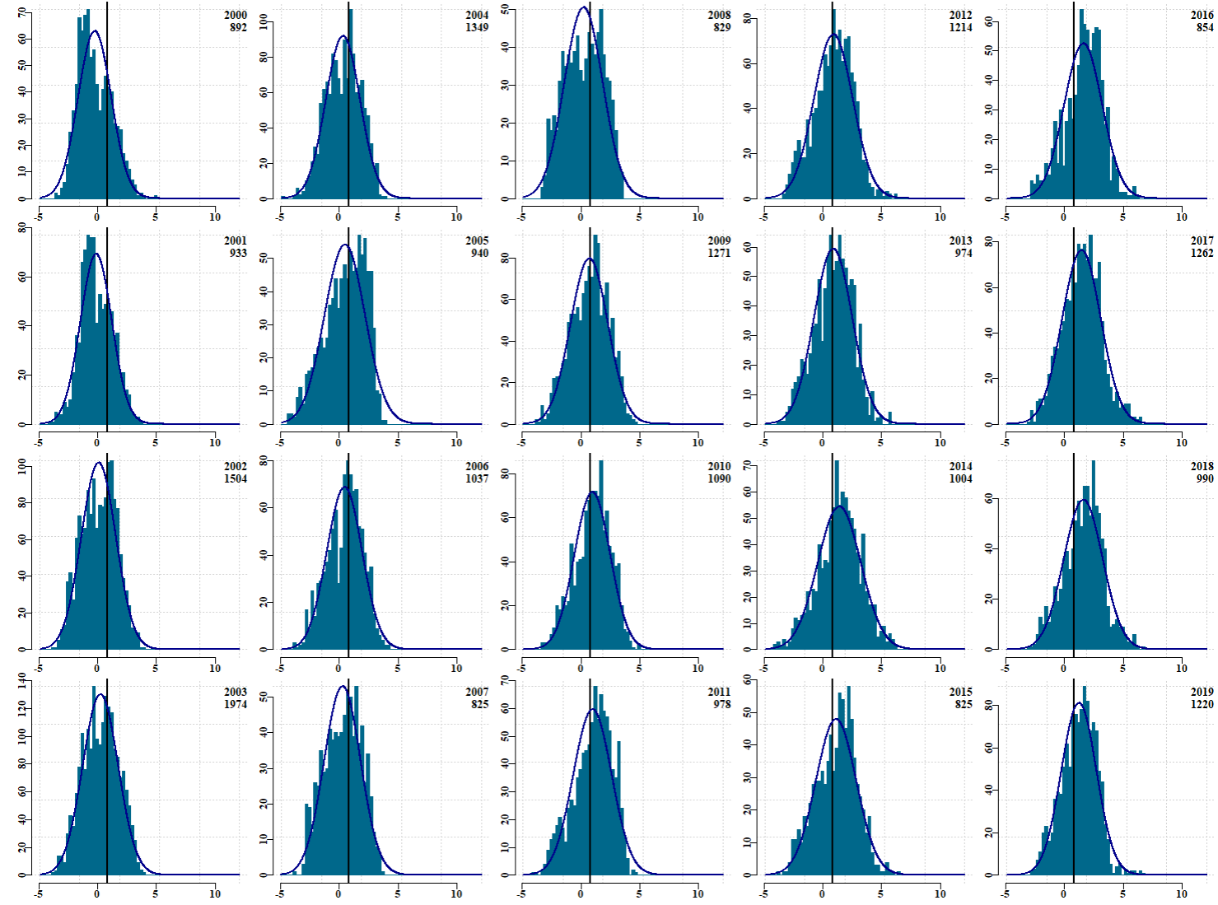
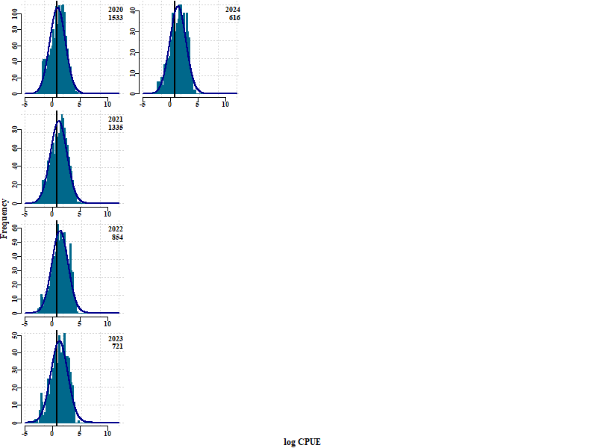
Figure 28. Distribution of log-transformed CPUE by year.

Model choice and diagnostics
A large range of models were tested before selecting the ZAG model. The selection is based on multiple criteria such as Akaike Information Criterion (AIC), dispersion and residual patterns. The models are also tested for zero inflation using ‘DHARMa’ R package (Hartig, 2022), which provides a histogram of the predicted number of zero records based on the fitted model and a red line indicating the actual number of zero records observed in the data set (Figure 29 and Figure 30).

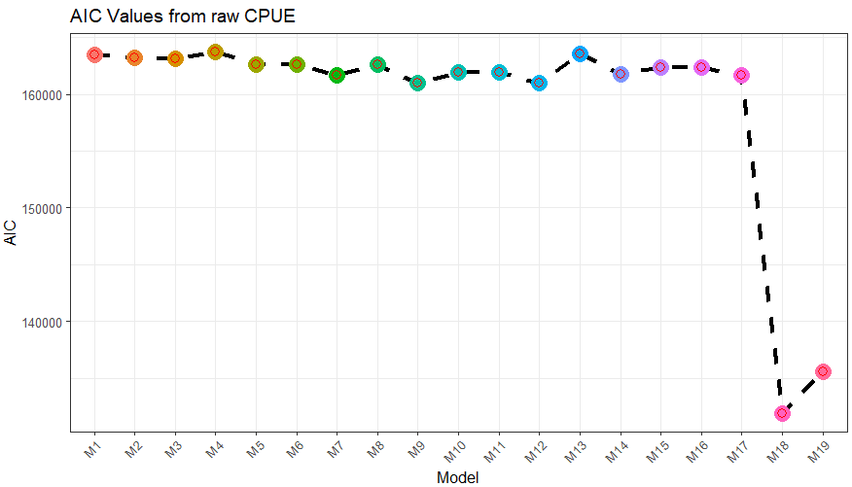
Figure 29. Akaike Information Criterion (AIC) values for the evaluated CPUE scenarios.

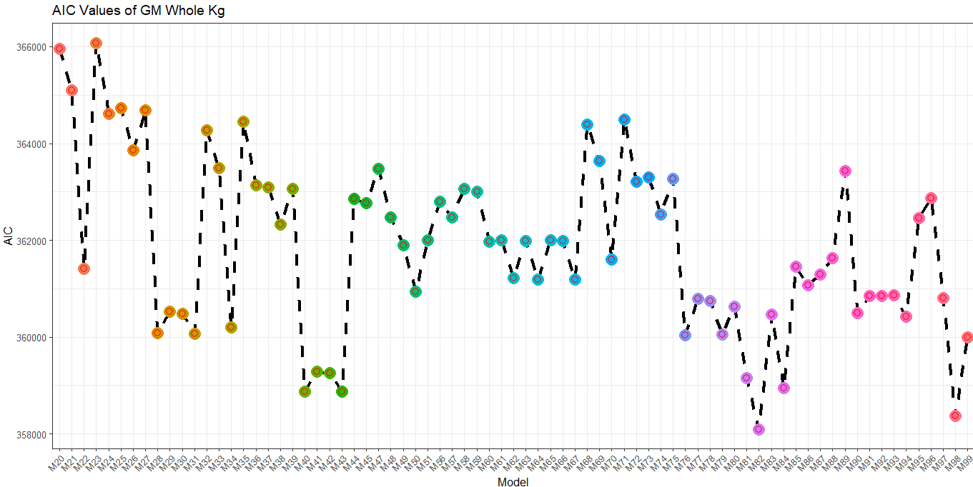
Figure 30. Akaike Information Criterion (AIC) values for the evaluated catch scenarios.

CPUE GLM Model
Family: truncated_nbinom2(log)
Formula:Catch ~ CY + Month + GRID_CODE + offset(log(effort)) + DEPTH + LICENCE_NO
Zero inflation: ~1 + GRID_CODE + LICENCE_NO + gear_units_scaled + SET_HRS + DEPTH
Data: western_gm

AIC BIC logLik deviance df.resid
251695.6 252400.5 -125758.8 251517.6 20252

Dispersion parameter for truncated_nbinom2 family (): 0.554

Conditional model:
Estimate Std. Error z value Pr(>|z|)
(Intercept) -50.921116 5.581685 -9.123 < 2e-16 ***
CY2007 -0.245253 0.064548 -3.800 0.000145 ***
CY2008 -0.350957 0.067272 -5.217 1.82e-07 ***
CY2009 0.065818 0.062726 1.049 0.294043
CY2010 0.326474 0.063767 5.120 3.06e-07 ***
CY2011 0.249346 0.065212 3.824 0.000132 ***
CY2012 0.065868 0.063191 1.042 0.297242
CY2013 0.271298 0.067062 4.045 5.22e-05 ***
CY2014 0.491151 0.067511 7.275 3.46e-13 ***
CY2015 0.207292 0.069087 3.000 0.002696 **
CY2016 0.765206 0.067716 11.300 < 2e-16 ***
CY2017 0.502946 0.061798 8.139 4.00e-16 ***
CY2018 0.512716 0.066745 7.682 1.57e-14 ***
CY2019 0.209333 0.065066 3.217 0.001294 **
CY2020 -0.244650 0.071483 -3.422 0.000620 ***
CY2021 0.287069 0.072401 3.965 7.34e-05 ***
CY2022 0.451346 0.078106 5.779 7.53e-09 ***
CY2023 0.438291 0.078356 5.594 2.22e-08 ***
CY2024 0.804483 0.088577 9.082 < 2e-16 ***
Month2 -0.072324 0.066654 -1.085 0.277891
Month3 0.064542 0.061846 1.044 0.296673
Month4 -0.042369 0.063198 -0.670 0.502589
Month5 -0.375840 0.063625 -5.907 3.48e-09 ***
Month6 -0.130154 0.065527 -1.986 0.047002 *
Month7 0.013054 0.069091 0.189 0.850138
Month8 0.104635 0.062497 1.674 0.094085
Month9 0.423257 0.062360 6.787 1.14e-11 ***
Month10 0.426289 0.061939 6.882 5.88e-12 ***
Month11 0.349535 0.061611 5.673 1.40e-08 ***
Month12 0.112858 0.064901 1.739 0.082048 .
GRID_CODE1033 -0.119833 0.371333 -0.323 0.746914
GRID_CODE1036 0.225192 0.306438 0.735 0.462419
GRID_CODE1129 -0.508912 0.165231 -3.080 0.002070 **
GRID_CODE1130 0.296032 0.103609 2.857 0.004274 **
GRID_CODE1131 0.082585 0.122337 0.675 0.499636
GRID_CODE1132 0.261217 0.103838 2.516 0.011882 *
GRID_CODE1133 0.592480 0.103847 5.705 1.16e-08 ***
GRID_CODE1134 0.441189 0.116713 3.780 0.000157 ***
GRID_CODE1135 0.656894 0.114045 5.760 8.41e-09 ***
GRID_CODE1136 0.678001 0.121796 5.567 2.60e-08 ***
GRID_CODE1229 -0.101686 0.118752 -0.856 0.391836
GRID_CODE1230 0.049630 0.099721 0.498 0.618706
GRID_CODE1231 -0.784931 0.514860 -1.525 0.127370
GRID_CODE1235 0.149833 0.173216 0.865 0.387035
GRID_CODE1236 -0.894947 0.251543 -3.558 0.000374 ***
GRID_CODE1329 0.170463 0.099681 1.710 0.087250
GRID_CODE1330 0.332956 0.109820 3.032 0.002431 **
DEPTH 0.009691 0.003009 3.221 0.001277 **
LICENCE_NO1861 0.215827 0.079716 2.707 0.006780 **
LICENCE_NO1879 0.556068 0.060975 9.120 < 2e-16 ***
LICENCE_NO4001 -0.632119 0.123128 -5.134 2.84e-07 ***
LICENCE_NO4024 0.434418 0.080273 5.412 6.24e-08 ***
LICENCE_NO4027 0.255988 0.082994 3.084 0.002040 **
LICENCE_NO4028 0.806871 0.093427 8.636 < 2e-16 ***
LICENCE_NO4029 0.626688 0.080472 7.788 6.83e-15 ***
LICENCE_NO4030 0.049727 0.083279 0.597 0.550430
LICENCE_NO5001 0.151158 0.095147 1.589 0.112135
LICENCE_NO5002 1.680928 0.061345 27.401 < 2e-16 ***
LICENCE_NO5003 -0.020842 0.163486 -0.127 0.898554
LICENCE_NO5004 0.358542 0.118704 3.020 0.002524 **
LICENCE_NO5005 -0.274972 0.077083 -3.567 0.000361 ***
LICENCE_NO5006 -0.169975 0.105646 -1.609 0.107637
LICENCE_NO5008 0.547273 0.061862 8.847 < 2e-16 ***
LICENCE_NO5009 -0.121838 0.102873 -1.184 0.236273
LICENCE_NO5010 0.394120 0.054912 7.177 7.11e-13 ***
LICENCE_NO5011 0.581797 0.056595 10.280 < 2e-16 ***
---
Signif. codes: 0 ‘***’ 0.001 ‘**’ 0.01 ‘*’ 0.05 ‘.’ 0.1 ‘ ’ 1

Zero-inflation model:
Estimate Std. Error z value Pr(>|z|)
(Intercept) -3.297779 0.357122 -9.234 < 2e-16 ***
GRID_CODE1033 -0.231272 0.865149 -0.267 0.78922
GRID_CODE1036 -6.502764 11.654699 -0.558 0.57688
GRID_CODE1129 -0.110520 0.317037 -0.349 0.72739
GRID_CODE1130 -0.200163 0.223810 -0.894 0.37114
GRID_CODE1131 -0.215145 0.272175 -0.790 0.42926
GRID_CODE1132 -0.996622 0.237373 -4.199 2.69e-05 ***
GRID_CODE1133 -1.105226 0.238630 -4.632 3.63e-06 ***
GRID_CODE1134 -0.588566 0.273970 -2.148 0.03169 *
GRID_CODE1135 -0.785527 0.273447 -2.873 0.00407 **
GRID_CODE1136 -0.858228 0.280226 -3.063 0.00219 **
GRID_CODE1229 0.234063 0.253202 0.924 0.35527
GRID_CODE1230 -0.201051 0.215311 -0.934 0.35042
GRID_CODE1231 1.935710 0.650243 2.977 0.00291 **
GRID_CODE1235 -1.323978 0.548140 -2.415 0.01572 *
GRID_CODE1236 0.689320 0.375310 1.837 0.06626 .
GRID_CODE1329 -0.645422 0.217927 -2.962 0.00306 **
GRID_CODE1330 -0.199996 0.242920 -0.823 0.41034
LICENCE_NO1861 1.203901 0.216852 5.552 2.83e-08 ***
LICENCE_NO1879 0.465078 0.183017 2.541 0.01105 *
LICENCE_NO4001 1.919458 0.257605 7.451 9.25e-14 ***
LICENCE_NO4024 0.299619 0.252592 1.186 0.23555
LICENCE_NO4027 0.909462 0.226443 4.016 5.91e-05 ***
LICENCE_NO4028 -0.300631 0.419447 -0.717 0.47354
LICENCE_NO4029 -0.126816 0.269309 -0.471 0.63772
LICENCE_NO4030 0.968239 0.243030 3.984 6.78e-05 ***
LICENCE_NO5001 -0.083431 0.329181 -0.253 0.79992
LICENCE_NO5002 0.258386 0.191567 1.349 0.17740
LICENCE_NO5003 2.444633 0.261964 9.332 < 2e-16 ***
LICENCE_NO5004 0.367309 0.359805 1.021 0.30732
LICENCE_NO5005 1.486258 0.226090 6.574 4.91e-11 ***
LICENCE_NO5006 2.345717 0.237018 9.897 < 2e-16 ***
LICENCE_NO5008 0.849299 0.189930 4.472 7.76e-06 ***
LICENCE_NO5009 0.714813 0.275254 2.597 0.00941 **
LICENCE_NO5010 0.065085 0.174534 0.373 0.70922
LICENCE_NO5011 0.394239 0.186938 2.109 0.03495 *
gear_units_scaled 0.070562 0.011953 5.903 3.56e-09 ***
SET_HRS -0.159605 0.023655 -6.747 1.51e-11 ***
DEPTH 0.021062 0.006535 3.223 0.00127 **
---
Signif. codes: 0 ‘***’ 0.001 ‘**’ 0.01 ‘*’ 0.05 ‘.’ 0.1 ‘ ’ 1

Diagnostics
QQ plot - Residual Patterns | Smooth scatter plot of residuals with quantile regression
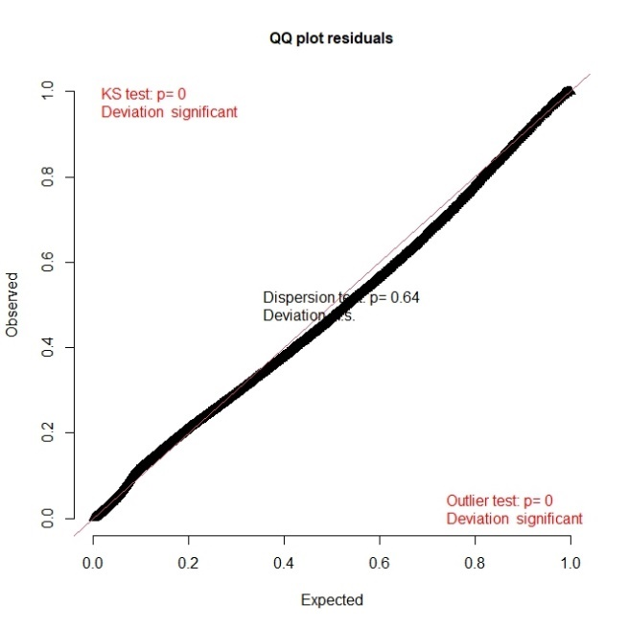 | 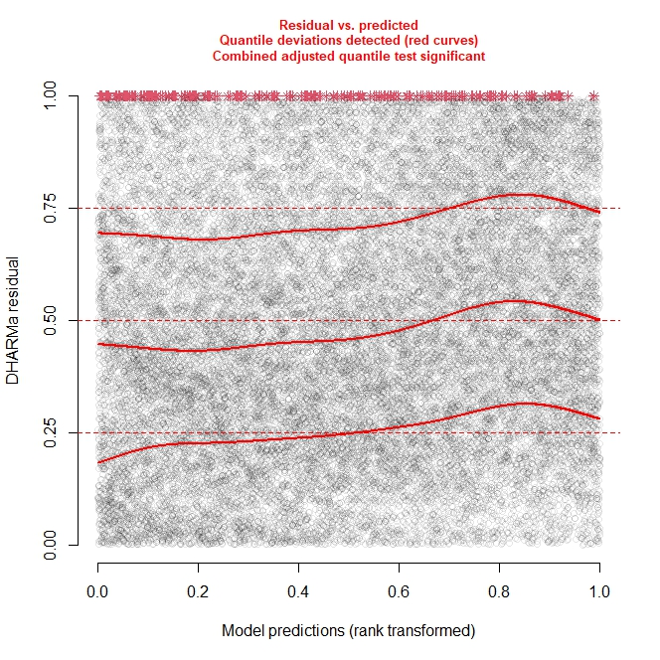
Dispersion test | Zero Inflation Test
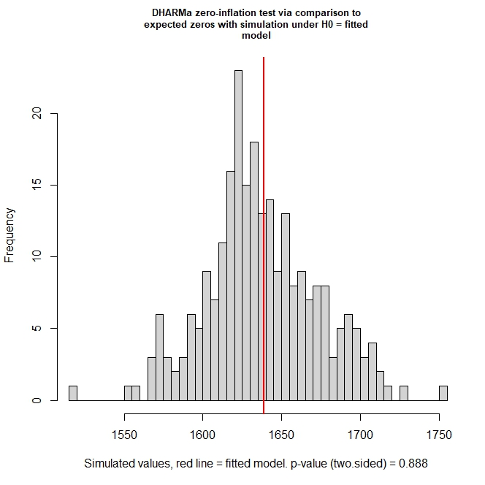 | 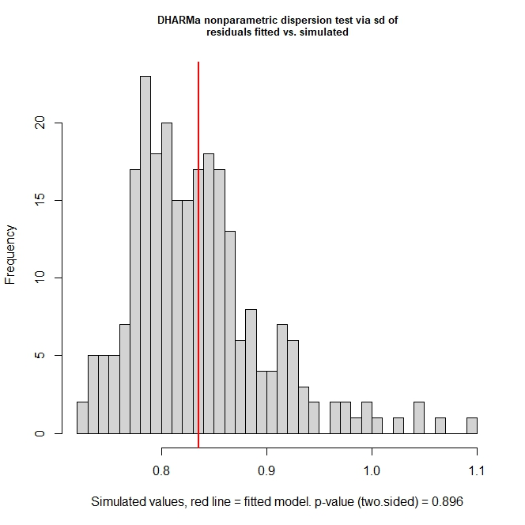
Figure 31. Characteristics of the ZAG - GLM model (M99) used to standardise the abundance index for Grey Mackerel catch in the Northern Territory.

Coefficient of variation for CPUE
Stock Synthesis requires the user to provide the coefficient of variation (CV) associated to CPUE values in the time series. This is achieved by fitting a smooth curve using a locally estimated scatterplot smoothing (aka LOESS) nonparametric method (the ‘loess’ function in R statistical software). No assumptions are made about the underlying structure of data. The degree of smoothing was set to α=0.4. The coefficient of variation is computed using the fit and standard error from predicted values of the LOESS model (Figure 32 and Figure 33).
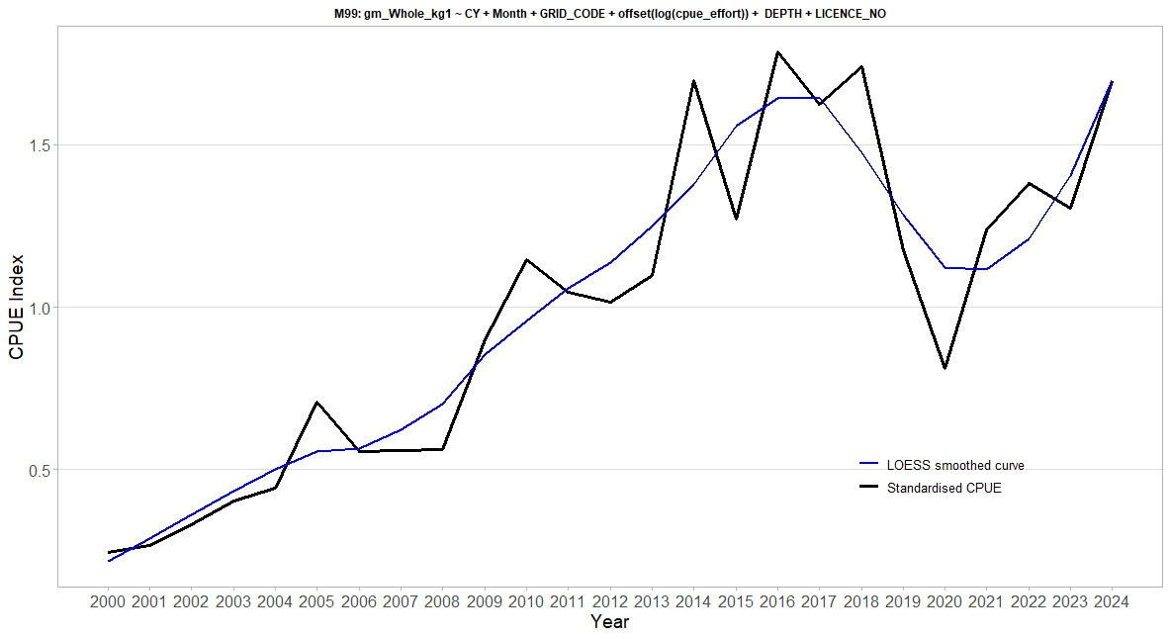

Figure 32. Standardised CPUE from 2000 to 2024 with a LOESS-fitted Smoothing.
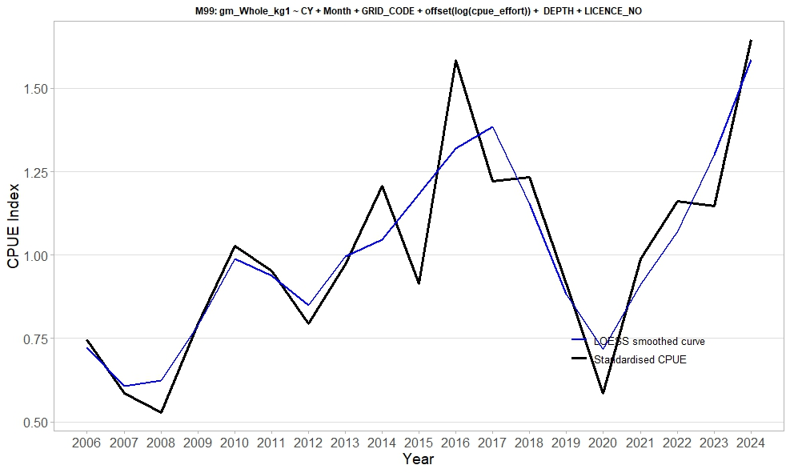
Figure 33. Standardised CPUE from 2006 to 2024 with a LOESS-fitted Smoothing.

Transition from 2000-2021 CPUE to 2006-2024 CPUE standardisation.
Standardisation of the CPUE index has been rigorously addressed in light of historical shifts in fishing practices and gear configurations that may confound the interpretation of relative abundance (see Appendix 9.2 for detailed methodological considerations). The original CPUE series from 2000 to 2021 includes periods of variable mesh sizes and non-targeted fishing, particularly prior to 2006 when the fishery operated with gillnets ranging from 135 to 250 mm and retained a multispecies catch. Following regulatory changes in 2006, mesh sizes were standardised to 160–185 mm and Grey Mackerel became the primary target. These modifications significantly enhanced the reliability of CPUE as a proxy for relative stock abundance from 2006 onwards. To evaluate the implications of these changes on stock dynamics, five alternative bridging assessment scenarios were developed, incorporating different CPUE periods and recruitment estimation periods, with and without tuning (Appendix 9.5.

Biology

Bayes Growth
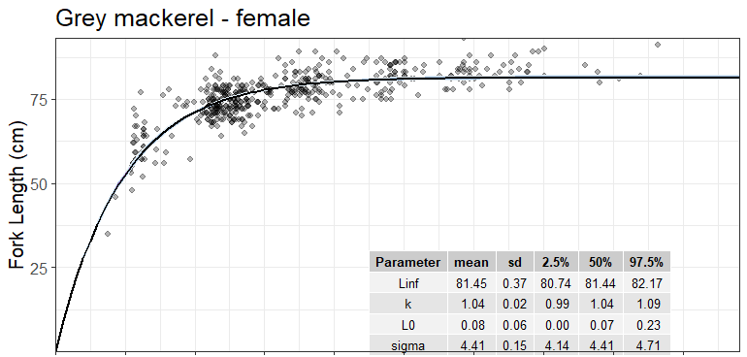
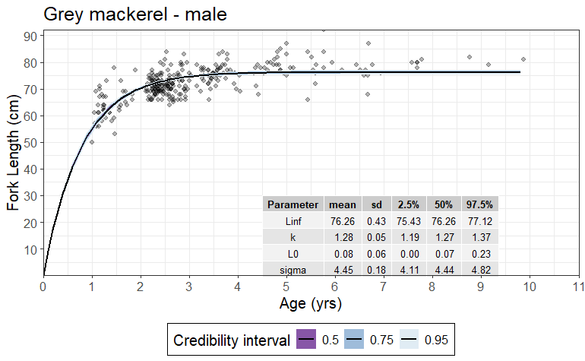
Figure 34. Estimated initial growth curve by sex for the North West NT stock of Grey Mackerel.

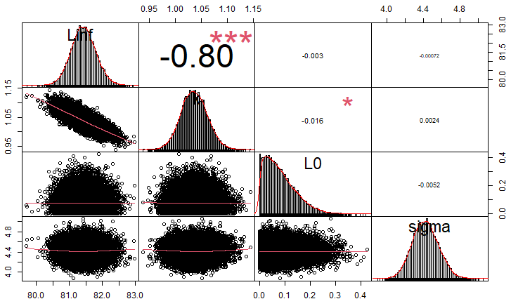
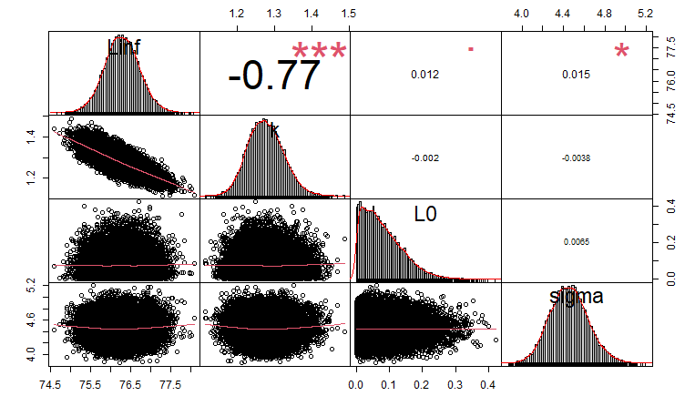
Figure 35. Autocorrelation matrix and kernel density overlays of growth parameters estimated by sex from the posterior distribution for the North West NT Grey Mackerel stock. Asterisks indicate statistical significance (0.05, 0.01 and 0.001).

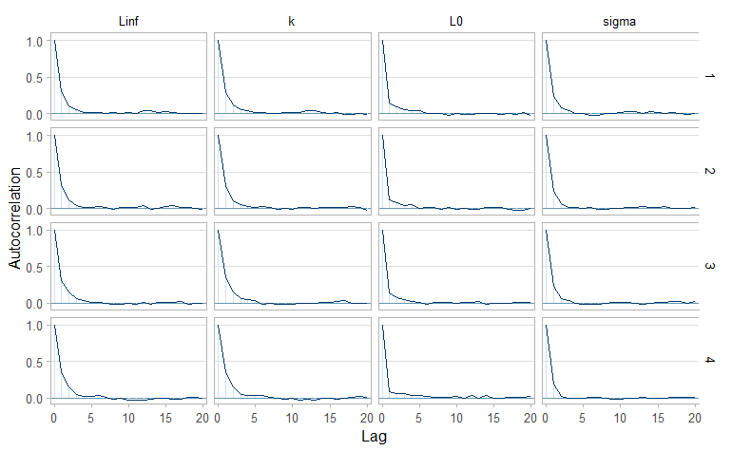

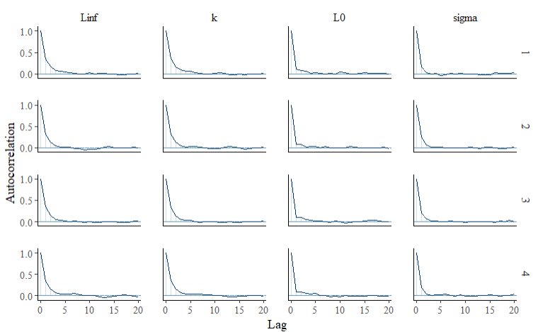
Figure 36. Autocorrelation plots for the MCMC samples of growth parameters (L∞, k, L₀, and σ) for the North West NT stock of Grey Mackerel. Each row represents one of the four Markov chains used in the Bayesian von Bertalanffy growth model.

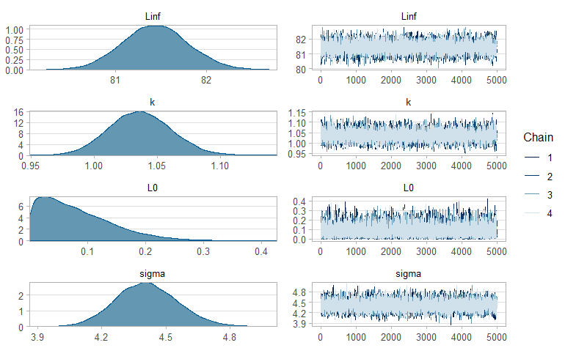
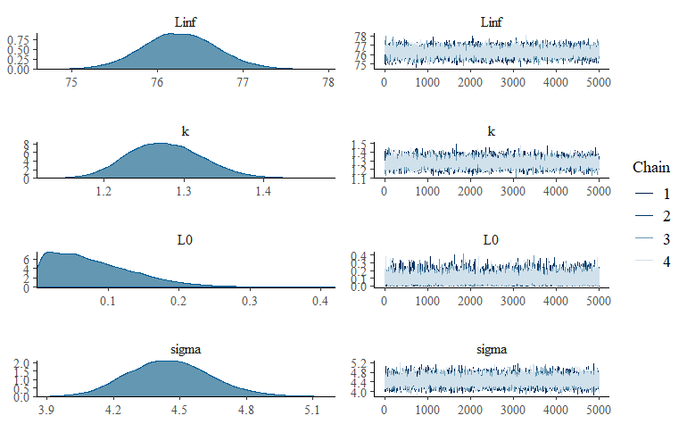
Figure 37. Probability of distribution and trace plots of growth parameters estimated from the posterior distribution for North West NT stock of Grey Mackerel.

Table 18. Summary statistics for growth parameters of male and females from the MCMC analysis of the North West NT Grey Mackerel stock.
Parameter | Mean | sd | Rhat | Neff/N | Geweke-Z
Females
$$L_{∞}$$ | 81.44 | 0.37 | 1 | 9734 | 1.93645
$$k$$ | 1.036 | 0.33 | 1 | 9391 | -1.88192
$$L_{0}$$ | 8.168 | 0.06 | 1 | 12852 | -1.55622
$$σ$$ | 4.412 | 0.14 | 0.99 | 12382 | -1.40461
Males
$$L_{∞}$$ | 76.26 | 0.43 | 1 | 9002 | 0.8585
$$k$$ | 1.28 | 0.05 | 1 | 8720 | -1.6736
$$L_{0}$$ | 0.08 | 0.06 | 1 | 12333 | 0.9076
$$σ$$ | 4.45 | 0.19 | 1 | 11441 | -0.1097

Table 19. Heidel Stationarity test for growth parameters of MCMC analysis of the North West NT Grey Mackerel stock.
Parameter | p-value | Halfwidth | Stationarity
Females
$$L_{∞}$$ | 0.1012 | 0.005360 | Passed
$$k$$ | 0.0795 | 0.000364 | Passed
$$L_{0}$$ | 0.0693 | 0.000857 | Passed
$$σ$$ | 0.5886 | 0.002060 | Passed
Males
$$L_{∞}$$ | 0.442 | 0.0057 | Passed
$$k$$ | 0.692 | 0.0006 | Passed
$$L_{0}$$ | 0.470 | 0.0008 | Passed
$$σ$$ | 0.424 | 0.0025 | Passed

Length-weight relationship
The externally estimated length–weight relationship, based on observed length and weight data for grey mackerel, indicated sex-specific differences in the intercept (a) and slope (b) parameters (Figure 38). For females, the intercept was estimated at $a=4×{10}^{-5}$with an allometric exponent of $b=2.63596$, indicating a steeper increase in weight with length. Males exhibited a slightly higher intercept ($a=5×{10}^{-5}$) and a lower slope ($b=2.59205$), reflecting a comparatively slower rate of weight gain as length increases. These externally derived parameter estimates were used as prior information and initial values in the Stock Synthesis (SS3) model.
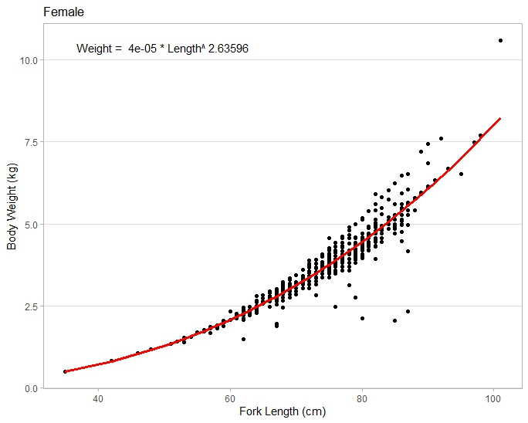
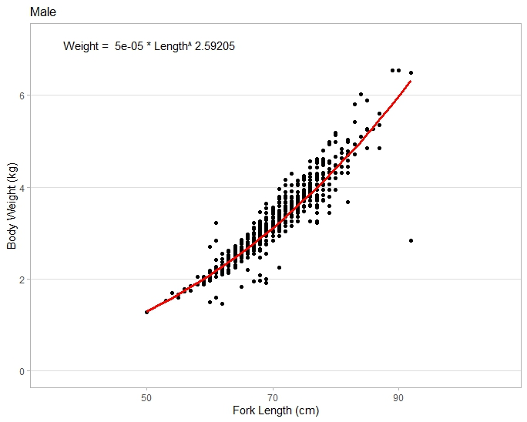
Figure 38. Length-weight relationship by sex of the Northwest Grey Mackerel stock.

Coefficient of variation of length composition
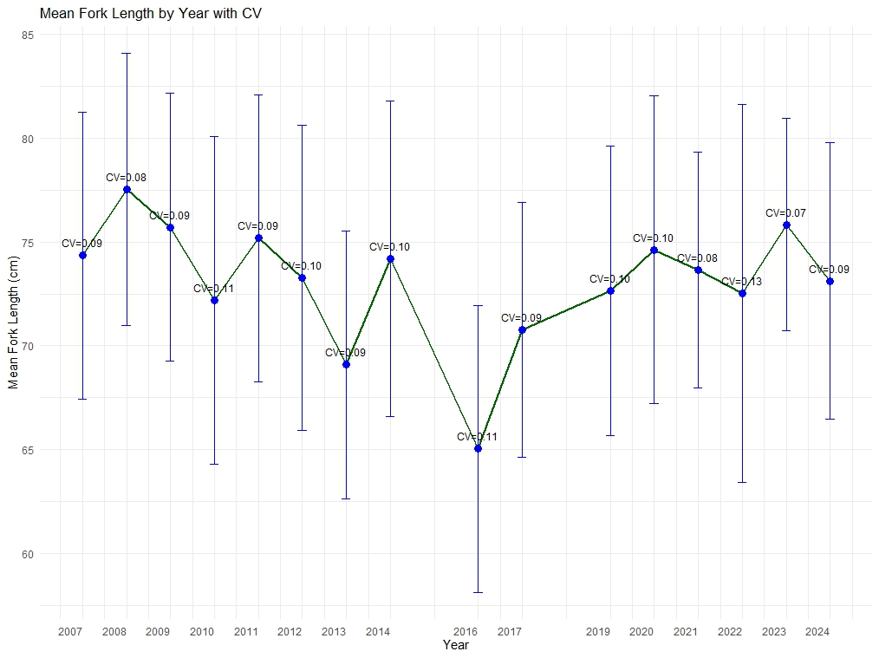
Figure 39. Coefficient of variation of fork length (cm) for combined sex by year that informed the 2025 SRA and SS3 assessments.
Table 20. Statistic summary of fork length for young and old male and female Grey Mackerel by year, used in the 2025 Integrated Stock Assessment Model.
 | Mean | Standard deviation | Coefficient of Variation
Young male | 70.62 | 5.732 | 0.081
Old male | 86.65 | 1.991 | 0.066
Young female | 60.70 | 3.8189 | 0.062
Old female | 87.42 | 2.993 | 0.034

SRA outcomes
The total biomass trajectories estimated by the bridging stochastic SRA scenarios exhibit significant variation from 1983 to 2024, with median biomass estimates ranging between approximately 1600 and 3400 tonnes (Figure 40). All scenarios indicate relatively high biomass levels at the beginning of the time series, with total biomass estimates around 2800–3500 t in 1995. A marked decline is observed between 1997 and 2005, with total biomass dropping to approximately 3200–1500 t, depending on the scenario. From 2008 to 2012, the total biomass estimates across scenarios show a period of stabilisation or modest recovery, with total biomass fluctuating around 2200–2800 t. From 2013 onwards, most scenarios demonstrate a consistent increasing trend, with total biomass gradually rising and stabilising between approximately 2400 and 2800 t by 2021. The 2022 SRA (red line and unpublished report) projects a biomass of ~2553 t in 2021.
From 2021 to 2024, some divergence among scenarios is apparent particularly among those incorporating different data i.e., CPUE time series, growth parameters, and recruitment variability. Nevertheless, all trajectories converge toward a similar biomass estimate for 2024, ranging between 2500 and 2560 t. The last four 2025 SRA scenarios, which incorporate updated growth parameters based on data until 2024, also estimate biomass levels within this same range.
Although the scenarios differ in model structure—including the use of two CPUE series (CPUE1: 2000–2021; CPUE2: 2006–2021), recruitment variability (σ=0.4 vs σ=0.6), and growth assumptions (2022 vs. 2025)—the convergence of biomass estimates by 2024 indicates that the integration of new data and CPUE sources has a limited effect on total biomass under a broad set of assumptions (Figure 40).
A similar pattern is observed in the depletion estimates derived from the joint posterior distribution of the bridging stochastic SRA scenarios (Figure 41). The 2022 SRA scenario (S1, Table 6), which utilised CPUE data from 2000–2021, 2022 growth parameters, and a recruitment variability of 0.4, estimated a median depletion of 0.68. In contrast, the 2025 SRA scenarios (S2 to S7, Table 6) which incorporated extended CPUE series (to 2024), revised growth parameters, and updated recruitment variability—produced a range of median depletion values between 0.71 and 0.88.
Although the 2025 SRA scenarios indicate slightly higher depletion estimates compared to 2022, the overall trend remains largely consistent. These results suggest that the incorporation of updated data up to 2024, along with two different CPUE standardised series, has not substantially impact the stock status estimation from SRA analysis (Figure 41).

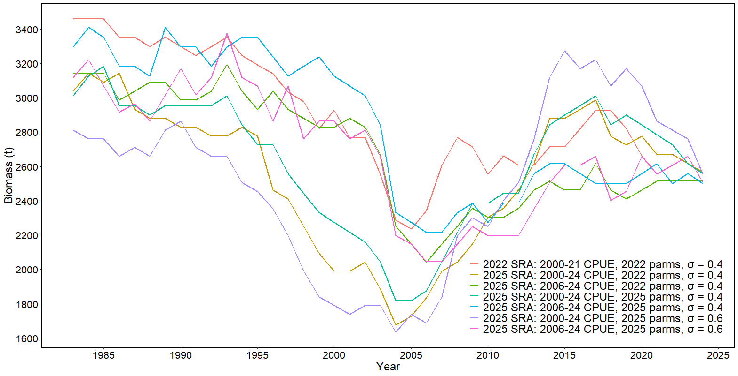
Figure 40. The estimate time-series of total biomass for the bridging SRA models of the 2025 North West NT Grey Mackerel assessment.

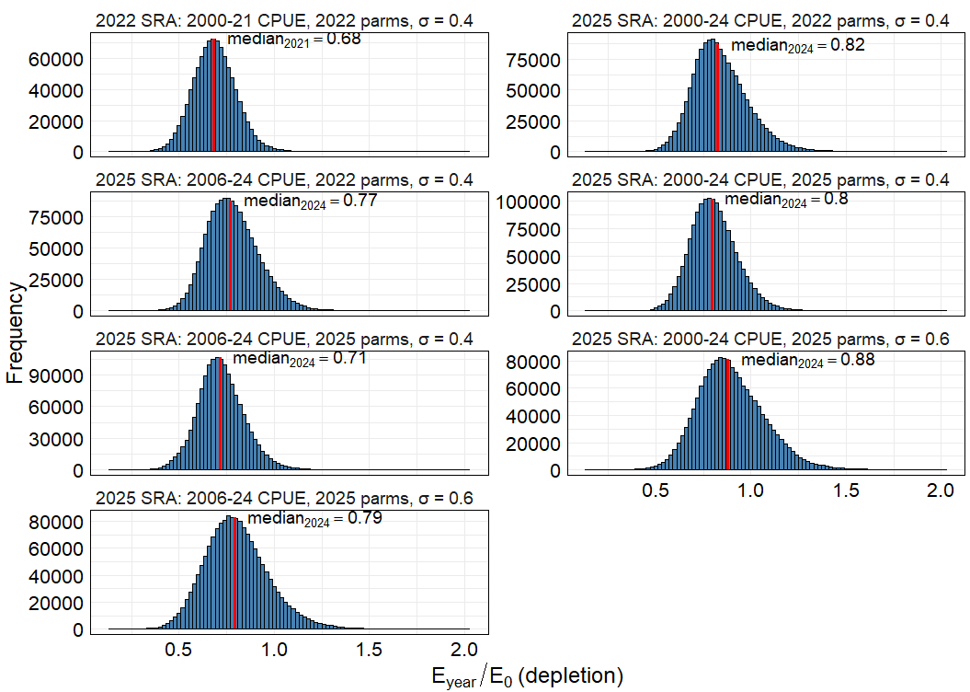
Figure 41. Depletion for the bridging SRA models of the 2025 North West Grey Mackerel assessment. Frequency distribution of depletion $(E_{current}/E_{0})$, defined as the ratio of estimated egg production in the current relative to unfished egg production ($E_{0}$) as proxy of ($B_{curr}/B_{0}$), based on the join posterior distribution MCMC samples from the Stochastic Reduction Analysis (SRA). The red line represents the median depletion value.
Given the minimal differences observed among the bridging scenarios in the SRA, only three Kobe plots are presented (Scenario 1, 6 and 7, Table 6). The first corresponds to the 2022 SRA (S1: CPUE from 2000–2021, 2022 growth parameters, σ = 0.4). Scenarios 6 (CPUE from 2000–2024, 2024 growth parameters, σ = 0.4) and 7 (S7: CPUE from 2006–2024, 2024 growth parameters, σ = 0.6) were selected for comparison, as they most closely align with the input assumptions used in the Stock Synthesis (SS3) framework.
The Kobe plot from SRA diagnostic shows the relative egg production ($E_{curr}/E_{0}$) as proxy of ${SBB}_{curr}/{SBB}_{0}$ plotted against relative fishing intensity, which provides a measure of overall fishing mortality in relation to reproductive capacity based on posterior median estimates from the MCMC analysis from SRA (Figure 42 and Figure 43).
The Kobe plot from the 2022 baseline SRA assessment shows that the reproductive capacity of the stock remains well above the critical limit reference point $(E_{2024}/E_{0}=0.67)$ and fishing intensity below one $(F_{2024}/F_{msy}=0.49)$, supporting a classification of the stock as sustainable under the SRA framework (Figure 43). Similarly, Scenario 6, which uses CPUE from 2000 until 2024, yields a posterior median with relative egg production at 0.88 and fishing intensity at 0.22, placing the stock firmly within the sustainable quadrant and indicating an even more favourable biological condition than observed under the 2022 SRA (Figure 43). Scenario 7, which excludes pre-2006 CPUE data to better reflect the period of targeted Grey Mackerel fishing, presents a posterior median of relative egg production at 0.79 and fishing intensity at 0.25, likewise reinforcing the sustainable classification (Figure 43). These results suggest that both bridging scenarios describe a stock with strong reproductive potential and fishing pressure well below $F_{msy}$. The notably higher $E_{curr}/E_{0}$ ratios in both scenarios, particularly Scenario 6, further confirm that the Northwest stock of Grey Mackerel remains well above biomass trigger thresholds, thereby reducing the likelihood of recruitment impairment or overexploitation of the resources. Collectively, all three scenarios (Scenario 1,6 and 7) fall within the sustainable quadrant as defined by the SRA framework $E_{curr}/E_{0}>0.2$ and $F_{curr}/F_{msy}<1$, and no evidence of depletion, overfishing, or stock recovery is indicated. Instead, the analyses consistently point toward a stock that is biologically healthy and sustainably harvested under current conditions.
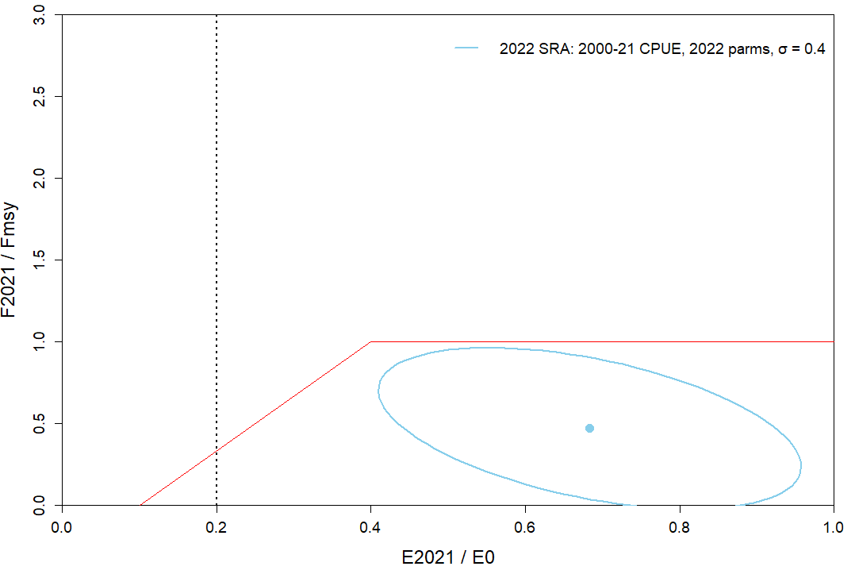
Figure 42. Kobe plot of relative egg production vs fishing intensity from the 2022 stochastic SRA model for North West stock of Grey Mackerel. The central point represents the median of the join posterior distribution with ~95% asymptotic intervals (blue ellipse). The dashed red line is the 0.2${SB}_{0}$ minimum threshold for relative egg production).

Figure 43. Kobe plot of relative egg production vs fishing intensity from the 2025 bridging stochastic SRA analysis for North West Grey Mackerel. The central point represents de median of the join posterior distribution with ~95% asymptotic intervals for each scenario (blue and green ellipse). The dashed line is the 0.2${SB}_{0}$ minimum stock threshold.

SRA diagnostics
Convergence and stationarity of the SRA scenarios were assessed using the following diagnostic statistics: i) Trace plots were visually inspected to evaluate adequate mixing and stability across iterations, where high autocorrelations indicate slow mixing and slow convergence, ii) Autocorrelation plots were examined to assess the degree of dependence between successive samples, where lower autocorrelation is preferred as it indicates more efficient sampling. Ideally, autocorrelations should decay to near zero within the first few lags. iii) Number of effective sample size (Neff) is calculated to quantify the number of independent samples contributing to each posterior distribution, with Neff values below 200 flagged as indicative of potential convergence issues. Iv) Geweke diagnostic test was applied to compare the means of the early and late part of the chain, where Z-scores within ±1.96 (at the 95% confidence level) suggest stationarity and convergency; and v) Heidelberger and Welch diagnostics was used to test both stationarity and the stability of the posterior mean through a two-stage evaluation comprising a stationarity test and a half-width test. The R package, coda (Plummer et al., 2006) and Bayesplot (Gabry and Mahr, 2019) were used to produce the plots and statistics diagnostics. Only parameters that passed all major diagnostics (trace and autocorrelation plots, Neff > 200, Geweke Z-scores within bounds, and Heidelberger-Welch stationarity) were used for final inference and decision-making.

SRA Diagnostics
Given the limited impact of incorporating additional CPUE data from recent years, updated biological parameters, and increased recruitment variability on the stock status estimates from the SRA analysis, only three scenarios were selected for bridging: scenario 1 (S1: 2000-21 CPUE, 2022 parms, $σ=0.4$), scenario 6 (S6: 2000-24 CPUE, 2025 parms, $σ=0.6$) and scenario 7 (S7: 2006-24 CPUE, 2025 parms, $σ=0.6$). Scenario 1 was included as it aligns with the previous stock assessment of North West NT stock of Grey Mackerel (Unpublished, 2021), while scenarios 6 and 7 were selected as they most closely align with the inputs used in the Stock Synthesis (SS) assessment.
Based on the convergence diagnostics derived from the Geweke statistic and supported by visual inspection of MCMC trace plots, the performance of the three scenarios in terms of parameter convergence was variable and, in several cases, insufficient to support robust inference (Figure 44 -Figure 47). Scenario S1 showed particularly pronounced convergence issues in key biomass-related parameters, such as total biomass in 2021 (${Btot}_{2021}$) and spawning stock biomass in 2021 (${SSB}_{2021}$), both of which recorded high Geweke Z-scores (Table 21, 3.40 and 6.01, respectively) and exhibited poor mixing and autocorrelation patterns in their trace plots (Figure 47) . Additionally, the egg production in the year 2021 relative to the egg production in the virgin year ($E_{2021}/E_{0}$) did not converge, with a low effective sample size and a Z-score of 2.04. Here, $E_{0}$ refers to the egg production in the virgin year ($E_{0}$).
Scenarios 6 and 7 demonstrated improved convergence compared to scenario 1, with most parameters falling within acceptable diagnostic thresholds. However, the goodyear recruitment compensation ratio (RecK) failed to converge in both scenarios, exhibiting a Geweke score of -2.2 and erratic trace plots, suggesting multimodality or poor chain mixing (Table 21). Despite this, key parameters including MCMC estimates of MSY (MCMC.MSY), exploitation at MSY (U_{MSY}), survival rate ($S$), relative egg production in 2024 ($E_{2024}/E_{0})$, relative exploitation in 2024 ($U_{2024}/U_{msy}$), total biomass in 2024 (${Btot}_{2024}$), spawning stock biomass in 2024 (${SSB}_{2024}$), and the SSB required to achieve MSY (${SSB}_{msy}$) consistently converged across scenarios (Table 21) . Therefore, scenarios 6 and 7 are more appropriate for management advice, as they incorporate updated biological parameters and CPUE time series while also demonstrating robust convergence for key parameters.

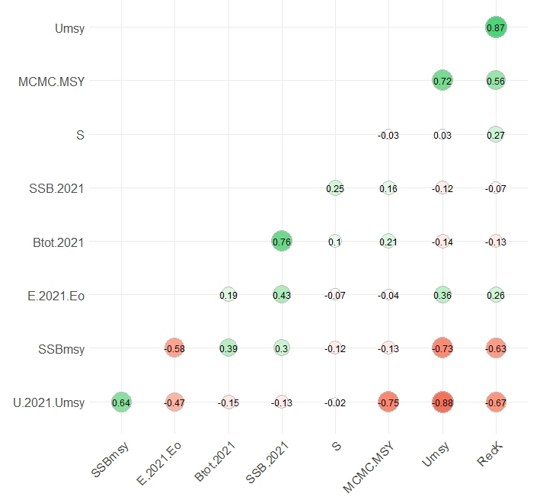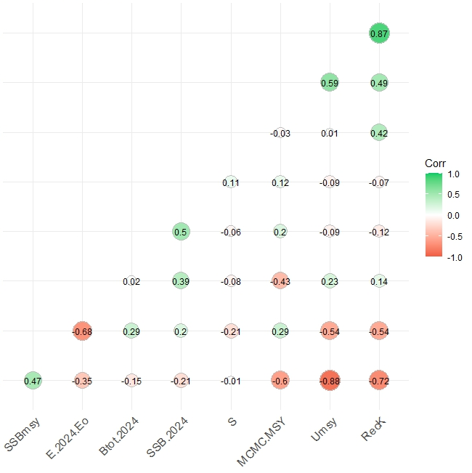
S1
S6
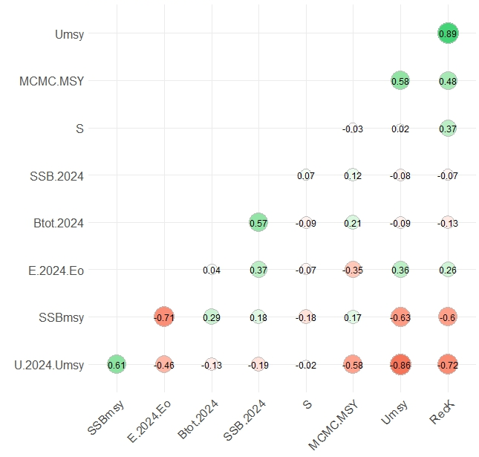
S7
Figure 44. Pairwise correlation matrix among key biological and management parameters from the posterior distribution of Scenarios 1, 6 and 7 of the SRA models for North West NT Grey Mackerel. The plot displays Pearson correlation coefficients, with the colour gradient ranging from red (strong negative correlation) to green (strong positive correlation). Circle size is proportional to the square root of the coefficient.

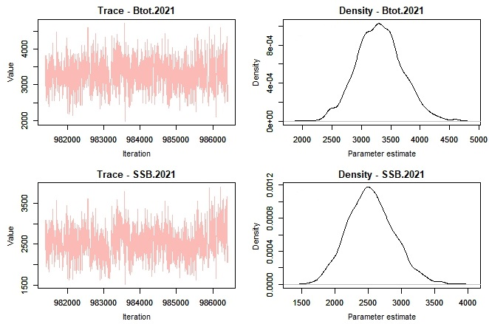
Figure 45. Trace plots to track autocorrelation and posterior density estimates of total biomass ($B_{tot}$) and spawning stock biomass ($SSB$) in 2021, from the SRA posterior distribution of scenario 1 (Updated 2022 SRA, Table 21).
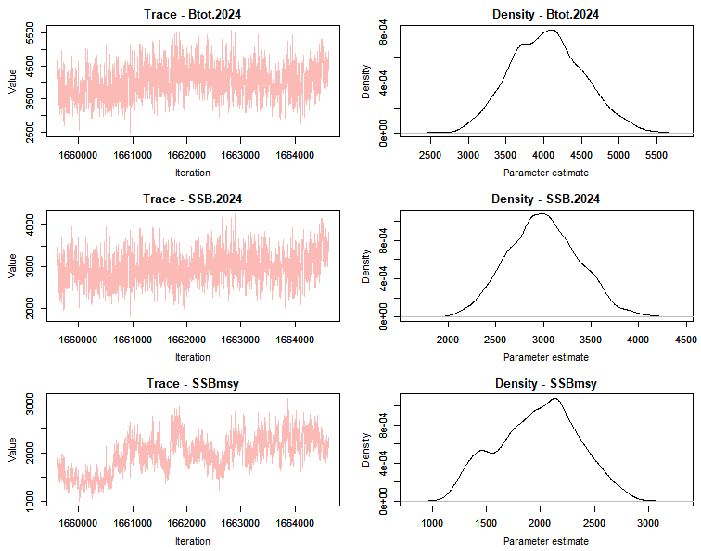

Figure 46. Trace plots to track autocorrelation and posterior density estimates of total biomass ($B_{tot}$) and spawning stock biomass ($SSB$) in 2024, from the SRA posterior distribution of scenario 6 (2025 SRA assessment with CPUE: 2000-2024).

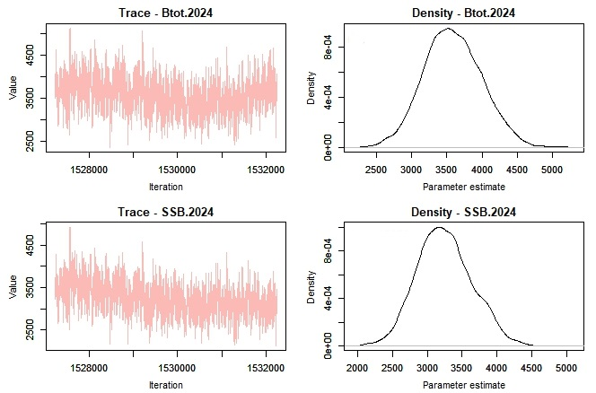
Figure 47. Trace plots to track autocorrelation and posterior density estimates of total biomass ($B_{tot}$) and spawning stock biomass ($SSB$) in 2024, from the SRA posterior distribution of scenario 7 (2025 SRA assessment with CPUE: 2006-2024).

Table 21. Summary statistics for quantities from the SRA MCMC analysis.
Scenarios | Parameter | Mean | SD | nEFF | Z-Geweke | Convergence
S1 | MCMC.MSY | 583.1 | 115.3 | 5042 | -1.41 | Converged
S1 | Umsy | 0.4 | 0.1 | 6142 | -0.27 | Converged
S1 | S | 0.7 | 0 | 6838 | 0.15 | Converged
S1 | E.2021.Eo | 0.7 | 0.1 | 683 | 2.04 | Not Converged
S1 | U.2021.Umsy | 0.5 | 0.2 | 5537 | 0.42 | Converged
S1 | RecK | 11.2 | 7.4 | 8598 | -0.34 | Converged
S1 | Btot.2021 | 3293 | 388.9 | 39146 | 3.4 | Not converged
S1 | SSB.2021 | 2565.2 | 368.5 | 12023 | 6.01 | Not converged
S1 | SSBmsy | 2276 | 503.6 | 2765 | -1 | Converged
S6 | MCMC.MSY | 569.6 | 150.2 | 5982 | 0.5 | Converged
S6 | Umsy | 0.5 | 0.2 | 8297 | -1.9 | Converged
S6 | S | 0.7 | 0.0 | 9193 | -1.2 | Converged
S6 | E.2024.Eo | 0.9 | 0.2 | 637 | -1.2 | Converged
S6 | U.2024.Umsy | 0.3 | 0.1 | 7256 | 1.2 | Converged
S6 | RecK | 5.9 | 2.7 | 10650 | -2.2 | Not converged
S6 | Btot.2024 | 3936.4 | 607.9 | 4500 | 0.4 | Converged
S6 | SSB.2024 | 3112.1 | 410.4 | 18047 | -1.8 | Converged
S6 | SSBmsy | 2298.3 | 578.3 | 2193 | 1.5 | Converged
S7 | MCMC.MSY | 598.6 | 152.0 | 6063 | 0.5 | Converged
S7 | Umsy | 0.5 | 0.2 | 9150 | -1.9 | Converged
S7 | S | 0.7 | 0.0 | 9631 | -1.2 | Converged
S7 | E.2024.Eo | 0.8 | 0.2 | 914 | -1.2 | Converged
S7 | U.2024.Umsy | 0.3 | 0.2 | 8690 | 1.2 | Converged
S7 | RecK | 5.9 | 2.8 | 11139 | -2.2 | Not converged
S7 | Btot.2024 | 3875.4 | 618.9 | 4441 | 0.4 | Converged
S7 | SSB.2024 | 3027.9 | 409.3 | 18825 | -1.8 | Converged
S7 | SSBmsy | 2489.6 | 682.0 | 3217 | 1.5 | Converged

Bridging Scenarios for CPUE and Estimated Recruitment Deviations using SS3
The CPUE bridging analysis shows that the scenario employing the entire CPUE series from 2000–2024 in conjunction with recruitment estimation from 1983–2021 (Scenario 1) resulted in implausibly low recruitment estimates during the early 2000s, which are not supported by independent biological indicators or empirical expectations (Figure 48). These discrepancies are attributed to the inclusion of inconsistent and potentially biased CPUE observations from the pre-2006 period. In contrast, scenarios restricting the CPUE input to the post 2006 yielded more stable and biologically coherent recruitment patterns, particularly when combined with tuning of recruitment deviations. Among these, the configuration using recruitment estimation from 2000–2021 with tuning (Scenario 5: CPUE_2006–24_recv_2000–21_Tuned) exhibited superior performance across key diagnostics, including improved fit to the CPUE index, realistic spawning biomass trajectories, and credible recruitment histories (Figure 48-Figure 50). By excluding the pre-2006 CPUE series and aligning recruitment estimation with the onset of directed fishing, this scenario minimises retrospective bias, enhances parameter identifiability, and better reflects the temporal structure of fishery operations under the current management regime. As a result, Scenario 5 was adopted as the preferred base case for the North West Grey Mackerel assessment due to its scientific defensibility and alignment with the ecological and regulatory history of the fishery.
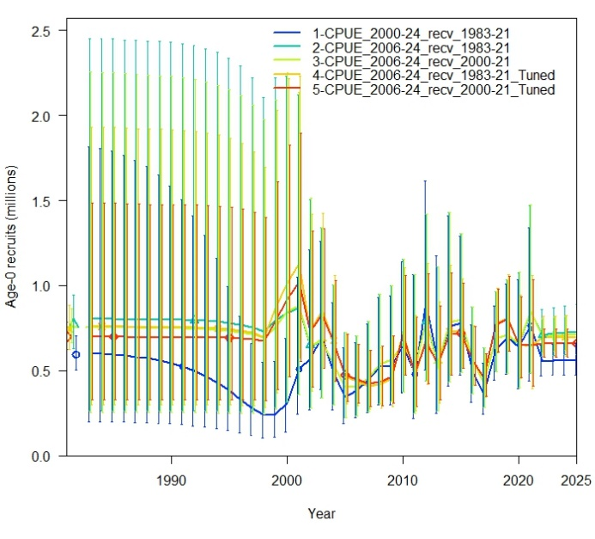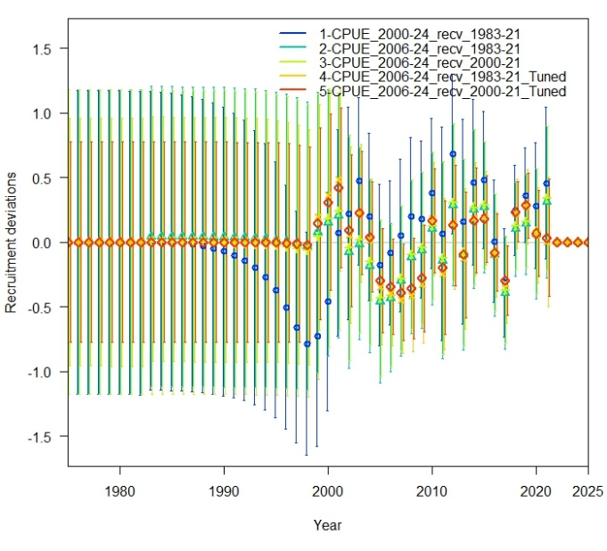
Figure 48. Comparison of the estimated recruitments and estimated recruitments deviations across scenarios used for the stock assessment.

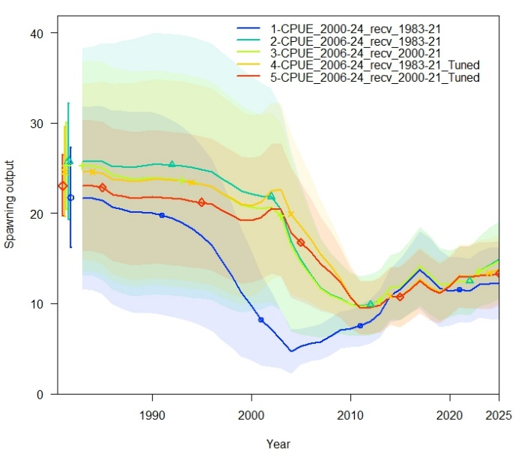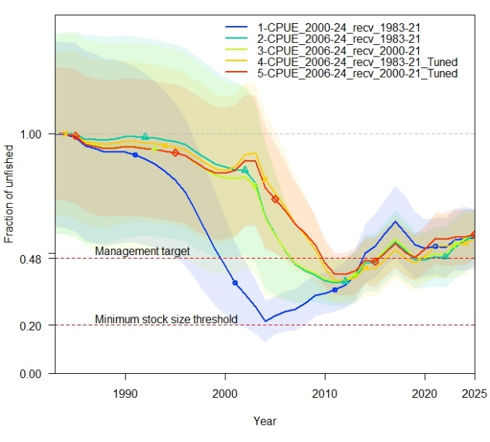
Figure 49. Comparison of absolute spawning biomass and relative unfished biomass fits across scenarios used for the stock assessment.

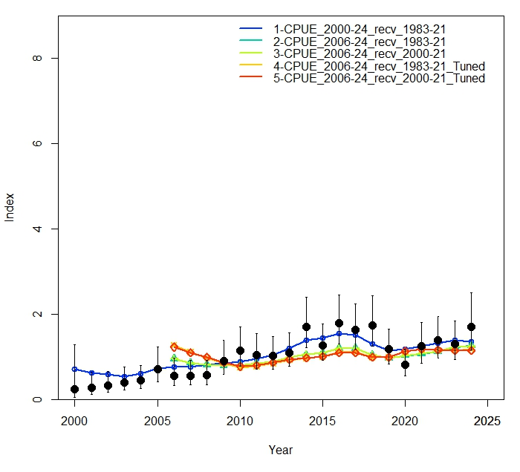
Figure 50. Comparison of model fits to CPUE indices considered in the bridging scenarios.

Fits of 2025 base case model
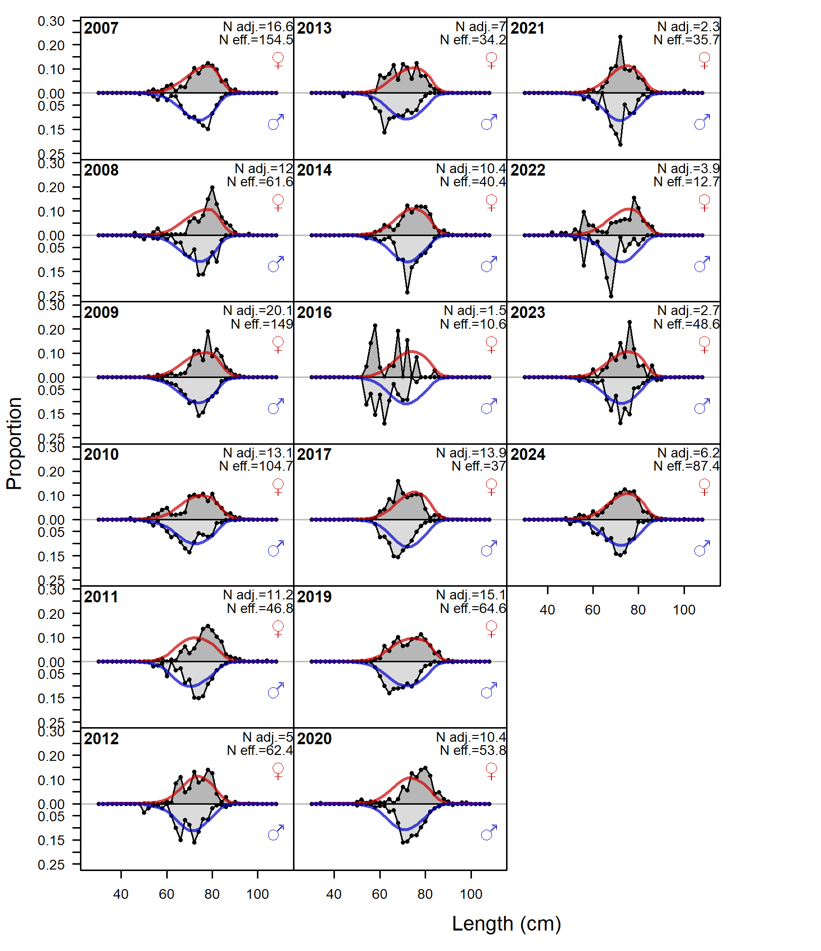
Figure 51. Length composition fits from the ONLF (commercial) fleet for the Grey Mackerel stock.

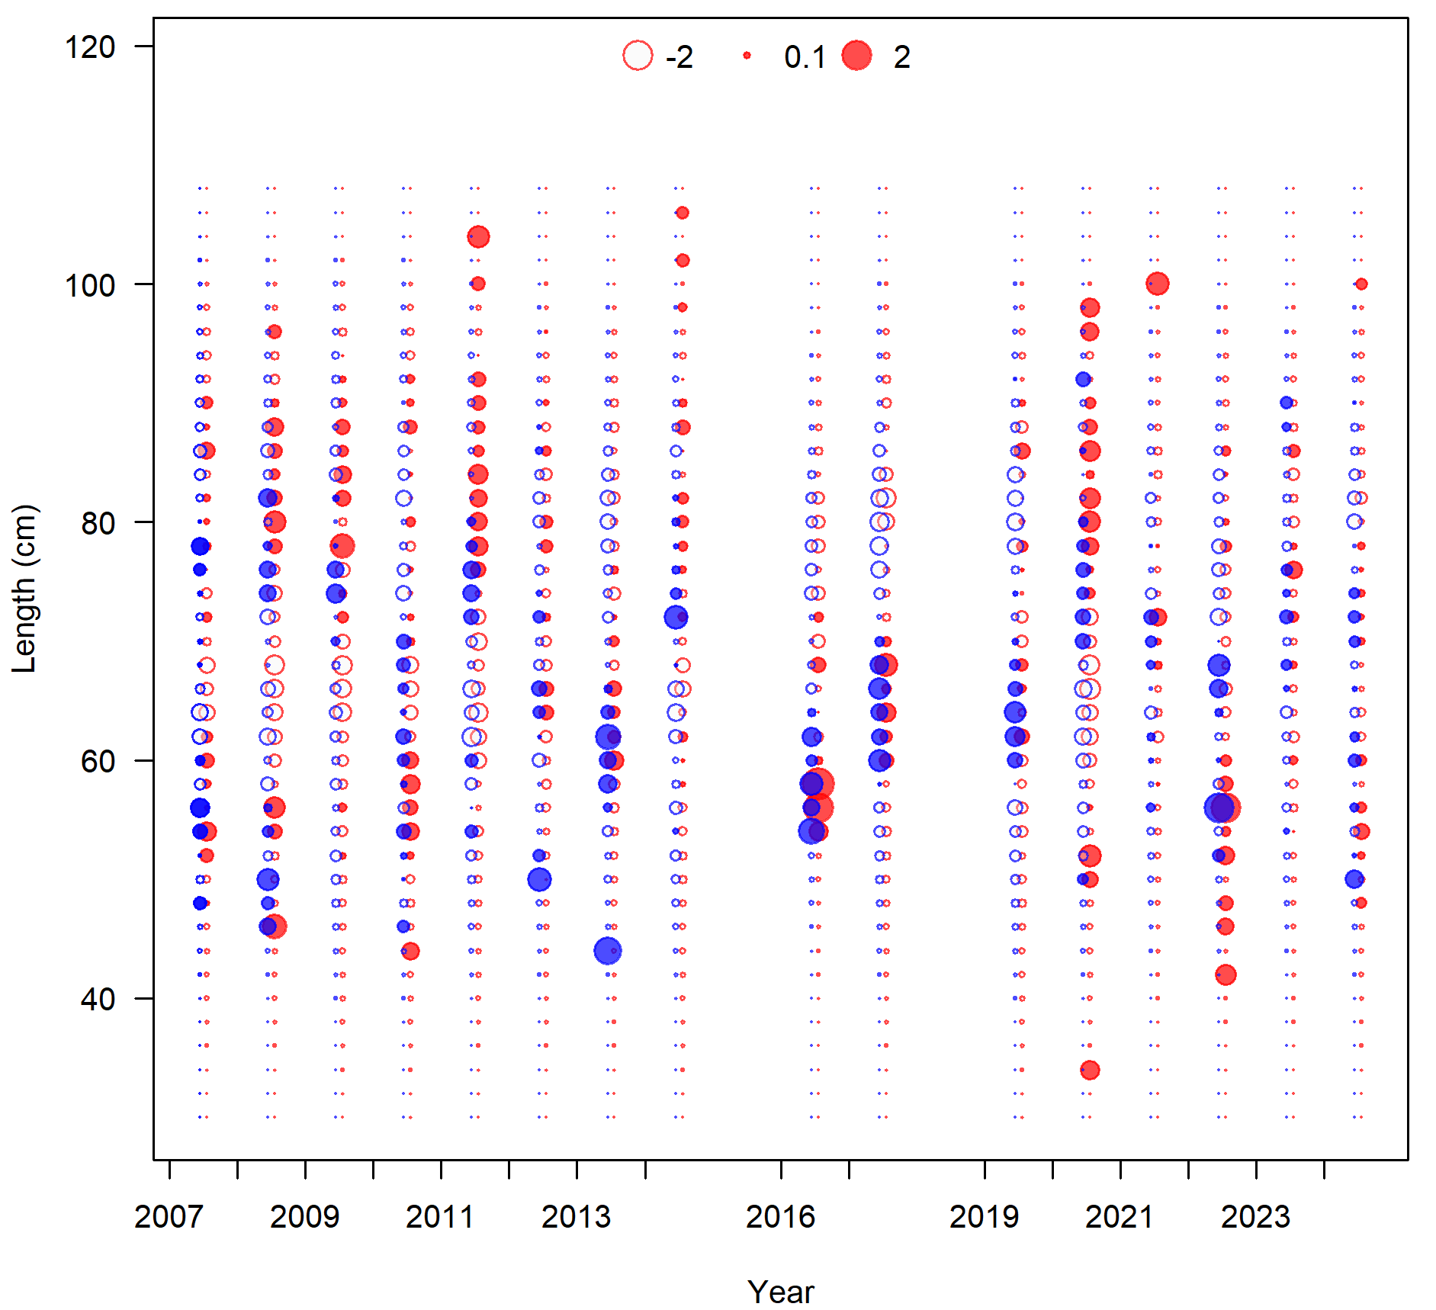
Figure 52. Pearson residuals from the model fit to length composition data for the commercial fleet.

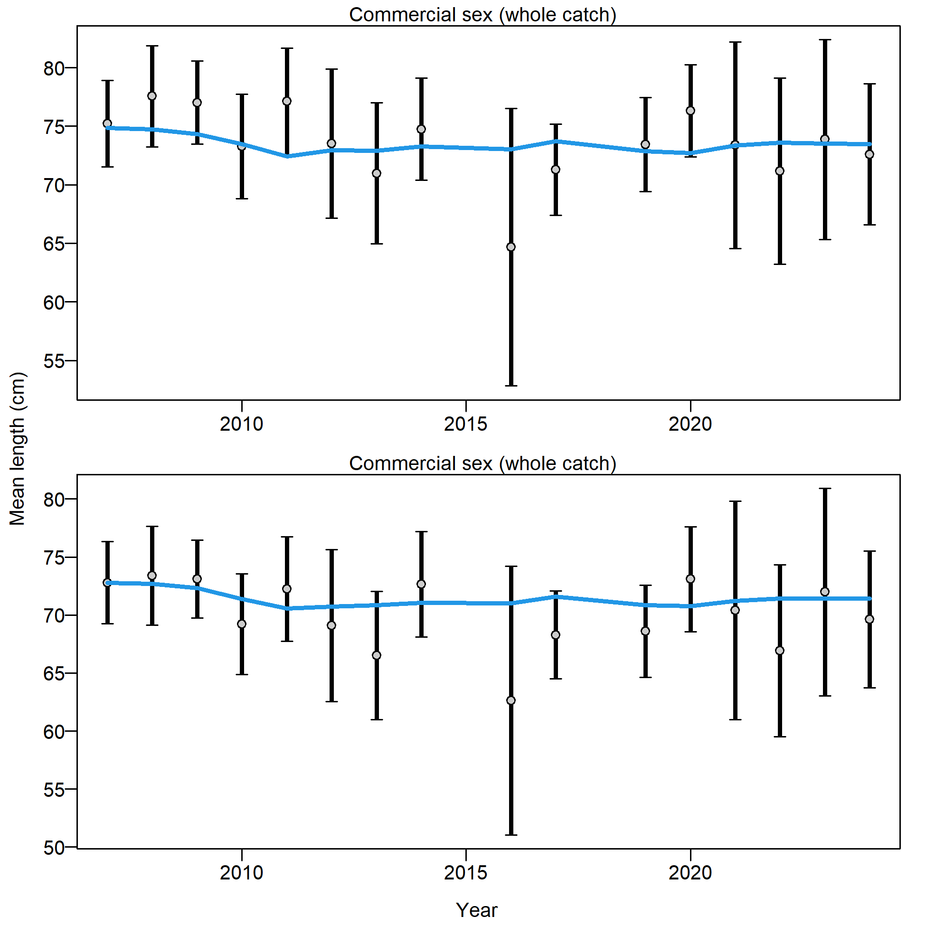
Figure 53. Mean length for commercial with 95% confidence intervals based on current sample sizes. Francis data weighting method TA1.8: Thinner intervals (with capped ends) show result of further adjusting sample sizes based on suggested multiplier (with 95% interval): 1 (0.7055-1.7118).

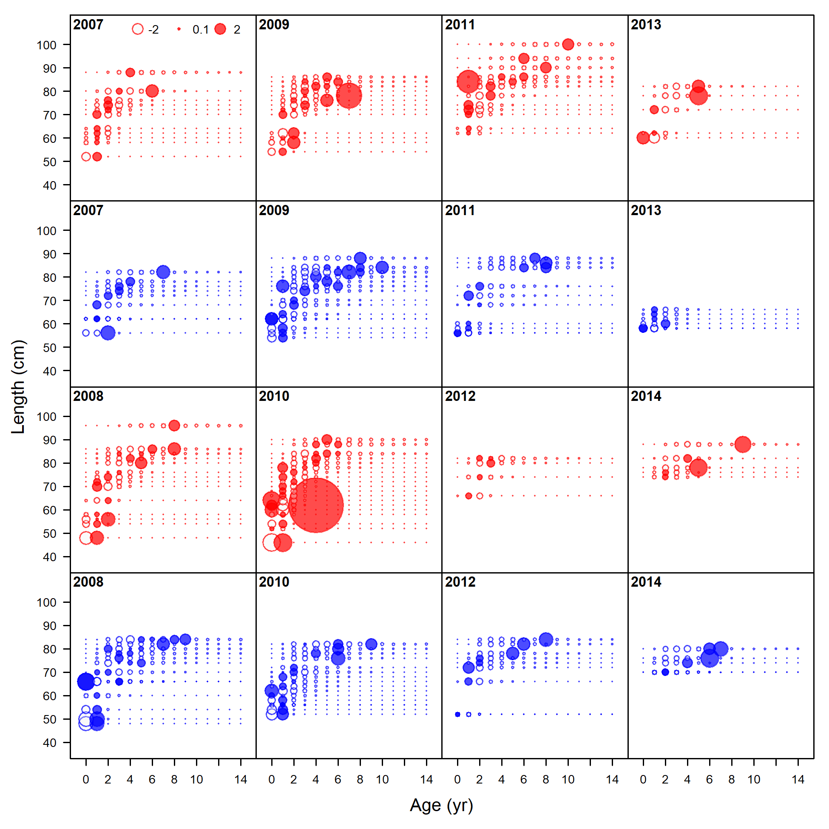
Figure 54. Pearson residuals from the fits to conditional age-at-length for the commercial fleet from 2007 to 2014. This plot gives an indication of the year-to-year variability in the conditional age-at-length samples.

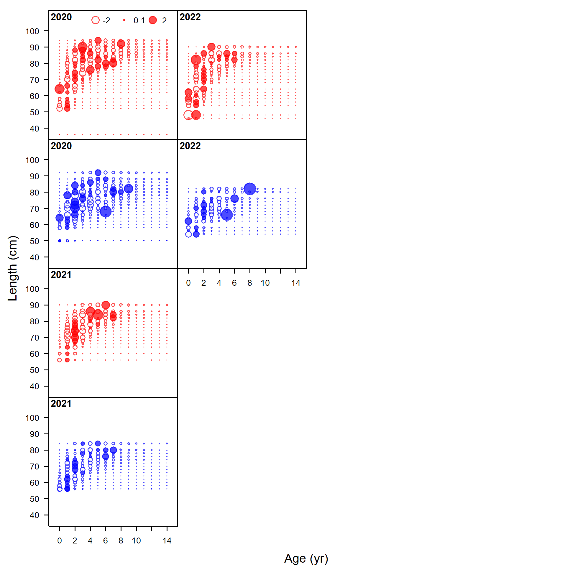
Figure 55. Pearson residuals from the fits to conditional age-at-length for the commercial fleet from 2020 to 2022. This plot gives an indication of the year-to-year variability in the conditional age-at-length samples.

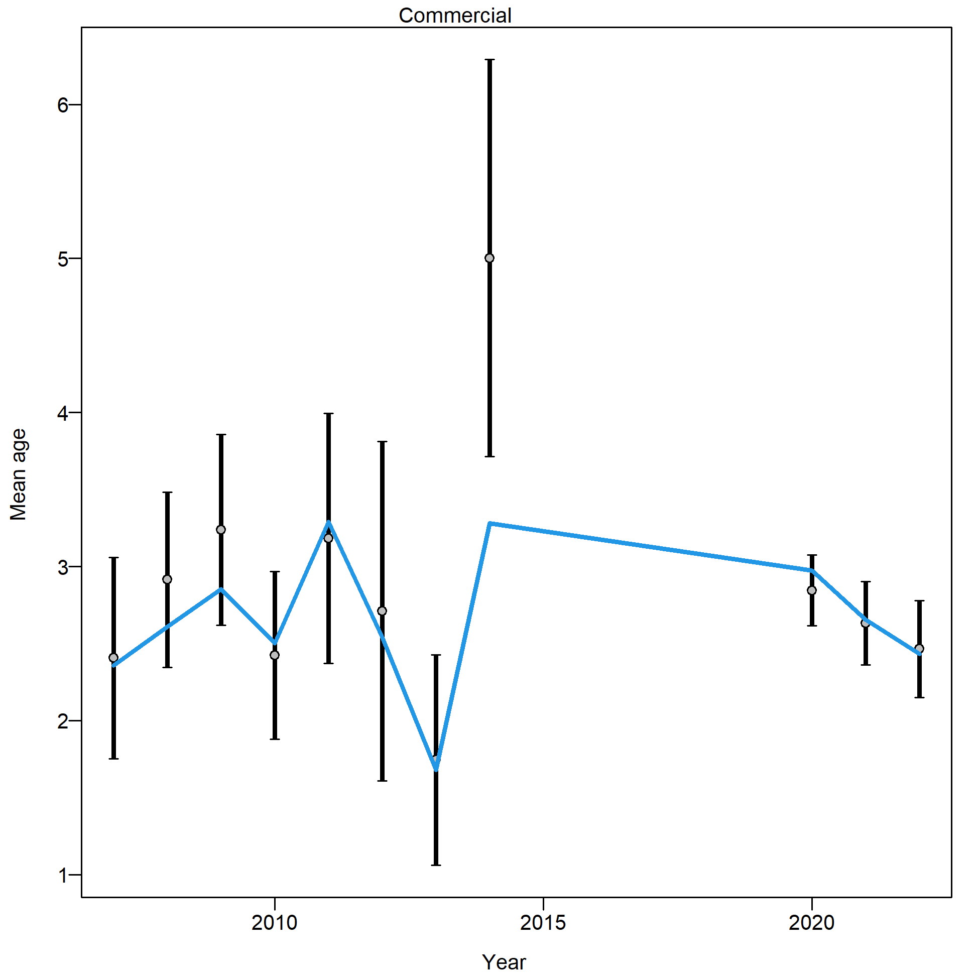
Figure 56. Mean age from conditional age-at-length data (aggregated across length bins) for the commercial fleet with 95% confidence intervals based on current samples sizes. Francis data weighting method TA1.8 was applied: Thinner intervals (with capped ends) show result of further adjusting sample sizes based on suggested multiplier (with 95% interval) for conditional age-at-length data: 1 (0.524-5.902)
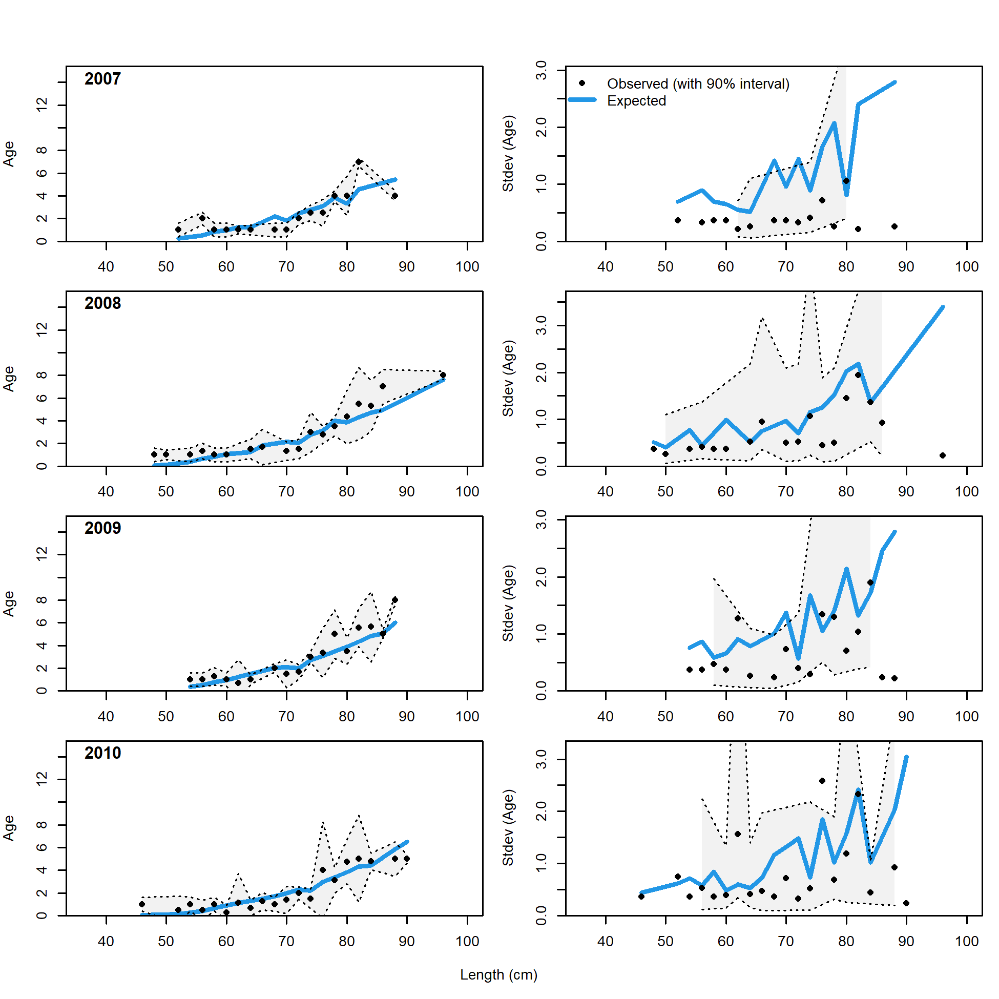
Figure 57. Fits to conditional age at length data for the commercial fleet (2007-2010).

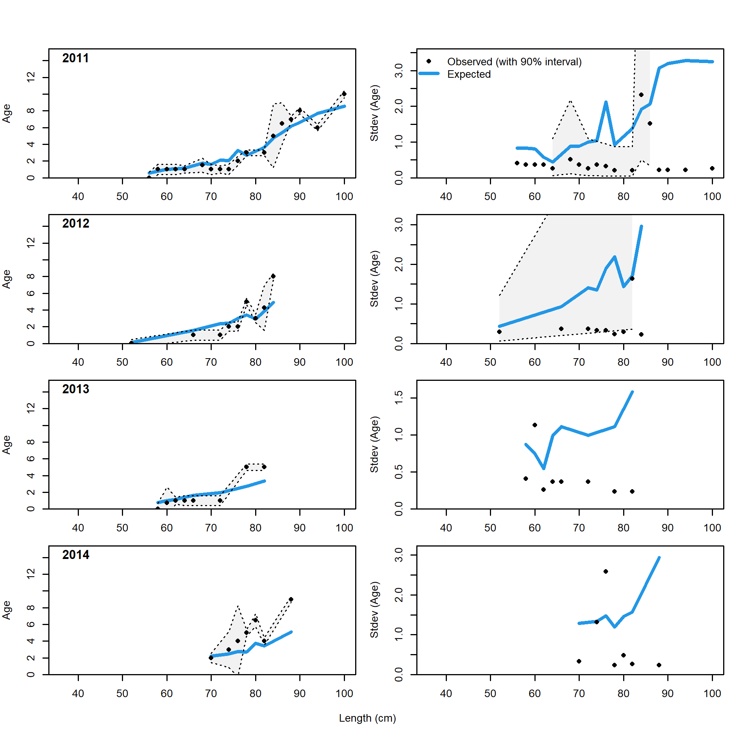
Figure 58. Fits to conditional age at length data for the commercial fleet (2011-2014).

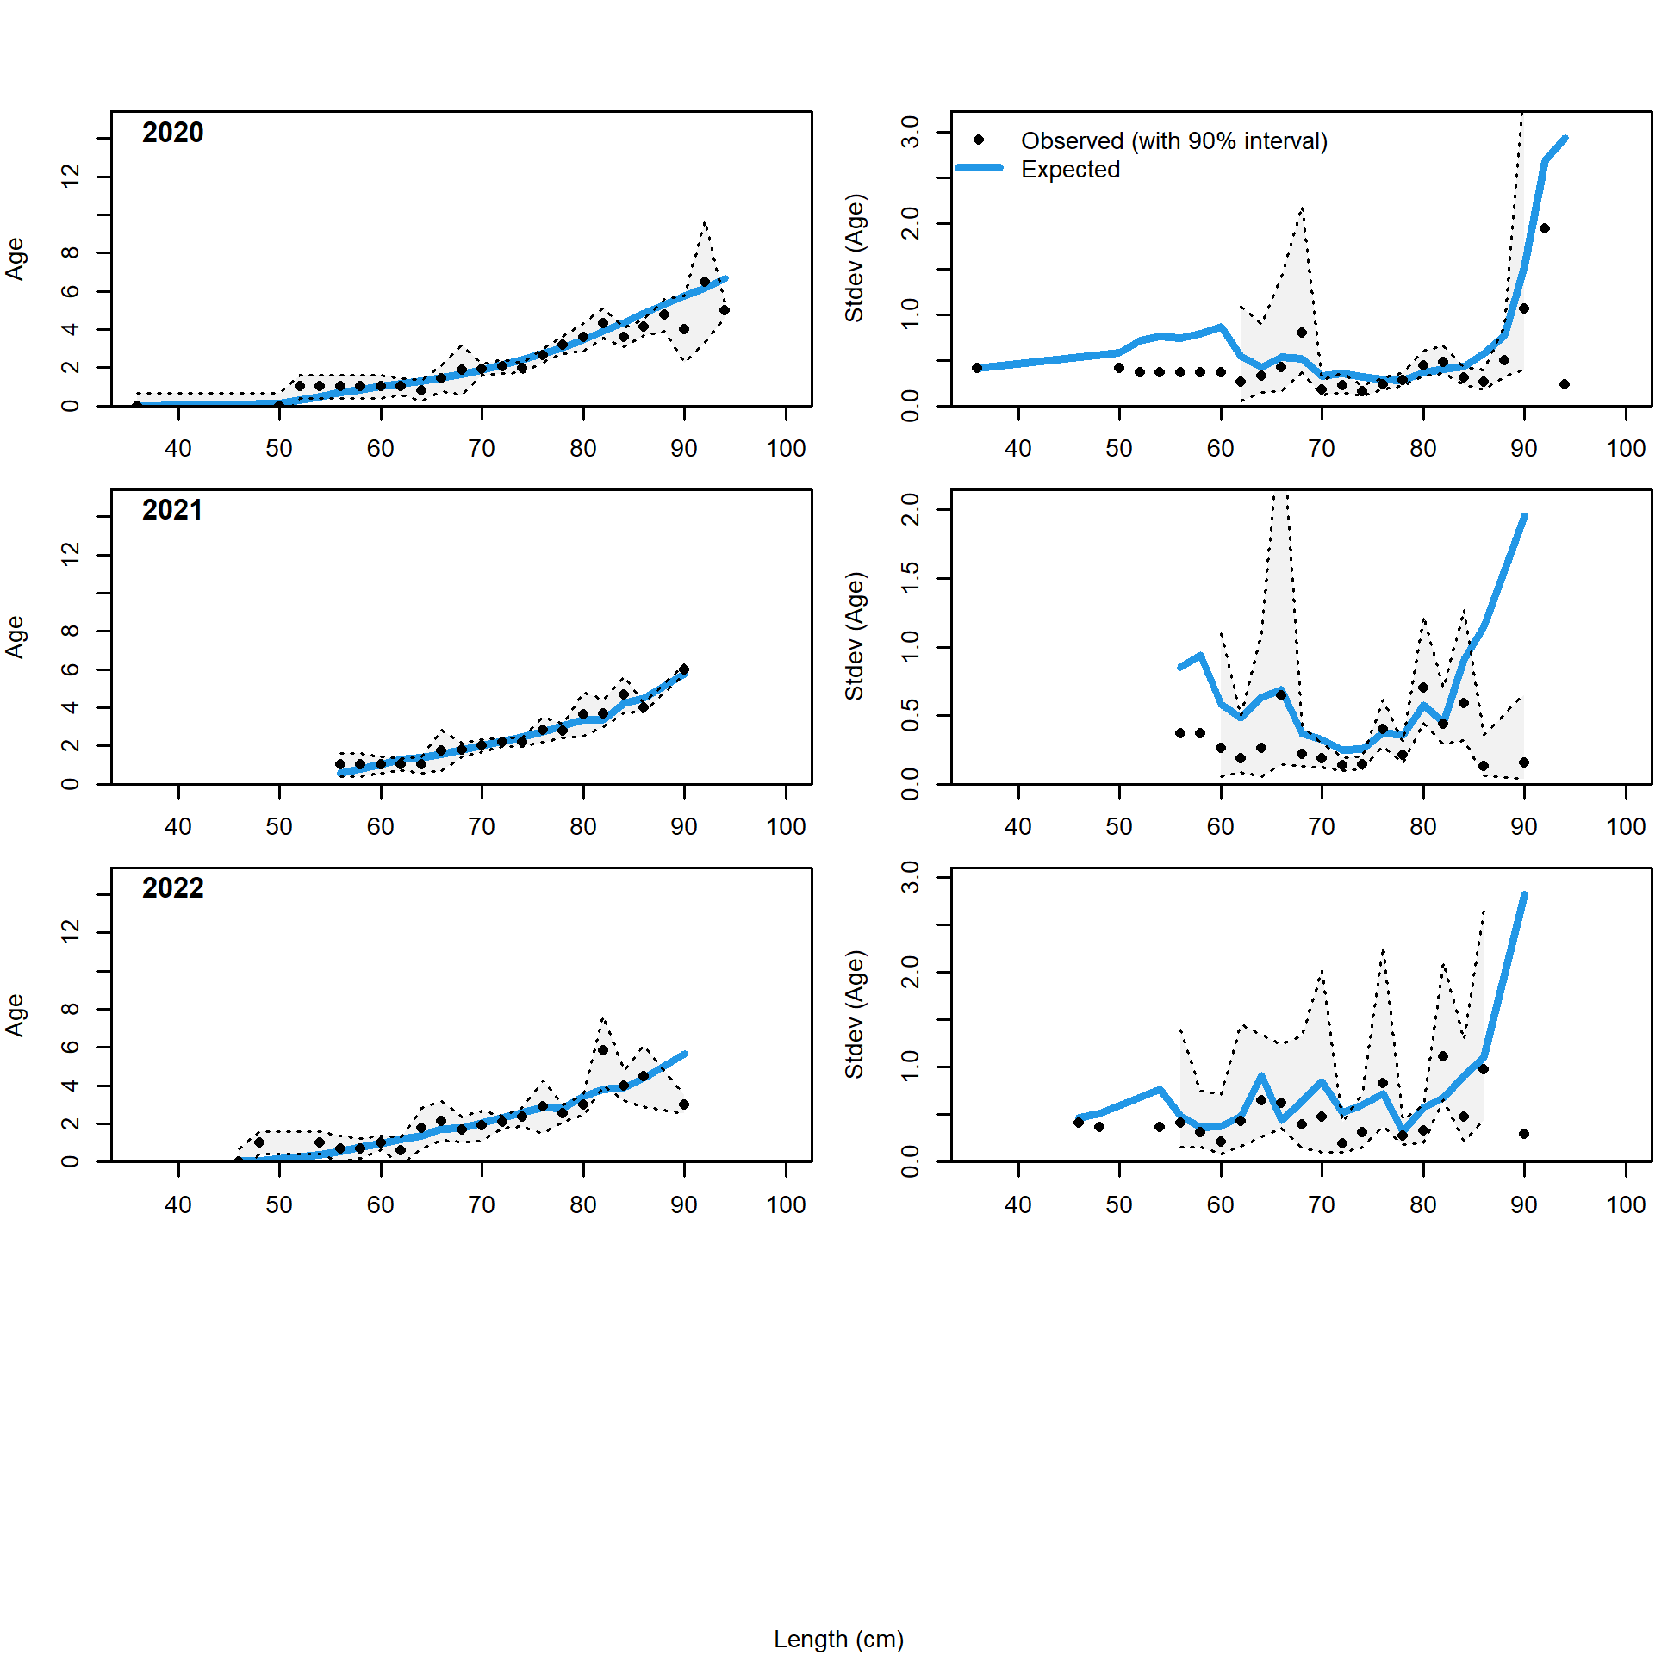
Figure 59. Fits to conditional age at length data for the commercial fleet (2011-2014).

Stock Assessment Diagnostics

Retrospective analysis
A retrospective analysis was conducted by sequentially removing the most recent year of data, working backward in time until five consecutive years of data were excluded from the assessment. This type of analysis is useful for identifying potential issues and instability within the assessment model.
Figure 60 displays the retrospective analysis for absolute spawning biomass, with the model that has data until 2024 represented in dark blue, and the successive years of data removed back to 2019 shown in red. Figure 61 presents the same analysis for relative spawning biomass. In both the absolute and relative spawning biomass assessments, the general trends remain consistent over time, with the 2020 and 2023 retrospective cases showing lower SSB compared to the other models from approximately 2009 onwards. This discrepancy is particularly evident in the recruitment estimates, especially for recent recruitment from 2005 onwards, with the 2020 to 2022 retrospective runs exhibiting lower estimated recruitment (Figure 62 and Figure 63).
These retrospective analyses do not indicate any pathological patterns or apparent biases in the estimates at the end of the time series due to the incorporation of new data. This further supports the stability of the assessment, and as such, the retrospective pattern is not expected to pose a concern for future management recommendations
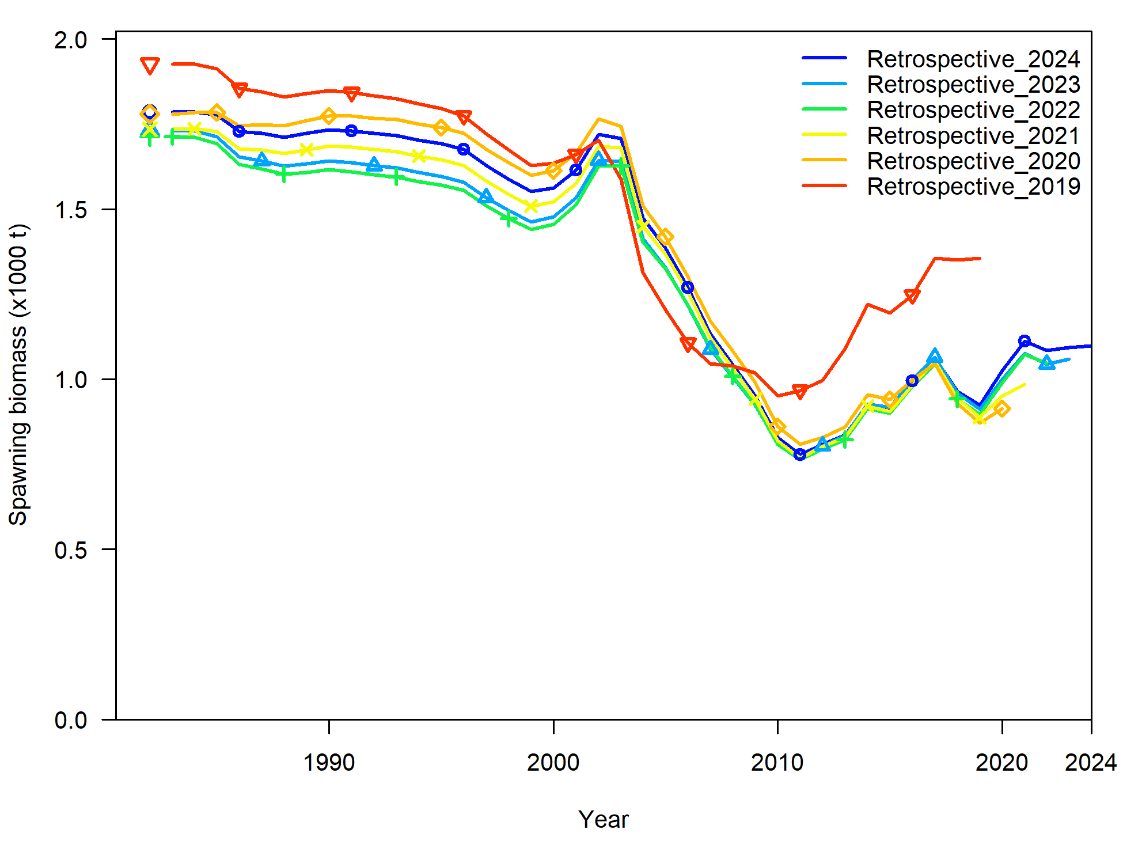

Figure 60. Retrospectives for absolute spawning biomass for the base case assessment of Grey Mackerel, with data included to 2024 (blue) and then successive years removed back to 2019 (red).

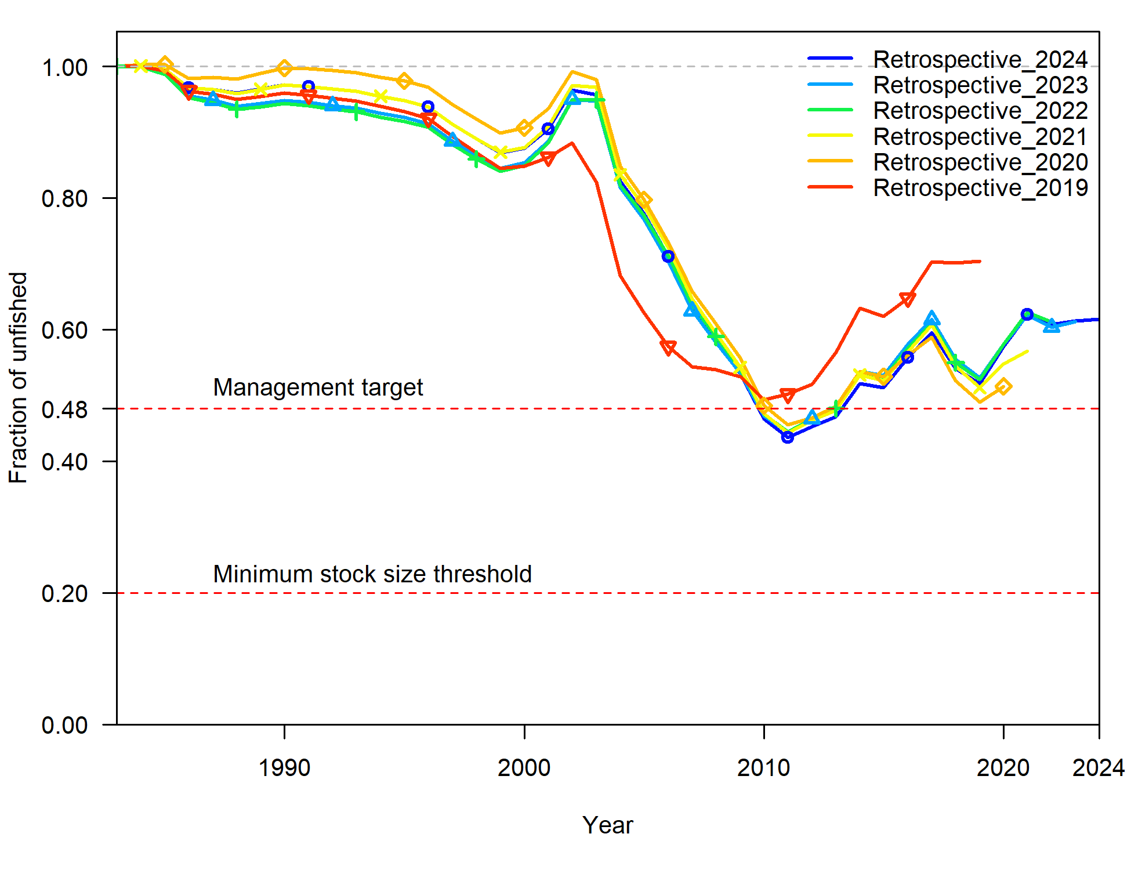
Figure 61. Retrospectives for relative stock status for the base case assessment of Grey Mackerel, with data included to 2024 (blue) and then successive years removed back to 2019 (red).
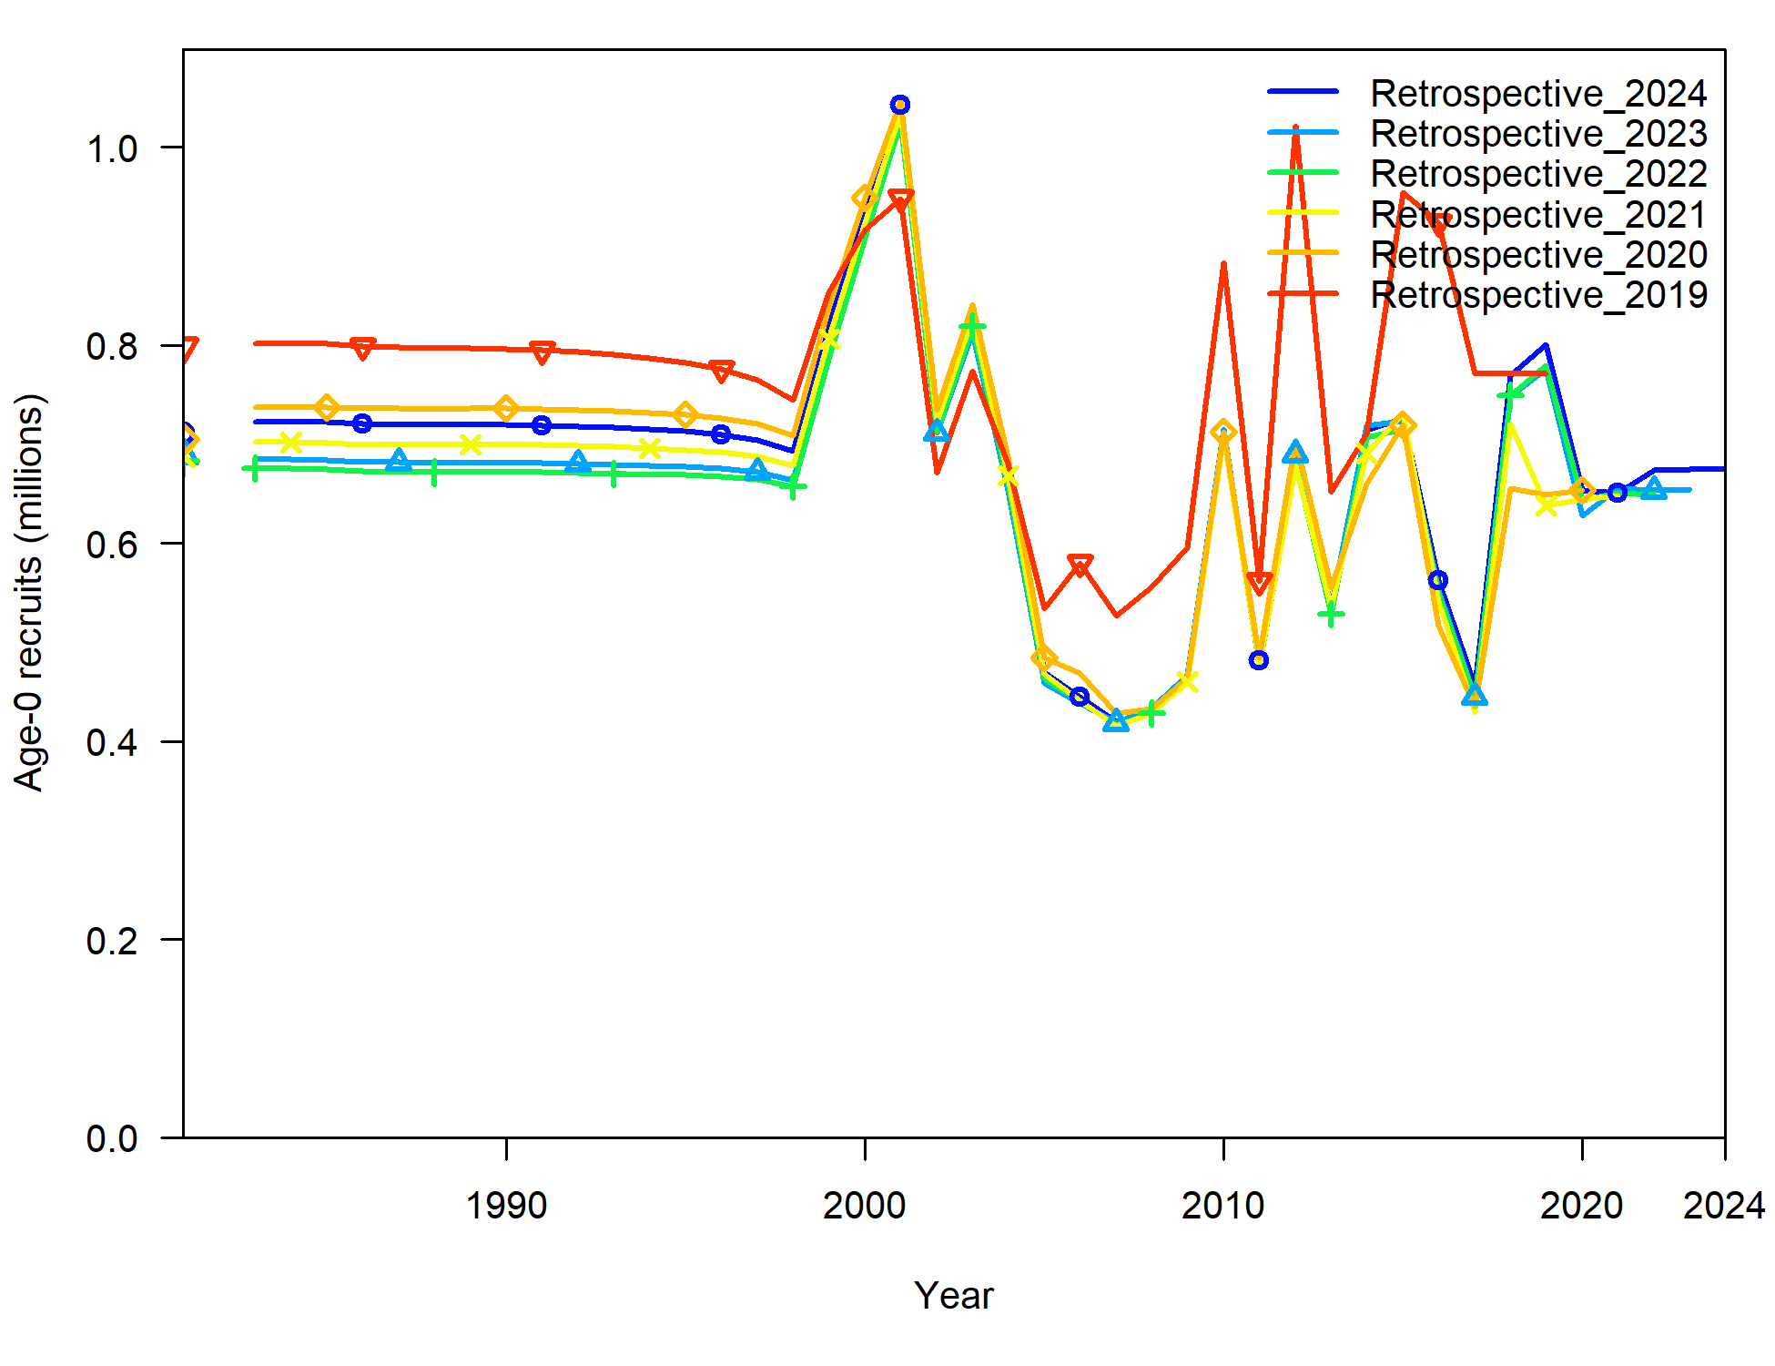
Figure 62. Retrospectives for Age-0 recruits for the base case assessment of North=western Grey Mackerel stock, with data included to 2024 (blue) and then successive years removed back to 2019 (red).

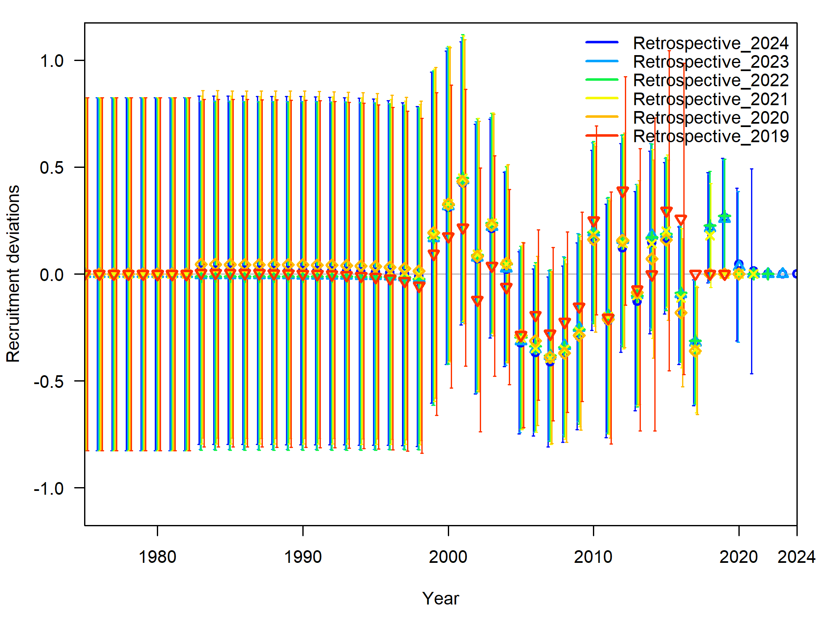
Figure 63. Retrospectives for recruitment deviations for the base case assessment of North West NT Grey Mackerel stock, with data included to 2024 (blue) and then successive years removed back to 2019 (red).

An alternative view of the retrospective analysis for the recruitment time series is presented in a “squid plot” (Figure 64). This plot illustrates how recruitment deviations for individual cohorts change as data from the last five years are progressively removed. Each coloured line represents a cohort and can include up to six points: one for the base case model using data through to 2024, and one for each of the five retrospectives. The lines are read from right to left, showing how recruitment estimates shift as successive years of data are removed. The y-axis reflects the magnitude and direction of these changes: negative values indicate an upward revision, while a positive value indicates a downward revision, relative to the most recent estimate. Large deviations suggest significant re-estimations and consistent shift in one direction may signal potential bias rather than random variation in the model’s recruitment estimates.
The squid plot for the base case shows recruitment deviations within a range of -0.2 to 0.2, indicating that there is no pathological retrospective pattern in recruitment deviation estimates (Figure 64). This range of deviations suggests stability and does not point to a model misspecification. The symmetrical distribution of the branches around zero further support the conclusion that the model is stable over time. As recruitment estimates remain relatively consistent in successive assessments, this pattern is considered normal and not indicative of any significant issues. Therefore, this retrospective pattern does not raise concerns from a management perspective and is not considered problematic.
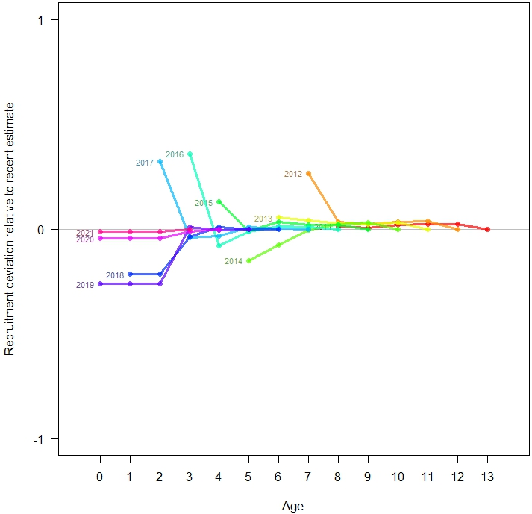
Figure 64. Retrospective analysis of recruitment deviations (squid plot), for the Grey Mackerel base case assessment, with data removed in successive years back to 2019. Recruitment deviations are the median log-scale differences between recruitment estimated by the model and expected recruitment from the stock-recruitment relationship.

The Mohn’s rho values estimated for the base case is consistent with retrospective patterns typically considered acceptable for short-lived species, such as Grey Mackerel, which has a maximum age of approximately 14 years. According to the thresholds proposed by Hurtado-Ferro et al. (2015), acceptable Mohn’s rho values for short-lived species fall within the range of -0.22 to 0.33 for SSB, -0.87 to 0.39 for recruitment, and -0.22 to 0.30 for fishing mortality (Table 22). In this assessment, the value for SSB is 0.035, indicating a minimal upward bias in historical estimates. Recruitment shows a rho of -0.021, reflecting a very slight tendency for upward revisions in earlier recruitment estimates when data from recent years are removed, with no indication of a pathological pattern (Table 22). Fishing mortality (F) has a value of 0.019, also within the acceptable range, suggesting a small positive retrospective bias. Overall, these values point to a stable model with no major retrospective patterns or model misspecification, providing confidence in the robustness of the assessment and its management advice.

Table 22. Mohn’s rho values for the recruitment retrospectives.
 | SSB | Recruitment | F | Stock status
GM base case 2025 | 0.035 | -0.021 | 0.019 | 0.033

Likelihood profiles
Likelihood profiles were conducted for natural mortality (M), stock-recruit steepness ($h$), growth coefficient by sex ($k$), asymptotic length by sex ($L_{∞}$) and some quantities of management such as virgin spawning biomass (${SSB}_{0}$), current spawning biomass ($SSB_{curr}$) and relative spawning biomass (stock status). Results of these profiles are shown in Figure 67 through Figure 75. The contribution of different data sources to the changes in likelihood within the profiles were considered in the context of a change of less than 1.92 units of negative log-likelihood, which were considered small, based on half of the 95% quantile of a Chi-squared distribution with 1 degree of freedom.

Natural mortality (M)
The likelihood profile for natural mortality ($M$) in Grey Mackerel is shown in Figure 65. The black line represents the total likelihood, while the coloured lines depict contributions from individual data components. The profile indicates that M is well estimated, with a maximum likelihood estimate at M = 0.44 year⁻¹ with 95% confidence intervals of M = 0.1 to M = 0.58 year⁻¹ (Figure 65). There is some evidence of data conflict in the data with the index data suggesting a lower M while the length data suggest a higher M.
The contribution from each fleet to the likelihood components is presented in Figure 65. The length data component appears to contribute limited information to the M estimate (Figure 65). Length data for the samples of the commercial fleet suggests higher M for the length composition, although there is little information in this data while age composition suggest smaller M estimate to the total value (Figure 65) For the index data (labelled survey likelihoods) the commercial CPUE is not informative in the commercial index (Figure 65).
Overall, the age data appears highly informative and representative of overall profile shape, with small minimum values (Figure 65). The index (is not informative), age data suggest lower value and length data (suggesting higher values) show some conflict in informing the value of M in the assessment.
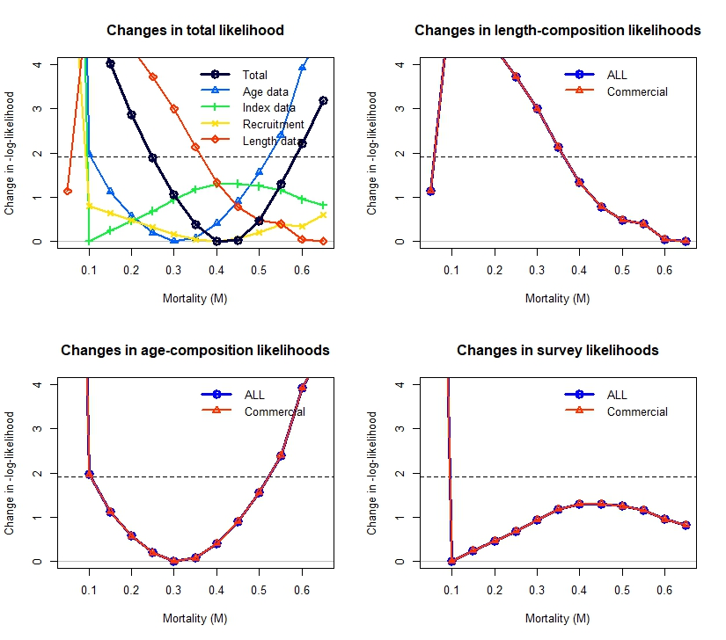
Figure 65. Pinerplot for the likelihood profile of natural mortality (M), showing components of the change in likelihood for length, age and indices (CPUE commercial) in addition to the changes in the total likelihood.

Steepness (h)
A likelihood profile on stock recruitment steepness parameter, h, is presented in Figure 66. The total likelihood is depicted in black, with contributions from different data sources shown in different colours (Figure 66). This figure shows that h is not well defined, as the 95% confidence limits are not crossed (log-likelihood of 1.92 on the y-axis) by the total likelihood within the range of values considered (h = 0.4 to 0.8). This is not surprising given the stock has not been depleted and then subsequently recovered to provide the information that would assist in the estimation of h. It is therefore reasonable to fix h at 0.75, the default value assumed in other pelagic fisheries.
The individual data components support this interpretation. The likelihood contributions from length composition, age composition, and the commercial CPUE index are all relatively flat across the steepness range, suggesting a lack of sensitivity to h. None of these data sources exhibit pronounced minima or curvature, indicating that they provide limited direct information to reliably estimate steepness (Figure 66).
Given these considerations, it is methodologically justified to fix steepness at h = 0.75, a biologically reasonable default value that aligns with assumptions commonly used in assessments of comparable pelagic species. Fixing h in this context ensures model stability while avoiding over-interpretation of poorly supported estimates.
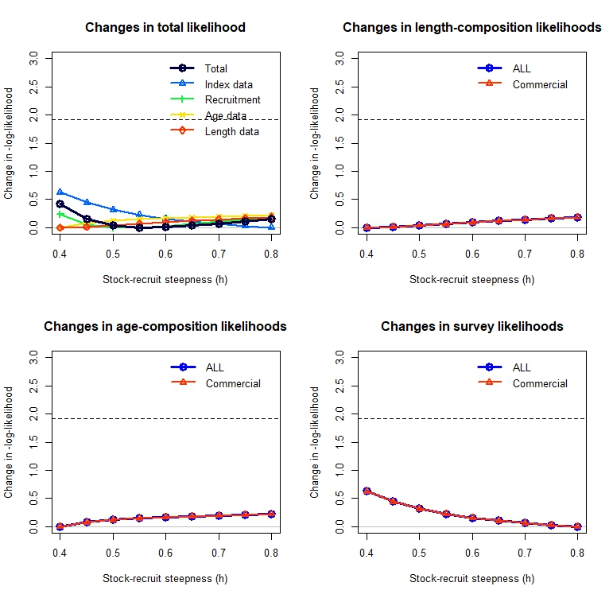
Figure 66. Pinerplot for the likelihood profile for steepness (h), showing components of the change in likelihood for length, age and indices (CPUE commercial) in addition to the changes in the total likelihood.

Growth Coefficient (k)
The likelihood profiles for the growth coefficient (K) for both males and females indicate that the parameter is well estimated, with a clear likelihood minimum identified for each sex. The estimated growth coefficient in the model for males is K=0.33 yr⁻¹, while the growth coefficient for females is estimated at K = 0.43 yr⁻¹, with a profiling range considered between 0.20 and 0.50 yr⁻¹ for both sexes (Figure 67 and Figure 68).
For females, the likelihood profile for the K shows that the age composition data fit best at a value slightly below the overall likelihood minimum. In contrast, the length composition and abundance index data exhibit conflicting signals, supporting different values of K. Specifically, the length composition data suggest a higher growth coefficient (K = 0.5), while the abundance index (commercial CPUE) supports a much lower value (K = 0.25). Recruitment data appear to be uninformative with respect to estimating K in females (Figure 67). Within the length composition data, observations from the commercial fleet support higher values of K, whereas the conditional age-at-length data favour K = 0.38, which corresponds to the local minimum in the total likelihood profile. Conversely, the index data derived from the commercial CPUE again suggest a lower growth coefficient for females (Figure 67).
For males, the likelihood profile for the K also reveals a well-defined minimum, although the age composition data provide the best fit at a value marginally below this point, suggesting moderate sensitivity to small deviations in K (Figure 68). Compared to females, the degree of agreement among data components is somewhat weaker, with greater divergence observed among the individual likelihood contributions. The length composition and index data support conflicting values, with the former suggesting a higher growth coefficient (K = 0.5), while the abundance index (commercial CPUE) and recruitment for males are also largely uninformative in estimating K (Figure 68).
Overall, the age composition data appear to be the most informative for both sexes and are broadly consistent with the shape of the total likelihood profile, producing a well-defined minimum for both females and males (Figure 67 and Figure 68). In contrast, the conflicting signals from the length composition data (suggesting higher K values) and the index data (suggesting lower K values) for both sexes highlight some inconsistency among data sources in informing the estimation of the growth coefficient within the assessment framework.
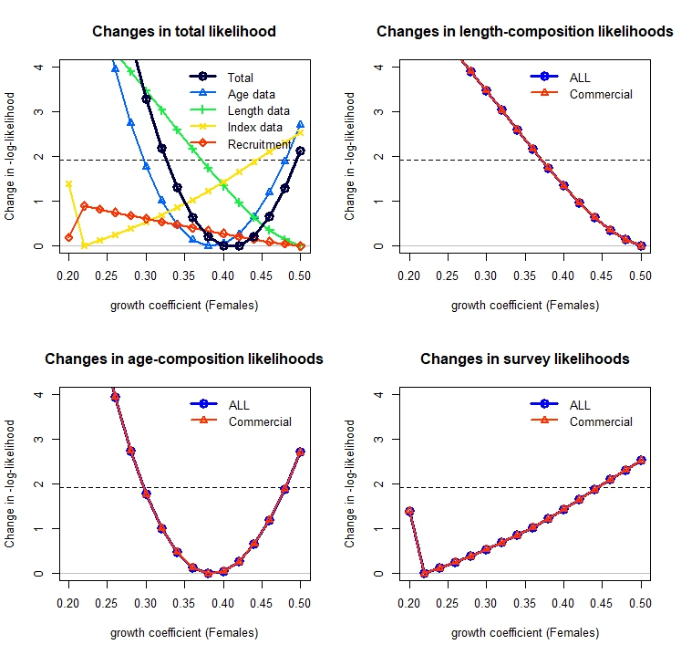
Figure 67. Pinerplot for the likelihood profile for the growth coefficient (K) for females, showing components of the change in likelihood for length, age and indices (CPUE commercial) in addition to the changes in the total likelihood.

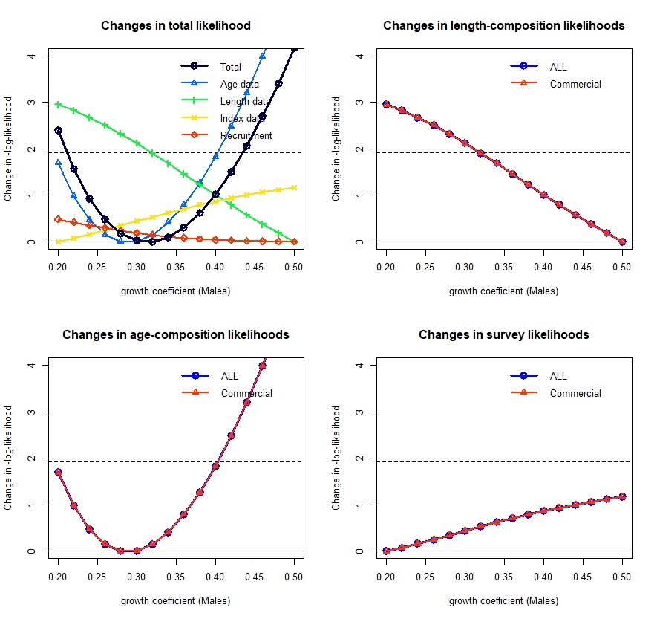
Figure 68. Pinerplot for the likelihood profile for the growth coefficient (K) for males, showing components of the change in likelihood for length, age and indices (CPUE commercial) in addition to the changes in the total likelihood.

Asymptotic Length ($L_{∞})$
The likelihood profiles for the asymptotic length $(L_{∞})$ for both females and males indicate that this parameter is well estimated, with a clearly defined likelihood minimum identified for each sex. In the model, the estimated $L_{∞}$ for females is 98 cm, while that for males is 90.1 cm, based on profiling across a range of 60 to 130 cm for both sexes (Figure 69 and Figure 70). For females, the likelihood profile shows that the overall minimum likelihood is achieved near the model estimate; however, length composition data suggest a slightly lower $L_{∞}$ of approximately 87 cm, albeit with a tight range of plausible values (Figure 69). Observations from the commercial fleet's length and age composition data are generally consistent, supporting similar $L_{∞}$ values for females. However, the commercial CPUE index data suggest a substantially higher $L_{∞}$, adding to the divergence in signal (Figure 69).
For males, the $L_{∞}$likelihood profile also displays a well-defined minimum, centered around 90 cm (Figure 70). The age composition data provide the best fit slightly below this value, indicating some sensitivity of the likelihood to small deviations in $L_{∞}$ (Figure 69 and Figure 70). Compared to females, the agreement among data components for males is weaker, with more pronounced divergence between individual likelihood contributions. The length composition suggest lower $L_{∞}$values near 80 cm, while the index data also present an alternative signal indicating higher values between 110 and 130 cm. Recruitment data for males is not informative. Notably, the age composition data remain the most influential in shaping the total likelihood, aligning closely with the global minimum.
Overall, the age composition data are the most informative source for both sexes and correspond well with the shape of the total likelihood profile, resulting in clearly defined minimums in both cases (Figure 69 and Figure 70). In contrast, conflicting signals from the length composition data (suggesting lower $L_{∞}$ for males) and the CPUE index data (suggesting higher $L_{∞}$for both sexes) reveal inconsistencies among data sources, which introduce uncertainty in the estimation of asymptotic length within the stock assessment framework.
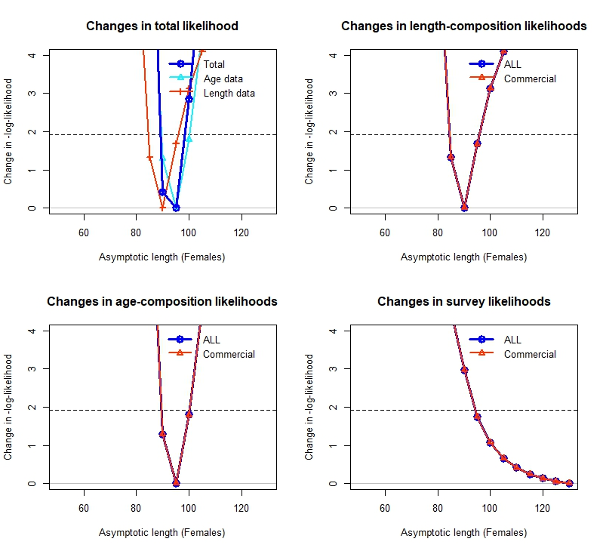
Figure 69. Pinerplot for the likelihood profile for asymptotic length ($L_{∞}$) for females, showing components of the change in likelihood for length, age and indices (CPUE commercial) in addition to the changes in the total likelihood.

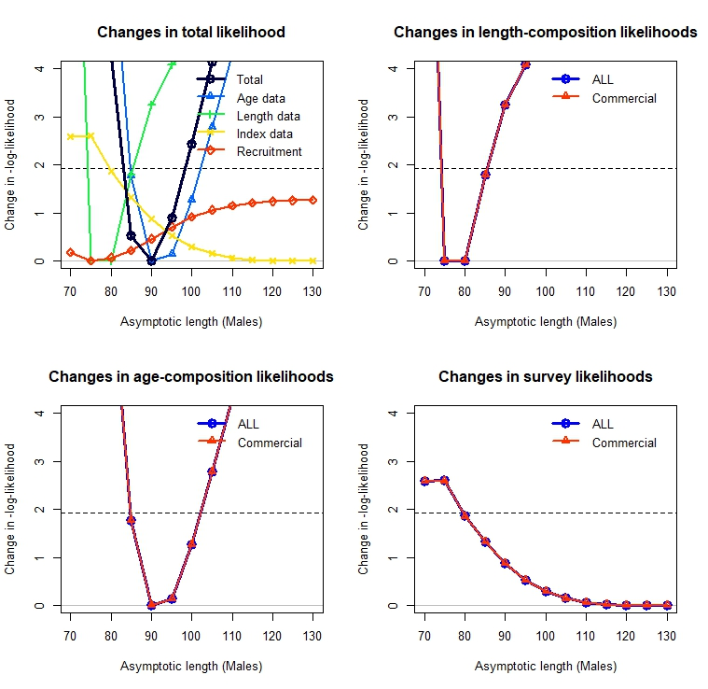
Figure 70. Pinerplot for the likelihood profile for asymptotic length ($L_{∞}$) for males, showing components of the change in likelihood for length, age and indices (CPUE commercial) in addition to the changes in the total likelihood.

Unfished Spawning stock Biomass ($S{SB}_{0})$
The likelihood profile on unfished spawning biomass ($S{SB}_{0})$ suggests that estimates range between 1184 t and 3184 t with the most likely value around 1750 t (Figure 71). The profiles suggest that unfished spawning biomass is well estimated, with a well-defined minimum in the likelihood. However, the length composition, age composition, and CPUE index components are not fully consistent, indicating conflict among data sources. Specifically, the age composition and CPUE index components support higher estimates of SSB₀ (between approximately 2,000 t and 3,000 t), whereas the length composition data support lower estimates (Figure 71).
Overall, the recruitment composition data is the most informative source for the estimation of $SSB_{0}$ and correspond well with the shape of the total likelihood profile, resulting in a clearly defined minimum (Figure 71). In contrast, there are conflicting signals from the length composition data (suggesting lower ${SB}_{0}$) and the CPUE index data (suggesting higher ${SSB}_{0}$).
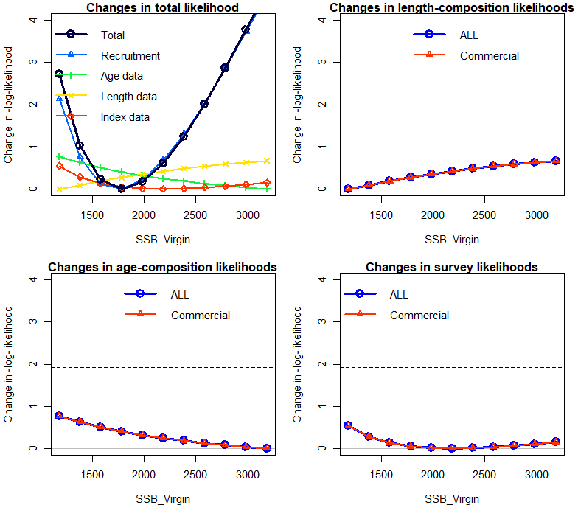
Figure 71. Pinerplot for the likelihood profile for virgin spawning biomass, showing components of the change in likelihood for length, age and indices (CPUE commercial) in addition to the changes in the total likelihood.

Current Spawning Biomass ($S{SB}_{2024})$
The likelihood profile on current spawning stock biomass (${SSB}_{24})$ suggests that estimates range between 498t and 1798t with the most likely value around 1100t (Figure 72). The profiles indicate that ${SSB}_{24}$ is well estimated, with a well-defined minimum in the likelihood. However, there is conflict among data sources. The recruitment component suggests lower $SSB_{2024}$ values, with a range between 978 t and 1000t, while the age composition data support a similarly wide range of $SSB_{2024}$ estimates, indicating that age data is not particularly informative (Figure 72). In contrast, the index data support a value of approximately 1200 t, which aligns closely with the overall likelihood estimate, suggesting that this data source exerts greater influence on the estimation of $SSB_{2024}$.
Length composition data from the commercial fleet suggest a lower estimate of ${SSB}_{24} \left(498\right)$compared to the total overall likelihood estimate, the length data does not strongly influence the likelihood and may provide limited information for estimating current spawning biomass. Similarly, the age component appears uninformative, contributing little to the definition of the likelihood minimum (Figure 72).
Overall, the index composition data is the most informative source for estimating ${SSB}_{24}$ and corresponds well with the shape of the total likelihood profile, resulting in a clearly defined minimum (Figure 72). In contrast, there are conflicting signals from the length composition data (suggesting lower ${SSB}_{2024}$ values) and recruitment data (suggesting multiple ${SSB}_{2024}$ estimates).

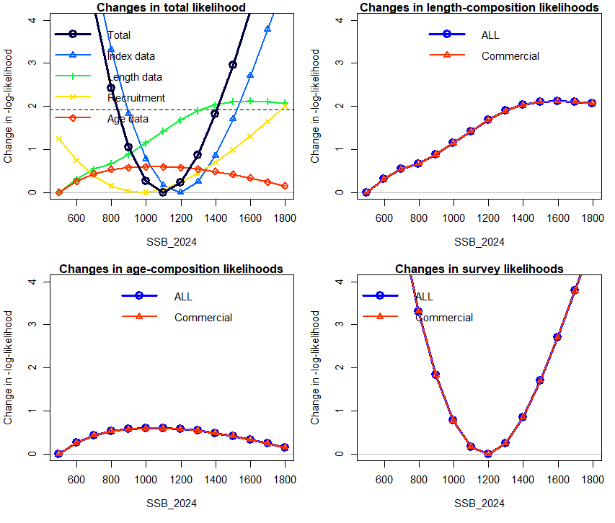
Figure 72. Pinerplot for the likelihood profile for the 2024 spawning biomass, showing components of the change in likelihood for length, age and indices (CPUE commercial) in addition to the changes in the total likelihood.

Stock Status (${SSB}_{2024}/{SSB}_{0})$
The likelihood profile for current spawning biomass relative to SSB₀ suggests a broad range of plausible stock status values for 2024, ranging from approximately 37% to 82%, with the most likely estimate near 61%. The index data and recruitment has the most influence on the profile (Figure 73), while the length and age composition components primarily suggest the lower bound of stock status near 30%. In contrast, the recruitment component supports similar value for stock status (60%). Overall, the profiles indicate that stock status is well estimated, with a clearly defined minimum in the likelihood.
The index composition data appear to be the most informative source for estimating stock status and correspond closely with the shape of the total likelihood profile, resulting in a clearly defined minimum (Figure 73). In contrast, conflicting signals from the length and age composition data (suggesting lower ${SSB}_{2024}$ values), both data sources are uninformative for determining current stock status.

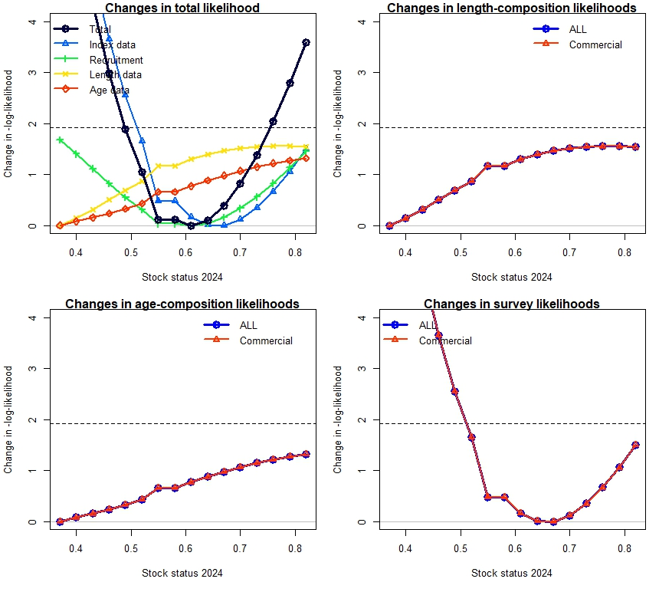
Figure 73. Piner plot for the likelihood profile for relative spawning biomass (stock status) in the 2024 Grey Mackerel model, showing components of the change in likelihood for length, age and indices (CPUE commercial) in addition to the changes in the total likelihood.

Jitter analysis
A jitter analysis was conducted with 25 replications, modifying initial parameter values by 10%. For the base case assessment, 25 of the 25 jitter replicates found the same optimal solution, with a negative log likelihood of 273.407 (Figure 74).
These results give confidence that the chosen initial parameter values for the base case model provide the best optimal solution.
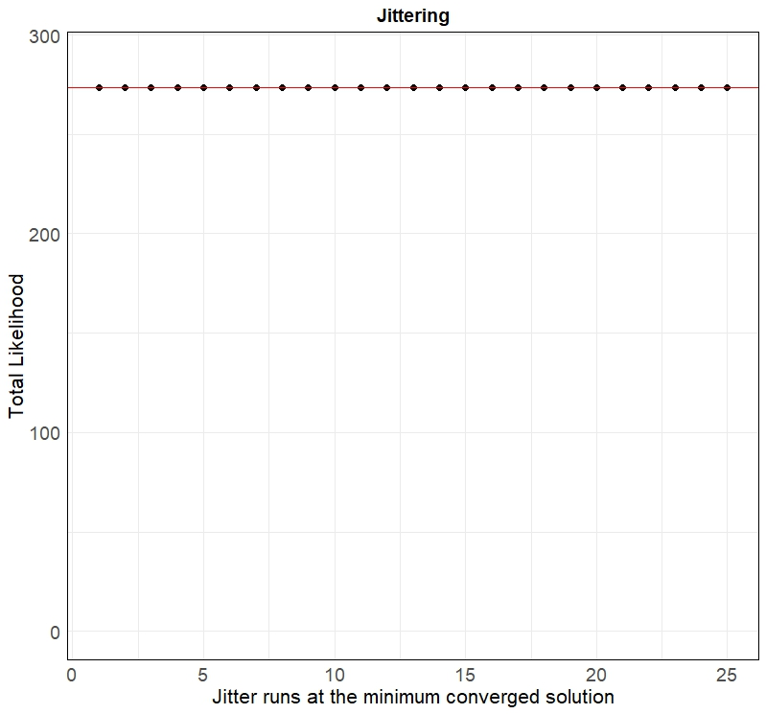
Figure 74. Results of models that converged during the jitter analysis and their log likelihood estimates.

Constant catch using current TACC
To evaluate the implications of current management settings, the integrate base case model was used to project the stock trajectory of Grey Mackerel under a constant annual catch of 404 tonnes for the North West NT stock, the current Total Allowable Commercial Catch (TACC) applied by the Northern Territory Government.
As shown in Figure 75 and Figure 76, the spawning biomass (SSB) relative to unfished levels (SSB₀) remains stable under this constant catch assumption. After reaching the management target of 48% SSB₀ around 2025, the biomass fluctuates slightly but stabilises just above the target for the remainder of the projection period (up to 2060). This indicates that the current TACC level is consistent with maintaining stock biomass near the target reference point under equilibrium conditions. Under the fix catch scenario the model-derived Recommended Biological Catch (RBC) is 415 t.
Importantly, the current fixed TACC of 404 t for the commercial sector is consistent with a constant catch management scenario. Under constant catch projections, a fixed RBC or TACC represents a static harvest strategy that does not adjust dynamically to changes in stock status. The model results demonstrate that this fixed catch level is sustainable under current stock conditions and maintains biomass near the target reference level. This supports the conclusion that the current fixed RBC approach adopted in NT is appropriate under constant catch assumptions and does not result in stock depletion or deviation from management targets.
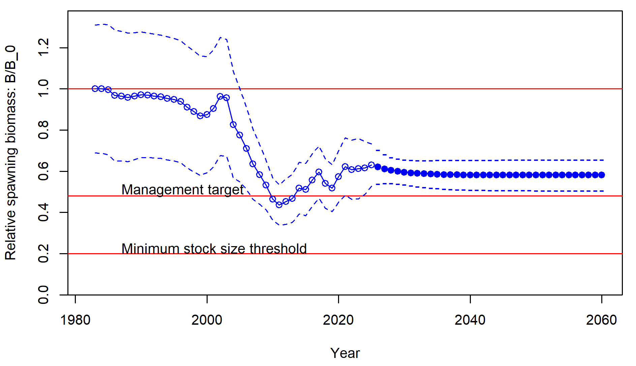
Figure 75. The estimated time-series of relative spawning biomass with projections to 2060 under fix catch scenario.
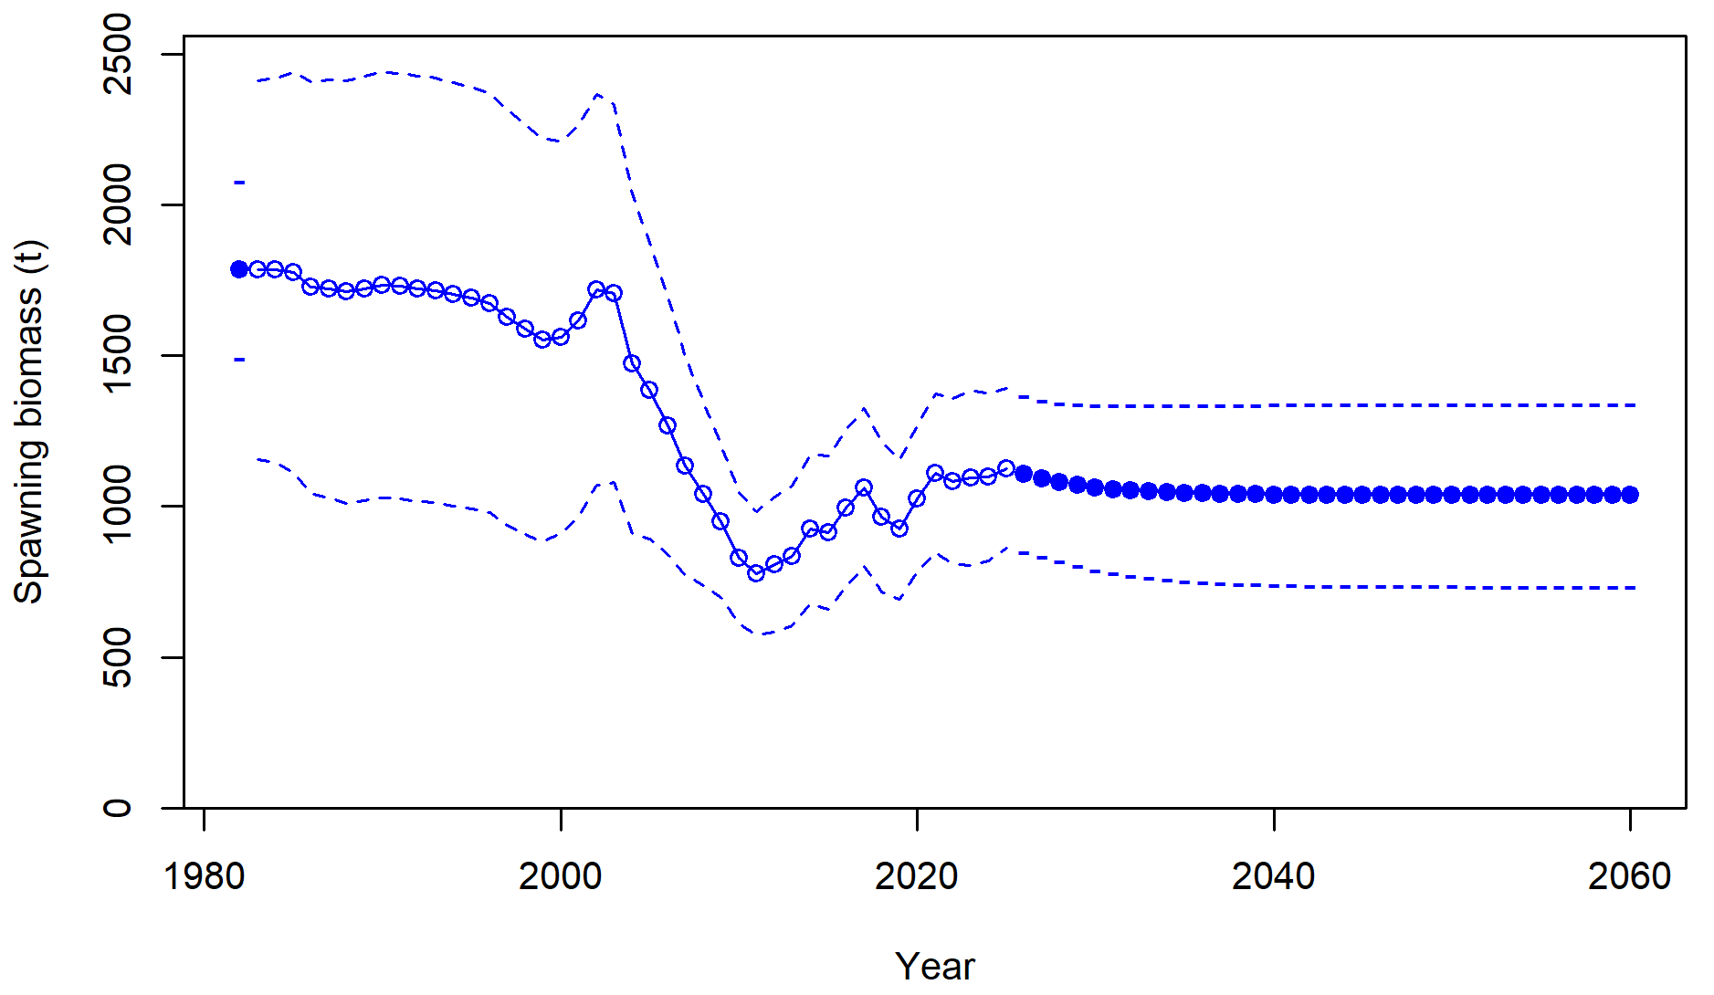
Figure 76. The estimated time-series of relative spawning biomass with projections to 2060 under fix catch scenario.

