Mineral Titles Act 2010
NOTICE OF LAND CEASING TO BE A MINERAL TITLE AREA
Title Type and Number: | Extractive Mineral Exploration Licence 33698
Area Ceased on: | 19 June 2026
Area: | 4 Blocks, 13.23 km²
Locality: | LARRIMAH
Name of Applicant(s)/Holder(s): | 100% TAMBORAN INFRASTRUCTURE PTY LTD [ACN. 163 215 156]
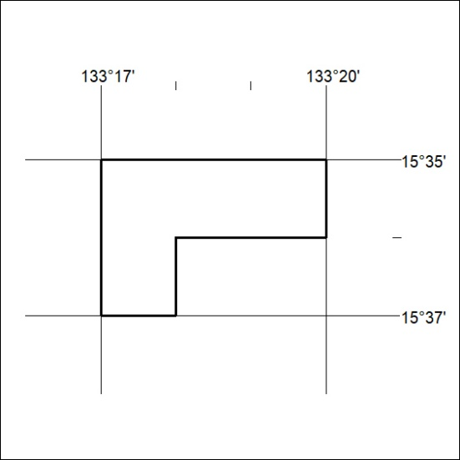

183/26

Mineral Titles Act 2010
NOTICE OF LAND CEASING TO BE A MINERAL TITLE AREA
Title Type and Number: | Extractive Mineral Exploration Licence 33699
Area Ceased on: | 19 June 2026
Area: | 4 Blocks, 13.23 km²
Locality: | LARRIMAH
Name of Applicant(s)/Holder(s): | 100% TAMBORAN INFRASTRUCTURE PTY LTD [ACN. 163 215 156]
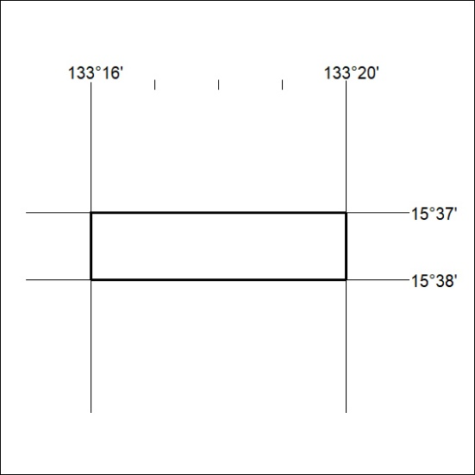

184/26

