Mineral Titles Act 2010
NOTICE OF LAND CEASING TO BE A MINERAL TITLE AREA
Title Type and Number: | Exploration Licence 31869
Area Ceased on: | 21 January 2026
Area: | 127 Blocks, 405.24 km²
Locality: | MOUNT PEAKE
Name of Applicant(s)/Holder(s): | 100% IGO LIMITED* [ACN. 092 786 304]
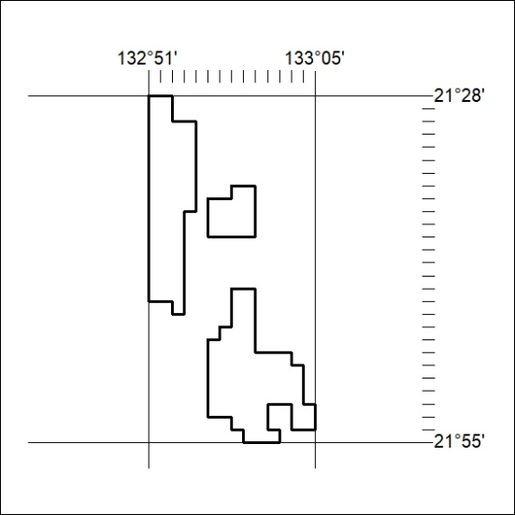

31/26

Mineral Titles Act 2010
NOTICE OF LAND CEASING TO BE A MINERAL TITLE AREA
Title Type and Number: | Exploration Licence 31871
Area Ceased on: | 21 January 2026
Area: | 44 Blocks, 140.95 km²
Locality: | CRAWFORD
Name of Applicant(s)/Holder(s): | 100% IGO LIMITED* [ACN. 092 786 304]
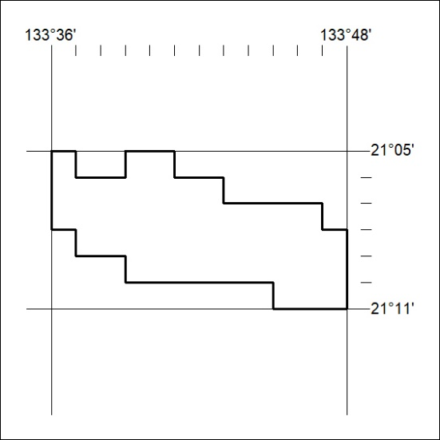

32/26

Mineral Titles Act 2010
NOTICE OF LAND CEASING TO BE A MINERAL TITLE AREA
Title Type and Number: | Exploration Licence 31872
Area Ceased on: | 21 January 2026
Area: | 65 Blocks, 147.91 km²
Locality: | CONICAL HILL
Name of Applicant(s)/Holder(s): | 100% IGO LIMITED* [ACN. 092 786 304]
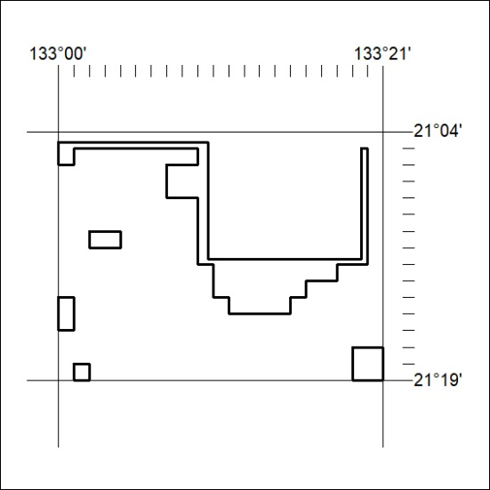

33/26

Mineral Titles Act 2010
NOTICE OF LAND CEASING TO BE A MINERAL TITLE AREA
Title Type and Number: | Exploration Licence 31874
Area Ceased on: | 21 January 2026
Area: | 28 Blocks, 89.55 km²
Locality: | WILLOWRA
Name of Applicant(s)/Holder(s): | 100% IGO LIMITED* [ACN. 092 786 304]
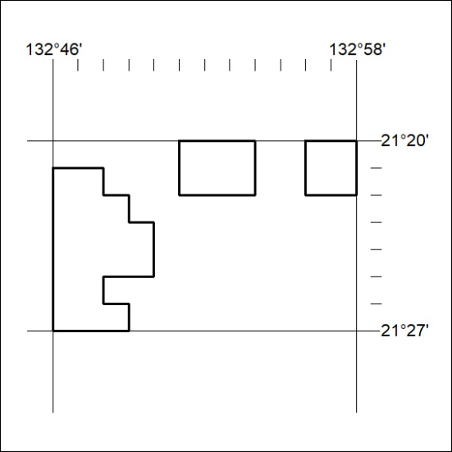

34/26

Mineral Titles Act 2010
NOTICE OF LAND CEASING TO BE A MINERAL TITLE AREA
Title Type and Number: | Exploration Licence 31889
Area Ceased on: | 21 January 2026
Area: | 131 Blocks, 370.85 km²
Locality: | WILLOWRA
Name of Applicant(s)/Holder(s): | 100% IGO LIMITED* [ACN. 092 786 304]
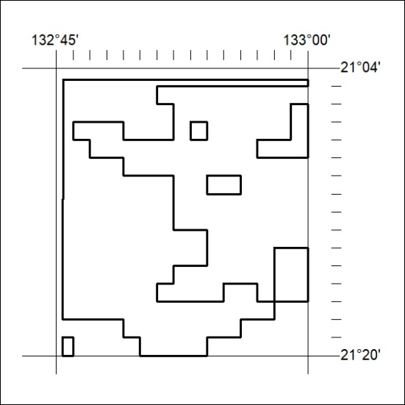

35/26

Mineral Titles Act 2010
NOTICE OF LAND CEASING TO BE A MINERAL TITLE AREA
Title Type and Number: | Exploration Licence 33848
Area Ceased on: | 21 January 2026
Area: | 32 Blocks, 96.93 km²
Locality: | GURNER
Name of Applicant(s)/Holder(s): | 100% WA1 RESOURCES LTD [ACN. 646 878 631]
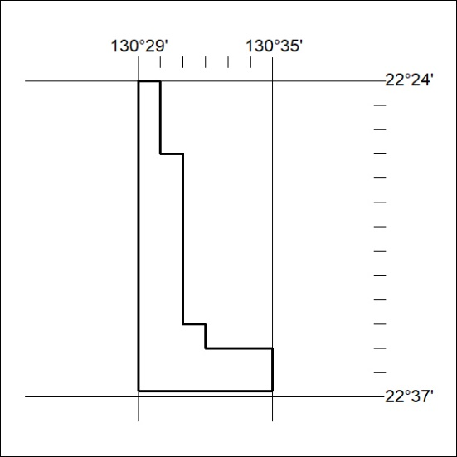

36/26

Mineral Titles Act 2010
NOTICE OF LAND CEASING TO BE A MINERAL TITLE AREA
Title Type and Number: | Extractive Mineral Permit 29542
Area ceased on: | 22 January 2026
Area: | 13.00 Hectare
Locality: | KOOLPINYAH
Name of Applicants(s)Holder(s): | 100% MARTIN Kenneth Morgan
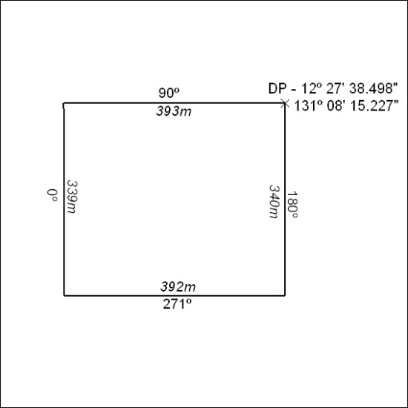

37/26

Mineral Titles Act 2010
NOTICE OF LAND CEASING TO BE A MINERAL TITLE AREA
Title Type and Number: | Extractive Mineral Permit 31458
Area ceased on: | 22 January 2026
Area: | 4.00 Hectare
Locality: | LANGDON
Name of Applicants(s)Holder(s): | 100% AMINJARRINJA ENTERPRISES ABORIGINAL CORPORATION
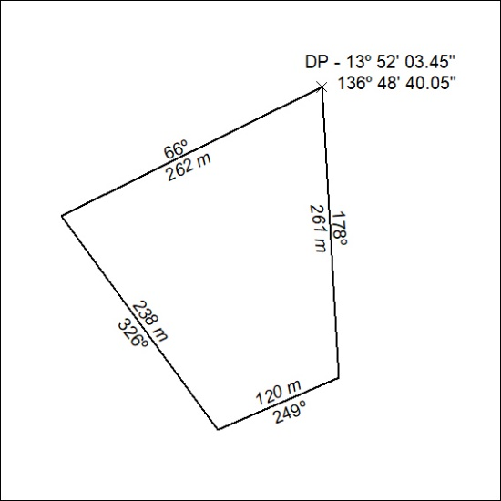

38/26

