Mineral Titles Act 2010
NOTICE OF LAND CEASING TO BE A MINERAL TITLE AREA
Title Type and Number: | Exploration Licence 32736
Area Ceased on: | 20 January 2026
Area: | 99 Blocks, 310.40 km²
Locality: | UNDOOLYA
Name of Applicant(s)/Holder(s): | 100% RIO TINTO EXPLORATION PTY LIMITED [ACN. 000 057 125]
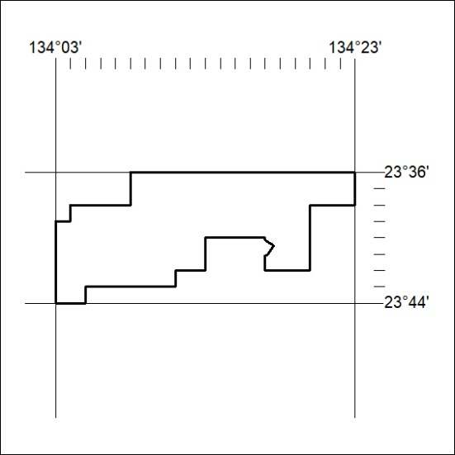

18/26

Mineral Titles Act 2010
NOTICE OF LAND CEASING TO BE A MINERAL TITLE AREA
Title Type and Number: | Extractive Mineral Lease 31081
Area ceased on: | 17 January 2026
Area: | .00 Hectare
Locality: | PEACHY
Name of Applicants(s)Holder(s): | 100% STONEMASONRY PTY. LTD. [ACN. 009 619 229]
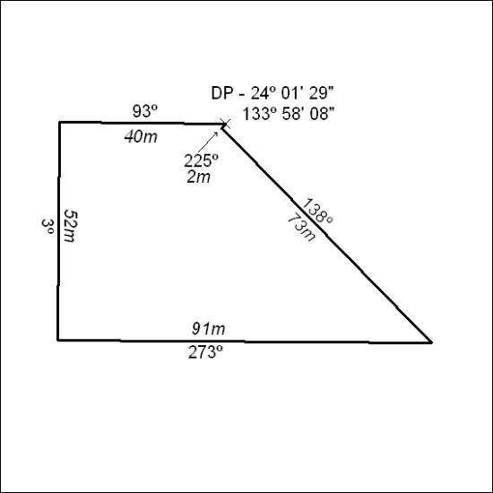

19/26

Mineral Titles Act 2010
NOTICE OF LAND CEASING TO BE A MINERAL TITLE AREA
Title Type and Number: | Extractive Mineral Lease 31082
Area ceased on: | 17 January 2026
Area: | 1.00 Hectare
Locality: | PEACHY
Name of Applicants(s)Holder(s): | 100% STONEMASONRY PTY. LTD. [ACN. 009 619 229]
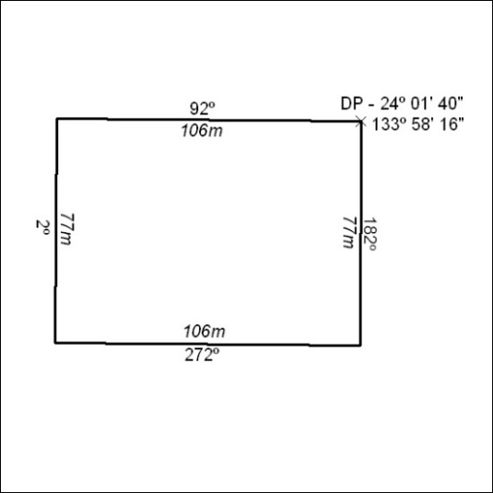

20/26

Mineral Titles Act 2010
NOTICE OF LAND CEASING TO BE A MINERAL TITLE AREA
Title Type and Number: | Extractive Mineral Lease 31083
Area ceased on: | 17 January 2026
Area: | 3.00 Hectare
Locality: | PEACHY
Name of Applicants(s)Holder(s): | 100% STONEMASONRY PTY. LTD. [ACN. 009 619 229]
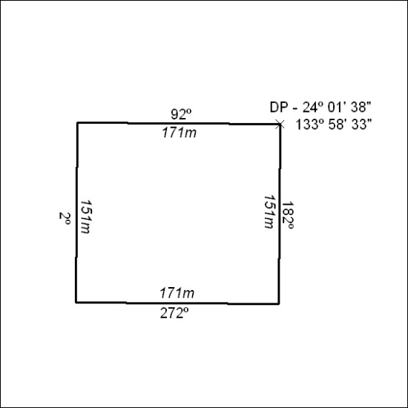

21/26

Mineral Titles Act 2010
NOTICE OF LAND CEASING TO BE A MINERAL TITLE AREA
Title Type and Number: | Extractive Mineral Lease 31084
Area ceased on: | 17 January 2026
Area: | 4.00 Hectare
Locality: | ALICE SPRINGS
Name of Applicants(s)Holder(s): | 100% STONEMASONRY PTY. LTD. [ACN. 009 619 229]
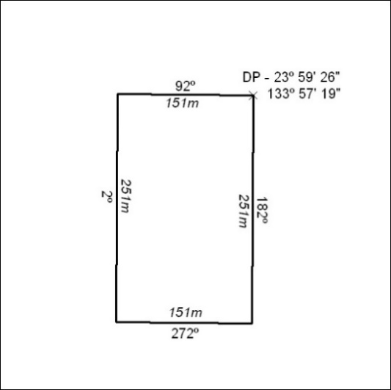

22/26

