Mineral Titles Act 2010
NOTICE OF LAND CEASING TO BE A MINERAL TITLE APPLICATION AREA
Title Type and Number: | Extractive Mineral Permit 33918
Area ceased on: | 16 January 2026
Area: | 11.00 Hectare
Locality: | NOONAMAH
Name of Applicants(s)Holder(s): | 100% OSTOJIC GROUP PTY LTD* [ACN. 009 629 805]
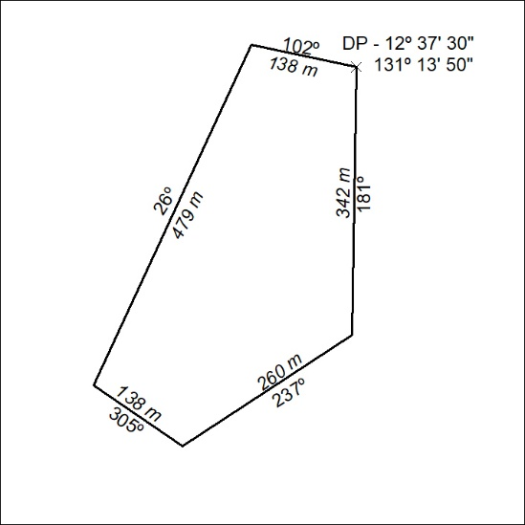

17/26

