Mineral Titles Act 2010
NOTICE OF LAND CEASING TO BE A MINERAL TITLE AREA
Title Type and Number: | Exploration Licence 32765
Area Ceased on: | 12 March 2025
Area: | 18 Blocks, 56.90 km²
Locality: | DNEIPER
Name of Applicant(s)/Holder(s): | 100% IGO NEWSEARCH PTY LTD [ACN. 142 192 701]
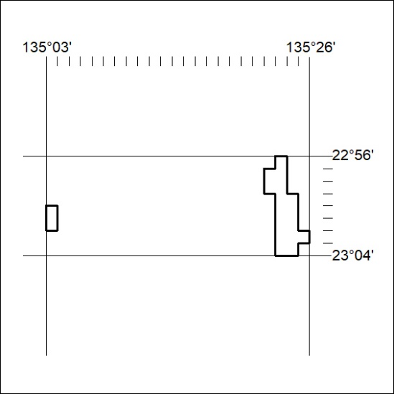
90/25

Mineral Titles Act 2010
NOTICE OF LAND CEASING TO BE A MINERAL TITLE AREA
Title Type and Number: | Exploration Licence 32766
Area Ceased on: | 12 March 2025
Area: | 27 Blocks, 85.39 km²
Locality: | DNEIPER
Name of Applicant(s)/Holder(s): | 100% IGO NEWSEARCH PTY LTD [ACN. 142 192 701]
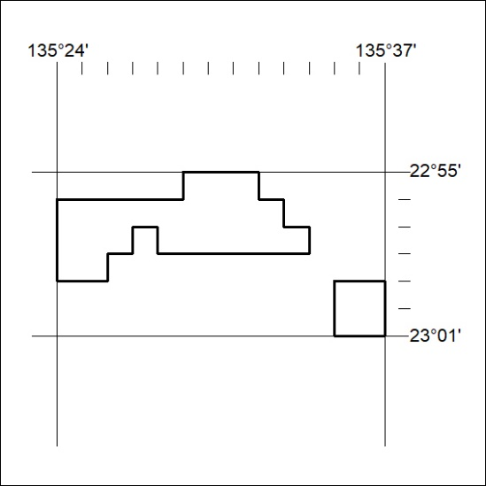
91/25

Mineral Titles Act 2010
NOTICE OF LAND CEASING TO BE A MINERAL TITLE AREA
Title Type and Number: | Exploration Licence 32771
Area Ceased on: | 12 March 2025
Area: | 94 Blocks, 296.84 km²
Locality: | BRAHMA
Name of Applicant(s)/Holder(s): | 100% IGO NEWSEARCH PTY LTD [ACN. 142 192 701]
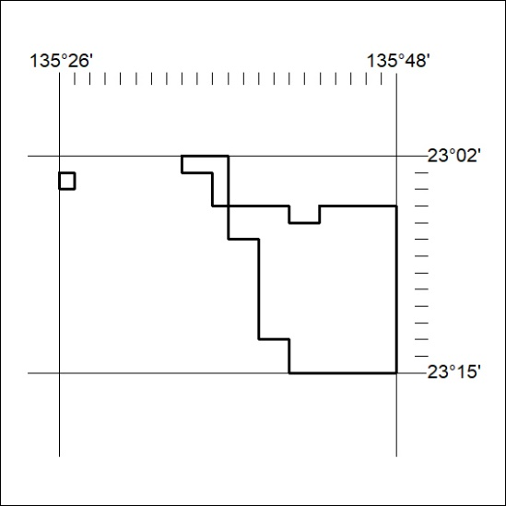
92/25

Mineral Titles Act 2010
NOTICE OF LAND CEASING TO BE A MINERAL TITLE AREA
Title Type and Number: | Exploration Licence 32777
Area Ceased on: | 13 March 2025
Area: | 24 Blocks, 38.01 km²
Locality: | DELNY
Name of Applicant(s)/Holder(s): | 100% IGO NEWSEARCH PTY LTD [ACN. 142 192 701]
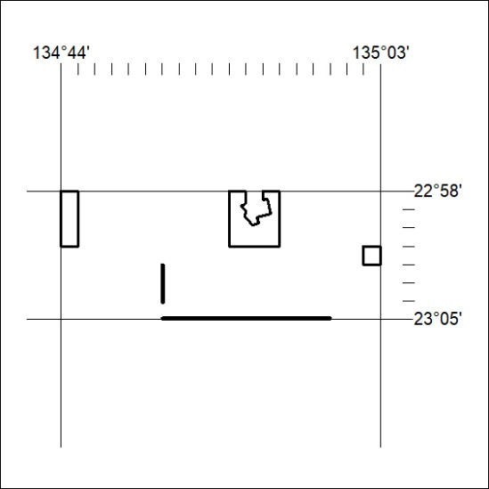
93/25

Mineral Titles Act 2010
NOTICE OF LAND CEASING TO BE A MINERAL TITLE APPLICATION AREA
Title Type and Number: | Exploration Licence 32994
Area Ceased on: | 11 March 2025
Area: | 54 Blocks, 149.63 km²
Locality: | KEATS
Name of Applicant(s)/Holder(s): | 100% TRACKER GEOSERVICES PTY LTD [ACN. 093 390 197]
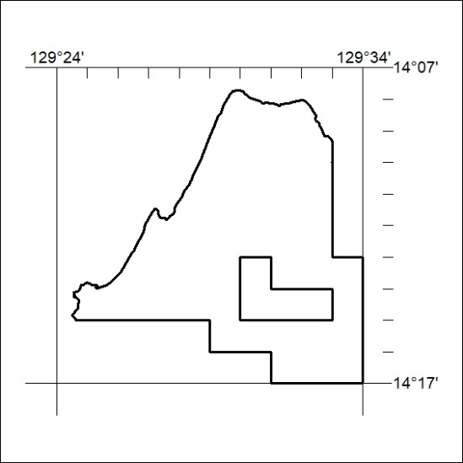
94/25

Mineral Titles Act 2010
NOTICE OF LAND CEASING TO BE A MINERAL TITLE AREA
Title Type and Number: | Exploration Licence 33088
Area Ceased on: | 11 March 2025
Area: | 47 Blocks, 147.51 km²
Locality: | KOOLPINYAH
Name of Applicant(s)/Holder(s): | 100% TRACHRE PTY LTD [ACN. 629 914 656]
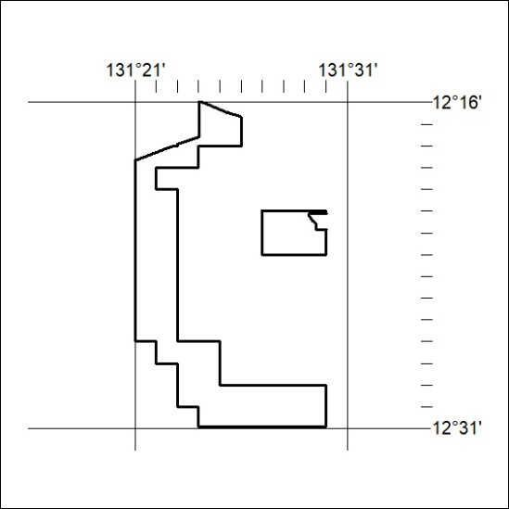
95/25

Mineral Titles Act 2010
NOTICE OF LAND CEASING TO BE A MINERAL TITLE AREA
Title Type and Number: | Exploration Licence 33089
Area Ceased on: | 11 March 2025
Area: | 69 Blocks, 190.97 km²
Locality: | MARY RIVER
Name of Applicant(s)/Holder(s): | 100% TRACHRE PTY LTD [ACN. 629 914 656]
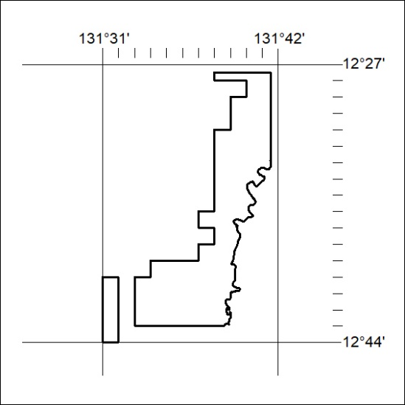
96/25

Mineral Titles Act 2010
NOTICE OF LAND CEASING TO BE A MINERAL TITLE AREA
Title Type and Number: | Exploration Licence 33694
Area Ceased on: | 12 March 2025
Area: | 49 Blocks, 113.11 km²
Locality: | DELNY
Name of Applicant(s)/Holder(s): | 100% IGO NEWSEARCH PTY LTD [ACN. 142 192 701]
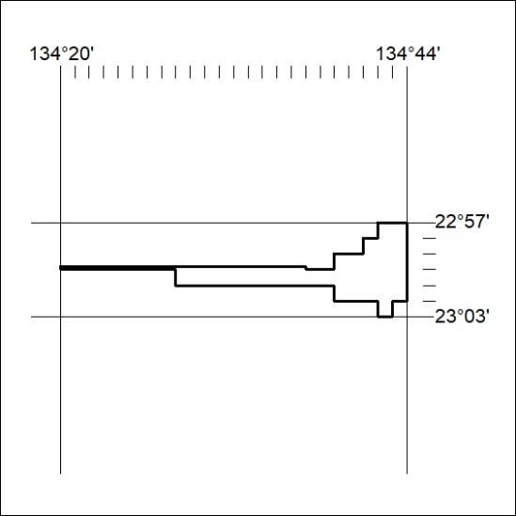
97/25

Mineral Titles Act
NOTICE OF GRANT OF A MINERAL TITLE
Title Type and Number: | Exploration Licence 33785
Granted: | 12 March 2025, for a period of 6 Years
Area: | 31 Blocks, 103.69 km²
Locality: | BATCHELOR
Name of Holder/s: | 100% NT MINING OPERATIONS PTY LTD* [ACN. 136 525 990]
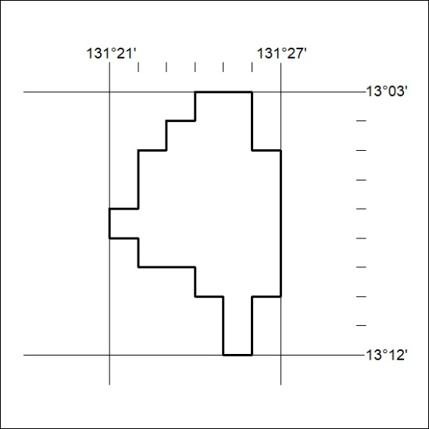
Area granted is indicated above. The titleholder is not permitted to exercise occupational rights on any land that is subject to a development title, or an application for a development title. Any land the subject of a Reserved Land gazettal under the Mineral Titles Act and all land vested in the Commonwealth of Australia is also excluded by description but not excised from the grant area.
98/25

Mineral Titles Act
NOTICE OF GRANT OF A MINERAL TITLE
Title Type and Number: | Exploration Licence 33788
Granted: | 12 March 2025, for a period of 6 Years
Area: | 2 Blocks, 6.68 km²
Locality: | McKINLAY RIVER
Name of Holder/s: | 100% BACCHUS RESOURCES PTY LTD [ACN. 606 340 872]
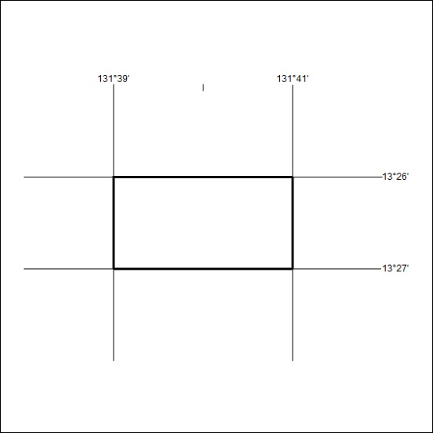
Area granted is indicated above. The titleholder is not permitted to exercise occupational rights on any land that is subject to a development title, or an application for a development title. Any land the subject of a Reserved Land gazettal under the Mineral Titles Act and all land vested in the Commonwealth of Australia is also excluded by description but not excised from the grant area.
99/25

Mineral Titles Act
NOTICE OF GRANT OF A MINERAL TITLE
Title Type and Number: | Exploration Licence 33881
Granted: | 12 March 2025, for a period of 6 Years
Area: | 131 Blocks, 416.30 km²
Locality: | REYNOLDS RANGE
Name of Holder/s: | 100% ITECH ENERGY PTY LTD [ACN. 674 433 151]
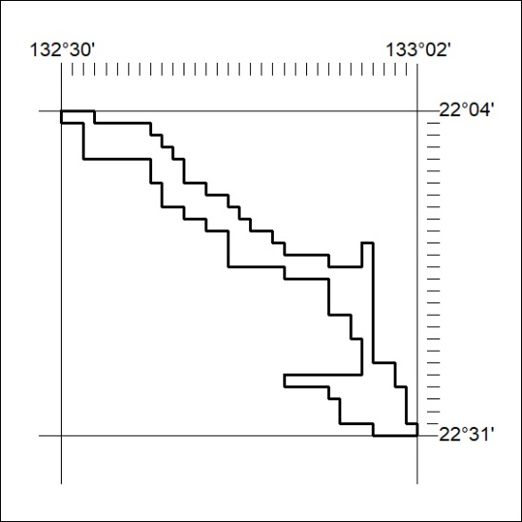
Area granted is indicated above. The titleholder is not permitted to exercise occupational rights on any land that is subject to a development title, or an application for a development title. Any land the subject of a Reserved Land gazettal under the Mineral Titles Act and all land vested in the Commonwealth of Australia is also excluded by description but not excised from the grant area.
100/25

