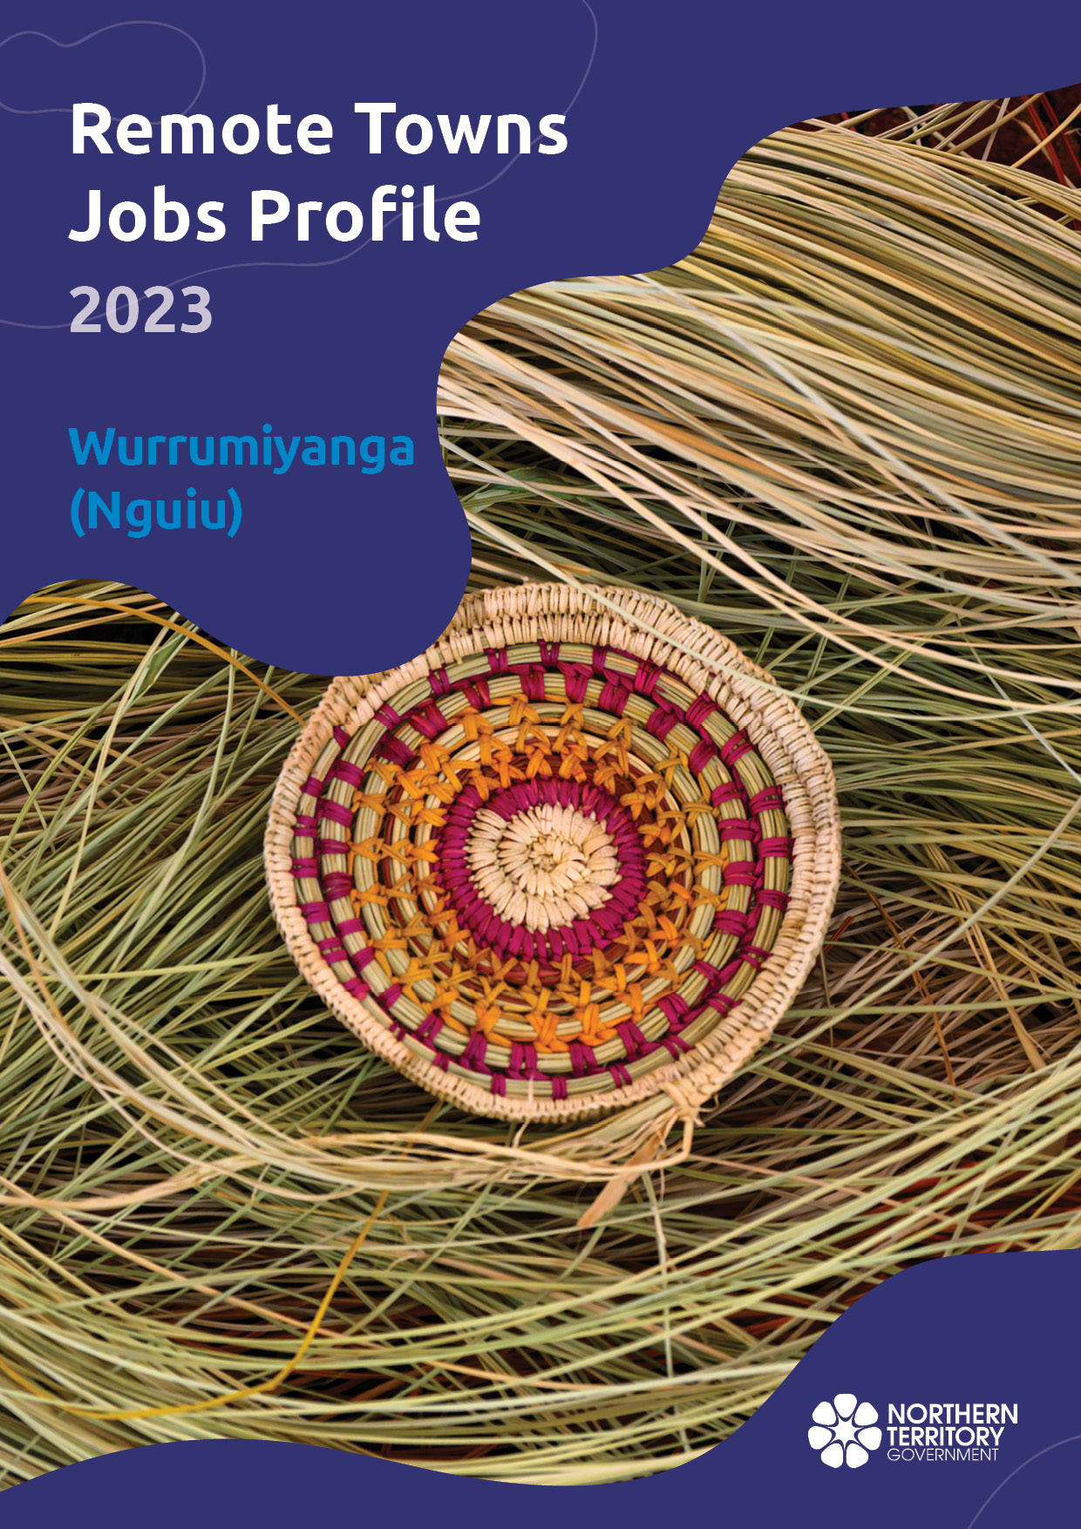

**© Northern Territory of Australia 2025**

**Preferred Reference:** Department of Trade, Business and Asian Relations, 2023 Remote Towns Jobs Profiles, Northern Territory Government, January 2025, Darwin.

**Front cover image:** Weaving materials at Injalak Art Centre, Gunbalanya

**Disclaimer**

The data in this publication was collected by conducting a survey of businesses located in the 28 remote town boundaries. This body of work was completed in 2023 by the former Northern Territory Department of Industry, Tourism and Trade.

The collection methodology was created in accordance with Australian Bureau of Statistics data quality framework principles. Data in this publication is only reflective of those businesses reported on as operating in the town at the time of data collection (see table at the end of publication for list of businesses reported on). To comply with privacy legislation or where appropriate, some data in this publication may have been adjusted and will not reflect the actual data reported by businesses. As a result of this, combined with certain data not being reported by some businesses, some components may not add to totals. Changes over time may also reflect change in business propensity to report on certain data items rather than actual changes over time. Total figures have generally not been adjusted. Caution is advised when interpreting the comparisons made to the earlier 2011, 2014 and 2017 publications as the businesses identified and reported on and the corresponding jobs may differ between publications. The surveys have not always gathered data on training and jobs in the same years.

**Notes for each table and chart are ordered alphabetically and listed at the end of the publication.**

The Northern Territory of Australia exercised due care and skill to ensure that at the time of publication the information contained in this publication is true and correct. However, it is not intended to be relied on as professional advice or used for commercial purposes. The Territory gives no warranty or assurances as to the accuracy of the information contained in the publication and to the maximum extent permitted by law accepts no direct or indirect liability for reliance on its content.

Any use of this report for commercial purposes is not endorsed by the Department of Trade, Business and Asian Relations.

Contents

Wurrumiyanga (Nguiu) 4

Introduction 5

Summary 6

Jobs Overview 7

Jobs by Aboriginality 8

Jobs by Sector: Private and Public 11

Job Status: Permanent or Temporary 18

Job Vacancies 22

Jobs by Industry 24

Jobs by Occupation 31

Jobs by Industry by Occupation 35

Jobs by Gender 39

Jobs by Age 45

Vocational Education and Training 51

Population 58

Community Development Program 60

Businesses 61

Notes 62

Abbreviations and Acronyms 63

.

# Wurrumiyanga (Nguiu)

Wurrumiyanga (Nguiu) is located on the southern coast of Bathurst Island, about 80 kilometres north of Darwin, with a population of 1417 residents.

*Source: Northern Territory Department of Industry, Tourism and Trade*

# Introduction

This jobs profile provides a snapshot of jobs and the characteristics of job holders in Wurrumiyanga (Nguiu) as of September 2023. Trends from the surveys conducted in 2011, 2014, and 2017 are also described. Additionally, it presents data on Community Development Program activity, Population, and Vocational Education and Training.

This job profile is one of 28 profiles developed for remote towns in the Northern Territory. It is anticipated these, and subsequent profiles will contribute to a robust evidence base to inform decision making in and relating to these remote Territory towns.

This profile contains information collected by the Northern Territory Department of Industry, Tourism and Trade from businesses operating within the town and is supplemented by other administrative data sets and information.

Each profile provides up-to-date information that is intended to inform the planning and design of current and future government programs and as an evidence base to inform decision making relating to workforce development, enterprise and job opportunities.

The profile may best be understood as a point-in-time tool. The number of business surveys from which the data was drawn is significantly less than in earlier surveys, and business participation has decreased with each survey. For Wurrumiyanga (Nguiu), 45% fewer businesses than in 2017 are reported here.

The data collection methodology and corresponding questionnaire were created in partnership with the Australian Bureau of Statistics (ABS) and in accordance with ABS data quality framework and survey principles.

The Northern Territory Department of Industry, Tourism and Trades’ Territory Engagement and Delivery, Skills Initiative and VET data teams collaborated with the Northern Institute at Charles Darwin University to facilitate the surveys and reports.

The information collected and reported on represents a significant goodwill investment by those businesses and organisations that participated. Each business is listed at the end of this publication.

# Summary

The 2023 jobs profile was developed based on responses from 12 businesses operating within the Wurrumiyanga (Nguiu) town boundary, 10 less than in the 2017 survey. Of these, there were:

* 8 businesses from the Private Sector, accounting for 122 filled jobs or 77% of total filled jobs
* 4 businesses from the Public Sector, accounting for 36 filled jobs or 23% of total filled jobs
* 8 businesses participated in all four surveys (completed in 2011, 2014, 2017 and 2023).

A total of 174 filled and vacant jobs in Wurrumiyanga (Nguiu) were reported, a decrease of 321 jobs from 2017.[1]

The 2023 profile highlights:

* there were 158 filled jobs of which:
* 107 jobs (68%) were filled by Aboriginal people, a decrease of 208 jobs from 2017
* 51 jobs (32%) were filled by non-Aboriginal people, a decrease of 95 jobs from 2017
* 58% of employed Aboriginal people are working in the Private Sector
* Aboriginal people accounted for 68% of job holders in the town, unchanged from 2017
* Aboriginal females made up 72% of total Aboriginal filled jobs in the town, compared to 55% in 2017
* there were 16 vacant jobs, of which:
* job vacancies as a percentage of jobs increased to 9.2% in 2023 from 6.9% in 2017
* job vacancies equate to 1 in 10.8 jobs
* 12 of the vacancies were in Community and Personal Service Works and Clerical and Administrative areas
* Education and Training was the largest industry employer in 2023
* Public Administration and Safety had the highest decrease in filled jobs of 82 between 2023 and 2017
* training had a decrease in student numbers between 2023 and 2016
* Community Services, Health and Education had the highest student numbers in 2023
* Building and Construction has the highest increase in student numbers between 2023 and 2016
* in 2023 Tourism and Hospitality was conducted for 11 students, a training area not delivered in 2013 and 2016.

The overall population in Wurrumiyanga (Nguiu) decreased by 110 people (-7.2%) between 2011 and 2021 to 1,417 people.

In comparison, the overall Northern Territory population increased by 9.7% between 2011 and 2021.

In 2021, the working age population (15 years and over) in Wurrumiyanga (Nguiu) was an estimated 1,117 people compared to 1,103 in 2011 an increase of 1.3%.

There were 0.2 jobs in Wurrumiyanga (Nguiu) per working age person compared to 0.3 jobs per working age person across the 28 remote towns in the NT.

# Jobs Overview

Table 1: Count of filled jobs and vacancies, 2011, 2014, 2017 & 2023 (a)(b)

|  |  |  |  |  |  |  |  |
| --- | --- | --- | --- | --- | --- | --- | --- |
|  | **2011** | **2014** | **2017** | **2023** | **Change 2011-2014** | **Change 2014-2017** | **Change 2017-2023** |
| **Total All Jobs** | **338** | **407** | **495** | **174** | **69** | **88** | **-321** |
| **Vacancies** | **10** | **17** | **34** | **16** | **7** | **17** | **-18** |
| Vacancies as % of Total All Jobs | 3.0% | 4.2% | 6.9% | 9.2% | 1.2 ppt | 2.7 ppt | 2.3 ppt |
| **Filled Jobs** | **328** | **390** | **461** | **158** | **62** | **71** | **-303** |
| Full-time | 260 | 246 | 249 | 67 | -14 | 3 | -182 |
| Part-time | 68 | 144 | 212 | 91 | 76 | 68 | -121 |

Source: Northern Territory Department of Industry, Tourism and Trade

Chart 1: Count of vacant jobs and filled jobs by full-time/part-time status, 2011, 2014, 2017 & 2023 (a)(b)

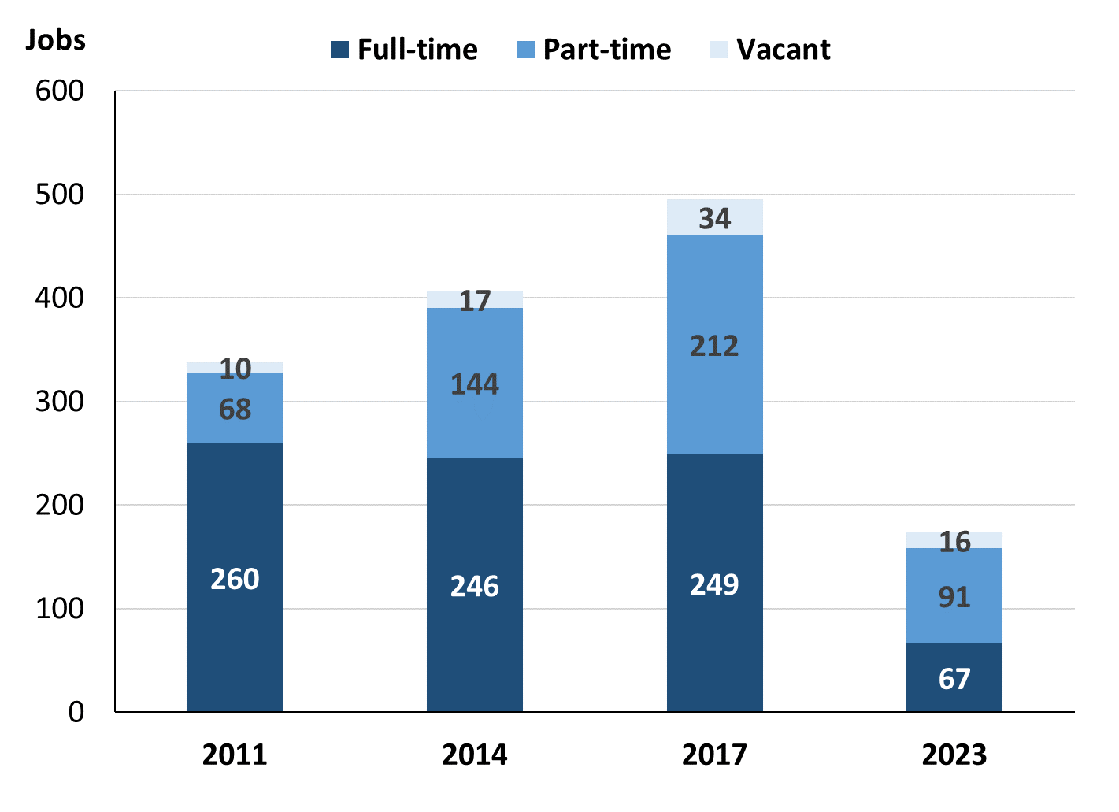

Source: Northern Territory Department of Industry, Tourism and Trade

In 2023 in Wurrumiyanga (Nguiu):

* there was a total of 158 **filled jobs**, a decrease of 303 jobs from 2017 and a decrease of 232 jobs from 2014
* of the 158 **filled jobs** in 2023:
* 67 were full-time jobs, a decrease of 182 jobs from 2017 and a decrease of 179 jobs from 2014
* 91 were part-time jobs, a decrease of 121 jobs from 2017 and a decrease of 53 jobs from 2014
* there were 16 total **job vacancies** in 2023, a decrease of 18 vacancies from 2017 and a decrease of 1 vacancy from 2014.

# Jobs by Aboriginality

Chart 2: Count of filled jobs by Aboriginality, 2011, 2014, 2017 & 2023 (a)(c)

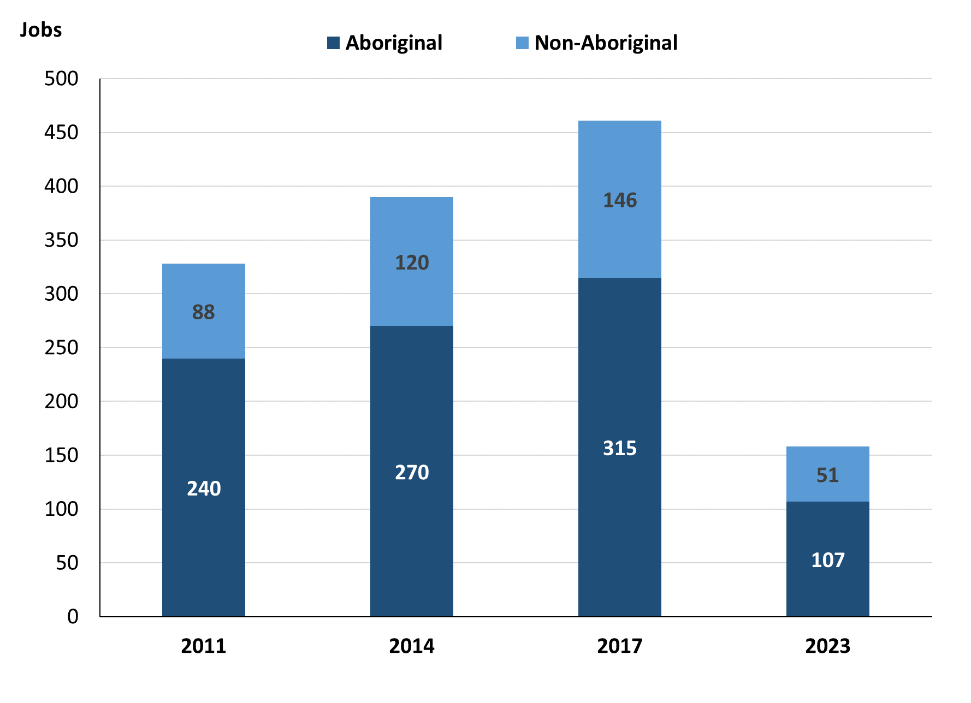

Source: Northern Territory Department of Industry, Tourism and Trade

In 2023 in Wurrumiyanga (Nguiu):

* of the 158 **filled jobs**:
* **Aboriginal** people filled 107 jobs, a decrease of 208 jobs from 2017 and a decrease of 163 jobs from 2014
* **non-Aboriginal** people filled 51 jobs, a decrease of 95 jobs from 2017 and a decrease of 69 jobs from 2014
* **Aboriginal** people accounted for 68% of job holders, unchanged from 2017 and 69% in 2014.

Table 2a: Count of filled jobs by full-time/part-time status, 2011, 2014, 2017 & 2023 (a)(b)(c)

|  |  |  |  |  |  |  |  |  |  |  |  |  |
| --- | --- | --- | --- | --- | --- | --- | --- | --- | --- | --- | --- | --- |
| **Indicator** | **2011** | | | **2014** | | | **2017** | | | **2023** | | |
| **Aboriginal** | **Non-Aboriginal** | **Total** | **Aboriginal** | **Non-Aboriginal** | **Total** | **Aboriginal** | **Non-Aboriginal** | **Total** | **Aboriginal** | **Non-Aboriginal** | **Total** |
| Full-time | 182 | 78 | **260** | 136 | 110 | **246** | 115 | 134 | **249** | 30 | 37 | **67** |
| Part-time | 58 | 10 | **68** | 134 | 10 | **144** | 200 | 12 | **212** | 77 | 14 | **91** |
| **Total** | **240** | **88** | **328** | **270** | **120** | **390** | **315** | **146** | **461** | **107** | **51** | **158** |

Source: Northern Territory Department of Industry, Tourism and Trade

Table 2b: Count of filled jobs by full-time/part-time status, 2011-2014, 2014-2017 & 2017-2023 (a)(b)(c)

|  |  |  |  |  |  |  |  |  |  |
| --- | --- | --- | --- | --- | --- | --- | --- | --- | --- |
| **Indicator** | **Change 2011-2014** | | | **Change 2014-2017** | | | **Change 2017-2023** | | |
| **Aboriginal** | **Non-Aboriginal** | **Total** | **Aboriginal** | **Non-Aboriginal** | **Total** | **Aboriginal** | **Non-Aboriginal** | **Total** |
| Full-time | -46 | 32 | **-14** | -21 | 24 | **3** | -85 | -97 | **-182** |
| Part-time | 76 | 0 | **76** | 66 | 2 | **68** | -123 | 2 | **-121** |
| **Total** | **30** | **32** | **62** | **45** | **26** | **71** | **-208** | **-95** | **-303** |

Source: Northern Territory Department of Industry, Tourism and Trade

Chart 3: Count of filled jobs by full-time/part-time status, 2011, 2014, 2017 & 2023 (a)(b)(c)

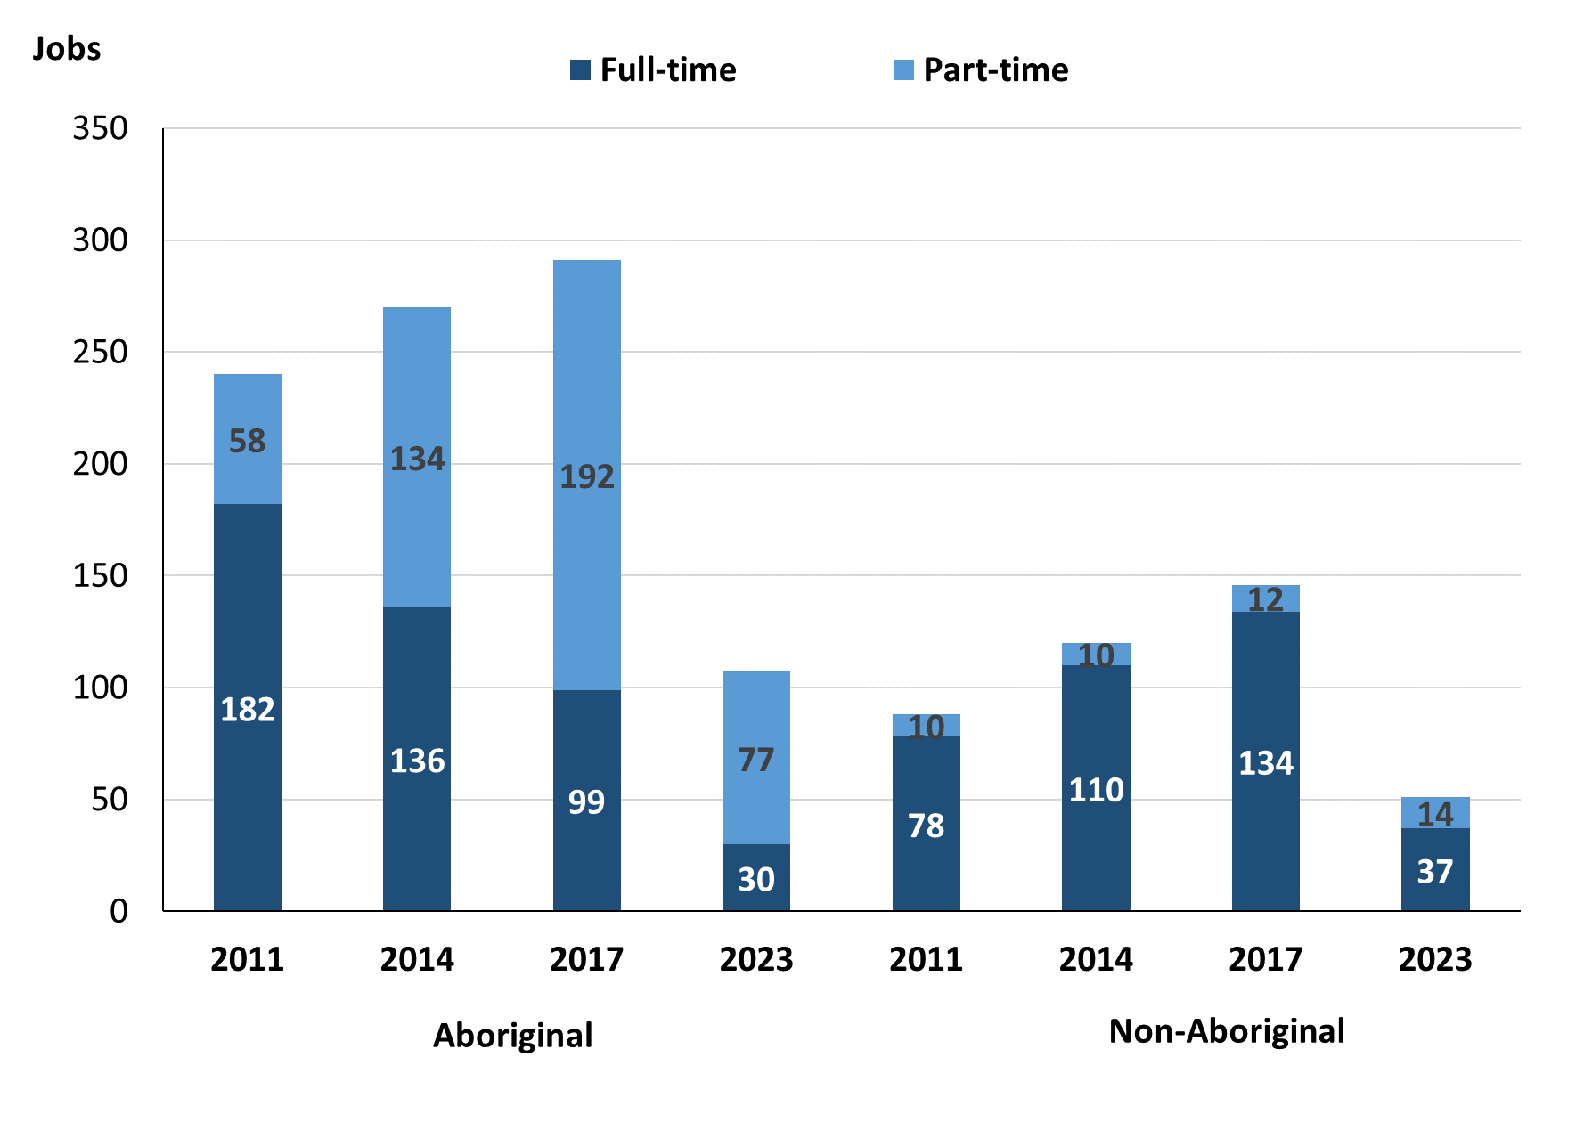

Source: Northern Territory Department of Industry, Tourism and Trade

In 2023 in Wurrumiyanga (Nguiu):

* of the 158 filled jobs:
* 30 were **full-time** jobs filled by **Aboriginal** people, a decrease of 85 jobs from 2017 and a decrease of 106 jobs from 2014
* 77 were **part-time** jobs filled by **Aboriginal** people, a decrease of 123 jobs from 2017 and a decrease of 57 jobs from 2014
* 37 were **full-time** jobs filled by **non-Aboriginal** people, a decrease of 97 jobs from 2017 and a decrease of 73 jobs from 2014
* 14 were **part-time** jobs filled by **non-Aboriginal** people, an increase of 2 jobs from 2017 and an increase of 4 jobs from 2014.

# Jobs by Sector: Private and Public

Table 3a: Count of filled jobs by business sector 2011, 2014, 2017 & 2023 (a)(b)(c)

|  |  |  |  |  |  |  |  |  |  |  |  |  |
| --- | --- | --- | --- | --- | --- | --- | --- | --- | --- | --- | --- | --- |
| **Indicator** | **2011** | | | **2014** | | | **2017** | | | **2023** | | |
| **Aboriginal** | **Non-Aboriginal** | **Total** | **Aboriginal** | **Non-Aboriginal** | **Total** | **Aboriginal** | **Non-Aboriginal** | **Total** | **Aboriginal** | **Non-Aboriginal** | **Total** |
| **Public Sector** | 79 | 20 | **99** | 83 | 36 | **119** | 86 | 43 | **129** | 16 | 20 | **36** |
| Australian Government | 5 | 2 | **7** | 5 | 1 | **6** | 5 | 1 | **6** | 0 | 1 | **1** |
| Territory Government | 9 | 5 | **14** | 18 | 14 | **32** | 21 | 21 | **42** | 16 | 19 | **35** |
| Local Government | 65 | 13 | **78** | 60 | 21 | **81** | 60 | 21 | **81** | 0 | 0 | **0** |
| **Private Sector** | 161 | 68 | **229** | 187 | 84 | **271** | 229 | 103 | **332** | 91 | 31 | **122** |
| **Total** | **240** | **88** | **328** | **270** | **120** | **390** | **315** | **146** | **461** | **107** | **51** | **158** |

Source: Northern Territory Department of Industry, Tourism and Trade

Table 3b: Count of filled jobs by business sector, 2011-2014, 2014-2017 & 2017-2023 (a)(b)(c)

|  |  |  |  |  |  |  |  |  |  |
| --- | --- | --- | --- | --- | --- | --- | --- | --- | --- |
| **Indicator** | **Change 2011-2014** | | | **Change 2014-2017** | | | **Change 2017-2023** | | |
| **Aboriginal** | **Non-Aboriginal** | **Total** | **Aboriginal** | **Non-Aboriginal** | **Total** | **Aboriginal** | **Non-Aboriginal** | **Total** |
| **Public Sector** | 4 | 16 | **20** | 3 | 7 | **10** | -70 | -23 | **-93** |
| Australian Government | 0 | -1 | **-1** | 0 | 0 | **0** | -5 | 0 | **-5** |
| Territory Government | 9 | 9 | **18** | 3 | 7 | **10** | -5 | -2 | **-7** |
| Local Government | -5 | 8 | **3** | 0 | 0 | **0** | -60 | -21 | **-81** |
| **Private Sector** | 26 | 16 | **42** | 42 | 19 | **61** | -138 | -72 | **-210** |
| **Total** | **30** | **32** | **62** | **45** | **26** | **71** | **-208** | **-95** | **-303** |

Source: Northern Territory Department of Industry, Tourism and Trade

**Chart 4: Count of filled jobs by business sector, 2011, 2014, 2017 & 2023 (a)(d)**

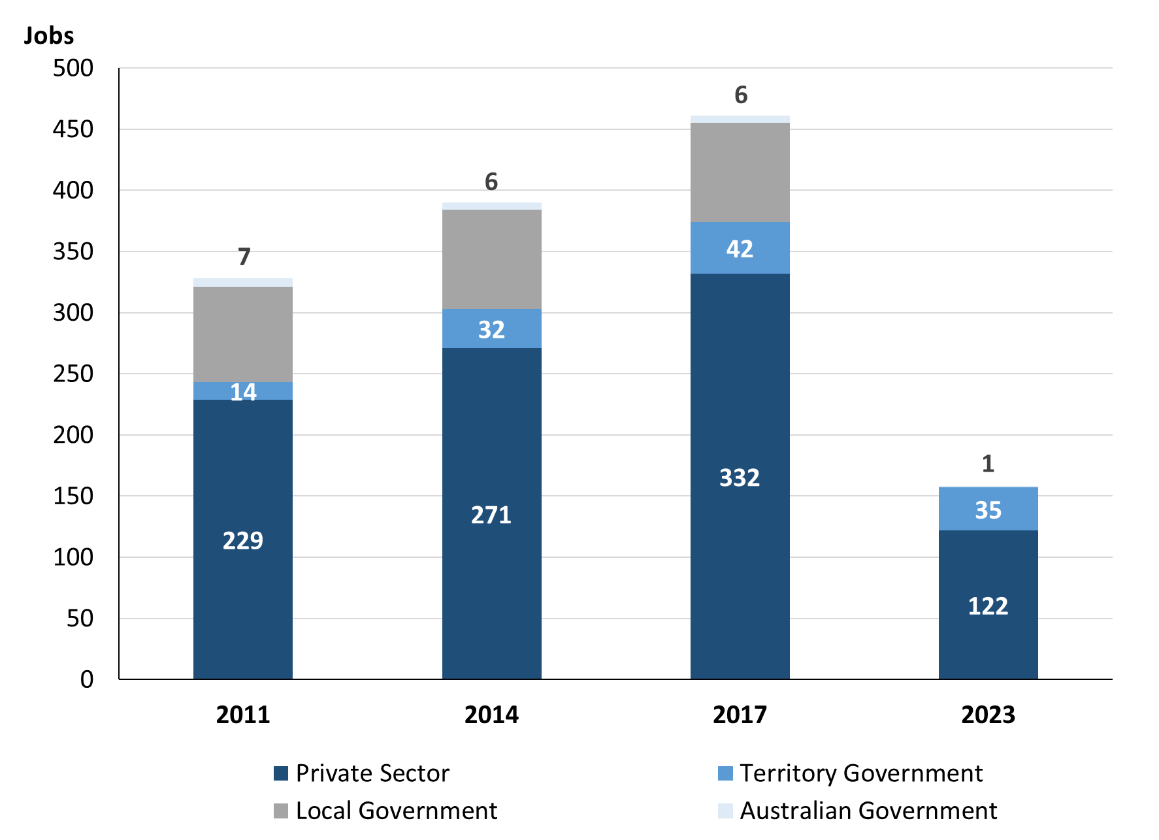

Source: Northern Territory Department of Industry, Tourism and Trade

Chart 5: Percentage of filled jobs by business sector in 2023 (a)(d)

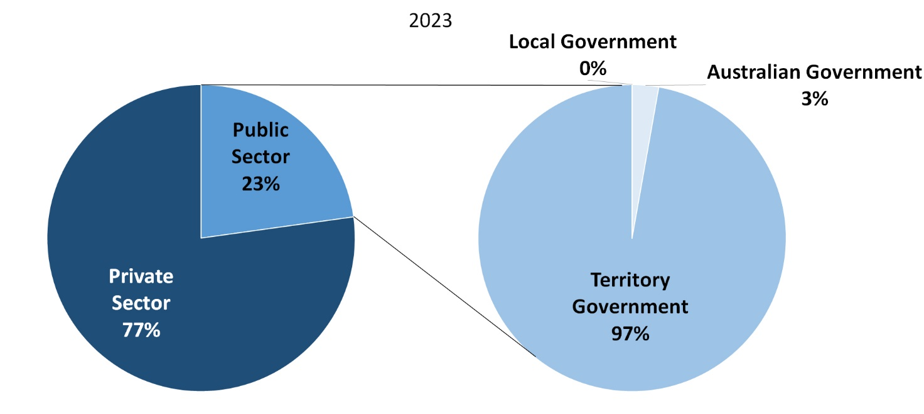

Source: Northern Territory Department of Industry, Tourism and Trade

In 2023 in Wurrumiyanga (Nguiu):

* there were 36 jobs in the **Public Sector**, a decrease of 93 jobs from 2017 and a decrease of 83 jobs from 2014
* of the 36 jobs in the **Public Sector**:
* 1 job was in the Australian Government, a decrease of 5 jobs from 2017 and a decrease of 5 jobs from 2014
* 35 jobs were in the Territory Government, a decrease of 7 jobs from 2017 and an increase of 3 jobs from 2014
* there were 122 jobs in the **Private Sector**, a decrease of 210 jobs from 2017 and a decrease of 149 jobs from 2014.

Chart 6: Count of filled jobs by sector 2011, 2014, 2017 & 2023 (a)(c)(d)

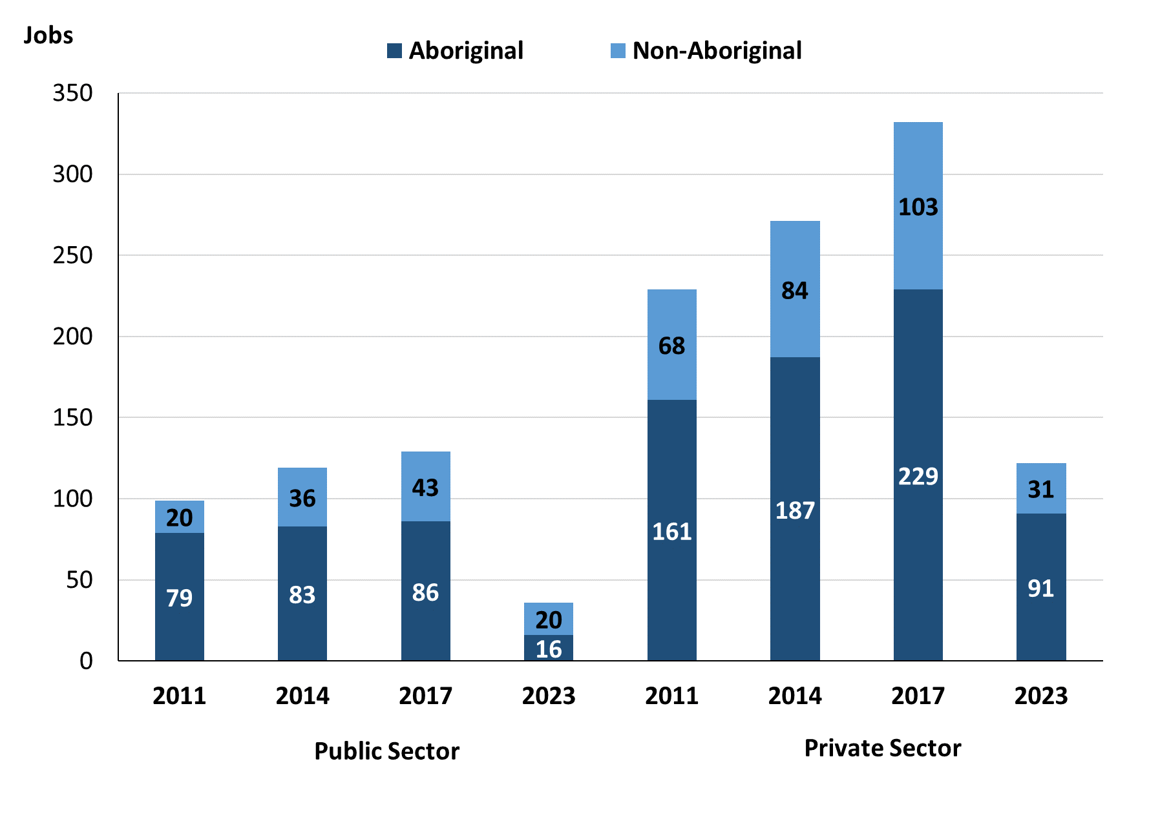

Source: Northern Territory Department of Industry, Tourism and Trade

In 2023 in Wurrumiyanga (Nguiu):

* of the 36 jobs in the **Public Sector**:
* **Aboriginal** people filled 16 jobs, a decrease of 70 jobs from 2017 and a decrease of 67 jobs from 2014
* **non-Aboriginal** people filled 20 jobs, a decrease of 23 jobs from 2017 and a decrease of 16 jobs from 2014
* of the 122 jobs in the **Private Sector**:
* **Aboriginal** people filled 91 jobs, a decrease of 138 jobs from 2017 and a decrease of 96 jobs from 2014
* **non-Aboriginal** people filled 31 jobs, a decrease of 72 jobs from 2017 and a decrease of 53 jobs from 2014.

Chart 7: Count of filled jobs by sector and full-time/part-time status, 2011, 2014, 2017 & 2023 (a)(b)(d)

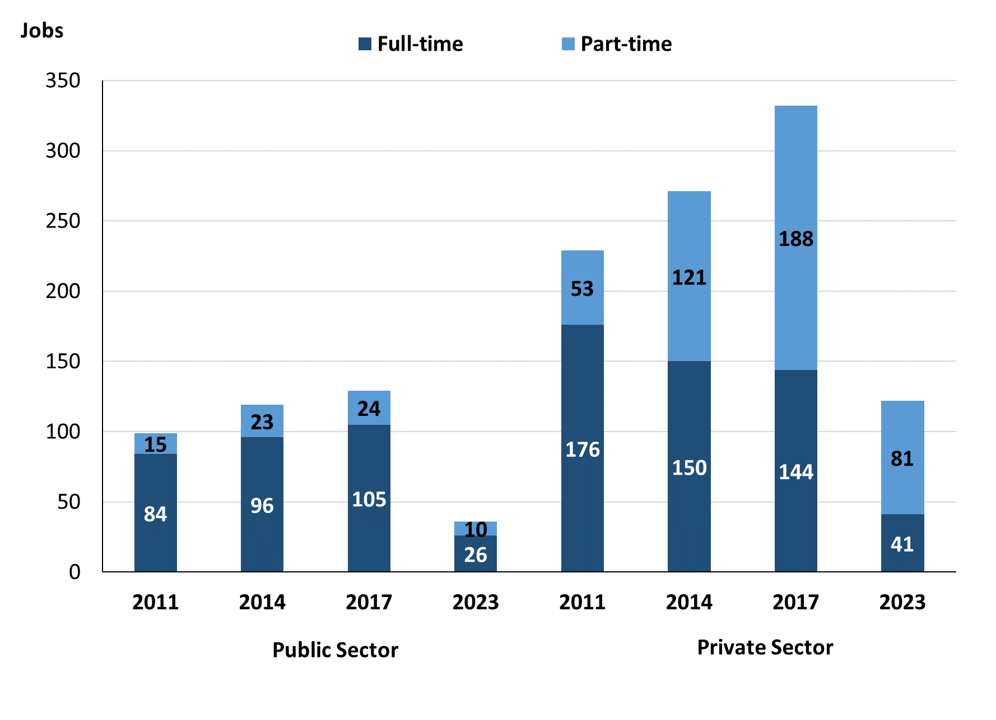

Source: Northern Territory Department of Industry, Tourism and Trade

In 2023 in Wurrumiyanga (Nguiu):

* of the 36 jobs in the **Public Sector**:
* 26 were **full-time** jobs, a decrease of 79 jobs from 2017 and a decrease of 70 jobs from 2014
* 10 were **part-time** jobs, a decrease of 14 jobs from 2017 and a decrease of 13 jobs from 2014
* of the 122 jobs in the **Private Sector**:
* 41 were **full-time** jobs, a decrease of 103 jobs from 2017 and a decrease of 109 jobs from 2014
* 81 were **part-time** jobs, a decrease of 107 jobs from 2017 and a decrease of 40 jobs from 2014.

Table 4: Count of filled jobs by full-time/part-time status by sector, 2011, 2014, 2017 & 2023 (a)(b)(c)(d)

|  |  |  |  |  |  |  |  |  |  |
| --- | --- | --- | --- | --- | --- | --- | --- | --- | --- |
| **Indicator** | **2011** | | | | | | | | |
| **Aboriginal** | | | **Non-Aboriginal** | | | **Total** | | |
| **Full-time** | **Part-time** | **Total** | **Full-time** | **Part-time** | **Total** | **Full-time** | **Part-time** | **Total** |
| Public Sector | 64 | 15 | **79** | 20 | 0 | **20** | 84 | 15 | **99** |
| Private Sector | 118 | 43 | **161** | 58 | 10 | **68** | 176 | 53 | **229** |
| **Total** | **182** | **58** | **240** | **78** | **10** | **88** | **260** | **68** | **328** |

|  |  |  |  |  |  |  |  |  |  |
| --- | --- | --- | --- | --- | --- | --- | --- | --- | --- |
| **Indicator** | **2014** | | | | | | | | |
| **Aboriginal** | | | **Non-Aboriginal** | | | **Total** | | |
| **Full-time** | **Part-time** | **Total** | **Full-time** | **Part-time** | **Total** | **Full-time** | **Part-time** | **Total** |
| Public Sector | 60 | 23 | **83** | 36 | 0 | **36** | 96 | 23 | **119** |
| Private Sector | 76 | 111 | **187** | 74 | 10 | **84** | 150 | 121 | **271** |
| **Total** | **136** | **134** | **270** | **110** | **10** | **120** | **246** | **144** | **390** |

|  |  |  |  |  |  |  |  |  |  |
| --- | --- | --- | --- | --- | --- | --- | --- | --- | --- |
| **Indicator** | **2017** | | | | | | | | |
| **Aboriginal** | | | **Non-Aboriginal** | | | **Total** | | |
| **Full-time** | **Part-time** | **Total** | **Full-time** | **Part-time** | **Total** | **Full-time** | **Part-time** | **Total** |
| Public Sector | 63 | 23 | **86** | 42 | 1 | **43** | 105 | 24 | **129** |
| Private Sector | 52 | 177 | **229** | 92 | 11 | **103** | 144 | 188 | **332** |
| **Total** | **136** | **134** | **315** | **134** | **12** | **146** | **249** | **212** | **461** |

|  |  |  |  |  |  |  |  |  |  |
| --- | --- | --- | --- | --- | --- | --- | --- | --- | --- |
| **Indicator** | **2023** | | | | | | | | |
| **Aboriginal** | | | **Non-Aboriginal** | | | **Total** | | |
| **Full-time** | **Part-time** | **Total** | **Full-time** | **Part-time** | **Total** | **Full-time** | **Part-time** | **Total** |
| Public Sector | 6 | 10 | **16** | 20 | 0 | **20** | 26 | 10 | **36** |
| Private Sector | 24 | 67 | **91** | 17 | 14 | **31** | 41 | 81 | **122** |
| **Total** | **30** | **77** | **107** | **37** | **14** | **51** | **67** | **91** | **158** |

Source: Northern Territory Department of Industry, Tourism and Trade

In 2023 in Wurrumiyanga (Nguiu) there were:

* 16 jobs in the **Public Sector** filled by **Aboriginal** people, a decrease of 70 jobs from 2017 and a decrease of 67 jobs from 2014, of which:
* 6 were **full-time** jobs, a decrease of 57 jobs from 2017 and a decrease of 54 jobs from 2014
* 10 were **part-time** jobs, a decrease of 13 jobs from 2017 and a decrease of 13 jobs from 2014
* 91 jobs in the **Private Sector** filled by **Aboriginal** people, a decrease of 138 jobs from 2017 and a decrease of 96 jobs from 2014, of which:
* 24 were **full-time** jobs, a decrease of 28 jobs from 2017 and a decrease of 52 jobs from 2014
* 67 were **part-time** jobs, a decrease of 110 jobs from 2017 and a decrease of 44 jobs from 2014
* 20 jobs in the **Public Sector** filled by **non-Aboriginal** people, a decrease of 23 jobs from 2017 and a decrease of 16 jobs from 2014, of which:
* 20 were **full-time** jobs, a decrease of 22 jobs from 2017 and a decrease of 16 jobs from 2014
* none were **part-time** jobs, a decrease of 1 job from 2017 and unchanged from 2014
* 31 jobs in the **Private Sector** filled by **non-Aboriginal** people, a decrease of 72 jobs from 2017 and a decrease of 53 jobs from 2014, of which:
* 17 were **full-time** jobs, a decrease of 75 jobs from 2017 and a decrease of 57 jobs from 2014
* 14 were **part-time** jobs, an increase of 3 jobs from 2017 and an increase of 4 jobs from 2014.

# Job Status: Permanent or Temporary

Table 5a: Count of filled jobs by employment status, 2011, 2014, 2017 & 2023 (a)(c)(e)

|  |  |  |  |  |  |  |  |  |  |  |  |  |
| --- | --- | --- | --- | --- | --- | --- | --- | --- | --- | --- | --- | --- |
| **Indicator** | **2011** | | | **2014** | | | **2017** | | | **2023** | | |
| **Aboriginal** | **Non-Aboriginal** | **Total** | **Aboriginal** | **Non-Aboriginal** | **Total** | **Aboriginal** | **Non-Aboriginal** | **Total** | **Aboriginal** | **Non-Aboriginal** | **Total** |
| Permanent | 119 | 50 | **169** | 144 | 74 | **218** | 132 | 55 | **187** | 25 | 15 | **40** |
| Temporary | 121 | 38 | **159** | 126 | 46 | **172** | 183 | 91 | **274** | 82 | 36 | **118** |
| **Total** | **240** | **88** | **328** | **270** | **120** | **390** | **315** | **146** | **461** | **107** | **51** | **158** |

Source: Northern Territory Department of Industry, Tourism and Trade

Table 5b: Count of filled jobs by employment status, 2011-2014, 2014-2017 & 2017-2023 (a)(c)(e)

|  |  |  |  |  |  |  |  |  |  |
| --- | --- | --- | --- | --- | --- | --- | --- | --- | --- |
| **Indicator** | **Change 2011-2014** | | | **Change 2014-2017** | | | **Change**  **2017-2023** | | |
| **Aboriginal** | **Non-Aboriginal** | **Total** | **Aboriginal** | **Non-Aboriginal** | **Total** | **Aboriginal** | **Non-Aboriginal** | **Total** |
| Permanent | 25 | 24 | **49** | -12 | -19 | **-31** | -107 | -40 | **-147** |
| Temporary | 5 | 8 | **13** | 57 | 45 | **102** | -101 | -55 | **-156** |
| **Total** | **30** | **32** | **62** | **45** | **26** | **71** | **-208** | **-95** | **-303** |

Source: Northern Territory Department of Industry, Tourism and Trade

Chart 8: Count of filled jobs by employment status, 2011, 2014, 2017 & 2023 (a)(c)(e)

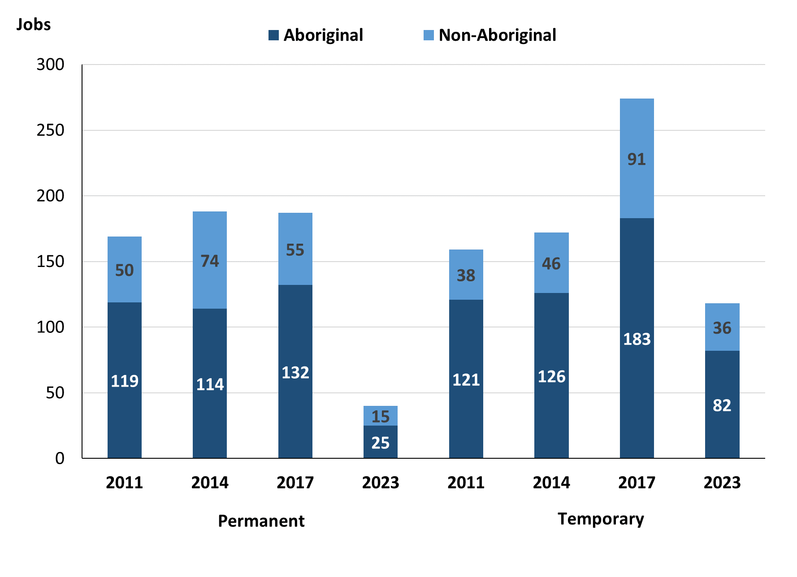

Source: Northern Territory Department of Industry, Tourism and Trade

In 2023 in Wurrumiyanga (Nguiu):

* there were 40 **permanent** jobs, a decrease of 147 jobs from 2017, and a decrease of 178 jobs from 2014, of which:
* **Aboriginal** people filled 25 jobs, a decrease of 107 jobs from 2017 and a decrease of 119 jobs from 2014
* **non-Aboriginal** people filled 15 jobs, a decrease of 40 jobs from 2017 and a decrease of 59 jobs from 2014
* there were 118 **temporary** jobs, a decrease of 156 jobs from 2017 and a decrease of 54 jobs from 2014, of which:
* **Aboriginal** people filled 82 jobs, a decrease of 101 jobs from 2017 and a decrease of 44 jobs from 2014
* **non-Aboriginal** people filled 36 jobs, a decrease of 55 jobs from 2017 and a decrease of 10 jobs from 2014.

Table 6: Count of filled jobs by sector, and employment status, 2011, 2014, 2017 & 2023 (a)(c)(d)(e)

|  |  |  |  |  |  |  |  |  |  |
| --- | --- | --- | --- | --- | --- | --- | --- | --- | --- |
| **Indicator** | **2011** | | | | | | | | |
| **Aboriginal** | | | **Non-Aboriginal** | | | **Total** | | |
| **Perm** | **Temp** | **Total** | **Perm** | **Temp** | **Total** | **Perm** | **Temp** | **Total** |
| Public Sector | 59 | 20 | **79** | 10 | 10 | **20** | 69 | 30 | **99** |
| Private Sector | 60 | 101 | **161** | 40 | 28 | **68** | 100 | 129 | **229** |
| **Total** | **119** | **121** | **240** | **50** | **38** | **88** | **169** | **159** | **328** |

|  |  |  |  |  |  |  |  |  |  |
| --- | --- | --- | --- | --- | --- | --- | --- | --- | --- |
| **Indicator** | **2014** | | | | | | | | |
| **Aboriginal** | | | **Non-Aboriginal** | | | **Total** | | |
| **Perm** | **Temp** | **Total** | **Perm** | **Temp** | **Total** | **Perm** | **Temp** | **Total** |
| Public Sector | 80 | 3 | **83** | 33 | 3 | **36** | 113 | 6 | **119** |
| Private Sector | 64 | 123 | **187** | 41 | 43 | **84** | 105 | 166 | **271** |
| **Total** | **144** | **126** | **270** | **74** | **46** | **120** | **218** | **172** | **390** |

|  |  |  |  |  |  |  |  |  |  |
| --- | --- | --- | --- | --- | --- | --- | --- | --- | --- |
| **Indicator** | **2017** | | | | | | | | |
| **Aboriginal** | | | **Non-Aboriginal** | | | **Total** | | |
| **Perm** | **Temp** | **Total** | **Perm** | **Temp** | **Total** | **Perm** | **Temp** | **Total** |
| Public Sector | 67 | 19 | **86** | 25 | 18 | **43** | 92 | 37 | **129** |
| Private Sector | 65 | 164 | **229** | 30 | 73 | **103** | 95 | 237 | **332** |
| **Total** | **132** | **183** | **315** | **55** | **91** | **146** | **187** | **274** | **461** |

|  |  |  |  |  |  |  |  |  |  |
| --- | --- | --- | --- | --- | --- | --- | --- | --- | --- |
| **Indicator** | **2023** | | | | | | | | |
| **Aboriginal** | | | **Non-Aboriginal** | | | **Total** | | |
| **Perm** | **Temp** | **Total** | **Perm** | **Temp** | **Total** | **Perm** | **Temp** | **Total** |
| Public Sector | 4 | 12 | **16** | 9 | 11 | **20** | 13 | 23 | **36** |
| Private Sector | 21 | 70 | **91** | 6 | 25 | **31** | 27 | 95 | **122** |
| **Total** | **25** | **82** | **107** | **15** | **36** | **51** | **40** | **118** | **158** |

Source: Northern Territory Department of Industry, Tourism and Trade

In 2023 in Wurrumiyanga (Nguiu):

* 36 jobs in the **Public Sector**, a decrease of 93 jobs from 2017 and a decrease of 83 jobs from 2014, of which:
* 13 jobs were **permanent**, a decrease of 79 jobs from 2017 and a decrease of 100 jobs from 2014, of which:
* **Aboriginal** people filled 4 jobs, a decrease of 63 jobs from 2017 and a decrease of 76 jobs from 2014
* **non-Aboriginal** people filled 9 jobs, a decrease of 16 jobs from 2017 and a decrease of 24 jobs from 2014
* 23 jobs were **temporary**, a decrease of 14 jobs from 2017 and an increase of 17 jobs from 2014, of which:
* **Aboriginal** people filled 12 jobs, a decrease of 7 jobs from 2017 and an increase of 9 jobs from 2014
* **non-Aboriginal** people filled 11 jobs, a decrease of 7 jobs from 2017 and an increase of 8 jobs from 2014
* 122 jobs in the **Private Sector**, a decrease of 210 jobs from 2017 and a decrease of 149 jobs from 2014, of which:
* 27 jobs were **permanent**, a decrease of 68 jobs from 2017 and a decrease of 78 jobs from 2014, of which:
* **Aboriginal** people filled 21 jobs, a decrease of 44 jobs from 2017 and a decrease of 43 jobs from 2014
* **non-Aboriginal** people filled 6 jobs, a decrease of 24 jobs from 2017 and a decrease of 35 jobs from 2014
* 95 jobs were **temporary**, a decrease of 142 jobs from 2017 and a decrease of 71 jobs from 2014, of which:
* **Aboriginal** people filled 70 jobs, a decrease of 94 jobs from 2017 and a decrease of 53 jobs from 2014
* **non-Aboriginal** people filled 25 jobs, a decrease of 48 jobs from 2017 and a decrease of 18 jobs from 2014.

# Job Vacancies

Table 7: Job vacancies, 2011, 2014, 2017 & 2023

|  |  |  |  |  |  |  |  |
| --- | --- | --- | --- | --- | --- | --- | --- |
| **Indicator** | **2011** | **2014** | **2017** | **2023** | **Change 2011-2014** | **Change 2014-2017** | **Change 2017-2023** |
| **Job vacancies** | **10** | **17** | **34** | **16** | **7** | **17** | **-18** |

Source: Northern Territory Department of Industry, Tourism and Trade

Table 8a: Job vacancies by occupation, 2011, 2014, 2017 & 2023 (f)(g)

|  |  |  |  |  |
| --- | --- | --- | --- | --- |
| **Occupation (ANZSCO major group)** | **2011** | **2014** | **2017** | **2023** |
| Clerical and Administrative Workers | 0 | 1 | 4 | 4 |
| Community and Personal Service Workers | 3 | 8 | 11 | 8 |
| Labourers | 0 | 2 | 6 | 1 |
| Machinery Operators and Drivers | 0 | 0 | 0 | 0 |
| Managers | 0 | 1 | 0 | 1 |
| Professionals | 6 | 2 | 6 | 2 |
| Sales Workers | 1 | 0 | 3 | 0 |
| Technicians and Trades Workers | 0 | 3 | 4 | 0 |
| **Total** | **10** | **17** | **34** | **16** |

Source: Northern Territory Department of Industry, Tourism and Trade

Table 8b: Job vacancies by occupation, 2011-2014, 2014-2017, 2017- 2023 (f)(g)

|  |  |  |  |
| --- | --- | --- | --- |
| **Occupation (ANZSCO major group)** | **Change 2011-2014** | **Change 2014-2017** | **Change 2017-2023** |
| Clerical and Administrative Workers | 1 | 3 | 0 |
| Community and Personal Service Workers | 5 | 3 | -3 |
| Labourers | 2 | 4 | -5 |
| Machinery Operators and Drivers | 0 | 0 | 0 |
| Managers | 1 | -1 | 1 |
| Professionals | -4 | 4 | -4 |
| Sales Workers | -1 | 3 | -3 |
| Technicians and Trades Workers | 3 | 1 | -4 |
| **Total** | **7** | **17** | **-18** |

Source: Northern Territory Department of Industry, Tourism and Trade

Table 9: Job vacancies by job title, 2023 profile (f)

|  |  |
| --- | --- |
| **Job Vacancy** | **No.** |
| Aboriginal and Torres Strait Islander Health Worker | 4 |
| General Clerk | 2 |
| Handyperson | 1 |
| Medical Administrator | 1 |
| Police Officer | 3 |
| Primary Health Organisation Manager | 1 |
| Program or Project Administrator | 1 |
| Registered Nurse nec | 1 |
| Vocational Education Teacher | 1 |
| Welfare Support Worker | 1 |
| **Total** | **16** |

Source: Northern Territory Department of Industry, Tourism and Trade

In 2023 in Wurrumiyanga (Nguiu):

* there were 16 **vacancies** reported, a decrease of 18 vacancies from 2017 and a decrease of 1 vacancy from 2014
* of the 16 reported vacancies, the largest requirements were for:
* 8 Community and Personal Service Workers, the majority of which are in the following jobs:
* Aboriginal and Torres Strait Islander Health Worker
* Police Officer
* Welfare Support Worker
* 4 Clerical and Administrative Workers in the following jobs:
* General Clerk
* Medical Administrator
* Program or Project Administrator
* 2 Professionals, the majority of which are in the following jobs:
* Vocational Education Teacher
* Registered Nurse nec.

# Jobs by Industry

Table 10: Count of filled jobs by industry of business, 2011, 2014, 2017 & 2023 and change in count of filled jobs by industry 2011-2014, 2014-2017 & 2017-2023 (a)(h)

|  |  |  |  |  |  |  |  |  |  |  |  |
| --- | --- | --- | --- | --- | --- | --- | --- | --- | --- | --- | --- |
| **Industry (ANZSIC Division)** | **2011** | | **2014** | | **2017** | | **2023** | | **Change 2011-2014** | **Change 2014-2017** | **Change 2017-2023** |
| **Total** | **% of Total** | **Total** | **% of Total** | **Total** | **% of Total** | **Total** | **% of Total** | **Total** | **Total** | **Total** |
| Accommodation and Food Services | 7 | 2.1% | 36 | 9.2% | 27 | 5.9% | 10 | 6.3% | 29 | -9 | -17 |
| Administrative and Support Services | 2 | 0.6% | 0 | 0.0% | 0 | 0.0% | 0 | 0.0% | -2 | 0 | 0 |
| Arts and Recreation Services | 18 | 5.5% | 15 | 3.8% | 49 | 10.6% | 23 | 14.6% | -3 | 34 | -26 |
| Construction | 27 | 8.2% | 15 | 3.8% | 22 | 4.8% | 0 | 0.0% | -12 | 7 | -22 |
| Education and Training | 69 | 21.0% | 126 | 32.3% | 132 | 28.6% | 78 | 49.4% | 57 | 6 | -54 |
| Financial and Insurance Services | 0 | 0.0% | 2 | 0.5% | 2 | 0.4% | 3 | 1.9% | 2 | 0 | 1 |
| Health Care and Social Assistance | 49 | 14.9% | 56 | 14.4% | 85 | 18.4% | 24 | 15.2% | 7 | 29 | -61 |
| Other Services | 1 | 0.3% | 2 | 0.5% | 1 | 0.2% | 0 | 0.0% | 1 | -1 | -1 |
| Public Administration and Safety | 103 | 31.4% | 91 | 23.3% | 94 | 20.4% | 12 | 7.6% | -12 | 3 | -82 |
| Rental, Hiring and Real Estate Services | 0 | 0.0% | 2 | 0.5% | 0 | 0.0% | 0 | 0.0% | 2 | -2 | 0 |
| Retail Trade | 52 | 15.9% | 44 | 11.3% | 48 | 10.4% | 7 | 4.4% | -8 | 4 | -41 |
| Transport, Postal and Warehousing | 0 | 0.0% | 1 | 0.3% | 1 | 0.2% | 1 | 0.6% | 1 | 0 | 0 |
| **Total** | **328** | **100.0%** | **390** | **100.0%** | **461** | **100.0%** | **158** | **100%** | **62** | **71** | **-303** |

Source: Northern Territory Department of Industry, Tourism and Trade

In 2023 in Wurrumiyanga (Nguiu):

* the Education and Training industry was the **largest** **industry** **employer**, with 78 filled jobs or 49.4% of filled jobs, a decrease of 54 jobs from 2017 and a decrease of 48 jobs from 2014
* **other** **significant** industry employers were:
* Health Care and Social Assistance with 24 jobs (or 15.2% of filled jobs), a decrease of 61 jobs from 2017 and a decrease of 32 jobs from 2014
* Arts and Recreation Services with 23 jobs (or 14.6% of filled jobs), a decrease of 26 jobs from 2017 and an increase of 8 jobs from 2014
* Public Administration and Safety with 12 jobs (or 7.6% of filled jobs), a decrease of 82 jobs from 2017 and a decrease of 79 jobs from 2014.

Table 11a: Count of filled jobs by industry of business, 2011, 2014, 2017 & 2023 (a)(c)(h)

|  |  |  |  |  |  |  |  |  |  |  |  |  |
| --- | --- | --- | --- | --- | --- | --- | --- | --- | --- | --- | --- | --- |
| **Industry (ANZSIC division)** | **2011** | | | **2014** | | | **2017** | | | **2023** | | |
| **Aboriginal** | **Non-Aboriginal** | **Total** | **Aboriginal** | **Non-Aboriginal** | **Total** | **Aboriginal** | **Non-Aboriginal** | **Total** | **Aboriginal** | **Non-Aboriginal** | **Total** |
| Accommodation and Food Services | 5 | 2 | **7** | 26 | 10 | **36** | 19 | 8 | **27** | 7 | 3 | **10** |
| Administrative and Support Services | 2 | 0 | **2** | 0 | 0 | **0** | 0 | 0 | **0** | 0 | 0 | **0** |
| Arts and Recreation Services | 12 | 6 | **18** | 12 | 3 | **15** | 47 | 2 | **49** | 20 | 3 | **23** |
| Construction | 25 | 2 | **27** | 9 | 6 | **15** | 8 | 14 | **22** | 0 | 0 | **0** |
| Education and Training | 38 | 31 | **69** | 89 | 37 | **126** | 83 | 49 | **132** | 58 | 20 | **78** |
| Financial and Insurance Services | 0 | 0 | **0** | 2 | 0 | **2** | 2 | 0 | **2** | 3 | 0 | **3** |
| Health Care and Social Assistance | 36 | 13 | **49** | 31 | 25 | **56** | 63 | 22 | **85** | 11 | 13 | **24** |
| Other Services | 0 | 1 | **1** | 0 | 2 | **2** | 0 | 1 | **1** | 0 | 0 | **0** |
| Public Administration and Safety | 85 | 18 | **103** | 66 | 25 | **91** | 70 | 24 | **94** | 5 | 7 | **12** |
| Rental, Hiring and Real Estate Services | 0 | 0 | **0** | 1 | 1 | **2** | 0 | 0 | **0** | 0 | 0 | **0** |
| Retail Trade | 37 | 15 | **52** | 34 | 10 | **44** | 23 | 25 | **48** | 3 | 4 | **7** |
| Transport, Postal and Warehousing | 0 | 0 | **0** | 0 | 1 | **1** | 0 | 1 | **1** | 0 | 1 | **1** |
| **Total** | **240** | **88** | **328** | **270** | **120** | **390** | **315** | **146** | **461** | **107** | **51** | **158** |

Source: Northern Territory Department of Industry, Tourism and Trade

Table 11b: Count of filled jobs by industry of business, 2011-2014, 2014-2017 & 2017-2023 (a)(c)(h)

|  |  |  |  |  |  |  |  |  |  |
| --- | --- | --- | --- | --- | --- | --- | --- | --- | --- |
| **Industry (ANZSIC division)** | **Change 2011-2014** | | | **Change  2014-2017** | | | **Change 2017-2023** | | |
| **Aboriginal** | **Non-Aboriginal** | **Total** | **Aboriginal** | **Non-Aboriginal** | **Total** | **Aboriginal** | **Non-Aboriginal** | **Total** |
| Accommodation and Food Services | 21 | 8 | **29** | -7 | -2 | **-9** | -12 | -5 | **-17** |
| Administrative and Support Services | -2 | 0 | **-2** | 0 | 0 | **0** | 0 | 0 | **0** |
| Arts and Recreation Services | 0 | -3 | **-3** | 35 | -1 | **34** | -27 | 1 | **-26** |
| Construction | -16 | 4 | **-12** | -1 | 8 | **7** | -8 | -14 | **-22** |
| Education and Training | 51 | 6 | **57** | -6 | 12 | **6** | -25 | -29 | **-54** |
| Financial and Insurance Services | 2 | 0 | **2** | 0 | 0 | **0** | 1 | 0 | **1** |
| Health Care and Social Assistance | -5 | 12 | **7** | 32 | -3 | **29** | -52 | -9 | **-61** |
| Other Services | 0 | 1 | **1** | 0 | -1 | **-1** | 0 | -1 | **-1** |
| Public Administration and Safety | -19 | 7 | **-12** | 4 | -1 | **3** | -65 | -17 | **-82** |
| Rental, Hiring and Real Estate Services | 1 | 1 | **2** | -1 | -1 | **-2** | 0 | 0 | **0** |
| Retail Trade | -3 | -5 | **-8** | -11 | 15 | **4** | -20 | -21 | **-41** |
| Transport, Postal and Warehousing | 0 | 1 | **1** | 0 | 0 | **0** | 0 | 0 | **0** |
| **Total** | **30** | **32** | **62** | **45** | **26** | **71** | **-208** | **-95** | **-303** |

Source: Northern Territory Department of Industry, Tourism and Trade

Chart 9: Count of filled jobs by top 5 industries of business, 2023 (a)(c)(h)

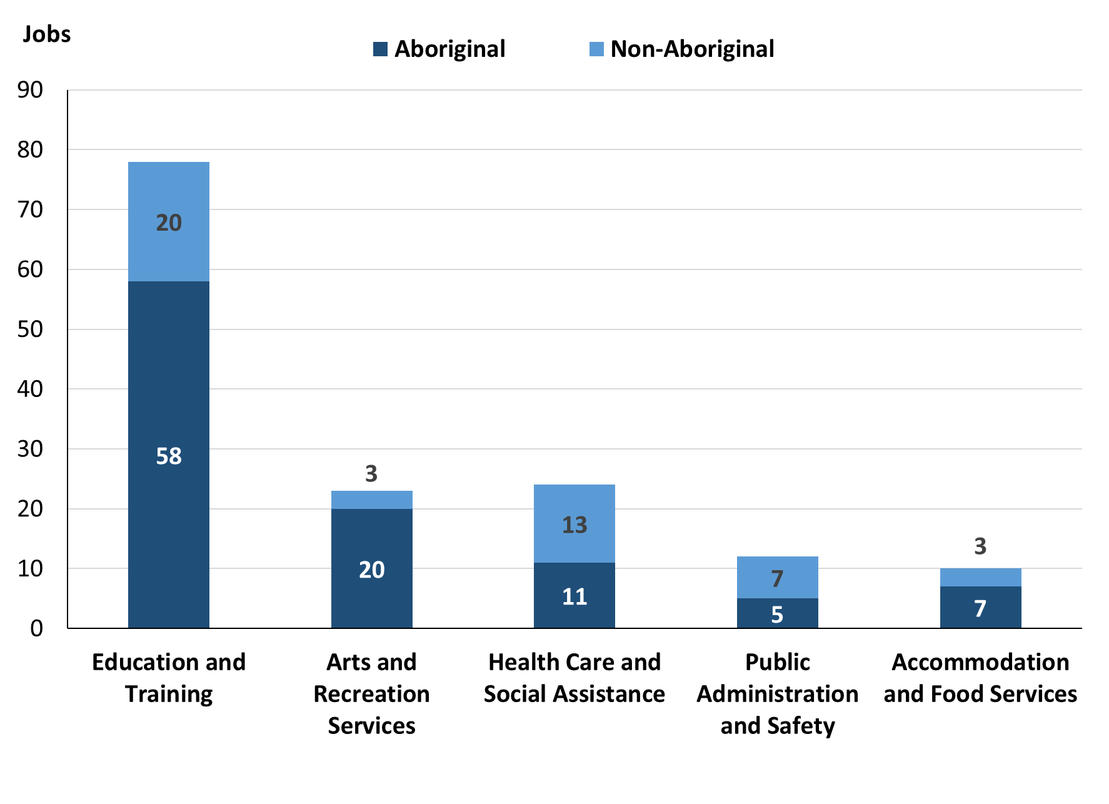

Source: Northern Territory Department of Industry, Tourism and Trade

In 2023 in Wurrumiyanga (Nguiu):

* of the 107 jobs filled by **Aboriginal** people, there were:
* 58 jobs in Education and Training, a decrease of 25 jobs from 2017 and a decrease of 31 jobs from 2014
* 20 jobs in Arts and Recreation Services, a decrease of 27 jobs from 2017 and an increase of 8 jobs from 2014
* 11 jobs in Health Care and Social Assistance, a decrease of 52 jobs from 2017 and a decrease of 20 jobs from 2014
* of the 51 jobs filled by **non-Aboriginal** people, there were:
* 20 jobs in Education and Training, a decrease of 29 jobs from 2017 and a decrease of 17 jobs from 2014
* 13 jobs in Health Care and Social Assistance, a decrease of 9 jobs from 2017 and a decrease of 12 jobs from 2014
* 7 jobs in Public Administration and Safety, a decrease of 17 jobs from 2017 and a decrease of 18 jobs from 2014.

Table 12: Count of filled jobs by industry, employment status, 2011 (a)(c)(e)(h)

|  |  |  |  |  |  |  |  |  |  |
| --- | --- | --- | --- | --- | --- | --- | --- | --- | --- |
| **Industry (ANZSIC division)** | **2011** | | | | | | | | |
| **Aboriginal** | | | **Non-Aboriginal** | | | **Total** | | |
| **Perm** | **Temp** | **Total** | **Perm** | **Temp** | **Total** | **Perm** | **Temp** | **Total** |
| Accommodation and Food Services | 5 | 0 | **5** | 2 | 0 | **2** | 7 | 0 | **7** |
| Administrative and Support Services | 2 | 0 | **2** | 0 | 0 | **0** | 2 | 0 | **2** |
| Arts and Recreation Services | 0 | 12 | **12** | 2 | 4 | **6** | 2 | 16 | **18** |
| Construction | 6 | 19 | **25** | 1 | 1 | **2** | 7 | 20 | **27** |
| Education and Training | 26 | 12 | **38** | 22 | 9 | **31** | 48 | 21 | **69** |
| Health Care and Social Assistance | 5 | 31 | **36** | 2 | 11 | **13** | 7 | 42 | **49** |
| Other Services | 0 | 0 | **0** | 1 | 0 | **1** | 1 | 0 | **1** |
| Public Administration and Safety | 62 | 23 | **85** | 12 | 6 | **18** | 74 | 29 | **103** |
| Retail Trade | 13 | 24 | **37** | 8 | 7 | **15** | 21 | 31 | **52** |
| **Total** | **119** | **121** | **240** | **50** | **38** | **88** | **169** | **159** | **328** |

Source: Northern Territory Department of Industry, Tourism and Trade

Table 13: Count of filled jobs by industry, and employment status, 2014 (a)(c)(e)(h)

|  |  |  |  |  |  |  |  |  |  |
| --- | --- | --- | --- | --- | --- | --- | --- | --- | --- |
| **Industry (ANZSIC division)** | **2014** | | | | | | | | |
| **Aboriginal** | | | **Non-Aboriginal** | | | **Total** | | |
| **Perm** | **Temp** | **Total** | **Perm** | **Temp** | **Total** | **Perm** | **Temp** | **Total** |
| Accommodation and Food Services | 15 | 11 | **26** | 7 | 3 | **10** | 22 | 14 | **36** |
| Arts and Recreation Services | 0 | 12 | **12** | 1 | 2 | **3** | 1 | 14 | **15** |
| Construction | 9 | 0 | **9** | 6 | 0 | **6** | 15 | 0 | **15** |
| Education and Training | 19 | 70 | **89** | 20 | 17 | **37** | 39 | 87 | **126** |
| Financial and Insurance Services | 2 | 0 | **2** | 0 | 0 | **0** | 2 | 0 | **2** |
| Health Care and Social Assistance | 16 | 15 | **31** | 15 | 10 | **25** | 31 | 25 | **56** |
| Other Services | 0 | 0 | **0** | 0 | 2 | **2** | 0 | 2 | **2** |
| Public Administration and Safety | 65 | 1 | **66** | 22 | 3 | **25** | 87 | 4 | **91** |
| Rental, Hiring and Real Estate Services | 1 | 0 | **1** | 1 | 0 | **1** | 2 | 0 | **2** |
| Retail Trade | 17 | 17 | **34** | 2 | 8 | **10** | 19 | 25 | **44** |
| Transport, Postal and Warehousing | 0 | 0 | **0** | 0 | 1 | **1** | 0 | 1 | **1** |
| **Total** | **144** | **126** | **270** | **74** | **46** | **120** | **218** | **172** | **390** |

Source: Northern Territory Department of Industry, Tourism and Trade

Table 14: Count of filled jobs by industry and employment status, 2017 (a)(c)(e)(h)

|  |  |  |  |  |  |  |  |  |  |
| --- | --- | --- | --- | --- | --- | --- | --- | --- | --- |
| **Industry (ANZSIC division)** | **2017** | | | | | | | | |
| **Aboriginal** | | | **Non-Aboriginal** | | | **Total** | | |
| **Perm** | **Temp** | **Total** | **Perm** | **Temp** | **Total** | **Perm** | **Temp** | **Total** |
| Accommodation and Food Services | 4 | 15 | **19** | 6 | 2 | **8** | 10 | 17 | **27** |
| Arts and Recreation Services | 15 | 32 | **47** | 0 | 2 | **2** | 15 | 34 | **49** |
| Construction | 0 | 8 | **8** | 1 | 13 | **14** | 1 | 21 | **22** |
| Education and Training | 0 | 83 | **83** | 0 | 49 | **49** | 0 | 132 | **132** |
| Financial and Insurance Services | 1 | 1 | **2** | 0 | 0 | **0** | 1 | 1 | **2** |
| Health Care and Social Assistance | 44 | 19 | **63** | 6 | 16 | **22** | 50 | 35 | **85** |
| Other Services | 0 | 0 | **0** | 1 | 0 | **1** | 1 | 0 | **1** |
| Public Administration and Safety | 64 | 6 | **70** | 21 | 3 | **24** | 85 | 9 | **94** |
| Rental, Hiring and Real Estate Services | 0 | 0 | **0** | 0 | 0 | **0** | 0 | 0 | **0** |
| Retail Trade | 4 | 19 | **23** | 20 | 5 | **25** | 24 | 24 | **48** |
| Transport, Postal and Warehousing | 0 | 0 | **0** | 0 | 1 | **1** | 0 | 1 | **1** |
| **Total** | **132** | **183** | **315** | **55** | **91** | **146** | **187** | **274** | **461** |

Source: Northern Territory Department of Industry, Tourism and Trade

Table 15: Count of filled jobs by industry and employment status, 2023 (a)(c)(e)(h)

|  |  |  |  |  |  |  |  |  |  |
| --- | --- | --- | --- | --- | --- | --- | --- | --- | --- |
| **Industry (ANZSIC division)** | **2023** | | | | | | | | |
| **Aboriginal** | | | **Non-Aboriginal** | | | **Total** | | |
| **Perm** | **Temp** | **Total** | **Perm** | **Temp** | **Total** | **Perm** | **Temp** | **Total** |
| Accommodation and Food Services | 3 | 4 | **7** | 3 | 0 | **3** | 6 | 4 | **10** |
| Arts and Recreation Services | 10 | 10 | **20** | 1 | 2 | **3** | 11 | 12 | **23** |
| Construction | 0 | 0 | **0** | 0 | 0 | **0** | 0 | 0 | **0** |
| Education and Training | 5 | 53 | **58** | 0 | 20 | **20** | 5 | 73 | **78** |
| Financial and Insurance Services | 3 | 0 | **3** | 0 | 0 | **0** | 3 | 0 | **3** |
| Health Care and Social Assistance | 4 | 7 | **11** | 3 | 10 | **13** | 7 | 17 | **24** |
| Other Services | 0 | 0 | **0** | 0 | 0 | **0** | 0 | 0 | **0** |
| Public Administration and Safety | 0 | 5 | **5** | 6 | 1 | **7** | 6 | 6 | **12** |
| Rental, Hiring and Real Estate Services | 0 | 0 | **0** | 0 | 0 | **0** | 0 | 0 | **0** |
| Retail Trade | 0 | 3 | **3** | 2 | 2 | **4** | 2 | 5 | **7** |
| Transport, Postal and Warehousing | 0 | 0 | **0** | 0 | 1 | **1** | 0 | 1 | **1** |
| **Total** | **25** | **82** | **107** | **15** | **36** | **51** | **40** | **118** | **158** |

Source: Northern Territory Department of Industry, Tourism and Trade

In 2023 in Wurrumiyanga (Nguiu):

* of the 40 **permanent** jobs, there were:
* 11 jobs in Arts and Recreation Services, a decrease of 4 jobs from 2017 and an increase of 10 jobs from 2014, including:
* **Aboriginal** people filled 10 jobs, a decrease of 5 jobs from 2017 and an increase of 10 jobs from 2014
* **non-Aboriginal** person filled 1 job, an increase of 1 job from 2017 and unchanged from 2014
* 7 jobs in Health Care and Social Assistance, a decrease of 43 jobs from 2017 and a decrease of 24 jobs from 2014, including:
* **Aboriginal** people filled 4 jobs, a decrease of 40 jobs from 2017 and a decrease of 12 jobs from 2014
* **non-Aboriginal** people filled 3 jobs, a decrease of 3 jobs from 2017 and a decrease of 12 jobs from 2014
* 6 jobs in Public Administration and Safety, a decrease of 79 jobs from 2017 and a decrease of 81 jobs from 2014, including:
* **Aboriginal** people filled 0 jobs, a decrease of 64 jobs from 2017 and a decrease of 65 jobs from 2014
* **non-Aboriginal** people filled 6 jobs, a decrease of 15 jobs from 2017 and a decrease of 16 jobs from 2014
* of the 118 **temporary** jobs, there were:
* 73 jobs in Education and Training, a decrease of 59 jobs from 2017 and a decrease of 14 jobs from 2014, including:
* **Aboriginal** people filled 53 jobs, a decrease of 30 jobs from 2017 and a decrease of 17 jobs from 2014
* **non-Aboriginal** people filled 20 jobs, a decrease of 29 jobs from 2017 and an increase of 3 jobs from 2014
* 17 jobs in Health Care and Social Assistance, a decrease of 18 jobs from 2017 and a decrease of 8 jobs from 2014, including:
* **Aboriginal** people filled 7 jobs, a decrease of 12 jobs from 2017 and a decrease of 8 jobs from 2014
* **non-Aboriginal** people filled 10 jobs, a decrease of 6 jobs from 2017 and unchanged from 2014
* 12 jobs in Arts and Recreation Services, a decrease of 22 jobs from 2017 and a decrease of 2 jobs from 2014, including
* **Aboriginal** people filled 10 jobs, a decrease of 22 jobs from 2017 and a decrease of 2 jobs from 2014
* **non-Aboriginal** people filled 2 jobs, unchanged from 2017 and 2014.

# Jobs by Occupation

Table 16a: Count of filled jobs by occupation, 2011, 2014, 2017 & 2023 (a)(f)(g)

|  |  |  |  |  |  |  |  |  |
| --- | --- | --- | --- | --- | --- | --- | --- | --- |
| **Occupation (ANZSCO major group)** | **2011** | | **2014** | | **2017** | | **2023** | |
| **Total** | **% of Total** | **Total** | **% of Total** | **Total** | **% of Total** | **Total** | **% of Total** |
| Clerical and Administrative Workers | 35 | 10.7% | 39 | 10.0% | 57 | 12.4% | 39 | 24.7% |
| Community and Personal Service Workers | 86 | 26.2% | 124 | 31.8% | 139 | 30.2% | 38 | 24.1% |
| Labourers | 56 | 17.1% | 103 | 26.4% | 75 | 16.3% | 20 | 12.7% |
| Machinery Operators and Drivers | 16 | 4.9% | 5 | 1.3% | 5 | 1.1% | 6 | 3.8% |
| Managers | 31 | 9.5% | 34 | 8.7% | 38 | 8.2% | 6 | 3.8% |
| Professionals | 67 | 20.4% | 50 | 12.8% | 84 | 18.2% | 39 | 24.7% |
| Sales Workers | 17 | 5.2% | 20 | 5.1% | 18 | 3.9% | 1 | 0.6% |
| Technicians and Trades Workers | 18 | 5.5% | 15 | 3.8% | 45 | 9.8% | 9 | 5.7% |
| **Total** | **328** | **100.0%** | **390** | **100.0%** | **461** | **100.0%** | **158** | **100.0%** |

Source: Northern Territory Department of Industry, Tourism and Trade

Table 16b: Count of filled jobs by occupation, 2011-2014, 2014-2017 & 2017-2023 (a)(f)(g)

|  |  |  |  |
| --- | --- | --- | --- |
| **Occupation (ANZSCO major group)** | **Change 2011-2014** | **Change 2014-2017** | **Change 2017-2023** |
| **Total** | **Total** | **Total** |
| Clerical and Administrative Workers | 4 | 18 | -18 |
| Community and Personal Service Workers | 38 | 15 | -101 |
| Labourers | 47 | -28 | -55 |
| Machinery Operators and Drivers | -11 | 0 | 1 |
| Managers | 3 | 4 | -32 |
| Professionals | -17 | 34 | -45 |
| Sales Workers | 3 | -2 | -17 |
| Technicians and Trades Workers | -3 | 30 | -36 |
| **Total** | **62** | **71** | **-303** |

Source: Northern Territory Department of Industry, Tourism and Trade

Chart 10: Percentage and count of top 6 filled jobs by occupation, 2011, 2014, 2017 & 2023 (a)(f)(g)

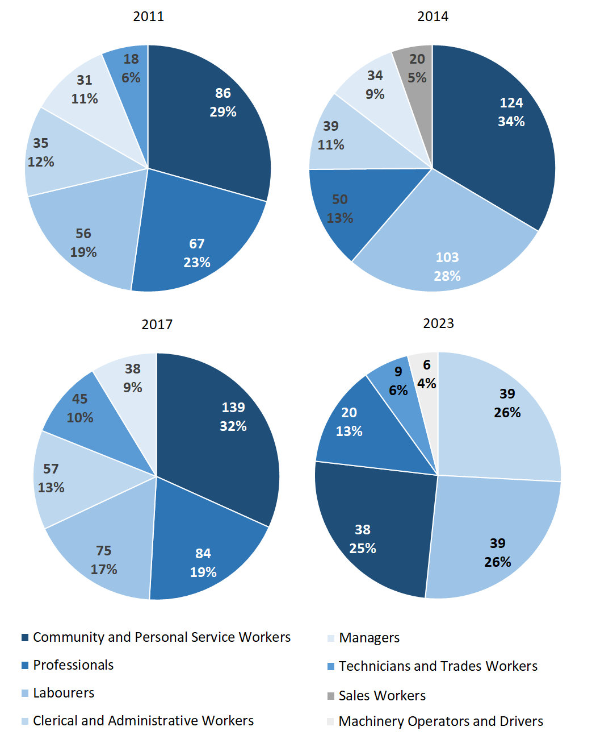

Source: Northern Territory Department of Industry, Tourism and Trade

In 2023 in Wurrumiyanga (Nguiu):

* Clerical and Administrative Workers and Professionals were the **largest** **occupation** **classification** in terms of filled jobs, accounting for 39 jobs each (24.7% of total filled jobs). A decrease of 18 jobs from 2017 and unchanged from 2014 for Clerical and Administrative Workers. A decrease of 45 jobs from 2017 and a decrease of 11 jobs from 2014 for Professionals.
* **other** **significant** occupation classifications were:
* Community and Personal Service Workers accounting for 38 jobs or 24.1% of total jobs, a decrease of 101 jobs from 2017 and a decrease of 86 jobs from 2014
* Labourers accounting for 20 jobs or 12.7% of total jobs, a decrease of 55 jobs from 2017 and a decrease of 83 jobs from 2014.

**Table 17a: Count of filled jobs by ANZSCO occupation, 2011, 2014, 2017 & 2023 (a)(c)(f)(g)**

|  |  |  |  |  |  |  |  |  |  |  |  |  |  |  |  |
| --- | --- | --- | --- | --- | --- | --- | --- | --- | --- | --- | --- | --- | --- | --- | --- |
| **Occupation (ANZSCO major group)** | **2011** | | | | **2014** | | | | **2017** | | | | **2023** | | |
| **Aboriginal** | **Non-Aboriginal** | **Total** | **Aboriginal** | | **Non-Aboriginal** | **Total** | **Aboriginal** | | **Non-Aboriginal** | **Total** | **Aboriginal** | | **Non-Aboriginal** | **Total** |
| Clerical and Administrative Workers | 26 | 9 | **35** | 22 | | 17 | **39** | 38 | | 19 | **57** | 26 | | 13 | **39** |
| Community and Personal Service Workers | 74 | 12 | **86** | 102 | | 22 | **124** | 126 | | 13 | **139** | 31 | | 7 | **38** |
| Labourers | 48 | 8 | **56** | 92 | | 11 | **103** | 66 | | 9 | **75** | 17 | | 3 | **20** |
| Machinery Operators and Drivers | 15 | 1 | **16** | 4 | | 1 | **5** | 1 | | 4 | **5** | 6 | | 0 | **6** |
| Managers | 11 | 20 | **31** | 8 | | 26 | **34** | 9 | | 29 | **38** | 1 | | 5 | **6** |
| Professionals | 38 | 29 | **67** | 17 | | 33 | **50** | 38 | | 46 | **84** | 20 | | 19 | **39** |
| Sales Workers | 13 | 4 | **17** | 19 | | 1 | **20** | 8 | | 10 | **18** | 1 | | 0 | **1** |
| Technicians and Trades Workers | 14 | 4 | **18** | 6 | | 9 | **15** | 29 | | 16 | **45** | 5 | | 4 | **9** |
| **Total** | **240** | **88** | **328** | **270** | | **120** | **390** | **315** | | **146** | **461** | **107** | | **51** | **158** |

Source: Northern Territory Department of Industry, Tourism and Trade

**Table 17b: Count of filled jobs by ANZSCO occupation, 2011-2014, 2014-2017 & 2017-2023** **(a)(c)(f)(g)**

|  |  |  |  |  |  |  |  |  |  |
| --- | --- | --- | --- | --- | --- | --- | --- | --- | --- |
| **Occupation (ANZSCO major group)** | **Change 2011-2014** | | | **Change 2014-2017** | | | **Change 2017-2023** | | |
| **Aboriginal** | **Non-Aboriginal** | **Total** | **Aboriginal** | **Non-Aboriginal** | **Total** | **Aboriginal** | **Non-Aboriginal** | **Total** |
| Clerical and Administrative Workers | -4 | 8 | **4** | 16 | 2 | **18** | -12 | -6 | **-18** |
| Community and Personal Service Workers | 28 | 10 | **38** | 24 | -9 | **15** | -95 | -6 | **-101** |
| Labourers | 44 | 3 | **47** | -26 | -2 | **-28** | -49 | -6 | **-55** |
| Machinery Operators and Drivers | -11 | 0 | **-11** | -3 | 3 | **0** | 5 | -4 | **1** |
| Managers | -3 | 6 | **3** | 1 | 3 | **4** | -8 | -24 | **-32** |
| Professionals | -21 | 4 | **-17** | 21 | 13 | **34** | -18 | -27 | **-45** |
| Sales Workers | 6 | -3 | **3** | -11 | 9 | **-2** | -7 | -10 | **-17** |
| Technicians and Trades Workers | -8 | 5 | **-3** | 23 | 7 | **30** | -24 | -12 | **-36** |
| **Total** | **30** | **32** | **62** | **45** | **26** | **71** | **-208** | **-95** | **-303** |

Source: Northern Territory Department of Industry, Tourism and Trade

In 2023 in Wurrumiyanga (Nguiu):

* of the 107 **jobs filled** by **Aboriginal** people, there were:
* 31 Community and Personal Service Workers, a decrease of 95 jobs from 2017 and a decrease of 71 jobs from 2014
* 26 Clerical and Administrative Workers, a decrease of 12 jobs from 2017 and an increase of 4 jobs from 2014
* 20 Professionals, a decrease of 18 jobs from 2017 and an increase of 3 jobs from 2014
* of the 51 **jobs filled** by **non-Aboriginal** people, there were:
* 19 Professionals, a decrease of 27 jobs from 2017 and a decrease of 14 jobs from 2014
* 13 Clerical and Administrative Workers, a decrease of 6 jobs from 2017 and a decrease of 4 jobs from 2014
* 7 Community and Personal Service Workers, a decrease of 6 jobs from 2017 and a decrease of 15 jobs from 2014.

# Jobs by Industry by Occupation

Table 18: Count of filled jobs by industry by occupation, 2011 (a)(f)(g)(h)

|  |  |  |  |  |  |  |  |  |  |  |
| --- | --- | --- | --- | --- | --- | --- | --- | --- | --- | --- |
| **2011** | | | | | | | | | | |
| **Industry (ANZSIC Division)** |  | **Occupation (ANZSCO major group)** | | | | | | | | |
| **Clerical and Administrative Workers** | **Community and Personal Service Workers** | **Labourers** | **Machinery Operators and Drivers** | **Managers** | **Professionals** | **Sales Workers** | **Technicians and Trades Workers** | **Other Occupations** | **Total** |
| Accommodation and Food Services | 0 | 5 | 0 | 0 | 2 | 0 | 0 | 0 | 0 | **7** |
| Administrative and Support Services | 0 | 0 | 0 | 0 | 0 | 2 | 0 | 0 | 0 | **2** |
| Arts and Recreation Services | 4 | 6 | 2 | 1 | 2 | 3 | 0 | 0 | 0 | **18** |
| Construction | 1 | 0 | 19 | 1 | 2 | 2 | 0 | 1 | 1 | **27** |
| Education and Training | 4 | 25 | 6 | 0 | 4 | 30 | 0 | 0 | 0 | **69** |
| Health Care and Social Assistance | 2 | 24 | 6 | 0 | 4 | 8 | 0 | 5 | 0 | **49** |
| Other Services | 0 | 0 | 0 | 0 | 0 | 1 | 0 | 0 | 0 | **1** |
| Public Administration and Safety | 21 | 26 | 14 | 4 | 10 | 20 | 2 | 5 | 1 | **103** |
| Retail Trade | 3 | 0 | 9 | 10 | 7 | 1 | 15 | 7 | 0 | **52** |
| **Total** | **35** | **86** | **56** | **16** | **31** | **67** | **17** | **18** | **2** | **328** |

Source: Northern Territory Department of Industry, Tourism and Trade

Table 19: Count of filled jobs by industry by occupation, 2014 (a)(f)(g)(h)

|  |  |  |  |  |  |  |  |  |  |  |
| --- | --- | --- | --- | --- | --- | --- | --- | --- | --- | --- |
| **2014** | | | | | | | | | | |
| **Industry (ANZSIC Division)** |  | **Occupation (ANZSCO major group)** | | | | | | | | |
| **Clerical and Administrative Workers** | **Community and Personal Service Workers** | **Labourers** | **Machinery Operators and Drivers** | **Managers** | **Professionals** | **Sales Workers** | **Technicians and Trades Workers** | **Other Occupations** | **Total** |
| Accommodation and Food Services | 7 | 8 | 15 | 0 | 2 | 2 | 0 | 2 | 0 | **36** |
| Arts and Recreation Services | 2 | 4 | 1 | 0 | 3 | 4 | 0 | 1 | 0 | **15** |
| Construction | 2 | 1 | 5 | 0 | 1 | 0 | 0 | 6 | 0 | **15** |
| Education and Training | 8 | 44 | 35 | 1 | 9 | 29 | 0 | 0 | 0 | **126** |
| Financial and Insurance Services | 2 | 0 | 0 | 0 | 0 | 0 | 0 | 0 | 0 | **2** |
| Health Care and Social Assistance | 3 | 37 | 5 | 1 | 3 | 5 | 0 | 2 | 0 | **56** |
| Other Services | 0 | 0 | 0 | 0 | 0 | 2 | 0 | 0 | 0 | **2** |
| Public Administration and Safety | 13 | 30 | 27 | 0 | 11 | 7 | 0 | 3 | 0 | **91** |
| Rental, Hiring and Real Estate Services | 1 | 0 | 0 | 0 | 0 | 0 | 1 | 0 | 0 | **2** |
| Retail Trade | 1 | 0 | 15 | 3 | 4 | 1 | 19 | 1 | 0 | **44** |
| Transport, Postal and Warehousing | 0 | 0 | 0 | 0 | 1 | 0 | 0 | 0 | 0 | **1** |
| **Total** | **39** | **124** | **103** | **5** | **34** | **50** | **20** | **15** | **0** | **390** |

Source: Northern Territory Department of Industry, Tourism and Trade

Table 20: Count of filled jobs by occupation and by industry, 2017 (a)(f)(g)(h)

|  |  |  |  |  |  |  |  |  |  |  |  |
| --- | --- | --- | --- | --- | --- | --- | --- | --- | --- | --- | --- |
| **2017** | | | | | | | | | | | |
| **Industry (ANZSIC Division)** |  | **Occupation (ANZSCO major group)** | | | | | | | | | |
| **Clerical and Administrative Workers** | **Community and Personal Service Workers** | **Labourers** | **Machinery Operators and Drivers** | **Managers** | **Professionals** | **Sales Workers** | **Technicians and Trades Workers** | **Other Occupations** | **Total** |
| Accommodation and Food Services | 6 | 0 | 14 | 0 | 0 | 3 | 0 | 4 | 0 | **27** |
| Arts and Recreation Services | 3 | 1 | 0 | 0 | 1 | 19 | 2 | 23 | 0 | **49** |
| Construction | 3 | 0 | 9 | 0 | 2 | 0 | 0 | 8 | 0 | **22** |
| Education and Training | 21 | 43 | 18 | 0 | 7 | 42 | 0 | 1 | 0 | **132** |
| Financial and Insurance Services | 2 | 0 | 0 | 0 | 0 | 0 | 0 | 0 | 0 | **2** |
| Health Care and Social Assistance | 8 | 48 | 6 | 1 | 8 | 12 | 0 | 2 | 0 | **85** |
| Other Services | 0 | 0 | 0 | 0 | 0 | 1 | 0 | 0 | 0 | **1** |
| Public Administration and Safety | 13 | 33 | 27 | 0 | 11 | 7 | 0 | 3 | 0 | **94** |
| Retail Trade | 1 | 14 | 1 | 3 | 9 | 0 | 16 | 4 | 0 | **48** |
| Transport, Postal and Warehousing | 0 | 0 | 0 | 1 | 0 | 0 | 0 | 0 | 0 | **1** |
| **Total** | **57** | **139** | **75** | **5** | **38** | **84** | **18** | **45** | **0** | **461** |

Source: Northern Territory Department of Industry, Tourism and Trade

Table 21: Count of filled jobs by occupation and by industry, 2023 (a)(f)(g)(h)

|  |  |  |  |  |  |  |  |  |  |  |  |
| --- | --- | --- | --- | --- | --- | --- | --- | --- | --- | --- | --- |
| **2023** | | | | | | | | | | | |
| **Industry (ANZSIC Division)** |  | **Occupation (ANZSCO major group)** | | | | | | | | | |
| **Clerical and Administrative Workers** | **Community and Personal Service Workers** | **Labourers** | **Machinery Operators and Drivers** | **Managers** | **Professionals** | **Sales Workers** | **Technicians and Trades Workers** | **Other Occupations** | **Total** |
| Accommodation and Food Services | 4 | 0 | 3 | 0 | 0 | 0 | 0 | 3 | 0 | **10** |
| Arts and Recreation Services | 5 | 7 | 2 | 5 | 0 | 3 | 1 | 0 | 0 | **23** |
| Construction | 0 | 0 | 0 | 0 | 0 | 0 | 0 | 0 | 0 | **0** |
| Education and Training | 21 | 20 | 13 | 0 | 5 | 19 | 0 | 0 | 0 | **78** |
| Financial and Insurance Services | 3 | 0 | 0 | 0 | 0 | 0 | 0 | 0 | 0 | **3** |
| Health Care and Social Assistance | 4 | 4 | 1 | 1 | 0 | 14 | 0 | 0 | 0 | **24** |
| Other Services | 0 | 0 | 0 | 0 | 0 | 0 | 0 | 0 | 0 | **0** |
| Public Administration and Safety | 2 | 7 | 0 | 0 | 0 | 3 | 0 | 0 | 0 | **12** |
| Retail Trade | 0 | 0 | 0 | 0 | 1 | 0 | 0 | 6 | 0 | **7** |
| Transport, Postal and Warehousing | 0 | 0 | 1 | 0 | 0 | 0 | 0 | 0 | 0 | **1** |
| **Total** | **39** | **38** | **20** | **6** | **6** | **39** | **1** | **9** | **0** | **158** |

Source: Northern Territory Department of Industry, Tourism and Trade

In 2023 in Wurrumiyanga (Nguiu):

* Clerical and Administrative Workers filled the majority of the jobs with 39 jobs which were in the Education and Training industry with 21 jobs,
* Professionals filled the majority of jobs with 39 jobs which were shared across the Education and Training with 19 jobs and Health Care and Social Assistance industries with 14 jobs,
* Education and Training (the largest industry) showed a decrease of 54 filled jobs from 2017,
* Health Care and Social Assistance (the 2nd largest industry) showed a decrease of 61 filled jobs from 2017,
* Community and Personal Service Workers showed a decrease of 101 filled jobs from 2017, and a decrease of 86 jobs from 2014.

# Jobs by Gender

Table 22a: Count of filled jobs by gender[2] , 2011, 2014, 2017 & 2023 (a)(c)(i)

|  |  |  |  |  |  |  |  |  |  |  |  |  |  |
| --- | --- | --- | --- | --- | --- | --- | --- | --- | --- | --- | --- | --- | --- |
| **Indicator** | **2011** | | | **2014** | | | **2017** | | | **2023** | | | |
| **Aboriginal** | **Non-Aboriginal** | **Total** | **Aboriginal** | **Non-Aboriginal** | **Total** | **Aboriginal** | **Non-Aboriginal** | **Total** | **Aboriginal** | **Non-Aboriginal** | **Total** |
| Male | 110 | 37 | **147** | 126 | 59 | **185** | 138 | 71 | **209** | 28 | 22 | **50** |
| Female | 94 | 21 | **115** | 144 | 61 | **205** | 166 | 75 | **241** | 73 | 28 | **101** |
| **Total** | **240** | **88** | **328** | **270** | **120** | **390** | **304** | **146** | **450** | **107** | **51** | **158** |

Source: Northern Territory Department of Industry, Tourism and Trade

Table 22b: Count of filled jobs by gender, 2011-2014, 2014-2017 & 2017-2023 (a)(c)(i)

|  |  |  |  |  |  |  |  |  |  |  |
| --- | --- | --- | --- | --- | --- | --- | --- | --- | --- | --- |
| **Indicator** | **2011-2014 Change** | | **2014-2017 Change** | | | | | **2017-2023 Change** | | |
| **Aboriginal** | **Non-Aboriginal** | | **Total** | **Aboriginal** | **Non-Aboriginal** | **Total** | **Aboriginal** | **Non-Aboriginal** | **Total** |
| Male | 16 | 22 | | **38** | 12 | 12 | **24** | -110 | -49 | **-159** |
| Female | 50 | 40 | | **90** | 22 | 14 | **36** | -93 | -47 | **-140** |
| **Total** | **30** | **32** | | **62** | **34** | **26** | **60** | **-197** | **-95** | **-292** |

Source: Northern Territory Department of Industry, Tourism and Trade

Chart 11: Count of filled jobs by gender, 2011, 2014, 2017 & 2023 (a)(c)(i)

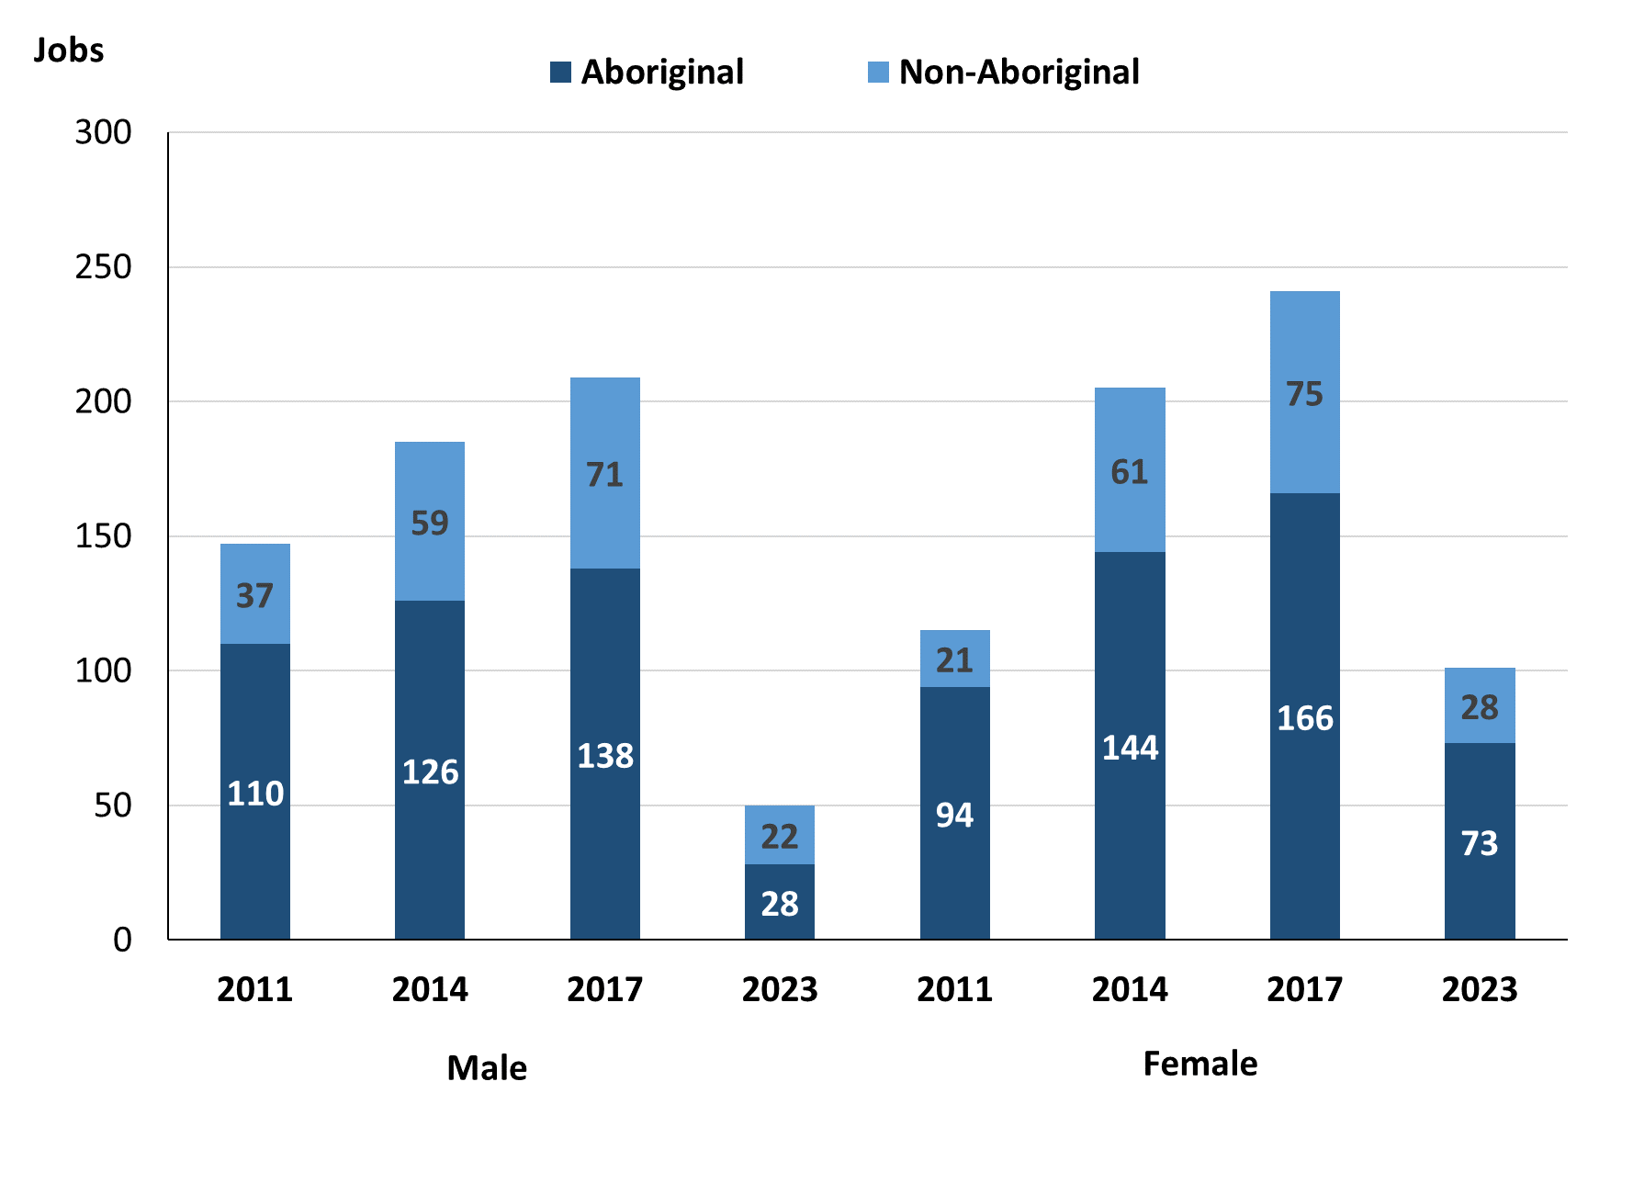

Source: Northern Territory Department of Industry, Tourism and Trade

In 2023 in Wurrumiyanga (Nguiu):

* there were 50 **jobs** **filled by males**, a decrease of 159 jobs from 2017 and a decrease of 135 jobs from 2014
* of the 50 jobs **filled by males**:
* 28 were **Aboriginal**, a decrease of 110 jobs from 2017 and a decrease of 98 jobs from 2014
* 22 were **non-Aboriginal**, a decrease of 49 jobs from 2017 and a decrease of 37 jobs from 2014
* there were 101 **jobs filled by females**, a decrease of 140 jobs from 2017 and a decrease of 104 jobs from 2014
* of the 101 **jobs filled by females**:
* 73 were **Aboriginal**, a decrease of 93 jobs from 2017 and a decrease of 71 jobs from 2014
* 28 were **non-Aboriginal**, a decrease of 47 jobs from 2017 and a decrease of 33 jobs from 2014.

Table 23: Count of filled jobs by gender, by full-time/part-time status, by job permanency and by sector 2011 (a)(b)(c)(d)(e)(i)

|  |  |  |  |  |  |  |  |  |  |
| --- | --- | --- | --- | --- | --- | --- | --- | --- | --- |
| **2011** | | | | | | | | | |
| **Indicator** | **Male** | | | **Female** | | | **Total** | | |
| **Aboriginal** | **Non-Aboriginal** | **Total** | **Aboriginal** | **Non-Aboriginal** | **Total** | **Aboriginal** | **Non-Aboriginal** | **Total** |
| Full-time | 86 | 34 | **120** | 70 | 20 | **90** | 182 | 78 | **260** |
| Part-time | 24 | 3 | **27** | 24 | 1 | **25** | 58 | 10 | **68** |
| **Total** | **110** | **37** | **147** | **94** | **21** | **115** | **240** | **88** | **328** |
| Permanent | 57 | 21 | **78** | 36 | 5 | **41** | 119 | 50 | **169** |
| Temporary | 53 | 16 | **69** | 58 | 16 | **74** | 121 | 38 | **159** |
| **Total** | **110** | **37** | **147** | **94** | **21** | **115** | **240** | **88** | **328** |
| Public Sector | 44 | 14 | **58** | 35 | 6 | **41** | 79 | 20 | **99** |
| Private Sector | 66 | 23 | **89** | 59 | 15 | **74** | 161 | 68 | **229** |
| **Total** | **110** | **37** | **147** | **94** | **21** | **115** | **240** | **88** | **328** |

Source: Northern Territory Department of Industry, Tourism and Trade

Table 24: Count of filled jobs by gender, by full-time/part-time status, by job permanency and by sector 2014 (a)(b)(c)(d)(e)(i)

|  |  |  |  |  |  |  |  |  |  |
| --- | --- | --- | --- | --- | --- | --- | --- | --- | --- |
| **2014** | | | | | | | | | |
| **Indicator** | **Male** | | | **Female** | | | **Total** | | |
| **Aboriginal** | **Non-Aboriginal** | **Total** | **Aboriginal** | **Non-Aboriginal** | **Total** | **Aboriginal** | **Non-Aboriginal** | **Total** |
| Full-time | 68 | 54 | **122** | 68 | 56 | **124** | 136 | 110 | **246** |
| Part-time | 58 | 5 | **63** | 76 | 5 | **81** | 134 | 10 | **144** |
| **Total** | **126** | **59** | **185** | **144** | **61** | **205** | **270** | **120** | **390** |
| Permanent | 78 | 37 | **115** | 66 | 37 | **103** | 144 | 74 | **218** |
| Temporary | 48 | 22 | **70** | 78 | 24 | **102** | 126 | 46 | **172** |
| **Total** | **126** | **59** | **185** | **144** | **61** | **205** | **270** | **120** | **390** |
| Public Sector | 38 | 19 | **57** | 45 | 17 | **62** | 83 | 36 | **119** |
| Private Sector | 88 | 40 | **128** | 99 | 44 | **143** | 187 | 84 | **271** |
| **Total** | **126** | **59** | **185** | **144** | **61** | **205** | **270** | **120** | **390** |

Source: Northern Territory Department of Industry, Tourism and Trade

Table 25: Count of filled jobs by gender[3], by full-time/part-time status, by job permanency and by sector 2017 (a)(b)(c)(d)(e)(i)

|  |  |  |  |  |  |  |  |  |  |
| --- | --- | --- | --- | --- | --- | --- | --- | --- | --- |
| **2017** | | | | | | | | | |
| **Indicator** | **Male** | | | **Female** | | | **Total** | | |
| **Aboriginal** | **Non-Aboriginal** | **Total** | **Aboriginal** | **Non-Aboriginal** | **Total** | **Aboriginal** | **Non-Aboriginal** | **Total** |
| Full-time | 60 | 66 | **126** | 55 | 68 | **123** | 115 | 134 | **249** |
| Part-time | 78 | 5 | **83** | 111 | 7 | **118** | 200 | 12 | **212** |
| **Total** | **138** | **71** | **209** | **166** | **75** | **241** | **315** | **146** | **461** |
| Permanent | 62 | 30 | **92** | 70 | 25 | **95** | 132 | 55 | **187** |
| Temporary | 76 | 41 | **117** | 96 | 50 | **146** | 183 | 91 | **274** |
| **Total** | **138** | **71** | **209** | **166** | **75** | **241** | **315** | **146** | **461** |
| Public Sector | 39 | 20 | **59** | 47 | 23 | **70** | 86 | 43 | **129** |
| Private Sector | 99 | 51 | **150** | 119 | 52 | **171** | 229 | 103 | **332** |
| **Total** | **138** | **71** | **209** | **166** | **75** | **241** | **315** | **146** | **461** |

Source: Northern Territory Department of Industry, Tourism and Trade

Table 26: Count of filled jobs by gender, by full-time/part-time status, by job permanency and by sector 2023 (a)(b)(c)(d)(e)(i)

|  |  |  |  |  |  |  |  |  |  |
| --- | --- | --- | --- | --- | --- | --- | --- | --- | --- |
| **2023** | | | | | | | | | |
| **Indicator** | **Male** | | | **Female** | | | **Total** | | |
| **Aboriginal** | **Non-Aboriginal** | **Total** | **Aboriginal** | **Non-Aboriginal** | **Total** | **Aboriginal** | **Non-Aboriginal** | **Total** |
| Full-time | 9 | 16 | **25** | 17 | 20 | **37** | 30 | 37 | **67** |
| Part-time | 19 | 6 | **25** | 56 | 8 | **64** | 77 | 14 | **91** |
| **Total** | **28** | **22** | **50** | **73** | **28** | **101** | **107** | **51** | **158** |
| Permanent | 5 | 8 | **13** | 15 | 6 | **21** | 25 | 15 | **40** |
| Temporary | 23 | 14 | **37** | 58 | 22 | **80** | 82 | 36 | **118** |
| **Total** | **28** | **22** | **50** | **73** | **28** | **101** | **107** | **51** | **158** |
| Public Sector | 28 | 12 | **40** | 57 | 18 | **75** | 91 | 31 | **122** |
| Private Sector | 0 | 10 | **10** | 16 | 10 | **26** | 16 | 20 | **36** |
| **Total** | **28** | **22** | **50** | **73** | **28** | **101** | **107** | **51** | **158** |

Source: Northern Territory Department of Industry, Tourism and Trade

In 2023 in Wurrumiyanga (Nguiu):

* of the 50 **jobs filled by males**, there were:
* 28 jobs filled by **Aboriginal** males, a decrease of 110 jobs from 2017 and a decrease of 98 jobs from 2014, including:
* 9 full-time jobs, a decrease of 51 jobs from 2017 and a decrease of 59 jobs from 2014
* 19 part-time jobs, a decrease of 59 jobs from 2017 and a decrease of 39 jobs from 2014
* 5 permanent jobs, a decrease of 57 jobs from 2017 and a decrease of 73 jobs from 2014
* 23 temporary jobs, a decrease of 53 jobs from 2017 and a decrease of 25 jobs from 2014
* 28 Public Sector jobs, a decrease of 11 jobs from 2017 and a decrease of 10 jobs from 2014
* nil Private Sector jobs, a decrease of 99 jobs from 2017 and a decrease of 88 jobs from 2014
* 22 jobs filled by **non-Aboriginal males**, a decrease of 49 jobs from 2017 and a decrease of 37 jobs from 2014, including:
* 16 full-time jobs, a decrease of 50 jobs from 2017 and a decrease of 38 jobs from 2014
* 6 part-time jobs, an increase of 1 job from 2017 and an increase of 1 job from 2014
* 8 permanent jobs, a decrease of 22 jobs from 2017 and a decrease of 29 jobs from 2014
* 14 temporary jobs, a decrease of 27 jobs from 2017 and a decrease of 8 jobs from 2014
* 12 Public Sector jobs, a decrease of 8 jobs from 2017 and a decrease of 7 jobs from 2014
* 10 Private Sector jobs, a decrease of 41 jobs from 2017 and a decrease of 30 jobs from 2014
* of the 101 **jobs filled by females**, there were:
* 73 jobs filled by **Aboriginal females**, a decrease of 93 jobs from 2017 and a decrease of 71 jobs from 2014, including:
* 17 full-time jobs, a decrease of 38 jobs from 2017 and a decrease of 51 jobs from 2014
* 56 part-time jobs, a decrease of 55 jobs from 2017 and a decrease of 20 jobs from 2014
* 15 permanent jobs, a decrease of 55 jobs from 2017 and a decrease of 51 jobs from 2014
* 58 temporary jobs, a decrease of 38 jobs from 2017 and a decrease of 20 jobs from 2014
* 57 Public Sector jobs, an increase of 10 jobs from 2017 and an increase of 12 jobs from 2014
* 16 Private Sector jobs, a decrease of 103 jobs from 2017 and a decrease of 83 jobs from 2014
* 28 jobs filled by **non-Aboriginal females**, a decrease of 47 jobs from 2017 and a decrease of 33 jobs from 2014, including:
* 20 full-time jobs, a decrease of 48 jobs from 2017 and a decrease of 36 jobs from 2014
* 8 part-time jobs, an increase of 1 job from 2017 and an increase of 3 jobs from 2014
* 6 permanent jobs, a decrease of 19 jobs from 2017 and a decrease of 31 jobs from 2014
* 22 temporary jobs, a decrease of 28 jobs from 2017 and a decrease of 2 jobs from 2014
* 18 Public Sector jobs, a decrease of 5 jobs from 2017 and an increase of 1 job from 2014
* 10 Private Sector jobs, a decrease of 42 jobs from 2017 and a decrease of 34 jobs from 2014.

# Jobs by Age

Table 27a: Count of filled jobs by age, 2011, 2014, 2017 & 2023 (a)(c)(j)

|  |  |  |  |  |  |  |  |  |  |  |  |  |
| --- | --- | --- | --- | --- | --- | --- | --- | --- | --- | --- | --- | --- |
| **Indicator** | **2011** | | | **2014** | | | **2017** | | | **2023** | | |
| **Aboriginal** | **Non-Aboriginal** | **Total** | **Aboriginal** | **Non-Aboriginal** | **Total** | **Aboriginal** | **Non-Aboriginal** | **Total** | **Aboriginal** | **Non-Aboriginal** | **Total** |
| 15-24 years | 19 | 0 | **19** | 35 | 14 | **49** | 44 | 9 | **53** | 13 | 1 | **14** |
| 25-44 years | 148 | 22 | **170** | 166 | 53 | **219** | 196 | 67 | **263** | 58 | 18 | **76** |
| 45+ years | 37 | 36 | **73** | 69 | 53 | **122** | 75 | 69 | **144** | 31 | 31 | **62** |
| **Total** | **240** | **88** | **328** | **270** | **120** | **390** | **315** | **146** | **461** | **107** | **51** | **158** |

Source: Northern Territory Department of Industry, Tourism and Trade

Table 27b: Count of filled jobs by age, 2011-2014, 2014-2017 & 2017-2023 (a)(c)(j)

|  |  |  |  |  |  |  |  |  |  |
| --- | --- | --- | --- | --- | --- | --- | --- | --- | --- |
| **Indicator** | **Change 2011-2014** | | | **Change 2014-2017** | | | **Change 2017-2023** | | |
| **Aboriginal** | **Non-Aboriginal** | **Total** | **Aboriginal** | **Non-Aboriginal** | **Total** | **Aboriginal** | **Non-Aboriginal** | **Total** |
| 15-24 years | 16 | 14 | **30** | 9 | -5 | **4** | -31 | -8 | **-39** |
| 25-44 years | 18 | 31 | **49** | 30 | 14 | **44** | -138 | -49 | **-187** |
| 45+ years | 32 | 17 | **49** | 6 | 16 | **22** | -44 | -38 | **-82** |
| **Total** | **30** | **32** | **62** | **45** | **26** | **71** | **-208** | **-94** | **-302** |

Source: Northern Territory Department of Industry, Tourism and Trade

Chart 12: Count of filled jobs by age, 2011, 2014, 2017 & 2023 (a)(c)(j)

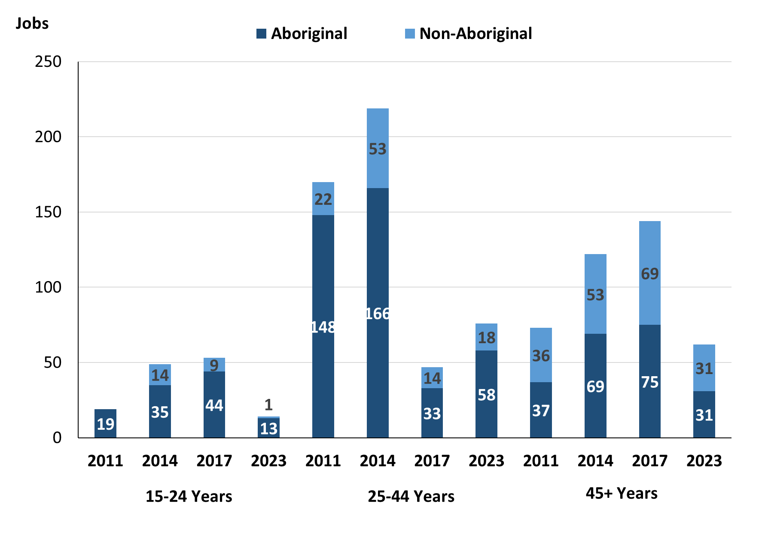

Source: Northern Territory Department of Industry, Tourism and Trade

In 2023 in Wurrumiyanga (Nguiu):

* there were 14 jobs filled by people aged **15-24 years**, a decrease of 39 jobs from 2017 and a decrease of 35 jobs from 2014. Of these:
* **Aboriginal** people filled 13 jobs, a decrease of 31 jobs from 2017 and a decrease of 22 jobs from 2014
* a **non-Aboriginal** person filled 1 job, a decrease of 8 jobs from 2017 and a decrease of 13 jobs from 2014
* there were 76 jobs filled by people aged **25-44 years**, a decrease of 187 jobs from 2017 and a decrease of 143 jobs from 2014
* **Aboriginal** people filled 58 jobs, a decrease of 138 jobs from 2017 and a decrease of 108 jobs from 2014
* **non-Aboriginal** people filled 18 jobs, a decrease of 49 jobs from 2017 and a decrease of 35 jobs from 2014
* there were 62 jobs filled by people aged **45+ years**, a decrease of 82 jobs from 2017 and a decrease of 60 jobs from 2014
* **Aboriginal** people filled 31 jobs, a decrease of 44 jobs from 2017 and a decrease of 38 jobs from 2014
* **non-Aboriginal** people filled 31 jobs, a decrease of 38 jobs from 2017 and a decrease of 22 jobs from 2014.

Table 28: Count of filled jobs by age, by full-time/part-time status, by job permanency and by sector June-July 2011 (a)(b)(c)(d)(e)(i)

|  |  |  |  |  |  |  |  |  |  |  |  |  |
| --- | --- | --- | --- | --- | --- | --- | --- | --- | --- | --- | --- | --- |
| **2011** | | | | | | | | | | | | |
| **Indicator** | **15-24 years** | | | **25-44 years** | | | **45+ years** | | | **Total** | | |
| **Aboriginal** | **Non-Aboriginal** | **Total** | **Aboriginal** | **Non-Aboriginal** | **Total** | **Aboriginal** | **Non-Aboriginal** | **Total** | **Aboriginal** | **Non-Aboriginal** | **Total** |
| Full-time | 14 | 0 | **14** | 119 | 21 | **140** | 23 | 33 | **56** | 182 | 78 | **260** |
| Part-time | 5 | 0 | **5** | 29 | 1 | **30** | 14 | 3 | **17** | 58 | 10 | **68** |
| **Total** | **19** | **0** | **19** | **148** | **22** | **170** | **37** | **36** | **73** | **240** | **88** | **328** |
| Permanent | 11 | 0 | **11** | 69 | 11 | **80** | 13 | 15 | **28** | 119 | 50 | **169** |
| Temporary | 8 | 0 | **8** | 79 | 11 | **90** | 24 | 21 | **45** | 121 | 38 | **159** |
| **Total** | **19** | **0** | **19** | **148** | **22** | **170** | **37** | **36** | **73** | **240** | **88** | **328** |
| Public Sector | 14 | 0 | **14** | 49 | 6 | **55** | 16 | 14 | **30** | 79 | 20 | **99** |
| Private Sector | 5 | 0 | **5** | 99 | 16 | **115** | 21 | 22 | **43** | 161 | 68 | **229** |
| **Total** | **19** | **0** | **19** | **148** | **22** | **170** | **37** | **36** | **73** | **240** | **88** | **328** |

Source: Northern Territory Department of Industry, Tourism and Trade

Table 29: Count of filled jobs by age, by full-time/part-time status, by job permanency and by sector June-July 2014 (a)(b)(c)(d)(e)(i)

|  |  |  |  |  |  |  |  |  |  |  |  |  |
| --- | --- | --- | --- | --- | --- | --- | --- | --- | --- | --- | --- | --- |
| **2014** | | | | | | | | | | | | |
| **Indicator** | **15-24 years** | | | **25-44 years** | | | **45+ years** | | | **Total** | | |
| **Aboriginal** | **Non-Aboriginal** | **Total** | **Aboriginal** | **Non-Aboriginal** | **Total** | **Aboriginal** | **Non-Aboriginal** | **Total** | **Aboriginal** | **Non-Aboriginal** | **Total** |
| Full-time | 7 | 13 | **20** | 84 | 47 | **131** | 45 | 50 | **95** | 136 | 110 | **246** |
| Part-time | 28 | 1 | **29** | 82 | 6 | **88** | 24 | 3 | **27** | 134 | 10 | **144** |
| **Total** | **35** | **14** | **49** | **166** | **53** | **219** | **69** | **53** | **122** | **270** | **120** | **390** |
| Permanent | 13 | 8 | **21** | 88 | 38 | **126** | 43 | 28 | **71** | 144 | 74 | **218** |
| Temporary | 22 | 6 | **28** | 78 | 15 | **93** | 26 | 25 | **51** | 126 | 46 | **172** |
| **Total** | **35** | **14** | **49** | **166** | **53** | **219** | **69** | **53** | **122** | **270** | **120** | **390** |
| Public Sector | 6 | 0 | **6** | 53 | 16 | **69** | 24 | 20 | **44** | 83 | 36 | **119** |
| Private Sector | 29 | 14 | **43** | 113 | 37 | **150** | 45 | 33 | **78** | 187 | 84 | **271** |
| **Total** | **35** | **14** | **49** | **166** | **53** | **219** | **69** | **53** | **122** | **270** | **120** | **390** |

Source: Northern Territory Department of Industry, Tourism and Trade

Table 30: Count of filled jobs by age, by full-time/part-time status, by job permanency and by sector June-July 2017 (a)(b)(c)(d)(e)(i)

|  |  |  |  |  |  |  |  |  |  |  |  |  |  |
| --- | --- | --- | --- | --- | --- | --- | --- | --- | --- | --- | --- | --- | --- |
| **2017** | | | | | | | | | | | | | |
| **Indicator** | **15-24 years** | | | **25-44 years** | | | **45+ years** | | | **Total** | | | |
| **Aboriginal** | **Non-Aboriginal** | **Total** | **Aboriginal** | **Non-Aboriginal** | **Total** | **Aboriginal** | **Non-Aboriginal** | **Total** | **Aboriginal** | **Non-Aboriginal** | **Total** |
| Full-time | 6 | 7 | **13** | 74 | 61 | **135** | 35 | 66 | **101** | 115 | 134 | **249** |
| Part-time | 38 | 2 | **40** | 122 | 6 | **128** | 40 | 3 | **43** | 200 | 12 | **212** |
| **Total** | **44** | **9** | **53** | **196** | **67** | **263** | **75** | **69** | **144** | **315** | **146** | **461** |
| Permanent | 12 | 2 | **14** | 93 | 25 | **118** | 27 | 28 | **55** | 132 | 55 | **187** |
| Temporary | 32 | 7 | **39** | 103 | 42 | **145** | 48 | 41 | **89** | 183 | 91 | **274** |
| **Total** | **44** | **9** | **53** | **196** | **67** | **263** | **75** | **69** | **144** | **315** | **146** | **461** |
| Public Sector | 4 | 3 | **7** | 57 | 15 | **72** | 25 | 25 | **50** | 86 | 43 | **129** |
| Private Sector | 40 | 6 | **46** | 139 | 52 | **191** | 50 | 44 | **94** | 229 | 103 | **332** |
| **Total** | **44** | **9** | **53** | **196** | **67** | **263** | **75** | **69** | **144** | **315** | **146** | **461** |

Source: Northern Territory Department of Industry, Tourism and Trade

Table 31: Count of filled jobs by age, by full-time/part-time status, by job permanency and by sector September 2023 (a)(b)(c)(d)(e)(i)

|  |  |  |  |  |  |  |  |  |  |  |  |  |  |
| --- | --- | --- | --- | --- | --- | --- | --- | --- | --- | --- | --- | --- | --- |
| **2023** | | | | | | | | | | | | | |
| **Indicator** | **15-24 years** | | | **25-44 years** | | | **45+ years** | | | **Total** | | | |
| **Aboriginal** | **Non-Aboriginal** | **Total** | **Aboriginal** | **Non-Aboriginal** | **Total** | **Aboriginal** | **Non-Aboriginal** | **Total** | **Aboriginal** | **Non-Aboriginal** | **Total** |
| Full-time | 1 | 0 | **1** | 16 | 13 | **29** | 9 | 24 | **33** | 30 | 37 | **67** |
| Part-time | 12 | 1 | **13** | 42 | 5 | **47** | 22 | 7 | **29** | 77 | 14 | **91** |
| **Total** | **13** | **1** | **14** | **58** | **18** | **76** | **31** | **31** | **62** | **107** | **51** | **158** |
| Permanent | 1 | 0 | **1** | 12 | 6 | **18** | 7 | 8 | **15** | 25 | 15 | **40** |
| Temporary | 12 | 1 | **13** | 46 | 12 | **58** | 24 | 23 | **47** | 82 | 36 | **118** |
| **Total** | **13** | **1** | **14** | **58** | **18** | **76** | **31** | **31** | **62** | **107** | **51** | **158** |
| Public Sector | 13 | 1 | **14** | 48 | 10 | **58** | 25 | 19 | **44** | 91 | 31 | **122** |
| Private Sector | 0 | 0 | **0** | 10 | 8 | **18** | 6 | 12 | **18** | 16 | 20 | **36** |
| **Total** | **13** | **1** | **14** | **58** | **18** | **76** | **31** | **31** | **62** | **107** | **51** | **158** |

Source: Northern Territory Department of Industry, Tourism and Trade

In 2023 in Wurrumiyanga (Nguiu):

* of the 14 jobs filled by people aged **15-24 years**, there were:
* 13 jobs filled by **Aboriginal** people, of which
* 1 was a full-time job, a decrease of 5 jobs from 2017 and a decrease of 6 jobs from 2014
* 12 were part-time jobs, a decrease of 26 jobs from 2017 and a decrease of 16 jobs from 2014
* 1 was a permanent job, a decrease of 11 jobs from 2017 and a decrease of 12 jobs from 2014
* 12 were temporary jobs, a decrease of 20 jobs from 2017 and a decrease of 10 jobs from 2014
* 13 were Public Sector jobs, an increase of 9 jobs from 2017 and an increase of 7 jobs from 2014
* none were Private Sector jobs, a decrease of 40 jobs from 2017 and a decrease of 29 jobs from 2014
* 1 job filled by **non-Aboriginal** person, of which:
* none were full-time jobs, a decrease of 7 jobs from 2017 and a decrease of 13 jobs from 2014
* 1 was a part-time job, a decrease of 1 job from 2017 and unchanged from 2014
* none were permanent jobs, a decrease of 2 jobs from 2017 and a decrease of 8 jobs from 2014
* 1 was a temporary job, a decrease of 6 jobs from 2017 and a decrease of 5 jobs from 2014
* 1 was a Public Sector job, a decrease of 2 jobs from 2017 and an increase of 1 job from 2014
* none were Private Sector jobs, a decrease of 6 jobs from 2017 and a decrease of 14 jobs from 2014
* of the 76 jobs filled by people aged **25-44 years**, there were:
* 58 jobs filled by **Aboriginal** people, of which:
* 16 were full-time jobs, a decrease of 58 jobs from 2017 and a decrease of 68 jobs from 2014
* 42 were part-time jobs, a decrease of 80 jobs from 2017 and a decrease of 40 jobs from 2014
* 12 were permanent jobs, a decrease of 81 jobs from 2017 and a decrease of 76 jobs from 2014
* 46 were temporary jobs, a decrease of 57 jobs from 2017 and a decrease of 32 jobs from 2014
* 48 were Public Sector jobs, a decrease of 9 jobs from 2017 and a decrease of 5 jobs from 2014
* 10 were Private Sector jobs, a decrease of 129 jobs from 2017 and a decrease of 103 jobs from 2014
* 18 jobs filled by **non-Aboriginal** people, of which:
* 13 were full-time jobs, a decrease of 48 jobs from 2017 and a decrease of 34 jobs from 2014
* 5 were part-time jobs, a decrease of 1 job from 2017 and a decrease of 1 job from 2014
* 6 were permanent jobs, a decrease of 19 jobs from 2017 and a decrease of 32 jobs from 2014
* 12 were temporary jobs, a decrease of 30 jobs from 2017 and a decrease of 3 jobs from 2014
* 10 were Public Sector jobs, a decrease of 5 jobs from 2017 and a decrease of 6 jobs from 2014
* 8 were Private Sector jobs, a decrease of 44 jobs from 2017 and a decrease of 29 jobs from 2014
* of the 62 jobs filled by people aged **45+ years**, there were:
* 31 jobs filled by **Aboriginal** people, of which:
* 9 were full-time jobs, a decrease of 26 jobs from 2017 and a decrease of 36 jobs from 2014
* 22 were part-time jobs, a decrease of 18 jobs from 2017 and a decrease of 2 jobs from 2014
* 7 were permanent jobs, a decrease of 20 jobs from 2017 and a decrease of 36 jobs from 2014
* 24 were temporary jobs, a decrease of 24 jobs from 2017 and a decrease of 2 jobs from 2014
* 25 were Public Sector jobs, unchanged from 2017 and an increase of 1 job from 2014
* 6 were Private Sector jobs, a decrease of 44 jobs from 2017 and a decrease of 39 jobs from 2014
* 31 jobs filled by **non-Aboriginal** people, of which:
* 24 were full-time jobs, a decrease of 42 jobs from 2017 and a decrease of 26 jobs from 2014
* 7 were part-time jobs, an increase of 4 jobs from 2017 and an increase of 4 jobs from 2014
* 8 were permanent jobs, a decrease of 20 jobs from 2017 and a decrease of 20 jobs from 2014
* 23 were temporary jobs, a decrease of 18 jobs from 2017 and a decrease of 2 jobs from 2014
* 19 were Public Sector jobs, a decrease of 6 jobs from 2017 and a decrease of 1 job from 2014
* 12 were Private Sector jobs, a decrease of 32 jobs from 2017 and a decrease of 21 jobs from 2014.

# Vocational Education and Training

Note: *The 2010 data is in accordance with the new, standardised reporting procedures that focus on all training activities conducted in the remote town, irrespective of funding source, as compared to earlier publications. As a result, the 2010 VET data values in this publication might not match those in earlier publications.*

*The impact of the Remote Jobs and Communities Program (RJCP), established in 2013, has played a significant role in the reduction of accredited training in many remote towns across the Territory.*

Table 32a: Northern Territory Vocational Education and Training (VET) students, 2010, 2013, 2016 and 2023 (k)

|  |  |  |  |  |  |  |  |  |
| --- | --- | --- | --- | --- | --- | --- | --- | --- |
| **VET Funding Group** | **2010** | | **2013** | | **2016** | | **2023** | |
| **No.** | **% of Total** | **No.** | **% of Total** | **No.** | **% of Total** | **No.** | **% of Total** |
| Arts, Entertainment, Sports and Recreation | 22 | 11% | 0 | 0% | 0 | 0% | 3 | 2% |
| Automotive | 8 | 4% | 0 | 0% | 0 | 0% | 0 | 0% |
| Building and Construction | 28 | 14% | 5 | 6% | 1 | 1% | 29 | 18% |
| Business and Clerical | 18 | 9% | 4 | 5% | 15 | 9% | 14 | 9% |
| Community Services, Health and Education | 43 | 22% | 21 | 24% | 77 | 46% | 73 | 46% |
| Engineering and Mining | 0 | 0% | 7 | 8% | 0 | 0% | 1 | 1% |
| Food Processing | 0 | 0% | 0 | 0% | 14 | 8% | 13 | 8% |
| General Education and Training | 34 | 17% | 39 | 45% | 27 | 16% | 2 | 1% |
| Primary Industry | 6 | 3% | 0 | 0% | 16 | 10% | 8 | 5% |
| Sales and Personal Service | 0 | 0% | 10 | 12% | 6 | 4% | 3 | 2% |
| Tourism and Hospitality | 0 | 0% | 0 | 0% | 0 | 0% | 11 | 7% |
| Transport and Storage | 36 | 18% | 0 | 0% | 12 | 7% | 0 | 0% |
| **Total** | **195** | **100%** | **86** | **100%** | **168** | **100%** | **154** | **100%** |

Source: Northern Territory Department of Industry, Tourism and Trade

**Table 32b: Northern Territory Vocational Education and Training (VET) students, 2010-2013, 2013-2016 & 2016-2023 (k)**

|  |  |  |  |
| --- | --- | --- | --- |
| **VET Funding Group** | **Change** | | |
| **2010-2013** | **2013-2016** | **2016-2023** |
| Arts, Entertainment, Sports and Recreation | - 22 | 0 | 3 |
| Automotive | - 8 | 0 | 0 |
| Building and Construction | - 23 | - 4 | 28 |
| Business and Clerical | - 14 | 11 | -1 |
| Community Services, Health and Education | - 22 | 56 | -4 |
| Engineering and Mining | 7 | - 7 | 1 |
| Food Processing | 0 | 14 | -1 |
| General Education and Training | 5 | - 12 | -25 |
| Primary Industry | - 6 | 16 | -8 |
| Sales and Personal Service | 10 | - 4 | -3 |
| Tourism and Hospitality | 0 | 0 | 11 |
| Transport and Storage | - 36 | 12 | -12 |
| **Total** | **- 109** | **82** | **-14** |

Source: Northern Territory Department of Industry, Tourism and Trade

In 2023 in Wurrumiyanga (Nguiu):

* there were 154 **VET students**, a decrease of 14 students from 2016 and an increase of 68 students from 2013,
* VET activity with the most students were Community Services, Health and Education with 73 students,
* Building and Construction had 29 students,
* Business and Clerical had 14 students,
* Building and Construction reported the largest increase in students with 28 more students compared to 2016,
* General Education and Training reported the largest decrease in students with 25 less students over the same period.

Table 33a: Northern Territory Vocational Education and Training (VET) unit enrolments, 2010, 2013, 2016 and 2023 (l)

|  |  |  |  |  |  |  |  |  |
| --- | --- | --- | --- | --- | --- | --- | --- | --- |
| **VET Funding Group** | **2010** | | **2013** | | **2016** | | **2023** | |
| **No.** | **% of Total** | **No.** | **% of Total** | **No.** | **% of Total** | **No.** | **% of Total** |
| Arts, Entertainment, Sports and Recreation | 22 | 3% | 0 | 0% | 0 | 0% | 3 | 0% |
| Automotive | 32 | 5% | 0 | 0% | 0 | 0% | 0 | 0% |
| Building and Construction | 181 | 26% | 16 | 4% | 1 | 0% | 262 | 38% |
| Business and Clerical | 49 | 7% | 5 | 1% | 75 | 11% | 114 | 16% |
| Community Services, Health and Education | 105 | 15% | 122 | 28% | 121 | 18% | 126 | 18% |
| Engineering and Mining | 0 | 0% | 14 | 3% | 0 | 0% | 1 | 0% |
| Food Processing | 0 | 0% | 0 | 0% | 126 | 19% | 104 | 15% |
| General Education and Training | 237 | 35% | 235 | 53% | 122 | 18% | 2 | 0% |
| Primary Industry | 16 | 2% | 0 | 0% | 46 | 7% | 8 | 1% |
| Sales and Personal Service | 0 | 0% | 50 | 11% | 64 | 10% | 33 | 5% |
| Tourism and Hospitality | 0 | 0% | 0 | 0% | 0 | 0% | 44 | 6% |
| Transport and Storage | 42 | 6% | 0 | 0% | 108 | 16% | 0 | 0% |
| **Total** | **684** | **100%** | **442** | **100%** | **663** | **100%** | **697** | **100%** |

Source: Northern Territory Department of Industry, Tourism and Trade

Table 33b: Northern Territory Vocational Education and Training (VET) unit enrolments, 2010-2013, 2013-2016 & 2016-2023 (l)

|  |  |  |  |
| --- | --- | --- | --- |
| **VET Funding Group** | **Change** | | |
| **2010-2013** | **2013-2016** | **2016-2023** |
| Arts, Entertainment, Sports and Recreation | - 22 | 0 | 3 |
| Automotive | - 32 | 0 | 0 |
| Building and Construction | - 165 | - 15 | 261 |
| Business and Clerical | - 44 | 70 | 39 |
| Community Services, Health and Education | 17 | - 1 | 5 |
| Engineering and Mining | 14 | - 14 | 1 |
| Food Processing | 0 | 126 | -22 |
| General Education and Training | - 2 | - 113 | -120 |
| Primary Industry | - 16 | 46 | -38 |
| Sales and Personal Service | 50 | 14 | -31 |
| Tourism and Hospitality | 0 | 0 | 44 |
| Transport and Storage | - 42 | 108 | -108 |
| **Total** | **- 242** | **221** | **34** |

Source: Northern Territory Department of Industry, Tourism and Trade

In 2023 in Wurrumiyanga (Nguiu):

* there were 697 **VET unit enrolments**, an increase of 34-unit enrolments from 2016 and an increase of 255-unit enrolments from 2013,
* VET activity with the most unit enrolments were Building and Construction with 262 enrolments,
* Community Services, Health and Education had 126-unit enrolments,
* Business and Clerical had 114-unit enrolments,
* Building and Construction reported the largest increase in unit enrolments with 261 more-unit enrolments compared to 2016,
* General Education and Training reported the largest decrease in unit enrolments with 120 less unit enrolments over the same period.

Table 34a: Northern Territory Vocational Education and Training (VET) nominal hours, 2010, 2013, 2016 and 2023 (m)

|  |  |  |  |  |  |  |  |  |  |
| --- | --- | --- | --- | --- | --- | --- | --- | --- | --- |
| **VET Funding Group** | **2010** | | **2013** | | **2016** | | | **2023** | |
| **No.** | **% of Total** | **No.** | **% of Total** | **No.** | **% of Total** | **No.** | | **% of Total** |
| Arts, Entertainment, Sports and Recreation | 900 | 4% | 0 | 0% | 0 | 0% | 54 | | 0% |
| Automotive | 544 | 3% | 0 | 0% | 0 | 0% | 0 | | 0% |
| Building and Construction | 6 432 | 31% | 1 852 | 11% | 0 | 0% | 11 802 | | 44% |
| Business and Clerical | 1 760 | 8% | 210 | 1% | 2 050 | 15% | 3 900 | | 15% |
| Community Services, Health and Education | 2 972 | 14% | 4 405 | 26% | 1 109 | 8% | 4 843 | | 18% |
| Engineering and Mining | 0 | 0% | 2 800 | 17% | 0 | 0% | 100 | | 0% |
| Food Processing | 0 | 0% | 0 | 0% | 3 500 | 25% | 3 575 | | 13% |
| General Education and Training | 6 430 | 31% | 6 160 | 36% | 160 | 1% | 160 | | 1% |
| Primary Industry | 480 | 2% | 0 | 0% | 1 780 | 13% | 160 | | 1% |
| Sales and Personal Service | 0 | 0% | 1 450 | 9% | 1 305 | 9% | 1 110 | | 4% |
| Tourism and Hospitality | 0 | 0% | 0 | 0% | 0 | 0% | 1 005 | | 4% |
| Transport and Storage | 1 200 | 6% | 0 | 0% | 4 020 | 29% | 0 | | 0% |
| **Total** | **20 718** | **100%** | **16 877** | **100%** | **13 924** | **100%** | **26 709** | | **100%** |

Source: Northern Territory Department of Industry, Tourism and Trade

Table 34b: Northern Territory Vocational Education and Training (VET) nominal hours, 2010-2013, 2013-2016 & 2016-2023 (m)

|  |  |  |  |
| --- | --- | --- | --- |
| **VET Funding Group** | **Change** | | |
| **2010-2013** | **2013-2016** | **2016-2023** |
| Arts, Entertainment, Sports and Recreation | - 900 | 0 | 54 |
| Automotive | - 544 | 0 | 0 |
| Building and Construction | -4 580 | -1 852 | 11 802 |
| Business and Clerical | -1 550 | 1 840 | 1 850 |
| Community Services, Health and Education | 1 433 | -3 296 | 3 734 |
| Engineering and Mining | 2 800 | -2 800 | 100 |
| Food Processing | 0 | 3 500 | 75 |
| General Education and Training | - 270 | -6 000 | 0 |
| Primary Industry | - 480 | 1 780 | -1 620 |
| Sales and Personal Service | 1 450 | - 145 | -195 |
| Tourism and Hospitality | 0 | 0 | 1 005 |
| Transport and Storage | -1 200 | 4 020 | -4 020 |
| **Total** | **-3 841** | **-2 953** | **12 785** |

Source: Northern Territory Department of Industry, Tourism and Trade

In 2023 in Wurrumiyanga (Nguiu):

* there were 26,709 **VET nominal hours** delivered, an increase of 12,785 nominal hours delivered from 2016 and an increase of 9,832 nominal hours delivered from 2013,
* VET activity with the most nominal hours delivered were Building and Construction with 11,802 nominal hours,
* Community Services, Health and Education had 4,843 nominal hours,
* Business and Clerical had 3,900 nominal hours,
* Building and Construction reported the largest increase in nominal hours delivered with 11,802 more nominal hours compared to 2016,
* Transport and Storage reported the largest decrease in nominal hours delivered 4,020 less nominal hours over the same period.

Caveat: *Nominal hours are based on the hours funded through Northern Territory Government contracts and fee for service. Students and units include delivery that may have been funded in a previous year. Because of these factors, a direct match cannot be made between hours and student/units.*

Table 35a: Northern Territory Vocational Education and Training (VET) unit completions, 2010, 2013, 2016 and 2023 (n)

|  |  |  |  |  |  |  |  |  |  |  |
| --- | --- | --- | --- | --- | --- | --- | --- | --- | --- | --- |
| **VET Funding Group** | **2010** | | | **2013** | | **2016** | | **2023** | | |
| **No.** | **% of Total** | **No.** | | **% of Total** | **No.** | **% of Total** | | **No.** | **% of Total** | |
| Arts, Entertainment, Sports and Recreation | 20 | 3% | 0 | | 0% | 0 | 0% | | 3 | 1% | |
| Automotive | 32 | 6% | 0 | | 0% | 0 | 0% | | 0 | 0% | |
| Building and Construction | 106 | 18% | 8 | | 3% | 1 | 0% | | 30 | 11% | |
| Business and Clerical | 49 | 8% | 5 | | 2% | 72 | 13% | | 53 | 20% | |
| Community Services, Health and Education | 82 | 14% | 16 | | 5% | 91 | 16% | | 67 | 25% | |
| Engineering and Mining | 0 | 0% | 14 | | 5% | 0 | 0% | | 0 | 0% | |
| Food Processing | 0 | 0% | 0 | | 0% | 93 | 17% | | 43 | 16% | |
| General Education and Training | 237 | 41% | 235 | | 79% | 120 | 22% | | 0 | 0% | |
| Primary Industry | 16 | 3% | 0 | | 0% | 42 | 8% | | 8 | 3% | |
| Sales and Personal Service | 0 | 0% | 21 | | 7% | 38 | 7% | | 33 | 12% | |
| Tourism and Hospitality | 0 | 0% | 0 | | 0% | 0 | 0% | | 29 | 11% | |
| Transport and Storage | 36 | 6% | 0 | | 0% | 98 | 18% | | 0 | 0% | |
| **Total** | **578** | **100%** | **299** | | **100%** | **555** | **100%** | | **266** | **100%** | |

Source: Northern Territory Department of Industry, Tourism and Trade

Table 35b: Northern Territory Vocational Education and Training (VET) unit completions, 2010-2013, 2013-2016 & 2016-2023 (n)

|  |  |  |  |
| --- | --- | --- | --- |
| **VET Funding Group** | **Change** | | |
| **2010-2013** | **2013-2016** | **2016-2023** |
| Arts, Entertainment, Sports and Recreation | - 20 | 0 | 3 |
| Automotive | - 32 | 0 | 0 |
| Building and Construction | - 98 | - 7 | 29 |
| Business and Clerical | - 44 | 67 | -19 |
| Community Services, Health and Education | - 66 | 75 | -24 |
| Engineering and Mining | 14 | - 14 | 0 |
| Food Processing | 0 | 93 | -50 |
| General Education and Training | - 2 | - 115 | -120 |
| Primary Industry | - 16 | 42 | -34 |
| Sales and Personal Service | 21 | 17 | -5 |
| Tourism and Hospitality | 0 | 0 | 29 |
| Transport and Storage | - 36 | 98 | -98 |
| **Total** | **- 279** | **256** | **-289** |

Source: Northern Territory Department of Industry, Tourism and Trade

In 2023 in Wurrumiyanga (Nguiu):

* There were 266 **VET unit completions**, a decrease of 289-unit completions from 2016 and a decrease of 33-unit completions from 2013,
* VET activity with the most unit completions were Community Services, Health and Education with 67-unit completions,
* Business and Clerical had 53-unit completions,
* Food Processing had 43-unit completions,
* Building and Construction and Tourism and Hospitality reported the largest increase in unit completions with 29 more-unit completions compared to 2016,
* General Education and Training reported the largest decrease in unit completions with 120 less unit completions over the same period.

# Population

**Table 36: Population distribution by gender and age (p)(r)**

|  |  |  |  |  |  |  |  |  |  |
| --- | --- | --- | --- | --- | --- | --- | --- | --- | --- |
| **Indicator** | **2011** | | | **2021** | | | **Change (2011-2021)** | | |
| **Male** | **Female** | **Total** | **Male** | **Female** | **Total** | **Male** | **Female** | **Total** |
| **0-4 years** | 63 | 48 | **111** | 44 | 42 | **86** | -19 | -6 | **-25** |
| **5-14 years** | 142 | 163 | **305** | 95 | 108 | **203** | -47 | -55 | **-102** |
| **15-24 years** | 141 | 149 | **290** | 117 | 114 | **231** | -24 | -35 | **-59** |
| **25-44 years** | 265 | 232 | **497** | 229 | 232 | **461** | -36 | 0 | **-36** |
| **45-64 years** | 140 | 147 | **287** | 165 | 194 | **359** | 25 | 47 | **72** |
| **65+ years** | 13 | 16 | **29** | 28 | 38 | **66** | 15 | 22 | **37** |
| **Total** | **767** | **760** | **1,527** | **682** | **735** | **1,417** | **-85** | **-25** | **-110** |

*Source: Australian Bureau of Statistics*

In 2021 in Wurrumiyanga (Nguiu):

* there were an estimated 1,417 people, of which:
* 682 (48.1%) were male
* 735 (51.9%) were female
* between 2011 and 2021, the **overall population** in Wurrumiyanga (Nguiu) decreased by 110 people from 2011, or an average of -0.7% per year compared to -0.5% across the 28 remote towns and 1.0% Territory wide
* the **male population** decreased by 85 people from 2011
* the **female population** decreased by 25 people from 2011
* in 2021, the **working age population** (15 years and over) in Wurrumiyanga (Nguiu) was an estimated 1117 people (78.8% of the total population) compared with 1103 people (72.2% of the total population) in 2011. Of these:
* 231 (16.3%) were between 15 and 24 years of age
* 461 (32.5%) were between 25 and 44 years of age
* 359 (25.3%) were between 45 and 64 years of age
* 66 (4.7%) were over 65 years of age
* of the 1117 people of **working age**:
* 539 (48.3%) were male
* 578 (51.7%) were female.

There were 0.2 jobs in Wurrumiyanga (Nguiu) per working age person compared to 0.3 jobs per working age person across the 28 remote towns in the NT.

**Chart 13: Population comparison (p)(q)**

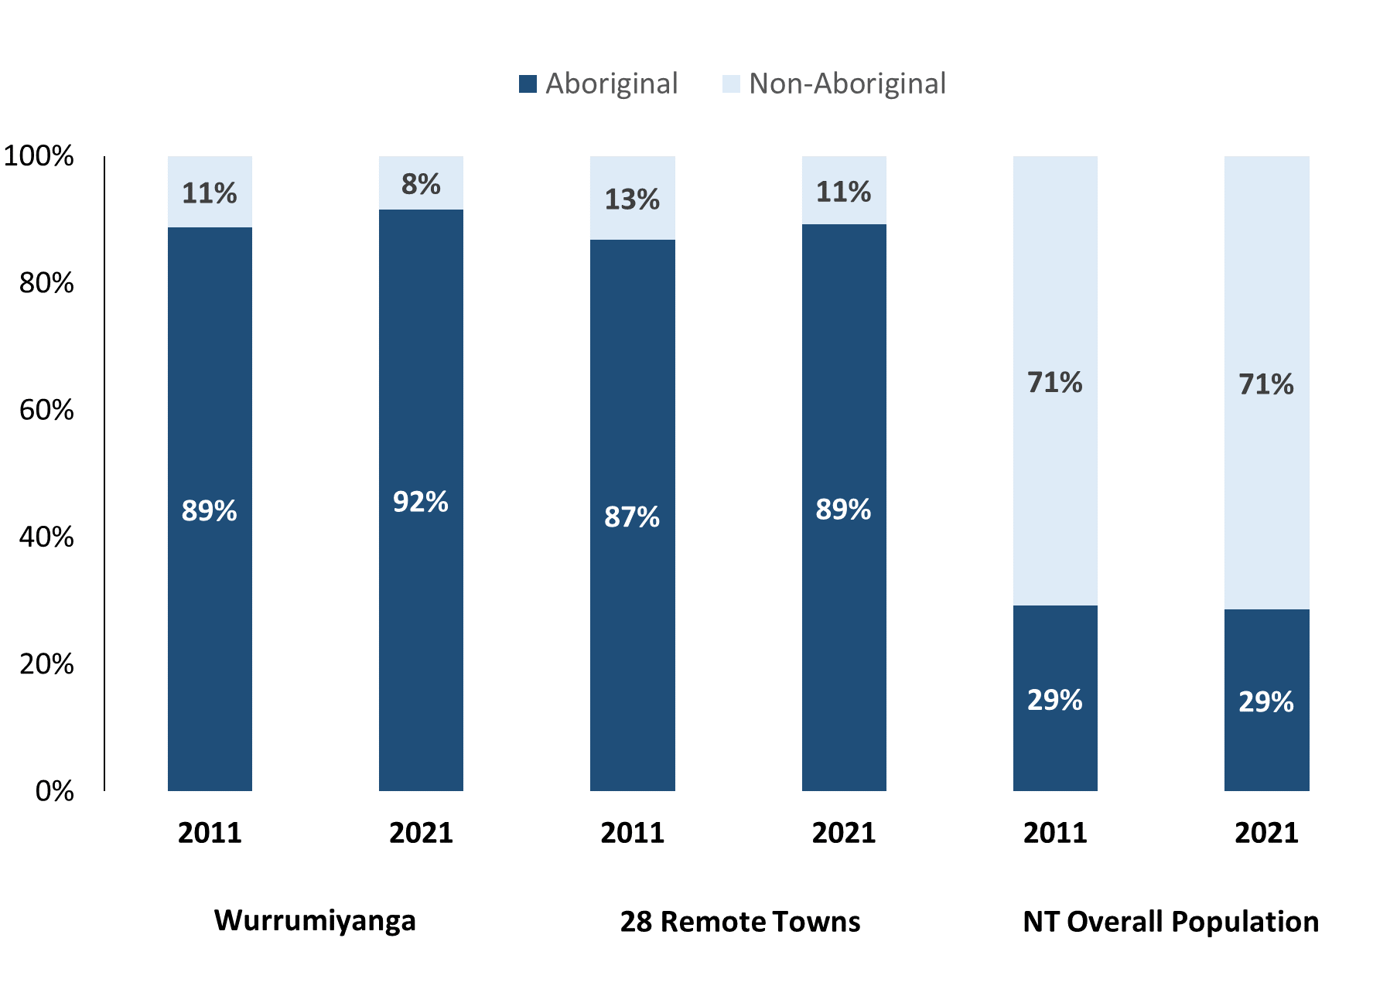

*Source: Australian Bureau of Statistics*

In 2021 in Wurrumiyanga (Nguiu):

* 92.0% of the population in Wurrumiyanga (Nguiu) were **Aboriginal**, compared to 89.0% in 2011
* 89.0% of the population across all 28 remote towns were **Aboriginal**
* 29.0% of the NT population were **Aboriginal**.

**Table 37: Unemployment and Aboriginal participation rates (q)**

|  |  |  |  |  |  |  |
| --- | --- | --- | --- | --- | --- | --- |
|  | **Wurrumiyanga (Nguiu)** | | | **Northern Territory** | | |
| **Aboriginal** | **Non-Aboriginal** | **Total** | **Aboriginal** | **Non-Aboriginal** | **Total** |
| **Unemployment rate** | 38.8% | 0.0% | 28.2% | 20.8% | 3.2% | 5.6% |
| **Participation rate** | 30.3% | 94.6% | 43.9% | 35.4% | 78.3% | 64.9% |

*Source: Australian Bureau of Statistics*

In 2021 in Wurrumiyanga (Nguiu) the:

* **total unemployment rate** was 28.2% compared to 5.6% for the total Northern Territory
* **Aboriginal unemployment rate** was 38.8% compared to 20.8% for the total Northern Territory
* **non-Aboriginal unemployment r**ate was 0.0% compared to 3.2% for the total Northern Territory
* **total participation rate** was 43.9% compared to 64.9% for the total Northern Territory
* **Aboriginal participation rate** was 30.3% compared to 35.4% for the total Northern Territory
* **non-Aboriginal participation rate** was 94.6% compared to 78.3% for the total Northern Territory.

# Community Development Program

**Table 34: Community Development Program Aboriginal Job Seekers, 31 December 2023 (o)**

|  |  |  |
| --- | --- | --- |
| **Indicator** | **Aboriginal** | |
| **No.** | **%** |
| **Total Aboriginal Job Seekers** | 507 | N/A |
| **Age (years)** | | |
| 15-24 | 125 | 24.7% |
| 25-44 | 249 | 49.1% |
| 45+ | 133 | 26.2% |
| **Total** | 507 | 100.0% |
| **Gender** | | |
| Male | 256 | 50.5% |
| Female | 251 | 49.5% |
| **Total** | 507 | 100.0% |
| **Employment Outcome - 1 January 2023 to 31 December 2023** | | |
| 13 Weeks | 28 | 52.8% |
| 26 Weeks | 25 | 47.2% |

*Source: Department of Prime Minister and Cabinet*

**Chart 14: Community Development Program Aboriginal Job Seekers by Gender and Age Group, 31 December 2023 (o)**

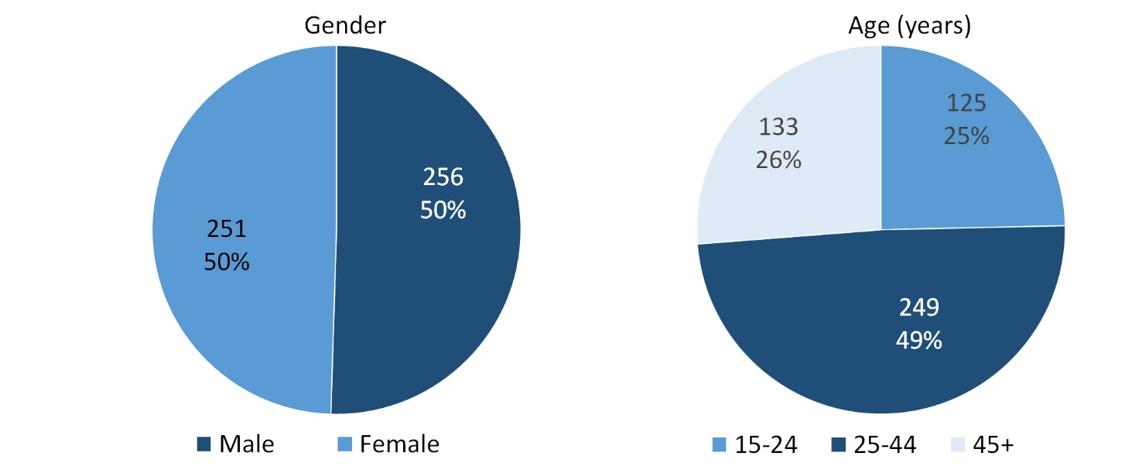

*Source: Department of Prime Minister and Cabinet*

As at 31 December 2023, in Wurrumiyanga (Nguiu), there were 507 CDP **Aboriginal** job seekers, of these:

* 256 (50.5%) were male and 251 (49.5%) were female
* 125 (24.7%) were aged 15-24 years, 249 (49.1%) were aged 25-44 years, and 133 (26.2%) were aged 45+ years
* between 1 January 2023 to 31 December 2023, 28 had reached the 13 week reporting milestone and 25 had reached the 26 week reporting milestone.

# Businesses

**Table 39: Businesses by sector (d)(s)**

|  |  |  |  |  |
| --- | --- | --- | --- | --- |
| **Business Name** | **Reported on in 2011** | **Reported on in 2014** | **Reported on in 2017** | **Reported on in 2023** |
| **PUBLIC SECTOR** | | | | |
| Department of Corrections | Yes | Yes | No | No |
| **Department of Health** | Yes | Yes | Yes | **Yes** |
| Department of Housing | Yes | Yes | No | No |
| Department of Human Services trading as Centrelink | Yes | Yes | Yes | No |
| Department of the Prime Minister and Cabinet | Yes | Yes | Yes | No |
| **National Indigenous Australians Agency** | No | No | No | **Yes** |
| **Northern Territory Police, Fire Emergency Services** | Yes | Yes | Yes | **Yes** |
| **Territory Families** | No | Yes | Yes | **Yes** |
| Tiwi Islands Regional Council[4] | Yes | Yes | No | No |
| **PRIVATE SECTOR** | | | | |
| AAT Australian Adventure Tours Pty Ltd trading as AAT Kings (Tiwi Tours) | Yes | Yes | No | No |
| Australian Red Cross | Yes | Yes | Yes | No |
| Bathurst Island Housing Association (BIHA) | Yes | Yes | Yes | No |
| **Bima Wear** | Yes | No | Yes | **Yes** |
| Calvary Home Care Services Limited trading as Calvary Silver Circle | Yes | Yes | Yes | No |
| Catholic Care NT | Yes | Yes | Yes | No |
| Catholic Church of the Diocese of Darwin | Yes | Yes | Yes | No |
| **Fly Tiwi (Hardy Aviation NT Pty Ltd)** | Yes | Yes | Yes | **Yes** |
| ITEC Employment | Yes | No | No | No |
| Menzies School of Health Research | Yes | No | No | No |
| **Murrupurtiyanuwu Catholic Primary School** | Yes | Yes | Yes | **Yes** |
| Ngaruwanajirri Inc (The Keeping House) – Disability Art Centre | Yes | No | No | No |
| **Nguiu Club Association Inc** | Yes | Yes | Yes | **Yes** |
| Nguiu Ullintjini Association Incorporated | Yes | Yes | Yes | No |
| Piliyamanyirra Supermarket | No | Yes | Yes | No |
| Relationships Australia | Yes | No | No | No |
| Tai Asian Food | Yes | Yes | Yes | No |
| **Tiwi Designs Aboriginal Corporation Incorporated** | Yes | Yes | Yes | **Yes** |
| **Tiwi Enterprises Pty Ltd** | Yes | Yes | Yes | **Yes** |
| Tiwi Islands Football League Inc | Yes | No | No | No |
| **Tiwi Islands Training and Employment Board (TITEB)** | Yes | Yes | Yes | **Yes** |
| Tiwi Land Council | Yes | No | No | No |
| **Traditional Credit Union (TCU)** | No | Yes | Yes | **Yes** |
| Xavier Catholic College Wurrumiyanga | Yes | Yes | Yes | No |

*Source: Northern Territory Department of Industry, Tourism and Trade*

*Note: Business names captured across the four survey periods have been identified by the current 2023 Business ABN name listed as at 2023.*

In 2023 in Wurrumiyanga (Nguiu):

* there were 12 businesses reported on, of which:
* 4 businesses were from the Public Sector (33%)
* 8 businesses were from the Private Sector (67 %)
* there was 1 business operation that was not operating in 2017.

# Notes

1. These counts represent numbers of filled jobs and not the number of people. As such the totals represent the total number of filled jobs, not the total number of employees. This count is not directly comparable to the total number of employed people as a person may have several jobs or one job may be shared by more than one person.
2. Full-time is defined as a job usually requiring 35 hours or more per week or that required 35 hours or more work during the reference week. Part-time is defined as a job usually requiring less than 35 hours per week or that required less than 35 hours work during the reference week. The reference week refers to the period that respondents were asked to provide information about. In most instances it would be the week prior to the week the questionnaire was completed. Questionnaires were predominantly conducted in June and July.
3. Care needs to be taken when analysing the counts of filled jobs by Aboriginal people. Aboriginality was reported by the business representative completing the questionnaire.
4. Sector was classified using the Standard Economic Sector of Classifications of Australia (SESCA), 2008.
5. Job permanency is classified according to what the business believes the level of job permanency is based on guidelines provided by data collectors. Those guidelines state a permanent job has paid annual and/or sick leave entitlements while a temporary job includes casual and fixed-term contract jobs.
6. Classified according to the Australian and New Zealand Standard Classification of Occupations (ANZSCO), 2006, major occupation level.
7. Other Occupations include jobs where occupation was not stated, not known or inadequately described.
8. Classified using the Australian and New Zealand Standard Industrial Classification (ANZSIC), 2006, division level.
9. Care needs to be taken when analysing the counts of filled jobs by the gender of people in the jobs. The gender of the person employed in a job is reported by the business representative completing the questionnaire.
10. Care needs to be taken when analysing the counts of filled jobs by the age of people in the jobs. The age of the person employed in a job is reported by the business representative completing the questionnaire.
11. Students represent the number of individual clients that enrolled in a Vocational Education and Training unit during the calendar year.
12. Unit enrolments represent the count of individual units that students enrolled in during the calendar year.
13. Nominal hours delivered is the sum of the nominal hours of the units commenced during the calendar year regardless of when the course enrolment commenced.
14. Unit completions are the count of all successfully completed units reported in the calendar year regardless of the year of commencement of the units.
15. The Community Development Program (CDP) supports job seekers in remote Australia to build skills, address barriers and contribute to their communities through a range of flexible activities. Under the CDP, job seekers with activity requirements are expected to do up to 25 hours per week of work-like activities that benefit their community. It should be noted that some CDP participants may be reported on within the profile if they are attached to a filled position with an employer captured in the survey. Due to confidentiality issues, data below 20 people is not published.
16. Population estimates for both 2011 and 2021 are taken from the estimated resident population (ERP) data produced by the Australian Bureau of Statistics (ABS) and based on Australian Statistical Geography Standard (ASGS) Statistical Area Level 1 (SA1) regions. ERP are official estimates of the Australian population, which link people to a place of usual residence with Australia. All ERP data sources, including the Census of Population and Housing (Census), are subject to error (including inaccuracies in collection, recording and processing data) and should be used with caution.
17. Indigenous population proportions, unemployment and workforce participation rates are based on ABS Census counts at ASGS Indigenous Locations (ILOCs) for each remote town.
18. Working-age population includes all residents aged 15 years and over (commonly referred to as the civilian population) and consists of people that are employed, unemployed or not in the labour force.
19. A ‘business’ has been defined as any organisation that has undertaken productive activities in the last year, including companies, non-profit organisations, government departments and enterprises operating within the designated remote geography (town), and has one or more employees in paid employment and an Australian Business Number (ABN).

# Abbreviations and Acronyms

ABN Australian Business Number

ABS Australian Bureau of Statistics

ANZSCO Australian and New Zealand Standard Classification of Occupations

ANZSIC Australian and New Zealand Standard Industrial Classification

ASGS Australian Statistical Geography Standard

CDP Community Development Program

ERP Estimated Resident Population

ILOC Indigenous Locations

nec Not Elsewhere Classified

No. Number

Perm Permanent

ppt Percentage point

RJCP Remote Jobs and Communities Program

Temp Temporary

SA1 Statistical Area Level 1

VET Vocational Education and Training

1. The number of filled jobs does not represent numbers of people as a person may have several jobs or one job may be shared by more than one person.
2. 11 Aboriginal filled jobs gender status not identified in 2017
3. 11 Aboriginal filled jobs gender status not identified in 2017
4. Did not participate in the 2017 survey round – data imputed from previous surveys completed in 2014 or 2016.