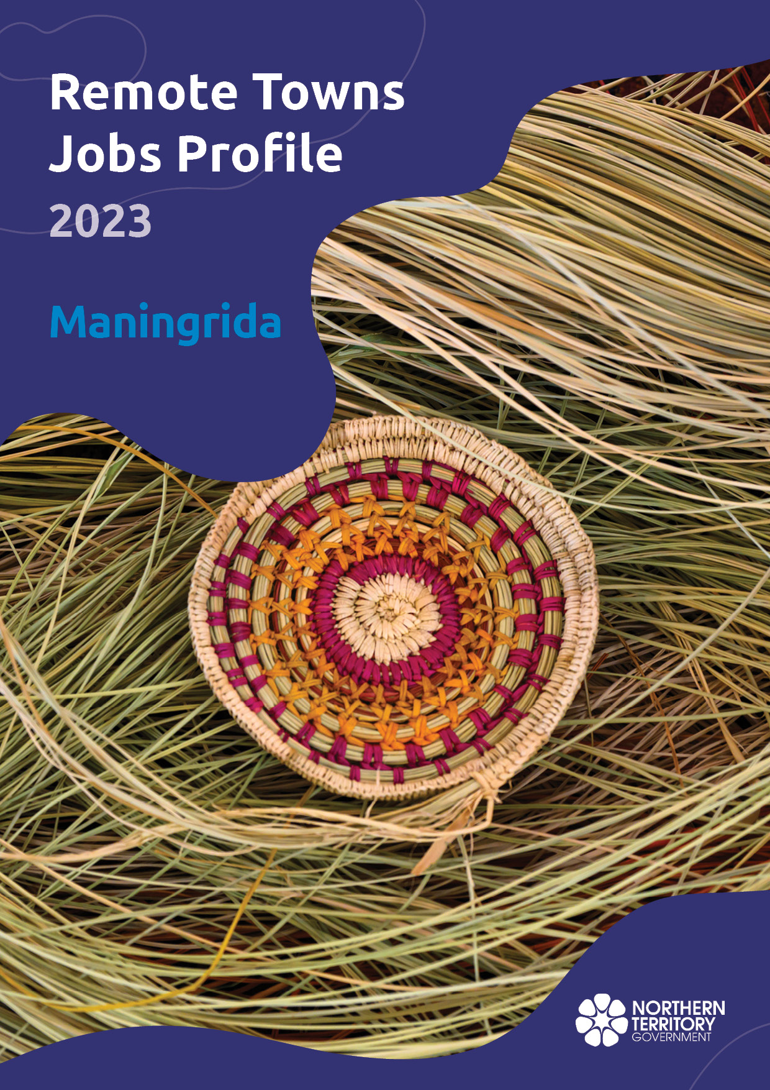

**© Northern Territory of Australia 2025**

**Preferred Reference:** Department of Trade, Business and Asian Relations, 2023 Remote Towns Jobs Profiles, Northern Territory Government, January 2025, Darwin.

**Front cover image:** Weaving materials at Injalak Art Centre, Gunbalanya

**Disclaimer**

The data in this publication was collected by conducting a survey of businesses located in the 28 remote town boundaries. This body of work was completed in 2023 by the former Northern Territory Department of Industry, Tourism and Trade.

The collection methodology was created in accordance with Australian Bureau of Statistics data quality framework principles. Data in this publication is only reflective of those businesses reported on as operating in the town at the time of data collection (see table at the end of publication for list of businesses reported on). To comply with privacy legislation or where appropriate, some data in this publication may have been adjusted and will not reflect the actual data reported by businesses. As a result of this, combined with certain data not being reported by some businesses, some components may not add to totals. Changes over time may also reflect change in business propensity to report on certain data items rather than actual changes over time. Total figures have generally not been adjusted. Caution is advised when interpreting the comparisons made to the earlier 2011, 2014 and 2017 publications as the businesses identified and reported on and the corresponding jobs may differ between publications. The surveys have not always gathered data on training and jobs in the same years.

**Notes for each table and chart are ordered alphabetically and listed at the end of the publication.**

The Northern Territory of Australia exercised due care and skill to ensure that at the time of publication the information contained in this publication is true and correct. However, it is not intended to be relied on as professional advice or used for commercial purposes. The Territory gives no warranty or assurances as to the accuracy of the information contained in the publication and to the maximum extent permitted by law accepts no direct or indirect liability for reliance on its content.

Any use of this report for commercial purposes is not endorsed by the Department of Trade, Business and Asian Relations.

Contents

Maningrida 4

Introduction 5

Summary 6

Jobs Overview 7

Jobs filled by Aboriginality 8

Jobs by Sector: Private and Public 11

Job Status: Permanent and Temporary 18

Job Vacancies 22

Jobs by Industry 24

Jobs by Occupation 31

Jobs by Industry by Occupation 35

Jobs by Gender 38

Jobs by Age 43

Vocational Education and Training 49

Population 56

Community Development Program 58

Businesses 59

Notes 60

Abbreviations and Acronyms 61

# Maningrida

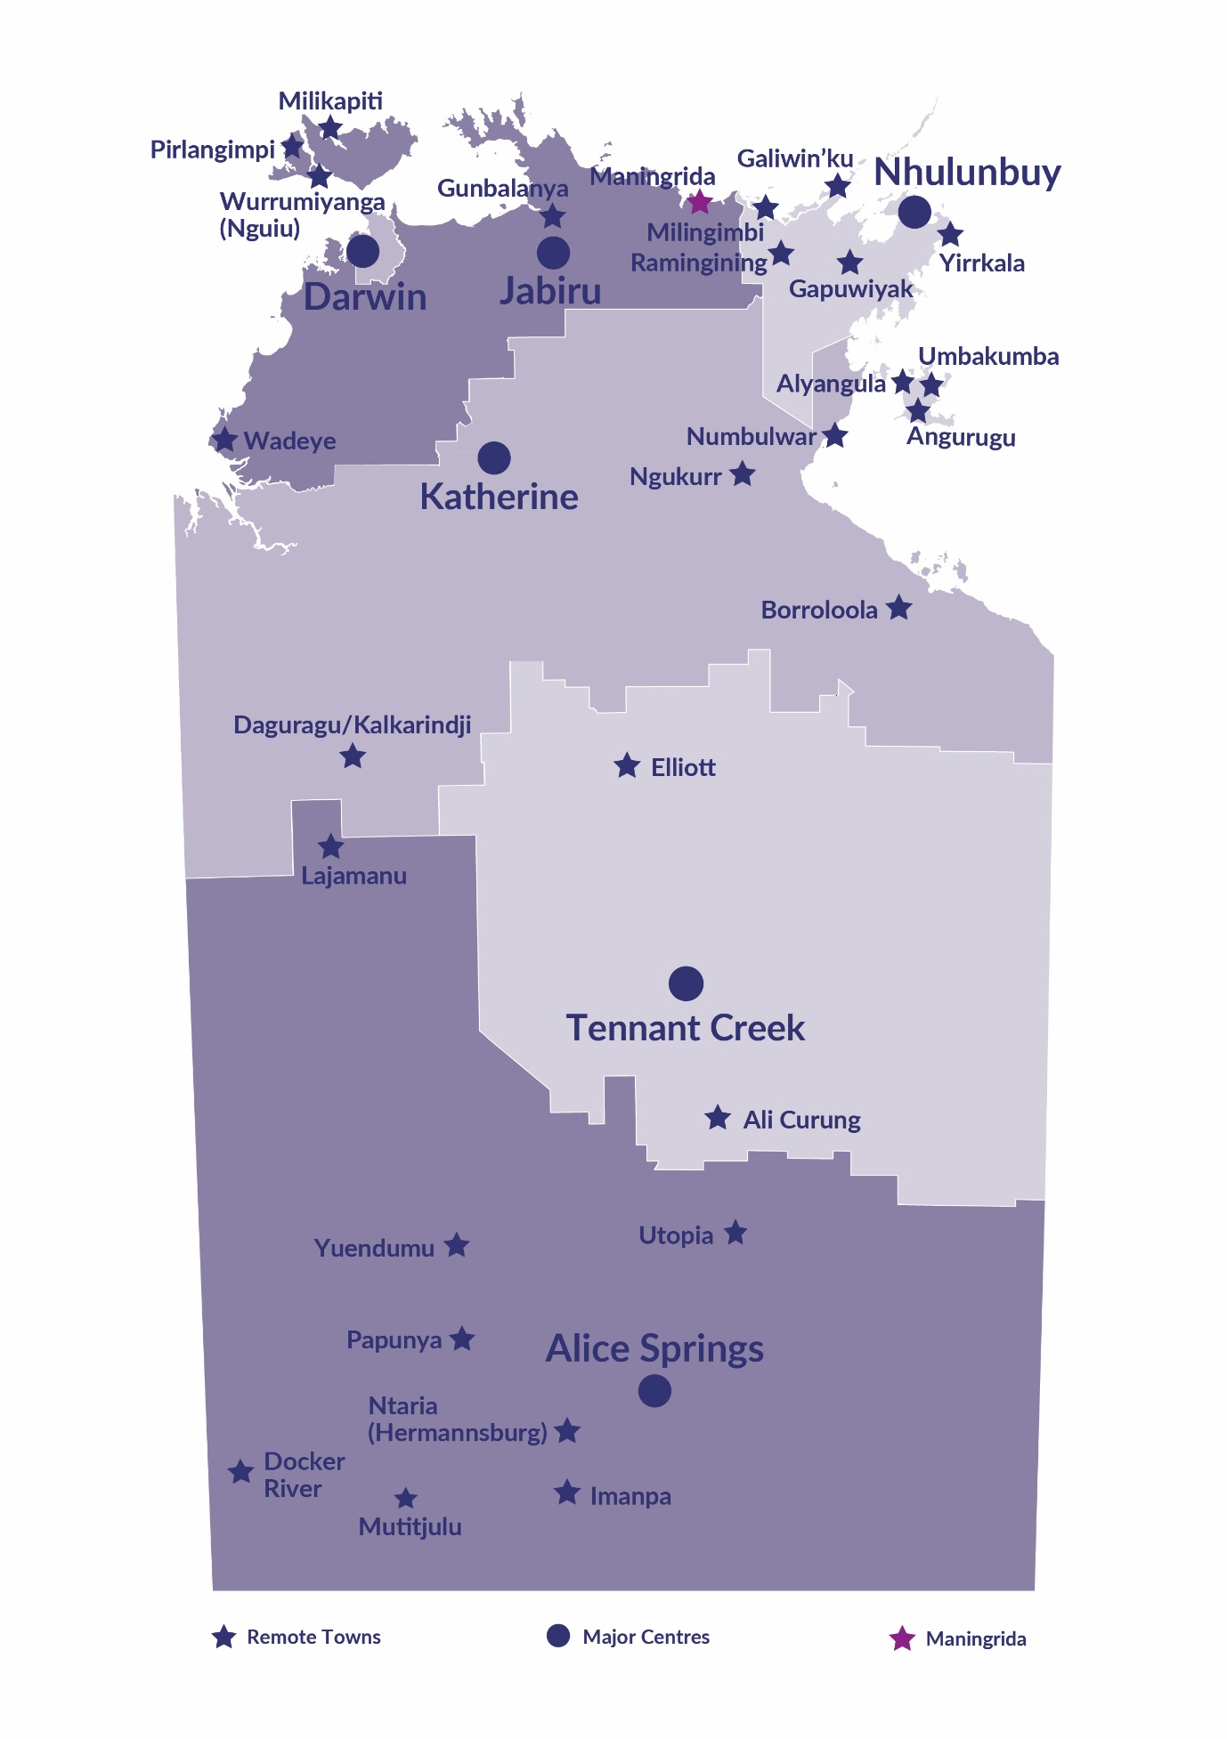Maningrida is located approximately 500 kilometres east of Darwin, and 300 kilometres northeast of Jabiru with access by sealed and dirt road. Maningrida is on the North Central Arnhem Land coast of the Arafura Sea; with a population of 2,516 residents.

*Source: Northern Territory Department of Industry, Tourism and Trade*

# Introduction

This jobs profile provides a snapshot of jobs and the characteristics of job holders in Maningrida as of September 2023. Trends from the surveys conducted in 2011, 2014, and 2017 are also described. Additionally, it presents data on Community Development Program activity, Population, and Vocational Education and Training.

This job profile is one of 28 profiles developed for remote towns in the Northern Territory. It is anticipated these, and subsequent profiles will contribute to a robust evidence base to inform decision making in and relating to these remote Territory towns.

This profile contains information collected by the Northern Territory Department of Industry, Tourism and Trade from businesses operating within the town and is supplemented by other administrative data sets and information.

Each profile provides up-to-date information that is intended to inform the planning and design of current and future government programs and as an evidence base to inform decision making relating to workforce development, enterprise and job opportunities.

The profile may best be understood as a point-in-time tool. The number of business surveys from which the data was drawn is significantly less than in earlier surveys, and business participation has decreased with each survey. For Maningrida, 36% fewer businesses than in 2017 are reported here.

The data collection methodology and corresponding questionnaire were created in partnership with the Australian Bureau of Statistics (ABS) and in accordance with ABS data quality framework and survey principles.

The Northern Territory Department of Industry, Tourism and Trades’ Territory Engagement and Delivery, Skills Initiative and VET data teams collaborated with the Northern Institute at Charles Darwin University to facilitate the surveys and reports.

The information collected and reported on represents a significant goodwill investment by those businesses and organisations that participated. Each business is listed at the end of this publication.

# Summary

The 2023 jobs profile was developed based on responses from 9 businesses operating within the Maningrida town boundary, 5 less than in the 2017 survey. Of these, there were:

* 4 businesses from the Private Sector, accounting for 163 filled jobs or 53% of total filled jobs
* 5 businesses from the Public Sector, accounting for 144 filled jobs or 47% of total filled jobs
* 6 businesses participated in all four surveys (completed in 2011, 2014, 2017 and 2023).

A total of 397 filled and vacant jobs in Maningrida were reported, a decrease of 92 jobs from 2017.[1]

The 2023 profile highlights:

* there were 307 filled jobs of which:
* 190 jobs (62%) were filled by Aboriginal people, a decrease of 54 jobs from 2017
* 117 jobs (38%) were filled by non-Aboriginal people, a decrease of 62 jobs from 2017
* 34% of employed Aboriginal people are working in the Private Sector
* Aboriginal people accounted for 62% of job holders in the town compared to 58% in 2017
* Aboriginal females made up 51% of total Aboriginal filled jobs in the town compared to 43% in 2017.
* there were 90 vacant jobs, of which:
* job vacancies as a percentage of jobs increased to 13.5% in 2017 to 22.7% in 2023
* job vacancies equate to 1 in 4 jobs
* 54 of the vacancies were in Professional and Community and Personal Service Workers areas.
* Education and Training was the largest industry employer with 105 jobs filled, followed by Public Administration and Safety with 44 jobs filled
* Administrative and Support Services and Health Care and Social Assistance had a decrease in filled jobs of 49 and 42 respectively between 2023 and 2017.
* training had an overall increase in student numbers of 25 between 2023 and 2016.
* Building and Construction had the largest increase in student numbers of 57 while General Education and Training had the largest decrease in student numbers of 15 in 2023
* new training activity in 2023, Engineering and mining was delivered to 17 students; this training area was not delivered in 2016 and 2013.

The overall population in Maningrida increased by 222 people (9.7%) between 2011 and 2021 to 2516 people.

In comparison, the overall Northern Territory population increased by 9.7% between 2011 and 2021.

In 2021, the working age population (15 years and over) in Maningrida was an estimated 1,893 people compared to 1,594 in 2011 an increase of 18.8%.

There were 0.2 jobs in Maningrida per working age person compared to 0.3 jobs per working age person across the 28 remote towns in the Northern Territory.

# Jobs Overview

Table 1: Count of filled jobs and vacancies, 2011, 2014, 2017 & 2023 (a)(b)

|  |  |  |  |  |  |  |  |
| --- | --- | --- | --- | --- | --- | --- | --- |
|  | **2011** | **2014** | **2017** | **2023** | **Change 2011-2014** | **Change 2014-2017** | **Change 2017-2023** |
| **Total All Jobs** | **307** | **436** | **489** | **397** | **129** | **53** | **-92** |
| **Vacancies** | **21** | **38** | **66** | **90** | **17** | **28** | **24** |
| Vacancies as % of Total All Jobs | 6.8% | 8.7% | 13.5% | 22.7% | 1.9 ppt | 4.8 ppt | 9.2 ppt |
| **Filled Jobs** | **286** | **398** | **423** | **307** | **112** | **25** | **-116** |
| Full-time | 232 | 296 | 285 | 245 | 64 | -11 | -40 |
| Part-time | 54 | 102 | 138 | 62 | 48 | 36 | -76 |

Source: Northern Territory Department of Industry, Tourism and Trade

Chart 1: Count of vacant jobs and filled jobs by full-time/part-time status, 2011, 2014, 2017 & 2023 (a)(b)

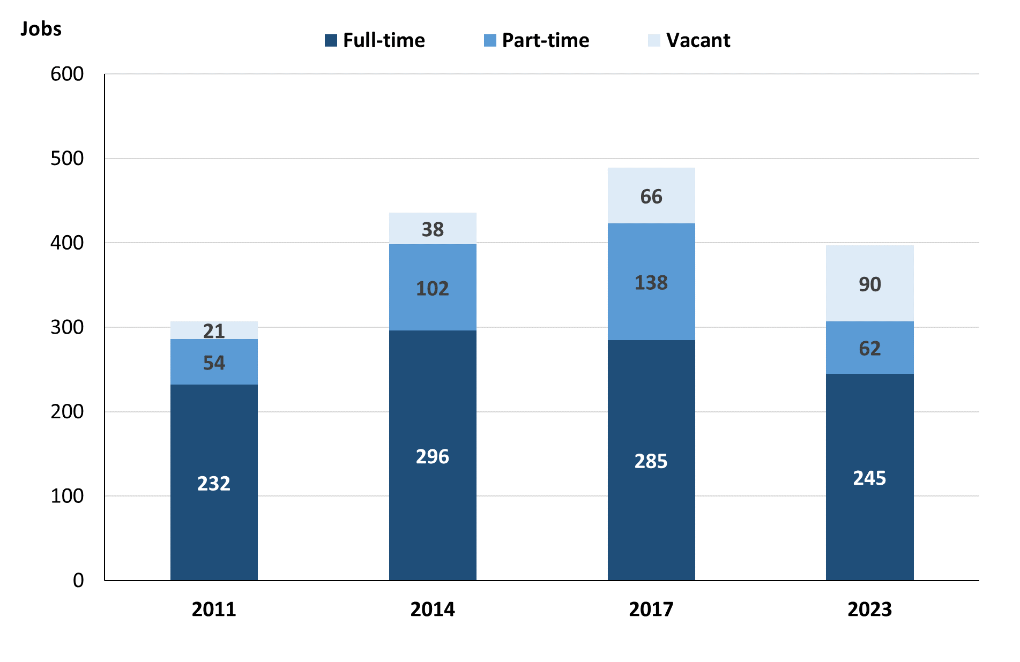

Source: Northern Territory Department of Industry, Tourism and Trade

In 2023 in Maningrida:

* there was a total of 307 **filled jobs**, a decrease of 116 jobs from 2017 and a decrease of 91 jobs from 2014
* of the 307 **filled jobs** in 2023:
* 245 were full-time jobs, a decrease of 40 jobs from 2017 and a decrease of 51 jobs from 2014
* 62 were part-time jobs, a decrease of 76 jobs from 2017 and a decrease of 40 jobs from 2014
* there were 90 total **job vacancies** in 2023, an increase of 24 vacancies from 2017 and an increase of 52 vacancies from 2014.

# Jobs filled by Aboriginality

Chart 2: Count of filled jobs by Aboriginality, 2011, 2014, 2017 & 2023 (a)(c)

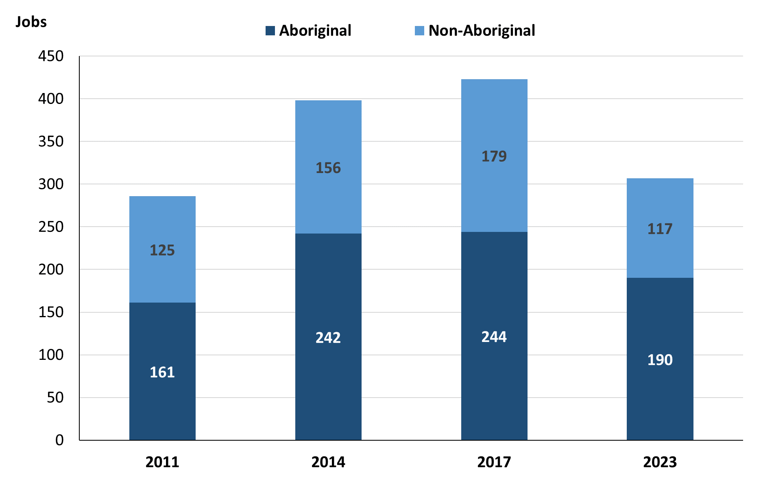

Source: Northern Territory Department of Industry, Tourism and Trade

In 2023 in Maningrida:

* of the 307 **filled jobs**:
* **Aboriginal** people filled 190 jobs, a decrease of 54 jobs from 2017 and a decrease of 52 jobs from 2014
* **non-Aboriginal** people filled 117 jobs, a decrease of 62 jobs from 2017 and a decrease of 39 jobs from 2014.
* **Aboriginal** people accounted for 62% of job holders compared to 58% in 2017 and 61% in 2014.

Table 2a: Count of filled jobs by full-time/part-time status, 2011, 2014, 2017 & 2023 (a)(b)(c)

|  |  |  |  |  |  |  |  |  |  |  |  |  |
| --- | --- | --- | --- | --- | --- | --- | --- | --- | --- | --- | --- | --- |
| **Indicator** | **2011** | | | **2014** | | | **2017** | | | **2023** | | |
| **Aboriginal** | **Non-Aboriginal** | **Total** | **Aboriginal** | **Non-Aboriginal** | **Total** | **Aboriginal** | **Non-Aboriginal** | **Total** | **Aboriginal** | **Non-Aboriginal** | **Total** |
| Full-time | 121 | 111 | **232** | 146 | 150 | **296** | 110 | 175 | **285** | 132 | 113 | **245** |
| Part-time | 40 | 14 | **54** | 96 | 6 | **102** | 134 | 4 | **138** | 58 | 4 | **62** |
| **Total** | **161** | **125** | **286** | **242** | **156** | **398** | **244** | **179** | **423** | **190** | **117** | **307** |

Source: Northern Territory Department of Industry, Tourism and Trade

Table 2b: Count of filled jobs by full-time/part-time status, 2011-2014, 2014-2017, 2017-2023 (a)(b)(c)

|  |  |  |  |  |  |  |  |  |  |
| --- | --- | --- | --- | --- | --- | --- | --- | --- | --- |
| **Indicator** | **Change 2011-2014** | | | **Change 2014-2017** | | | **Change 2017-2023** | | |
| **Aboriginal** | **Non-Aboriginal** | **Total** | **Aboriginal** | **Non-Aboriginal** | **Total** | **Aboriginal** | **Non-Aboriginal** | **Total** |
| Full-time | 25 | 39 | **64** | -36 | 25 | **-11** | 22 | -62 | **-40** |
| Part-time | 56 | -8 | **48** | 38 | -2 | **36** | -76 | 0 | **-76** |
| **Total** | **81** | **31** | **112** | **2** | **23** | **25** | **-54** | **-62** | **-116** |

Source: Northern Territory Department of Industry, Tourism and Trade

Chart 3: Count of filled jobs by full-time/part-time status, 2011, 2014, 2017 & 2023 (a)(b)(c)

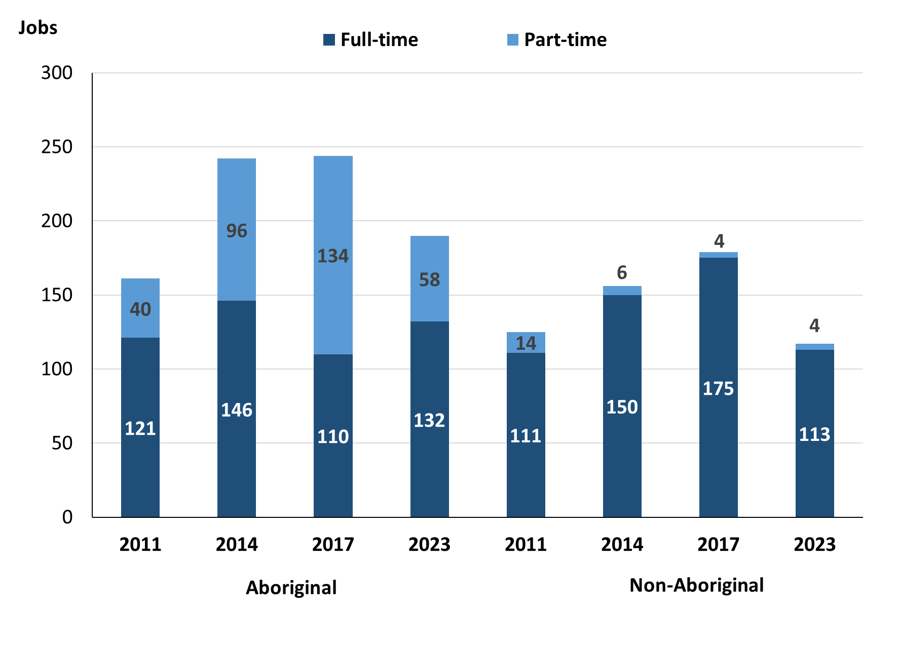

Source: Northern Territory Department of Industry, Tourism and Trade

In 2023 in Maningrida:

* of the 307 **filled jobs**:
* 132 were **full-time** jobs filled by **Aboriginal** people, an increase of 22 jobs from 2017 and a decrease of 14 jobs from 2014
* 58 were **part-time** jobs filled by **Aboriginal** people, a decrease of 76 jobs from 2017 and a decrease of 38 jobs from 2014
* 113 were **full-time** jobs filled by **non-Aboriginal** people, a decrease of 62 jobs from 2017 and a decrease of 37 jobs from 2014
* 4 were **part-time** jobs filled by **non-Aboriginal** people, unchanged from 2017 and a decrease of 2 jobs from 2014.

# Jobs by Sector: Private and Public

Table 3a: Count of filled jobs by business sector 2011, 2014, 2017 & 2023 (a)(b)(c)

|  |  |  |  |  |  |  |  |  |  |  |  |  |
| --- | --- | --- | --- | --- | --- | --- | --- | --- | --- | --- | --- | --- |
| **Indicator** | **2011** | | | **2014** | | | **2017** | | | **2023** | | |
| **Aboriginal** | **Non-Aboriginal** | **Total** | **Aboriginal** | **Non-Aboriginal** | **Total** | **Aboriginal** | **Non-Aboriginal** | **Total** | **Aboriginal** | **Non-Aboriginal** | **Total** |
| **Public Sector** | 52 | 85 | **137** | 65 | 95 | **160** | 69 | 96 | **165** | 85 | 59 | **144** |
| Australian Government | 3 | 2 | **5** | 6 | 2 | **8** | 4 | 1 | **5** | 1 | 1 | **2** |
| Territory Government | 29 | 67 | **96** | 34 | 83 | **117** | 42 | 80 | **122** | 64 | 50 | **114** |
| Local Government | 20 | 16 | **36** | 25 | 10 | **35** | 23 | 15 | **38** | 20 | 8 | **28** |
| **Private Sector** | 109 | 40 | **149** | 177 | 61 | **238** | 175 | 83 | **258** | 105 | 58 | **163** |
| **Total** | **161** | **125** | **286** | **242** | **156** | **398** | **244** | **179** | **423** | **190** | **117** | **307** |

Source: Northern Territory Department of Industry, Tourism and Trade

Table 3b: Count of filled jobs by business sector, 2011-2014, 2014-2017 & 2017-2023 (a)(b)(c)

|  |  |  |  |  |  |  |  |  |  |
| --- | --- | --- | --- | --- | --- | --- | --- | --- | --- |
| **Indicator** | **Change 2011-2014** | | | **Change 2014-2017** | | | **Change 2017-2023** | | |
| **Aboriginal** | **Non-Aboriginal** | **Total** | **Aboriginal** | **Non-Aboriginal** | **Total** | **Aboriginal** | **Non-Aboriginal** | **Total** |
| **Public Sector** | 13 | 10 | **23** | 4 | 1 | **5** | 16 | -37 | **-21** |
| Australian Government | 3 | 0 | **3** | -2 | -1 | **-3** | -3 | 0 | **-3** |
| Territory Government | 5 | 16 | **21** | 8 | -3 | **5** | 22 | -30 | **-8** |
| Local Government | 5 | -6 | **-1** | -2 | 5 | **3** | -3 | -7 | **-10** |
| **Private Sector** | 68 | 21 | **89** | -2 | 22 | **20** | -70 | -25 | **-95** |
| **Total** | **81** | **31** | **112** | **2** | **23** | **25** | **-54** | **-62** | **-116** |

Source: Northern Territory Department of Industry, Tourism and Trade

Chart 4: Count of filled jobs by business sector, 2011, 2014, 2017 & 2023 (a)(d)

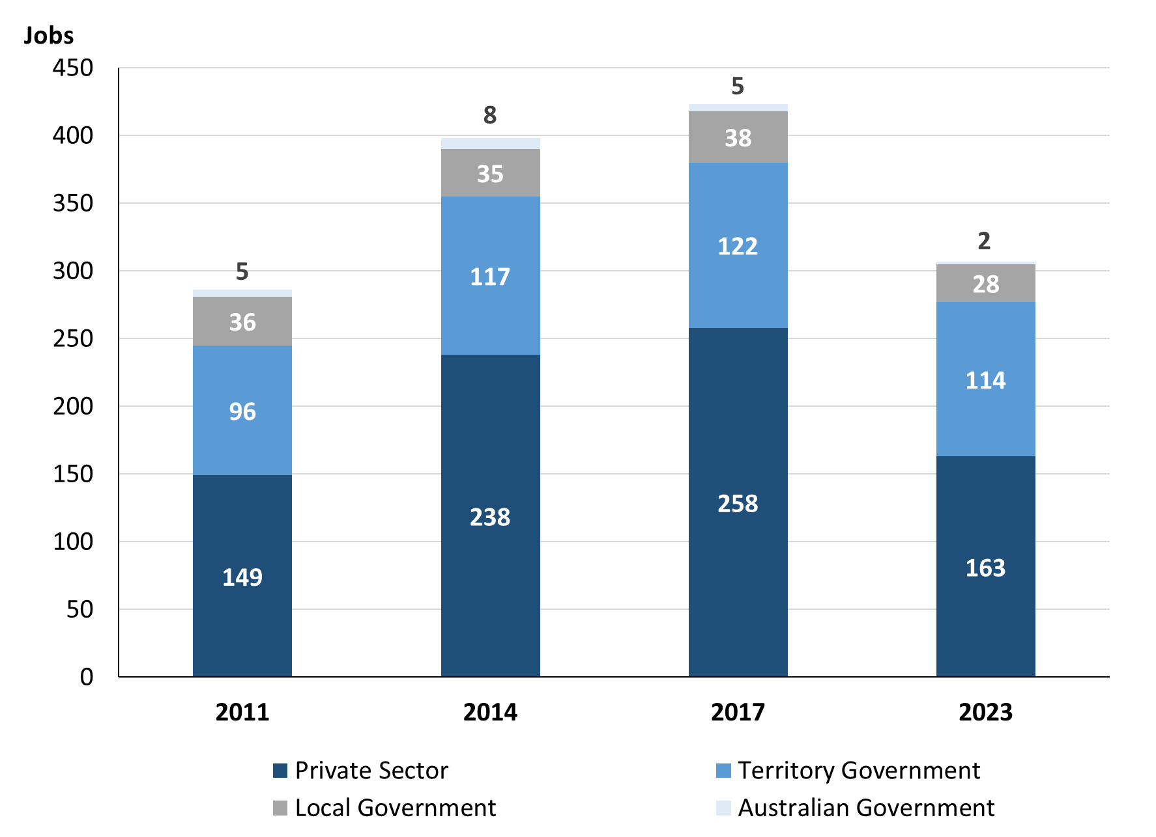

Source: Northern Territory Department of Industry, Tourism and Trade

Chart 5: Percentage of filled jobs by business sector in 2023 (a)(d)

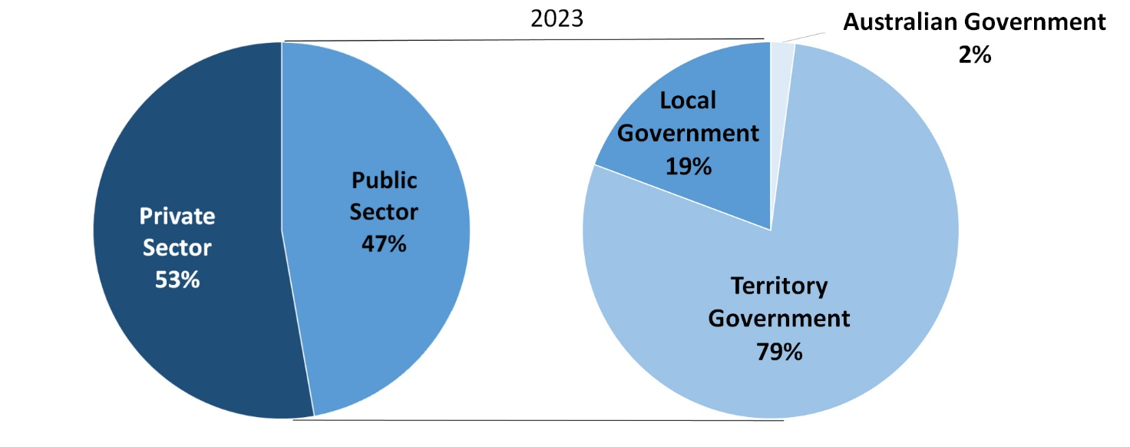

*Source: Northern Territory Department of Industry, Tourism and Trade*

In 2023 in Maningrida:

* there were 144 jobs in the **Public Sector**, a decrease of 21 jobs from 2017 and a decrease of 16 jobs from 2014.
* of the 144 jobs in the **Public Sector**:
* 2 jobs were in the Australian Government, a decrease of 3 jobs from 2017 and a decrease of 6 jobs from 2014
* 114 jobs were in the Territory Government, a decrease of 8 jobs from 2017 and a decrease of 3 jobs from 2014
* 28 jobs were in the Local Government, a decrease of 10 jobs from 2017 and a decrease of 7 jobs from 2014
* there were 163 jobs in the **Private Sector**, a decrease of 95 jobs from 2017 and a decrease of 75 jobs from 2014.

Chart 6: Count of filled jobs by sector, 2011, 2014, 2017 & 2023 (a)(c)(d)

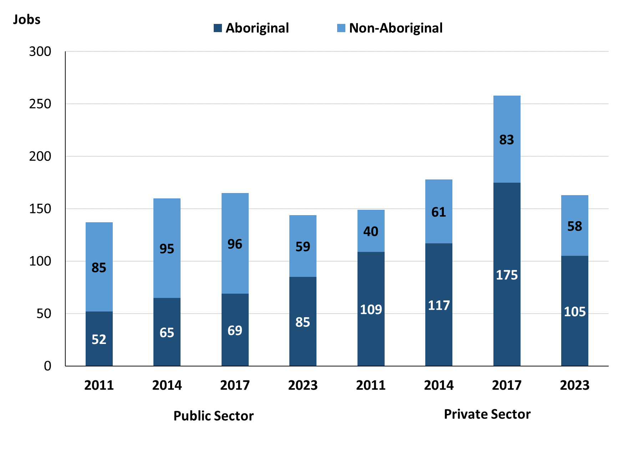

Source: Northern Territory Department of Industry, Tourism and Trade

In 2023 in Maningrida:

* of the 144 jobs in the **Public Sector**:
* 85 jobs were filled by **Aboriginal** people, an increase of 16 jobs from 2017 and an increase of 20 jobs from 2014
* 59 jobs were filled by **non-Aboriginal** people, a decrease of 37 jobs from 2017 and a decrease of 36 jobs from 2014
* of the 163 jobs in the **Private Sector**:
* 105 jobs were filled by **Aboriginal** people, a decrease of 70 jobs from 2017 and a decrease of 72 jobs from 2014
* 58 jobs were filled by **non-Aboriginal** people, a decrease of 25 jobs from 2017 and a decrease of 3 jobs from 2014.

Chart 7: Count of filled jobs by sector and full-time/part-time status, 2011, 2014, 2017 & 2023 (a)(b)(d)

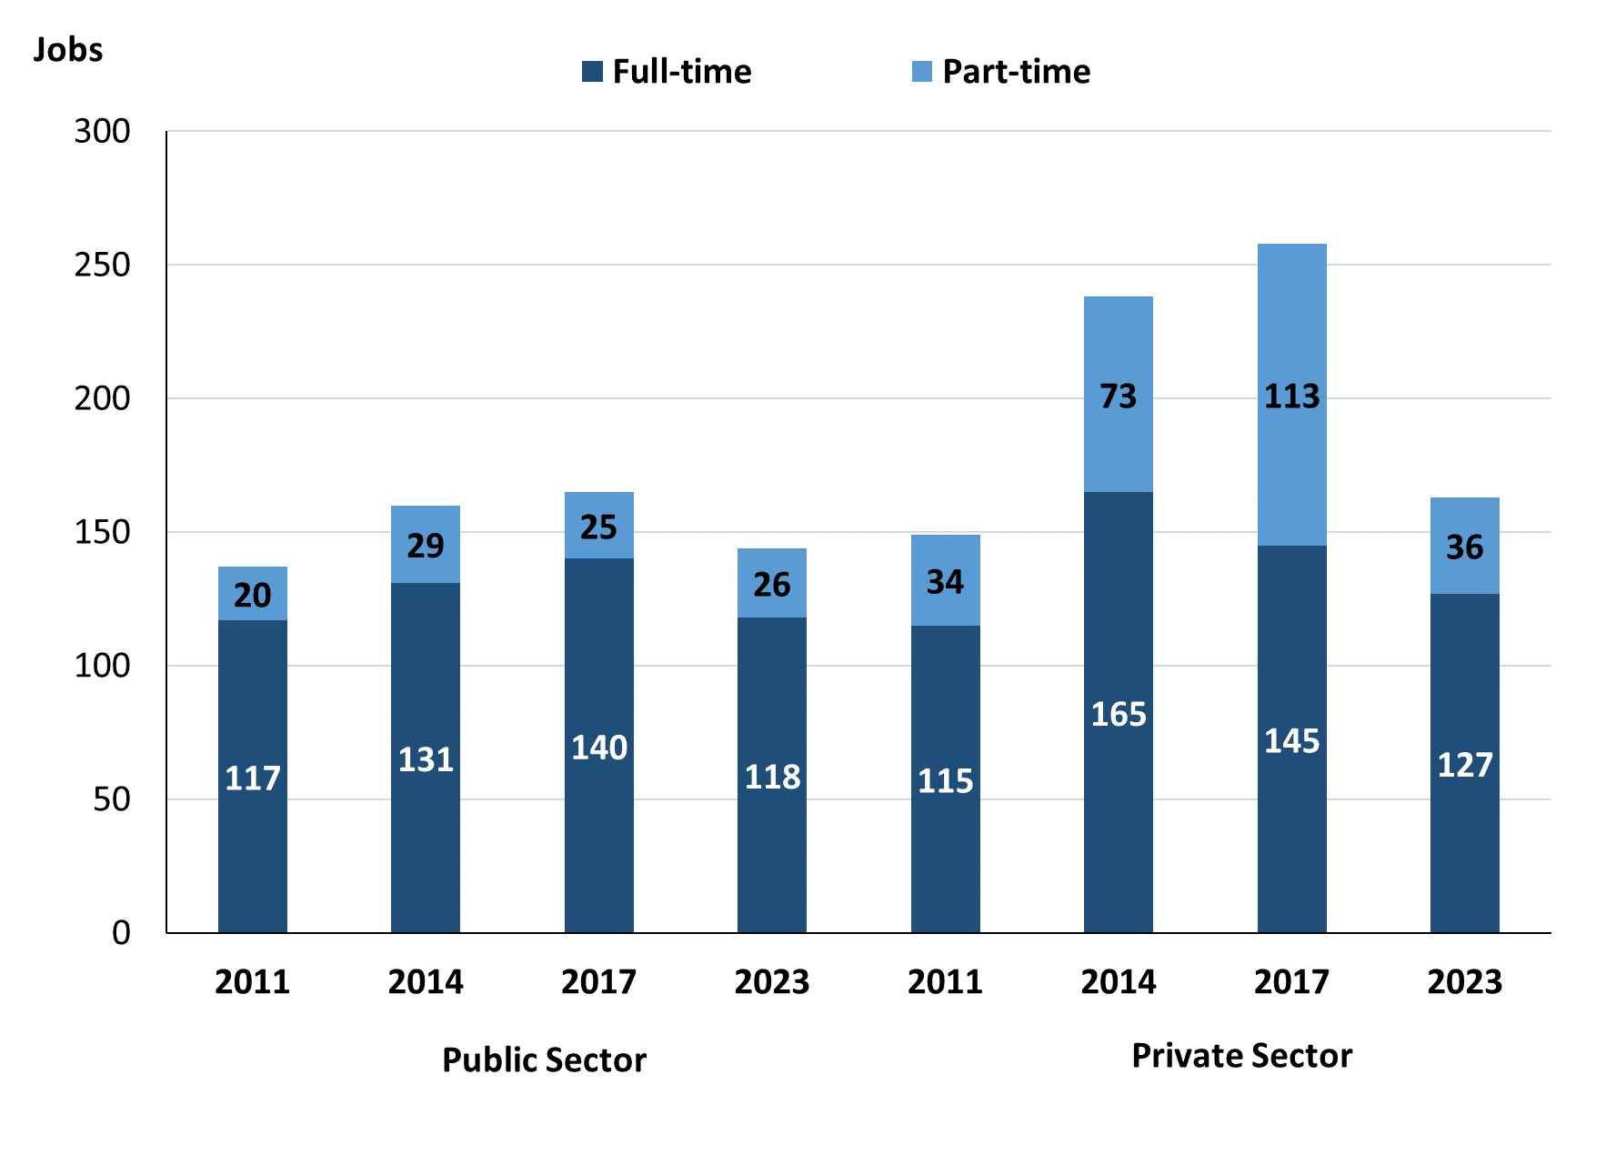

Source: Northern Territory Department of Industry, Tourism and Trade

In 2023 in Maningrida there were:

* of the 144 jobs in the **Public Sector**:
* 118 were **full-time** jobs, a decrease of 22 jobs from 2017 and a decrease of 13 jobs from 2014
* 26 were **part-time** jobs, an increase of 1 job from 2017 and a decrease of 3 jobs from 2014
* of the 163 jobs in the **Private Sector**:
* 127 were **full-time** jobs, a decrease of 18 jobs from 2017 and a decrease of 38 jobs from 2014
* 36 were **part-time** jobs, a decrease of 77 jobs from 2017 and a decrease of 37 jobs from 2014.

Table 4: Count of filled jobs by full-time/part-time status by sector, 2011, 2014, 2017 & 2023 (a)(b)(c)(d)

|  |  |  |  |  |  |  |  |  |  |  |
| --- | --- | --- | --- | --- | --- | --- | --- | --- | --- | --- |
| **Indicator** | **2011** | | | | | | | | | |
| **Aboriginal** | | | **Non-Aboriginal** | | | **Total** | | | |
| **Full-time** | **Part-time** | **Total** | **Full-time** | **Part-time** | **Total** | **Full-time** | **Part-time** | **Total** |
| Public Sector | 38 | 14 | **52** | 79 | 6 | **85** | 117 | 20 | **137** |
| Private Sector | 83 | 26 | **109** | 32 | 8 | **40** | 115 | 34 | **149** |
| **Total** | **121** | **40** | **161** | **111** | **14** | **125** | **232** | **54** | **286** |

|  |  |  |  |  |  |  |  |  |  |
| --- | --- | --- | --- | --- | --- | --- | --- | --- | --- |
| **Indicator** | **2014** | | | | | | | | |
| **Aboriginal** | | | **Non-Aboriginal** | | | **Total** | | |
| **Full-time** | **Part-time** | **Total** | **Full-time** | **Part-time** | **Total** | **Full-time** | **Part-time** | **Total** |
| Public Sector | 42 | 23 | **65** | 89 | 6 | **95** | 131 | 29 | **160** |
| Private Sector | 104 | 73 | **177** | 61 | 0 | **61** | 165 | 73 | **238** |
| **Total** | **146** | **96** | **242** | **150** | **6** | **156** | **296** | **102** | **398** |

|  |  |  |  |  |  |  |  |  |  |
| --- | --- | --- | --- | --- | --- | --- | --- | --- | --- |
| **Indicator** | **2017** | | | | | | | | |
| **Aboriginal** | | | **Non-Aboriginal** | | | **Total** | | |
| **Full-time** | **Part-time** | **Total** | **Full-time** | **Part-time** | **Total** | **Full-time** | **Part-time** | **Total** |
| Public Sector | 48 | 21 | **69** | 92 | 4 | **96** | 140 | 25 | **165** |
| Private Sector | 62 | 113 | **175** | 83 | 0 | **83** | 145 | 113 | **258** |
| **Total** | **146** | **96** | **244** | **175** | **4** | **179** | **285** | **138** | **423** |

|  |  |  |  |  |  |  |  |  |  |
| --- | --- | --- | --- | --- | --- | --- | --- | --- | --- |
| **Indicator** | **2023** | | | | | | | | |
| **Aboriginal** | | | **Non-Aboriginal** | | | **Total** | | |
| **Full-time** | **Part-time** | **Total** | **Full-time** | **Part-time** | **Total** | **Full-time** | **Part-time** | **Total** |
| Public Sector | 61 | 24 | **85** | 57 | 2 | **59** | 118 | 26 | **146** |
| Private Sector | 71 | 34 | **105** | 56 | 2 | **58** | 127 | 36 | **161** |
| **Total** | **132** | **58** | **190** | **113** | **4** | **117** | **245** | **62** | **307** |

Source: Northern Territory Department of Industry, Tourism and Trade

In 2023 in Maningrida there were:

* 85 jobs in the **Public Sector** filled by **Aboriginal** people, an increase of 16 jobs from 2017 and an increase of 20 jobs from 2014, of which:
* 61 were **full-time** jobs, an increase of 13 jobs from 2017 and an increase of 19 jobs from 2014
* 24 were **part-time** jobs, an increase of 3 jobs from 2017 and an increase of 1 job from 2014
* 105 jobs in the **Private Sector** filled by **Aboriginal** people, a decrease of 70 jobs from 2017 and a decrease of 72 jobs from 2014, of which:
* 71 were **full-time** jobs, an increase of 9 jobs from 2017 and a decrease of 33 jobs from 2014
* 34 were **part-time** jobs, a decrease of 79 jobs from 2017 and a decrease of 39 jobs from 2014
* 59 jobs in the **Public Sector** filled by **non-Aboriginal** people, a decrease of 37 jobs from 2017 and a decrease of 36 jobs from 2014, of which:
* 57 were **full-time** jobs, a decrease of 35 jobs from 2017 and a decrease of 32 jobs from 2014
* 2 were **part-time** jobs, a decrease of 2 jobs from 2017 and a decrease of 4 jobs from 2014
* 58 jobs in the **Private Sector** filled by **non-Aboriginal** people, a decrease of 25 jobs from 2017 and a decrease of 3 jobs from 2014, of which:
* 56 were **full-time** jobs, a decrease of 27 jobs from 2017 and a decrease of 5 jobs from 2014
* 2 were **part-time** jobs, an increase of 2 jobs from 2017 and an increase of 2 jobs from 2014.

# Job Status: Permanent and Temporary

Table 5a: Count of filled jobs by employment status, 2011, 2014, 2017 & 2023 (a)(c)(e)

|  |  |  |  |  |  |  |  |  |  |  |  |  |
| --- | --- | --- | --- | --- | --- | --- | --- | --- | --- | --- | --- | --- |
| **Indicator** | **2011** | | | **2014** | | | **2017** | | | **2023** | | |
| **Aboriginal** | **Non-Aboriginal** | **Total** | **Aboriginal** | **Non-Aboriginal** | **Total** | **Aboriginal** | **Non-Aboriginal** | **Total** | **Aboriginal** | **Non-Aboriginal** | **Total** |
| Permanent | 132 | 67 | **199** | 188 | 123 | **311** | 123 | 116 | **239** | 118 | 87 | **205** |
| Temporary | 29 | 58 | **87** | 54 | 33 | **87** | 121 | 63 | **184** | 72 | 30 | **102** |
| **Total** | **161** | **125** | **286** | **242** | **156** | **398** | **244** | **179** | **423** | **190** | **117** | **307** |

Source: Northern Territory Department of Industry, Tourism and Trade

Table 5b: Count of filled jobs by employment status, 2011-2014, 2014-2017 & 2017-2023 (a)(c)(e)

|  |  |  |  |  |  |  |  |  |  |
| --- | --- | --- | --- | --- | --- | --- | --- | --- | --- |
| **Indicator** | **Change 2011-2014** | | | **Change 2014-2017** | | | **Change**  **2017-2023** | | |
| **Aboriginal** | **Non-Aboriginal** | **Total** | **Aboriginal** | **Non-Aboriginal** | **Total** | **Aboriginal** | **Non-Aboriginal** | **Total** |
| Permanent | 56 | 56 | **112** | -65 | -7 | **-72** | -5 | -29 | **-34** |
| Temporary | 25 | -25 | **0** | 67 | 30 | **97** | -49 | -33 | **-82** |
| **Total** | **81** | **31** | **112** | **2** | **23** | **25** | **-54** | **-62** | **-116** |

Source: Northern Territory Department of Industry, Tourism and Trade

Chart 8: Count of filled jobs by employment status, 2011, 2014, 2017 & 2023 (a)(c)(e)

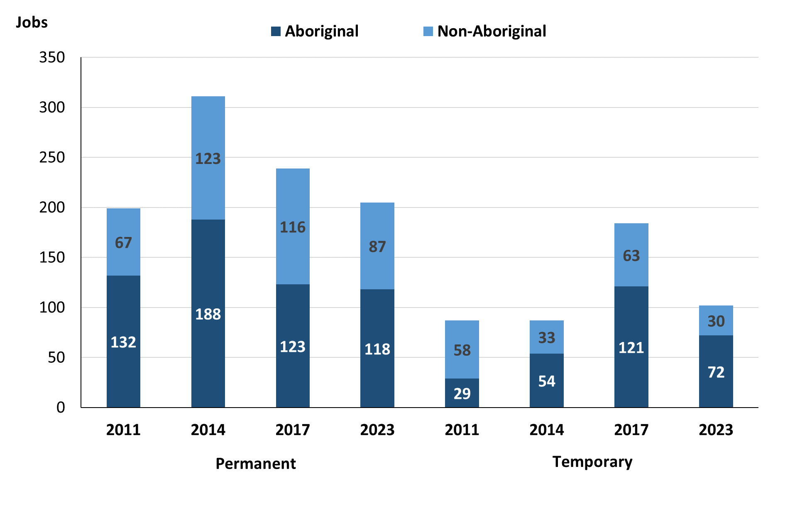

Source: Northern Territory Department of Industry, Tourism and Trade

In 2023 in Maningrida:

* there were 205 **permanent jobs**, a decrease of 34 jobs from 2017, and a decrease of 106 jobs from 2014, of which:
* **Aboriginal** people filled 118 jobs, a decrease of 5 jobs from 2017 and a decrease of 70 jobs from 2014
* **non-Aboriginal** people filled 87 jobs, a decrease of 29 jobs from 2017 and a decrease of 36 jobs from 2014
* there were 102 **temporary jobs**, a decrease of 82 jobs from 2017 and an increase of 15 jobs from 2014, of which:
* **Aboriginal** people filled 72 jobs, a decrease of 49 jobs from 2017 and an increase of 18 jobs from 2014
* **non-Aboriginal** people filled 30 jobs, a decrease of 33 jobs from 2017 and a decrease of 3 jobs from 2014.

Table 6: Count of filled jobs by sector and employment status, 2011, 2014, 2017 & 2023 (a)(c)(d)(e)

|  |  |  |  |  |  |  |  |  |  |
| --- | --- | --- | --- | --- | --- | --- | --- | --- | --- |
| **Indicator** | **2011** | | | | | | | | |
| **Aboriginal** | | | **Non-Aboriginal** | | | **Total** | | |
| **Perm** | **Temp** | **Total** | **Perm** | **Temp** | **Total** | **Perm** | **Temp** | **Total** |
| Public Sector | 32 | 20 | **52** | 29 | 56 | **85** | 61 | 76 | **137** |
| Private Sector | 100 | 9 | **109** | 38 | 2 | **40** | 138 | 11 | **149** |
| **Total** | **132** | **29** | **161** | **67** | **58** | **125** | **199** | **87** | **286** |

|  |  |  |  |  |  |  |  |  |  |
| --- | --- | --- | --- | --- | --- | --- | --- | --- | --- |
| **Indicator** | **2014** | | | | | | | | |
| **Aboriginal** | | | **Non-Aboriginal** | | | **Total** | | |
| **Perm** | **Temp** | **Total** | **Perm** | **Temp** | **Total** | **Perm** | **Temp** | **Total** |
| Public Sector | 30 | 35 | **65** | 80 | 15 | **95** | 110 | 50 | **160** |
| Private Sector | 158 | 19 | **177** | 43 | 18 | **61** | 201 | 37 | **238** |
| **Total** | **188** | **54** | **242** | **123** | **33** | **156** | **311** | **87** | **398** |

|  |  |  |  |  |  |  |  |  |  |
| --- | --- | --- | --- | --- | --- | --- | --- | --- | --- |
| **Indicator** | **2017** | | | | | | | | |
| **Aboriginal** | | | **Non-Aboriginal** | | | **Total** | | |
| **Perm** | **Temp** | **Total** | **Perm** | **Temp** | **Total** | **Perm** | **Temp** | **Total** |
| Public Sector | 38 | 31 | **69** | 58 | 38 | **96** | 96 | 69 | **165** |
| Private Sector | 85 | 90 | **175** | 58 | 25 | **83** | 143 | 115 | **258** |
| **Total** | **123** | **121** | **244** | **116** | **63** | **179** | **239** | **184** | **423** |

|  |  |  |  |  |  |  |  |  |  |
| --- | --- | --- | --- | --- | --- | --- | --- | --- | --- |
| **Indicator** | **2023** | | | | | | | | |
| **Aboriginal** | | | **Non-Aboriginal** | | | **Total** | | |
| **Perm** | **Temp** | **Total** | **Perm** | **Temp** | **Total** | **Perm** | **Temp** | **Total** |
| Public Sector | 23 | 62 | **85** | 31 | 28 | **59** | 54 | 90 | **144** |
| Private Sector | 95 | 10 | **105** | 56 | 2 | **58** | 151 | 12 | **163** |
| **Total** | **118** | **72** | **190** | **87** | **30** | **117** | **205** | **102** | **307** |

Source: Northern Territory Department of Industry, Tourism and Trade

In 2023 in Maningrida there were:

* 144 jobs in the **Public Sector**, a decrease of 21 jobs from 2017 and a decrease of 16 jobs from 2014, of which:
* 54 jobs were **permanent**, a decrease of 42 jobs from 2017 and a decrease of 56 jobs from 2014, of which:
* **Aboriginal** people filled 23 jobs, a decrease of 15 jobs from 2017 and a decrease of 7 jobs from 2014
* **non-Aboriginal** people filled 31 jobs, a decrease of 27 jobs from 2017 and a decrease of 49 jobs from 2014
* 90 jobs were **temporary**, an increase of 21 jobs from 2017 and an increase of 40 jobs from 2014, of which:
* **Aboriginal** people filled 62 jobs, an increase of 31 jobs from 2017 and an increase of 27 jobs from 2014
* **non-Aboriginal** people filled 28 jobs, a decrease of 10 jobs from 2017 and an increase of 13 jobs from 2014
* 163 jobs in the **Private Sector**, a decrease of 95 jobs from 2017 and a decrease of 75 jobs from 2014, of which:
* 151 jobs were **permanent**, an increase of 8 jobs from 2017 and a decrease of 50 jobs from 2014, of which:
* **Aboriginal** people filled 95 jobs, an increase of 10 jobs from 2017 and a decrease of 63 jobs from 2014
* **non-Aboriginal** people filled 56 jobs, a decrease of 2 jobs from 2017 and an increase of 13 jobs from 2014
* 12 jobs were **temporary**, a decrease of 103 jobs from 2017 and a decrease of 25 jobs from 2014, of which:
* **Aboriginal** people filled 10 jobs, a decrease of 80 jobs from 2017 and a decrease of 9 jobs from 2014
* **non-Aboriginal** people filled 2 jobs, a decrease of 23 jobs from 2017 and a decrease of 16 jobs from 2014.

# Job Vacancies

Table 7: Job vacancies, 2011, 2014, 2017 & 2023

|  |  |  |  |  |  |  |  |
| --- | --- | --- | --- | --- | --- | --- | --- |
| **Indicator** | **2011** | **2014** | **2017** | **2023** | **Change 2011-2014** | **Change 2014-2017** | **Change 2017-2023** |
| **Job vacancies** | **21** | **38** | **66** | **90** | **17** | **28** | **24** |

Source: Northern Territory Department of Industry, Tourism and Trade

Table 8a: Job vacancies by occupation, 2011, 2014, 2017 & 2023 (f)(g)

|  |  |  |  |  |
| --- | --- | --- | --- | --- |
| **Occupation (ANZSCO major group)** | **2011** | **2014** | **2017** | **2023** |
| Clerical and Administrative Workers | 8 | 8 | 16 | 19 |
| Community and Personal Service Workers | 3 | 11 | 13 | 23 |
| Labourers | 0 | 4 | 11 | 8 |
| Machinery Operators and Drivers | 1 | 0 | 3 | 1 |
| Managers | 0 | 1 | 3 | 1 |
| Professionals | 6 | 11 | 17 | 31 |
| Sales Workers | 2 | 2 | 2 | 0 |
| Technicians and Trades Workers | 0 | 1 | 1 | 7 |
| Other Occupations | 1 | 0 | 0 | 0 |
| **Total** | **21** | **38** | **66** | **90** |

Source: Northern Territory Department of Industry, Tourism and Trade

Table 8b: Job vacancies by occupation, 2011-2014, 2014-2017 & 2017-2023 (f)(g)

|  |  |  |  |
| --- | --- | --- | --- |
| **Occupation (ANZSCO major group)** | **Change 2011-2014** | **Change 2014-2017** | **Change 2017-2023** |
| Clerical and Administrative Workers | 0 | 8 | 3 |
| Community and Personal Service Workers | 8 | 2 | 10 |
| Labourers | 4 | 7 | -3 |
| Machinery Operators and Drivers | -1 | 3 | -2 |
| Managers | 1 | 2 | -2 |
| Professionals | 5 | 6 | 14 |
| Sales Workers | 0 | 0 | -2 |
| Technicians and Trades Workers | 1 | 0 | 6 |
| Other Occupations | -1 | 0 | 0 |
| **Total** | **17** | **28** | **24** |

Source: Northern Territory Department of Industry, Tourism and Trade

Table 9: Job vacancies by job title, 2023 profile (f)

|  |  |  |  |
| --- | --- | --- | --- |
| **Job Vacancy** | **No.** | **Job Vacancy** | **No.** |
| Aboriginal and Torres Strait Islander Education Worker | 12 | Motor Mechanic | 1 |
| Aboriginal and Torres Strait Islander Land and Sea Ranger | 1 | Office Manager | 2 |
| Bus Driver | 1 | Photographer | 1 |
| Chief Executive Officer | 1 | Police Officer | 2 |
| Classroom Teacher | 21 | Program or Project Administrator | 8 |
| Commercial Cleaner | 1 | Receptionist (General) | 2 |
| Cook | 1 | Recreation Officer | 2 |
| Food Trades Assistant | 1 | Senior Teacher | 3 |
| General Clerk | 6 | Senior Teacher Early Childhood | 2 |
| Handyperson | 7 | Sport and Fitness Worker | 1 |
| Health and Welfare Services Manager nec. | 1 | Storeperson | 1 |
| Horticultural Trade Team Leader | 1 | Teachers’ Aide | 2 |
| Human Resource Clerk | 1 | Vocational Education Teacher | 1 |
| Lifeguard | 1 | Welfare Support Worker | 3 |
| Mobile Plant Operators | 1 | Youth Worker | 1 |
| Mobile Plant Team Leader | 1 | **Total** | **90** |

Source: Northern Territory Department of Industry, Tourism and Trade

In 2023 in Maningrida:

* there were 90 **vacancies** reported, an increase of 24 vacancies from 2017 and an increase of 52 vacancies from 2014
* Of the 90 reported vacancies, the largest requirements were for:
* Professionals with 31 vacancies, the majority of which are in the following jobs:
* Classroom Teacher with 21 vacancies
* Recreation Officer with 2 vacancies
* Senior Teacher with 3 vacancies
* Senior Teacher Early Childhood with 2 vacancies
* 23 Community and Personal Service Workers, the majority of which are in the following jobs:
* Aboriginal and Torres Strait Islander Education Worker with 12 vacancies
* Police Officer with 2 vacancies
* Teachers’ Aide with 2 vacancies
* Welfare Support Worker with 3 vacancies
* 19 Clerical and Administrative Workers, the majority of which are in the following jobs:
* General Clerk with 6 vacancies
* Program or Project Administrator with 8 vacancies.

# Jobs by Industry

Table 10: Count of filled jobs by industry, 2011, 2014, 2017, 2023 and change in count of filled jobs by industry 2011-2014, 2014-2017 & 2017-2023 (a)(h)

|  |  |  |  |  |  |  |  |  |  |  |  |
| --- | --- | --- | --- | --- | --- | --- | --- | --- | --- | --- | --- |
| **Industry (ANZSIC Division)** | **2011** | | **2014** | | **2017** | | **2023** | | **Change 2011-2014** | **Change 2014-2017** | **Change 2017-2023** |
| **Total** | **% of Total** | **Total** | **% of Total** | **Total** | **% of Total** | **Total** | **% of Total** | **Total** | **Total** | **Total** |
| Accommodation and Food Services | 0 | 0.0% | 18 | 4.5% | 7 | 1.7% | 1 | 0.3% | 18 | -11 | -6 |
| Administrative and Support Services | 0 | 0.0% | 0 | 0.0% | 92 | 21.7% | 43 | 14.0% | 0 | 92 | -49 |
| Agriculture, Forestry and Fishing | 0 | 0.0% | 0 | 0.0% | 4 | 0.9% | 1 | 0.3% | 0 | 4 | -3 |
| Arts and Recreation Services | 0 | 0.0% | 0 | 0.0% | 35 | 8.3% | 29 | 9.4% | 0 | 35 | -6 |
| Construction | 2 | 0.7% | 7 | 1.8% | 34 | 8.0% | 14 | 4.6% | 5 | 27 | -20 |
| Education and Training | 67 | 23.4% | 86 | 21.6% | 82 | 19.4% | 105 | 34.2% | 19 | -4 | 23 |
| Financial and Insurance Services | 2 | 0.7% | 2 | 0.5% | 2 | 0.5% | 5 | 1.6% | 0 | 0 | 3 |
| Health Care and Social Assistance | 23 | 8.0% | 41 | 10.3% | 53 | 12.5% | 11 | 3.6% | 18 | 12 | -42 |
| Public Administration and Safety | 188 | 65.7% | 196 | 49.2% | 54 | 12.8% | 44 | 14.3% | 8 | -142 | -10 |
| Rental, Hiring and Real Estate Services | 0 | 0.0% | 6 | 1.5% | 0 | 0.0% | 0 | 0.0% | 6 | -6 | 0 |
| Retail Trade | 4 | 1.4% | 42 | 10.6% | 60 | 14.2% | 30 | 9.8% | 38 | 18 | -30 |
| Transport, Postal and Warehousing | 0 | 0.0% | 0 | 0.0% | 0 | 0.0% | 4 | 1.3% | 0 | 0 | 4 |
| Other | 0 | 0.0% | 0 | 0.0% | 0 | 0.0% | 20 | 6.5% | 0 | 0 | 20 |
| **Total** | **286** | **100.0%** | **398** | **100.0%** | **423** | **100.0%** | **307** | **100.0%** | **112** | **25** | **-116** |

Source: Northern Territory Department of Industry, Tourism and Trade

In 2023 in Maningrida:

* the Education and Training industry was the **largest** **industry** **employer**, with 105 filled jobs or 34.2% of filled jobs, an increase of 23 jobs from 2017 and an increase of 19 jobs from 2014
* **other** **significant** industry employers were:
* Public Administration and Safety with 44 jobs (or 14.3% of filled jobs), a decrease of 10 jobs from 2017 and a decrease of 152 jobs from 2014
* Administrative and Support Services with 43 jobs (or 14.0% of filled jobs), a decrease of 49 jobs from 2017 and an increase of 43 jobs from 2014
* Retail Trade with 30 jobs (or 9.8% of filled jobs), a decrease of 30 jobs from 2017 and a decrease of 12 jobs from 2014.

Table 11a: Count of filled jobs by business industry, 2011, 2014, 2017 & 2023 (a)(c)(h)

|  |  |  |  |  |  |  |  |  |  |  |  |  |  |  |  |
| --- | --- | --- | --- | --- | --- | --- | --- | --- | --- | --- | --- | --- | --- | --- | --- |
| **Industry (ANZSIC division)** | **2011** | | | | **2014** | | | | **2017** | | | **2023** | | | |
| **Aboriginal** | **Non-Aboriginal** | **Total** | **Aboriginal** | | **Non-Aboriginal** | **Total** | **Aboriginal** | | **Non-Aboriginal** | **Total** | **Aboriginal** | **Non-Aboriginal** | **Total** |
| Accommodation and Food Services | 0 | 0 | **0** | 16 | | 2 | **18** | 1 | | 6 | **7** | 0 | 1 | **1** |
| Administrative and Support Services | 0 | 0 | **0** | 0 | | 0 | **0** | 70 | | 22 | **92** | 19 | 24 | **43** |
| Agriculture, Forestry and Fishing | 0 | 0 | **0** | 0 | | 0 | **0** | 4 | | 0 | **4** | 1 | 0 | **1** |
| Arts and Recreation Services | 0 | 0 | **0** | 0 | | 0 | **0** | 30 | | 5 | **35** | 26 | 3 | **29** |
| Construction | 1 | 1 | **2** | 2 | | 5 | **7** | 13 | | 21 | **34** | 5 | 9 | **14** |
| Education and Training | 14 | 53 | **67** | 29 | | 57 | **86** | 30 | | 52 | **82** | 61 | 44 | **105** |
| Financial and Insurance Services | 0 | 0 | **0** | 0 | | 0 | **0** | 0 | | 0 | **0** | 5 | 0 | **5** |
| Health Care and Social Assistance | 14 | 9 | **23** | 18 | | 23 | **41** | 22 | | 31 | **53** | 11 | 0 | **11** |
| Public Administration and Safety | 126 | 62 | **188** | 147 | | 49 | **196** | 33 | | 21 | **54** | 27 | 17 | **44** |
| Rental, Hiring and Real Estate Services | 0 | 0 | **0** | 5 | | 1 | **6** | 0 | | 0 | **0** | 0 | 0 | **0** |
| Retail Trade | 4 | 0 | **4** | 23 | | 19 | **42** | 39 | | 21 | **60** | 16 | 14 | **30** |
| Transport, Postal and Warehousing | 0 | 0 | **0** | 0 | | 0 | **0** | 0 | | 0 | **0** | 2 | 2 | **4** |
| Other Services | 0 | 0 | **0** | 0 | | 0 | **0** | 0 | | 0 | **0** | 17 | 3 | **20** |
| **Total** | **161** | **125** | **286** | **242** | | **156** | **398** | **244** | | **179** | **423** | **190** | **117** | **307** |

Source: Northern Territory Department of Industry, Tourism and Trade

Table 11b: Count of filled jobs by business industry, 2011-2014, 2014-2017 & 2017-2023 (a)(c)(h)

|  |  |  |  |  |  |  |  |  |  |  |
| --- | --- | --- | --- | --- | --- | --- | --- | --- | --- | --- |
| **Industry (ANZSIC division)** | **Change 2011-2014** | | | | **Change  2014-2017** | | | **Change 2017-2023** | | |
| **Aboriginal** | **Non-Aboriginal** | **Total** | **Aboriginal** | | **Non-Aboriginal** | **Total** | **Aboriginal** | **Non-Aboriginal** | **Total** |
| Accommodation and Food Services | 16 | 2 | **18** | -15 | | 4 | **-11** | -1 | -5 | **-6** |
| Administrative and Support Services | 0 | 0 | **0** | 70 | | 22 | **92** | -51 | 2 | **-49** |
| Agriculture, Forestry and Fishing | 0 | 0 | **0** | 4 | | 0 | **4** | -3 | 0 | **-3** |
| Arts and Recreation Services | 0 | 0 | **0** | 30 | | 5 | **35** | -4 | -2 | **-6** |
| Construction | 1 | 4 | **5** | 11 | | 16 | **27** | -8 | -12 | **-20** |
| Education and Training | 15 | 4 | **19** | 1 | | -5 | **-4** | 31 | -8 | **23** |
| Financial and Insurance Services | 0 | 0 | **0** | 0 | | 0 | **0** | 5 | 0 | **5** |
| Health Care and Social Assistance | 4 | 14 | **18** | 4 | | 8 | **12** | -11 | -31 | **-42** |
| Public Administration and Safety | 21 | -13 | **8** | -114 | | -28 | **-142** | -6 | -4 | **-10** |
| Rental, Hiring and Real Estate Services | 5 | 1 | **6** | -5 | | -1 | **-6** | 0 | 0 | **0** |
| Retail Trade | 19 | 19 | **38** | 16 | | 2 | **18** | -23 | -7 | **-30** |
| Transport, Postal and Warehousing | 0 | 0 | **0** | 0 | | 0 | **0** | 2 | 2 | **4** |
| Other Services | 0 | 0 | **0** | 0 | | 0 | **0** | 17 | 3 | **20** |
| **Total** | **81** | **31** | **112** | **2** | | **23** | **25** | **-54** | **-62** | **-116** |

Source: Northern Territory Department of Industry, Tourism and Trade

Chart 9: Count of filled jobs by top 5 industries, 2023 (a)(c)(h)

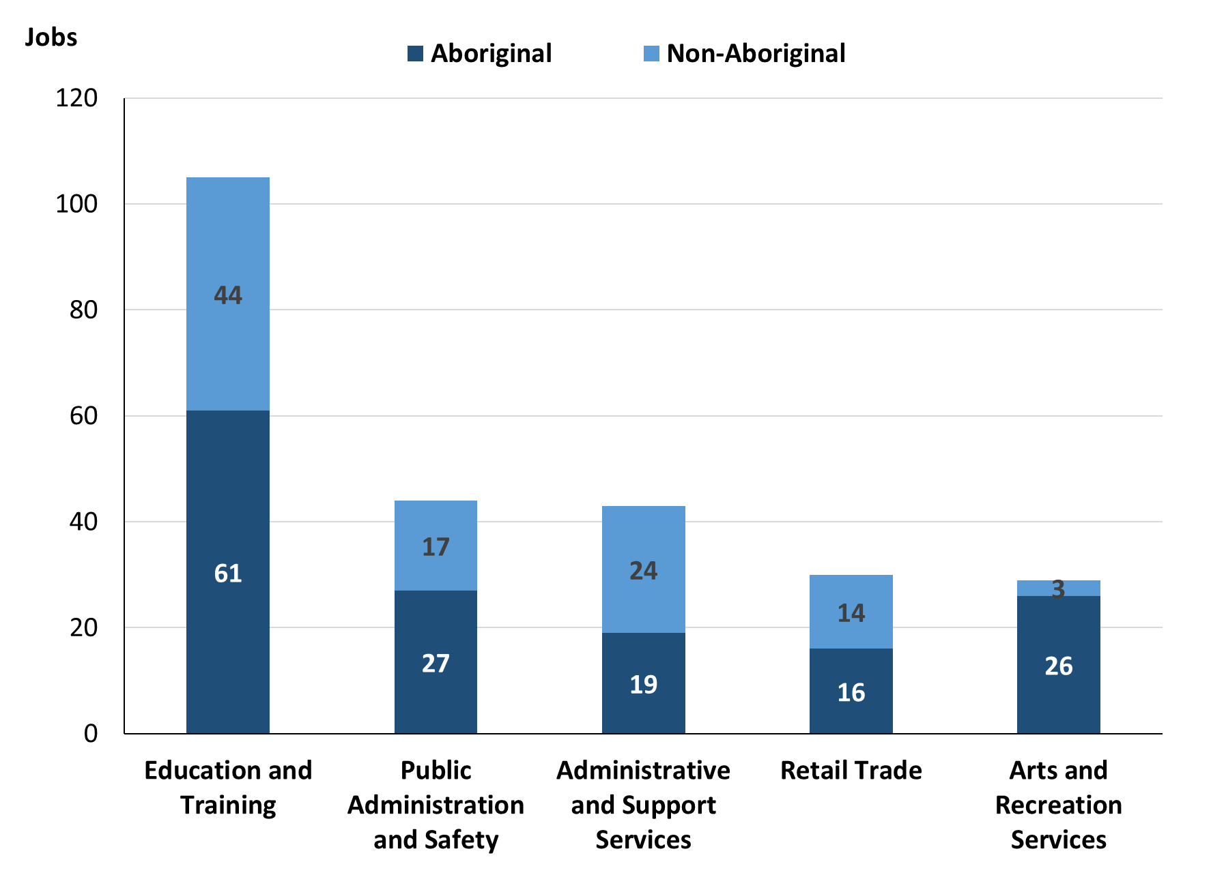

Source: Northern Territory Department of Industry, Tourism and Trade

In 2023 in Maningrida:

* of the 190 **jobs filled** by **Aboriginal** people, there were:
* 61 jobs in Education and Training, an increase of 31 jobs from 2017 and an increase of 32 jobs from 2014
* 27 jobs in Public Administration and Safety, a decrease of 6 jobs from 2017 and a decrease of 120 jobs from 2014
* 26 jobs in Arts and Recreation Services, a decrease of 4 jobs from 2017 and an increase of 26 jobs from 2014
* of the 117 **jobs filled** by **non-Aboriginal** people, there were:
* 44 jobs in Education and Training, a decrease of 8 jobs from 2017 and a decrease of 13 jobs from 2014
* 24 jobs in Administrative and Support Services, an increase of 2 jobs from 2017 and an increase of 24 jobs from 2014
* 17 jobs in Public Administration and Safety, a decrease of 4 jobs from 2017 and a decrease of 32 jobs from 2014.

Table 12: Count of filled jobs by industry and employment status, 2011 (a)(c)(e)(h)

|  |  |  |  |  |  |  |  |  |  |
| --- | --- | --- | --- | --- | --- | --- | --- | --- | --- |
| **Industry (ANZSIC division)** | **2011** | | | | | | | | |
| **Aboriginal** | | | **Non-Aboriginal** | | | **Total** | | |
| **Perm** | **Temp** | **Total** | **Perm** | **Temp** | **Total** | **Perm** | **Temp** | **Total** |
| Construction | 1 | 0 | **1** | 1 | 0 | **1** | 2 | 0 | **2** |
| Education and Training | 11 | 3 | **14** | 18 | 35 | **53** | 29 | 38 | **67** |
| Financial and Insurance Services | 2 | 0 | **2** | 0 | 0 | **0** | 2 | 0 | **2** |
| Health Care and Social Assistance | 6 | 8 | **14** | 2 | 7 | **9** | 8 | 15 | **23** |
| Public Administration and Safety | 108 | 18 | **126** | 46 | 16 | **62** | 154 | 34 | **188** |
| Retail Trade | 4 | 0 | **4** | 0 | 0 | **0** | 4 | 0 | **4** |
| **Total** | **132** | **29** | **161** | **67** | **58** | **125** | **199** | **87** | **286** |

Source: Northern Territory Department of Industry, Tourism and Trade

Table 13: Count of filled jobs by industry and employment status, 2014 (a)(c)(e)(h)

|  |  |  |  |  |  |  |  |  |  |
| --- | --- | --- | --- | --- | --- | --- | --- | --- | --- |
| **Industry (ANZSIC division)** | **2014** | | | | | | | | |
| **Aboriginal** | | | **Non-Aboriginal** | | | **Total** | | |
| **Perm** | **Temp** | **Total** | **Perm** | **Temp** | **Total** | **Perm** | **Temp** | **Total** |
| Accommodation and Food Services | 8 | 8 | **16** | 0 | 2 | **2** | 8 | 10 | **18** |
| Construction | 1 | 1 | **2** | 1 | 4 | **5** | 2 | 5 | **7** |
| Education and Training | 6 | 23 | **29** | 46 | 11 | **57** | 52 | 34 | **86** |
| Financial and Insurance Services | 2 | 0 | **2** | 0 | 0 | **0** | 2 | 0 | **2** |
| Health Care and Social Assistance | 18 | 0 | **18** | 23 | 0 | **23** | 41 | 0 | **41** |
| Public Administration and Safety | 133 | 14 | **147** | 43 | 6 | **49** | 176 | 20 | **196** |
| Rental, Hiring and Real Estate Services | 5 | 0 | **5** | 1 | 0 | **1** | 6 | 0 | **6** |
| Retail Trade | 15 | 8 | **23** | 9 | 10 | **19** | 24 | 18 | **42** |
| **Total** | **188** | **54** | **242** | **123** | **33** | **156** | **311** | **87** | **398** |

Source: Northern Territory Department of Industry, Tourism and Trade

Table 14: Count of filled jobs by industry and employment status, 2017 (a)(c)(e)(h)

|  |  |  |  |  |  |  |  |  |  |
| --- | --- | --- | --- | --- | --- | --- | --- | --- | --- |
| **Industry (ANZSIC division)** | **2017** | | | | | | | | |
| **Aboriginal** | | | **Non-Aboriginal** | | | **Total** | | |
| **Perm** | **Temp** | **Total** | **Perm** | **Temp** | **Total** | **Perm** | **Temp** | **Total** |
| Accommodation and Food Services | 0 | 1 | **1** | 2 | 4 | **6** | 2 | 5 | **7** |
| Administrative and Support Services | 43 | 27 | **70** | 19 | 3 | **22** | 62 | 30 | **92** |
| Agriculture, Forestry and Fishing | 0 | 4 | **4** | 0 | 0 | **0** | 0 | 4 | **4** |
| Arts and Recreation Services | 17 | 13 | **30** | 5 | 0 | **5** | 22 | 13 | **35** |
| Construction | 3 | 10 | **13** | 10 | 11 | **21** | 13 | 21 | **34** |
| Education and Training | 25 | 5 | **30** | 36 | 16 | **52** | 61 | 21 | **82** |
| Financial and Insurance Services | 2 | 0 | **2** | 0 | 0 | **0** | 2 | 0 | **2** |
| Health Care and Social Assistance | 8 | 14 | **22** | 13 | 18 | **31** | 21 | 32 | **53** |
| Public Administration and Safety | 10 | 23 | **33** | 17 | 4 | **21** | 27 | 27 | **54** |
| Retail Trade | 15 | 24 | **39** | 14 | 7 | **21** | 29 | 31 | **60** |
| **Total** | **123** | **121** | **244** | **116** | **63** | **179** | **239** | **184** | **423** |

Source: Northern Territory Department of Industry, Tourism and Trade

Table 15: Count of filled jobs by industry and employment status, 2023 (a)(c)(e)(h)

|  |  |  |  |  |  |  |  |  |  |
| --- | --- | --- | --- | --- | --- | --- | --- | --- | --- |
| **Industry (ANZSIC division)** | **2023** | | | | | | | | |
| **Aboriginal** | | | **Non-Aboriginal** | | | **Total** | | |
| **Perm** | **Temp** | **Total** | **Perm** | **Temp** | **Total** | **Perm** | **Temp** | **Total** |
| Accommodation and Food Services | 0 | 0 | **0** | 1 | 0 | **1** | 1 | 0 | **1** |
| Administrative and Support Services | 19 | 0 | **19** | 24 | 0 | **24** | 43 | 0 | **43** |
| Agriculture, Forestry and Fishing | 0 | 1 | **1** | 0 | 0 | **0** | 0 | 1 | **1** |
| Arts and Recreation Services | 18 | 8 | **26** | 3 | 0 | **3** | 21 | 8 | **29** |
| Construction | 5 | 0 | **5** | 9 | 0 | **9** | 14 | 0 | **14** |
| Education and Training | 12 | 49 | **61** | 18 | 26 | **44** | 30 | 75 | **105** |
| Financial and Insurance Services | 5 | 0 | **5** | 0 | 0 | **0** | 5 | 0 | **5** |
| Health Care and Social Assistance | 11 | 0 | **11** | 0 | 0 | **0** | 11 | 0 | **11** |
| Public Administration and Safety | 14 | 13 | **27** | 14 | 3 | **17** | 28 | 16 | **44** |
| Retail Trade | 15 | 1 | **16** | 13 | 1 | **14** | 28 | 2 | **30** |
| Transport, Postal and Warehousing | 2 | 0 | **2** | 2 | 0 | **2** | 4 | 0 | **4** |
| Other services | 17 | 0 | **17** | 3 | 0 | **3** | 20 | 0 | **20** |
| **Total** | **118** | **72** | **190** | **87** | **30** | **117** | **205** | **102** | **307** |

Source: Northern Territory Department of Industry, Tourism and Trade

In 2023 in Maningrida:

* of the 205 **permanent jobs**, there were:
* 43 jobs in Administrative and Support Services, a decrease of 19 jobs from 2017 and an increase of 43 jobs from 2014, including:
* **Aboriginal** people filled 19 jobs, a decrease of 24 jobs from 2017 and an increase of 19 jobs from 2014
* **non-Aboriginal** people filled 24 jobs, an increase of 5 jobs from 2017 and an increase of 24 jobs from 2014
* 30 jobs in Education and Training, a decrease of 31 jobs from 2017 and a decrease of 22 jobs from 2014, including:
* **Aboriginal** people filled 12 jobs, a decrease of 13 jobs from 2017 and an increase of 6 jobs from 2014
* **non-Aboriginal** people filled 18 jobs, a decrease of 18 jobs from 2017 and a decrease of 28 jobs from 2014
* 28 jobs in Retail Trade, a decrease of 1 job from 2017 and an increase of 4 jobs from 2014, including:
* **Aboriginal** people filled 14 jobs, a decrease of 1 from 2017 and unchanged from 2014
* **non-Aboriginal** people filled 14 jobs, a decrease of 1 job from 2017 and an increase of 4 jobs from 2014
* of the 102 **temporary jobs**, there were:
* 75 jobs in Education and Training, an increase of 54 jobs from 2017 and an increase of 41 jobs from 2014, including:
* **Aboriginal** people filled 49 jobs, an increase of 44 jobs from 2017 and an increase of 26 jobs from 2014
* **non-Aboriginal** people filled 26 jobs, an increase of 10 jobs from 2017 and an increase of 15 jobs from 2014
* 16 jobs in Public Administration and Safety, a decrease of 11 jobs from 2017 and a decrease of 4 jobs from 2014, including:
* **Aboriginal** people filled 13 jobs, a decrease of 10 jobs from 2017 and a decrease of 1 job from 2014
* **non-Aboriginal** people filled 3 jobs, a decrease of 1 job from 2017 and a decrease of 3 jobs from 2014
* 8 jobs in Arts and Recreation Services, a decrease of 5 jobs from 2017 and an increase of 8 jobs from 2014, including:
* **Aboriginal** people filled 8 jobs, a decrease of 5 jobs from 2017 and an increase of 8 jobs from 2014
* **non-Aboriginal** people filled 0 jobs, unchanged from 2017 and unchanged from 2014.

# Jobs by Occupation

Table 16a: Count of filled jobs by occupation, 2011, 2014, 2017 and 2023 (a)(f)(g)

|  |  |  |  |  |  |  |  |  |
| --- | --- | --- | --- | --- | --- | --- | --- | --- |
| **Occupation (ANZSCO major group)** | **2011** | | **2014** | | **2017** | | **2023** | |
| **Total** | **% of Total** | **Total** | **% of Total** | **Total** | **% of Total** | **Total** | **% of Total** |
| Clerical and Administrative Workers | 25 | 8.7% | 63 | 15.8% | 67 | 15.8% | 72 | 23.5% |
| Community and Personal Service Workers | 73 | 25.5% | 84 | 21.1% | 65 | 15.4% | 78 | 25.4% |
| Labourers | 58 | 20.3% | 59 | 14.8% | 66 | 15.6% | 25 | 8.1% |
| Machinery Operators and Drivers | 5 | 1.7% | 13 | 3.3% | 14 | 3.3% | 12 | 3.9% |
| Managers | 3 | 1.0% | 34 | 8.5% | 34 | 8.0% | 14 | 4.6% |
| Professionals | 87 | 30.4% | 108 | 27.1% | 114 | 27.0% | 73 | 23.8% |
| Sales Workers | 26 | 9.1% | 20 | 5.0% | 35 | 8.3% | 6 | 2.0% |
| Technicians and Trades Workers | 6 | 2.1% | 17 | 4.3% | 28 | 6.6% | 27 | 8.8% |
| Other Occupations | 3 | 1.0% | 0 | 0.0% | 0 | 0.0% | 0 | 0.0% |
| **Total** | **286** | **100.0%** | **398** | **100.0%** | **423** | **100.0%** | **307** | **100.0%** |

Source: Northern Territory Department of Industry, Tourism and Trade

Table 16b: Count of filled jobs by occupation, 2011-2014, 2014-2017 and 2017-2023 (a)(f)(g)

|  |  |  |  |
| --- | --- | --- | --- |
| **Occupation (ANZSCO major group)** | **Change 2011-2014** | **Change 2014-2017** | **Change 2017-2023** |
| **Total** | **Total** | **Total** |
| Clerical and Administrative Workers | 38 | 4 | 5 |
| Community and Personal Service Workers | 11 | -19 | 13 |
| Labourers | 1 | 7 | -41 |
| Machinery Operators and Drivers | 8 | 1 | -2 |
| Managers | 31 | 0 | -20 |
| Professionals | 21 | 6 | -41 |
| Sales Workers | -6 | 15 | -29 |
| Technicians and Trades Workers | 11 | 11 | -1 |
| Other Occupations | -3 | 0 | 0 |
| **Total** | **112** | **25** | **-116** |

Source: Northern Territory Department of Industry, Tourism and Trade

Chart 10: Percentage and count of top 6 filled jobs by occupation, 2011, 2014, 2017 & 2023 (a)(f)(g)

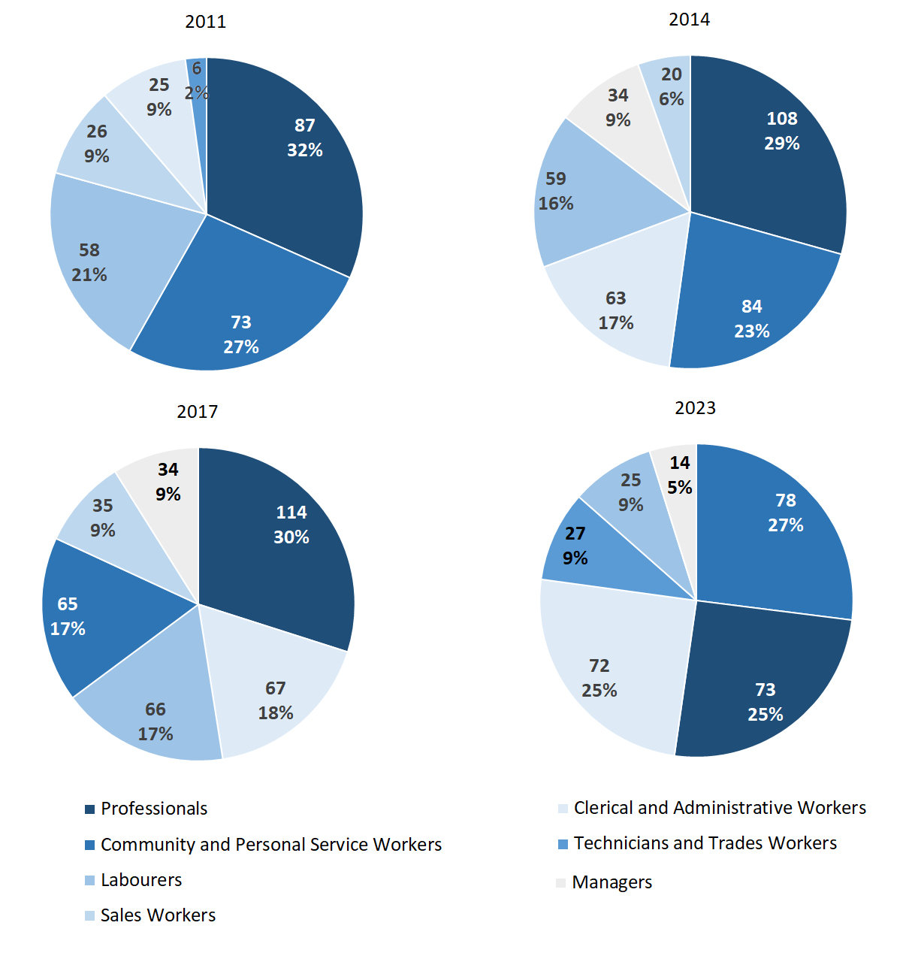Source: Northern Territory Department of Industry, Tourism and Trade

In 2023 in Maningrida:

* Community and Personal Service Workers was the **largest** **occupation** **classification** in terms of filled jobs, accounting for 78 jobs (25.4% of total filled jobs), an increase of 13 jobs from 2017 and a decrease of 6 jobs from 2014
* **other** **significant** occupation classifications were:
* Professionals accounting for 73 jobs or 23.8% of total jobs a decrease of 41 jobs from 2017 and a decrease of 35 jobs from 2014
* Clerical and Administrative Workers accounting for 72 jobs or 23.5% of total jobs an increase of 5 jobs from 2017 and an increase of 9 jobs from 2014
* Technicians and Trades Workers accounting for 27 jobs or 8.8% of total jobs a decrease of 1 job from 2017 and an increase of 10 jobs from 2014.

**Table 17a: Count of filled jobs by ANZSCO occupation, 2011, 2014, 2017 & 2023 (a)(c)(f)(g)**

|  |  |  |  |  |  |  |  |  |  |  |  |  |
| --- | --- | --- | --- | --- | --- | --- | --- | --- | --- | --- | --- | --- |
| **Occupation (ANZSCO major group)** | **2011** | | | **2014** | | | **2017** | | | **2023** | | |
| **Aboriginal** | **Non-Aboriginal** | **Total** | **Aboriginal** | **Non-Aboriginal** | **Total** | **Aboriginal** | **Non-Aboriginal** | **Total** | **Aboriginal** | **Non-Aboriginal** | **Total** |
| Clerical and Administrative Workers | 11 | 14 | **25** | 46 | 17 | **63** | 38 | 29 | **67** | 43 | 29 | **72** |
| Community and Personal Service Workers | 46 | 27 | **73** | 71 | 13 | **84** | 56 | 9 | **65** | 68 | 10 | **78** |
| Labourers | 50 | 8 | **58** | 46 | 13 | **59** | 55 | 11 | **66** | 19 | 6 | **25** |
| Machinery Operators and Drivers | 3 | 2 | **5** | 7 | 6 | **13** | 9 | 5 | **14** | 9 | 3 | **12** |
| Managers | 0 | 3 | **3** | 5 | 29 | **34** | 2 | 32 | **34** | 3 | 11 | **14** |
| Professionals | 33 | 54 | **87** | 46 | 62 | **108** | 51 | 63 | **114** | 27 | 46 | **73** |
| Sales Workers | 13 | 13 | **26** | 15 | 5 | **20** | 31 | 4 | **35** | 6 | 0 | **6** |
| Technicians and Trades Workers | 2 | 4 | **6** | 6 | 11 | **17** | 2 | 26 | **28** | 15 | 12 | **27** |
| Other Occupations | 3 | 0 | **3** | 0 | 0 | **0** | 0 | 0 | **0** | 0 | 0 | **0** |
| **Total** | **161** | **125** | **286** | **242** | **156** | **398** | **244** | **179** | **423** | **190** | **117** | **307** |

Source: Northern Territory Department of Industry, Tourism and Trade

**Table 17b: Count of filled jobs by ANZSCO occupation, 2011-2014, 2014-2017 & 2017-2023 (a)(c)(f)(g)**

|  |  |  |  |  |  |  |  |  |  |  |  |  |
| --- | --- | --- | --- | --- | --- | --- | --- | --- | --- | --- | --- | --- |
| **Occupation (ANZSCO major group)** | **Change 2011-2014** | | | | **Change 2014-2017** | | | | **Change 2017-2023** | | | |
| **Aboriginal** | **Non-Aboriginal** | **Total** | **Aboriginal** | | **Non-Aboriginal** | **Total** | **Aboriginal** | | **Non-Aboriginal** | **Total** |
| Clerical and Administrative Workers | 35 | 3 | **38** | -8 | | 12 | **4** | 5 | | 0 | **5** |
| Community and Personal Service Workers | 25 | -14 | **11** | -15 | | -4 | **-19** | 12 | | 1 | **13** |
| Labourers | -4 | 5 | **1** | 9 | | -2 | **7** | -36 | | -5 | **-41** |
| Machinery Operators and Drivers | 4 | 4 | **8** | 2 | | -1 | **1** | 0 | | -2 | **-2** |
| Managers | 5 | 26 | **31** | -3 | | 3 | **0** | 1 | | -21 | **-20** |
| Professionals | 13 | 8 | **21** | 5 | | 1 | **6** | -24 | | -17 | **-41** |
| Sales Workers | 2 | -8 | **-6** | 16 | | -1 | **15** | -25 | | -4 | **-29** |
| Technicians and Trades Workers | 4 | 7 | **11** | -4 | | 15 | **11** | 13 | | -14 | **-1** |
| Other Occupations | -3 | 0 | **-3** | 0 | | 0 | **0** | 0 | | 0 | **0** |
| **Total** | **81** | **31** | **112** | **2** | | **23** | **25** | **-54** | | **-62** | **-116** |

Source: Northern Territory Department of Industry, Tourism and Trade

In 2023 in Maningrida:

* of the 190 **jobs filled by** **Aboriginal** people, there were:
* 68 Community and Personal Service Workers, an increase of 12 jobs from 2017 and a decrease of 3 jobs from 2014
* 43 Clerical and Administrative Workers, an increase of 5 jobs from 2017 and a decrease of 3 jobs from 2014
* 27 Professionals, a decrease of 24 jobs from 2017 and a decrease of 19 jobs from 2014
* of the 117 **jobs filled by** **non-Aboriginal** people, there were:
* 46 Professionals, a decrease of 17 jobs from 2017 and a decrease of 16 jobs from 2014
* 29 Clerical and Administrative Workers, unchanged from 2017 and an increase of 12 jobs from 2014
* 12 Technicians and Trades Workers, a decrease of 14 jobs from 2017 and an increase of 1 job from 2014.

# Jobs by Industry by Occupation

Table 18: Count of filled jobs by industry by occupation, 2011 (a)(f)(g)(h)

|  |  |  |  |  |  |  |  |  |  |  |
| --- | --- | --- | --- | --- | --- | --- | --- | --- | --- | --- |
| **2011** | | | | | | | | | | |
| **Industry (ANZSIC Division)** |  | **Occupation (ANZSCO major group)** | | | | | | | | |
| **Clerical and Administrative Workers** | **Community and Personal Service Workers** | **Labourers** | **Machinery Operators and Drivers** | **Managers** | **Professionals** | **Sales Workers** | **Technicians and Trades Workers** | **Other Occupations** | **Total** |
| Construction | 1 | 0 | 0 | 0 | 0 | 1 | 0 | 0 | 0 | **2** |
| Education and Training | 6 | 22 | 0 | 0 | 1 | 38 | 0 | 0 | 0 | **67** |
| Financial and Insurance Services | 2 | 0 | 0 | 0 | 0 | 0 | 0 | 0 | 0 | **2** |
| Health Care and Social Assistance | 1 | 2 | 7 | 0 | 0 | 9 | 0 | 1 | 3 | **23** |
| Public Administration and Safety | 15 | 49 | 51 | 3 | 2 | 39 | 24 | 5 | 0 | **188** |
| Retail Trade | 0 | 0 | 0 | 2 | 0 | 0 | 2 | 0 | 0 | **4** |
| **Total** | **25** | **73** | **58** | **5** | **3** | **87** | **26** | **6** | **3** | **286** |

Source: Northern Territory Department of Industry, Tourism and Trade

Table 19: Count of filled jobs by industry by occupation, 2014 (a)(f)(g)(h)

|  |  |  |  |  |  |  |  |  |  |  |
| --- | --- | --- | --- | --- | --- | --- | --- | --- | --- | --- |
| **2014** | | | | | | | | | | |
| **Industry (ANZSIC Division)** |  | **Occupation (ANZSCO major group)** | | | | | | | | |
| **Clerical and Administrative Workers** | **Community and Personal Service Workers** | **Labourers** | **Machinery Operators and Drivers** | **Managers** | **Professionals** | **Sales Workers** | **Technicians and Trades Workers** | **Other Occupations** | **Total** |
| Accommodation and Food Services | 0 | 0 | 7 | 2 | 1 | 0 | 2 | 6 | 0 | **18** |
| Construction | 0 | 0 | 0 | 0 | 7 | 0 | 0 | 0 | 0 | **7** |
| Education and Training | 2 | 25 | 6 | 0 | 4 | 49 | 0 | 0 | 0 | **86** |
| Financial and Insurance Services | 2 | 0 | 0 | 0 | 0 | 0 | 0 | 0 | 0 | **2** |
| Health Care and Social Assistance | 2 | 19 | 4 | 0 | 3 | 13 | 0 | 0 | 0 | **41** |
| Public Administration and Safety | 55 | 40 | 32 | 1 | 12 | 45 | 0 | 11 | 0 | **196** |
| Rental, Hiring and Real Estate Services | 0 | 0 | 1 | 0 | 1 | 0 | 4 | 0 | 0 | **6** |
| Retail Trade | 2 | 0 | 9 | 10 | 6 | 1 | 14 | 0 | 0 | **42** |
| **Total** | **63** | **84** | **59** | **13** | **34** | **108** | **20** | **17** | **0** | **398** |

Source: Northern Territory Department of Industry, Tourism and Trade

Table 20: Count of filled jobs by occupation and by industry, 2017 (a)(f)(g)(h)

|  |  |  |  |  |  |  |  |  |  |  |
| --- | --- | --- | --- | --- | --- | --- | --- | --- | --- | --- |
| **2017** | | | | | | | | | | |
| **Industry (ANZSIC Division)** |  | **Occupation (ANZSCO major group)** | | | | | | | | |
| **Clerical and Administrative Workers** | **Community and Personal Service Workers** | **Labourers** | **Machinery Operators and Drivers** | **Managers** | **Professionals** | **Sales Workers** | **Technicians and Trades Workers** | **Other Occupations** | **Total** |
| Accommodation and Food Services | 0 | 0 | 3 | 0 | 2 | 0 | 0 | 2 | 0 | **7** |
| Administrative and Support Services | 36 | 15 | 11 | 5 | 7 | 12 | 2 | 4 | 0 | **92** |
| Agriculture, Forestry and Fishing | 0 | 0 | 4 | 0 | 0 | 0 | 0 | 0 | 0 | **4** |
| Arts and Recreation Services | 1 | 0 | 0 | 1 | 2 | 31 | 0 | 0 | 0 | **35** |
| Construction | 1 | 0 | 13 | 0 | 4 | 0 | 0 | 16 | 0 | **34** |
| Education and Training | 7 | 21 | 3 | 0 | 5 | 46 | 0 | 0 | 0 | **82** |
| Financial and Insurance Services | 2 | 0 | 0 | 0 | 0 | 0 | 0 | 0 | 0 | **2** |
| Health Care and Social Assistance | 9 | 18 | 2 | 0 | 4 | 20 | 0 | 0 | 0 | **53** |
| Public Administration and Safety | 7 | 11 | 24 | 0 | 2 | 4 | 0 | 6 | 0 | **54** |
| Retail Trade | 4 | 0 | 6 | 8 | 8 | 1 | 33 | 0 | 0 | **60** |
| **Total** | **67** | **65** | **66** | **14** | **34** | **114** | **35** | **28** | **0** | **423** |

Source: Northern Territory Department of Industry, Tourism and Trade

Table 21: Count of filled jobs by occupation and by industry, 2023 (a)(f)(g)(h)

|  |  |  |  |  |  |  |  |  |  |  |
| --- | --- | --- | --- | --- | --- | --- | --- | --- | --- | --- |
| **2023** | | | | | | | | | | |
| **Industry (ANZSIC Division)** |  | **Occupation (ANZSCO major group)** | | | | | | | | |
| **Clerical and Administrative Workers** | **Community and Personal Service Workers** | **Labourers** | **Machinery Operators and Drivers** | **Managers** | **Professionals** | **Sales Workers** | **Technicians and Trades Workers** | **Other Occupations** | **Total** |
| Accommodation and Food Services | 0 | 0 | 1 | 0 | 0 | 0 | 0 | 0 | 0 | **1** |
| Administrative and Support Services | 25 | 0 | 0 | 0 | 3 | 15 | 0 | 0 | 0 | **43** |
| Agriculture, Forestry and Fishing | 0 | 0 | 1 | 0 | 0 | 0 | 0 | 0 | 0 | **1** |
| Arts and Recreation Services | 9 | 12 | 0 | 0 | 0 | 8 | 0 | 0 | 0 | **29** |
| Construction | 1 | 0 | 0 | 0 | 0 | 1 | 0 | 12 | 0 | **14** |
| Education and Training | 15 | 40 | 11 | 0 | 0 | 36 | 0 | 3 | 0 | **105** |
| Financial and Insurance Services | 5 | 0 | 0 | 0 | 0 | 0 | 0 | 0 | 0 | **5** |
| Health Care and Social Assistance | 0 | 11 | 0 | 0 | 0 | 0 | 0 | 0 | 0 | **11** |
| Public Administration and Safety | 14 | 15 | 2 | 1 | 3 | 4 | 0 | 5 | 0 | **44** |
| Retail Trade | 2 | 0 | 0 | 6 | 6 | 4 | 6 | 6 | 0 | **30** |
| Transport, Postal and Warehousing | 0 | 0 | 4 | 0 | 0 | 0 | 0 | 0 | 0 | **4** |
| Other services | 1 | 0 | 6 | 5 | 2 | 5 | 0 | 1 | 0 | **20** |
| **Total** | **72** | **78** | **25** | **12** | **14** | **73** | **6** | **27** | **0** | **307** |

Source: Northern Territory Department of Industry, Tourism and Trade

In 2023 in Maningrida:

* Community and Personal Service Workers accounted for 78 jobs (the largest occupation group) were shared across the Education and Training with 40 jobs, Public Administration and Safety had 15 jobs, Arts and Recreation Services had 12 jobs and Health Care and Social Assistance industries had 11 jobs,
* Professional jobs had the majority (the 2nd largest occupation group with 73 jobs) which were shared across the Education and Training sector with 36 jobs and Administrative and Support Services industries with 15 jobs,
* Education and Training (the largest industry with 105 jobs), where there were 40 filled jobs in the Community and Personal Service Workers occupation group followed by 36 filled jobs in Professionals occupation group,
* Administrative and Support Services and Health Care and Social Assistance showed a decrease in filled jobs of 49 jobs and 42 jobs respectively between 2023 and 2017
* Transport, Postal and Warehousing was a new industry in 2023 with 4 filled jobs; this industry had no jobs filled in 2017.

# Jobs by Gender

Table 22a: Count of filled jobs by gender[2], 2011, 2014, 2017 & 2023 (a)(c)(i)

|  |  |  |  |  |  |  |  |  |  |  |  |  |  |  |  |  |
| --- | --- | --- | --- | --- | --- | --- | --- | --- | --- | --- | --- | --- | --- | --- | --- | --- |
| **Indicator** | **2011** | | | | **2014** | | | | **2017** | | | | **2023** | | | |
| **Aboriginal** | **Non-Aboriginal** | **Total** | **Aboriginal** | | **Non-Aboriginal** | **Total** | **Aboriginal** | | **Non-Aboriginal** | **Total** | **Aboriginal** | | **Non-Aboriginal** | **Total** |
| Male | 92 | 52 | **144** | 151 | | 78 | **229** | 136 | | 92 | **228** | 94 | | 50 | **144** |
| Female | 68 | 73 | **141** | 91 | | 78 | **169** | 102 | | 87 | **189** | 96 | | 66 | **162** |
| **Total** | **161** | **125** | **286** | **242** | | **156** | **398** | **238** | | **179** | **417** | **190** | | **117** | **307** |

Source: Northern Territory Department of Industry, Tourism and Trade

Table 22b: Count of filled jobs by gender, 2011-2014, 2014-2017 & 2017-2023 (a)(c)(i)

|  |  |  |  |  |  |  |  |  |  |
| --- | --- | --- | --- | --- | --- | --- | --- | --- | --- |
| **Indicator** | **2011-2014 Change** | | | **2014-2017 Change** | | | **2017-2023 Change** | | |
| **Aboriginal** | **Non-Aboriginal** | **Total** | **Aboriginal** | **Non-Aboriginal** | **Total** | **Aboriginal** | **Non-Aboriginal** | **Total** |
| Male | 59 | 26 | **85** | -15 | 14 | **-1** | -42 | -42 | **-84** |
| Female | 23 | 5 | **28** | 11 | 9 | **20** | -6 | -21 | **-27** |
| **Total** | **81** | **31** | **112** | **-4** | **23** | **19** | **-48** | **-62** | **-110** |

Source: Northern Territory Department of Industry, Tourism and Trade

Chart 11: Count of filled jobs by gender, 2011, 2014, 2017 & 2023 (a)(c)(i)

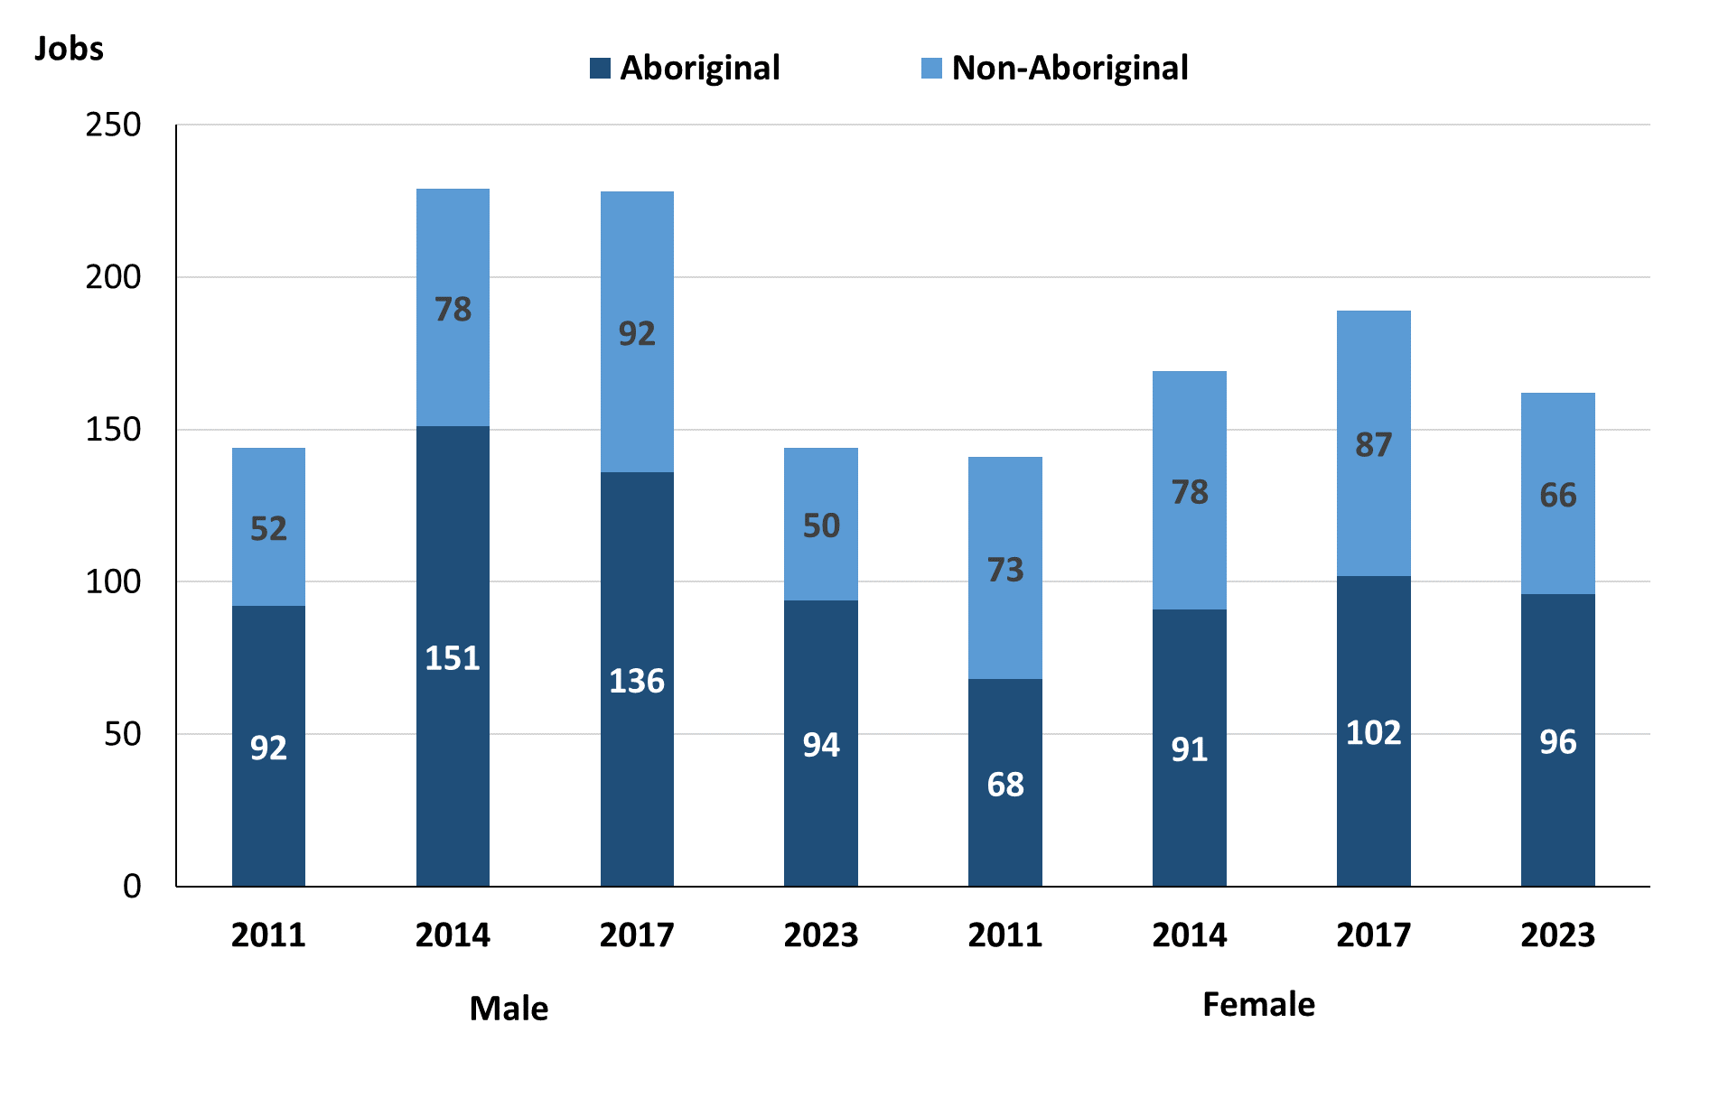

Source: Northern Territory Department of Industry, Tourism and Trade

In 2023 in Maningrida:

* there were 144 job**s** **filled** **by** **males**, a decrease of 84 jobs from 2017 and a decrease of 85 jobs from 2014
* of the 144 jobs **filled** by **males**:
* 94 were **Aboriginal**, a decrease of 42 jobs from 2017 and a decrease of 57 jobs from 2014
* 50 were **non-Aboriginal**, a decrease of 42 jobs from 2017 and a decrease of 28 jobs from 2014
* there were 162 **jobs** **filled** **by** **females**, a decrease of 27 jobs from 2017 and a decrease of 7 jobs from 2014
* of the 162 jobs **filled** by **females:**
* 96 were **Aboriginal**, a decrease of 6 jobs from 2017 and an increase of 5 jobs from 2014
* 66 were **non-Aboriginal**, a decrease of 21 jobs from 2017 and a decrease of 12 jobs from 2014.

Table 23: Count of filled jobs by gender, by full-time/part-time status, by job permanency and by sector 2011 (a)(b)(c)(d)(e)(i)

|  |  |  |  |  |  |  |  |  |  |  |
| --- | --- | --- | --- | --- | --- | --- | --- | --- | --- | --- |
| **2011** | | | | | | | | | | |
| **Indicator** | **Male** | | | **Female** | | | **Total** | | | |
| **Aboriginal** | **Non-Aboriginal** | **Total** | **Aboriginal** | **Non-Aboriginal** | **Total** | **Aboriginal** | **Non-Aboriginal** | **Total** |
| Full-time | 70 | 48 | **118** | 50 | 63 | **113** | 121 | 111 | **232** |
| Part-time | 22 | 4 | **26** | 18 | 10 | **28** | 40 | 14 | **54** |
| **Total** | **92** | **52** | **144** | **68** | **73** | **141** | **161** | **125** | **286** |
| Permanent | 78 | 26 | **104** | 54 | 41 | **95** | 132 | 67 | **199** |
| Temporary | 14 | 26 | **40** | 14 | 32 | **46** | 29 | 58 | **87** |
| **Total** | **92** | **52** | **144** | **68** | **73** | **141** | **161** | **125** | **286** |
| Public Sector | 32 | 37 | **69** | 19 | 48 | **67** | 52 | 85 | **137** |
| Private Sector | 60 | 15 | **75** | 49 | 25 | **74** | 109 | 40 | **149** |
| **Total** | **92** | **52** | **144** | **68** | **73** | **141** | **161** | **125** | **286** |

Source: Northern Territory Department of Industry, Tourism and Trade

Table 24: Count of filled jobs by gender, by full-time/part-time status, by job permanency and by sector 2014 (a)(b)(c)(d)(e)(i)

|  |  |  |  |  |  |  |  |  |  |
| --- | --- | --- | --- | --- | --- | --- | --- | --- | --- |
| **2014** | | | | | | | | | |
| **Indicator** | **Male** | | | **Female** | | | **Total** | | |
| **Aboriginal** | **Non-Aboriginal** | **Total** | **Aboriginal** | **Non-Aboriginal** | **Total** | **Aboriginal** | **Non-Aboriginal** | **Total** |
| Full-time | 102 | 74 | **176** | 44 | 76 | **120** | 146 | 150 | **296** |
| Part-time | 49 | 4 | **53** | 47 | 2 | **49** | 96 | 6 | **102** |
| **Total** | **151** | **78** | **229** | **91** | **78** | **169** | **242** | **156** | **398** |
| Permanent | 132 | 60 | **192** | 56 | 63 | **119** | 188 | 123 | **311** |
| Temporary | 19 | 18 | **37** | 35 | 15 | **50** | 54 | 33 | **87** |
| **Total** | **151** | **78** | **229** | **91** | **78** | **169** | **242** | **156** | **398** |
| Public Sector | 31 | 39 | **70** | 34 | 56 | **90** | 65 | 95 | **160** |
| Private Sector | 120 | 39 | **159** |  | 22 | **79** | 177 | 61 | **238** |
| **Total** | **151** | **78** | **229** | **91** | **78** | **169** | **242** | **156** | **398** |

Source: Northern Territory Department of Industry, Tourism and Trade

Table 25: Count of filled jobs by gender[3], by full-time/part-time status, by job permanency and by sector 2017 (a)(b)(c)(d)(e)(i)

|  |  |  |  |  |  |  |  |  |  |
| --- | --- | --- | --- | --- | --- | --- | --- | --- | --- |
| **2017** | | | | | | | | | |
| **Indicator** | **Male** | | | **Female** | | | **Total** | | |
| **Aboriginal** | **Non-Aboriginal** | **Total** | **Aboriginal** | **Non-Aboriginal** | **Total** | **Aboriginal** | **Non-Aboriginal** | **Total** |
| Full-time | 60 | 92 | **152** | 44 | 83 | **127** | 110 | 175 | **285** |
| Part-time | 76 | 0 | **76** | 58 | 4 | **62** | 134 | 4 | **138** |
| **Total** | **136** | **92** | **228** | **102** | **87** | **189** | **244** | **179** | **423** |
| Permanent | 60 | 59 | **119** | 57 | 57 | **114** | 123 | 116 | **239** |
| Temporary | 76 | 33 | **109** | 45 | 30 | **75** | 121 | 63 | **184** |
| **Total** | **136** | **92** | **228** | **102** | **87** | **189** | **244** | **179** | **423** |
| Public Sector | 32 | 38 | **70** | 31 | 58 | **89** | 69 | 96 | **165** |
| Private Sector | 104 | 54 | **158** | 71 | 29 | **100** | 175 | 83 | **258** |
| **Total** | **136** | **92** | **228** | **102** | **87** | **189** | **244** | **179** | **423** |

Source: Northern Territory Department of Industry, Tourism and Trade

Table 26: Count of filled jobs by gender, by full-time/part-time status, by job permanency and by sector 2023 (a)(b)(c)(d)(e)(i)

|  |  |  |  |  |  |  |  |  |  |
| --- | --- | --- | --- | --- | --- | --- | --- | --- | --- |
| **2023** | | | | | | | | | |
| **Indicator** | **Male** | | | **Female** | | | **Total** | | |
| **Aboriginal** | **Non-Aboriginal** | **Total** | **Aboriginal** | **Non-Aboriginal** | **Total** | **Aboriginal** | **Non-Aboriginal** | **Total** |
| Full-time | 71 | 50 | **121** | 61 | 62 | **123** | 132 | 113 | **245** |
| Part-time | 23 | 0 | **23** | 35 | 4 | **39** | 58 | 4 | **62** |
| **Total** | **94** | **50** | **144** | **96** | **66** | **162** | **190** | **117** | **307** |
| Permanent | 69 | 38 | **107** | 49 | 49 | **98** | 118 | 87 | **205** |
| Temporary | 25 | 12 | **37** | 47 | 17 | **64** | 72 | 30 | **102** |
| **Total** | **94** | **50** | **144** | **96** | **66** | **162** | **190** | **117** | **307** |
| Public Sector | 33 | 22 | **55** | 52 | 36 | **88** | 85 | 59 | **144** |
| Private Sector | 61 | 28 | **89** | 44 | 30 | **74** | 105 | 58 | **163** |
| **Total** | **94** | **50** | **144** | **96** | **66** | **162** | **190** | **117** | **307** |

Source: Northern Territory Department of Industry, Tourism and Trade

In 2023 in Maningrida:

* of the 144 **jobs** **filled** **by** **males,** there were:
* 94 jobs filled by **Aboriginal males**, a decrease of 42 jobs from 2017 and a decrease of 57 jobs from 2014, including:
* 71 full-time jobs, an increase of 11 jobs from 2017 and a decrease of 31 jobs from 2014
* 23 part-time jobs, a decrease of 53 jobs from 2017 and a decrease of 26 jobs from 2014
* 69 permanent jobs, an increase of 9 jobs from 2017 and a decrease of 63 jobs from 2014
* 25 temporary jobs, a decrease of 51 jobs from 2017 and an increase of 6 jobs from 2014
* 33 Public Sector jobs, an increase of 1 job from 2017 and an increase of 2 jobs from 2014
* 61 Private Sector jobs, a decrease of 43 jobs from 2017 and a decrease of 59 jobs from 2014
* 50 jobs filled by **non-Aboriginal males**, a decrease of 42 jobs from 2017 and a decrease of 28 jobs from 2014, including:
* 50 full-time jobs, a decrease of 42 jobs from 2017 and a decrease of 24 jobs from 2014
* none were part-time jobs, unchanged from 2017 and a decrease of 4 jobs from 2014
* 38 permanent jobs, a decrease of 21 jobs from 2017 and a decrease of 22 jobs from 2014
* 12 temporary jobs, a decrease of 21 jobs from 2017 and a decrease of 6 jobs from 2014
* 22 Public Sector jobs, a decrease of 16 jobs from 2017 and a decrease of 17 jobs from 2014
* 28 Private Sector jobs, a decrease of 26 jobs from 2017 and a decrease of 11 jobs from 2014
* of the 162 **jobs** **filled** **by** **females**, there were:
* 96 jobs filled by **Aboriginal females**, a decrease of 6 jobs from 2017 and an increase of 5 jobs from 2014, including:
* 61 full-time jobs, an increase of 17 jobs from 2017 and an increase of 17 jobs from 2014
* 35 part-time jobs, a decrease of 23 jobs from 2017 and a decrease of 12 jobs from 2014
* 49 permanent jobs, a decrease of 8 jobs from 2017 and a decrease of 7 jobs from 2014
* 47 temporary jobs, an increase of 2 jobs from 2017 and an increase of 12 jobs from 2014
* 52 Public Sector jobs, an increase of 21 jobs from 2017 and an increase of 18 jobs from 2014
* 44 Private Sector jobs, a decrease of 27 jobs from 2017 and a decrease of 13 jobs from 2014
* 66 jobs filled by **non-Aboriginal females**, a decrease of 21 jobs from 2017 and a decrease of 12 jobs from 2014, including:
* 62 full-time jobs, a decrease of 21 jobs from 2017 and a decrease of 14 jobs from 2014
* 4 part-time jobs, unchanged from 2017 and an increase of 2 jobs from 2014
* 49 permanent jobs, a decrease of 8 jobs from 2017 and a decrease of 14 jobs from 2014
* 17 temporary jobs, a decrease of 13 jobs from 2017 and an increase of 2 jobs from 2014
* 36 Public Sector jobs, a decrease of 22 jobs from 2017 and a decrease of 20 jobs from 2014
* 30 Private Sector jobs, an increase of 1 job from 2017 and an increase of 8 jobs from 2014.

# Jobs by Age

Table 27a: Count of filled jobs by age, 2011, 2014, 2017 & 2023 (a)(c)(j)

|  |  |  |  |  |  |  |  |  |  |  |  |  |  |
| --- | --- | --- | --- | --- | --- | --- | --- | --- | --- | --- | --- | --- | --- |
| **Indicator** | **2011** | | | **2014** | | | **2017** | | | **2023** | | | |
| **Aboriginal** | **Non-Aboriginal** | **Total** | **Aboriginal** | **Non-Aboriginal** | **Total** | **Aboriginal** | **Non-Aboriginal** | **Total** | **Aboriginal** | **Non-Aboriginal** | **Total** |
| 15-24 years | 20 | 3 | **23** | 22 | 6 | **28** | 35 | 5 | **40** | 23 | 4 | **27** |
| 25-44 years | 86 | 54 | **140** | 192 | 92 | **284** | 126 | 93 | **219** | 115 | 62 | **177** |
| 45+ years | 54 | 68 | **122** | 28 | 58 | **86** | 77 | 81 | **158** | 50 | 51 | **101** |
| **Total** | **161** | **125** | **286** | **242** | **156** | **398** | **244** | **179** | **423** | **190** | **117** | **307** |

Source: Northern Territory Department of Industry, Tourism and Trade

Table 27b: Count of filled jobs by age, 2011-2014, 2014-2017 & 2017-2023 (a)(c)(j)

|  |  |  |  |  |  |  |  |  |  |
| --- | --- | --- | --- | --- | --- | --- | --- | --- | --- |
| **Indicator** | **Change 2011-2014** | | | **Change 2014-2017** | | | **Change 2017-2023** | | |
| **Aboriginal** | **Non-Aboriginal** | **Total** | **Aboriginal** | **Non-Aboriginal** | **Total** | **Aboriginal** | **Non-Aboriginal** | **Total** |
| 15-24 years | 2 | 3 | **5** | 13 | -1 | **12** | -12 | -1 | **-13** |
| 25-44 years | 106 | 38 | **144** | -66 | 1 | **-65** | -11 | -31 | **-42** |
| 45+ years | -26 | -10 | **-36** | 49 | 23 | **72** | -27 | -30 | **-57** |
| **Total** | **81** | **31** | **112** | **2** | **23** | **25** | **-48** | **-62** | **-110** |

Source: Northern Territory Department of Industry, Tourism and Trade

Chart 12: Count of filled jobs by age, 2011, 2014, 2017 & 2023 (a)(c)(j)

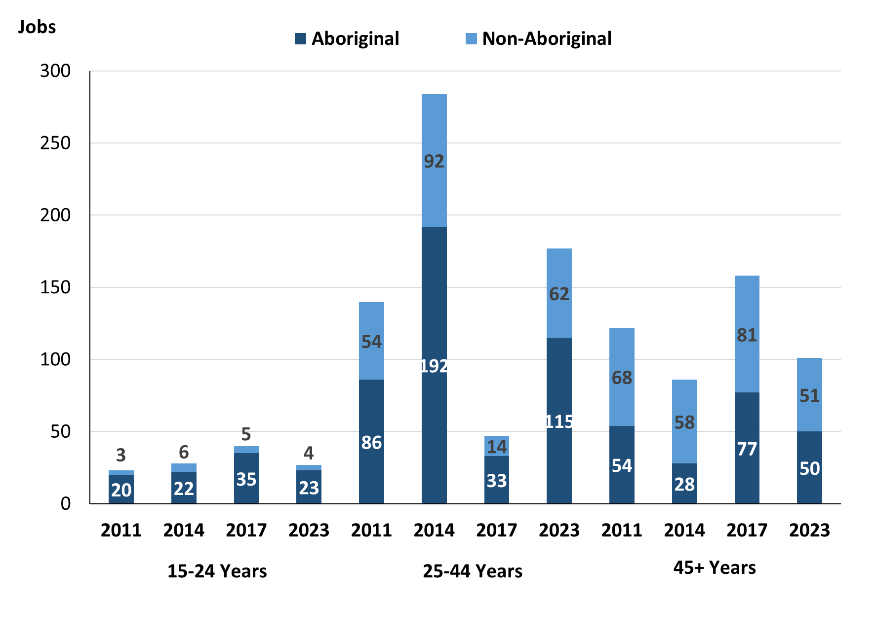

Source: Northern Territory Department of Industry, Tourism and Trade

In 2023 in Maningrida:

* there were 27 **jobs** **filled** by people aged **15-24 years**, a decrease of 13 jobs from 2017 and a decrease of 1 job from 2014. Of these:
* **Aboriginal** people filled 23 jobs, a decrease of 12 jobs from 2017 and an increase of 1 job from 2014
* **non-Aboriginal** people filled 4 jobs, a decrease of 1 job from 2017 and a decrease of 2 jobs from 2014
* there were 177 **jobs** **filled** by people aged **25-44 years**, an increase of 130 jobs from 2017 and a decrease of 107 jobs from 2014. Of these:
* **Aboriginal** people filled 115 jobs, an increase of 82 jobs from 2017 and a decrease of 77 jobs from 2014
* **non-Aboriginal** people filled 62 jobs, an increase of 48 jobs from 2017 and a decrease of 30 jobs from 2014
* there were 101 **jobs** **filled** by people aged **45+ years**, a decrease of 57 jobs from 2017 and an increase of 15 jobs from 2014. Of these:
* **Aboriginal** people filled 50 jobs, a decrease of 27 jobs from 2017 and an increase of 22 jobs from 2014
* **non-Aboriginal** people filled 51 jobs, a decrease of 30 jobs from 2017 and a decrease of 7 jobs from 2014.

Table 28: Count of filled jobs by age, by full-time/part-time status, by job permanency and by sector June-July 2011 (a)(b)(c)(d)(e)(i)

|  |  |  |  |  |  |  |  |  |  |  |  |  |  |
| --- | --- | --- | --- | --- | --- | --- | --- | --- | --- | --- | --- | --- | --- |
| **2011** | | | | | | | | | | | | | |
| **Indicator** | **15-24 years** | | | **25-44 years** | | | **45+ years** | | | **Total** | | | |
| **Aboriginal** | **Non-Aboriginal** | **Total** | **Aboriginal** | **Non-Aboriginal** | **Total** | **Aboriginal** | **Non-Aboriginal** | **Total** | **Aboriginal** | **Non-Aboriginal** | **Total** |
| Full-time | 11 | 3 | **14** | 64 | 46 | **110** | 45 | 62 | **107** | 121 | 111 | **232** |
| Part-time | 9 | 0 | **9** | 22 | 8 | **30** | 9 | 6 | **15** | 40 | 14 | **54** |
| **Total** | **20** | **3** | **23** | **86** | **54** | **140** | **54** | **68** | **122** | **161** | **125** | **286** |
| Permanent | 17 | 1 | **18** | 71 | 26 | **97** | 44 | 40 | **84** | 132 | 67 | **199** |
| Temporary | 3 | 2 | **5** | 15 | 28 | **43** | 10 | 28 | **38** | 29 | 58 | **87** |
| **Total** | **20** | **3** | **23** | **86** | **54** | **140** | **54** | **68** | **122** | **161** | **125** | **286** |
| Public Sector | 2 | 3 | **5** | 30 | 41 | **71** | 19 | 41 | **60** | 52 | 85 | **137** |
| Private Sector | 18 | 0 | **18** | 56 | 13 | **69** | 35 | 27 | **62** | 109 | 40 | **149** |
| **Total** | **20** | **3** | **23** | **86** | **54** | **140** | **54** | **68** | **122** | **161** | **125** | **286** |

Source: Northern Territory Department of Industry, Tourism and Trade

Table 29: Count of filled jobs by age, by full-time/part-time status, by job permanency and by sector June-July 2014 (a)(b)(c)(d)(e)(i)

|  |  |  |  |  |  |  |  |  |  |  |  |  |  |
| --- | --- | --- | --- | --- | --- | --- | --- | --- | --- | --- | --- | --- | --- |
| **2014** | | | | | | | | | | | | | |
| **Indicator** | **15-24 years** | | | **25-44 years** | | | **45+ years** | | | **Total** | | | |
| **Aboriginal** | **Non-Aboriginal** | **Total** | **Aboriginal** | **Non-Aboriginal** | **Total** | **Aboriginal** | **Non-Aboriginal** | **Total** | **Aboriginal** | **Non-Aboriginal** | **Total** |
| Full-time | 12 | 6 | **18** | 111 | 88 | **199** | 23 | 56 | **79** | 146 | 150 | **296** |
| Part-time | 10 | 0 | **10** | 81 | 4 | **85** | 5 | 2 | **7** | 96 | 6 | **102** |
| **Total** | **22** | **6** | **28** | **192** | **92** | **284** | **28** | **58** | **86** | **242** | **156** | **398** |
| Permanent | 16 | 1 | **17** | 156 | 75 | **231** | 16 | 47 | **63** | 188 | 123 | **311** |
| Temporary | 6 | 5 | **11** | 36 | 17 | **53** | 12 | 11 | **23** | 54 | 33 | **87** |
| **Total** | **22** | **6** | **28** | **192** | **92** | **284** | **28** | **58** | **86** | **242** | **156** | **398** |
| Public Sector | 2 | 2 | **4** | 41 | 56 | **97** | 22 | 37 | **59** | 65 | 95 | **160** |
| Private Sector | 20 | 4 | **24** | 151 | 36 | **187** | 6 | 21 | **27** | 177 | 61 | **238** |
| **Total** | **22** | **6** | **28** | **192** | **92** | **284** | **28** | **58** | **86** | **242** | **156** | **398** |

Source: Northern Territory Department of Industry, Tourism and Trade

Table 30: Count of filled jobs by age, by full-time/part-time status, by job permanency and by sector June-July 2017 (a)(b)(c)(d)(e)(i)

|  |  |  |  |  |  |  |  |  |  |  |  |  |  |
| --- | --- | --- | --- | --- | --- | --- | --- | --- | --- | --- | --- | --- | --- |
| **2017** | | | | | | | | | | | | | |
| **Indicator** | **15-24 years** | | | **25-44 years** | | | **45+ years** | | | **Total** | | | |
| **Aboriginal** | **Non-Aboriginal** | **Total** | **Aboriginal** | **Non-Aboriginal** | **Total** | **Aboriginal** | **Non-Aboriginal** | **Total** | **Aboriginal** | **Non-Aboriginal** | **Total** |
| Full-time | 14 | 5 | **19** | 60 | 91 | **151** | 30 | 79 | **109** | 110 | 175 | **285** |
| Part-time | 21 | 0 | **21** | 66 | 2 | **68** | 47 | 2 | **49** | 134 | 4 | **138** |
| **Total** | **35** | **5** | **40** | **126** | **93** | **219** | **77** | **81** | **158** | **244** | **179** | **423** |
| Permanent | 11 | 2 | **13** | 62 | 55 | **117** | 44 | 59 | **103** | 123 | 116 | **239** |
| Temporary | 24 | 3 | **27** | 64 | 38 | **102** | 33 | 22 | **55** | 121 | 63 | **184** |
| **Total** | **35** | **5** | **40** | **126** | **93** | **219** | **77** | **81** | **158** | **244** | **179** | **423** |
| Public Sector | 1 | 0 | **1** | 36 | 49 | **85** | 26 | 47 | **73** | 69 | 96 | **165** |
| Private Sector | 34 | 5 | **39** | 90 | 44 | **134** | 51 | 34 | **85** | 175 | 83 | **258** |
| **Total** | **35** | **5** | **40** | **126** | **93** | **219** | **77** | **81** | **158** | **244** | **179** | **423** |

Source: Northern Territory Department of Industry, Tourism and Trade

Table 31: Count of filled jobs by age, by full-time/part-time status, by job permanency and by sector September 2023 (a)(b)(c)(d)(e)(i)

|  |  |  |  |  |  |  |  |  |  |  |  |  |  |
| --- | --- | --- | --- | --- | --- | --- | --- | --- | --- | --- | --- | --- | --- |
| **2023** | | | | | | | | | | | | | |
| **Indicator** | **15-24 years** | | | **25-44 years** | | | **45+ years** | | | **Total** | | | |
| **Aboriginal** | **Non-Aboriginal** | **Total** | **Aboriginal** | **Non-Aboriginal** | **Total** | **Aboriginal** | **Non-Aboriginal** | **Total** | **Aboriginal** | **Non-Aboriginal** | **Total** |
| Full-time | 12 | 4 | **16** | 85 | 59 | **144** | 34 | 50 | **84** | 132 | 113 | **245** |
| Part-time | 11 | 0 | **11** | 30 | 3 | **33** | 16 | 1 | **17** | 58 | 4 | **62** |
| **Total** | **23** | **4** | **27** | **115** | **62** | **177** | **50** | **51** | **101** | **190** | **117** | **307** |
| Permanent | 10 | 2 | **12** | 72 | 38 | **110** | 36 | 47 | **83** | 118 | 87 | **205** |
| Temporary | 13 | 2 | **15** | 43 | 24 | **67** | 14 | 4 | **18** | 72 | 30 | **102** |
| **Total** | **23** | **4** | **27** | **115** | **62** | **177** | **50** | **51** | **101** | **190** | **117** | **307** |
| Public Sector | 9 | 4 | **13** | 50 | 35 | **85** | 24 | 20 | **44** | 85 | 59 | **144** |
| Private Sector | 14 | 0 | **14** | 65 | 27 | **92** | 26 | 31 | **57** | 105 | 58 | **163** |
| **Total** | **23** | **4** | **27** | **115** | **62** | **177** | **50** | **51** | **101** | **190** | **117** | **307** |

Source: Northern Territory Department of Industry, Tourism and Trade

In 2023 in Maningrida:

* of the 27 **jobs filled** by people aged **15-24 years**, there were:
* 23 jobs filled by **Aboriginal** people, of which
* 12 were full-time jobs, a decrease of 2 jobs from 2017 and unchanged from 2014
* 11 were part-time jobs, a decrease of 10 jobs from 2017 and an increase of 1 job from 2014
* 10 were permanent jobs, a decrease of 1 job from 2017 and a decrease of 6 jobs from 2014
* 13 were temporary jobs, a decrease of 11 jobs from 2017 and an increase of 7 jobs from 2014
* 9 were Public Sector jobs, an increase of 8 jobs from 2017 and an increase of 7 jobs from 2014
* 14 were Private Sector jobs, a decrease of 20 jobs from 2017 and a decrease of 6 jobs from 2014
* 4 jobs filled by **non-Aboriginal** people, of which:
* 4 were full-time jobs, a decrease of 1 job from 2017 and a decrease of 2 jobs from 2014
* none were part-time jobs, unchanged from 2017 and unchanged from 2014
* 2 were permanent jobs, unchanged from 2017 and an increase of 1 job from 2014
* 2 were temporary jobs, a decrease of 1 job from 2017 and a decrease of 3 jobs from 2014
* 4 were Public Sector jobs, an increase of 4 jobs from 2017 and an increase of 2 jobs from 2014
* none were Private Sector jobs, a decrease of 5 jobs from 2017 and a decrease of 4 jobs from 2014
* of the 177 **jobs** **filled** by people aged **25-44 years**, there were:
* 115 jobs filled by **Aboriginal** people, of which:
* 85 were full-time jobs, an increase of 25 jobs from 2017 and a decrease of 26 jobs from 2014
* 30 were part-time jobs, a decrease of 36 jobs from 2017 and a decrease of 51 jobs from 2014
* 72 were permanent jobs, an increase of 10 jobs from 2017 and a decrease of 84 jobs from 2014
* 43 were temporary jobs, a decrease of 21 jobs from 2017 and an increase of 7 jobs from 2014
* 50 were Public Sector jobs, an increase of 14 jobs from 2017 and an increase of 9 jobs from 2014
* 65 were Private Sector jobs, a decrease of 25 jobs from 2017 and a decrease of 86 jobs from 2014
* 62 jobs filled by **non-Aboriginal** people, of which:
* 59 were full-time jobs, a decrease of 32 jobs from 2017 and a decrease of 29 jobs from 2014
* 3 were part-time jobs, an increase of 1 job from 2017 and a decrease of 1 job from 2014
* 38 were permanent jobs, a decrease of 17 jobs from 2017 and a decrease of 37 jobs from 2014
* 24 were temporary jobs, a decrease of 14 jobs from 2017 and an increase of 7 jobs from 2014
* 35 were Public Sector jobs, a decrease of 14 jobs from 2017 and a decrease of 21 jobs from 2014
* 27 were Private Sector jobs, a decrease of 17 jobs from 2017 and a decrease of 9 jobs from 2014
* of the 101 **jobs** **filled** by people aged **45+ years**, there were:
* 50 jobs filled by **Aboriginal** people, of which:
* 34 were full-time jobs, an increase of 4 jobs from 2017 and an increase of 11 jobs from 2014
* 16 were part-time jobs, a decrease of 31 jobs from 2017 and an increase of 11 jobs from 2014
* 36 were permanent jobs, a decrease of 8 jobs from 2017 and an increase of 20 jobs from 2014
* 14 were temporary jobs, a decrease of 19 jobs from 2017 and an increase of 2 jobs from 2017
* 24 were Public Sector jobs, a decrease of 2 jobs from 2017 and an increase of 2 jobs from 2014
* 26 were Private Sector jobs, a decrease of 25 jobs from 2017 and an increase of 20 jobs from 2014
* 51 jobs filled by **non-Aboriginal** people, of which:
* 50 were full-time jobs, a decrease of 29 jobs from 2017 and a decrease of 6 jobs from 2017
* 1 was a part-time job, a decrease of 1 job from 2017 and a decrease of 1 job from 2014
* 47 were permanent jobs, a decrease of 12 jobs from 2017 and unchanged from 2014
* 4 were temporary jobs, a decrease of 18 jobs from 2017 and a decrease of 7 jobs from 2014
* 20 were Public Sector jobs, a decrease of 27 jobs from 2017 and a decrease of 17 jobs from 2014
* 31 were Private Sector jobs, a decrease of 3 jobs from 2017 and an increase of 10 jobs from 2014.

# Vocational Education and Training

Note: *The 2010 data is in accordance with the new, standardised reporting procedures that focus on all training activities conducted in the remote town, irrespective of funding source, as compared to earlier publications. As a result, the 2010 VET data values in this publication might not match those in earlier publications.*

*The impact of the Remote Jobs and Communities Program (RJCP), established in 2013, has played a significant role in the reduction of accredited training in many remote towns across the Territory.*

Table 32a: Northern Territory Vocational Education and Training (VET) students, 2010, 2013, 2016 and 2023 (k)

|  |  |  |  |  |  |  |  |  |
| --- | --- | --- | --- | --- | --- | --- | --- | --- |
| **VET Funding Group** | **2010** | | **2013** | | **2016** | | **2023** | |
| **No.** | **% of Total** | **No.** | **% of Total** | **No.** | **% of Total** | **No.** | **% of Total** |
| Arts, Entertainment, Sports and Recreation | 14 | 5% | 46 | 23% | 27 | 10% | 29 | 9% |
| Automotive | 13 | 5% | 3 | 2% | 12 | 5% | 4 | 1% |
| Building and Construction | 63 | 25% | 28 | 14% | 0 | 0% | 57 | 18% |
| Business and Clerical | 0 | 0% | 0 | 0% | 10 | 4% | 0 | 0% |
| Community Services, Health and Education | 47 | 18% | 47 | 24% | 99 | 38% | 121 | 38% |
| Engineering and Mining | 0 | 0% | 0 | 0% | 0 | 0% | 17 | 5% |
| Finance, Banking and Insurance | 4 | 2% | 3 | 2% | 3 | 1% | 0 | 0% |
| Food Processing | 0 | 0% | 10 | 5% | 0 | 0% | 0 | 0% |
| General Education and Training | 0 | 0% | 10 | 5% | 24 | 9% | 9 | 3% |
| Primary Industry | 29 | 11% | 20 | 10% | 50 | 19% | 44 | 14% |
| Sales and Personal Services | 8 | 3% | 0 | 0% | 1 | 0% | 7 | 2% |
| Tourism and Hospitality | 22 | 9% | 25 | 13% | 22 | 9% | 14 | 4% |
| Transport and Storage | 41 | 16% | 7 | 4% | 10 | 4% | 13 | 4% |
| Utilities | 14 | 5% | 0 | 0% | 0 | 0% | 0 | 0% |
| Other | 0 | 0% | 0 | 0% | 0 | 0% | 4 | 1% |
| **Total** | **255** | **100%** | **199** | **100%** | **258** | **100%** | **283** | **100%** |

Source: Northern Territory Department of Industry, Tourism and Trade

Table 32b: Northern Territory Vocational Education and Training (VET) students, 2010-2013, 2013-2016 and 2016-2023 (k)

|  |  |  |  |
| --- | --- | --- | --- |
| **VET Funding Group** | **Change** | | |
| **2010-2013** | **2013-2016** | **2016-2023** |
| Arts, Entertainment, Sports and Recreation | 32 | - 19 | 2 |
| Automotive | - 10 | 9 | -8 |
| Building and Construction | - 35 | - 28 | 57 |
| Business and Clerical | 0 | 10 | -10 |
| Community Services, Health and Education | 0 | 52 | 22 |
| Engineering and Mining | 0 | 0 | 17 |
| Finance, Banking and Insurance | - 1 | 0 | -3 |
| Food Processing | 10 | - 10 | 0 |
| General Education and Training | 10 | 14 | -15 |
| Primary Industry | - 9 | 30 | -6 |
| Sales and Personal Services | - 8 | 1 | 6 |
| Tourism and Hospitality | 3 | - 3 | -8 |
| Transport and Storage | - 34 | 3 | 3 |
| Utilities | - 14 | 0 | 0 |
| Other | 0 | 0 | 4 |
| **Total** | **- 56** | **59** | **25** |

Source: Northern Territory Department of Industry, Tourism and Trade

In 2023 in Maningrida:

* there were 283 **VET students**, an increase of 25 students from 2016 and an increase of 84 students from 2013,
* VET activity with the most students were Community Services, Health and Education with 121 students,
* Building and Construction had 57 students,
* Primary Industry had 44 students,
* Building and Construction reported the largest increase in students with an increase of 57 students compared to 2016,
* General Education and Training reported the largest decrease in students with 15 less students over the same period.

Table 33a: Northern Territory Vocational Education and Training (VET) unit enrolments, 2010, 2013, 2016 and 2023 (l)

|  |  |  |  |  |  |  |  |  |
| --- | --- | --- | --- | --- | --- | --- | --- | --- |
| **VET Funding Group** | **2010** | | **2013** | | **2016** | | **2023** | |
| **No.** | **% of Total** | **No.** | **% of Total** | **No.** | **% of Total** | **No.** | **% of Total** |
| Arts, Entertainment, Sports and Recreation | 55 | 5% | 218 | 24% | 69 | 7% | 231 | 21% |
| Automotive | 49 | 5% | 13 | 1% | 75 | 7% | 11 | 1% |
| Building and Construction | 194 | 18% | 89 | 10% | 0 | 0% | 84 | 8% |
| Business and Clerical | 0 | 0% | 0 | 0% | 10 | 1% | 0 | 0% |
| Community Services, Health and Education | 106 | 10% | 159 | 18% | 328 | 32% | 343 | 31% |
| Engineering and Mining | 0 | 0% | 0 | 0% | 0 | 0% | 19 | 2% |
| Finance, Banking and Insurance | 12 | 1% | 14 | 2% | 18 | 2% | 0 | 0% |
| Food Processing | 0 | 0% | 90 | 10% | 0 | 0% | 0 | 0% |
| General Education and Training | 0 | 0% | 28 | 3% | 89 | 9% | 23 | 2% |
| Primary Industry | 130 | 12% | 69 | 8% | 208 | 20% | 224 | 20% |
| Sales and Personal Services | 30 | 3% | 0 | 0% | 1 | 0% | 81 | 7% |
| Tourism and Hospitality | 88 | 8% | 185 | 21% | 132 | 13% | 14 | 1% |
| Transport and Storage | 239 | 22% | 28 | 3% | 90 | 9% | 80 | 7% |
| Utilities | 163 | 15% | 0 | 0% | 0 | 0% | 0 | 0% |
| Other | 0 | 0% | 0 | 0% | 0 | 0% | 7 | 1% |
| **Total** | **1,066** | **100%** | **893** | **100%** | **1,020** | **100%** | **1,117** | **100%** |

Source: Northern Territory Department of Industry, Tourism and Trade

Table 33b: Northern Territory Vocational Education and Training (VET) unit enrolments, 2010-2013, 2013-2016 and 2016-2023 (l)

|  |  |  |  |
| --- | --- | --- | --- |
| **VET Funding Group** | **Change** | | |
| **2010-2013** | **2013-2016** | **2016-2023** |
| Arts, Entertainment, Sports and Recreation | 163 | - 149 | 162 |
| Automotive | - 36 | 62 | -64 |
| Building and Construction | - 105 | - 89 | 84 |
| Business and Clerical | 0 | 10 | -10 |
| Community Services, Health and Education | 53 | 169 | 15 |
| Finance, Banking and Insurance | 2 | 4 | 19 |
| Engineering and Mining | 0 | 0 | -18 |
| Food Processing | 90 | - 90 | 0 |
| General Education and Training | 28 | 61 | -66 |
| Primary Industry | - 61 | 139 | 16 |
| Sales and Personal Services | - 30 | 1 | 80 |
| Tourism and Hospitality | 97 | - 53 | -118 |
| Transport and Storage | - 211 | 62 | -10 |
| Utilities | - 163 | 0 | 0 |
| Other | 0 | 0 | 7 |
| **Total** | **- 173** | **127** | **97** |

Source: Northern Territory Department of Industry, Tourism and Trade

In 2023 in Maningrida:

* there were 1,117 **VET unit enrolments**, an increase of 97-unit enrolments from 2016 and an increase of 224-unit enrolments from 2013,
* VET activity with the most unit enrolments were Community Services, Health and Education with 343-unit enrolments,
* Arts, Entertainment, Sports and Recreation had 231-unit enrolments,
* Primary Industry had 224-unit enrolments,
* Arts, Entertainment, Sports and Recreation reported the largest increase in unit enrolments with an increase of 162-unit enrolments compared to 2016,
* Tourism and Hospitality reported the largest decrease in unit enrolments with 118 less enrolments over the same period.

Table 34a: Northern Territory Vocational Education and Training (VET) nominal hours, 2010, 2013, 2016 and 2023 (m)

|  |  |  |  |  |  |  |  |  |  |
| --- | --- | --- | --- | --- | --- | --- | --- | --- | --- |
| **VET Funding Group** | **2010** | | **2013** | | **2016** | | | **2023** | |
| **No.** | **% of Total** | **No.** | **% of Total** | **No.** | **% of Total** | **No.** | | **% of Total** |
| Arts, Entertainment, Sports and Recreation | 749 | 3% | 7 298 | 27% | 850 | 4% | 13290 | | 38% |
| Automotive | 955 | 3% | 170 | 1% | 1 160 | 5% | 185 | | 1% |
| Building and Construction | 5 628 | 19% | 3 672 | 14% | 0 | 0% | 1202 | | 3% |
| Business and Clerical | 0 | 0% | 0 | 0% | 200 | 1% | 0 | | 0% |
| Community Services, Health and Education | 2 441 | 8% | 6 090 | 23% | 6 290 | 29% | 6712 | | 19% |
| Engineering and Mining | 0 | 0% | 0 | 0% | 0 | 0% | 720 | | 2% |
| Finance, Banking and Insurance | 420 | 1% | 390 | 1% | 350 | 2% | 0 | | 0% |
| Food Processing | 0 | 0% | 2 500 | 9% | 0 | 0% | 0 | | 0% |
| General Education and Training | 0 | 0% | 840 | 3% | 1 300 | 6% | 255 | | 1% |
| Primary Industry | 4 525 | 16% | 1 520 | 6% | 5 520 | 25% | 5870 | | 17% |
| Sales and Personal Service | 855 | 3% | 0 | 0% | 0 | 0% | 2675 | | 8% |
| Tourism and Hospitality | 1 763 | 6% | 3 558 | 13% | 3 344 | 15% | 168 | | 0% |
| Transport and Storage | 6 325 | 22% | 770 | 3% | 3 015 | 14% | 3425 | | 10% |
| Utilities | 5 400 | 19% | 0 | 0% | 0 | 0% | 0 | | 0% |
| Other | 0 | 0% | 0 | 0% | 0 | 0% | 152 | | 0% |
| **Total** | **29,061** | **100%** | **26,808** | **100%** | **22,029** | **100%** | **34,654** | | **100%** |

Source: Northern Territory Department of Industry, Tourism and Trade

Table 34b: Northern Territory Vocational Education and Training (VET) nominal hours, 2010-2013, 2013-2016 and 2016-2023 (m)

|  |  |  |  |
| --- | --- | --- | --- |
| **VET Funding Group** | **Change** | | |
| **2010-2013** | **2013-2016** | **2016-2023** |
| Arts, Entertainment, Sports and Recreation | 6 549 | -6 448 | 12440 |
| Automotive | - 785 | 990 | -975 |
| Building and Construction | -1 956 | -3 672 | 1202 |
| Business and Clerical | 0 | 200 | -200 |
| Community Services, Health and Education | 3 649 | 200 | 422 |
| Engineering and Mining | 0 | 0 | 720 |
| Finance, Banking and Insurance | - 30 | - 40 | -350 |
| Food Processing | 2 500 | -2 500 | 0 |
| General Education and Training | 840 | 460 | -1045 |
| Primary Industry | -3 005 | 4 000 | 350 |
| Sales and Personal Service | - 855 | 0 | 2675 |
| Tourism and Hospitality | 1 795 | - 214 | -3176 |
| Transport and Storage | -5 555 | 2 245 | 410 |
| Utilities | -5 400 | 0 | 0 |
| Other | 0 | 0 | 152 |
| **Total** | **-2 253** | **-4 779** | **12625** |

Source: Northern Territory Department of Industry, Tourism and Trade

In 2023 in Maningrida:

* there were 34,654 **VET nominal hours** delivered, an increase of 12,625 nominal hours delivered from 2016 and an increase of 7,846 nominal hours delivered from 2013,
* VET activity with the most nominal hours delivered were Arts, Entertainment, Sports and Recreation with 13,290 nominal hours,
* Community Services, Health and Education with 6,712 nominal hours,
* Primary Industry with 5,870 nominal hours,
* Arts, Entertainment, Sports and Recreation reported the largest increase in nominal hours delivered with 12,440 nominal hours compared to 2016,
* Tourism and Hospitality reported the largest decrease in nominal hours delivered with 3,176 less hours over the same period.

Caveat: *Nominal hours are based on the hours funded through Northern Territory Government contracts and fee for service. Students and units include delivery that may have been funded in a previous year. Because of these factors, a direct match cannot be made between hours and student/units.*

Table 35a: Northern Territory Vocational Education and Training (VET) unit completions, 2010, 2013, 2016 and 2023 (n)

|  |  |  |  |  |  |  |  |  |
| --- | --- | --- | --- | --- | --- | --- | --- | --- |
| **VET Funding Group** | **2010** | | **2013** | | **2016** | | **2023** | |
| **No.** | **% of Total** | **No.** | **% of Total** | **No.** | **% of Total** | **No.** | **% of Total** |
| Arts, Entertainment, Sports and Recreation | 0 | 0% | 39 | 8% | 46 | 7% | 91 | 12% |
| Automotive | 11 | 1% | 0 | 0% | 44 | 6% | 8 | 1% |
| Building and Construction | 85 | 11% | 45 | 10% | 0 | 0% | 83 | 11% |
| Community Services, Health and Education | 80 | 10% | 64 | 14% | 188 | 27% | 297 | 38% |
| Engineering and Mining | 0 | 0% | 0 | 0% | 0 | 0% | 16 | 2% |
| Finance, Banking and Insurance | 5 | 1% | 1 | 0% | 7 | 1% | 0 | 0% |
| Food Processing | 0 | 0% | 54 | 12% | 0 | 0% | 0 | 0% |
| General Education and Training | 0 | 0% | 3 | 1% | 87 | 13% | 18 | 2% |
| Primary Industry | 125 | 16% | 57 | 12% | 132 | 19% | 178 | 23% |
| Sales and Personal Services | 29 | 4% | 0 | 0% | 0 | 0% | 19 | 2% |
| Tourism and Hospitality | 83 | 11% | 173 | 37% | 100 | 14% | 0 | 0% |
| Transport and Storage | 231 | 30% | 28 | 6% | 90 | 13% | 60 | 8% |
| Utilities | 119 | 15% | 0 | 0% | 0 | 0% | 0 | 0% |
| Other | 0 | 0% | 0 | 0% | 0 | 0% | 6 | 1% |
| **Total** | **768** | **100%** | **464** | **100%** | **694** | **100%** | **776** | **100%** |

Source: Northern Territory Department of Industry, Tourism and Trade

Table 35b: Northern Territory Vocational Education and Training (VET) unit completions, 2010-2013, 2013-2016 and 2016-2023 (n)

|  |  |  |  |
| --- | --- | --- | --- |
| **VET Funding Group** | **Change** | | |
| **2010-2013** | **2013-2016** | **2016-2023** |
| Arts, Entertainment, Sports and Recreation | 39 | 7 | 45 |
| Automotive | - 11 | 44 | -36 |
| Building and Construction | - 40 | - 45 | 83 |
| Community Services, Health and Education | - 16 | 124 | 109 |
| Engineering and Mining | 0 | 0 | 16 |
| Finance, Banking and Insurance | - 4 | 6 | -7 |
| Food Processing | 54 | - 54 | 0 |
| General Education and Training | 3 | 84 | -69 |
| Primary Industry | - 68 | 75 | 46 |
| Sales and Personal Services | - 29 | 0 | 19 |
| Tourism and Hospitality | 90 | - 73 | -100 |
| Transport and Storage | - 203 | 62 | -30 |
| Utilities | - 119 | 0 | 0 |
| Other | 0 | 0 | 6 |
| **Total** | **- 304** | **230** | **82** |

Source: Northern Territory Department of Industry, Tourism and Trade

In 2023 in Maningrida:

* there were 776 **VET unit completions**, an increase of 82-unit completions from 2016 and an increase of 312-unit completions from 2013,
* VET activity with the most completions were Community Services, Health and Education with 297-unit completions,
* Primary Industry had 178-unit completions,
* Arts, Entertainment, Sports and Recreation had 91-unit completions,
* Community Services, Health and Education reported the largest increase in unit completions with an increase of 109-unit completions compared to 2016,
* Tourism and Hospitality reported the largest decrease in unit completions with 100 less completions over the same period.

# Population

**Table 36: Population distribution by gender and age (p)(r)**

|  |  |  |  |  |  |  |  |  |  |
| --- | --- | --- | --- | --- | --- | --- | --- | --- | --- |
| **Indicator** | **2011** | | | **2021** | | | **Change (2011-2021)** | | |
| **Male** | **Female** | **Total** | **Male** | **Female** | **Total** | **Male** | **Female** | **Total** |
| **0-4 years** | 110 | 103 | **213** | 94 | 89 | **183** | -16 | -14 | **-30** |
| **5-14 years** | 264 | 213 | **477** | 244 | 198 | **442** | -20 | -15 | **-35** |
| **15-24 years** | 230 | 267 | **497** | 263 | 235 | **498** | 33 | -32 | **1** |
| **25-44 years** | 397 | 353 | **750** | 430 | 450 | **880** | 33 | 97 | **130** |
| **45-64 years** | 156 | 142 | **298** | 232 | 211 | **443** | 76 | 69 | **145** |
| **65+ years** | 19 | 30 | **49** | 39 | 33 | **72** | 20 | 3 | **23** |
| **Total** | **1183** | **1111** | **2294** | **1296** | **1220** | **2516** | **113** | **109** | **222** |

*Source: Australian Bureau of Statistics*

In 2021 in Maningrida:

* there were an estimated 2,516 people, of which:
* 1,296 (51.5%) were male
* 1,220 (48.5%) were female
* Between 2011 and 2021, the **overall population** in Maningrida increased by 222 people from 2011, or an average of 1.0% per year compared to -0.5% across the 28 remote towns and 1.0% Territory wide
* The **male population** increased by 113 people from 2011
* The **female population** increased by 109 people from 2011
* In 2021, the working age population (15 years and over) in Maningrida was an estimated 1,893 people (75.2% of the total population) compared with 1,594 people (69.5% of the total population) in 2011. Of these:
* 498 (19.8%) were between 15 and 24 years of age
* 880 (35%) were between 25 and 44 years of age
* 443 (17.6%) were between 45 and 64 years of age
* 72 (2.9%) were over 65 years of age
* Of the 1893 people of **working age**:
* 964 (50.9%) were male
* 929 (49.1%) were female.

There were 0.2 jobs in Maningrida per working age person compared to 0.3 jobs per working age person across the 28 remote towns in the Northern Territory.

**Chart 13: Population comparison (p)(q)**

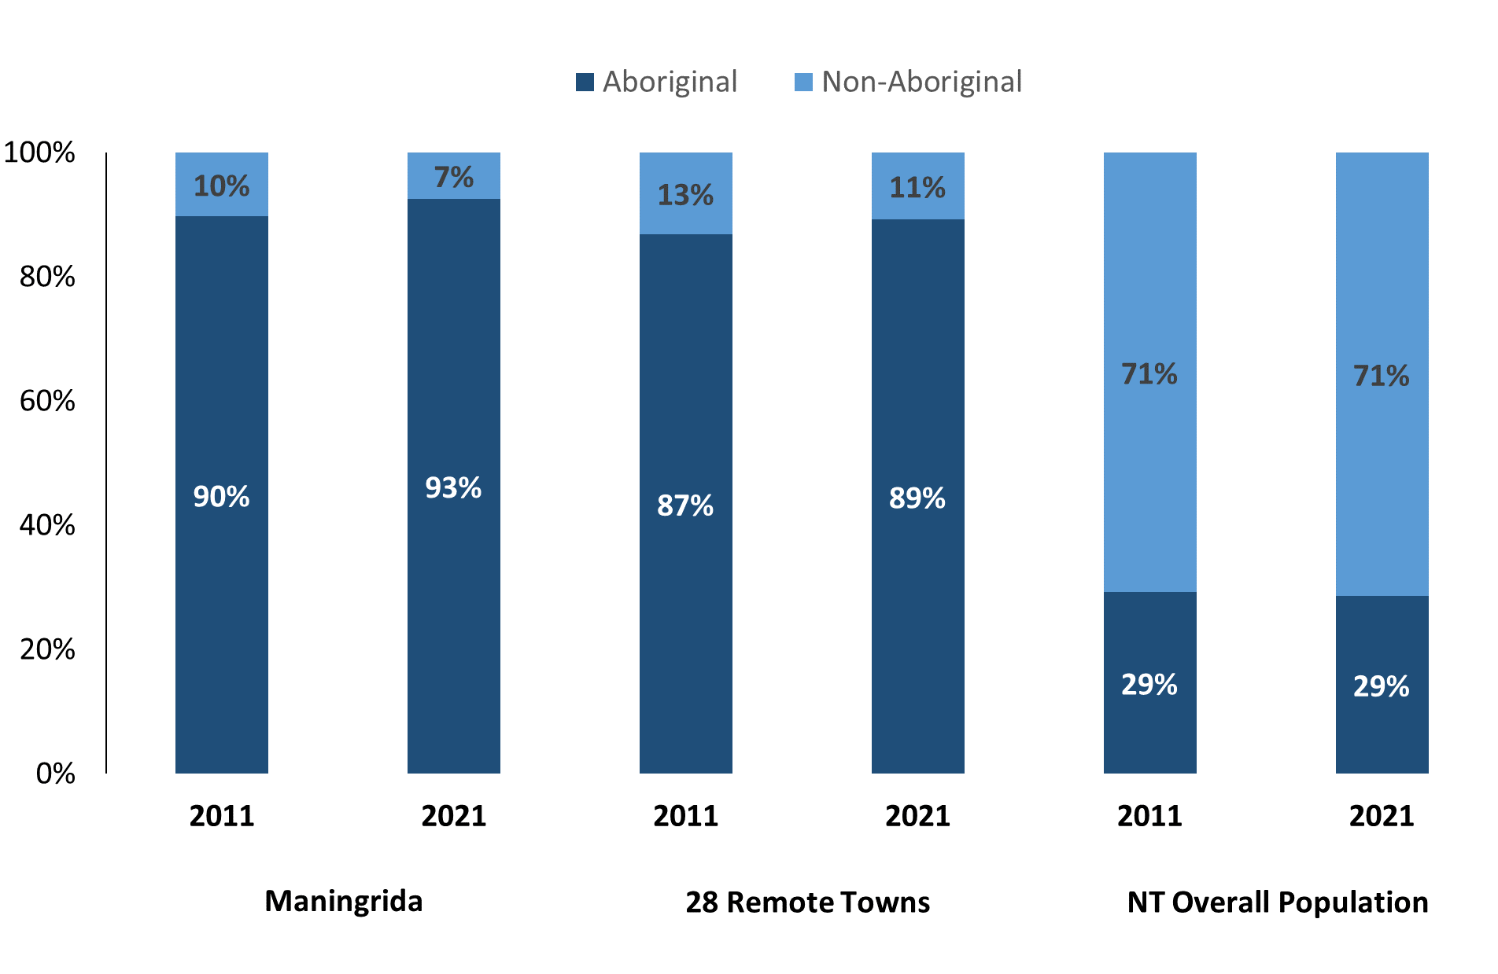

*Source: Australian Bureau of Statistics*

In 2021 in Maningrida:

* 93% of the population in Maningrida were **Aboriginal,** compared to 90% in 2011
* 89% of the population across all 28 remote towns were **Aboriginal**
* 29% of the NT population were **Aboriginal.**

**Table 37: Unemployment and Aboriginal participation rates (q)**

|  |  |  |  |  |  |  |
| --- | --- | --- | --- | --- | --- | --- |
|  | **Maningrida** | | | **Northern Territory** | | |
| **Aboriginal** | **Non-Aboriginal** | **Total** | **Aboriginal** | **Non-Aboriginal** | **Total** |
| **Unemployment rate** | 46.0% | 2.8% | 36.2% | 20.8% | 3.2% | 5.6% |
| **Participation rate** | 28.8% | 96.0% | 45.9% | 35.4% | 78.3% | 64.9% |

*Source: Australian Bureau of Statistics*

In 2021 in Maningrida the:

* **total unemployment rate** was 36.2% compared to 5.6% for the total Northern Territory
* **Aboriginal unemployment rate** was 46.0% compared to 20.8% for the total Northern Territory
* **non-Aboriginal unemployment rate** was 2.8% compared to 3.2% for the total Northern Territory
* **total participation rate** was 45.9% compared to 64.9% for the total Northern Territory
* **Aboriginal participation** **rate** was 28.8% compared to 35.4% for the total Northern Territory
* **non-Aboriginal participation rate** was 96.0% compared to 78.3% for the total Northern Territory.

# Community Development Program

**Table 38: Community Development Program, Aboriginal Job Seekers,** **31 December 2023 (o)**

|  |  |  |
| --- | --- | --- |
| **Indicator** | **Aboriginal** | |
| **No.** | **%** |
| **Total Aboriginal Job Seekers** | 1001 | N/A |
| **Age (years)** | | |
| 15-24 | 280 | 28.0% |
| 25-44 | 530 | 52.9% |
| 45+ | 191 | 19.1% |
| **Total** | 1001 | 100.0% |
| **Gender** | | |
| Male | 583 | 58.2% |
| Female | 418 | 41.8% |
| **Total** | 1001 | 100.0% |
| **Employment Outcome – 1 January 2023 to 31 December 2023** | | |
| 13 Weeks | 39 | 48.1% |
| 26 Weeks | 42 | 51.9% |

*Source: Department of Prime Minister and Cabinet*

**Chart 14: Community Development Program, Aboriginal Job Seekers by Gender and Age Group, 31 December 2023 (o)**

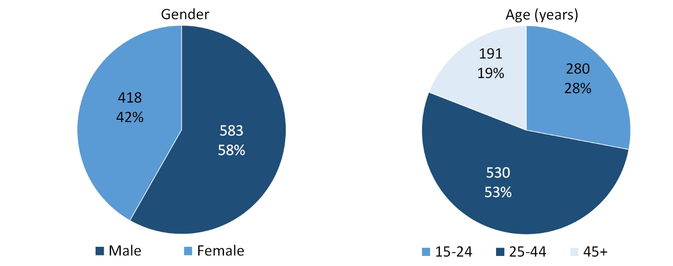

*Source: Department of Prime Minister and Cabinet*

As of 31 December 2023, in Maningrida, there were 1001 CDP **Aboriginal** job seekers, of these:

* 583 (58.2%) were male and 418 (41.8%) were female
* 280 (28.0%) were aged 15-24 years, 530 (52.9%) were aged 25-44 years, and 191 (19.1%) were aged 45+ years
* between 1 January 2023 to 31 December 2023, 39 had reached the 13-week reporting milestone and 42 had reached the 26 week reporting milestone.

# Businesses

**Table 39: Businesses by sector (d)(s)**

|  |  |  |  |  |
| --- | --- | --- | --- | --- |
| **Business Name** | **Reported on in 2011** | **Reported on in 2014** | **Reported on in 2017** | **Reported on in 2023** |
| **PUBLIC SECTOR** | | | | |
| **Department of Education** | Yes | Yes | Yes | **Yes** |
| Department of Health | Yes | Yes | Yes | No |
| Department of Housing, Local Government and Regional Services (DHLGRS) | Yes | No | No | No |
| Department of Human Services trading as Centrelink | Yes | Yes | Yes | No |
| Department of the Prime Minister and Cabinet | Yes | Yes | Yes | No |
| Maningrida Community Education Centre Council Inc | Yes | No | No | No |
| **National Indigenous Australians Agency** | No | No | No | **Yes** |
| **Northern Territory Police, Fire Emergency Services** | Yes | Yes | Yes | **Yes** |
| **Territory Families** | No | No | Yes | **Yes** |
| **West Arnhem Regional Council** | Yes | Yes | Yes | **Yes** |
| **PRIVATE SECTOR** | | | | |
| Batchelor Institute of Indigenous Tertiary Education (BIITE) | Yes | Yes | No | No |
| **Bawinanga Aboriginal Corporation (BAC)** | Yes | Yes | Yes | **Yes** |
| Dhukurrdji Development Corporation Limited | No | No | Yes | No |
| Intract Indigenous Employment | No | Yes | No | No |
| Malabam Health Board Aboriginal Corporation | No | Yes | Yes | No |
| **Maningrida Progress Association Inc** | Yes | Yes | Yes | **Yes** |
| McMahon Services Australia Pty Ltd - (Intract Indigenous Contractors) | No | No | Yes | No |
| Menzies School of Health Research | Yes | No | No | No |
| Stedman Construction & Engineering Pty Ltd | No | Yes | Yes | No |
| **Northern Land Council** | No | No | No | **Yes** |
| **Traditional Credit Union (TCU)** | Yes | Yes | Yes | **Yes** |

*Source: Northern Territory Department of Industry, Tourism and Trade*

*Note: Business names captured across the four survey periods have been identified by the current 2023 Business ABN name listed as at 2023.*

In 2023 in Maningrida:

* there were 9 businesses reported on, of which:
* 5 businesses were from the Public Sector (56%)
* 4 businesses were from the Private Sector (44%)
* there were 2 businesses operating that were not operating in 2017.

# Notes

1. These counts represent numbers of filled jobs and not the number of people. As such the totals represent the total number of filled jobs, not the total number of employees. This count is not directly comparable to the total number of employed people as a person may have several jobs or one job may be shared by more than one person.
2. Full-time is defined as a job usually requiring 35 hours or more per week or that required 35 hours or more work during the reference week. Part-time is defined as a job usually requiring less than 35 hours per week or that required less than 35 hours work during the reference week. The reference week refers to the period that respondents were asked to provide information about. In most instances it would be the week prior to the week the questionnaire was completed. Questionnaires were predominantly conducted in June and July.
3. Care needs to be taken when analysing the counts of filled jobs by Aboriginal people. Aboriginality was reported by the business representative completing the questionnaire.
4. Sector was classified using the Standard Economic Sector of Classifications of Australia (SESCA), 2008.
5. Job permanency is classified according to what the business believes the level of job permanency is based on guidelines provided by data collectors. Those guidelines state a permanent job has paid annual and/or sick leave entitlements while a temporary job includes casual and fixed-term contract jobs.
6. Classified according to the Australian and New Zealand Standard Classification of Occupations (ANZSCO), 2006, major occupation level.
7. Other Occupations include jobs where occupation was not stated, not known or inadequately described.
8. Classified using the Australian and New Zealand Standard Industrial Classification (ANZSIC), 2006, division level.
9. Care needs to be taken when analysing the counts of filled jobs by the gender of people in the jobs. The gender of the person employed in a job is reported by the business representative completing the questionnaire.
10. Care needs to be taken when analysing the counts of filled jobs by the age of people in the jobs. The age of the person employed in a job is reported by the business representative completing the questionnaire.
11. Students represent the number of individual clients that enrolled in a Vocational Education and Training unit during the calendar year.
12. Unit enrolments represent the count of individual units that students enrolled in during the calendar year.
13. Nominal hours delivered is the sum of the nominal hours of the units commenced during the calendar year regardless of when the course enrolment commenced.
14. Unit completions are the count of all successfully completed units reported in the calendar year regardless of the year of commencement of the units.
15. The Community Development Program (CDP) supports job seekers in remote Australia to build skills, address barriers and contribute to their communities through a range of flexible activities. Under the CDP, job seekers with activity requirements are expected to do up to 25 hours per week of work-like activities that benefit their community. It should be noted that some CDP participants may be reported on within the profile if they are attached to a filled position with an employer captured in the survey. Due to confidentiality issues, data below 20 people is not published.
16. Population estimates for both 2011 and 2021 are taken from the estimated resident population (ERP) data produced by the Australian Bureau of Statistics (ABS) and based on Australian Statistical Geography Standard (ASGS) Statistical Area Level 1 (SA1) regions. ERP are official estimates of the Australian population, which link people to a place of usual residence with Australia. All ERP data sources, including the Census of Population and Housing (Census), are subject to error (including inaccuracies in collection, recording and processing data) and should be used with caution.
17. Indigenous population proportions, unemployment and workforce participation rates are based on ABS Census counts at ASGS Indigenous Locations (ILOCs) for each remote town.
18. Working-age population includes all residents aged 15 years and over (commonly referred to as the civilian population) and consists of people that are employed, unemployed or not in the labour force.
19. A ‘business’ has been defined as any organisation that has undertaken productive activities in the last year, including companies, non-profit organisations, government departments and enterprises operating within the designated remote geography (town), and has one or more employees in paid employment and an Australian Business Number (ABN).

# Abbreviations and Acronyms

ABN Australian Business Number

ABS Australian Bureau of Statistics

ANZSCO Australian and New Zealand Standard Classification of Occupations

ANZSIC Australian and New Zealand Standard Industrial Classification

ASGS Australian Statistical Geography Standard

CDP Community Development Program

ERP Estimated Resident Population

ILOC Indigenous Locations

nec Not Elsewhere Classified

No. Number

Perm Permanent

ppt Percentage point

RJCP Remote Jobs and Communities Program

Temp Temporary

SA1 Statistical Area Level 1

VET Vocational Education and Training

1. The number of filled jobs does not represent numbers of people as a person may have several jobs or one job may be shared by more than one person.
2. 6 Aboriginal filled jobs gender status not identified in 2017
3. 6 Aboriginal filled jobs gender status not identified in 2017