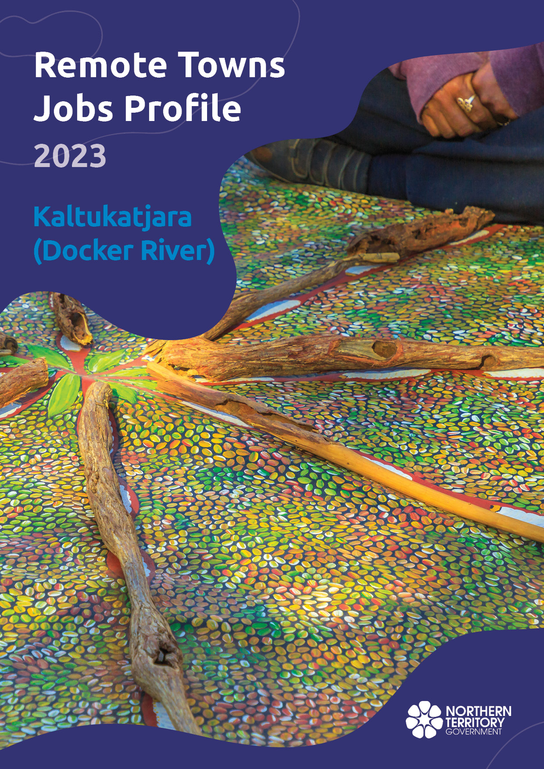

© Northern Territory of Australia 2025
Preferred Reference: Department of Trade, Business and Asian Relations, 2023 Remote Towns Jobs Profiles, Northern Territory Government, January 2025, Darwin.
Front cover image: Aboriginal bush painting at Karrke Aboriginal Cultural Experience.
Disclaimer
The data in this publication was collected by conducting a survey of businesses located in the 28 remote town boundaries. This body of work was completed in 2023 by the former Northern Territory Department of Industry, Tourism and Trade.
The collection methodology was created in accordance with Australian Bureau of Statistics data quality framework principles. Data in this publication is only reflective of those businesses reported on as operating in the town at the time of data collection (see table at the end of publication for list of businesses reported on). To comply with privacy legislation or where appropriate, some data in this publication may have been adjusted and will not reflect the actual data reported by businesses. As a result of this, combined with certain data not being reported by some businesses, some components may not add to totals. Changes over time may also reflect change in business propensity to report on certain data items rather than actual changes over time. Total figures have generally not been adjusted. Caution is advised when interpreting the comparisons made to the earlier 2011, 2014 and 2017 publications as the businesses identified and reported on and the corresponding jobs may differ between publications. The surveys have not always gathered data on training and jobs in the same years.
Notes for each table and chart are ordered alphabetically and listed at the end of the publication.
The Northern Territory of Australia exercised due care and skill to ensure that at the time of publication the information contained in this publication is true and correct. However, it is not intended to be relied on as professional advice or used for commercial purposes. The Territory gives no warranty or assurances as to the accuracy of the information contained in the publication and to the maximum extent permitted by law accepts no direct or indirect liability for reliance on its content.
Any use of this report for commercial purposes is not endorsed by the Department of Trade, Business and Asian Relations.

Contents

Docker River 4
Introduction 5
Summary 6
Jobs Overview 7
Jobs filled by Aboriginality 8
Jobs by Sector: Private and Public 10
Job Status: Permanent and Temporary 14
Job Vacancies 16
Jobs by Industry 17
Jobs by Occupation 21
Jobs by Industry by Occupation 23
Jobs by Gender 25
Jobs by Age 28
Vocational Education and Training 32
Population 35
Community Development Program 37
Businesses 38
Notes 39
Abbreviations and Acronyms 40

Docker River
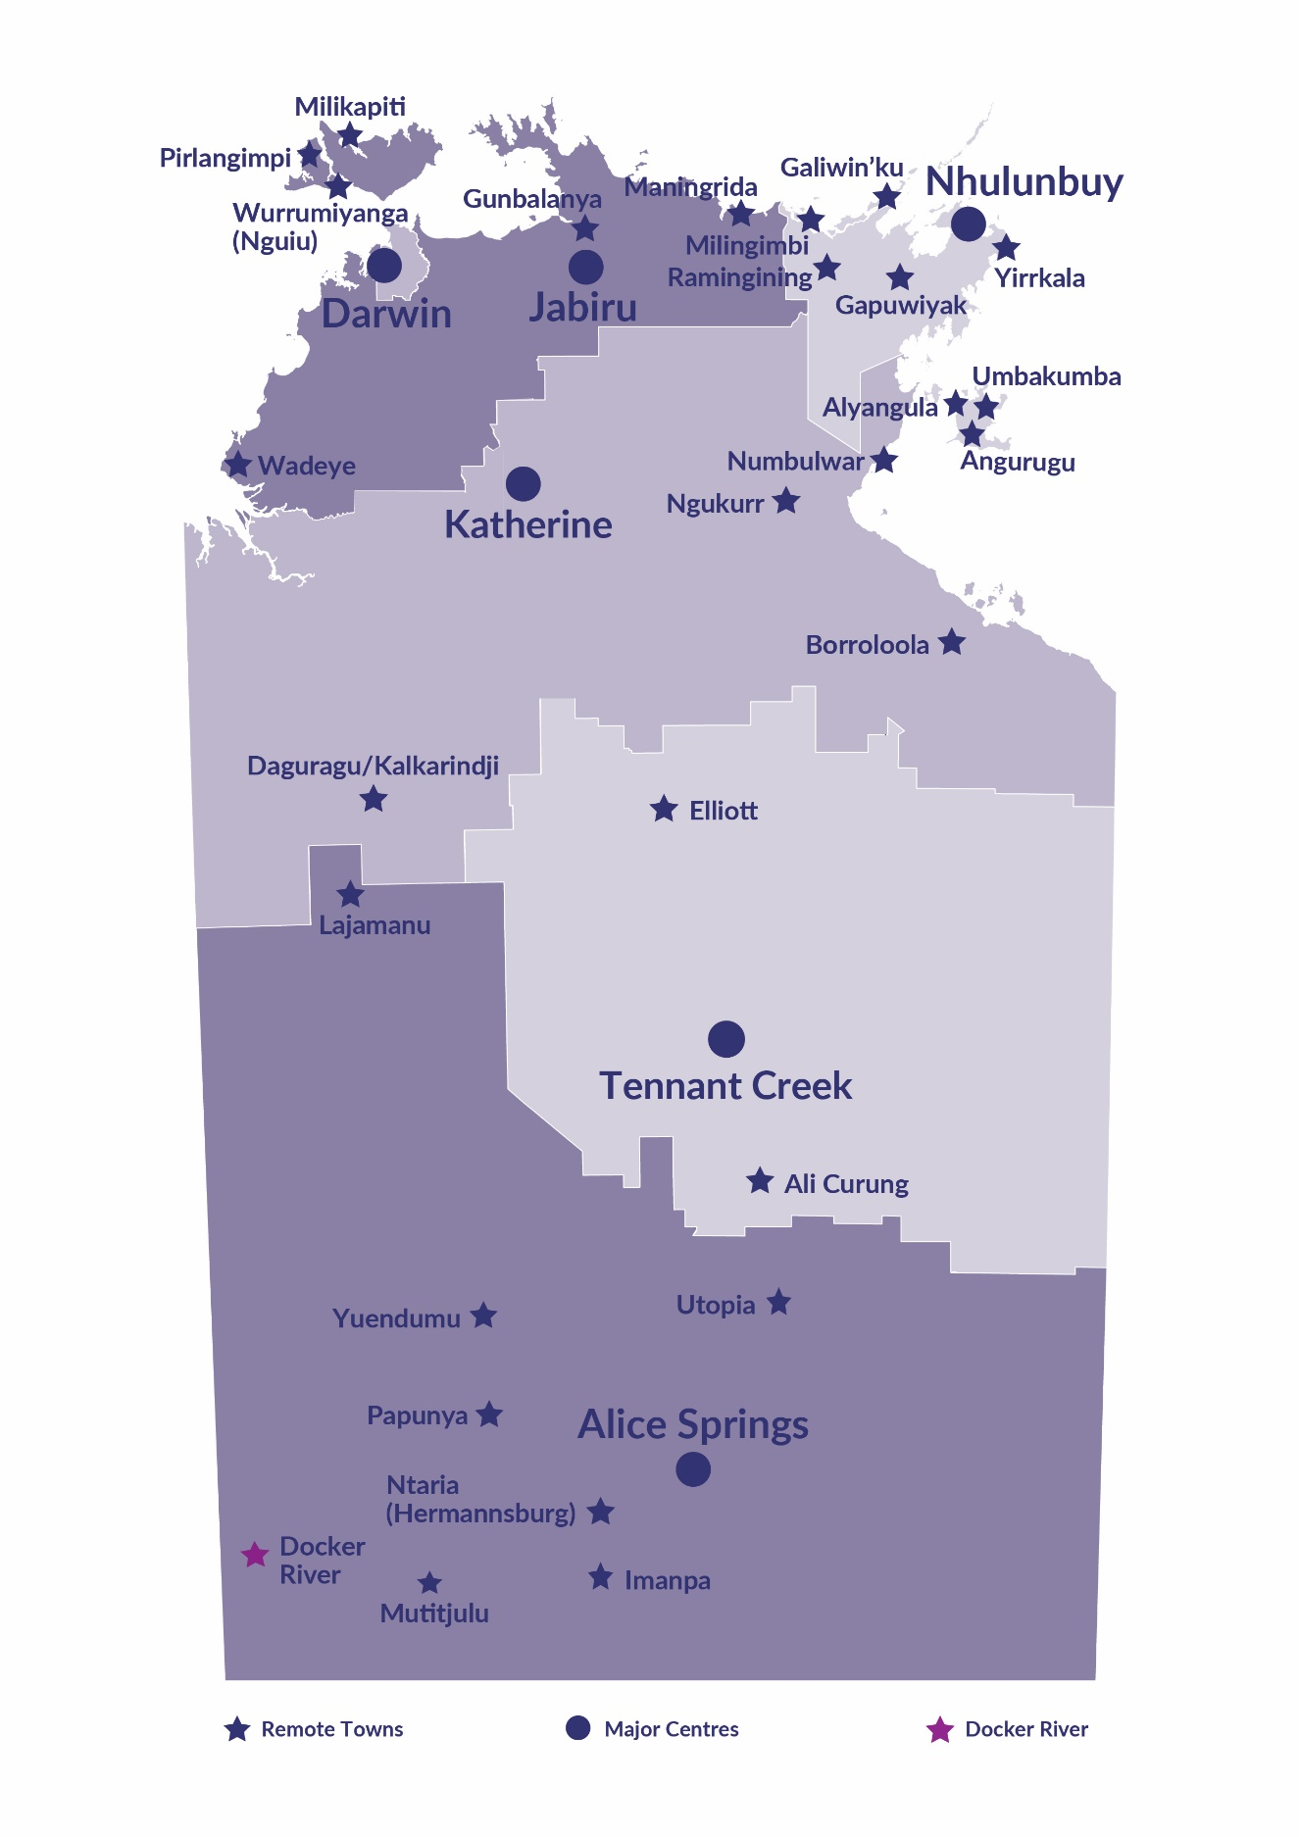
Docker River (Kaltukatjara) is located 670 kilometres south-west of Alice Springs near the Western Australia boarder, with a population of 225 residents.
Source: Northern Territory Department of Industry, Tourism and Trade

Introduction
This jobs profile provides a snapshot of jobs and the characteristics of job holders in Docker River as of September 2023. Trends from the surveys conducted in 2011, 2014, and 2017 are also described. Additionally, it presents data on Community Development Program activity, Population, and Vocational Education and Training.
This job profile is one of 28 profiles developed for remote towns in the Northern Territory. It is anticipated these, and subsequent profiles will contribute to a robust evidence base to inform decision making in and relating to these remote Territory towns.
This profile contains information collected by the Northern Territory Northern Territory Department of Industry, Tourism and Trade from businesses operating within the town and is supplemented by other administrative data sets and information.
Each profile provides up-to-date information that is intended to inform the planning and design of current and future government programs and as an evidence base to inform decision making relating to workforce development, enterprise and job opportunities.
The profile may best be understood as a point-in-time tool. On the whole the number of business surveys from which the data was drawn is significantly less than in earlier surveys, generally, business participation has decreased with each survey. Notably, for Docker River (Kaltukatjara), there is one additional business reported since 2017.
The data collection methodology and corresponding questionnaire were created in partnership with the Australian Bureau of Statistics (ABS) and in accordance with ABS data quality framework and survey principles.
The Northern Territory Northern Territory Department of Industry, Tourism and Trades’ Territory Engagement and Delivery, Skills Initiative and VET data teams collaborated with the Northern Institute at Charles Darwin University to facilitate the surveys and reports.
The information collected and reported on represents a significant goodwill investment by those businesses and organisations that participated. Each business is listed at the end of this publication.

Summary
The 2023 jobs profile was developed based on responses from 8 businesses operating within the Docker River town boundary, 1 more than the 2017 survey. Of these, there were:
- 7 businesses from the Private Sector, accounting for 43 filled jobs or 90% of total filled jobs
- 1 business from the Public Sector, accounting for 5 filled jobs or 10% of total filled jobs.
A total of 65 filled and vacant jobs in Docker River were reported.
The 2023 profile highlights:
- there were 48 filled jobs of which:
- 33 jobs (69%) were filled by Aboriginal people
- 15 jobs (31%) were filled by non-Aboriginal people
- 60% of employed Aboriginal people are working in the Private Sector
- Aboriginal females made up 69% of total Aboriginal filled jobs
- there were 17 vacant jobs, of which:
- job vacancies as a percentage of jobs is 26.2%
- job vacancies equate to 1 in 4 jobs
- 14 of the vacancies were in the Professionals and Community and Personal Service Workers areas
- Public Administration and Safety was the largest industry employer in 2023
- Business and Clerical had the highest student numbers in 2023.
The overall population in Docker River decreased by 66 people (-23%) between 2011 and 2021 to 225 people.
In comparison, the overall Northern Territory population increased by 9.7% between 2011 and 2021.
In 2021, the working age population (15 years and over) in Docker River was an estimated 172 people compared to 234 in 2011 a decrease of 26%.
There were 0.4 jobs in Docker River per working age person compared to 0.3 jobs per person across the 28 remote towns in the Northern Territory.

Jobs Overview
Table 1: Count of filled jobs and vacancies, 2017 & 2023 (a)(b)
 | 2017 | 2023 | Change  2017-2023
Total All Jobs | 58 | 65 | 7
Vacancies | 19 | 17 | -2
Vacancies as % of Total All Jobs | 32.8% | 26.2% | -6.6 ppt
Filled Jobs | 39 | 48 | 9
Full-time | 26 | 30 | 4
Part-time | 13 | 18 | 5
Source: Northern Territory Northern Territory Department of Industry, Tourism and Trade
Chart 1: Count of vacant jobs and filled jobs by full-time/part-time status, 2017 & 2023 (a)(b)
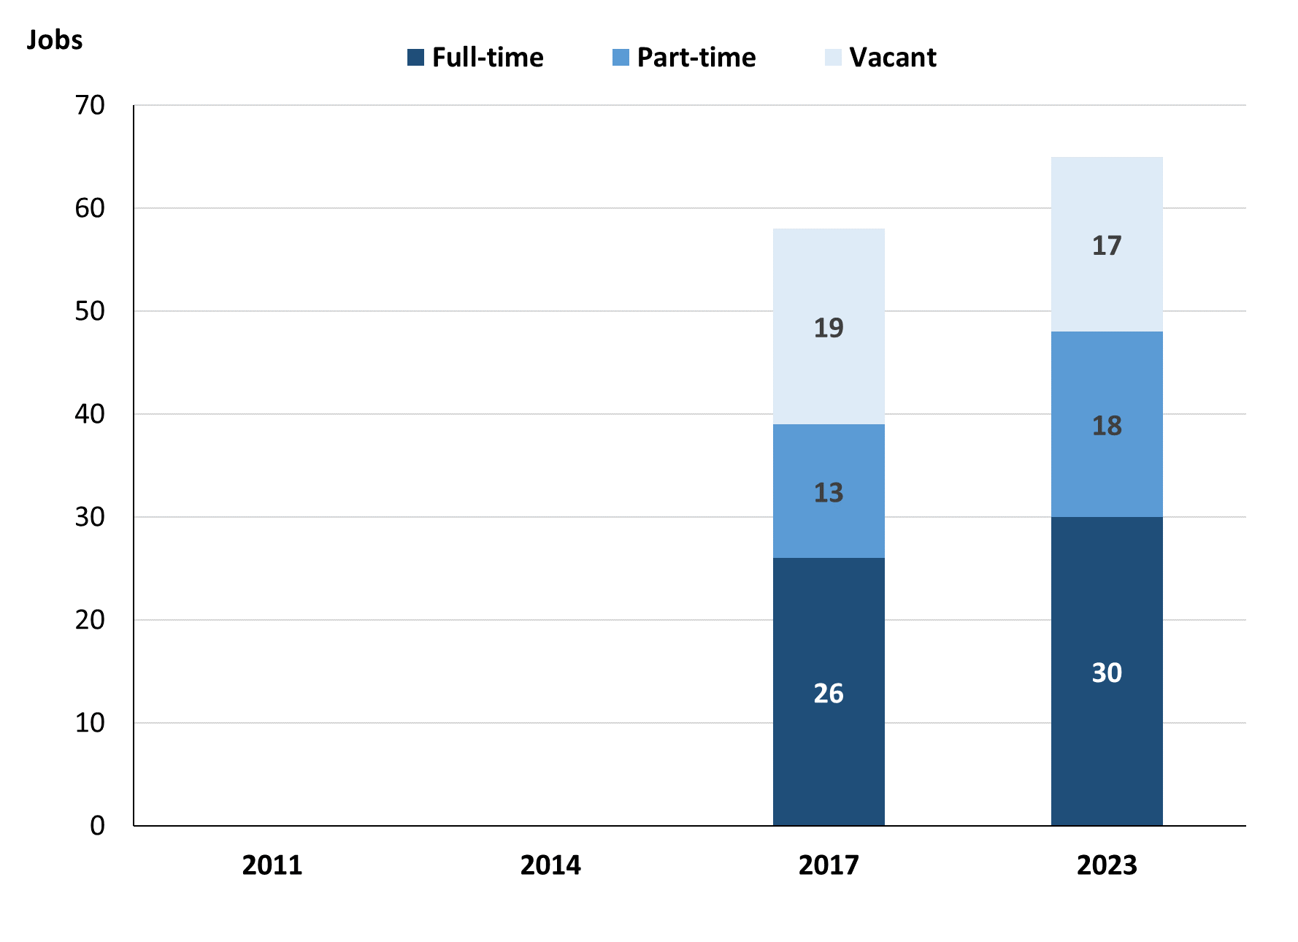
Source: Northern Territory Northern Territory Department of Industry, Tourism and Trade
In 2023 in Docker River there were:
- a total of 48 filled jobs, an increase of 9 jobs from 2017. Of these:
- 30 were full-time jobs, an increase of 4 jobs from 2017
- 18 were part-time jobs, an increase of 5 jobs from 2017
- 17 total job vacancies, a decrease of 2 vacancies from 2017.

Jobs filled by Aboriginality
Chart 2: Count of filled jobs by Aboriginality, 2017 & 2023 (a)(c)
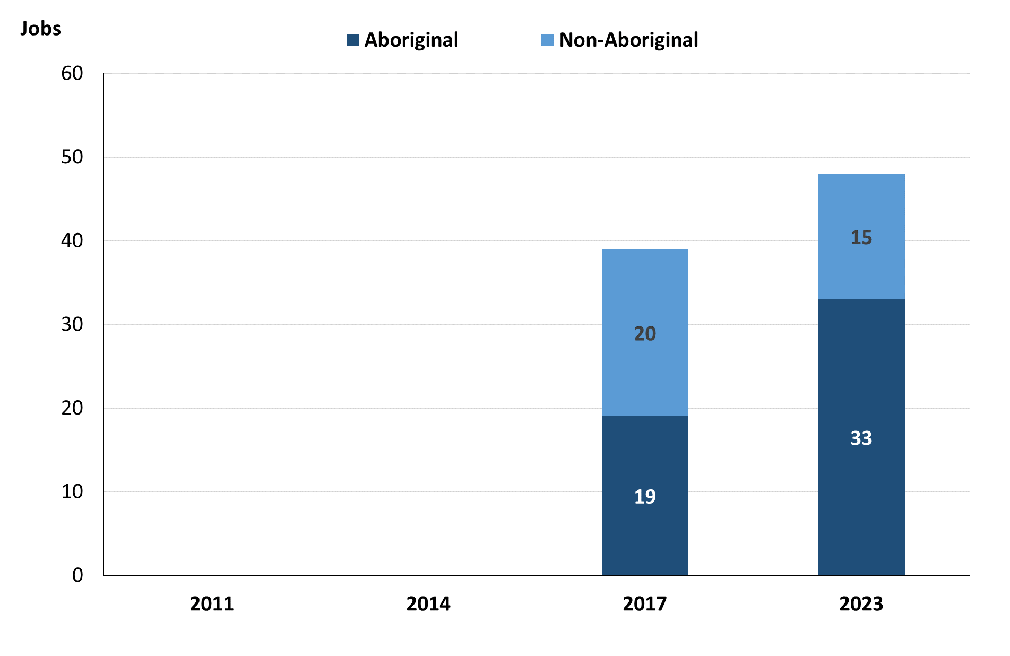
Source: Northern Territory Department of Industry, Tourism and Trade
In 2023 in Docker River:
- of the 48 filled jobs:
- 33 jobs were filled by Aboriginal people, an increase of 14 jobs from 2017
- 15 jobs were filled by non-Aboriginal people, a decrease of 5 jobs from 2017
- Aboriginal people accounted for 69% of job holders compared to 49% in 2017.

Table 2: Count of filled jobs by full-time/part-time status, 2017 & 2023 (a)(b)(c)
Indicator | 2017 |  |  | 2023 |  |  | Change  2017-2023
Indicator | Aboriginal | Non-Aboriginal | Total | Aboriginal | Non-Aboriginal | Total | Aboriginal | Non-Aboriginal | Total
Full-time | 7 | 19 | 26 | 16 | 14 | 30 | 9 | -5 | 4
Part-time | 12 | 1 | 13 | 17 | 1 | 18 | 5 | 0 | 5
Total | 19 | 20 | 39 | 33 | 15 | 48 | 14 | -5 | 9
Source: Northern Territory Department of Industry, Tourism and Trade
Chart 3: Count of filled jobs by full-time/part-time status, 2017 & 2023 (a)(b)(c)
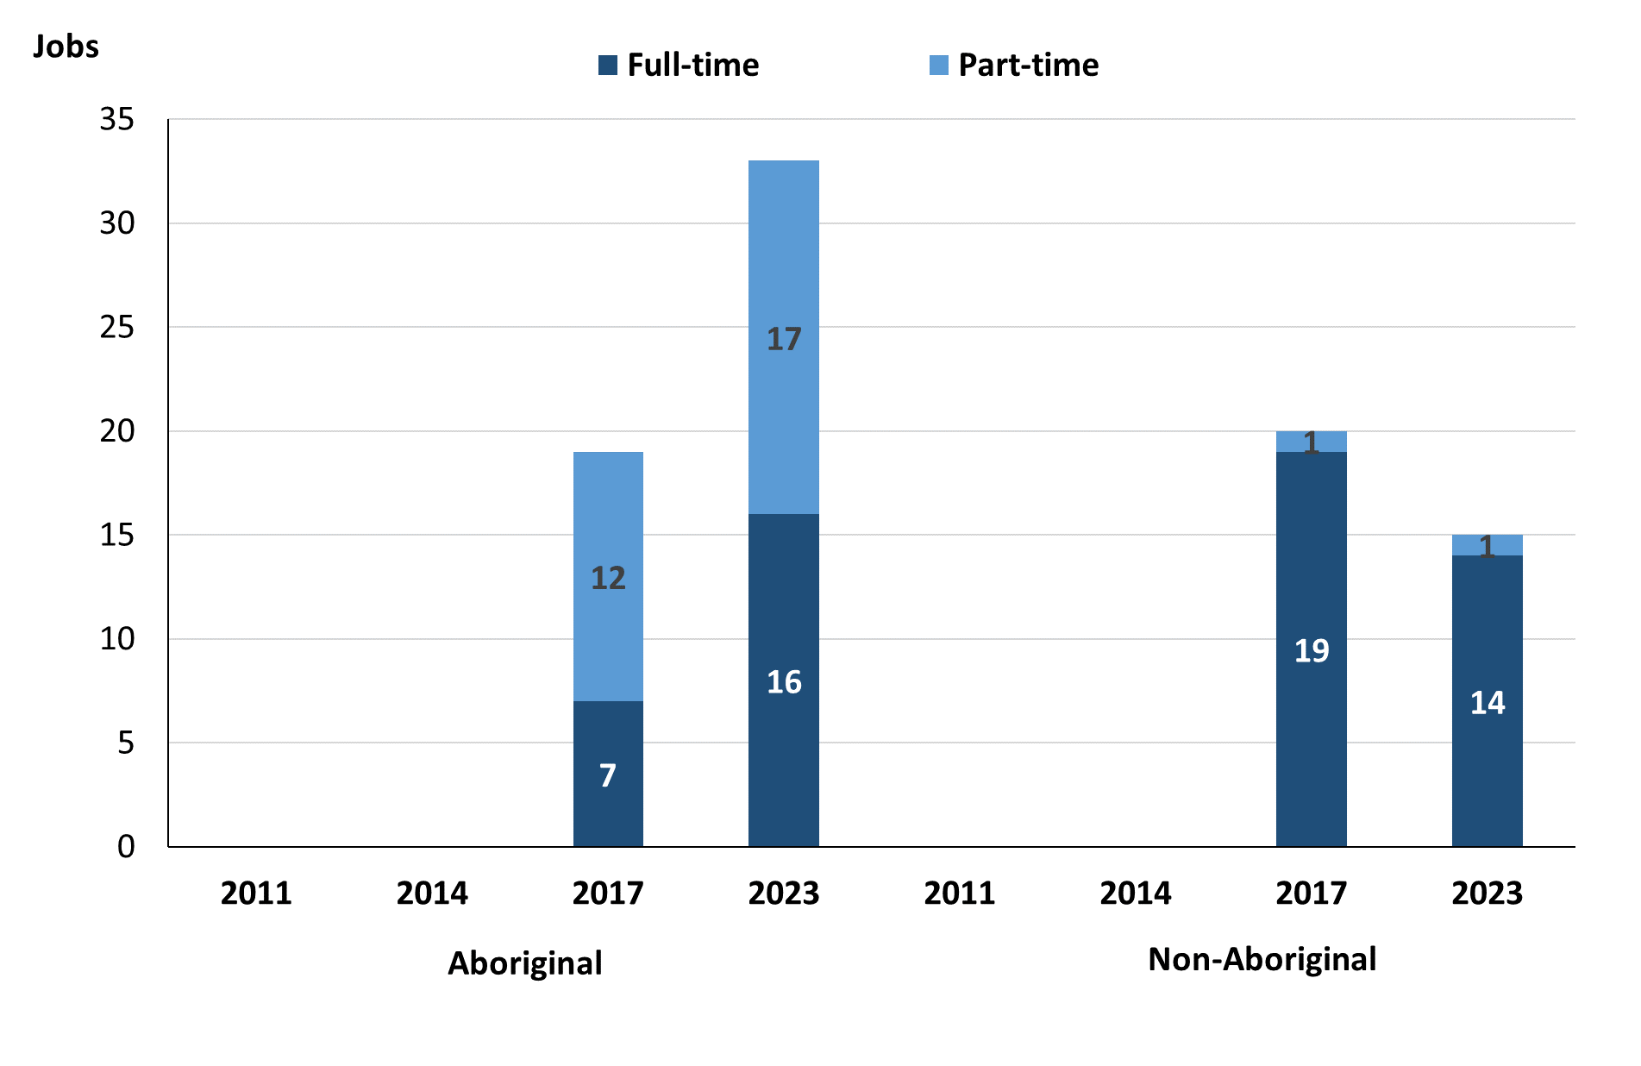
Source: Northern Territory Department of Industry, Tourism and Trade
In 2023 in Docker River:
- of the 48 filled jobs:
- 16 were full-time jobs filled by Aboriginal people, an increase of 9 jobs from 2017
- 17 were part-time jobs filled by Aboriginal people, an increase of 5 jobs from 2017
- 14 were full-time jobs filled by non-Aboriginal people, a decrease of 5 jobs from 2017
- 1 was a part-time job filled by a non-Aboriginal person, unchanged from 2017.

Jobs by Sector: Private and Public
Table 3: Count of filled jobs by sector of business, 2017 & 2023 (a)(c)(d)
Indicator | 2017 |  |  | 2023 |  |  | Change  2017-2023
Indicator | Aboriginal | Non-Aboriginal | Total | Aboriginal | Non-Aboriginal | Total | Aboriginal | Non-Aboriginal | Total
Public Sector | 1 | 3 | 4 | 4 | 1 | 5 | 3 | -2 | 1
Australian Government | 0 | 0 | 0 | 0 | 0 | 0 | 0 | 0 | 0
Territory Government | 1 | 2 | 3 | 0 | 0 | 0 | -1 | -2 | -3
Local Government | 0 | 1 | 1 | 4 | 1 | 5 | 4 | 0 | 4
Private Sector | 18 | 17 | 35 | 29 | 14 | 43 | 11 | -3 | 8
Total | 19 | 20 | 39 | 33 | 15 | 48 | 14 | -5 | 9
Source: Northern Territory Department of Industry, Tourism and Trade
Chart 4: Count of filled jobs by sector of business, 2023 (a)(d)
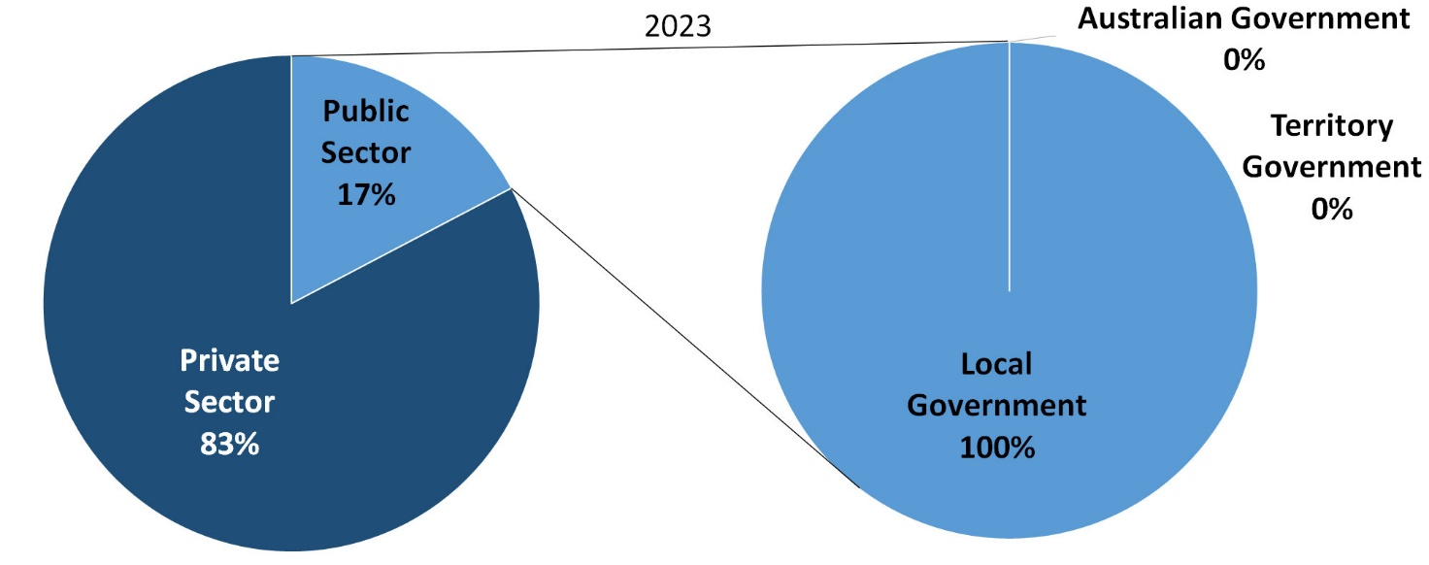
Source: Northern Territory Department of Industry, Tourism and Trade
In 2023 in Docker River:
- there were 5 jobs in the Public Sector, an increase of 1 job from 2017. Of these:
- none were in the Australian Government, unchanged from 2017
- none were in the Territory Government, a decrease of 3 jobs from 2017
- 5 jobs were in the Local Government, an increase of 4 jobs from 2017
- there were 43 jobs in the Private Sector, an increase of 8 jobs from 2017.
Chart 5: Count of filled jobs by sector of business, 2017 & 2023 (a)(c)(d)
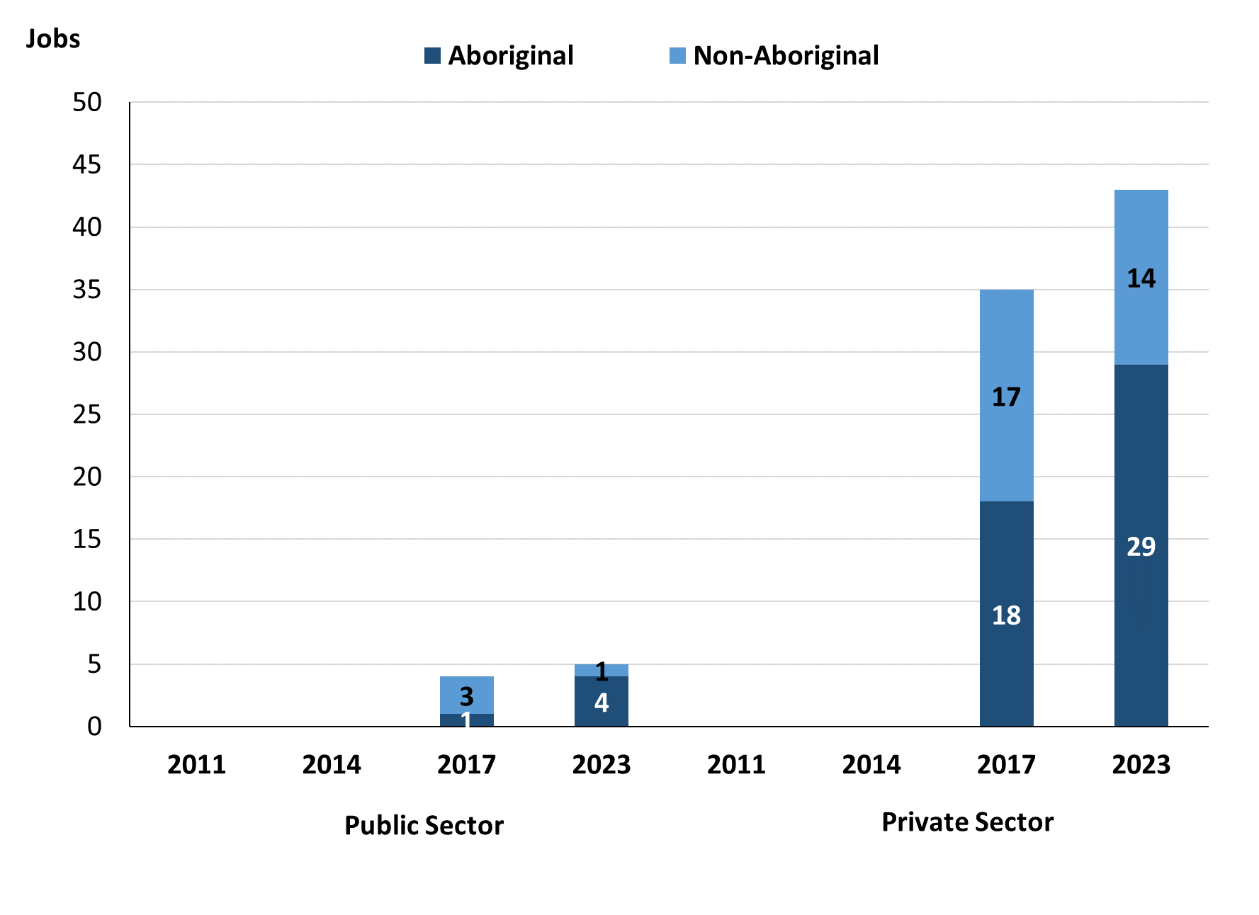
Source: Northern Territory Department of Industry, Tourism and Trade
In 2023 in Docker River:
- of the 5 jobs in the Public Sector:
- Aboriginal people filled 4 jobs, an increase of 3 jobs from 2017
- a non-Aboriginal person filled 1 job, a decrease of 2 jobs from 2017
- of the 43 jobs in the Private Sector:
- Aboriginal people filled 29 jobs, an increase of 11 jobs from 2017
- non-Aboriginal people filled 14 jobs, a decrease of 3 jobs from 2017.

Chart 6: Count of filled jobs by sector and full-time/part-time status, 2017 & 2023 (a)(b)(d)
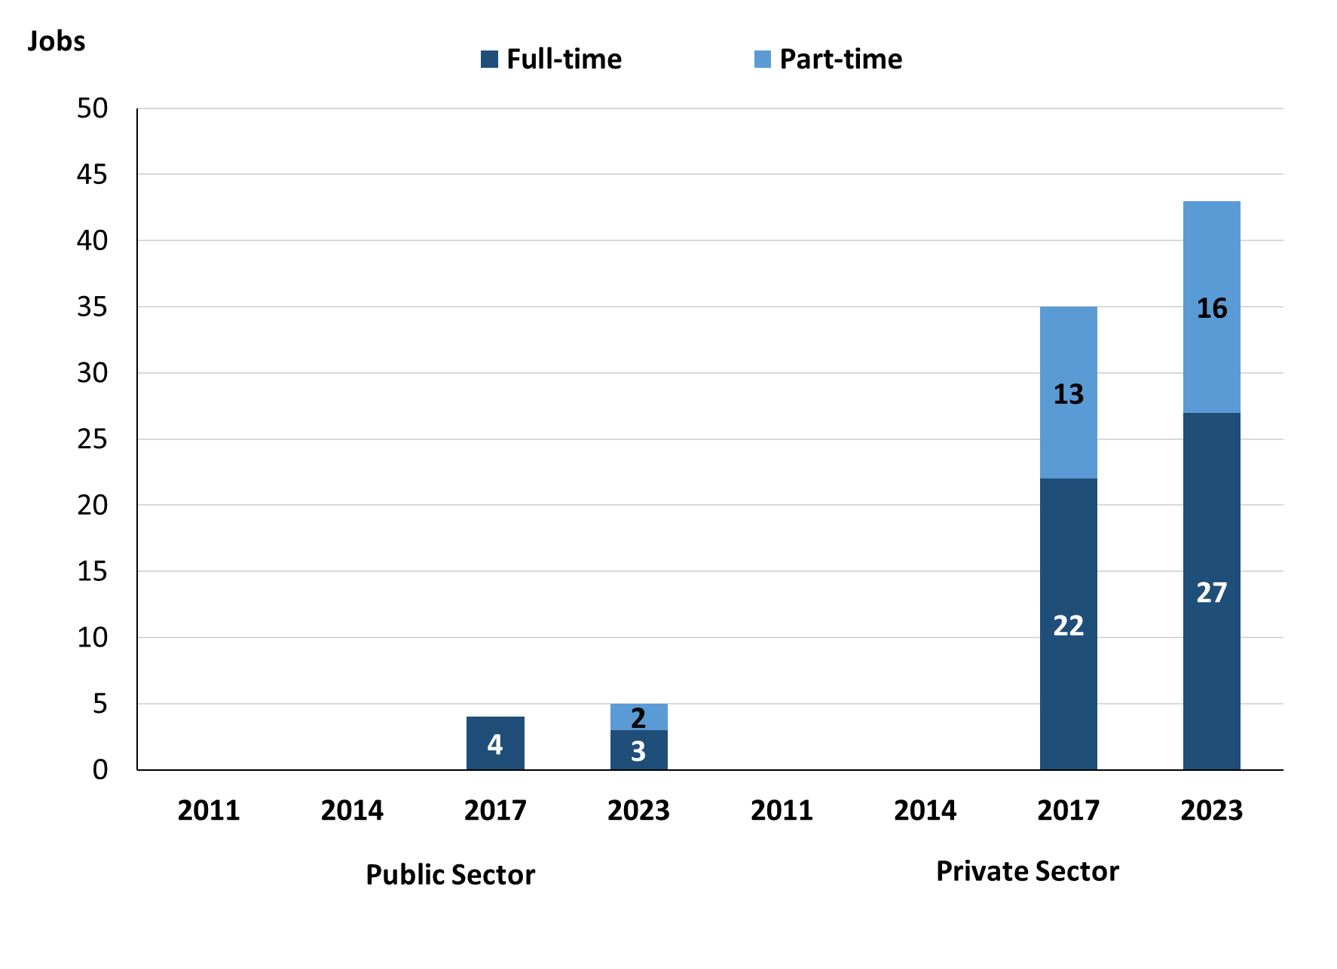
Source: Northern Territory Department of Industry, Tourism and Trade
In 2023 in Docker River:
- of the 5 jobs in the Public Sector:
- 3 were full-time jobs, a decrease of 1 job from 2017
- 2 were part-time jobs, an increase of 2 jobs from 2017
- of the 43 jobs in the Private Sector:
- 27 were full-time jobs, an increase of 5 jobs from 2017
- 16 were part-time jobs, an increase of 3 jobs from 2017.

Table 4: Count of filled jobs by full-time/part-time status by sector, 2017 & 2023 (a)(b)(c)(d)
Indicator | 2017
Indicator | Aboriginal |  |  | Non-Aboriginal |  |  | Total
Indicator | Full-time | Part-time | Total | Full-time | Part-time | Total | Full-time | Part-time | Total
Public Sector | 1 | 0 | 1 | 3 | 0 | 3 | 4 | 0 | 4
Private Sector | 6 | 12 | 18 | 16 | 1 | 17 | 22 | 13 | 35
Total | 7 | 12 | 19 | 19 | 1 | 20 | 26 | 13 | 39

Indicator | 2023
Indicator | Aboriginal |  |  | Non-Aboriginal |  |  | Total
Indicator | Full-time | Part-time | Total | Full-time | Part-time | Total | Full-time | Part-time | Total
Public Sector | 2 | 2 | 4 | 1 | 0 | 1 | 3 | 2 | 5
Private Sector | 14 | 15 | 29 | 13 | 1 | 14 | 27 | 16 | 43
Total | 16 | 17 | 33 | 14 | 1 | 15 | 30 | 18 | 48
Source: Northern Territory Department of Industry, Tourism and Trade
In 2023 in Docker River there were:
- 4 jobs in the Public Sector filled by Aboriginal people, an increase of 3 jobs from 2017, of which:
- 2 were full-time jobs, an increase of 1 job from 2017
- 2 were part-time jobs, an increase of 2 jobs from 2017
- 29 jobs in the Private Sector filled by Aboriginal people, an increase of 11 jobs from 2017, of which:
- 14 were full-time jobs, an increase of 8 jobs from 2017
- 15 were part-time jobs, an increase of 3 jobs from 2017
- 1 job in the Public Sector filled by a non-Aboriginal person, a decrease of 2 jobs from 2017, of which:
- 1 was a full-time job, a decrease of 2 jobs from 2017
- none were part-time jobs, unchanged from 2017
- 14 jobs in the Private Sector filled by non-Aboriginal people, a decrease of 3 jobs from 2017, of which:
- 13 were full-time jobs, a decrease of 3 jobs from 2017
- 1 was a part-time job, unchanged from 2017.

Job Status: Permanent and Temporary
Table 5: Count of filled jobs by employment status, 2017 & 2023 (a)(c)(e)
Indicator | 2017 |  |  | 2023 |  |  | Change  2017-2023
Indicator | Aboriginal | Non-Aboriginal | Total | Aboriginal | Non-Aboriginal | Total | Aboriginal | Non-Aboriginal | Total
Permanent | 2 | 11 | 13 | 3 | 8 | 11 | 1 | -3 | -2
Temporary | 17 | 9 | 26 | 30 | 7 | 37 | 13 | -2 | 11
Total | 19 | 20 | 39 | 33 | 15 | 48 | 14 | -5 | 9
Source: Northern Territory Department of Industry, Tourism and Trade
Chart 7: Count of filled jobs by employment status, 2017 & 2023 (a)(c)(e)
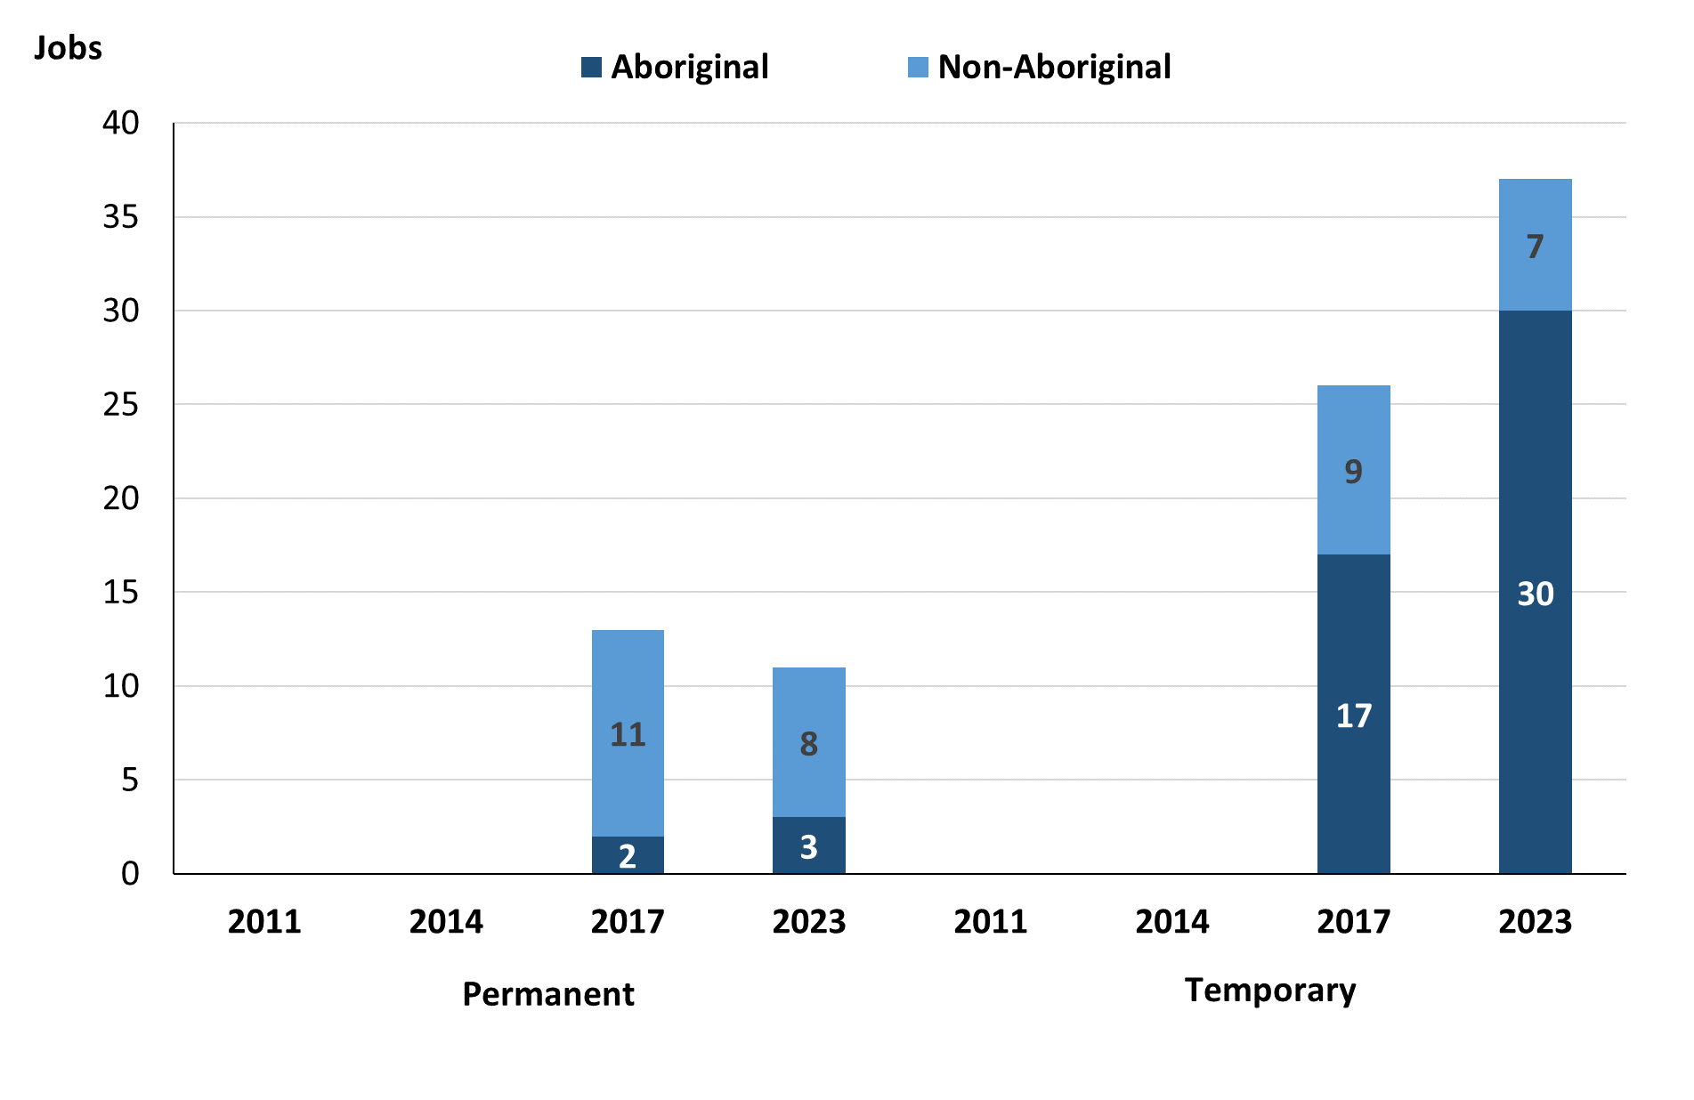
Source: Northern Territory Department of Industry, Tourism and Trade
In 2023 in Docker River:
- there were 11 Permanent jobs, a decrease of 2 jobs from 2017, of which:
- Aboriginal people filled 3 jobs, an increase of 1 job from 2017
- non-Aboriginal people filled 8 jobs, a decrease of 3 jobs from 2017
- there were 37 Temporary jobs, an increase of 11 jobs from 2017, of which:
- Aboriginal people filled 30 jobs, an increase of 13 jobs from 2017
- non-Aboriginal people filled 7 jobs, a decrease of 2 jobs from 2017.
Table 6: Count of filled jobs by sector and employment status, 2017 & 2023 (a)(c)(d)(e)
Indicator | 2017
Indicator | Aboriginal |  |  | Non-Aboriginal |  |  | Total
Indicator | Perm | Temp | Total | Perm | Temp | Total | Perm | Temp | Total
Public Sector | 0 | 1 | 1 | 1 | 2 | 3 | 1 | 3 | 4
Private Sector | 2 | 16 | 18 | 10 | 7 | 17 | 12 | 23 | 35
Total | 2 | 17 | 19 | 11 | 9 | 20 | 13 | 26 | 39

Indicator | 2023
Indicator | Aboriginal |  |  | Non-Aboriginal |  |  | Total
Indicator | Perm | Temp | Total | Perm | Temp | Total | Perm | Temp | Total
Public Sector | 0 | 4 | 4 | 1 | 0 | 1 | 1 | 4 | 5
Private Sector | 3 | 26 | 29 | 7 | 7 | 14 | 10 | 33 | 43
Total | 3 | 30 | 33 | 8 | 7 | 15 | 11 | 37 | 48
Source: Northern Territory Department of Industry, Tourism and Trade
In 2023 in Docker River there were:
- 5 jobs in the Public Sector, an increase of 1 job from 2017, of which:
- 1 job was permanent, unchanged from 2017, of which:
- Aboriginal people filled no jobs, unchanged from 2017
- a non-Aboriginal person filled 1 job, unchanged from 2017
- 4 jobs were temporary, an increase of 1 job from 2017, of which:
- Aboriginal people filled 4 jobs, an increase of 3 jobs from 2017
- non-Aboriginal people filled 0 jobs, a decrease of 2 jobs from 2017
- 43 jobs in the Private Sector, an increase of 8 jobs from 2017, of which:
- 10 jobs were permanent, a decrease of 2 jobs from 2017, of which:
- Aboriginal people filled 3 jobs, an increase of 1 job from 2017
- non-Aboriginal people filled 7 jobs, a decrease of 3 jobs from 2017
- 33 jobs were temporary, an increase of 10 jobs from 2017, of which:
- Aboriginal people filled 26 jobs, an increase of 10 jobs from 2017
- non-Aboriginal people filled 7 jobs, unchanged from 2017.

Job Vacancies
Table 7: Job vacancies, 2017 & 2023
Indicator | 2017 | 2023 | Change  2017-2023
Job vacancies | 19 | 17 | -2
Source: Northern Territory Department of Industry, Tourism and Trade
Table 8: Job vacancies by occupation, 2017 & 2023 (f)(g)
Occupation (ANZSCO major group) | 2017 | 2023 | Change  2017-2023
Clerical and Administrative Workers | 1 | 1 | 0
Community and Personal Service Workers | 9 | 5 | -4
Labourers | 3 | 0 | -3
Managers | 0 | 1 | 1
Professionals | 6 | 9 | 3
Other | 0 | 1 | 1
Total | 19 | 17 | -2
Source: Northern Territory Department of Industry, Tourism and Trade
Table 9: Job vacancies by job title, 2023 profile (f)
Job Vacancy | No.
Aboriginal and Torres Strait Islander Land and Sea Ranger | 6
Arts Administrator or Manager | 1
Child Care Worker | 1
Family Support Worker | 3
Liaison Officer | 1
Park Ranger | 1
Program or Project Administrator | 1
Recreation Officer | 2
Other (inadequately described) | 1
Total | 17
Source: Northern Territory Department of Industry, Tourism and Trade
In 2023 in Docker River:
- there were 17 vacancies reported, a decrease of 2 vacancies from 2017
- of the 17 reported vacancies, the largest requirements were for:
- 9 Professionals, the majority of which were in the following jobs:
- Aboriginal and Torres Strait Islander Land and Sea Ranger
- Recreation Officer
- 5 Community and Personal Service Workers in the following jobs:
- Child Care Worker
- Family Support Worker
- Liaison Officer.

Jobs by Industry
Table 10: Count of filled jobs by industry of business, 2017 & 2023 (a)(h)
Industry (ANZSIC Division) | 2017 |  | 2023 |  | Change 2017-2023
Industry (ANZSIC Division) | Total | % of Total | Total | % of Total | Total
Administrative and Support Services | 3 | 7.7% | 0 | 0.0% | -3
Arts and Recreation Services | 0 | 0.0% | 10 | 20.8% | 10
Education and Training | 19 | 48.7% | 10 | 20.8% | -9
Health Care and Social Assistance | 6 | 15.4% | 6 | 12.5% | 0
Public Administration and Safety | 2 | 5.1% | 12 | 25.0% | 10
Retail Trade | 9 | 23.1% | 10 | 20.8% | 1
Total | 39 | 100.0% | 48 | 100.0% | 9
Source: Northern Territory Department of Industry, Tourism and Trade
In 2023 in Docker River:
- the Public Administration and Safety were the largest employers, with 12 filled jobs or 25.0% of filled jobs, an increase of 10 jobs from 2017
- other significant industry employers were:
- Retail Trade with 10 jobs (or 20.8% of filled jobs), an increase of 1 job from 2017
- Education and Training with 10 jobs (or 20.8% of filled jobs), a decrease of 9 jobs from 2017
- Arts and Recreation Services with 10 jobs (or 20.8% of filled jobs), an increase of 10 jobs from 2017.
Table 11: Count of filled jobs by industry of business, 2017 & 2023 (a)(c)(h)
Industry (ANZSIC division) | 2017 |  |  | 2023 |  |  | Change  2017-2023
Industry (ANZSIC division) | Aboriginal | Non-Aboriginal | Total | Aboriginal | Non-Aboriginal | Total | Aboriginal | Non-Aboriginal | Total
Administrative and Support Services | 2 | 1 | 3 | 0 | 0 | 0 | -2 | -1 | -3
Arts and Recreation Services | 0 | 0 | 0 | 8 | 2 | 10 | 8 | 2 | 10
Education and Training | 11 | 8 | 19 | 4 | 6 | 10 | -7 | -2 | -9
Health Care and Social Assistance | 1 | 5 | 6 | 3 | 3 | 6 | 2 | -2 | 0
Public Administration and Safety | 1 | 1 | 2 | 11 | 1 | 12 | 10 | 0 | 10
Retail Trade | 4 | 5 | 9 | 7 | 3 | 10 | 3 | -2 | 1
Total | 19 | 20 | 39 | 33 | 15 | 48 | 14 | -5 | 9
Source: Northern Territory Department of Industry, Tourism and Trade
Chart 8: Count of filled jobs by top 5 industries, 2023 (a)(c)(h)
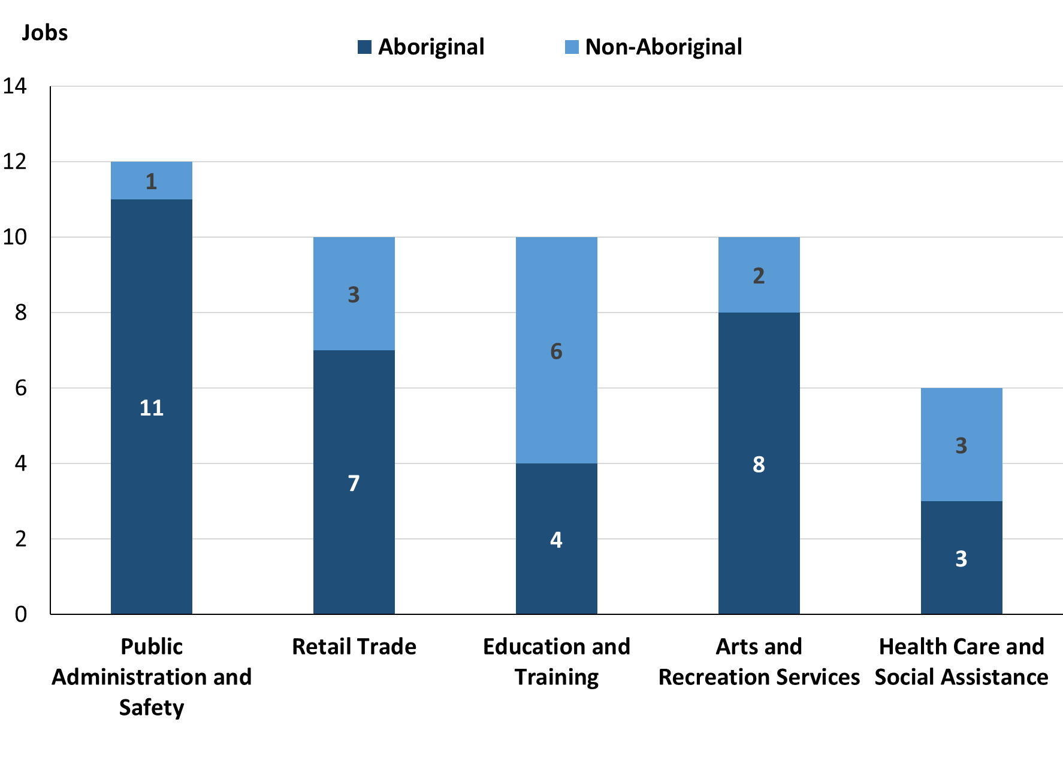
Source: Northern Territory Department of Industry, Tourism and Trade
In 2023 in Docker River:
- of the 33 jobs filled by Aboriginal people, there were:
- 11 jobs in Public Administration and Safety, an increase of 10 jobs from 2017
- 8 jobs in Arts and recreation services, an increase of 8 jobs from 2017
- 7 jobs in Retail Trade, an increase of 3 jobs from 2017
- of the 15 jobs filled by non-Aboriginal people, there were:
- 6 jobs in Education and Training, a decrease of 2 jobs from 2017
- 3 jobs in Retail Trade, a decrease of 2 jobs from 2017
- 3 jobs in Health Care and Social Assistance, a decrease of 2 jobs from 2017.

Table 12: Count of filled jobs by industry and employment status, 2017 (a)(c)(e)(h)
Industry (ANZSIC division) | 2017
Industry (ANZSIC division) | Aboriginal |  |  | Non-Aboriginal |  |  | Total
Industry (ANZSIC division) | Perm | Temp | Total | Perm | Temp | Total | Perm | Temp | Total
Administrative and Support Services | 2 | 0 | 2 | 1 | 0 | 1 | 3 | 0 | 3
Education and Training | 0 | 11 | 11 | 5 | 3 | 8 | 5 | 14 | 19
Health Care and Social Assistance | 0 | 1 | 1 | 3 | 2 | 5 | 3 | 3 | 6
Public Administration and Safety | 0 | 1 | 1 | 1 | 0 | 1 | 1 | 1 | 2
Retail Trade | 0 | 4 | 4 | 1 | 4 | 5 | 1 | 8 | 9
Total | 2 | 17 | 19 | 11 | 9 | 20 | 13 | 26 | 39
Source: Northern Territory Department of Industry, Tourism and Trade

Table 13: Count of filled jobs by industry and employment status, 2023 (a)(c)(e)(h)
Industry (ANZSIC division) | 2023
Industry (ANZSIC division) | Aboriginal |  |  | Non-Aboriginal |  |  | Total
Industry (ANZSIC division) | Perm | Temp | Total | Perm | Temp | Total | Perm | Temp | Total
Arts and Recreation Services | 0 | 8 | 8 | 2 | 0 | 2 | 2 | 8 | 10
Education and Training | 0 | 4 | 4 | 0 | 6 | 6 | 0 | 10 | 10
Health Care and Social Assistance | 3 | 0 | 3 | 3 | 0 | 3 | 6 | 0 | 6
Public Administration and Safety | 0 | 11 | 11 | 1 | 0 | 1 | 1 | 11 | 12
Retail Trade | 0 | 7 | 7 | 2 | 1 | 3 | 2 | 8 | 10
Total | 3 | 30 | 33 | 8 | 7 | 15 | 11 | 37 | 48
Source: Northern Territory Department of Industry, Tourism and Trade

In 2023 in Docker River:
- of the 11 Permanent jobs, there were:
- 6 jobs in Health Care and Social Assistance, an increase of 3 jobs from 2017,
- Aboriginal people filled 3 jobs, an increase of 3 jobs from 2017
- non-Aboriginal people filled 3 jobs, unchanged from 2017
- 2 jobs in Arts and recreation services, an increase of 2 jobs from 2017, including:
- Aboriginal people filled 0 jobs, unchanged from 2017
- non-Aboriginal people filled 2 jobs, an increase of 2 jobs from 2017
- 2 jobs in Retail Trade, an increase of 1 job from 2017, including:
- Aboriginal people filled 0 jobs, unchanged from 2017
- non-Aboriginal people filled 2 jobs, an increase of 1 job from 2017
- of the 37 Temporary jobs, there were:
- 11 jobs in Public Administration and Safety, an increase of 10 jobs from 2017, including:
- Aboriginal people filled 11 jobs, an increase of 10 jobs from 2017
- non-Aboriginal people filled 0 jobs, unchanged from 2017
- 10 jobs in Education and Training, a decrease of 4 jobs from 2017, including:
- Aboriginal people filled 4 jobs, a decrease of 7 jobs from 2017
- non-Aboriginal people filled 6 jobs, an increase of 3 jobs from 2017
- 8 jobs in Arts and recreation services, an increase of 8 jobs from 2017, including:
- Aboriginal people filled 8 jobs, an increase of 8 jobs from 2017
- non-Aboriginal people filled 0 jobs, unchanged from 2017.

Jobs by Occupation
Table 14: Count of filled jobs by occupation, 2017 & 2023 (a)(f)(g)
Occupation (ANZSCO major group) | 2017 |  | 2023 |  | Change  2017-2023
Occupation (ANZSCO major group) | Total | % of Total | Total | % of Total | Total
Clerical and Administrative Workers | 3 | 7.7% | 7 | 14.6% | 4
Community and Personal Service Workers | 13 | 33.3% | 11 | 22.9% | -2
Labourers | 1 | 2.6% | 1 | 2.1% | 0
Managers | 3 | 7.7% | 2 | 4.2% | -1
Professionals | 10 | 25.6% | 18 | 37.5% | 8
Sales Workers | 8 | 20.5% | 8 | 16.7% | 0
Technicians and Trades Workers | 1 | 2.6% | 1 | 2.1% | 0
Total | 39 | 100.0% | 48 | 100.0% | 9
Source: Northern Territory Department of Industry, Tourism and Trade
Chart 9: Count of top 6 filled jobs by occupation, 2017 & 2023 (a)(f)(g)

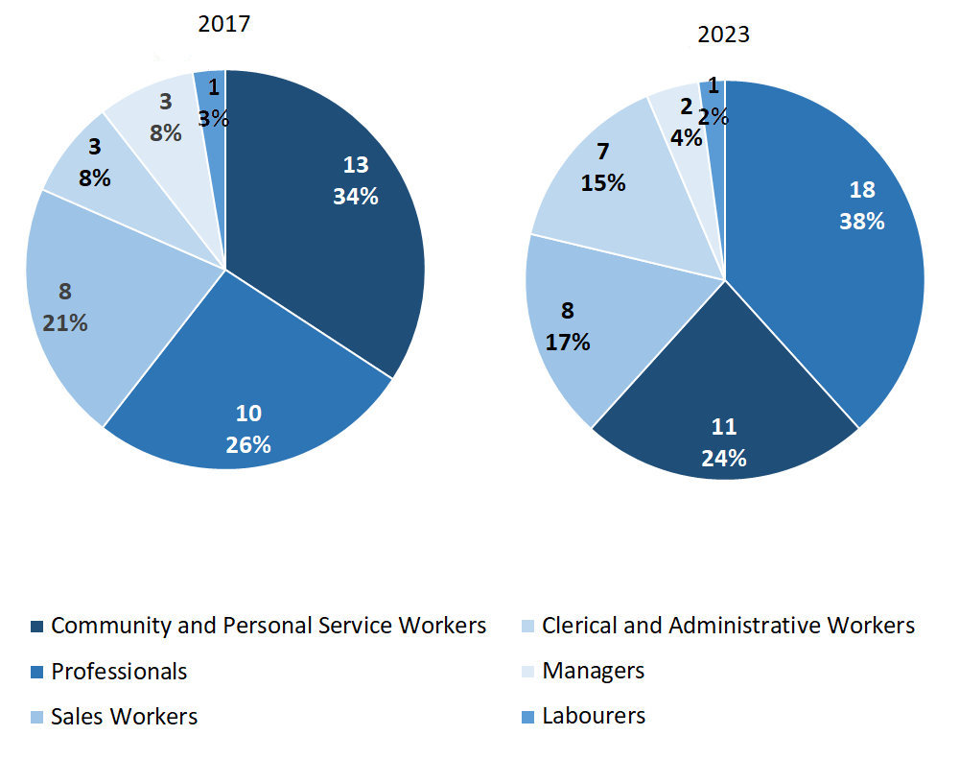Source: Northern Territory Department of Industry, Tourism and Trade
In 2023 in Docker River:
- Professionals were the largest occupation classification in terms of filled jobs, accounting for 18 jobs (37.5% of total filled jobs), an increase of 8 jobs from 2017
- other significant occupation classifications were:
- Community and Personal Service Workers (11 jobs or 22.9%), a decrease of 2 jobs from 2017
- Sales Workers (8 jobs or 16.7%), unchanged from 2017
- Clerical and Administrative Workers (7 jobs or 14.6%), an increase of 4 jobs from 2017.

Table 15: Count of filled jobs by ANZSCO occupation, 2017 & 2023 (a)(c)(f)(g)
Occupation (ANZSCO major group) | 2017 |  |  | 2023 |  |  | Change  2017-2023
Occupation (ANZSCO major group) | Aboriginal | Non-Aboriginal | Total | Aboriginal | Non-Aboriginal | Total | Aboriginal | Non-Aboriginal | Total
Clerical and Administrative Workers | 2 | 1 | 3 | 4 | 3 | 7 | 2 | 2 | 4
Community and Personal Service Workers | 12 | 1 | 13 | 11 | 0 | 11 | -1 | -1 | -2
Labourers | 0 | 1 | 1 | 1 | 0 | 1 | 1 | -1 | 0
Managers | 0 | 3 | 3 | 0 | 2 | 2 | 0 | -1 | -1
Professionals | 1 | 9 | 10 | 10 | 8 | 18 | 9 | -1 | 8
Sales Workers | 4 | 4 | 8 | 7 | 1 | 8 | 3 | -3 | 0
Technicians and Trades Workers | 0 | 1 | 1 | 0 | 1 | 1 | 0 | 0 | 0
Total | 19 | 20 | 39 | 33 | 15 | 48 | 14 | -5 | 9
Source: Northern Territory Department of Industry, Tourism and Trade
In 2023 in Docker River:
- of the 33 jobs filled by Aboriginal people, there were:
- Community and Personal Service Workers in 11 jobs, a decrease of 1 job from 2017
- Professionals in 10 jobs, an increase of 9 jobs from 2017
- Sales Workers in 7 jobs, an increase of 3 jobs from 2017
- of the 15 jobs filled by non-Aboriginal people, there were:
- Professionals in 8 jobs, a decrease of 1 job from 2017
- Clerical and Administrative Workers in 3 jobs, an increase of 2 jobs from 2017
- Managers in 2 jobs, a decrease of 1 job from 2017.

Jobs by Industry by Occupation
Table 16: Count of filled jobs by occupation and by industry, 2017 (a)(f)(g)(h)
2017
Industry (ANZSIC Division) | Occupation (ANZSCO major group)
Industry (ANZSIC Division) | Clerical and Administrative Workers | Community and Personal Service Workers | Labourers | Machinery Operators and Drivers | Managers | Professionals | Sales Workers | Technicians and Trades Workers | Other Occupations | Total
Administrative and Support Services | 3 | 0 | 0 | 0 | 0 | 0 | 0 | 0 | 0 | 3
Education and Training | 0 | 12 | 1 | 0 | 1 | 5 | 0 | 0 | 0 | 19
Health Care and Social Assistance | 0 | 0 | 0 | 0 | 1 | 5 | 0 | 0 | 0 | 6
Public Administration and Safety | 0 | 1 | 0 | 0 | 0 | 0 | 0 | 1 | 0 | 2
Retail Trade | 0 | 0 | 0 | 0 | 1 | 0 | 8 | 0 | 0 | 9
Total | 3 | 13 | 1 | 0 | 3 | 10 | 8 | 1 | 0 | 39
Source: Northern Territory Department of Industry, Tourism and Trade

Table 17: Count of filled jobs by occupation and by industry, 2023 (a)(f)(g)(h)
2023
Industry (ANZSIC Division) | Occupation (ANZSCO major group)
Industry (ANZSIC Division) | Clerical and Administrative Workers | Community and Personal Service Workers | Labourers | Machinery Operators and Drivers | Managers | Professionals | Sales Workers | Technicians and Trades Workers | Other Occupations | Total
Arts and Recreation Services | 2 | 0 | 0 | 0 | 0 | 8 | 0 | 0 | 0 | 10
Education and Training | 0 | 3 | 1 | 0 | 0 | 5 | 0 | 1 | 0 | 10
Health Care and Social Assistance | 1 | 0 | 0 | 0 | 0 | 5 | 0 | 0 | 0 | 6
Public Administration and Safety | 4 | 8 | 0 | 0 | 0 | 0 | 0 | 0 | 0 | 12
Retail Trade | 0 | 0 | 0 | 0 | 2 | 0 | 8 | 0 | 0 | 10
Total | 7 | 11 | 1 | 0 | 2 | 18 | 8 | 1 | 0 | 48
Source: Northern Territory Department of Industry, Tourism and Trade

In 2023 in Docker River:
- Professionals held the majority of jobs with 18 jobs held (the largest occupation group) with
  - Arts and Recreation Services holding 8 jobs,
  - Education and Training holding 5 jobs
  - Health Care and Social Assistance industries holding 5 jobs
- Community and Personal Service Workers held the majority of jobs with 11 jobs (the second largest occupation group) with
  - Public Administration and Safety holding 8 jobs
  - Education and Training holding 6 jobs
- Public Administration and Safety (the largest industry) showed an increase of 10 filled jobs between 2023 and 2017
- Education and Training showed a decrease of 9 jobs between 2023 and 2017.

Jobs by Gender
Table 18: Count of filled jobs by gender, 2017 & 2023 (a)(c)(i)
Indicator | 2017 |  |  | 2023 |  |  | 2017-2023 Change
Indicator | Aboriginal | Non-Aboriginal | Total | Aboriginal | Non-Aboriginal | Total |  | Aboriginal | Non-Aboriginal | Total
Male | 4 | 8 | 12 | 9 | 6 | 15 |  | 5 | -2 | 3
Female | 15 | 12 | 27 | 20 | 8 | 28 |  | 5 | -4 | 1
Total | 19 | 20 | 39 | 33 | 15 | 48 |  | 14 | -5 | 9
Source: Northern Territory Department of Industry, Tourism and Trade
Chart 10: Count of filled jobs by gender, 2017 & 2023 (a)(c)(i)

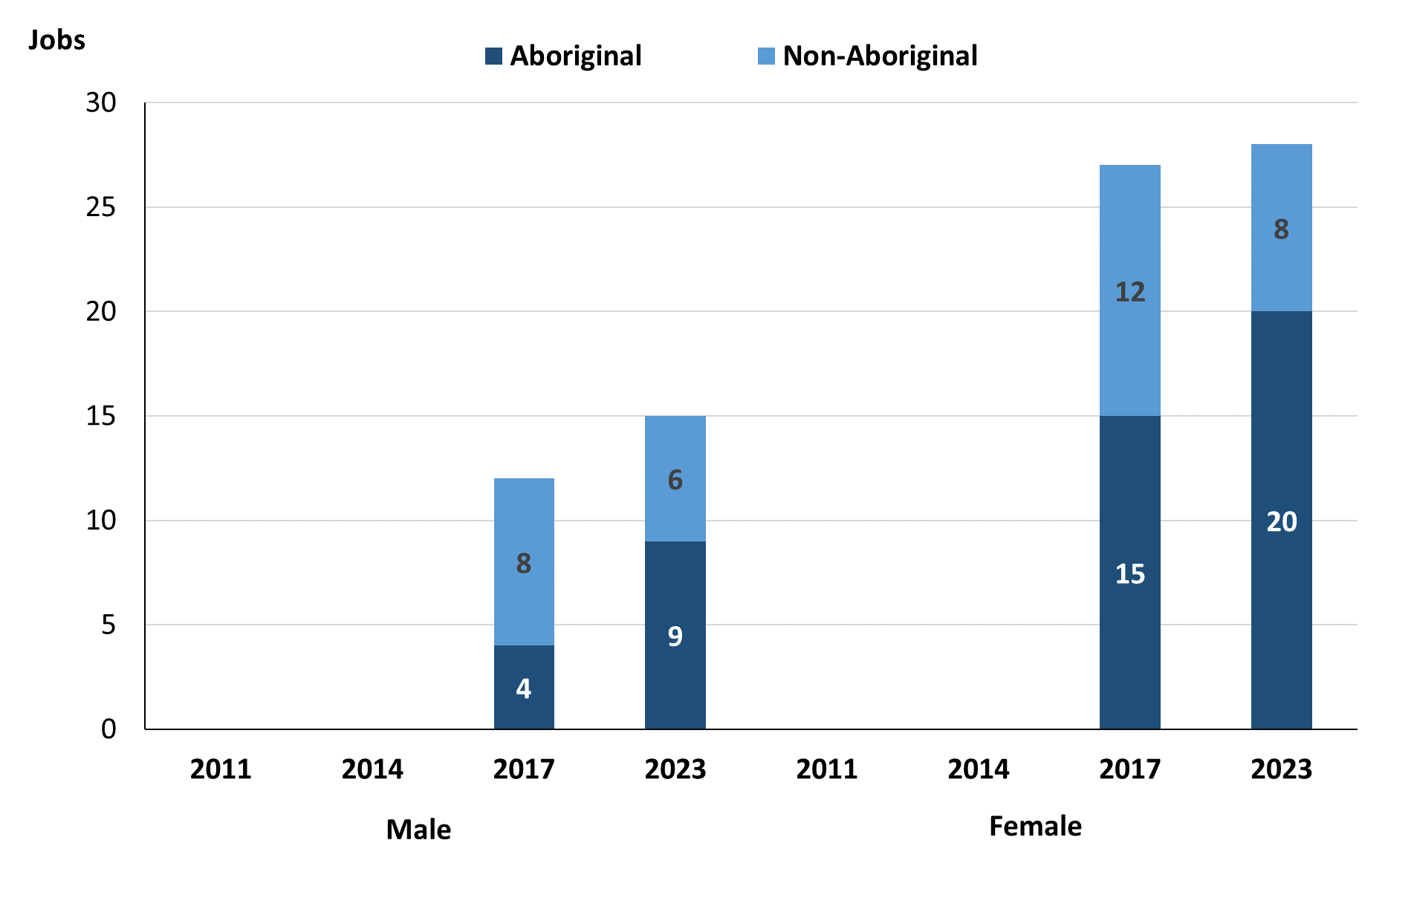
Source: Northern Territory Department of Industry, Tourism and Trade
In 2023 in Docker River there were:
- 15 jobs filled by males, an increase of 3 jobs from 2017. Of these:
- Aboriginal males filled 9 jobs, an increase of 5 jobs from 2017
- non-Aboriginal males filled 6 jobs, a decrease of 2 jobs from 2017
- 28 jobs filled by females, an increase of 1 job from 2017. Of these:
- Aboriginal females filled 20 jobs, an increase of 5 jobs from 2017
- non-Aboriginal females filled 8 jobs, a decrease of 4 jobs from 2017.
Table 19: Count of filled jobs by gender, by full-time/part-time status, by job permanency and by sector, 2017 (a)(b)(c)(d)(e)(i)
2017
Indicator | Male |  |  | Female |  |  | Total
Indicator | Aboriginal | Non-Aboriginal | Total | Aboriginal | Non-Aboriginal | Total | Aboriginal | Non-Aboriginal | Total
Full-time | 3 | 8 | 11 | 4 | 11 | 15 | 7 | 19 | 26
Part-time | 1 | 0 | 1 | 11 | 1 | 12 | 12 | 1 | 13
Total | 4 | 8 | 12 | 15 | 12 | 27 | 19 | 20 | 39
Permanent | 2 | 5 | 7 | 0 | 6 | 6 | 2 | 11 | 13
Temporary | 2 | 3 | 5 | 15 | 6 | 21 | 17 | 9 | 26
Total | 4 | 8 | 12 | 15 | 12 | 27 | 19 | 20 | 39
Public Sector | 0 | 1 | 1 | 1 | 2 | 3 | 1 | 3 | 4
Private Sector | 4 | 7 | 11 | 14 | 10 | 24 | 18 | 17 | 35
Total | 4 | 8 | 12 | 15 | 12 | 27 | 19 | 20 | 39
Source: Northern Territory Department of Industry, Tourism and Trade
Table 20: Count of filled jobs by gender, by full-time/part-time status, by job permanency and by sector 2023 (a)(b)(c)(d)(e)(i)
2023
Indicator | Male |  |  | Female |  |  | Total
Indicator | Aboriginal | Non-Aboriginal | Total | Aboriginal | Non-Aboriginal | Total | Aboriginal | Non-Aboriginal | Total
Full-time | 5 | 6 | 11 | 9 | 8 | 17 | 16 | 14 | 30
Part-time | 4 | 0 | 4 | 11 | 0 | 11 | 17 | 1 | 18
Total | 9 | 6 | 15 | 20 | 8 | 28 | 33 | 15 | 48
Permanent | 0 | 4 | 4 | 3 | 4 | 7 | 3 | 8 | 11
Temporary | 9 | 2 | 11 | 17 | 4 | 21 | 30 | 7 | 37
Total | 9 | 6 | 15 | 20 | 8 | 28 | 33 | 15 | 48
Public Sector | 0 | 1 | 1 | 0 | 0 | 0 | 0 | 1 | 1
Private Sector | 9 | 5 | 14 | 20 | 8 | 28 | 29 | 13 | 42
Total | 9 | 6 | 15 | 20 | 8 | 28 | 33 | 15 | 48
Source: Northern Territory Department of Industry, Tourism and Trade

In 2023 in Docker River:
- of the 15 jobs filled by males, there were:
- 9 jobs filled by Aboriginal males, an increase of 5 jobs from 2017, including:
- 5 full-time jobs, an increase of 2 jobs from 2017
- 4 part-time jobs, an increase of 3 jobs from 2017
- 0 Permanent jobs, a decrease of 2 jobs from 2017
- 9 Temporary jobs, an increase of 7 jobs from 2017
- 0 Public Sector jobs, unchanged from 2017
- 9 Private Sector jobs, an increase of 5 jobs from 2017
- 6 jobs filled by non-Aboriginal males, a decrease of 2 jobs from 2017, including:
- 6 full-time jobs, a decrease of 2 jobs from 2017
- 0 part-time jobs, unchanged from 2017
- 4 Permanent jobs, a decrease of 1 job from 2017
- 2 Temporary jobs, a decrease of 1 job from 2017
- 1 Public Sector job, unchanged from 2017
- 5 Private Sector jobs, a decrease of 2 jobs from 2017
- of the 28 jobs filled by females, there were:
- 20 jobs filled by Aboriginal females, an increase of 5 jobs from 2017, including:
- 9 full-time jobs, an increase of 5 jobs from 2017
- 11 part-time jobs, unchanged from 2017
- 3 Permanent jobs, an increase of 3 jobs from 2017
- 17 Temporary jobs, an increase of 2 jobs from 2017
- 0 Public Sector jobs, a decrease of 1 job from 2017
- 20 Private Sector jobs, an increase of 6 jobs from 2017
- 8 jobs filled by non-Aboriginal females, a decrease of 4 jobs from 2017, including:
- 8 full-time jobs, a decrease of 3 jobs from 2017
- 0 part-time jobs, a decrease of 1 job from 2017
- 4 Permanent jobs, a decrease of 2 jobs from 2017
- 4 Temporary jobs, a decrease of 2 jobs from 2017
- 0 Public Sector jobs, a decrease of 2 jobs from 2017
- 8 Private Sector jobs, a decrease of 2 jobs from 2017.

Jobs by Age
Table 21: Count of filled jobs by age, 2017 & 2023 (a)(c)(j)
Indicator | 2017 |  |  | 2023 |  |  | Change  2017-2023
Indicator | Aboriginal | Non-Aboriginal | Total | Aboriginal | Non-Aboriginal | Total | Aboriginal | Non-Aboriginal | Total
15-24 years | 0 | 0 | 0 | 4 | 0 | 4 | 4 | 0 | 4
25-44 years | 13 | 4 | 17 | 15 | 4 | 19 | 2 | 0 | 2
45+ years | 6 | 16 | 22 | 10 | 9 | 19 | 4 | -7 | -3
Total | 19 | 20 | 39 | 33 | 15 | 48 | 14 | -5 | 9
Source: Northern Territory Department of Industry, Tourism and Trade
Chart 11: Count of filled jobs by age, 2017 & 2023 (a)(c)(j)
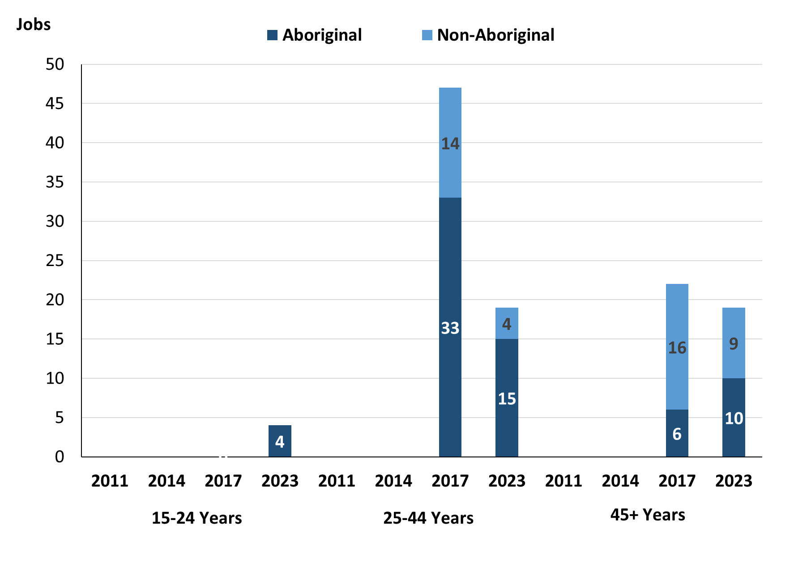
Source: Northern Territory Department of Industry, Tourism and Trade

In 2023 in Docker River there were:
- 4 jobs filled by people aged 15-24 years, an increase of 4 jobs from 2017, of these:
- Aboriginal people filled 4 jobs, an increase of 4 jobs from 2017
- non-Aboriginal people filled 0 jobs, unchanged from 2017
- 19 jobs filled by people aged 25-44 years, an increase of 2 jobs from 2017, of these:
- Aboriginal people filled 15 jobs, an increase of 2 jobs from 2017
- non-Aboriginal people filled 4 jobs, unchanged from 2017
- 19 jobs filled by people aged 45+ years, a decrease of 3 jobs from 2017, of these:
- Aboriginal people filled 10 jobs, an increase of 4 jobs from 2017
- non-Aboriginal people filled 9 jobs, a decrease of 7 jobs from 2017.

Table 22: Count of filled jobs by age, by full-time/part-time status, by job permanency and by sector, July 2017 (a)(b)(c)(d)(e)(i)
2017
Indicator | 15-24 years |  |  | 25-44 years |  |  | 45+ years |  |  | Total
Indicator | Aboriginal | Non-Aboriginal | Total | Aboriginal | Non-Aboriginal | Total | Aboriginal | Non-Aboriginal | Total | Aboriginal | Non-Aboriginal | Total
Full-time | 0 | 0 | 0 | 4 | 3 | 7 | 3 | 16 | 19 | 7 | 19 | 26
Part-time | 0 | 0 | 0 | 9 | 1 | 10 | 3 | 0 | 3 | 12 | 1 | 13
Total | 0 | 0 | 0 | 13 | 4 | 17 | 6 | 16 | 22 | 19 | 20 | 39
Permanent | 0 | 0 | 0 | 1 | 0 | 1 | 1 | 11 | 12 | 2 | 11 | 13
Temporary | 0 | 0 | 0 | 12 | 4 | 16 | 5 | 5 | 10 | 17 | 9 | 26
Total | 0 | 0 | 0 | 13 | 4 | 17 | 6 | 16 | 22 | 19 | 20 | 39
Public Sector | 0 | 0 | 0 | 0 | 0 | 0 | 1 | 3 | 4 | 1 | 3 | 4
Private Sector | 0 | 0 | 0 | 13 | 4 | 17 | 5 | 13 | 18 | 18 | 17 | 35
Total | 0 | 0 | 0 | 13 | 4 | 17 | 6 | 16 | 22 | 19 | 20 | 39
Source: Northern Territory Department of Industry, Tourism and Trade

Table 23: Count of filled jobs by age, by full-time/part-time status, by job permanency and by sector, September 2023 (a)(b)(c)(d)(e)(i)
2023
Indicator | 15-24 years |  |  | 25-44 years |  |  | 45+ years |  |  | Total
Indicator | Aboriginal | Non-Aboriginal | Total | Aboriginal | Non-Aboriginal | Total | Aboriginal | Non-Aboriginal | Total | Aboriginal | Non-Aboriginal | Total
Full-time | 0 | 0 | 0 | 7 | 4 | 11 | 7 | 9 | 16 | 16 | 14 | 30
Part-time | 4 | 0 | 4 | 8 | 0 | 8 | 3 | 0 | 3 | 17 | 1 | 18
Total | 4 | 0 | 4 | 15 | 4 | 19 | 10 | 9 | 19 | 33 | 15 | 48
Permanent | 0 | 0 | 0 | 2 | 4 | 6 | 1 | 3 | 4 | 3 | 8 | 11
Temporary | 4 | 0 | 4 | 13 | 0 | 13 | 9 | 6 | 15 | 30 | 7 | 37
Total | 4 | 0 | 4 | 15 | 4 | 19 | 10 | 9 | 19 | 33 | 15 | 48
Public Sector | 0 | 0 | 0 | 0 | 0 | 0 | 0 | 1 | 1 | 0 | 1 | 1
Private Sector | 4 | 0 | 4 | 15 | 4 | 19 | 10 | 8 | 18 | 29 | 12 | 41
Total | 4 | 0 | 4 | 15 | 4 | 19 | 10 | 9 | 19 | 33 | 15 | 48
Source: Northern Territory Department of Industry, Tourism and Trade
In 2023 in Docker River:
- of the 4 jobs filled by people aged 15-24 years, there were:
- 4 jobs filled by Aboriginal people, of which:
- none were full-time jobs, unchanged from 2017
- 4 were part-time jobs, an increase of 4 jobs from 2017
- none were Permanent jobs, unchanged from 2017
- 4 were Temporary jobs, an increase of 4 jobs from 2017
- none were Public Sector jobs, unchanged from 2017
- 4 were Private Sector jobs, an increase of 4 jobs from 2017
- no jobs filled by non-Aboriginal people
- of the 19 jobs filled by people aged 25-44 years, there were:
- 15 jobs filled by Aboriginal people, of which:
- 7 were full-time jobs, an increase of 3 jobs from 2017
- 8 were part-time jobs, a decrease of 1 job from 2017
- 2 were Permanent jobs, an increase of 1 job from 2017
- 13 were Temporary jobs, an increase of 1 job from 2017
- none were Public Sector jobs, unchanged from 2017
- 15 were Private Sector jobs, an increase of 2 jobs from 2017

- 4 jobs filled by non-Aboriginal people, of which:
- 4 were full-time jobs, an increase of 1 job from 2017
- none were part-time jobs, a decrease of 1 job from 2017
- 4 were Permanent jobs, an increase of 4 jobs from 2017
- none were Temporary jobs, a decrease of 4 jobs from 2017
- none were Public Sector jobs, unchanged from 2017
- 4 were Private Sector jobs, unchanged from 2017
- of the 19 jobs filled by people aged 45+ years, there were:
- 10 jobs filled by Aboriginal people, of which:
- 7 were full-time jobs, an increase of 4 jobs from 2017
- 3 were part-time jobs, unchanged from 2017
- 1 was a permanent job, unchanged from 2017
- 9 were Temporary jobs, an increase of 4 jobs from 2017
- none were Public Sector jobs, a decrease of 1 job from 2017
- 10 were Private Sector jobs, an increase of 5 jobs from 2017
- 9 jobs filled by non-Aboriginal people, of which:
- 9 were full-time jobs, a decrease of 7 jobs from 2017
- none were part-time jobs, unchanged from 2017
- 3 were Permanent jobs, a decrease of 8 jobs from 2017
- 6 were Temporary jobs, an increase of 1 job from 2017
- 1 was a Public Sector job, a decrease of 2 jobs from 2017
- 8 were Private Sector jobs, a decrease of 5 jobs from 2017.

Vocational Education and Training
Note: The 2010 data is in accordance with the new, standardised reporting procedures that focus on all training activities conducted in the remote town, irrespective of funding source, as compared to earlier publications. As a result, the 2010 VET data values in this publication might not match those in earlier publications.
The impact of the Remote Jobs and Communities Program (RJCP), established in 2013, has played a significant role in the reduction of accredited training in many remote towns across the Territory.

Table 24: Northern Territory Vocational Education and Training (VET) students, 2016 & 2023 (k)
VET Funding Group | 2016 |  | 2023 |  | Change
VET Funding Group | No. | % of Total | No. | % of Total | 2016-2023
Arts, Entertainment, Sports and Recreation | 0 | 0% | 4 | 33% | 4
Business and Clerical | 17 | 74% | 7 | 58% | -10
Community Services, Health and Education | 6 | 26% | 0 | 0% | -6
Primary Industry | 0 | 0% | 1 | 8% | 1
Total | 23 | 100% | 12 | 100% | -11
Source: Northern Territory Department of Industry, Tourism and Trade
In Docker River in 2023:
- there were 12 VET students, a decrease of 11 students from 2016
- VET activity with the most students were Business and Clerical with 7 students
- Arts, Entertainment, Sports and Recreation had 4 students
- Primary Industry had 1 student
- Arts, Entertainment, Sports and Recreation reported the largest increase in students with 4 students compared to 2016
- Business and Clerical reported the largest decrease in students with 10 less students over the same period.
Table 25: Northern Territory Vocational Education and Training (VET) unit enrolments, 2016 & 2023 (l)
VET Funding Group | 2016 |  | 2023 |  | Change
VET Funding Group | No. | % of Total | No. | % of Total | 2016-2023
Arts, Entertainment, Sports and Recreation | 0 | 0% | 7 | 9% | 7
Business and Clerical | 6 | 27% | 69 | 84% | 63
Community Services, Health and Education | 16 | 73% | 0 | 0% | -16
Primary Industry | 0 | 0% | 6 | 7% | 6
Total | 22 | 100% | 82 | 100% | 60
Source: Northern Territory Department of Industry, Tourism and Trade

In Docker River in 2023:
- there were 82 VET unit enrolments, an increase of 60 enrolments from 2016,
- VET activity with the most unit enrolments were Business and Clerical with 69-unit enrolments,
- Arts, Entertainment, Sports and Recreation had 7-unit enrolments,
- Primary Industry had 6-unit enrolments,
- Business and Clerical reported the largest increase in unit enrolments with 63-unit enrolments compared to 2016,
- Community Services, Health and Education reported the largest decrease in unit enrolments with 16 less unit enrolments over the same period.
Table 26: Northern Territory Vocational Education and Training (VET) nominal hours, 2016 & 2023 (m)
VET Funding Group | 2016 |  | 2023 |  | Change
VET Funding Group | No. | % of Total | No. | % of Total | 2016-2023
Arts, Entertainment, Sports and Recreation | 0 | 0% | 260 | 8% | 260
Business and Clerical | 460 | 14% | 2810 | 87% | 2350
Community Services, Health and Education | 2755 | 86% | 0 | 0% | -2755
Primary Industry | 0 | 0% | 160 | 5% | 160
Total | 3215 | 100% | 3230 | 100% | 15
Source: Northern Territory Department of Industry, Tourism and Trade
In Docker River in 2023:
- there were 3230 VET nominal hours delivered, an increase of 15 nominal hours delivered from 2016,
- VET activity with the most nominal hours delivered were Business and Clerical with 2,810 nominal hours delivered,
- Arts, Entertainment, Sports and Recreation delivered 260 nominal hours,
- Primary Industry delivered 160 nominal hours,
- Business and Clerical reported the largest increase in nominal hours delivered with 2,350 nominal hours compared to 2016,
- Community Services, Health and Education reported the largest decrease in nominal hours with 2,755 less nominal hours delivered over the same period.

Caveat: Nominal hours are based on the hours funded through Northern Territory Government contracts and fee for service. Students and units include delivery that may have been funded in a previous year. Because of these factors, a direct match cannot be made between hours and student/units.

Table 27: Northern Territory Vocational Education and Training (VET) unit completions, 2016 & 2023 (n)
VET Funding Group | 2016 |  | 2023 |  | Change
VET Funding Group | No. | % of Total | No. | % of Total | 2016-2023
Arts, Entertainment, Sports and Recreation | 0 | 0% | 4 | 31% | 4
Business and Clerical | 20 | 32% | 3 | 23% | -17
Community Services, Health and Education | 42 | 68% | 0 | 0% | -42
Primary Industry | 0 | 0% | 6 | 46% | 6
Total | 62 | 100% | 13 | 100% | -49
Source: Northern Territory Department of Industry, Tourism and Trade
In Docker River in 2023:
- there were 13 VET unit completions, a decrease of 49-unit completions from 2016,
- VET activity with the most unit completions were Primary Industry with 6-unit completions,
- Arts, Entertainment, Sports and Recreation had 4-unit completions,
- Business and Clerical had 3-unit completions,
- Primary Industry reported the largest increase in unit completions with 6-unit completions compared to 2016,
- Community Services, Health and Education reported the largest decrease in unit completions 42 less unit completions over the same period.

Population
Table 28: Population distribution by gender and age (p)(r)
Indicator | 2011 |  |  | 2021 |  |  | Change (2011-2021)
Indicator | Male | Female | Total | Male | Female | Total | Male | Female | Total
0-4 years | 11 | 10 | 21 | 10 | 8 | 18 | -1 | -2 | -3
5-14 years | 24 | 32 | 56 | 18 | 10 | 28 | -6 | -22 | -28
15-24 years | 27 | 42 | 69 | 5 | 12 | 17 | -22 | -30 | -52
25-44 years | 40 | 49 | 89 | 35 | 43 | 78 | -5 | -6 | -11
45-64 years | 25 | 25 | 50 | 29 | 28 | 57 | 4 | 3 | 7
65+ years | 9 | 17 | 26 | 9 | 11 | 20 | 0 | -6 | -6
Total | 125 | 166 | 291 | 107 | 118 | 225 | -18 | -48 | -66
Source: Australian Bureau of Statistics
In 2021 in Docker River:
- there were an estimated 225 people, of which:
- 107 (47.6%) were male
- 118 (52.4%) were female
- between 2011 and 2021, the overall population in Docker River decreased by 66 people from 2011, or an average of -2.3% per year compared to -0.5% across the 28 remote towns and 1.0% Territory wide
- the male population decreased by 18 people from 2011
- the female population decreased by 48 people from 2011
- in 2021, the working age population (15 years and over) in Docker River was an estimated 172 people (76.4% of the total population) compared with 234 people (80.4% of the total population) in 2011. Of these:
- 17 (7.6%) were between 15 and 24 years of age
- 78 (34.7%) were between 25 and 44 years of age
- 57 (25.3%) were between 45 and 64 years of age
- 20 (8.9%) were over 65 years of age
- of the 172 people of working age:
- 78 (45.3%) were male
- 94 (54.7%) were female.
There were 0.4 jobs in Docker River per working age person compared to 0.3 jobs per person across the 28 remote towns in the Northern Territory.

Chart 12: Population comparison (p)(q)
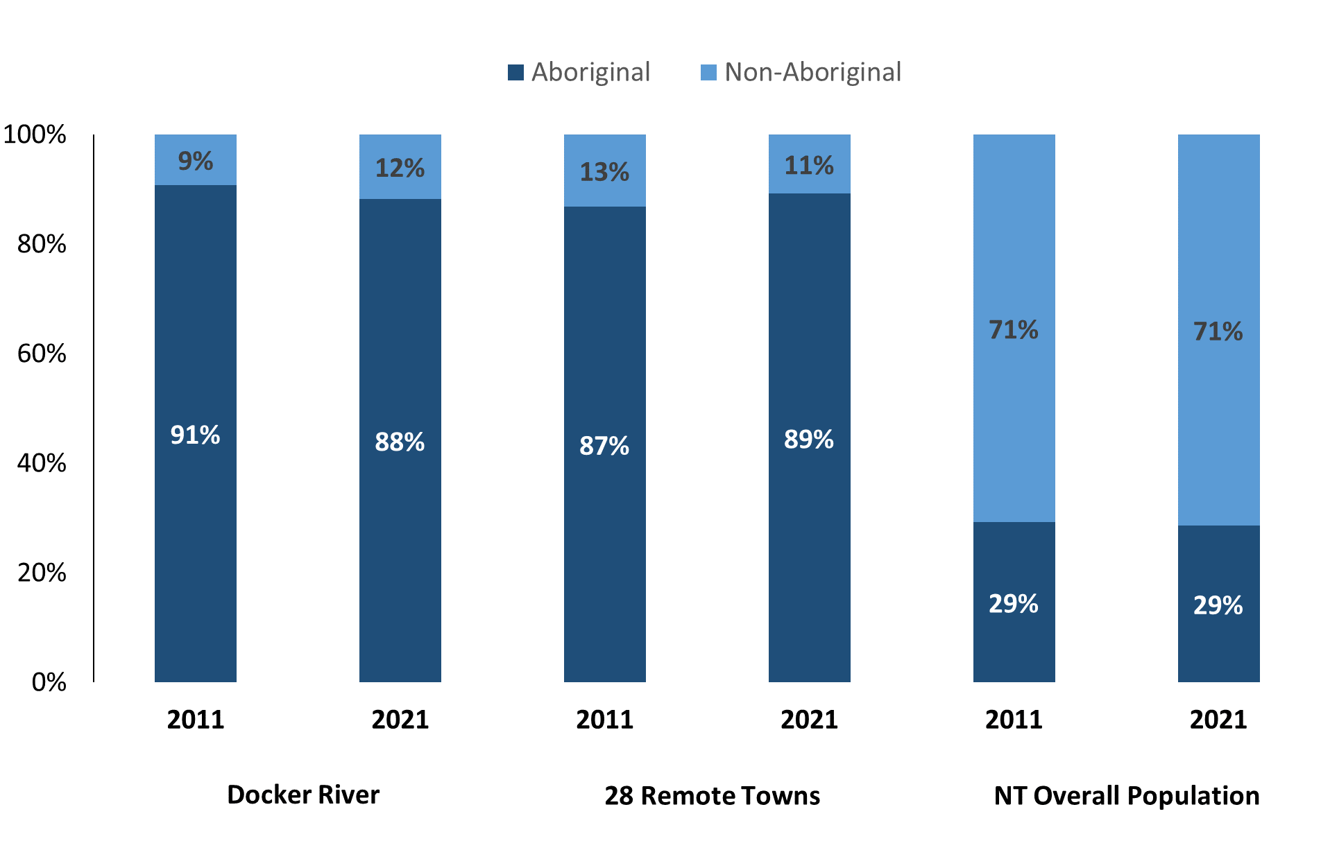
Source: Australian Bureau of Statistics
In 2021 in Docker River:
- 88% of the population in Docker River were Aboriginal, compared to 91% in 2011
- 89% of the population across all 28 remote towns were Aboriginal
- 29% of the NT population were Aboriginal.
Table 29: Unemployment and Aboriginal participation rates (q)
 | Docker River |  |  | Northern Territory
 | Aboriginal | Non-Aboriginal | Total | Aboriginal | Non-Aboriginal | Total
Unemployment rate | 11.1% | 0.0% | 6.8% | 20.8% | 3.2% | 5.6%
Participation rate | 23.8% | 100.0% | 35.6% | 35.4% | 78.3% | 64.9%
Source: Australian Bureau of Statistics
In 2021 in Docker River the:
- total unemployment rate was 6.8% compared to 5.6% for the total Northern Territory
- Aboriginal unemployment rate was 11.1% compared to 20.8% for the total Northern Territory
- non-Aboriginal unemployment rate was 0.0% compared to 3.2% for the total Northern Territory
- total participation rate was 35.6% compared to 64.9% for the total Northern Territory
- Aboriginal participation rate was 23.8% compared to 35.4% for the total Northern Territory
- non-Aboriginal participation rate was 100.0% compared to 78.3% for the total Northern Territory.

Community Development Program
Table 30: Community Development Program Aboriginal Job Seekers, 31 December 2023 (o)
Indicator | Aboriginal
Indicator | No. | %
Total Aboriginal Job Seekers | 94 | N/A
Age (years)
15-24 | <20 | N/A
25-44 | n.p. | N/A
45+ | 38 | 40.4%
Total | 94 | 100.0%
Gender
Male | 46 | 48.9%
Female | 48 | 51.1%
Total | 94 | 100.0%
Employment Outcome – 1 January 2023 to 31 December 2023
13 Weeks | <20 | N/A
26 Weeks | <20 | N/A
Source: Department of Prime Minister and Cabinet
Chart 13: Community Development Program Aboriginal Job Seekers by Gender and Age Group, 31 December 2023 (o)
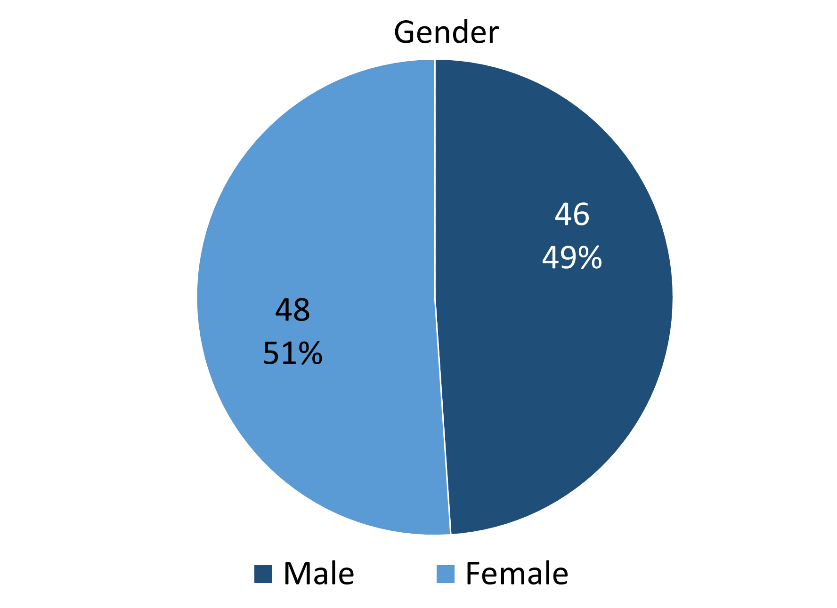
Source: Department of Prime Minister and Cabinet
As of 31 December 2023, in Docker River, there were 94 CDP Aboriginal job seekers, of these:
- 46 (48.9%) were male and 48 (51.1%) were female
- Less than 20 were aged 15-24 years, numbers not provided for ages 25-44 years, and 38 (40.4%) were aged 45+ years
- between 1 January 2023 to 31 December 2023, less than 20 had reached the 13-week reporting milestone and less than 20 had reached the 26-week reporting milestone.

Businesses
Table 31: Businesses by sector (d)(s)
Business Name | Reported on in 2017 | Reported on in 2023
PUBLIC SECTOR
Department of Health | Yes | No
MacDonnell Regional Council | Yes | Yes
PRIVATE SECTOR
Australian Regional and Remote Community Services Ltd | Yes | No
Central Land Council | No | Yes
Mutitjulu Community Aboriginal Corporation | Yes | No
NPY Women’s Council | No | Yes
Nyangatjatjara Aboriginal Corporation (Nyangatjatjara Primary College) | Yes | Yes
Rise Ngurratjuta Pty Ltd | No | Yes
The Trustee for Wana Ungkunytja Trust trading as Anangu Jobs | Yes | No
Tjarlirli Art Indigenous Corporation | No | Yes
Western Desert Highway Pty Ltd trading as Docker River Store | Yes | Yes
Purple House WDNWPT (Kaltukatjara Dialysis Unit) | No | Yes
Source: Northern Territory Department of Industry, Tourism and Trade
Note: Business names captured have been identified by the current 2023 Business ABN name listed.
In 2023 in Docker River:
- there were 8 businesses reported on, of which:
- 1 business was from the Public Sector (12.5%)
- 7 businesses were from the Private Sector (87.5%).

Notes
- These counts represent numbers of filled jobs and not number of people. As such the totals represent the total number of filled jobs, not the total number of employees. This count is not directly comparable to the total number of employed people as a person may have several jobs or one job may be shared by more than one person.
- Full-time is defined as a job usually requiring 35 hours or more per week or that required 35 hours or more work during the reference week. Part-time is defined as a job usually requiring less than 35 hours per week or that required less than 35 hours work during the reference week. The reference week refers to the period that respondents were asked to provide information about. In most instances it would be the week prior to the week the questionnaire was completed. Questionnaires were predominantly conducted in June and July.
- Care needs to be taken when analysing the counts of filled jobs by Aboriginal people. Aboriginality was reported by the business representative completing the questionnaire.
- Sector was classified using the Standard Economic Sector of Classifications of Australia (SESCA), 2008.
- Job permanency is classified according to what the business believes the level of job permanency is based on guidelines provided by data collectors. Those guidelines state a permanent job has paid annual and/or sick leave entitlements while a temporary job includes casual and fixed-term contract jobs.
- Classified according to the Australian and New Zealand Standard Classification of Occupations (ANZSCO), 2006, major occupation level.
- Other Occupations include jobs where occupation was not stated, not known or inadequately described.
- Classified using the Australian and New Zealand Standard Industrial Classification (ANZSIC), 2006, division level.
- Care needs to be taken when analysing the counts of filled jobs by the gender of people in the jobs. The gender of the person employed in a job is reported by the business representative completing the questionnaire.
- Care needs to be taken when analysing the counts of filled jobs by the age of people in the jobs. The age of the person employed in a job is reported by the business representative completing the questionnaire.
- Students represent the number of individual clients that enrolled in a Vocational Education and Training unit during the calendar year.
- Unit enrolments represent the count of individual units that students enrolled in during the calendar year.
- Nominal hours delivered is the sum of the nominal hours of the units commenced during the calendar year regardless of when the course enrolment commenced.
- Unit completions are the count of all successfully completed units reported in the calendar year regardless of the year of commencement of the units.
- The Community Development Program (CDP) supports job seekers in remote Australia to build skills, address barriers and contribute to their communities through a range of flexible activities. Under the CDP, job seekers with activity requirements are expected to do up to 25 hours per week of work-like activities that benefit their community. It should be noted that some CDP participants may be reported on within the profile if they are attached to a filled position with an employer captured in the survey. Due to confidentiality issues, data below 20 people is not published.
- Population estimates for both 2011 and 2021 are taken from the estimated resident population (ERP) data produced by the Australian Bureau of Statistics (ABS) and based on Australian Statistical Geography Standard (ASGS) Statistical Area Level 1 (SA1) regions. ERP are official estimates of the Australian population, which link people to a place of usual residence with Australia. All ERP data sources, including the Census of Population and Housing (Census), are subject to error (including inaccuracies in collection, recording and processing data) and should be used with caution.
- Indigenous population proportions, unemployment and workforce participation rates are based on ABS Census counts at ASGS Indigenous Locations (ILOCs) for each remote town.
- Working-age population includes all residents aged 15 years and over (commonly referred to as the civilian population) and consists of people that are employed, unemployed or not in the labour force.
- A ‘business’ has been defined as any organisation that has undertaken productive activities in the last year, including companies, non-profit organisations, government departments and enterprises operating within the designated remote geography (town), and has one or more employees in paid employment and an Australian Business Number (ABN).

Abbreviations and Acronyms
ABN Australian Business Number
ABS Australian Bureau of Statistics
ANZSCO Australian and New Zealand Standard Classification of Occupations
ANZSIC Australian and New Zealand Standard Industrial Classification
ASGS Australian Statistical Geography Standard
CDP Community Development Program
ERP Estimated Resident Population
ILOC Indigenous Locations
nec Not Elsewhere Classified
No. Number
Perm Permanent
ppt Percentage point
RJCP Remote Jobs and Communities Program
Temp Temporary
SA1 Statistical Area Level 1
VET Vocational Education and Training

The number of filled jobs does not represent numbers of people as a person may have several jobs or one job may be shared by more than one person.

