Mineral Titles Act 2010
NOTICE OF LAND CEASING TO BE A MINERAL TITLE APPLICATION AREA
Title Type and Number: | Exploration Licence 33884
Area Ceased on: | 17 January 2025
Area: | 168 Blocks, 549.60 km²
Locality: | INVERWAY
Name of Applicant(s)/Holder(s): | 100% CALIDUS OTWAYS PTY LTD [ACN. 640 807 183]
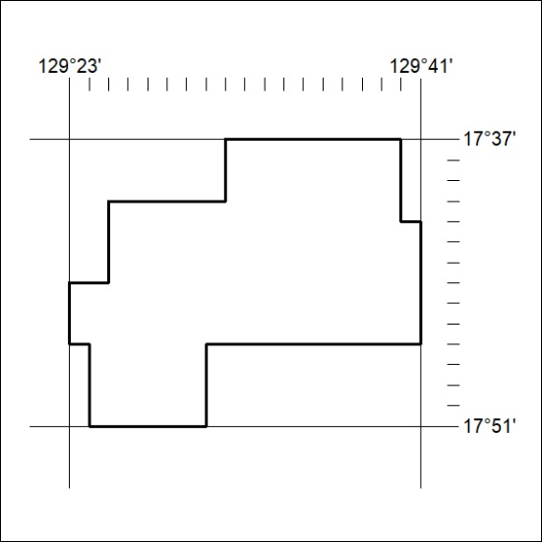

30/25

Mineral Titles Act 2010
NOTICE OF LAND CEASING TO BE A MINERAL TITLE APPLICATION AREA
Title Type and Number: | Exploration Licence 33885
Area Ceased on: | 17 January 2025
Area: | 219 Blocks, 715.67 km²
Locality: | INVERWAY
Name of Applicant(s)/Holder(s): | 100% CALIDUS OTWAYS PTY LTD [ACN. 640 807 183]
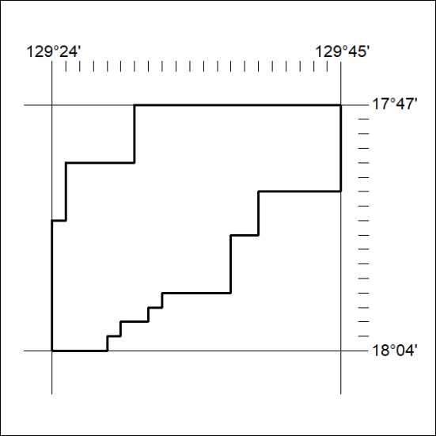

31/25

