Mineral Titles Act 2010
NOTICE OF LAND CEASING TO BE A MINERAL TITLE APPLICATION AREA
Title Type and Number: | Exploration Licence 33944
Area Ceased on: | 16 January 2025
Area: | 153 Blocks, 483.29 km²
Locality: | ANNINGIE
Name of Applicant(s)/Holder(s): | 100% LITHIUM DEVELOPMENTS PTY LTD [ACN. 612 245 020]
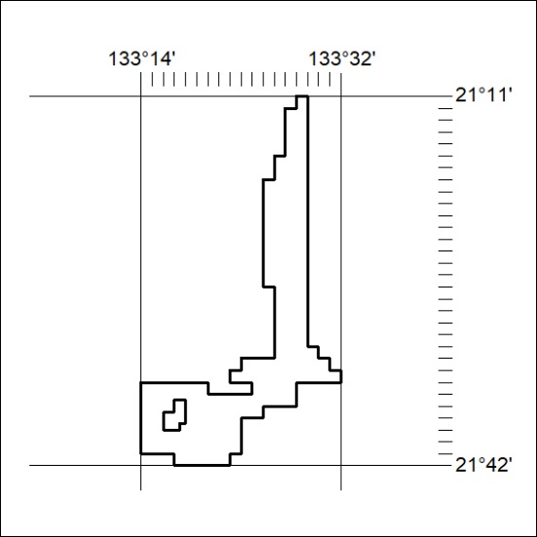

29/25

