Mineral Titles Act 2010
NOTICE OF LAND CEASING TO BE A MINERAL TITLE AREA
Title Type and Number: | Mineral Leases (Central) 4, 5, 127 & 129
Area ceased on: | 27 November 2024
Area: | 60.00 Hectare
Locality: | TENNANT CREEK
Name of Applicants(s)Holder(s): | 100% SANTEXCO PTY LTD [ACN. 002 910 296]
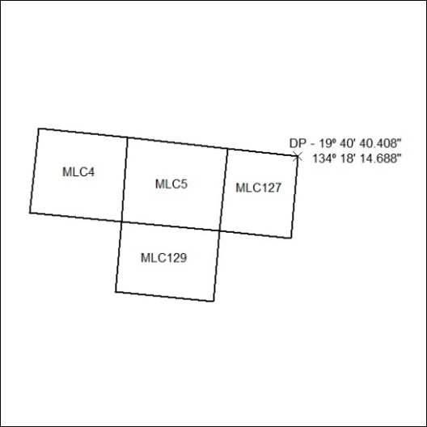
(Area now amalgamated into Mineral Lease 34011 under s102)

433/24

Mineral Titles Act 2010
NOTICE OF LAND CEASING TO BE A MINERAL TITLE AREA
Title Type and Number: | Mineral Leases (Central) 348, 349, 350 & 351
Area ceased on: | 27 November 2024
Area: | 64.00 Hectare
Locality: | TENNANT CREEK
Name of Applicants(s)Holder(s): | 100% SANTEXCO PTY LTD [ACN. 002 910 296]
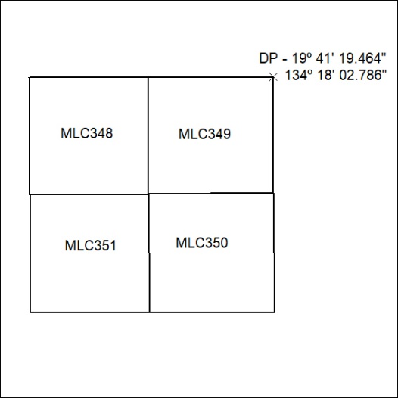
(Area now amalgamated into Mineral Lease 34012 under s102)

434/24

Mineral Titles Act 2010
NOTICE OF LAND CEASING TO BE A MINERAL TITLE AREA
Title Type and Number: | Extractive Mineral Permit 30942
Area ceased on: | 29 November 2024
Area: | 16.00 Hectare
Locality: | MARY RIVER
Name of Applicants(s)Holder(s): | 100% OSTOJIC GROUP PTY LTD* [ACN. 009 629 805]
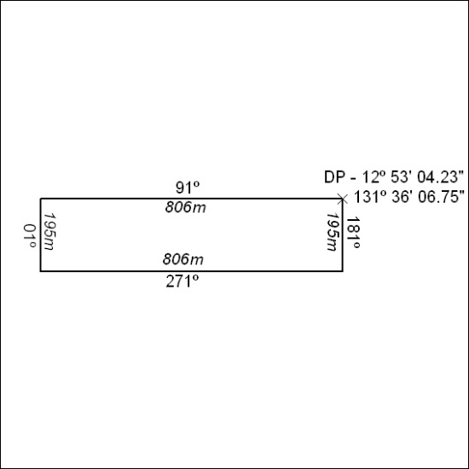

435/24

Mineral Titles Act 2010
NOTICE OF LAND CEASING TO BE A MINERAL TITLE APPLICATION AREA
Title Type and Number: | Exploration Licence 33623
Area Ceased on: | 29 November 2024
Area: | 21 Blocks, 65.13 km²
Locality: | EGERTON
Name of Applicant(s)/Holder(s): | 100% TALI RESOURCES PTY LTD [ACN. 624 284 706]
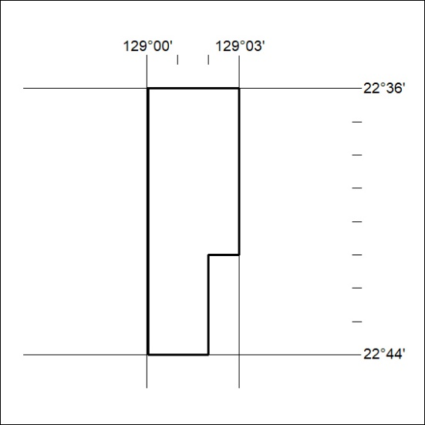

436/24

