Mineral Titles Act 2010
NOTICE OF LAND CEASING TO BE A MINERAL TITLE AREA
Title Type and Number: | Exploration Licence 33045
Area Ceased on: | 24 November 2024
Area: | 54 Blocks, 178.06 km²
Locality: | NEWRY
Name of Applicant(s)/Holder(s): | 100% ROSEWOOD MINERALS PTY LTD [ACN. 653 271 179]
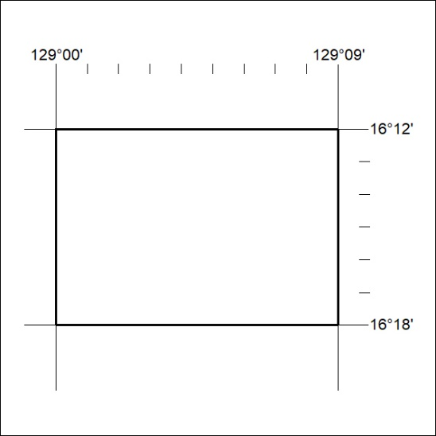

427/24

Mineral Titles Act 2010
NOTICE OF LAND CEASING TO BE A MINERAL TITLE AREA
Title Type and Number: | Exploration Licence 32080
Area Ceased on: | 25 November 2024
Area: | 27 Blocks, 79.66 km²
Locality: | DOREEN
Name of Applicant(s)/Holder(s): | 100% ECLIPSE METALS LIMITED* [ACN. 142 366 541]
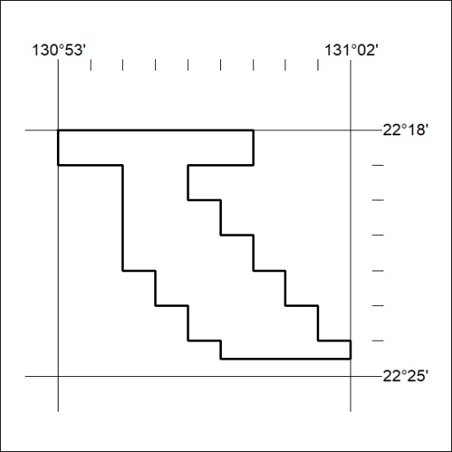

428/24

Mineral Titles Act
NOTICE OF GRANT OF A MINERAL TITLE
Title Type and Number: | Exploration Licence 33684
Granted: | 25 November 2024, for a period of 6 Years
Area: | 57 Blocks, 179.04 km²
Locality: | CRAWFORD
Name of Holder/s: | 100% WILUNA WEST GOLD PTY LTD [ACN. 116 550 111]
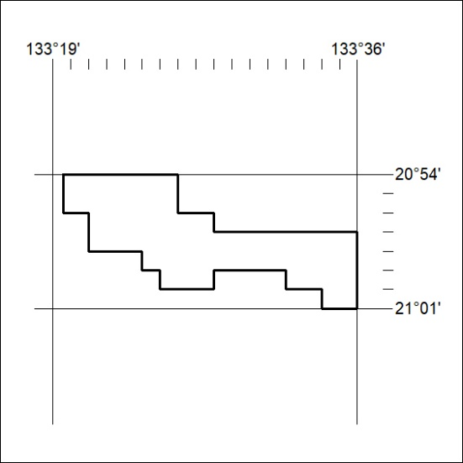
Area granted is indicated above. The titleholder is not permitted to exercise occupational rights on any land that is subject to a development title, or an application for a development title. Any land the subject of a Reserved Land gazettal under the Mineral Titles Act and all land vested in the Commonwealth of Australia is also excluded by description but not excised from the grant area.

429/24

