Mineral Titles Act 2010
NOTICE OF LAND CEASING TO BE A MINERAL TITLE APPLICATION AREA
Title Type and Number: | Exploration Licence 33682
Area Ceased on: | 15 May 2024
Area: | 65 Blocks, 208.11 km²
Locality: | CRAWFORD
Name of Applicant(s)/Holder(s): | 100% ROX 1 PTY LTD [ACN. 649 500 916]
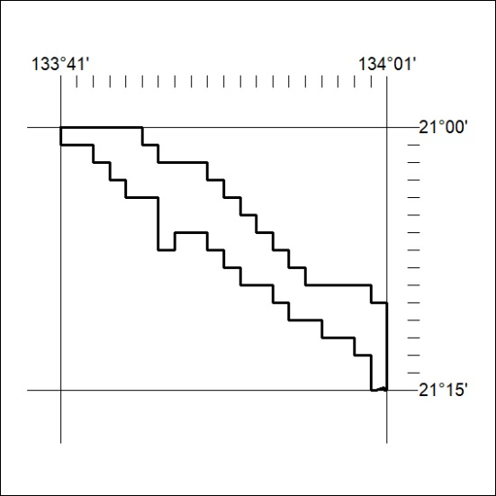
199/24

