Mineral Titles Act 2010
NOTICE OF LAND CEASING TO BE A MINERAL TITLE AREA
Title Type and Number: | Mineral Lease (Southern) 119
Area ceased on: | 18 April 2024
Area: | 8.00 Hectare
Locality: | TANAMI
Name of Applicants(s)Holder(s): | 50% NORTHERN STAR (TANAMI) PTY LTD [ACN. 603 860 831], 50% TANAMI (NT) PTY LTD [ACN. 141 658 933]
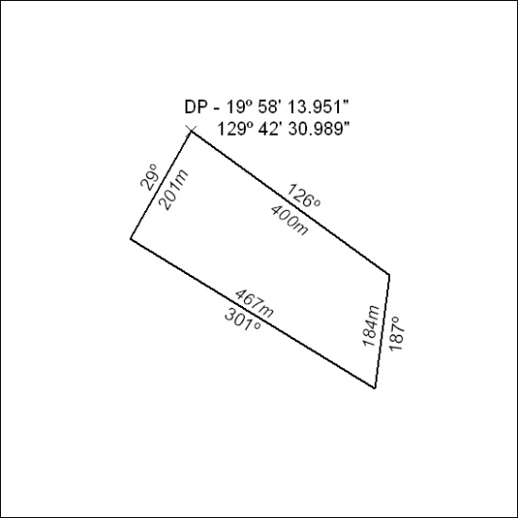
(Area now amalgamated into Mineral Lease 33760 under s102)

145/24

Mineral Titles Act 2010
NOTICE OF LAND CEASING TO BE A MINERAL TITLE AREA
Title Type and Number: | Mineral Lease (Southern) 120
Area ceased on: | 18 April 2024
Area: | 9.00 Hectare
Locality: | TANAMI
Name of Applicants(s)Holder(s): | 50% NORTHERN STAR (TANAMI) PTY LTD [ACN. 603 860 831], 50% TANAMI (NT) PTY LTD [ACN. 141 658 933]
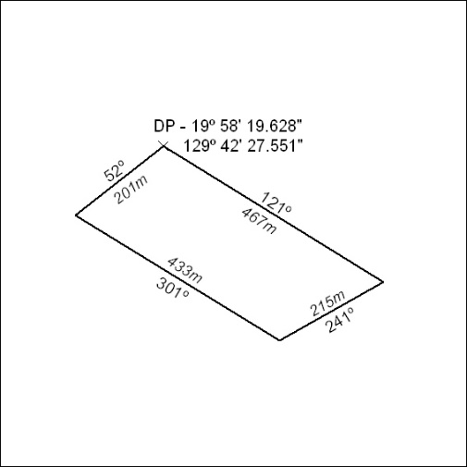
(Area now amalgamated into Mineral Lease 33760 under s102)

146/24

Mineral Titles Act 2010
NOTICE OF LAND CEASING TO BE A MINERAL TITLE AREA
Title Type and Number: | Mineral Lease (Southern) 121
Area ceased on: | 18 April 2024
Area: | 8.00 Hectare
Locality: | TANAMI
Name of Applicants(s)Holder(s): | 50% NORTHERN STAR (TANAMI) PTY LTD [ACN. 603 860 831], 50% TANAMI (NT) PTY LTD [ACN. 141 658 933]
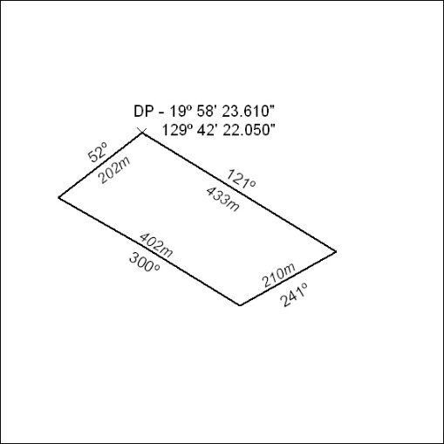
(Area now amalgamated into Mineral Lease 33760 under s102)

147/24

Mineral Titles Act 2010
NOTICE OF LAND CEASING TO BE A MINERAL TITLE AREA
Title Type and Number: | Mineral Lease (Southern) 122
Area ceased on: | 18 April 2024
Area: | 10.00 Hectare
Locality: | TANAMI
Name of Applicants(s)Holder(s): | 50% NORTHERN STAR (TANAMI) PTY LTD [ACN. 603 860 831], 50% TANAMI (NT) PTY LTD [ACN. 141 658 933]
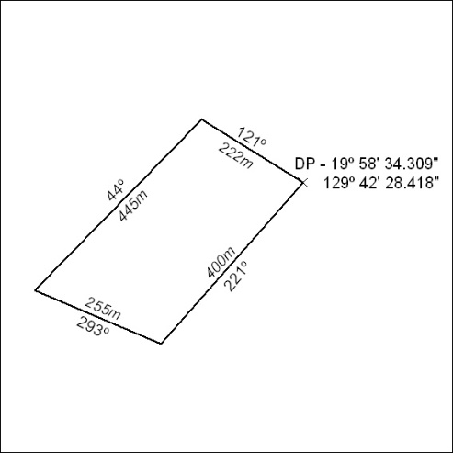
(Area now amalgamated into Mineral Lease 33760 under s102)

148/24

Mineral Titles Act 2010
NOTICE OF LAND CEASING TO BE A MINERAL TITLE AREA
Title Type and Number: | Mineral Lease (Southern) 123
Area ceased on: | 18 April 2024
Area: | 8.00 Hectare
Locality: | TANAMI
Name of Applicants(s)Holder(s): | 50% NORTHERN STAR (TANAMI) PTY LTD [ACN. 603 860 831], 50% TANAMI (NT) PTY LTD [ACN. 141 658 933]
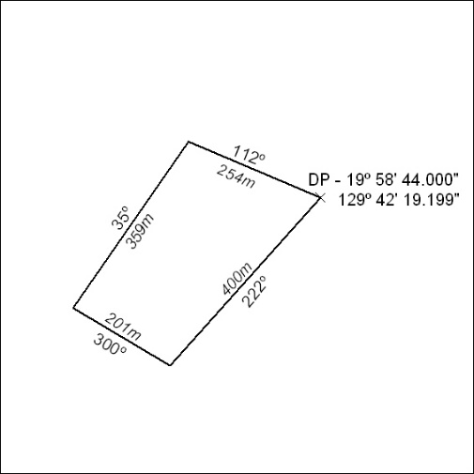
(Area now amalgamated into Mineral Lease 33760 under s102)

149/24

Mineral Titles Act 2010
NOTICE OF LAND CEASING TO BE A MINERAL TITLE AREA
Title Type and Number: | Mineral Lease (Southern) 124
Area ceased on: | 18 April 2024
Area: | 7.00 Hectare
Locality: | TANAMI
Name of Applicants(s)Holder(s): | 50% NORTHERN STAR (TANAMI) PTY LTD [ACN. 603 860 831], 50% TANAMI (NT) PTY LTD [ACN. 141 658 933]
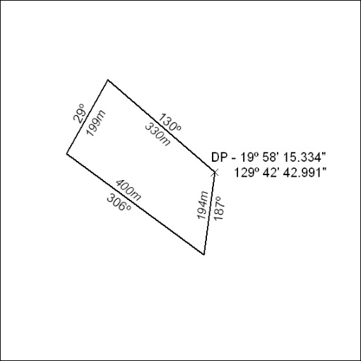
(Area now amalgamated into Mineral Lease 33760 under s102)

150/24

Mineral Titles Act 2010
NOTICE OF LAND CEASING TO BE A MINERAL TITLE AREA
Title Type and Number: | Mineral Lease (Southern) 125
Area ceased on: | 18 April 2024
Area: | 10.00 Hectare
Locality: | TANAMI
Name of Applicants(s)Holder(s): | 50% NORTHERN STAR (TANAMI) PTY LTD [ACN. 603 860 831], 50% TANAMI (NT) PTY LTD [ACN. 141 658 933]
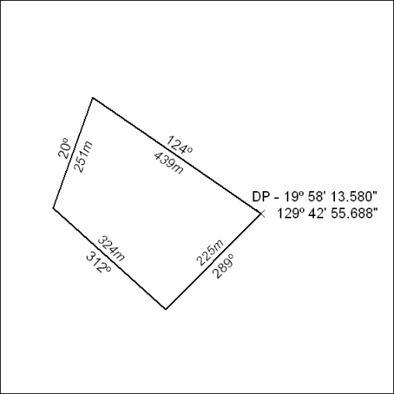
(Area now amalgamated into Mineral Lease 33760 under s102)

151/24

Mineral Titles Act 2010
NOTICE OF LAND CEASING TO BE A MINERAL TITLE AREA
Title Type and Number: | Mineral Lease (Southern) 126
Area ceased on: | 18 April 2024
Area: | 7.00 Hectare
Locality: | TANAMI
Name of Applicants(s)Holder(s): | 50% NORTHERN STAR (TANAMI) PTY LTD [ACN. 603 860 831], 50% TANAMI (NT) PTY LTD [ACN. 141 658 933]
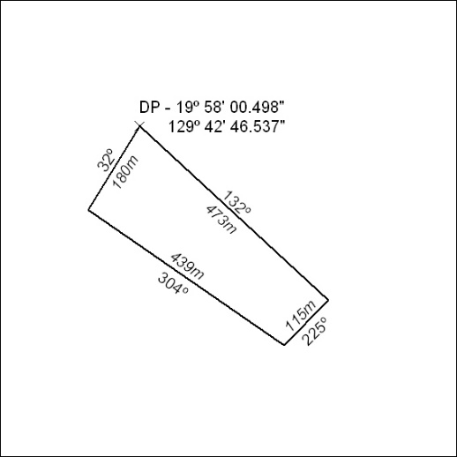
(Area now amalgamated into Mineral Lease 33760 under s102)

152/24

Mineral Titles Act 2010
NOTICE OF LAND CEASING TO BE A MINERAL TITLE AREA
Title Type and Number: | Mineral Lease (Southern) 127
Area ceased on: | 18 April 2024
Area: | 10.00 Hectare
Locality: | TANAMI
Name of Applicants(s)Holder(s): | 50% NORTHERN STAR (TANAMI) PTY LTD [ACN. 603 860 831], 50% TANAMI (NT) PTY LTD [ACN. 141 658 933]
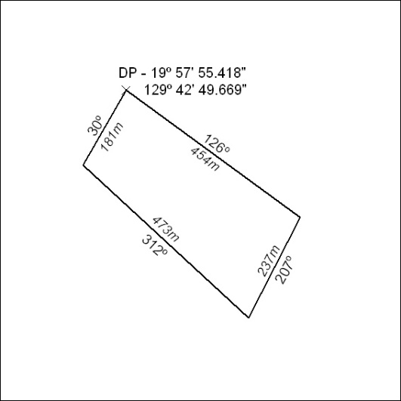
(Area now amalgamated into Mineral Lease 33760 under s102)

153/24

Mineral Titles Act 2010
NOTICE OF LAND CEASING TO BE A MINERAL TITLE AREA
Title Type and Number: | Mineral Lease (Southern) 128
Area ceased on: | 18 April 2024
Area: | 21.00 Hectare
Locality: | TANAMI
Name of Applicants(s)Holder(s): | 50% NORTHERN STAR (TANAMI) PTY LTD [ACN. 603 860 831], 50% TANAMI (NT) PTY LTD [ACN. 141 658 933]
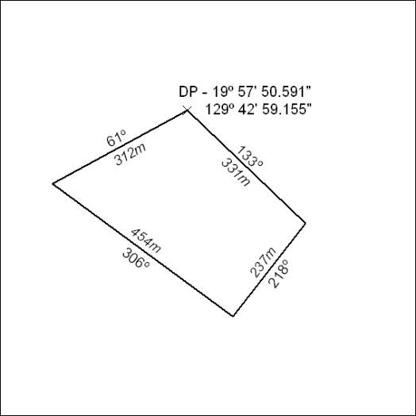
(Area now amalgamated into Mineral Lease 33760 under s102)

154/24

Mineral Titles Act 2010
NOTICE OF LAND CEASING TO BE A MINERAL TITLE AREA
Title Type and Number: | Mineral Lease (Southern) 129
Area ceased on: | 18 April 2024
Area: | 8.00 Hectare
Locality: | TANAMI
Name of Applicants(s)Holder(s): | 50% NORTHERN STAR (TANAMI) PTY LTD [ACN. 603 860 831], 50% TANAMI (NT) PTY LTD [ACN. 141 658 933]
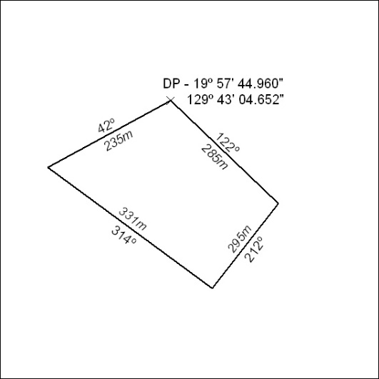
(Area now amalgamated into Mineral Lease 33760 under s102)

155/24

Mineral Titles Act 2010
NOTICE OF LAND CEASING TO BE A MINERAL TITLE AREA
Title Type and Number: | Mineral Lease (Southern) 130
Area ceased on: | 18 April 2024
Area: | 7.00 Hectare
Locality: | TANAMI
Name of Applicants(s)Holder(s): | 50% NORTHERN STAR (TANAMI) PTY LTD [ACN. 603 860 831], 50% TANAMI (NT) PTY LTD [ACN. 141 658 933]
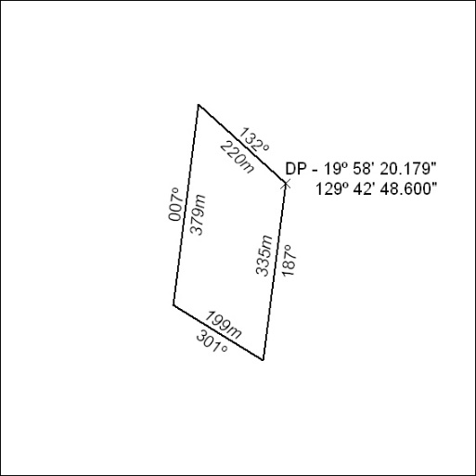
(Area now amalgamated into Mineral Lease 33760 under s102)

156/24

Mineral Titles Act 2010
NOTICE OF LAND CEASING TO BE A MINERAL TITLE AREA
Title Type and Number: | Mineral Lease (Southern) 131
Area ceased on: | 18 April 2024
Area: | 8.00 Hectare
Locality: | TANAMI
Name of Applicants(s)Holder(s): | 50% NORTHERN STAR (TANAMI) PTY LTD [ACN. 603 860 831], 50% TANAMI (NT) PTY LTD [ACN. 141 658 933]
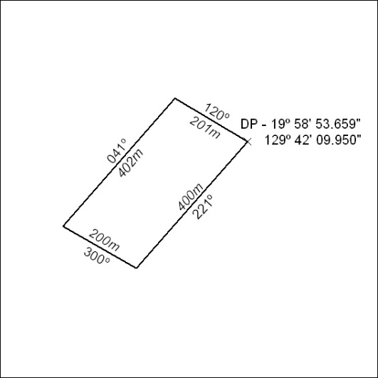
(Area now amalgamated into Mineral Lease 33760 under s102)

157/24

Mineral Titles Act 2010
NOTICE OF LAND CEASING TO BE A MINERAL TITLE AREA
Title Type and Number: | Mineral Lease (Southern) 132
Area ceased on: | 18 April 2024
Area: | 8.00 Hectare
Locality: | TANAMI
Name of Applicants(s)Holder(s): | 50% NORTHERN STAR (TANAMI) PTY LTD [ACN. 603 860 831], 50% TANAMI (NT) PTY LTD [ACN. 141 658 933]
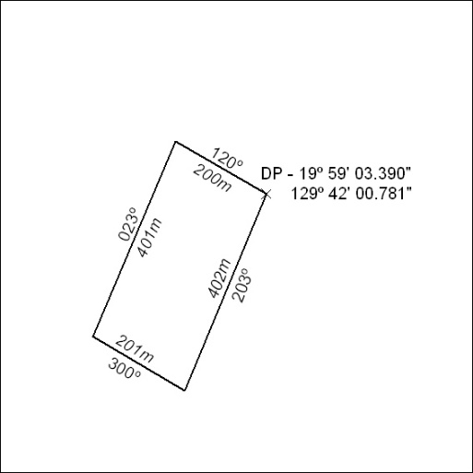
(Area now amalgamated into Mineral Lease 33760 under s102)

158/24

Mineral Titles Act 2010
NOTICE OF LAND CEASING TO BE A MINERAL TITLE AREA
Title Type and Number: | Mineral Lease (Southern) 133
Area ceased on: | 18 April 2024
Area: | 7.00 Hectare
Locality: | TANAMI
Name of Applicants(s)Holder(s): | 50% NORTHERN STAR (TANAMI) PTY LTD [ACN. 603 860 831], 50% TANAMI (NT) PTY LTD [ACN. 141 658 933]
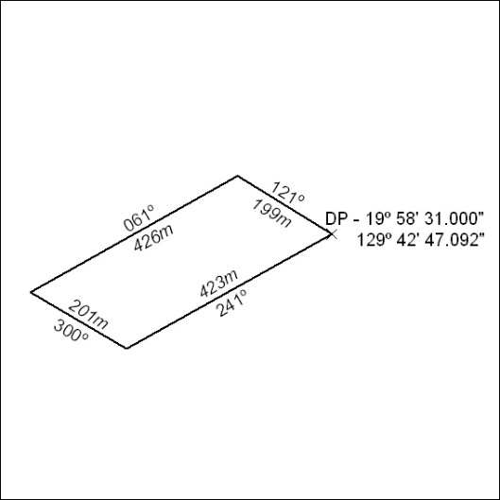
(Area now amalgamated into Mineral Lease 33760 under s102)

159/24

Mineral Titles Act 2010
NOTICE OF LAND CEASING TO BE A MINERAL TITLE AREA
Title Type and Number: | Mineral Lease (Southern) 153
Area ceased on: | 18 April 2024
Area: | 124.00 Hectares
Locality: | TANAMI
Name of Applicants(s)Holder(s): | 50% NORTHERN STAR (TANAMI) PTY LTD [ACN. 603 860 831], 50% TANAMI (NT) PTY LTD [ACN. 141 658 933]
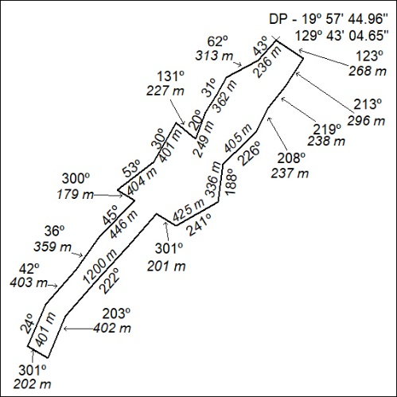
(Area now amalgamated into Mineral Lease 33760 under s102

160/24

Mineral Titles Act 2010
NOTICE OF LAND CEASING TO BE A MINERAL TITLE AREA
Title Type and Number: | Mineral Lease (Northern) 893
Area ceased on: | 22 April 2024
Area: | 8.00 Hectare
Locality: | BATCHELOR
Name of Applicants(s)Holder(s): | 100% CR & E PTY LTD [ACN. 163 015 110]
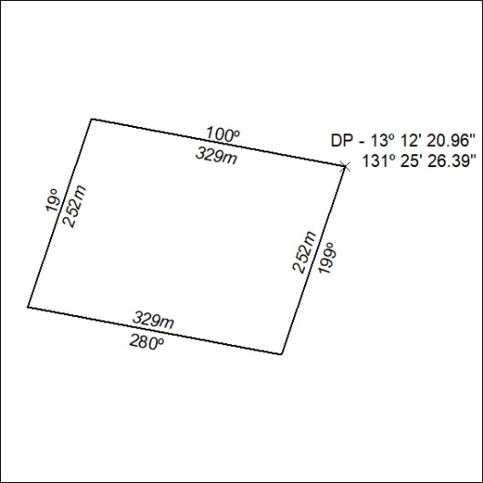
(Area now amalgamated into Mineral Lease 33757 under s102)

161/24

Mineral Titles Act 2010
NOTICE OF LAND CEASING TO BE A MINERAL TITLE AREA
Title Type and Number: | Mineral Lease (Northern) 894
Area ceased on: | 22 April 2024
Area: | 7.00 Hectare
Locality: | BATCHELOR
Name of Applicants(s)Holder(s): | 100% CR & E PTY LTD [ACN. 163 015 110]
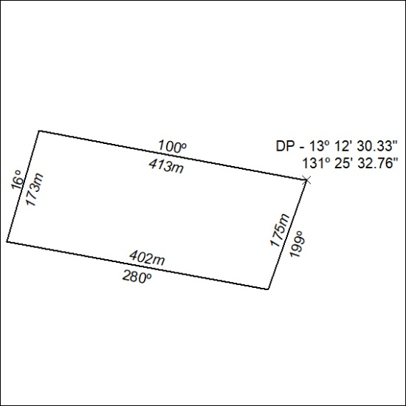
(Area now amalgamated into Mineral Lease 33757 under s102)

162/24

Mineral Titles Act 2010
NOTICE OF LAND CEASING TO BE A MINERAL TITLE APPLICATION AREA
Title Type and Number: | Exploration Licence 33717
Area Ceased on: | 19 April 2024
Area: | 5 Blocks, 15.98 km²
Locality: | ELKEDRA
Name of Applicant(s)/Holder(s): | 50% BASTET AND CO PTY LTD [ACN. 619 411 835], 50% GLENBUILT PTY LTD [ACN. 163 041 316]
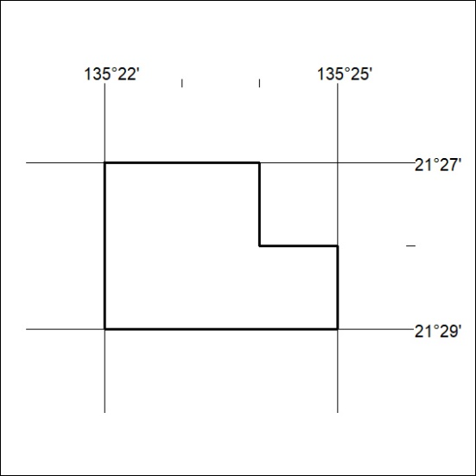

163/24

