Mineral Titles Act 2010
NOTICE OF LAND CEASING TO BE A MINERAL TITLE AREA
Title Type and Number: | Exploration Licence 32866
Area Ceased on: | 05 April 2024
Area: | 123 Blocks, 388.72 km²
Locality: | BUSHY PARK
Name of Applicant(s)/Holder(s): | 100% PEGMATITE ONE PTY LTD [ACN. 652 853 391]
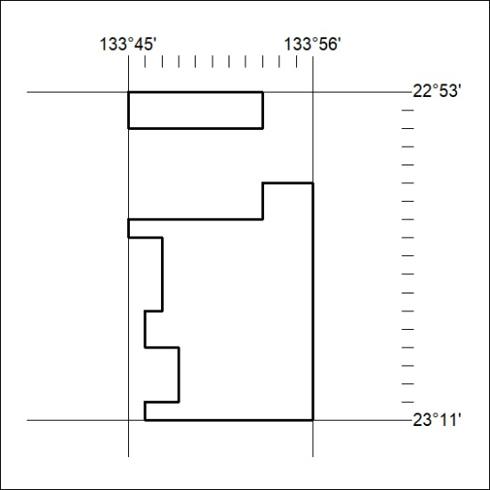

125/24

Mineral Titles Act 2010
NOTICE OF LAND CEASING TO BE A MINERAL TITLE AREA
Title Type and Number: | Exploration Licence 32869
Area Ceased on: | 05 April 2024
Area: | 24 Blocks, 76.06 km²
Locality: | AILERON
Name of Applicant(s)/Holder(s): | 100% PEGMATITE ONE PTY LTD [ACN. 652 853 391]
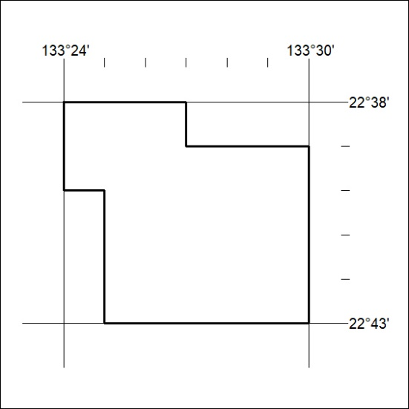

126/24

Mineral Titles Act 2010
NOTICE OF LAND CEASING TO BE A MINERAL TITLE AREA
Title Type and Number: | Exploration Licence 32871
Area Ceased on: | 05 April 2024
Area: | 60 Blocks, 190.39 km²
Locality: | WOODGREEN
Name of Applicant(s)/Holder(s): | 100% PEGMATITE ONE PTY LTD [ACN. 652 853 391]
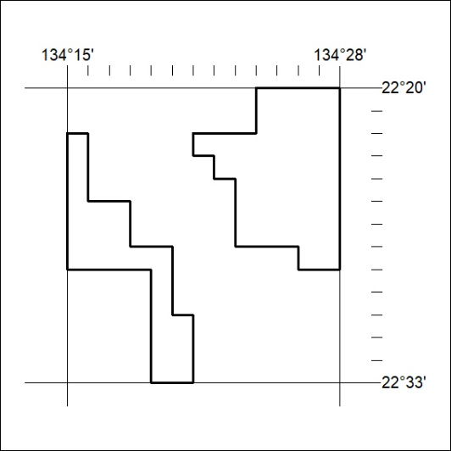

127/24

Mineral Titles Act 2010
NOTICE OF LAND CEASING TO BE A MINERAL TITLE AREA
Title Type and Number: | Exploration Licence 32872
Area Ceased on: | 05 April 2024
Area: | 164 Blocks, 512.97 km²
Locality: | MACDONALD DOWNS
Name of Applicant(s)/Holder(s): | 100% PEGMATITE ONE PTY LTD [ACN. 652 853 391]
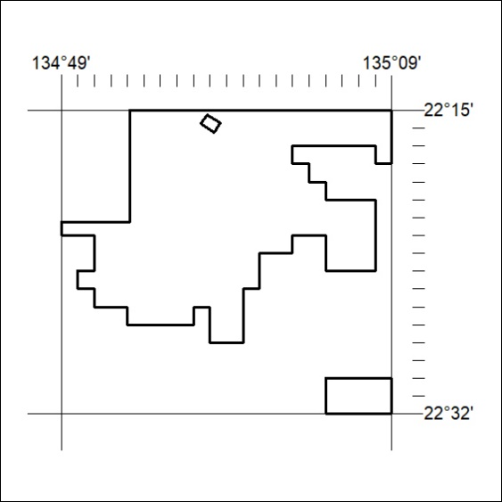

128/24

Corrigendum
Notice Number 107/24 appearing in MN39/24 on 10 April 2024 is hereby cancelled and replaced by the following:

Mineral Titles Act 2010
NOTICE OF LAND CEASING TO BE A MINERAL TITLE AREA
Title Type and Number: | Exploration Licence 32834
Area Ceased on: | 05 April 2024
Area: | 97 Blocks, 309.47 km²
Locality: | HOME OF BULLION
Name of Applicant(s)/Holder(s): | 100% PEGMATITE ONE PTY LTD [ACN. 652 853 391]
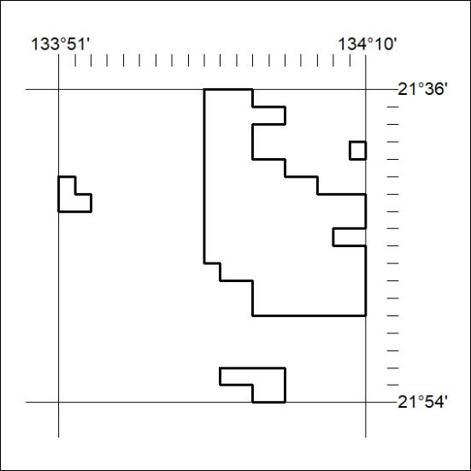
129/24

Corrigendum
Notice Number 108/24 appearing in MN39/24 on 10 April 2024 is hereby cancelled and replaced by the following:

Mineral Titles Act 2010
NOTICE OF LAND CEASING TO BE A MINERAL TITLE AREA
Title Type and Number: | Exploration Licence 32840
Area Ceased on: | 05 April 2024
Area: | 21 Blocks, 67.12 km²
Locality: | CONICAL HILL
Name of Applicant(s)/Holder(s): | 100% PEGMATITE ONE PTY LTD [ACN. 652 853 391]
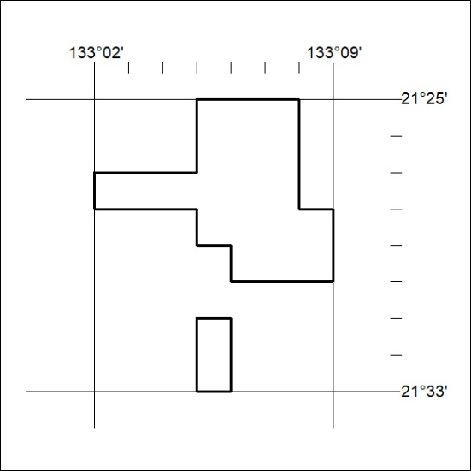
130/24
Corrigendum
Notice Number 10/24 appearing in MN39/24 on 10 April 2024 is hereby cancelled and replaced by the following:

Mineral Titles Act 2010
NOTICE OF LAND CEASING TO BE A MINERAL TITLE AREA
Title Type and Number: | Exploration Licence 32868
Area Ceased on: | 05 April 2024
Area: | 16 Blocks, 51.11 km²
Locality: | HOME OF BULLION
Name of Applicant(s)/Holder(s): | 100% PEGMATITE ONE PTY LTD [ACN. 652 853 391]
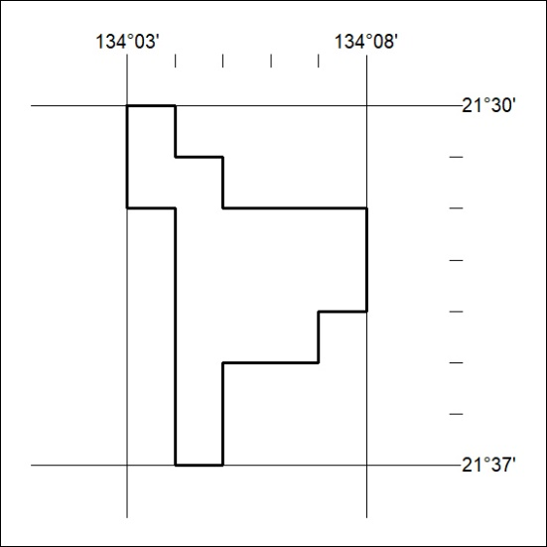
131/24

Corrigendum
Notice Number 110/24 appearing in MN40/24 on 11 April 2024 is hereby cancelled and replaced by the following:

Mineral Titles Act 2010
NOTICE OF LAND CEASING TO BE A MINERAL TITLE AREA
Title Type and Number: | Exploration Licence 32844
Area Ceased on: | 05 April 2024
Area: | 142 Blocks, 451.69 km²
Locality: | REYNOLDS RANGE
Name of Applicant(s)/Holder(s): | 100% PEGMATITE ONE PTY LTD [ACN. 652 853 391]
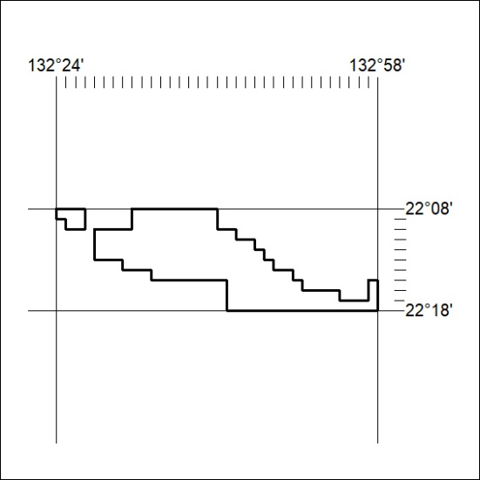
132/24
Corrigendum
Notice Number 111/24 appearing in MN40/24 on 11 April 2024 is hereby cancelled and replaced by the following:

Mineral Titles Act 2010
NOTICE OF LAND CEASING TO BE A MINERAL TITLE AREA
Title Type and Number: | Exploration Licence 32845
Area Ceased on: | 05 April 2024
Area: | 127 Blocks, 401.99 km²
Locality: | REYNOLDS RANGE
Name of Applicant(s)/Holder(s): | 100% PEGMATITE ONE PTY LTD [ACN. 652 853 391]
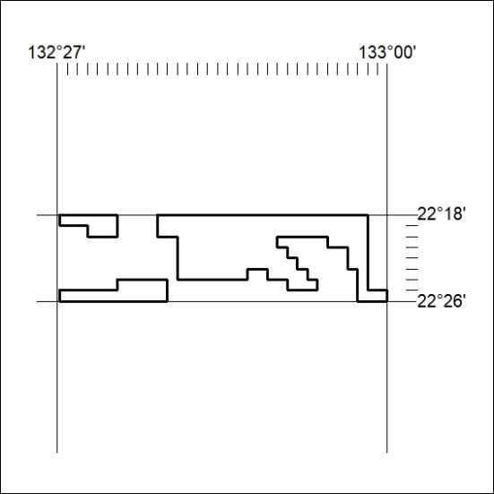
133/24

Corrigendum
Notice Number 112/24 appearing in MN40/24 on 11 April 2024 is hereby cancelled and replaced by the following:

Mineral Titles Act 2010
NOTICE OF LAND CEASING TO BE A MINERAL TITLE AREA
Title Type and Number: | Exploration Licence 32846
Area Ceased on: | 05 April 2024
Area: | 73 Blocks, 231.66 km²
Locality: | REYNOLDS RANGE
Name of Applicant(s)/Holder(s): | 100% PEGMATITE ONE PTY LTD [ACN. 652 853 391]
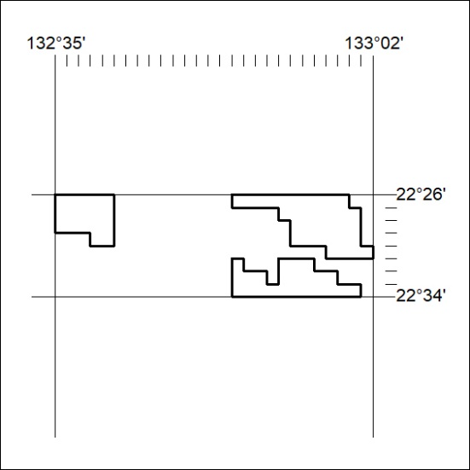
134/21
Corrigendum
Notice Number 115/24 appearing in MN41/24 on 15 April 2024 is hereby cancelled and replaced by the following:

Mineral Titles Act 2010
NOTICE OF LAND CEASING TO BE A MINERAL TITLE AREA
Title Type and Number: | Exploration Licence 32848
Area Ceased on: | 05 April 2024
Area: | 14 Blocks, 44.78 km²
Locality: | CRAWFORD
Name of Applicant(s)/Holder(s): | 100% PEGMATITE ONE PTY LTD [ACN. 652 853 391]
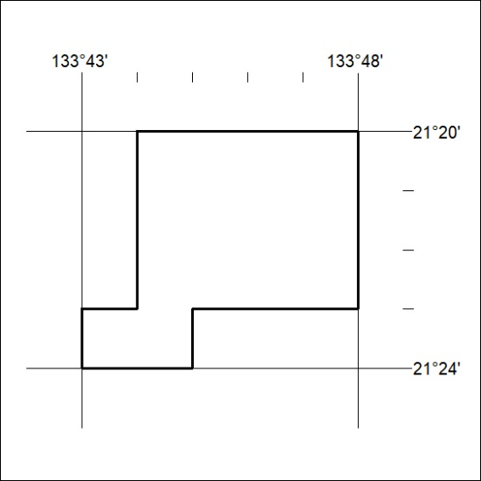
135/24

Corrigendum
Notice Number 116/24 appearing in MN41/24 on 15 April 2024 is hereby cancelled and replaced by the following:

Mineral Titles Act 2010
NOTICE OF LAND CEASING TO BE A MINERAL TITLE AREA
Title Type and Number: | Exploration Licence 32851
Area Ceased on: | 05 April 2024
Area: | 34 Blocks, 108.22 km²
Locality: | DENISON
Name of Applicant(s)/Holder(s): | 100% PEGMATITE ONE PTY LTD [ACN. 652 853 391]
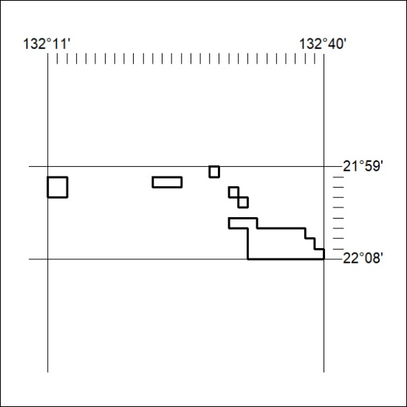
136/24
Corrigendum
Notice Number 117/24 appearing in MN41/24 on 15 April 2024 is hereby cancelled and replaced by the following:

Mineral Titles Act 2010
NOTICE OF LAND CEASING TO BE A MINERAL TITLE AREA
Title Type and Number: | Exploration Licence 32852
Area Ceased on: | 05 April 2024
Area: | 9 Blocks, 28.63 km²
Locality: | DENISON
Name of Applicant(s)/Holder(s): | 100% PEGMATITE ONE PTY LTD [ACN. 652 853 391]
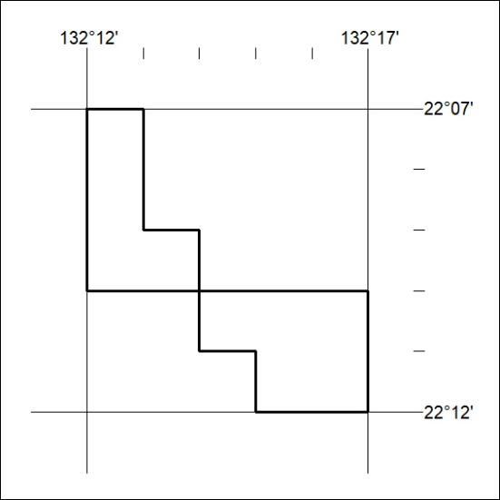
137/24

Corrigendum
Notice Number 118/24 appearing in MN41/24 on 15 April 2024 is hereby cancelled and replaced by the following:

Mineral Titles Act 2010
NOTICE OF LAND CEASING TO BE A MINERAL TITLE AREA
Title Type and Number: | Exploration Licence 32854
Area Ceased on: | 05 April 2024
Area: | 147 Blocks, 455.48 km²
Locality: | LAUGHLEN
Name of Applicant(s)/Holder(s): | 100% PEGMATITE ONE PTY LTD [ACN. 652 853 391]
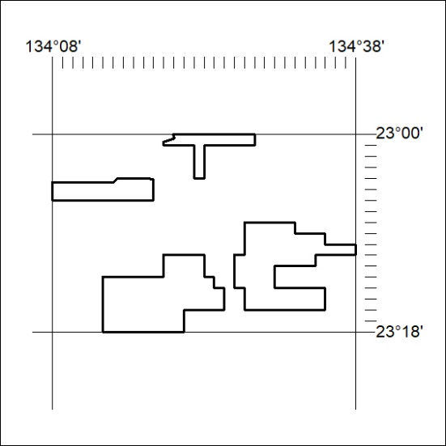
138/24
Corrigendum
Notice Number 119/24 appearing in MN41/24 on 15 April 2024 is hereby cancelled and replaced by the following:

Mineral Titles Act 2010
NOTICE OF LAND CEASING TO BE A MINERAL TITLE AREA
Title Type and Number: | Exploration Licence 32855
Area Ceased on: | 05 April 2024
Area: | 57 Blocks, 179.82 km²
Locality: | RIDDOCH
Name of Applicant(s)/Holder(s): | 100% PEGMATITE ONE PTY LTD [ACN. 652 853 391]
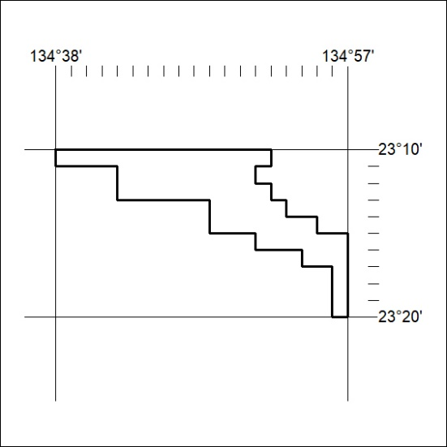
139/24

Corrigendum
Notice Number 120/24 appearing in MN42/24 on 16 April 2024 is hereby cancelled and replaced by the following:

Mineral Titles Act 2010
NOTICE OF LAND CEASING TO BE A MINERAL TITLE AREA
Title Type and Number: | Exploration Licence 32861
Area Ceased on: | 05 April 2024
Area: | 165 Blocks, 524.07 km²
Locality: | TEA TREE
Name of Applicant(s)/Holder(s): | 100% PEGMATITE ONE PTY LTD [ACN. 652 853 391]
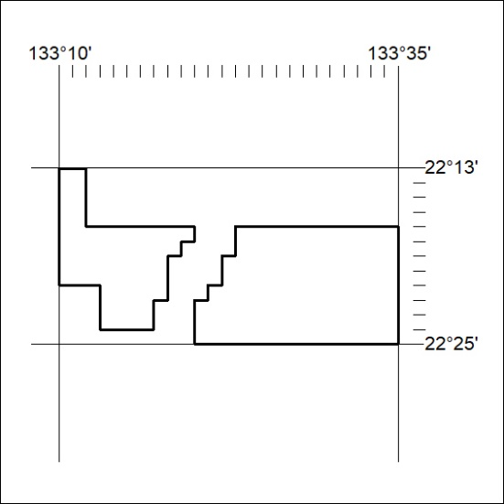
140/24
Corrigendum
Notice Number 121/24 appearing in MN42/24 on 16 April 2024 is hereby cancelled and replaced by the following:

Mineral Titles Act 2010
NOTICE OF LAND CEASING TO BE A MINERAL TITLE AREA
Title Type and Number: | Exploration Licence 32862
Area Ceased on: | 05 April 2024
Area: | 39 Blocks, 123.78 km²
Locality: | TEA TREE
Name of Applicant(s)/Holder(s): | 100% PEGMATITE ONE PTY LTD [ACN. 652 853 391]
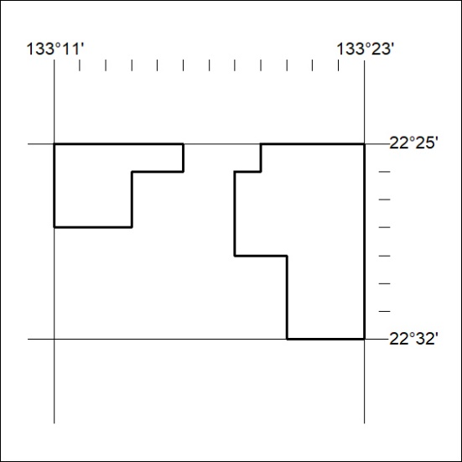
141/24

