Mineral Titles Act 2010
NOTICE OF LAND CEASING TO BE A MINERAL TITLE AREA
Title Type and Number: | Exploration Licence 28803
Area Ceased on: | 19 March 2024
Area: | 3 Blocks, 10.01 km²
Locality: | RANFORD HILL
Name of Applicant(s)/Holder(s): | 100% AUSTRALIA MINING & GEMSTONE CO. PTY LTD [ACN. 114 395 247]
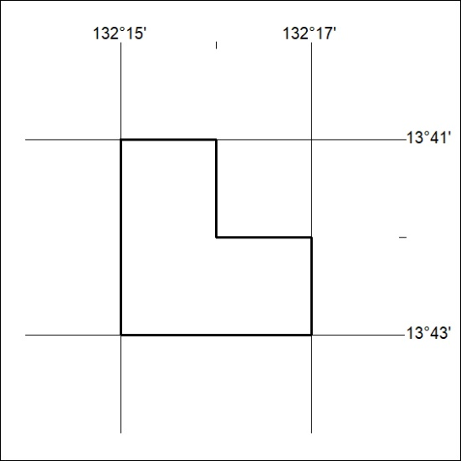

64/24

Mineral Titles Act 2010
NOTICE OF LAND CEASING TO BE A MINERAL TITLE AREA
Title Type and Number: | Exploration Licence 32942
Area Ceased on: | 18 March 2024
Area: | 188 Blocks, 589.35 km²
Locality: | PELLINORE
Name of Applicant(s)/Holder(s): | 100% GEMPART (NT) PTY LTD* [ACN. 081 859 896]
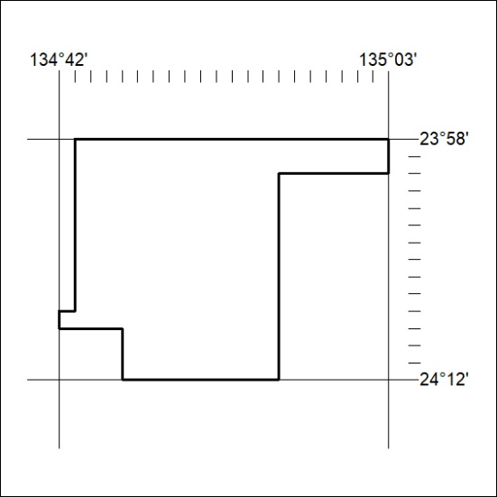

65/24
Mineral Titles Act 2010
NOTICE OF LAND CEASING TO BE A MINERAL TITLE AREA
Title Type and Number: | Exploration Licence 33306
Area Ceased on: | 18 March 2024
Area: | 232 Blocks, 722.34 km²
Locality: | BURT
Name of Applicant(s)/Holder(s): | 100% GEMPART (NT) PTY LTD* [ACN. 081 859 896]
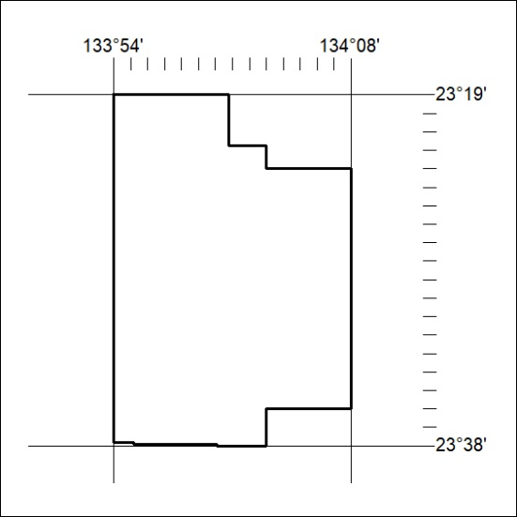

66/24

