Mineral Titles Act 2010
NOTICE OF LAND CEASING TO BE A MINERAL TITLE AREA
Title Type and Number: | Exploration Licence 30785
Area Ceased on: | 14 March 2024
Area: | 32 Blocks, 88.38 km²
Locality: | REYNOLDS RIVER
Name of Applicant(s)/Holder(s): | 100% FINNIS CONTRACTING PTY LTD [ACN. 154 086 129]
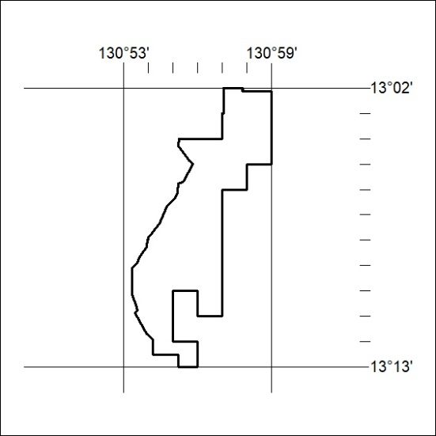

59/24

Mineral Titles Act
NOTICE OF GRANT OF A MINERAL TITLE
Title Type and Number: | Exploration Licence 33308
Granted: | 14 March 2024, for a period of 6 Years
Area: | 250 Blocks, 818.54 km²
Locality: | MONTEJINNI
Name of Holder/s: | 100% BANKS Aaron
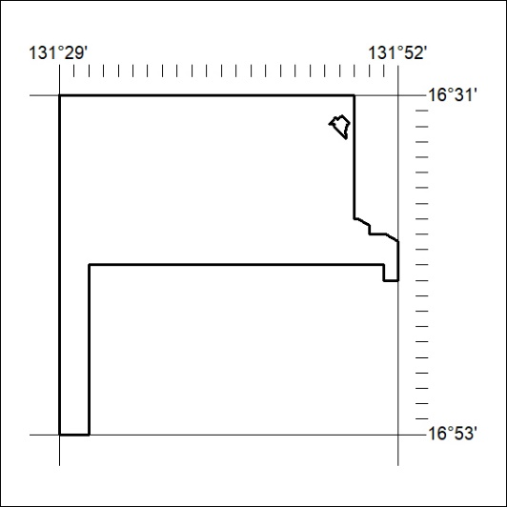
Area granted is indicated above. The titleholder is not permitted to exercise occupational rights on any land that is subject to a development title, or an application for a development title. Any land the subject of a Reserved Land gazettal under the Mineral Titles Act and all land vested in the Commonwealth of Australia is also excluded by description but not excised from the grant area.

60/24

Mineral Titles Act
NOTICE OF GRANT OF A MINERAL TITLE
Title Type and Number: | Exploration Licence 33309
Granted: | 14 March 2024, for a period of 6 Years
Area: | 250 Blocks, 818.45 km²
Locality: | MONTEJINNI
Name of Holder/s: | 100% BANKS Aaron
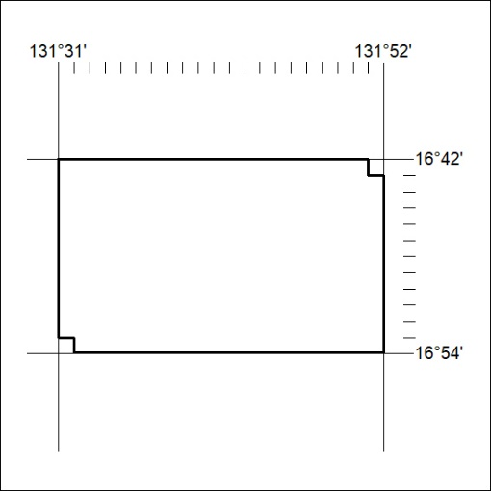
Area granted is indicated above. The titleholder is not permitted to exercise occupational rights on any land that is subject to a development title, or an application for a development title. Any land the subject of a Reserved Land gazettal under the Mineral Titles Act and all land vested in the Commonwealth of Australia is also excluded by description but not excised from the grant area.

61/24

Mineral Titles Act
NOTICE OF GRANT OF A MINERAL TITLE
Title Type and Number: | Exploration Licence 33348
Granted: | 14 March 2024, for a period of 6 Years
Area: | 198 Blocks, 563.45 km²
Locality: | MONTEJINNI
Name of Holder/s: | 100% BANKS Aaron
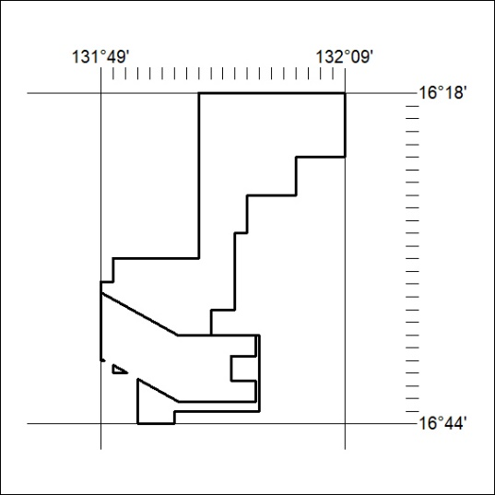
Area granted is indicated above. The titleholder is not permitted to exercise occupational rights on any land that is subject to a development title, or an application for a development title. Any land the subject of a Reserved Land gazettal under the Mineral Titles Act and all land vested in the Commonwealth of Australia is also excluded by description but not excised from the grant area.

62/24

Mineral Titles Act
NOTICE OF GRANT OF A MINERAL TITLE
Title Type and Number: | Exploration Licence 33601
Granted: | 15 March 2024, for a period of 6 Years
Area: | 5 Blocks, 10.80 km²
Locality: | BATCHELOR
Name of Holder/s: | 100% HOWARD Michael James
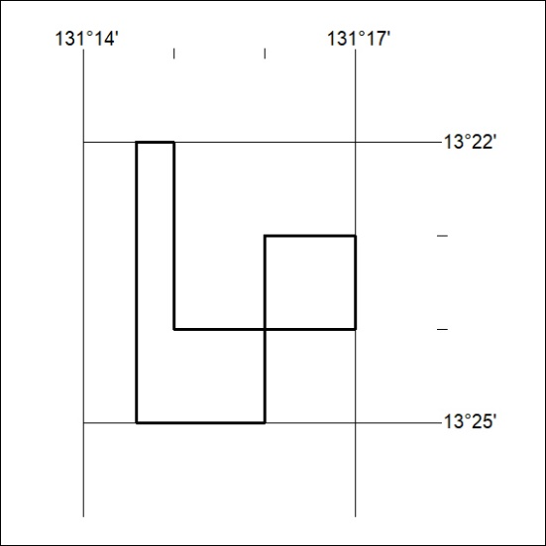
Area granted is indicated above. The titleholder is not permitted to exercise occupational rights on any land that is subject to a development title, or an application for a development title. Any land the subject of a Reserved Land gazettal under the Mineral Titles Act and all land vested in the Commonwealth of Australia is also excluded by description but not excised from the grant area.

63/24

