How to submit a venue site plan

Overview
Licensed premises site plans are a critical component of a licence application. Your site plan identifies your licensed premises boundaries and are considered in a range of licensing matters.
Having up-to date, good quality floor plans that meet our requirements will allow us to process your application in a more streamlined manner and more importantly, define your business licensed boundaries.

When do I need to supply a site plan?
- applications for a new liquor licence.
- applications to add other authorities to your existing liquor licence or substitute other premises.
- applications for a variation to the conditions of your licence which may involve a reconfiguration of the layout of your premises.
- application to the Liquor Commission to change (material alterations) your site plan PRIOR to making these changes, this would be where you denote the changes you are considering on your existing site map and they will be considered. To undertake this you will have to lodge a material alteration application licensed-premises/make-changes-to-licensed-premises. It is a breach of the provisions of the Liquor Act 2019 (the Act) to undertake a material alteration to a licensed premises without approval of the Liquor Commission, in accordance with Section of the Act.

How do I prepare my floor plan?
- If the licensed area is an indoor area, the plans provided must include floor plans for the entire premises with the relevant areas clearly marked.
- If the licensed area includes both an indoor and an outdoor area, the plans provided must include floor plans of the indoor area and the outside area.
- A floor map needs to be set out on an A4 sized paper (at a minimum) and graph paper is not accepted.
- If the proposed area does not follow a physical barrier (such as a wall), describe what is being used to separate the area (i.e. planter boxes, fence, bollards) and denote it on your site map. Where possible in this circumstance measurements or GPS co-ordinates should be provided.
- The licensed area needs to be outlined, like the example attached in red.
- In an example where the licensed premises is a building with several floors (i.e. a hotel) plans must be provided for each level with each level clearly labelled e.g. ground floor, first floor etc.
- each page must be numbered and i.e.: Page 1 of 3 and have the date they were submitted.
- Include the address of the premises.
- Internal parts of the premises must be labelled i.e. kitchen, amenities, gaming room, lounge, bistro, bar areas, function room, office, exits etc.
- The floor plan should be drawn to a scale, so that required elements are clearly identified. A suggested scale is 1:100 (1cm = metre). So clear and consistent measurements on the plan.
If the plan does not meet these requirements, the applicant will be required to resubmit the plan

What am I required to do with my approved plan.
When your plan has been accepted by Licensing NT, you will receive an approved copy for your records. This forms a part of your liquor licence and must be on display, in a conspicuous place on or in the licensed premises that is visible to patrons, in accordance with Section 290 of the Liquor Act 2019.
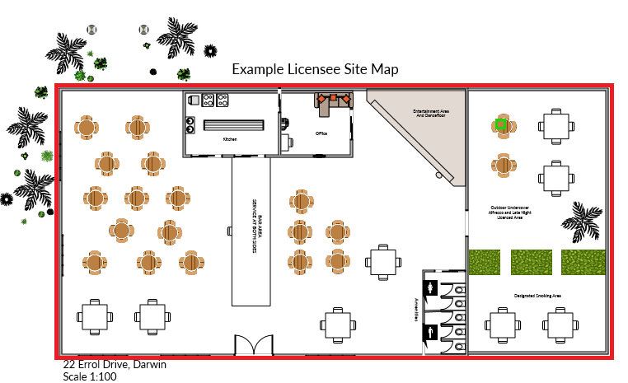

Further information
If you require further advice in how to undertake a floor plan, please contact Licensing NT on
08 8999 1800 or e-mail LiquorLicensing.DITT@nt.gov.au

