Mineral Titles Act 2010
NOTICE OF LAND CEASING TO BE A MINERAL TITLE AREA
Title Type and Number: | Exploration Licence 31251
Area Ceased on: | 09 November 2023
Area: | 28 Blocks, 88.01 km²
Locality: | ILLOGWA
Name of Applicant(s)/Holder(s): | 100% GEMPART (NT) PTY LTD* [ACN. 081 859 896]
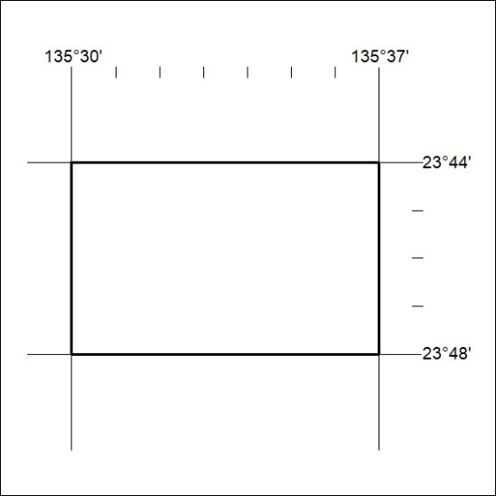

472/23

Mineral Titles Act 2010
NOTICE OF LAND CEASING TO BE A MINERAL TITLE AREA
Title Type and Number: | Exploration Licence 32336
Area Ceased on: | 09 November 2023
Area: | 4 Blocks, 12.78 km²
Locality: | AMMAROO
Name of Applicant(s)/Holder(s): | 25% SMITH Kimberley Alice, 25% SMITH Scott William, 18% LIU TAO, 16% FENG QINGNING, 16% FENG ZHI
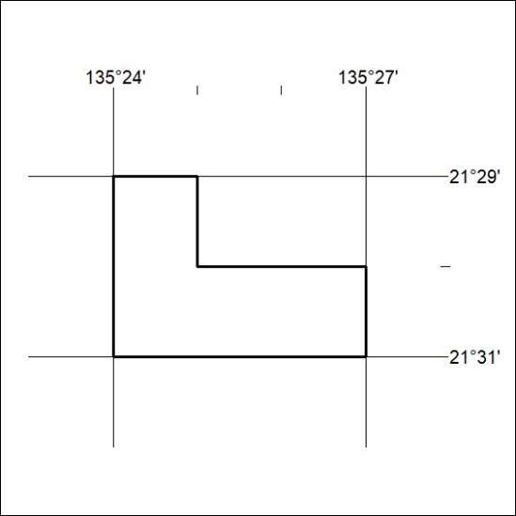

473/23

Mineral Titles Act
NOTICE OF GRANT OF A MINERAL TITLE
Title Type and Number: | Exploration Licence 33505
Granted: | 08 November 2023, for a period of 6 Years
Area: | 20 Blocks, 64.80 km²
Locality: | SHORT RANGE
Name of Holder/s: | 100% TENNANT CONSOLIDATED MINING GROUP PTY LTD [ACN. 645 263 547]
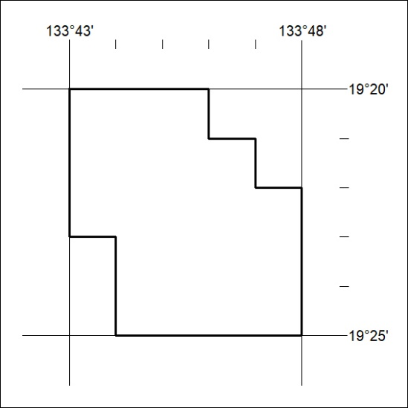
Area granted is indicated above. The titleholder is not permitted to exercise occupational rights on any land that is subject to a development title, or an application for a development title. Any land the subject of a Reserved Land gazettal under the Mineral Titles Act and all land vested in the Commonwealth of Australia is also excluded by description but not excised from the grant area.

474/23

