  - Schedule 4 and 8 – veterinary chemical products
- Part 3 Division 4 of the Agricultural and Veterinary Chemicals (Control of Use) Act 2004 governs the use of veterinary chemical products in the NT. This includes both veterinarians and non veterinarian’s use of all scheduled products contained within the Poisons Standard and administered in conjunction with the Medicines, Poisons and Therapeutic Goods Act 2012.

Specified requirements
- There is no legislative basis for non-veterinarians to use a Schedule 4 or 8 veterinary chemical product without a lawful authority. In accordance with section 25 (1) of the Agricultural and Veterinary Chemicals (Control of Use), non-veterinarians can only get lawful authority to possess and use veterinary chemical products through:
- an authority issued by the Medicines and Poisons Team (Department of Health) to possess and use (for scheduled substances only); or
- the written instructions provided by the veterinarian who prescribed, recommended or supplied the product; or
- if no instructions are provided comply with the directions on the label.
- However for schedule 4 and 8 substances non-veterinarians cannot rely on the third condition because of Section 77 of the Medicines, Poisons and Therapeutic Goods Act 2012 which states the person administer in accordance with the instruction of the veterinarian.
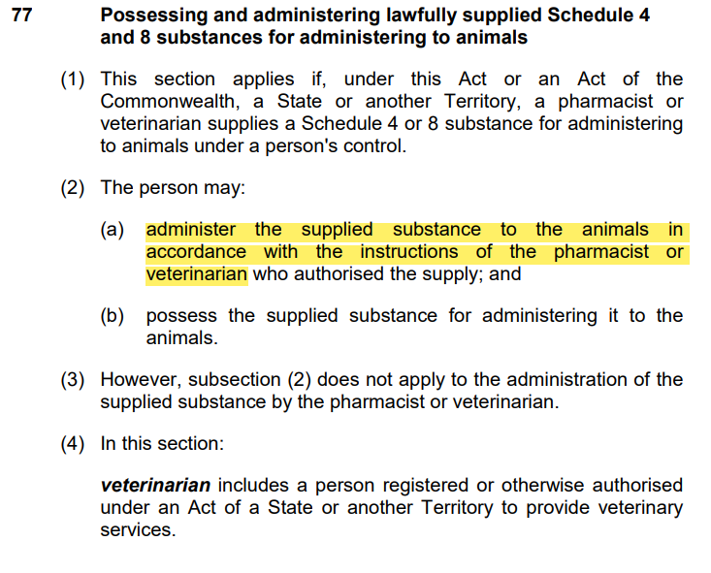

Directions
- In order to provide clarity and remove ambiguity, the Chemical Coordinator has determined that to protect users (non-veterinarians) of a class of chemical product (Schedule 4 and 8 substances), instructions by a veterinarian must be in writing in accordance with Section 25 (2)(a) of the Agricultural and Veterinary Chemicals (Control of Use) Act.
- These directions are issued in accordance with Section 87 (b)(i) of the Agricultural and Veterinary Chemicals (Control of Use) Act and have been gazetted in NTG Gazette 22 on the 26th October 2023.

Offences
- The use of veterinary chemicals without a lawful authority constitutes an offence under Section 25(1) of the Agricultural and Veterinary Chemicals (Control of Use) Act 2004.
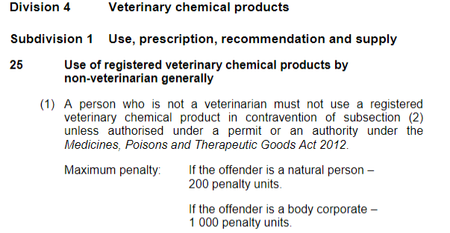
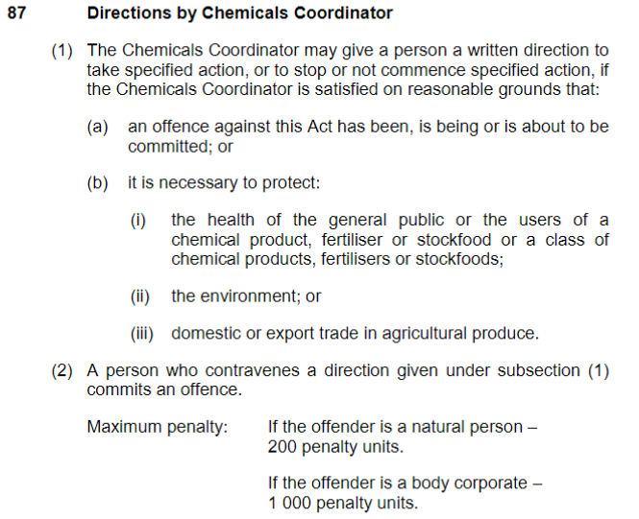
- Furthermore a person who contravenes a direction by the Chemical Coordinator commits a further offence under Section 87 of the Agricultural and Veterinary Chemicals (Control of Use) Act 2004.

Further information
- Further information on the safety and handling of chemicals and fertilisers can be found on their respective labels, safety data sheets as well as the APVMA or Chem Alert websites.
- www.chemalert.rmt.com.au
- https://portal.apvma.gov.au/pubcris
- Further information on Scheduled substances can be found on the NTG Medicine and Poisons website: Medicines and poisons | NT Health

