Mineral Titles Act
NOTICE OF GRANT OF A MINERAL TITLE
Title Type and Number: | Exploration Licence 33479
Granted: | 01 November 2023, for a period of 6 Years
Area: | 10 Blocks, 33.41 km²
Locality: | BATCHELOR
Name of Holder/s: | 100% PNX METALS LIMITED* [ACN. 127 446 271]
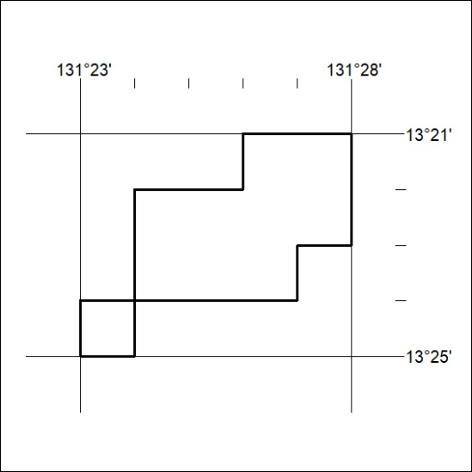
Area granted is indicated above. The titleholder is not permitted to exercise occupational rights on any land that is subject to a development title, or an application for a development title. Any land the subject of a Reserved Land gazettal under the Mineral Titles Act and all land vested in the Commonwealth of Australia is also excluded by description but not excised from the grant area.

460/23

Mineral Titles Act
NOTICE OF GRANT OF A MINERAL TITLE
Title Type and Number: | Exploration Licence 33502
Granted: | 01 November 2023, for a period of 6 Years
Area: | 11 Blocks, 3.00 km²
Locality: | McKINLAY RIVER
Name of Holder/s: | 90% PNX METALS LIMITED* [ACN. 127 446 271], 10% NT MINING OPERATIONS PTY LTD* [ACN. 136 525 990]
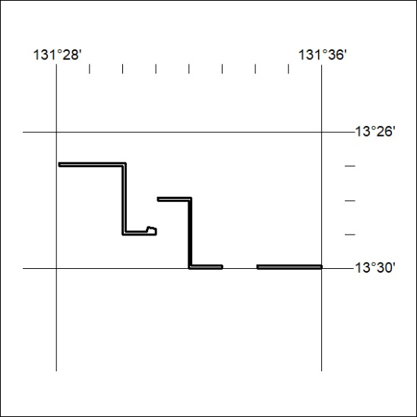
Area granted is indicated above. The titleholder is not permitted to exercise occupational rights on any land that is subject to a development title, or an application for a development title. Any land the subject of a Reserved Land gazettal under the Mineral Titles Act and all land vested in the Commonwealth of Australia is also excluded by description but not excised from the grant area.

461/23

Mineral Titles Act
NOTICE OF GRANT OF A MINERAL TITLE
Title Type and Number: | Exploration Licence 33503
Granted: | 01 November 2023, for a period of 6 Years
Area: | 19 Blocks, 4.39 km²
Locality: | BATCHELOR
Name of Holder/s: | 90% PNX METALS LIMITED* [ACN. 127 446 271], 10% NT MINING OPERATIONS PTY LTD* [ACN. 136 525 990]
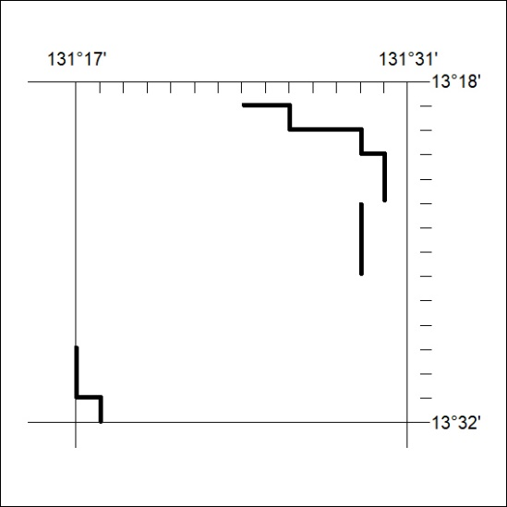
Area granted is indicated above. The titleholder is not permitted to exercise occupational rights on any land that is subject to a development title, or an application for a development title. Any land the subject of a Reserved Land gazettal under the Mineral Titles Act and all land vested in the Commonwealth of Australia is also excluded by description but not excised from the grant area.

462/23

