Mineral Titles Act 2010
NOTICE OF LAND CEASING TO BE A MINERAL TITLE AREA
Title Type and Number: | Exploration Licence 33061
Area Ceased on: | 26 September 2023
Area: | 20 Blocks, 64.80 km²
Locality: | FLYNN
Name of Applicant(s)/Holder(s): | 100% 6 CORNERS GOLD PTY LTD [ACN. 653 505 214]
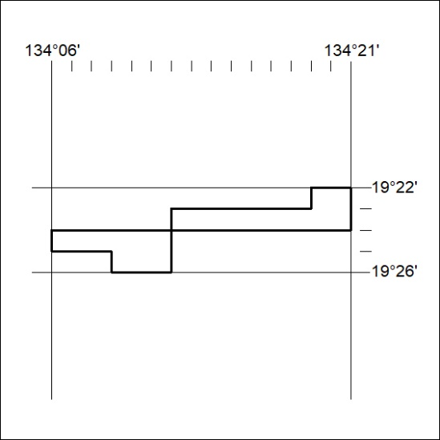

382/23

Mineral Titles Act 2010
NOTICE OF LAND CEASING TO BE A MINERAL TITLE APPLICATION AREA
Title Type and Number: | Exploration Licence 33539
Area Ceased on: | 19 September 2023
Area: | 250 Blocks, 793.76 km²
Locality: | WARBURTON
Name of Applicant(s)/Holder(s): | 100% URO CORPORATION PTY LTD [ACN. 653 927 998]
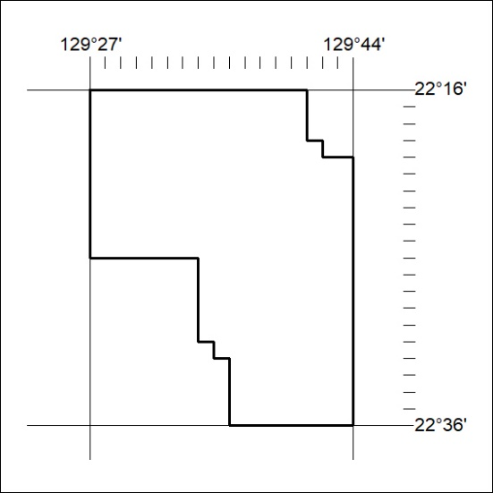

383/23

