Mineral Titles Act 2010
NOTICE OF LAND CEASING TO BE A MINERAL TITLE AREA
Title Type and Number: | Exploration Licence 32962
Area Ceased on: | 01 August 2023
Area: | 128 Blocks, 412.18 km²
Locality: | DALY RIVER
Name of Applicant(s)/Holder(s): | 100% ALTAN NEVADA MINERALS (AUST) PTY LTD [ACN. 632 387 878]
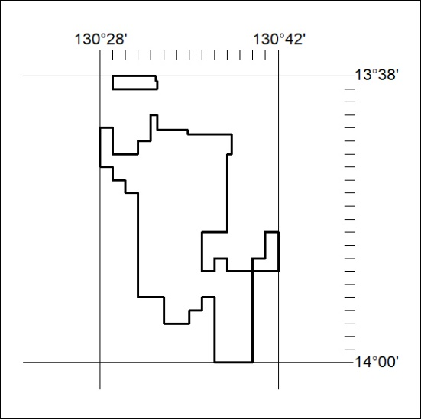

340/23

Mineral Titles Act 2010
NOTICE OF LAND CEASING TO BE A MINERAL TITLE AREA
Title Type and Number: | Exploration Licence 32963
Area Ceased on: | 01 August 2023
Area: | 76 Blocks, 253.37 km²
Locality: | DALY RIVER
Name of Applicant(s)/Holder(s): | 100% ALTAN NEVADA MINERALS (AUST) PTY LTD [ACN. 632 387 878]
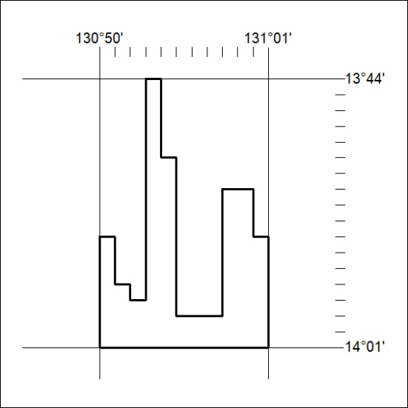

341/23

Mineral Titles Act
NOTICE OF GRANT OF A MINERAL TITLE
Title Type and Number: | Exploration Licence 33461
Granted: | 10 August 2023, for a period of 6 Years
Area: | 2 Blocks, 6.69 km²
Locality: | BATCHELOR
Name of Holder/s: | 100% BACCHUS RESOURCES PTY LTD [ACN. 606 340 872]
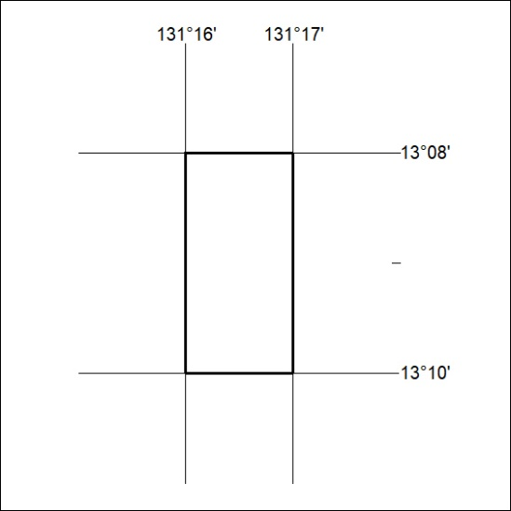
Area granted is indicated above. The titleholder is not permitted to exercise occupational rights on any land that is subject to a development title, or an application for a development title. Any land the subject of a Reserved Land gazettal under the Mineral Titles Act and all land vested in the Commonwealth of Australia is also excluded by description but not excised from the grant area.

342/23

