Mineral Titles Act 2010
NOTICE OF LAND CEASING TO BE A MINERAL TITLE AREA
Title Type and Number: | Exploration Licence 32889
Area Ceased on: | 01 August 2023
Area: | 248 Blocks, 807.37 km²
Locality: | BAUHINIA DOWNS
Name of Applicant(s)/Holder(s): | 100% GEMPART (NT) PTY LTD* [ACN. 081 859 896]
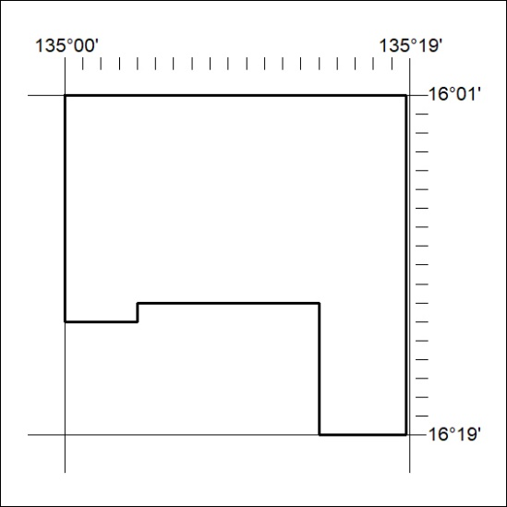

327/23

Mineral Titles Act 2010
NOTICE OF LAND CEASING TO BE A MINERAL TITLE AREA
Title Type and Number: | Exploration Licence 32974
Area Ceased on: | 01 August 2023
Area: | 248 Blocks, 769.60 km²
Locality: | EBENEZER
Name of Applicant(s)/Holder(s): | 100% CORE URANIUM LIMITED [ACN. 652 691 579]
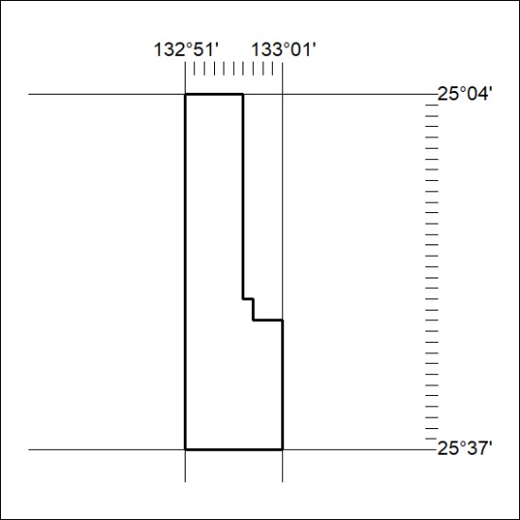

328/23
Mineral Titles Act 2010
NOTICE OF LAND CEASING TO BE A MINERAL TITLE AREA
Title Type and Number: | Exploration Licence 32975
Area Ceased on: | 01 August 2023
Area: | 250 Blocks, 776.64 km²
Locality: | ERLDUNDA
Name of Applicant(s)/Holder(s): | 100% CORE URANIUM LIMITED [ACN. 652 691 579]
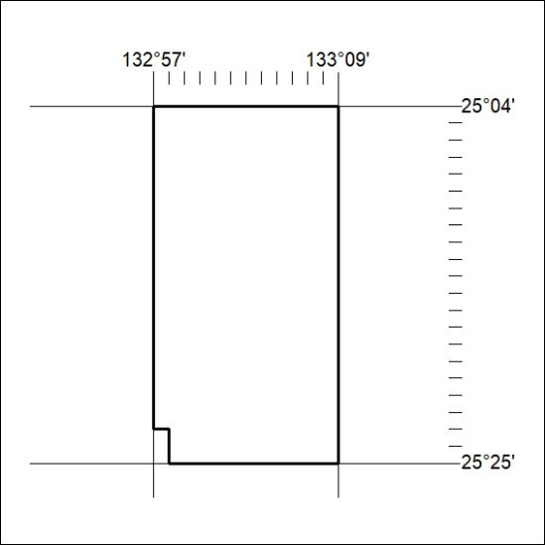

329/23

Mineral Titles Act 2010
NOTICE OF LAND CEASING TO BE A MINERAL TITLE AREA
Title Type and Number: | Exploration Licence 32976
Area Ceased on: | 01 August 2023
Area: | 241 Blocks, 748.68 km²
Locality: | ERLDUNDA
Name of Applicant(s)/Holder(s): | 100% CORE URANIUM LIMITED [ACN. 652 691 579]
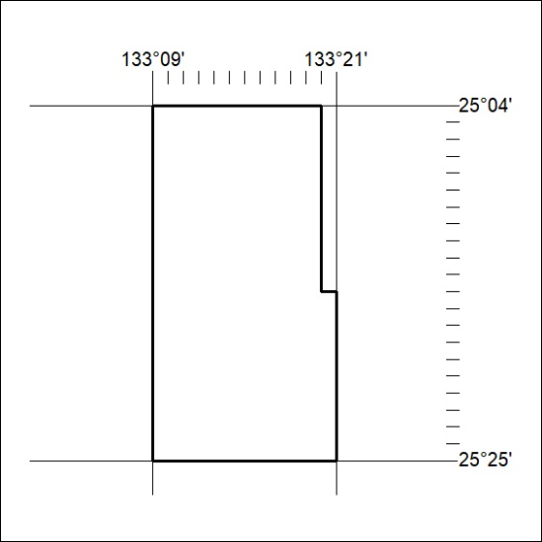

330/23
Mineral Titles Act 2010
NOTICE OF LAND CEASING TO BE A MINERAL TITLE AREA
Title Type and Number: | Exploration Licence 32977
Area Ceased on: | 01 August 2023
Area: | 244 Blocks, 755.88 km²
Locality: | KULGERA
Name of Applicant(s)/Holder(s): | 100% CORE URANIUM LIMITED [ACN. 652 691 579]
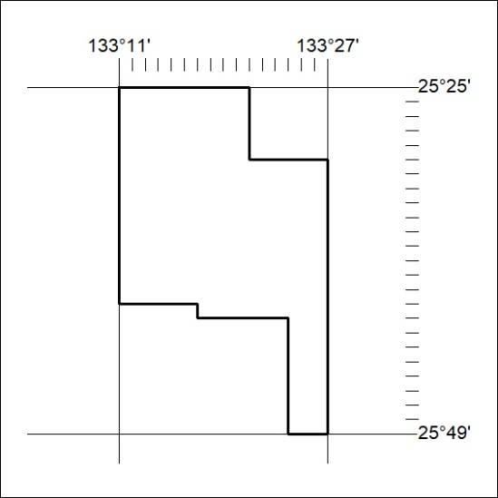

331/23

Mineral Titles Act 2010
NOTICE OF LAND CEASING TO BE A MINERAL TITLE AREA
Title Type and Number: | Exploration Licence 32983
Area Ceased on: | 01 August 2023
Area: | 240 Blocks, 745.31 km²
Locality: | IDRA COWRA
Name of Applicant(s)/Holder(s): | 100% CORE URANIUM LIMITED [ACN. 652 691 579]
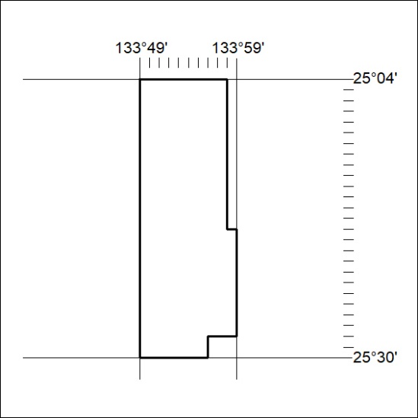

332/23
Mineral Titles Act 2010
NOTICE OF LAND CEASING TO BE A MINERAL TITLE AREA
Title Type and Number: | Exploration Licence 32984
Area Ceased on: | 01 August 2023
Area: | 246 Blocks, 764.27 km²
Locality: | ENGOORDINA
Name of Applicant(s)/Holder(s): | 100% CORE URANIUM LIMITED [ACN. 652 691 579]
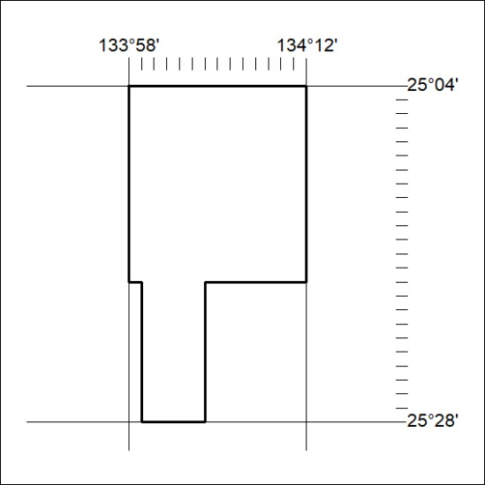

332/23

Mineral Titles Act 2010
NOTICE OF LAND CEASING TO BE A MINERAL TITLE AREA
Title Type and Number: | Exploration Licence 32999
Area Ceased on: | 25 July 2023
Area: | 43 Blocks, 137.00 km²
Locality: | VAUGHAN
Name of Applicant(s)/Holder(s): | 100% URO CORPORATION PTY LTD [ACN. 653 927 998]
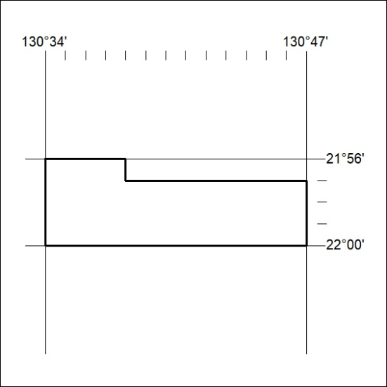
(Area now divided into Exploration Licence 33575 under s101 – EL moratorium period does not apply)

333/23

